Online Traffic Fine Payment System

(OLMS – Jurmana)

Bachelor of Technology Computer Science and Engineering

Submitted By
Ragyam Sinha (13000123064)

September 2025


Techno Main
EM-4/1, Sector-V, Salt Lake Kolkata- 700091
West Bengal India

Contents
- Introduction 3
- Life–Cycle Model Used and its Justification 3
- Design 3
  - DFD – 0 (Context Diagram) 4
  - DFD – 1 (Detailed Diagram) 5
  - DFD – 2 (Application & Approval Processes) 6
  - Complete Data Dictionary 8
- Size Estimation using FP Metric 10
a) Estimate the size of each module 10
- COCOMO Estimations 10
- Justify the choice of COCOMO Model 10
- Justify the choice of Product Class for each module 11
- Effort 11
- Development Time 11
- Development Cost 11
- Staff Requirement 11
- Conclusion 11
- References 11

Introduction
The Online Traffic Fine Payment System (OTFPS – JURMANA) is a web-based application designed to digitize the process of issuing, managing, and paying traffic fines. It allows citizens to view and pay fines online, admins (traffic police/officials) to issue fines and manage disputes, and integrates with external systems like Parivahan DB, payment gateways, and SMS/Email providers.
The system aims to reduce manual errors, improve transparency, and provide 24/7 accessibility for citizens while supporting government compliance with traffic rules and digital governance initiatives.

Life–Cycle Model Used and its Justification
For the development of LeaveSync, the Iterative Development Model has been selected. This model breaks down the development of a large application into smaller, more manageable parts or iterations. Each iteration goes through its own cycle of requirements, design, implementation, and testing, resulting in a functional piece of the software.

Justification:
The Iterative Waterfall Model (or Incremental Development Model) is most appropriate for this project.
- Why?
  - The system requirements are well-defined (registration, fine management, payment, disputes, notifications, reports, EV rules).
  - Modules can be built and tested incrementally (e.g., start with user registration → fine issuance → payment → disputes).
  - Supports integration with external APIs (Parivahan, Payment Gateway, SMS/Email), which can be developed in later iterations.
  - Reduces risks compared to a pure waterfall model by allowing feedback at each stage while still maintaining a structured development cycle.
Thus, the Iterative Waterfall / Incremental Model ensures a balance between structured planning and flexibility.

Design
The design of the system is modelled using Data Flow Diagrams (DFDs) to visualize the flow of information. The comprehensive data dictionary below provides a detailed repository of all data elements, processes, and stores used in the system, decomposed to multiple levels.

DFD – 0 (Context Diagram)

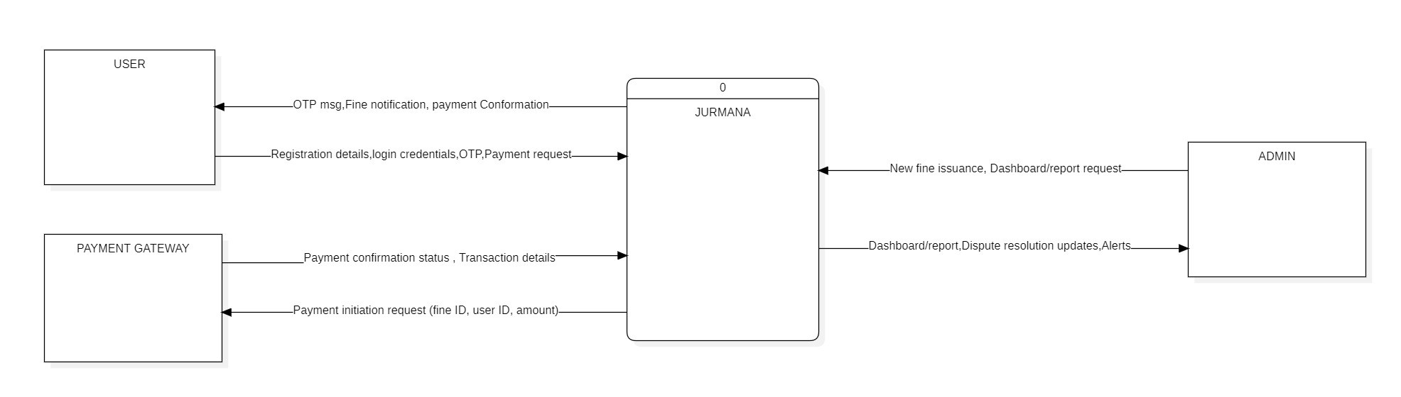

Overview: he Level 0 DFD, or Context Diagram, represents the Online Traffic Fine Payment System (OTFPS – JURMANA) as a single high-level process. It defines the boundaries of the system by showing how it interacts with external entities. This diagram highlights the key inputs received by the system and the outputs it generates, without exposing any internal processing complexity.

Process:
0 OTFPS – JURMANA: This central process handles all the major functionalities including user registration/authentication, fine management, online payment, notifications, dispute handling, and reporting.

External Entities:
The system interacts with three main external entities:
- User (Citizen/Vehicle Owner)
  - Provides: registration details, login credentials, OTP, payment requests.
  - Receives: OTP messages, fine notifications, payment confirmations.
- Admin (Traffic Authority/Official)
  - Provides: new fine issuance data, dashboard/report requests.
  - Receives: dashboards, reports, dispute resolution updates, alerts.
- Payment Gateway
  - Provides: payment confirmation status, transaction details.
  - Receives: payment initiation requests (fine ID, user ID, amount).

Data Stores:

At this level (DFD-0 / Context Diagram), no internal data stores are shown, since the focus is only on external interactions between the system and its entities.

DFD – 1 (Detailed Diagram)

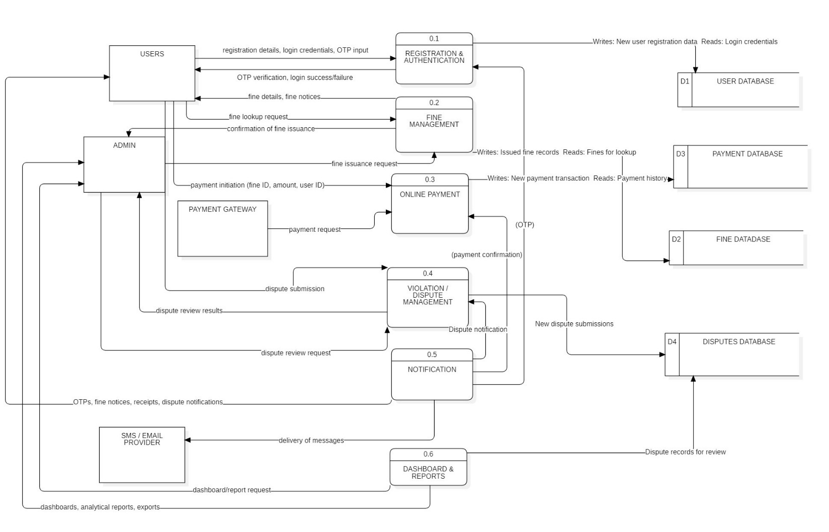

Overview:
The Level 1 DFD expands on the Level 0 Context Diagram by breaking the single OTFPS – JURMANA process into its major sub-systems. It provides a detailed view of the key functional modules, shows how each module interacts with external entities, and introduces the internal databases (data stores) where persistent information is kept. This level highlights the flow of data between users, admins, payment gateways, notification services, and the internal processes of the system.

Processes:

- 0.1 Registration & Authentication
Handles user/admin registration, login, and OTP verification.
↔ Reads/writes User Database (D1)
- 0.2 Fine Management
Enables admins to issue fines and users to view fine details.
↔ Reads/writes Fine Database (D2)
- 0.3 Online Payment
Processes payment initiation, forwards to payment gateway, and updates records.
↔ Reads/writes Payment Database (D3)
- 0.4 Violation/Dispute Management
Allows users to submit disputes and admins to review them.
↔ Reads/writes Disputes Database (D4)
- 0.5 Notification System
Sends OTPs, fine notices, receipts, and dispute updates via SMS/Email provider.
- 0.6 Dashboards & Reports
Generates analytical dashboards and custom reports for admins.
- users and generating business reports for management.

External Entities:

- Users (Citizens/Vehicle Owners): Provide registration details, login credentials, OTP, fine lookup requests, payments, and disputes. Receive OTPs, fine notices, receipts, and dispute updates.
- Admin (Traffic Authorities/Officials): Provide fine issuance details, dashboard/report requests, and dispute review decisions. Receive confirmation of fine issuance, analytical dashboards, and alerts.
- Payment Gateway: Processes fine payment requests and returns transaction confirmations.
- SMS/Email Provider: Delivers OTPs, fine notices, and confirmation messages to users.

Data Stores:
- D1 User Database – Stores user and admin credentials, profiles, and authentication data.
- D2 Fine Database – Maintains fine records (issued, paid, disputed).
- D3 Payment Database – Stores all payment transaction records.
- D4 Disputes Database – Contains dispute submissions and resolution history.

DFD – 2 (Application & Approval Processes)

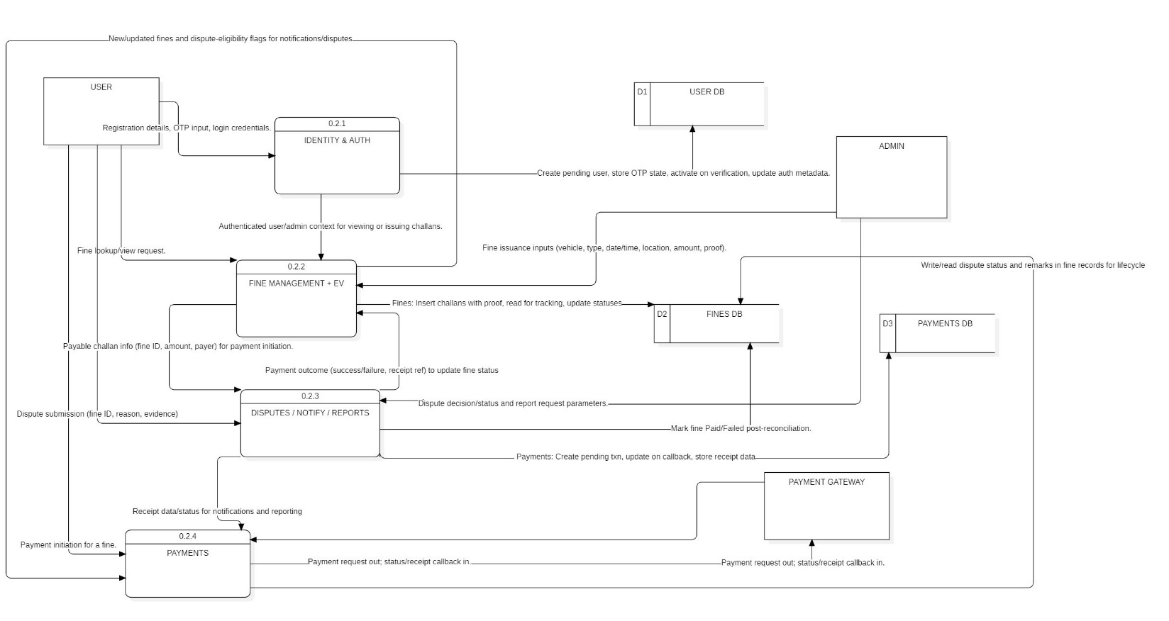
Overview:
This Level 2 DFD provides a more detailed view by expanding the 0.2 Fine Management + EV process from the Level 1 diagram. It breaks down how fines are created, validated, stored, and updated, including integration with the payment and dispute modules. The diagram also shows how fine records interact with internal data stores and external entities.

Processes:

- 0.2.1 Identity & Authentication
Validates the user or admin credentials before allowing access to fine-related operations.
↔ Interacts with User Database (D1) for login/verification.
- 0.2.2 Fine Management + EV
Handles issuance of new fines by the admin, tracks fine details, and incorporates EV-specific rules (e.g., exemptions or special handling).
↔ Reads/writes Fine Database (D2).
- 0.2.3 Disputes / Notification / Reports
Manages user disputes on fines, generates reports, and prepares notifications (fine status, dispute outcomes).
↔ Reads/writes Disputes Database (D4).
- 0.2.4 Payments
Initiates fine payments, communicates with the payment gateway, and updates payment outcomes (success/failure).
↔ Reads/writes Payment Database (D3).

External Entities:
- User: Provides registration details, OTP input, login credentials, fine lookup requests, disputes, and payment initiation. Receives OTPs, fine notices, receipts, and dispute decisions.
- Admin: Provides fine issuance inputs (vehicle no., violation type, proof, etc.), requests reports, and reviews disputes. Receives confirmations, dashboards, and alerts.
- Payment Gateway: Processes fine payment requests and sends back confirmation/transaction results.

Data Stores:

• D1 User Database – Stores registration/login data and OTP verification states.
• D2 Fine Database – Stores all issued fines, tracking details, and EV eligibility flags.
• D3 Payment Database – Maintains payment transactions and receipts linked to fines.
• D4 Disputes Database – Stores dispute submissions, admin reviews, and resolution history.

Complete Data Dictionary

Name | Type | Description | Composition | Source | Destination | Format
Registration Details | Data Flow | Info required for user account creation | Name, Mobile, Email, Vehicle No., Password | User | 0.1 Registration & Authentication | Text/Alphanumeric
Login Credentials | Data Flow | Credentials for authentication | User ID, Password | User/Admin | 0.1 Registration & Authentication | Text (Encrypted)
OTP Input | Data Flow | OTP entered by user for verification | OTP Code (6 digits) | User | 0.1 Registration & Authentication | Numeric (6-digit)
OTP Verification Result | Data Flow | Response after OTP check | Status (Success/Failure), Message | 0.1 Registration & Authentication | User | Text Message
User Data | Data Store (D1) | Stores registered user/admin details | User ID, Name, Contact, Vehicle No., Password, OTP state | 0.1 Registration & Authentication | All Auth Processes | Relational DB
Fine Issuance Request | Data Flow | Admin request to create fine | Vehicle No., Violation, Date/Time, Location, Amount, Proof | Admin | 0.2 Fine Management | Structured Record
Fine Details / Notices | Data Flow | User fines issued or retrieved | Fine ID, Amount, Status, Proof, Due Date | 0.2 Fine Management | User | Structured Record
Fine Lookup Request | Data Flow | Query for fine records | User ID / Vehicle No. | User | 0.2 Fine Management | Text / Numeric
Fine Records | Data Store (D2) | Stores fine details and status | Fine ID, Vehicle No., Violation, Amount, Status, Proof | 0.2 Fine Management | 0.2, 0.4, 0.6 | Relational DB
Payment Initiation Request | Data Flow | User request to pay fine | Fine ID, User ID, Amount, Method | User | 0.3 Online Payment | Structured Request
Payment Request | Data Flow | Payment forwarded to gateway | Fine ID, User ID, Amount, Method | 0.3 Online Payment | Payment Gateway | API JSON/XML
Payment Confirmation | Data Flow | Result from payment gateway | Transaction ID, Status, Timestamp, Amount | Payment Gateway | 0.3 Online Payment | API JSON/XML
Payment Records | Data Store (D3) | Stores all transactions | Payment ID, Fine ID, User ID, Amount, Date, Status | 0.3 Online Payment | 0.3, 0.6 | Relational DB
Receipt / Confirmation | Data Flow | Confirmation/receipt to user | Transaction ID, Fine ID, Amount, Status | 0.3 Online Payment | User | PDF/Email/SMS
Dispute Submission | Data Flow | User raises complaint on a fine | Fine ID, Reason, Evidence | User | 0.4 Dispute Management | Text + File (Image/PDF)
Dispute Review Request | Data Flow | Admin reviews disputes | Dispute ID, Comments, Status Update | Admin | 0.4 Dispute Management | Text
Dispute Updates | Data Flow | Results of dispute decisions to users | Dispute ID, Status, Remarks | 0.4 Dispute Management | User | Text / Email
Dispute Records | Data Store (D4) | Stores user disputes and admin resolutions | Dispute ID, Fine ID, Reason, Evidence, Status, Admin Remarks | 0.4 Dispute Management | 0.4, 0.6 | Relational DB
Notifications | Data Flow | Alerts and messages to users | OTP, Fine Notice, Payment Receipt, Dispute Update | 0.5 Notification | SMS/Email Provider | SMS/Email
Delivery of Messages | Data Flow | Sent via external provider | OTPs, Alerts, Confirmations | SMS/Email Provider | Users | SMS/Email
Dashboards/Reports | Data Flow | Summaries for admin | Reports of fines, disputes, payments | 0.6 Dashboards & Reports | Admin | PDF/Excel/Graphical UI

Size Estimation using FP Metric
Function Point (FP) analysis is a standardized method used to measure the size of a software system based on its functionality from a user's perspective. It is independent of the programming language or technology used, making it a reliable metric for estimation.

a) Estimate the size of each module
The analysis for the JURMANA system was conducted by identifying key user functions from the Data Flow Diagrams (DFDs) and categorizing them into four logical modules. The final adjusted Function Point (FP) size for each module is summarized below.
Module Name | Unadjusted FP (UFP) | Adjusted FP
1. User & Authentication Module | 22 | 23.1
2. Fine & Payment Management | 44 | 46.2
3. Dispute Management Module | 16 | 16.8
4. Notification & Reporting | 18 | 18.9
Total Project Size | 100 | 105

The detailed, step-by-step calculations for this Function Point analysis are available in the following spreadsheet

COCOMO Estimations
The Constructive Cost Model (COCOMO) is used to provide estimations for the project's effort, schedule, and staffing requirements based on the estimated size of the software.
spreadsheet

Below is a summary of the methodology and final results derived from those calculations.

Justify the choice of COCOMO Model
The Basic COCOMO model is chosen because this is an early-stage estimation for a medium-scale web application. It provides a quick and straightforward estimate based on the software’s estimated size.
b) Justify the choice of Product Class
The Semi-Detached product class is selected for this project.
- Justification: JURMANA integrates multiple external systems (Payment Gateway, SMS/Email Provider, Parivahan DB), involves both users and admins, and requires more coordination than a simple organic system. The complexity is moderate but not as high as embedded real-time systems, making Semi-Detached the best fit.

- Inputs / conversions
  - Adjusted FP = 105
  - LOC/FP = 60 (assumption)
  - Total LOC = 105 × 60 = 6,300 LOC
  - KLOC = 6,300 / 1,000 = 6.3 KLOC

Effort
• Total LOC = 105 FP × 60 LOC/FP = 6,300 LOC = 6.3 KLOC
• Effort (E) = 3.0 × (6.3)^1.12 ≈ 23.57 Person-Months

Development Time
  - Time (D) = 0.35 × (23.57) ≈ 8.25 Months

Development Cost
• Assuming an average loaded cost of ₹50,000 per person per month
• Cost = 23.57 × 50,000 ≈ ₹11,78,500
• Average Cost per Month = ₹11,78,500 ÷ 8.25 ≈ ₹1,42,800 / month

Staff Requirement
• Staff (S) = 23.57 ÷ 8.25 ≈ 2.86 Persons
• This suggests a core development team of 3 people

Conclusion
The JURMANA – Online Traffic Fine Payment System has been analyzed and estimated using Function Point Analysis and the Basic COCOMO model. The system’s design ensures comprehensive functionality, covering user authentication, fine issuance, payment integration, dispute management, notifications, and reporting.
From the Function Point analysis, the system size is estimated at 105 FP, corresponding to approximately 6.3 KLOC of code. Using the COCOMO (Semi-Detached mode) model with parameters (a = 3.0, b = 1.12, c = 0.35), the following results were derived:
- Effort ≈ 23.57 Person-Months
- Development Time ≈ 8.25 Months
- Staff Requirement ≈ 3 People
- Total Development Cost (@₹50,000 per PM) ≈ ₹11,78,500
- Average Cost per Month ≈ ₹1,42,800
These estimates suggest that the project is feasible with a small, dedicated team over a development timeline of about 8 months. The combination of Function Point sizing and COCOMO estimation provides a reliable baseline for planning, resource allocation, scheduling, and budgeting.
The study confirms that JURMANA is a cost-effective, efficient, and scalable solution that can digitize traffic fine management, ensure transparency, and improve citizen convenience while supporting government traffic enforcement.

References
- Pressman, R. S., & Maxim, B. R. (2019). Software Engineering: A Practitioner's Approach. McGraw-Hill Education.
- Sommerville, I. (2015). Software Engineering. Pearson Education.
- Boehm, B. W. (1981). Software Engineering Economics. Prentice-Hall.

