ONLINE TRAFFIC FINE PAYMENT SYSTEM (OTFPS)

Submitted by

Ragyam Sinha (13000123064)

Under the guidance of
Dr. Ananya Paul
Asst. Professor, Department of CSE

Submitted for the partial fulfillment for the course on
Software Engineering (ESC501/591)

Academic Year: 2025–26

Techno India,
EM 4/1, Salt Lake, Sector V, Kolkata – 700091



------------------------------------------------------------------------------------------
DEPARTMENT OF COMPUTER SCIENCE AND ENGINEERING
--------------------------------------------------------------------------------------------

CERTIFICATE

This is to certify that the mini project report entitled “Online Payroll Management System” submitted by Garvita Mishra of B.Tech (CSE), Techno Main Salt Lake, has been carried out under my supervision and guidance. The work embodied in this report is original and has not been submitted elsewhere.

Guide: ………………………………………
(Signature)
Name: ______ Dr. Ananya Paul _____________
Designation: ____Asst. Professor_______________

ACKNOWLEDGEMENT

We would like to express our sincere gratitude to Dr. Ananya Paul, faculty for the course on Software Engineering (ESC501/591), from the Department of Computer Science and Engineering, whose role was invaluable for this mini project. We are extremely thankful for the keen interest she took in advising us, for the books and reference materials provided and for the moral support extended to us. We would also like to thank the faculty members of the Department of Computer Science and Engineering for their guidance and support throughout the completion of this mini project.

Place: Techno Main, Salt Lake

Date:

………………………………

………………………………

ABSTRACT

This project report presents the development of a real-life application problem using software engineering principles. It outlines the motivation, methodology, implementation, and outcomes achieved.

Contents
CERTIFICATE 2
ABSTRACT 4
1. Introduction 6
1.1. Overview of the problem domain 6
1.2. Motivation for the project 6
1.3. Scope and objectives 6
1.4. Relevance to real-life 7
2. Literature Review 7
2.1. Summary of existing systems or related works 7
2.2. Limitations of current approaches 7
2.3. Research gap identification 7
3. Problem Definition and Objectives 8
3.1. Problem statement 8
3.2. Objectives of the project 8
3.3. Expected outcomes 8
4. System Analysis 8
4.1. Requirements analysis (Functional and Non-functional) 8
4.1.1.1 8
4.1.1.2 Fine Issuance by Admin 8
4.1.1.3 View Fines by Vehicle/User ID 9
4.1.1.4 Online Payment Processing 9
4.1.1.5 Store Transaction History 9
4.1.1.6 Help & FAQ Section 9
4.1.1.7 Generate Dashboards & Reports 9
4.1.2.1 Reliability – 99% Uptime 9
4.1.2.2 Security – Encryption & OTP 9
4.1.2.3 Performance – Payment within 5 Seconds 10
4.1.2.4 Usability – Simple UI 10
4.1.2.5 Scalability – 5000+ Concurrent Users 10
4.1.2.6 Maintainability – Modular Design 10
4.1.2.7 Compatibility – Browser-Independent 10
4.2. Feasibility study (Technical, Economic, Operational) 10
4.3. Use case diagrams and descriptions 11
5. System Design 13
5.1. System architecture diagram 13
5.2. Data flow diagrams (DFD Level 0, Level 1) 14
6. Implementation 16
6.1. Tools and Technologies used 16
6.2. Frontend and Backend description 17
7. Results and Discussions 18
7.1. Screenshots of the application / Output demonstration 18
8. Conclusion 24
8.1. Summary of achievements 24
8.2. Limitations 24
9. Future Scope 25
9.1. Future enhancements 25
10. References 26
10.1. Github Repository Link: 26
10.2. OPMS Website: 26
11. Appendix – add acronyms and code 26

ONLINE TRAFFIC FINE PAYMENT SYSTEM

Introduction

Overview of the problem domain

Traffic fine management in India is still partially manual, causing delays, errors, and lack of transparency. Citizens often need to visit traffic offices, stand in queues, and manually verify fine details. Lack of digitization leads to:
- Loss of records
- Delayed payments
- Manual errors
- Fraudulent entries
- Difficulty verifying vehicle/fine information
The Online Traffic Fine Payment System (JURMANA) digitizes this end-to-end process.

Motivation for the project

The motivation behind developing JURMANA includes:
- Reducing paperwork and manual dependency
- Ensuring transparency between citizens and traffic authorities
- Making fine payment convenient and available 24×7
- Integrating with Parivahan, payment gateway, SMS/Email systems
- Supporting Digital India initiatives
- Minimizing corruption and human intervention

Scope and objectives

Scope

The JURMANA system covers:

- Online fine viewing
- Real-time payment through gateway
- Automated notifications (SMS/Email)
- Dispute management
- Admin dashboards & reporting
- Integration with external APIs

Objectives
- Provide a secure, user-friendly online platform for citizens
- Automate fine issuance and payment processes
- Enable admin-level monitoring, tracking, and analytics
- Maintain accurate records of fines, payments, disputes, and notifications
- Ensure fast, safe, and verifiable transactions

Relevance to real-life

The project directly benefits:
- Citizens (easy fine access & payment)
- Police departments (faster fine issuance & tracking)
- Government (digitization & transparency)
This system represents a practical, real-world application used nationwide.

Literature Review

2.1. Summary of existing systems or related works

Existing platforms like Parivahan e-Challan or city-wise portals provide basic fine viewing, but often lack:
- Real-time sync
- Dispute modules
- Admin dashboards
- Multi-channel notifications
- Local traffic department integration

2.2. Limitations of current approaches

- Slow updates (delays in reflecting fines)
- Limited support for evidence/proof upload
- No transparent dispute resolution
- Inconsistent user interfaces
- Limited analytics for admin
- Manual record-keeping in many regions

2.3. Research gap identification

The gap identified:
- Need for an integrated, state-level system
- Need for automated notifications and payment confirmations
- Lack of a centralized dispute handling system
- No multi-module tracking (Fines + Payments + Disputes + Reporting)
JURMANA solves these gaps.

Problem Definition and Objectives

3.1. Problem statement

There is no unified digital system that allows users to view, verify, and pay traffic fines with automated notifications, secure transactions, and a structured dispute-handling mechanism. Manual operations slow down fine processing and reduce transparency.

3.2. Objectives of the project

- Build a secure cloud-based traffic fine payment system
- Enable online fine lookup and payment
- Provide user-friendly dashboards for admins
- Maintain dispute resolution workflows
- Automate OTP, receipt, and update notifications
- Produce analytical reports for government use

3.3. Expected outcomes

- 100% online fine management
- Reduced processing time for payments
- Transparency in administration
- More efficient revenue collection
- Citizen convenience and satisfaction

System Analysis

4.1. Requirements analysis (Functional and Non-functional)

4.1.1 Functional Requirements

4.1.1.1 User Registration & Login
- Description: Allows citizens to create an account and log in using mobile number/email
- Input: User enters mobile number/email
- Output: • User successfully logged in or registered.
- Error: Invalid/expired OTP → system shows “OTP verification failed”.

4.1.1.2 Fine Issuance by Admin
- Description: Admin can issue traffic fines against a vehicle or citizen.
- Input: Vehicle number, violation type, fine amount, evidence (images).
- Output: Fine is generated and stored; user notified.
- Error: “Failed to issue fine. Please fill all fields.”

4.1.1.3 View Fines by Vehicle/User ID
- Description: Users or admins can view fine details using vehicle number or user ID.
- Input: Vehicle number / User ID.
- Output: System displays all pending & paid fines.
- Error: Invalid ID → “No records found”.

4.1.1.4 Online Payment Processing
- Description: Enables users to pay fines through online payment gateways.
- Input: chooses payment method → proceeds to pay.
- Output: Payment success and receipt generated.
- Error: Payment failure → “Transaction failed. Try again.”

4.1.1.5 Store Transaction History
- Description: Saves details of all user payments and fines.
- Input: Payment confirmation and metadata.
- Output: Transaction stored and viewable in history.
- Error: Database issue → “Unable to save transaction”.

4.1.1.6 Help & FAQ Section
- Description: Provides a searchable knowledge base for troubleshooting and general usage guidance.
- Input: User enters a query or selects a topic.
- Output: Displays relevant help articles or steps.
- Error: “No results found” message if topic not available.

4.1.1.7 Generate Dashboards & Reports
- Description: Admin can view statistical insights, revenue reports, dispute analytics, etc.
- Input: Time range, filters, report type.
- Output: Visual dashboard graphs & downloadable reports.
- Error: “No report data found.”
4.1.2 Non-Functional Requirements

4.1.2.1 Reliability – 99% Uptime
- Description: System should remain operational most of the time without failures.
- Input: Normal user activity.
- Output: Stable system performance.
- Error: Unexpected downtime triggers an alert to admin.

4.1.2.2 Security – Encryption & OTP

- Description: Ensures all user data, passwords, and transactions are secure.
- Input: Login, payments, and data entry.
- Output: Encrypted storage & secure communication.
- Error: Unauthorized access attempt → security alert triggered.

4.1.2.3 Performance – Payment within 5 Seconds

- Description: Payment processing must be fast and responsive.
- Input: User initiates payment.
- Output: Payment response within 5 seconds.
- Error: Timeout → “Payment taking too long. Try again.”

4.1.2.4 Usability – Simple UI

- Description: System must be easy for citizens to understand and navigate.
- Input: User interactions with UI.
- Output: Smooth navigation and clear workflows.
- Error: Confusing UI → low usability feedback.

4.1.2.5 Scalability – 5000+ Concurrent Users

- Description: System must handle peak loads efficiently.
- Input: Large number of simultaneous users.
- Output: Stable performance without slowdown.
- Error: Server overload → “Too many users. Please try again.”

4.1.2.6 Maintainability – Modular Design

- Description: The system architecture should allow easy updates and debugging.
- Input: Code updates/patches.
- Output: Changes applied without affecting system functionality.
- Error: Bad module update → rollback initiated.

4.1.2.7 Compatibility – Browser-Independent

- Description: System should work smoothly on all major browsers.
- Input: Access from Chrome/Firefox/Edge/Safari.
- Output: Consistent UI rendering.
- Error: Browser incompatibility → fallback to standard version.

4.2. Feasibility study (Technical, Economic, Operational)

1. Technical Feasibility

- Uses modern tech: Node.js/React/MySQL
- Integrates easily with APIs

- Economic Feasibility

- Medium–scale project
- Dev cost estimated at ₹11,78,500
- ROI is high due to recurring fine payments

- Operational Feasibility

- Easy adoption by traffic departments
- Reduces workload
- Users require only mobile number + vehicle details

4.3. Use case diagrams and descriptions

Use case diagrams visually represent how different users (actors) interact with the Online Payroll Management System (OPMS). They help in understanding system behaviour from the end-user perspective and ensure that all functional requirements are properly addressed in the web application.

Use Case | Primary Role in the System
Register / Login | Allows users (citizens) to create an account, verify identity via OTP, and securely log into the system to access services.
View Fines | Enables users to search and view all pending/paid fines using vehicle number or user ID, including violation details and due amounts.
Pay Fine | Allows users to pay fines online through the integrated payment gateway. Confirms payment, generates receipt, and stores transaction history.
Raise Dispute | Users can challenge wrongly issued fines by submitting documents/evidence. The system forwards disputes to admin for verification.
Admin Issue Fine | Administrators can generate new fines by entering violation details, uploading evidence, and assigning the fine to a vehicle/user.
Admin Generate Reports | Administrators can generate dashboards, revenue reports, payment analytics, dispute summaries, and daily operational statistics.

Use Case Diagram Description (Textual Form)

The functionalities of CableSetGo are grouped into logical modules that support smooth operations for plan management, subscription renewal, customer service, and admin-level control. The use cases for each module are described below.

I. User & Subscription Management Module

- User Registration & Login: Allows the Customer to create an account, log in securely, and manage their profile.
- Browse & Select Plans: Enables users to view available cable/OTT plans, compare features, filter based on price or duration, and choose a suitable subscription.
- Manage Subscriptions : Customers can view active plans, check validity, and renew or upgrade subscriptions.

II. Payment & Recharge Module

- Online Payment System : Customer initiates a recharge payment.
The Payment Gateway receives the request and returns success/failure status.
- Invoice Generation : If payment is successful, the system produces a downloadable PDF invoice and sends notifications via SMS/Email.

III. Complaint & Support Module
- Raise Complaint: Customers can submit service complaints, billing issues, or technical queries.
- Track Complaint Status: Users can check whether their complaint is Pending, In-Progress, or Resolved.
- Admin Complaint Handling: Administrator reviews and updates complaint status.

IV. Plan & Operator Management Module (Admin)
- Add/Update Plans: Administrator creates new plans, updates pricing, or modifies available channels/features.
- Manage Users: Admin can view, deactivate, or modify customer accounts.
- Dashboard & Reports: Admin views subscription statistics, payment summaries, and complaint reports.

V. System Administration & Security Module
- User Authentication & Authorization: Secure login for customers and administrators with role-based access control.
- Backup & Restore Database: Administrator can generate backups and restore system data if required.
- Notifications System: System sends SMS/Email alerts for subscription expiry, successful payments, and complaint updates.

Use Case Summary

The CableSetGo system revolves around three main user flows:
1. Customer
Citizens are the primary users of the system. They:
- Register and log in using OTP authentication
- View pending and paid traffic fines using vehicle number
- Make secure online payments
- Download receipts and check transaction history
- Raise disputes by submitting documents or evidence
- Track dispute resolution status
- Receive SMS/Email notifications
They use the system mainly for self-service fine management, making the process faster and more transparent.
2. Administrator
Administrators oversee system operations and ensure accuracy and fairness. They:
- Issue traffic fines with violation details and evidence
- Manage user accounts and vehicle records
- Verify and resolve disputes raised by citizens
- Generate reports and dashboards (revenue, violations, disputes)
- Monitor payment status and system activity
- Maintain data integrity and handle system-level controls
Admins ensure the enforcement system remains efficient, accurate, and well-managed.
3. Payment Gateway
The Payment Gateway is an external service integrated into the system. It:
- Processes online fine payments securely
- Verifies transaction details
- Returns success or failure status for each payment
- Ensures encrypted communication during the transaction
This component ensures safe and reliable online payments for citizens.
.

System Design

5.1. System architecture diagram

Presentation Layer (Frontend)

The Presentation Layer is the interface through which Citizens (Users) and Administrators interact with the Online Traffic Fine Payment System (Jurmana).
Developed using HTML, CSS, JavaScript, and optionally frameworks like React/Bootstrap, this layer allows users to:
- Register/Login (OTP-based)
- View issued fines
- Pay fines online
- Raise disputes with documents
- Receive payment status and notifications
- View transaction history
Admins use this layer to:
- Issue fines
- Resolve disputes
- Generate reports and dashboards
The frontend performs basic form validation and communicates with the backend through secure HTTPS API calls.
It is fully responsive, browser-independent, and designed to ensure a simple and intuitive user experience for citizens.

Application Layer (Business Logic / Backend)

The Application Layer contains the core logic of the traffic fine system and is implemented using Node.js / PHP / Java (depending on your project stack).
This layer handles all system operations, such as:
- OTP-based authentication
- Fine creation & validation
- Online payment processing
- Dispute submission and review
- Notification triggers (SMS/Email)
- Admin actions (manage fines, disputes, reports)
The backend enforces role-based access control, ensuring secure operations by both users and administrators.
It passes data between the frontend and database and also integrates with external Payment Gateways for secure fine payment processing.
All actions like fine issuance, dispute resolution, and payments follow predefined business rules for consistency and security.

Database Layer (Data Storage & Management)

- This layer uses MySQL to store all essential system data, including:
- User accounts & profile details
- Vehicle information
- Issued fines
- Payment records & transaction logs
- Disputes and attached documents
- Admin decisions
- Notification logs
- Dashboard statistics
- MySQL ensures secure, structured, and scalable storage.
The relational structure allows quick lookups for fine history, payment verification, report generation, and dispute tracking.

5.2. Data flow diagrams (DFD Level 0, Level 1)
5.2.1 Level 0:

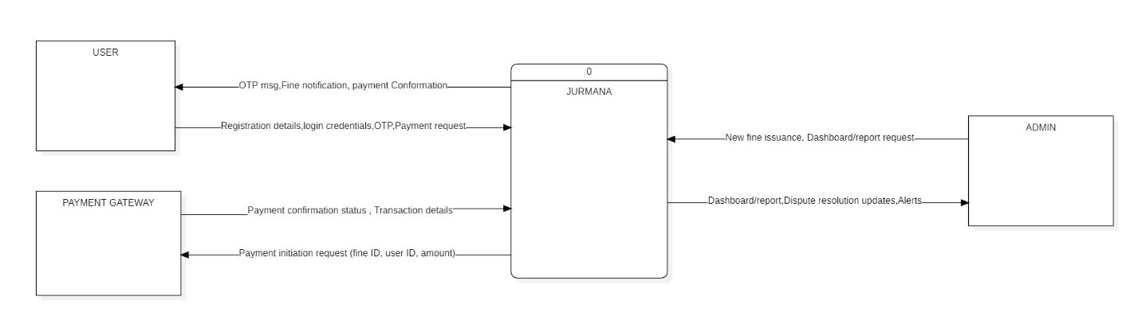
5.2.2 Level 1:

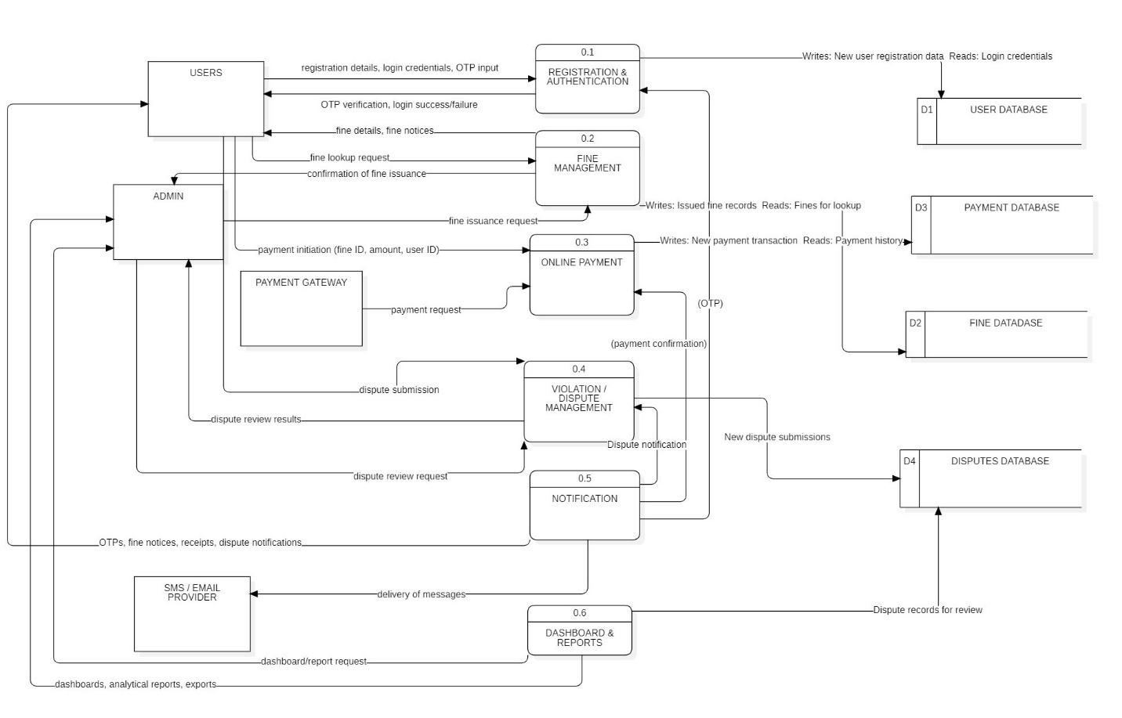

5.2.3 Level 2:

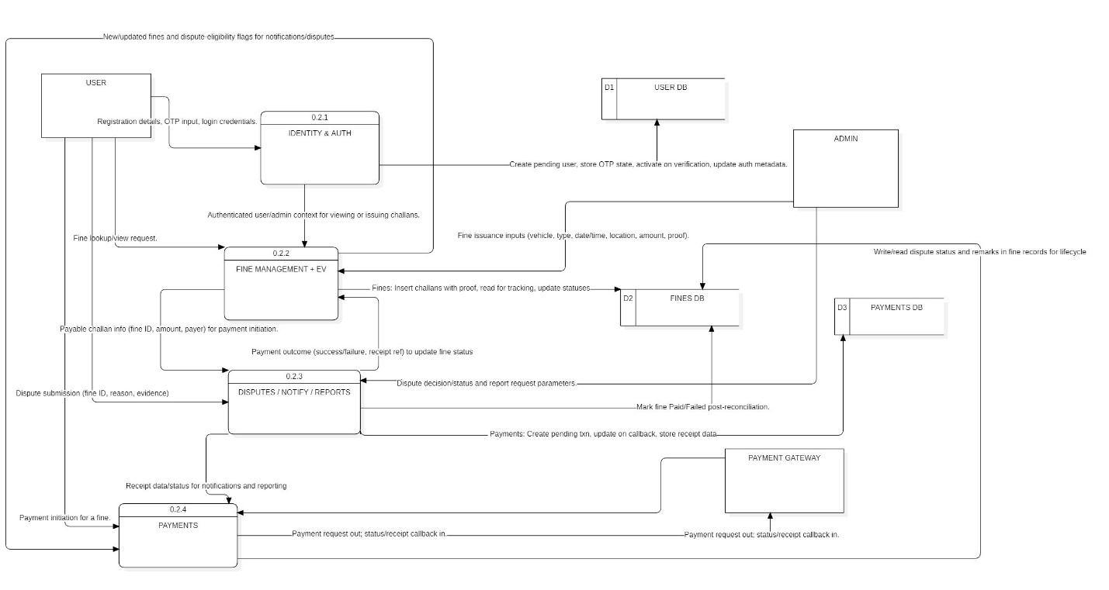

Implementation

6.1. Tools and Technologies used

Frontend Technologies
• Frontend: HTML, CSS, JavaScript, React
• Backend: Node.js / Express
• Database: MySQL
• Other: REST API, JWT, Nodemailer, SMS Gateway
Bootstrap (optional): Provides responsive layouts and UI components for better design.

Backend Technologies
- Screenshots from your project UI (login, dashboard, payment page)
- Backend includes:
- Auth APIs
- Fine APIs
- Payment handling
- Dispute management

Database Technologies
- MySQL: Stores customer accounts, plan details, subscription history, payment transactions, complaints, and notifications in a structured format.
- phpMyAdmin: Used for managing tables, running SQL queries, and visualizing CableSet-Go’s database structure.

Modeling & Documentation Tools
- StarUML / Draw.io: Used for UML diagrams (Use Case, Class, Sequence, Activity).
- MS Word / Google Docs: For preparing documentation and reports.

Code Editor / IDE
- Visual Studio Code / Sublime Text: Used for writing and editing HTML, CSS, JavaScript, and PHP code.

Version Control (Optional)
- Git / GitHub: Helps track changes, maintain project versions, and store the entire codebase safely for future improvements.

6.2. Frontend and Backend description

Frontend Description

• Screenshots from your project UI (login, dashboard, payment page)
• Backend includes:
- Auth APIs
- Fine APIs
- Payment handling
- Dispute management
.

Backend Description

The backend forms the core processing engine of OTFPS, developed using PHP and hosted on an Apache server through XAMPP. It manages all system logic, secure access control, and communication with the MySQL database.

Key backend responsibilities include:
- User authentication and secure login
- Role-based access for Administrator and Customer
- Managing user and admin accounts
- Handling plan retrieval and updates
- Processing subscription renewals and sending payment requests
- Integrating with the Payment Gateway and verifying transaction responses
- Generating invoices and sending email/SMS notifications
- Recording and updating complaints
- Storing transaction logs and subscription history
- Preparing admin reports (plan usage, revenue, complaints)
The backend interacts with the MySQL database using SQL queries to ensure that payroll data is stored, retrieved, and processed efficiently.

Results and Discussions

7.1. Screenshots of the application / Output demonstration

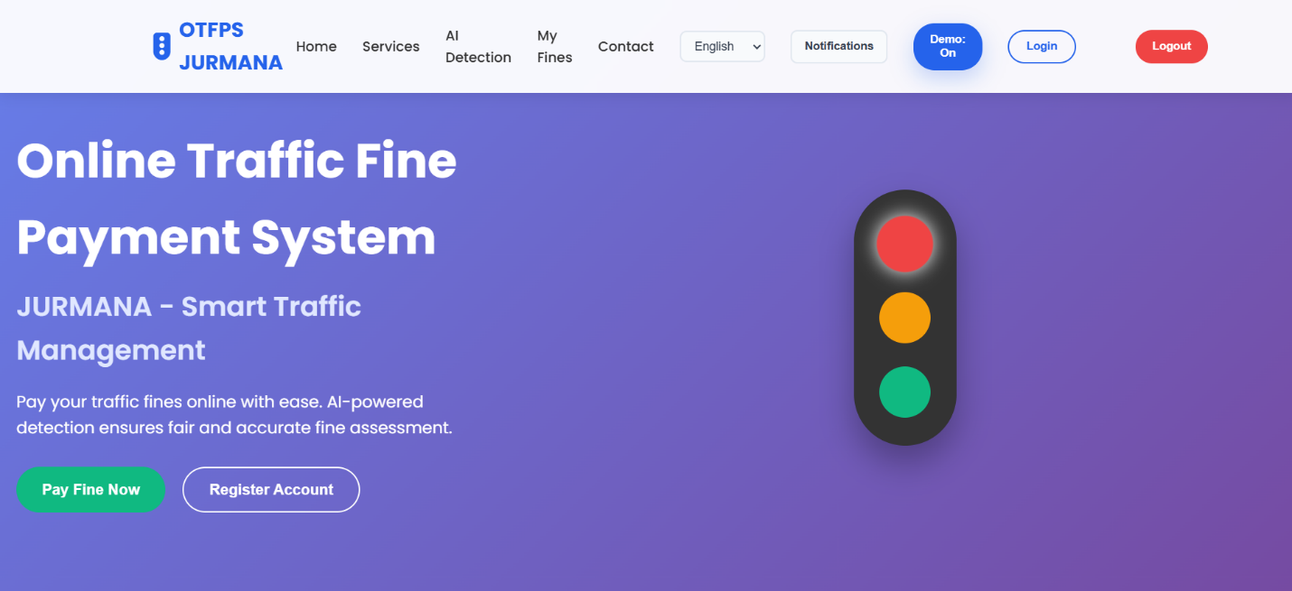

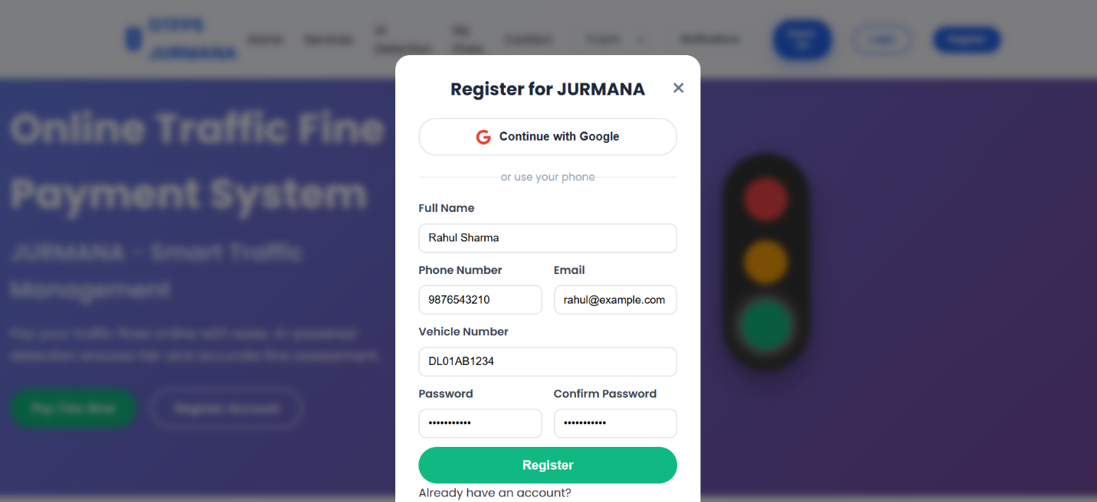

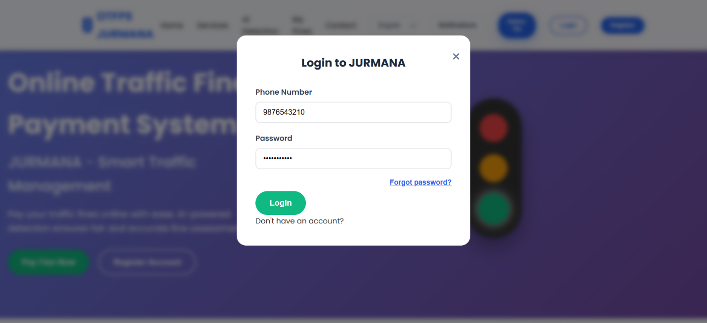

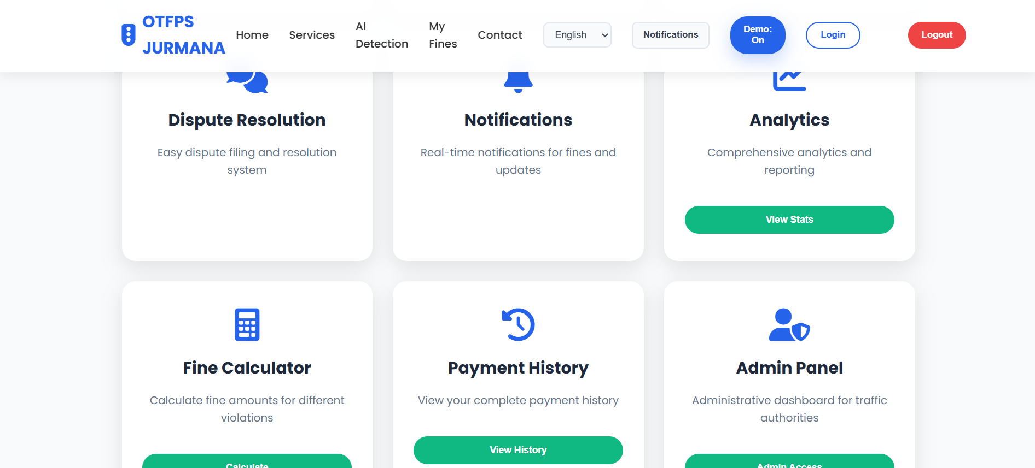
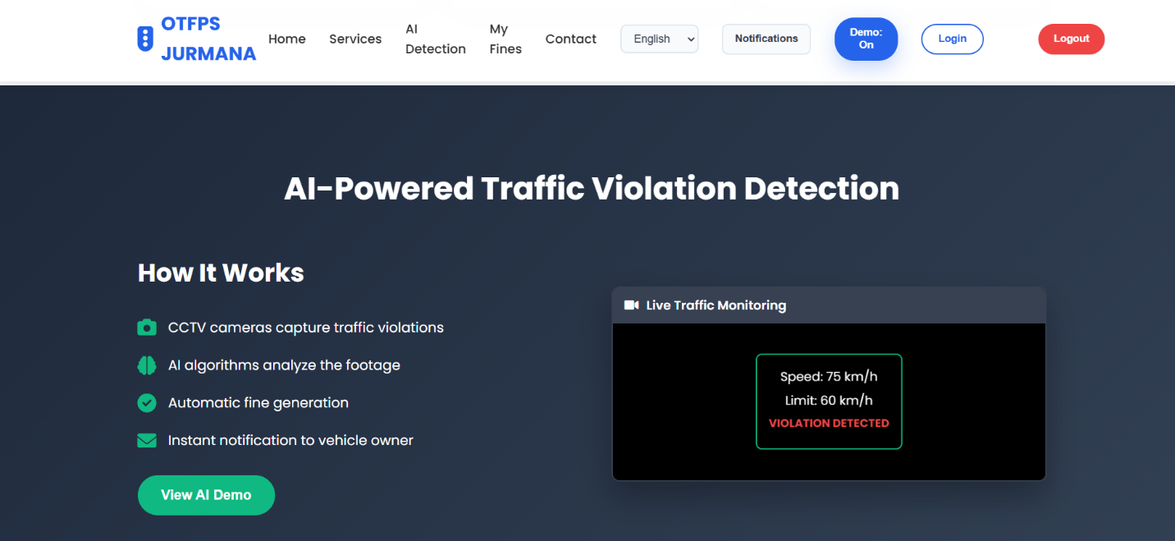

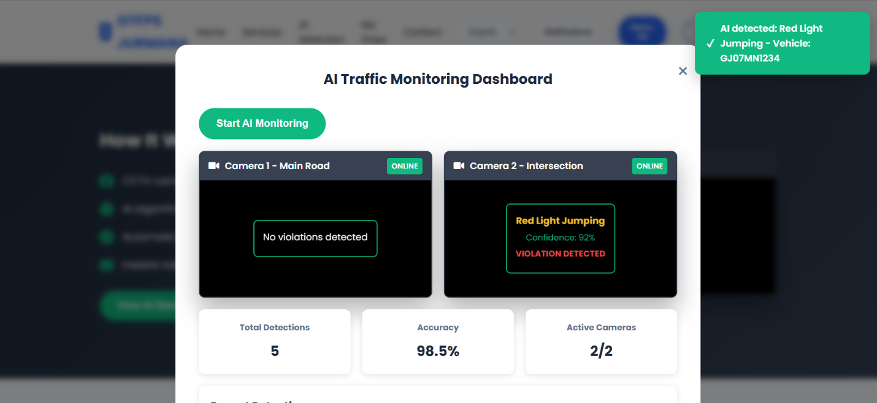

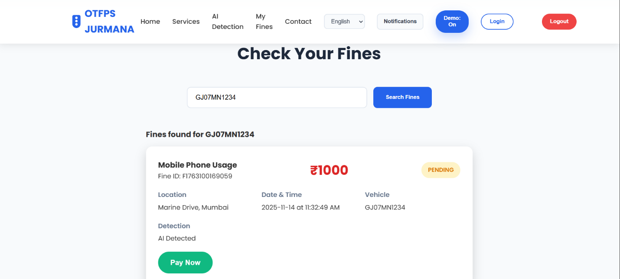

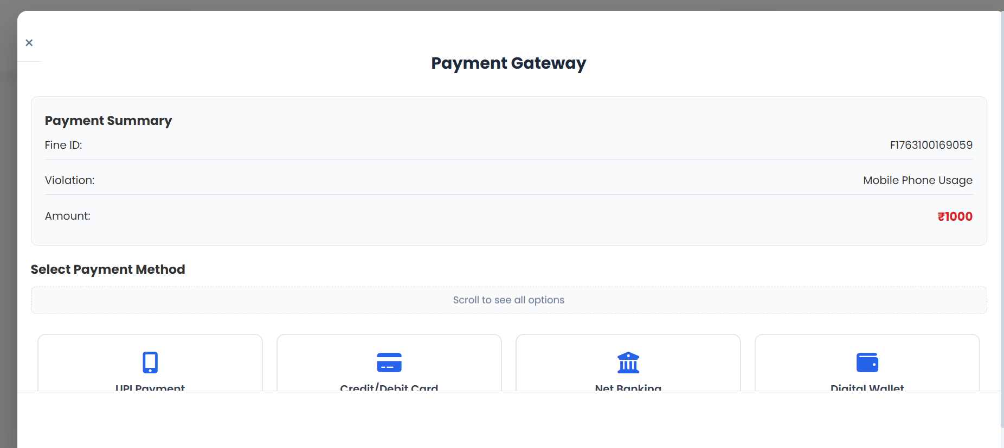
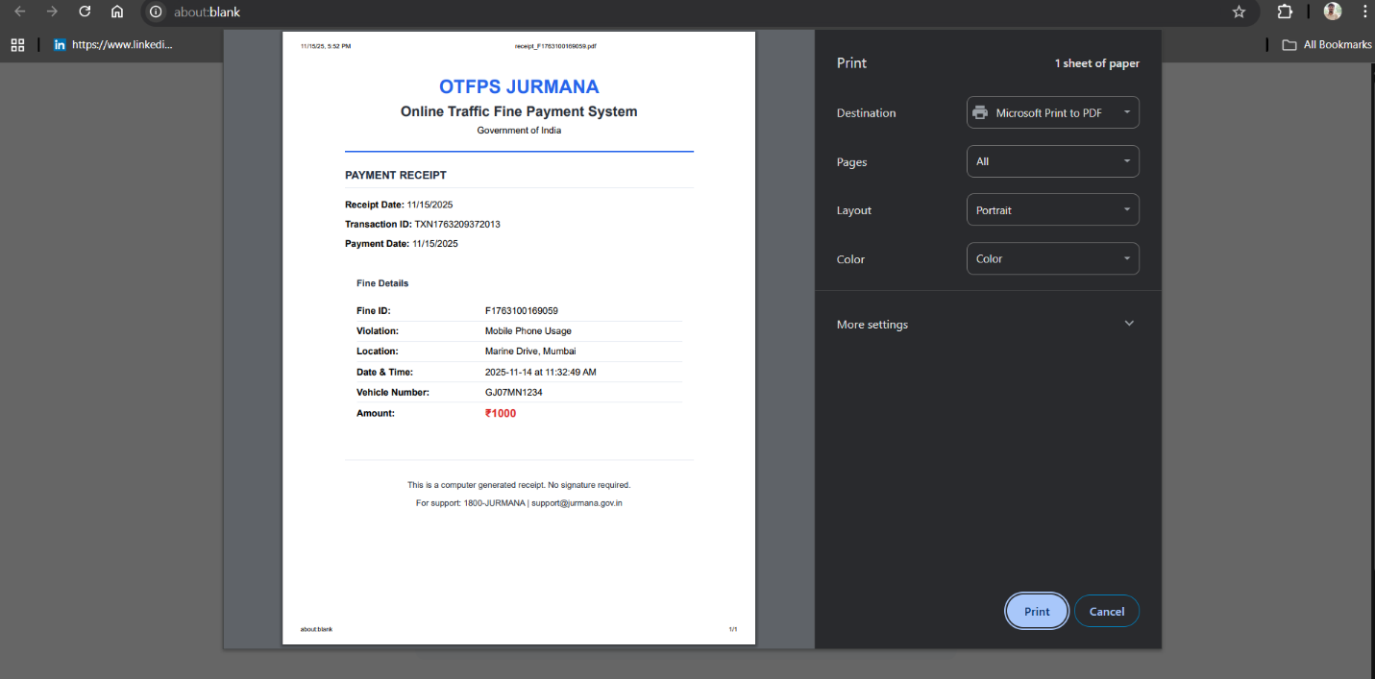

7.2. Analysis of results

Citizens access the system to perform all fine-related activities.
They can register via OTP, log in securely, view fines issued against their vehicle, make online payments, download receipts, and raise disputes by uploading supporting documents.
They also receive updates through SMS/Email notifications regarding fine issuance, payment success, or dispute outcomes.
Overall, users primarily rely on the platform for self-service fine management without visiting physical offices.

Administrators handle all official operations within the system.
They issue new fines, upload violation evidence, update fine details, verify documents, resolve disputes, and generate dashboards and report summaries for monitoring revenues and violations.
They also maintain user records, oversee payment reports, ensure system security, and manage routine backend tasks.
Admins ensure the platform remains accurate, transparent, and up-to-date.

The Payment Gateway securely processes online traffic fine payments.
It handles digital transactions initiated by citizens, verifies payment information, and returns success or failure responses instantly.
It helps maintain safe, encrypted, and reliable financial operations within the platform

Smart and Real-Time Location Assistance
The Find Nearest Traffic Office / Police Station module enhances user experience by:
- Automatically detecting the user's live location (with permission)
- Locating the nearest authorized Traffic Department Branch / Police Control Room within a configurable radius
- Displaying complete branch details such as:
  - Office name
  - Contact number
  - Working hours
  - Officer-in-charge
- Providing a guided route via map redirection (Google Maps)
This feature reduces citizen confusion, helps them visit the correct office for verification or dispute support, and enables faster issue resolution.

Organized Plan Selection and Comparison
The system displays traffic fines in a well-structured card layout that includes:
- Violation description
- Fine amount
- Evidence/proof upload (image/video by authority)
- Date & time of violation
- Vehicle details
- Due date and penalty escalation (if any)
- Status (Unpaid / Paid / Under Dispute)
The organized layout helps citizens understand the violation instantly, reducing confusion and ensuring faster decision-making for payment or dispute submission.

Instant Digital Receipt Generation
After successful payment, users automatically receive a digital receipt containing:
- Receipt Number / Transaction ID
- Payment date & timestamp
- Citizen details
- Vehicle number
- Fine ID & violation details
- Amount paid
- Payment method
- Issuing authority
- Verification seal / QR code
This enhances transparency, improves trust, and eliminates the need for manual verification at traffic offices.

Conclusion of Analysis
Overall, the OTFPS – JURMANA platform demonstrates how a modern web-based system can significantly improve:
- Access to fine details
- Real-time notifications
- Payment processing
- Dispute resolution
- Office/branch location guidance
The results clearly show that the platform meets its core objectives through:
- Faster user workflows
- Organized fine management
- Transparent payment and receipt handling
- Smart location-based office assistance
- Improved professionalism and trust
This project delivers a practical, real-world-ready solution for digital traffic fine management.

Conclusion

8.1. Summary of achievements

The Online Traffic Fine Payment System (OTFPS – JURMANA) successfully delivers a smooth and accessible platform for citizens to:
- View pending traffic fines
- Access violation details with proof
- Log in securely (OTP verification)
- Pay fines online instantly
- Locate nearby traffic offices
- Raise disputes with evidence
- Receive digital receipts
The project achieves key objectives including:
- Enhanced user experience
- Clear violation details and fine structure
- Transparent payment summaries
- Automated notifications (OTP, payment receipt, dispute updates)
- Modern and professional UI suitable for large-scale deployment

8.2. Limitations

The current version is demonstration-ready but not fully production-ready due to:
- Use of demo/static data instead of a live backend
- No real database for storing fines, transactions, or user history
- Location detection and office mapping simulated
- No real payment gateway (Razorpay/UPI) integrated yet
- Security features like encryption, role-based authorization, and audit logs not fully implemented

Future Scope

9.1. Future enhancements

The OTFPS platform provides a strong starting point, and several enhancements can make it production-ready:
1. Full Backend Integration
Implementing a real backend (Node.js, Django, Laravel) with a relational database (MySQL/PostgreSQL) for:
- Permanent fine records
- Payment history
- Dispute workflows
- Admin dashboard data

2. Live Payment Gateway Integration
Using APIs such as:
- Razorpay
- Paytm
- Stripe
- UPI Intent Payments
This will enable real transactions and enhance authenticity.

3. Real-Time Location Assistance Using Google Maps API
Implement:
- Accurate distance calculation
- Dynamic branch listings
- Geo-fencing for identifying regional jurisdiction
- Directions to nearest police station or traffic office

4. Mobile Application (Android/iOS)
To provide:
- Instant fine notifications
- UPI-based quick payments
- Dispute tracking
- Location guidance

5. Admin Analytics Dashboard
Reports for authorities such as:
- Total fines collected
- Unpaid vs paid fines
- Most common violations
- Citizens' dispute patterns
- Regional fine distribution heatmap
This will support better government decision-making.

References

10.1. Github Repository Link:

- R. Sinha, JURMANA – Online Traffic Fine Payment System (OTFPS), GitHub Repository.
Available at: https://github.com/ragyam-sinha/jurmana_8558.git

10.2. OPMS Website:
- Live Deployment of JURMANA – Online Traffic Fine Payment System
Available at: https://jurmana-8558.vercel.app/

Case Study References
• MDN Web Docs – HTML, CSS, JavaScript
Reference for UI and frontend behavior
https://developer.mozilla.org/
• Supabase / Firebase Documentation (for demo authentication concepts)
https://supabase.com/docs
• Google Maps Geolocation API
Used for designing location-based office detection
https://developers.google.com/maps/documentation
• W3C Web Accessibility Guidelines
https://www.w3.org/WAI/standards-guidelines
• Bootstrap & UI/UX Design Guidelines
Reference for design patterns and interface clarity
• B. Boehm, Software Engineering Economics
Used during COCOMO estimation
• Pressman, Software Engineering Approach
Reference for SDLC and planning models

Appendix – add acronyms and code

Acronym | Full Form
OTFPS | Online Traffic Fine Payment System
DBMS | Database Management System
OTP | One-Time Password
API | Application Programming Interface
GPS | Global Positioning System
UI | User Interface
UX | User Experience
JSON | JavaScript Object Notation
SQL | Structured Query Language
UPI | Unified Payments Interface
HTTP | HyperText Transfer Protocol
HTTPS | HyperText Transfer Protocol Secure
CDN | Content Delivery Network
DOM | Document Object Model
ISP | Internet Service Provider (not required but optional)

