Software Requirements Specification
for
Online Traffic Fine Payment System
(OTFPS – JURMANA )
Version 1.0 approved
Prepared by Ragyam Sinha
TMSL-CSE
02.08.2025
Table of Contents
Table of Contents
1. Introduction 4
1.1. Purpose/Objective 4
1.2. Document Conventions (Definition, Acronyms, Abbreviations) 4
1.2.1. OTP: One Time Password 4
1.2.2. EV: Electric Vehicle 4
1.2.3. UI: User Interface 4
1.2.4. Admin: Traffic Police or Authorized Government Official 4
1.2.5. User: Citizen or vehicle owner 4
1.2.6. System: Online Traffic Fine Payment Web Application 4
1.3. Scope 4
1.4. References 4
2. History/Background Study (Sources of Domain Knowledge) 4
2.1. Technical Literature 4
2.2. Existing Applications 4
2.3. Customer Surveys 6
2.4. Expert Advice 6
2.5. Current/Future requirements 9
3. Overall Description 9
3.1. Product Functions 9
3.1.1. Hardware Requirement 9
3.1.2. Client Side: Any modern device with internet (PC/Laptop/Mobile) 9
3.1.3. Software Requirement 9
3.1.4. Client Side: Web browser (Chrome, Edge, Firefox), OS: Windows / Android / iOS / Linux 9
3.2. Functional Requirements 10
3.2.1. User Registration and Authentication 10
3.2.2. OTP Verification 10
3.2.3. User Login 10
3.2.4. Admin Login 10
3.2.5. Fine Management 10
3.2.6. Online Payment 11
3.2.7. Violation Management 11
3.2.8. Notification System 12
3.3. Non-Functional Requirements 13
3.3.1. Correctness Requirement 13
3.3.2. Portability requirement 13
3.3.3. Efficiency Requirement 14
3.3.4. Usability Requirement 14
3.3.5. Reusability Requirement 14
3.3.6. Reliability Requirement 14
3.3.7. Maintainability Requirement 14
3.4. User Characteristics 14
3.5. Design & Implementation Constraints 14
3.6. Assumptions & Dependencies 15
4. Interface Requirements 15
4.1. User Interfaces 15
4.2. Hardware Interfaces 15
4.3. Software Interfaces 15
4.4. Communication Interfaces 15
5. Conclusion 16

Introduction

Purpose/Objective
The purpose of this document is to define the software requirements for the development of an Online Traffic Fine Payment System. The system will allow citizens to view and pay traffic violation fines online, enable authorities to issue and manage fines digitally, and streamline the overall traffic enforcement process.

Document Conventions (Definition, Acronyms, Abbreviations)

OTP: One Time Password

EV: Electric Vehicle

UI: User Interface

Admin: Traffic Police or Authorized Government Official

User: Citizen or vehicle owner

System: Online Traffic Fine Payment Web Application

Scope
This project provides an online platform for traffic fine management in urban and rural areas. It supports user registration, fine notification, online payments, violation tracking, and dispute handling. The system ensures transparency, reduces manual errors, and integrates with national vehicle databases and e-wallets.
It includes features for both citizens (view/pay/dispute fines) and admins (issue fines, review disputes, generate reports). Special rules for Electric Vehicles are also incorporated.

References
Indian Motor Vehicle Act, 1988:- https://morth.nic.in/en/motor-vehicles-act-1988
Government e-Challan portal:- https://echallan.parivahan.gov.in/
Vahan: - https://vahan.parivahan.gov.in/nrservices/

History/Background Study (Sources of Domain Knowledge)

Technical Literature
Research papers and government guidelines on traffic enforcement automation and smart city integration were studied to design system modules and ensure legal compliance.

Existing Applications

Category | Traditional Fine System | Online Fine Payment System
Mode of Payment | Cash only at police booths or courts | UPI, Net Banking, Credit/Debit Card, Wallets
User Convenience | Requires physical presence, time-consuming | 24/7 access from anywhere
Registration | Manual documentation | Digital registration with OTP verification
Fine Issuance | Paper challan with handwritten details | Auto-generated digital challan with media proof
Notifications | No real-time alerts | SMS/Email notifications for fines and updates
Payment Confirmation | Manual receipt | Instant digital receipt + history in dashboard
Dispute Handling | Long queues, physical application | Online dispute submission and tracking
Admin Efficiency | Manual record keeping, prone to loss | Centralized dashboard, filters, and reports
Security | Risk of human error or tampering | OTPs, encrypted transactions, role-based access
Tracking & Reports | Paper logs and manual reports | Instant reports (paid/unpaid/disputed fines)
Support for EV Rules | Not available or inconsistent | Automated waiver checks for EVs
Environmental Impact | Uses paper for challans and receipts | Paperless system (eco-friendly)
Fraud Prevention | Higher risk (cash mishandling, fake slips) | Audit trails, secure payments, verified IDs
Cost of Implementation | Low tech cost, high manpower | High initial tech cost, low operational manpower
Public Transparency | Limited user insight | Transparent fine records, proof-based violations

We analyzed government portals like e-Challan, Delhi Traffic Police Portal, and apps like paravian to understand their strengths and limitations.

Customer Surveys
- Click here to view Customer form.
- Click here to view Response Sheet.

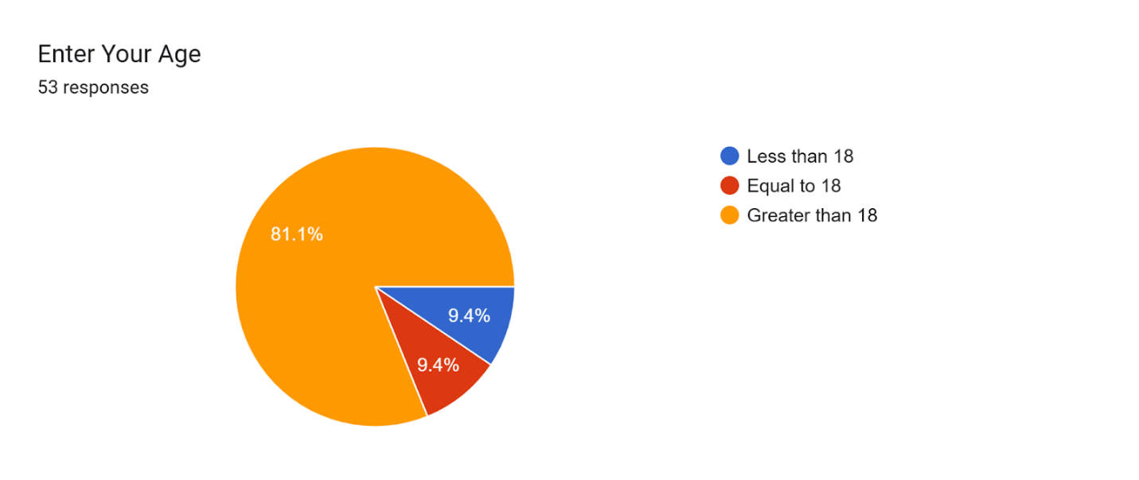

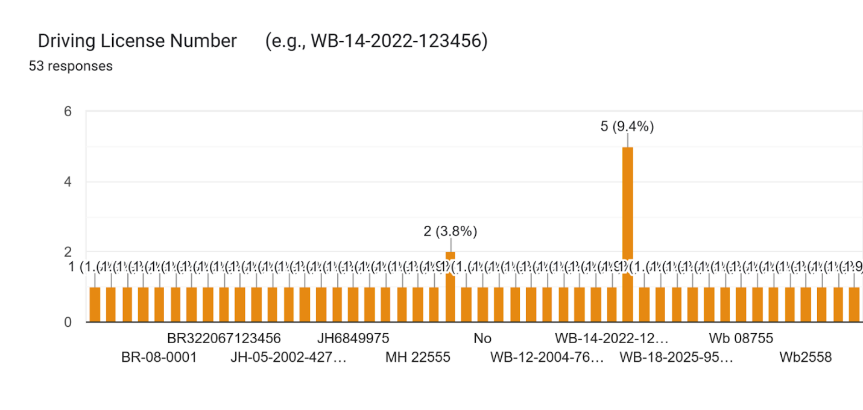

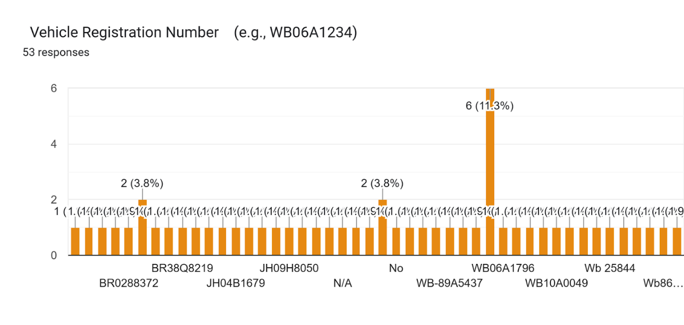

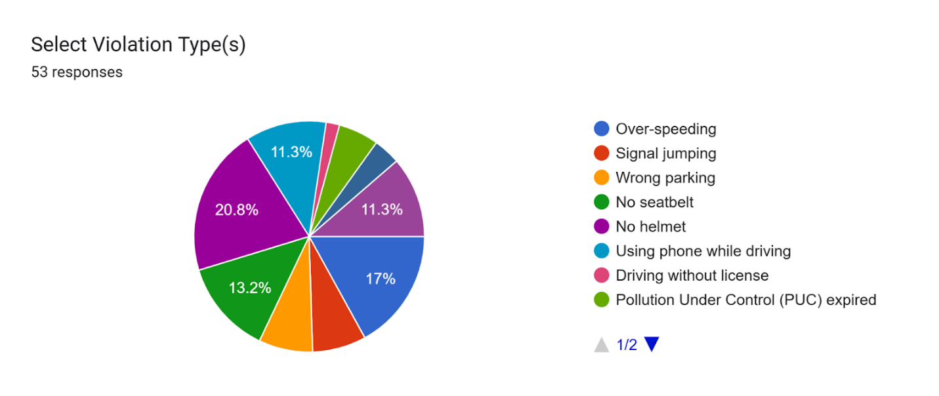

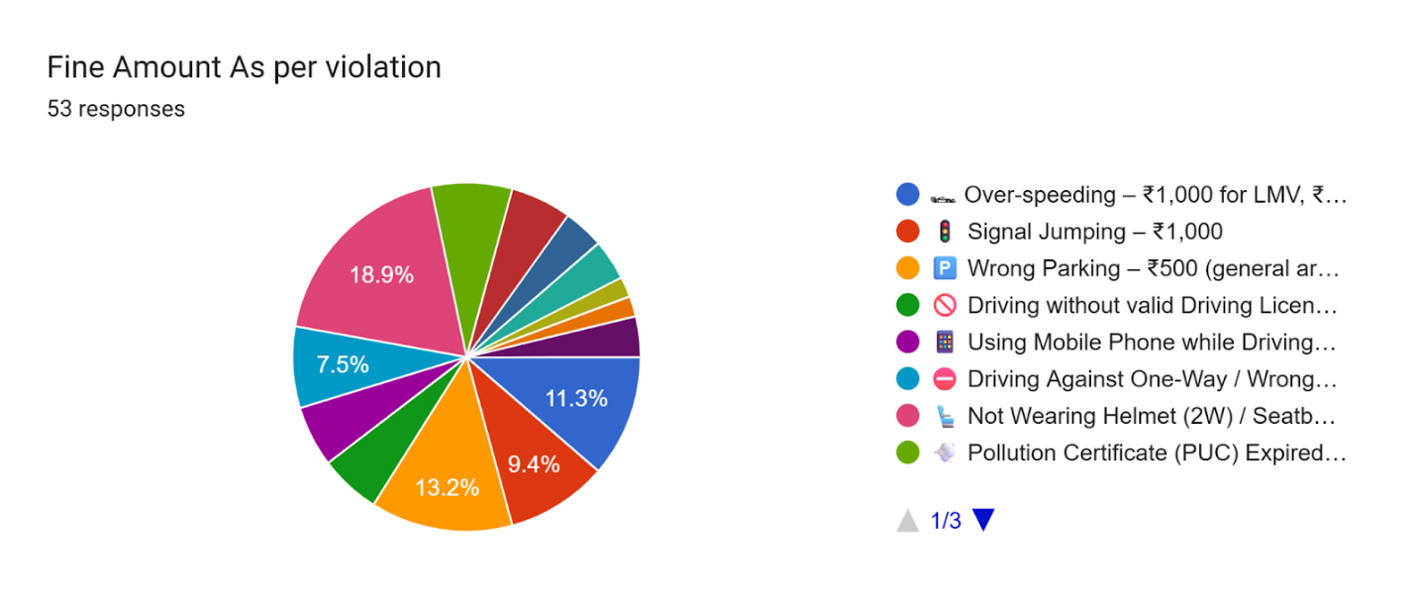
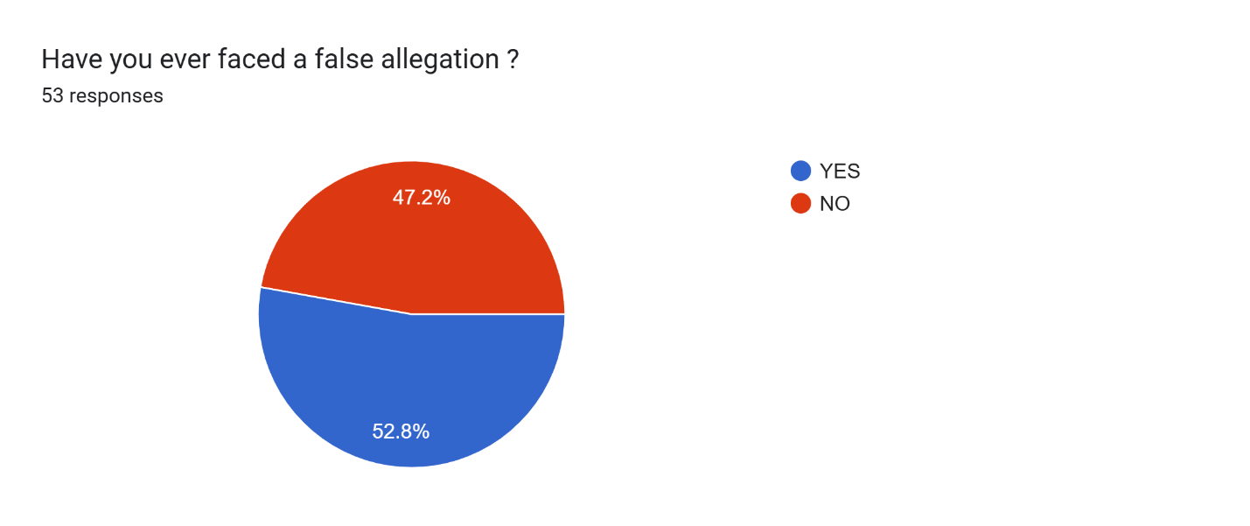

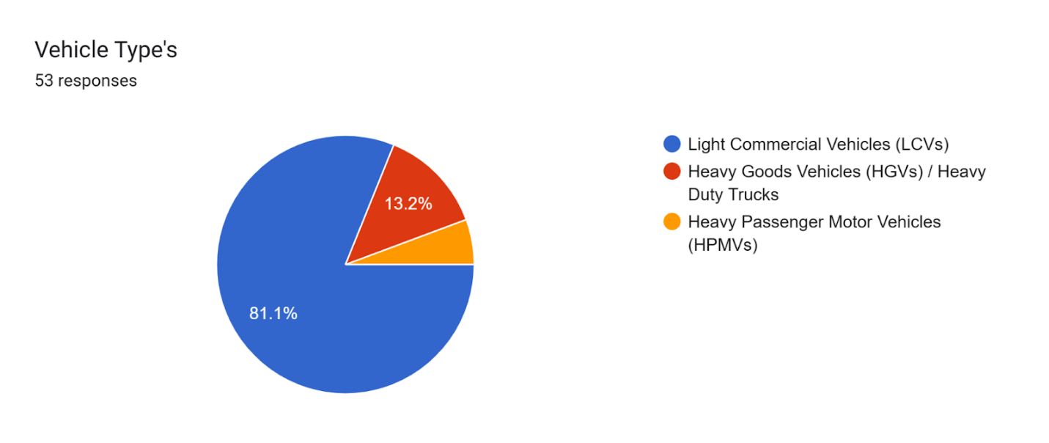

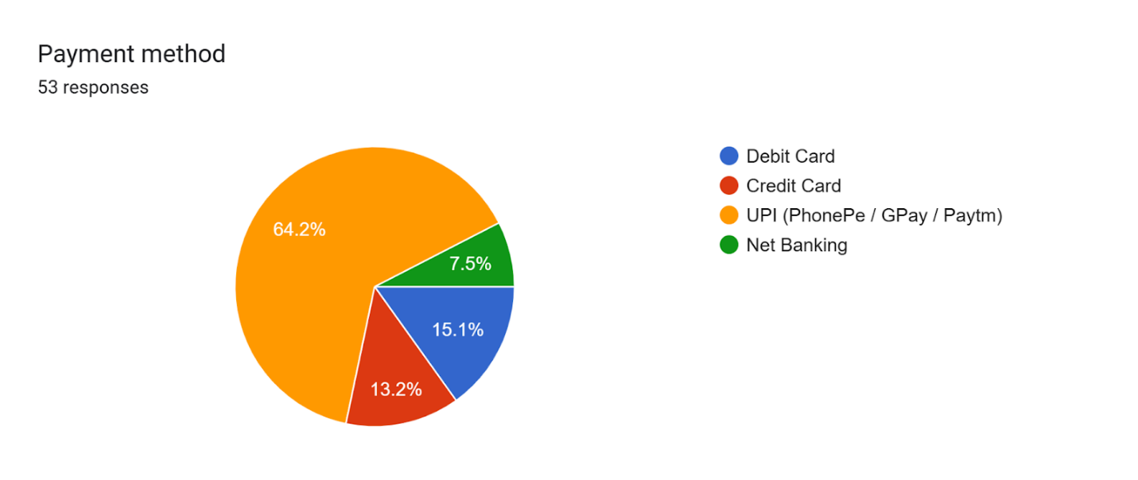

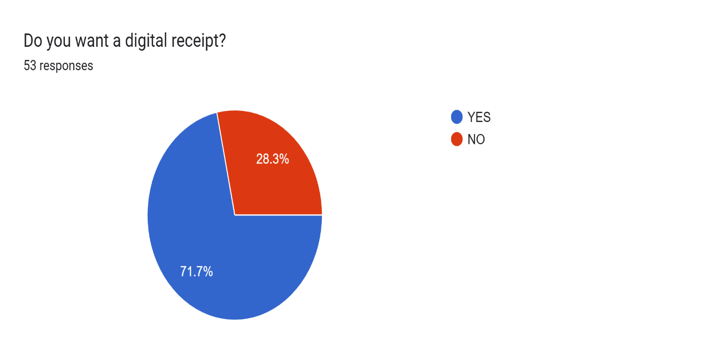

Expert Advice
Consultation with traffic police officers and municipal IT professionals helped us identify the practical workflow for issuing fines and handling disputes.

Current/Future requirements
Current requirements include online payment, user dashboard, admin……panel, and dispute…….module.
Future additions may include AI-based violation detection from CCTV footage and mobile app integration.

Overall Description

Product Functions

Hardware Requirement

Client Side: Any modern device with internet (PC/Laptop/Mobile)
              - Server Side:
                - Processor: Intel Xeon or AMD equivalent
                - RAM: Minimum 8 GB
                - Storage: 200 GB SSD
                - Internet: 100 Mbps bandwidth
                - Backup Power and Cooling

Software Requirement

Client Side: Web browser (Chrome, Edge, Firefox), OS: Windows / Android / iOS / Linux
              - Server Side:
                - OS: Ubuntu Server 20.04 LTS
                - Web Server: Apache / Nginx
                - Backend: Node.js / Java / Python (Django)
                - Database: MySQL / PostgreSQL
                - APIs: Government vehicle DB API, Payment Gateway API
                - Security: SSL/TLS, CAPTCHA, JWT Authentication

Functional Requirements

User Registration and Authentication
Description: Allows a new user to register on the system with their personal and vehicle details.
Input: Name, Mobile Number, Email ID, Vehicle Registration Number, Password.
Output: Account created message or validation error; OTP sent for verification.
Error: mobile/email exists, invalid input, vehicle number wrong, fields empty

OTP Verification
Description: Verifies the user account through OTP sent to registered mobile/email.
Input: OTP (One-Time Password).
Output: Confirmation of successful verification or failure message.
Error: wrong otp, otp expired, too many attempts.

User Login
Description: Allows registered users to log in securely to their account.
Input: Email/Phone Number, Password.
Output: Successful login with dashboard access or error message for invalid credentials.
Error: wrong credentials, not verified, login limit reached

Admin Login
Description: Allows traffic officers or authorized personnel to log in as an admin.
Input: Admin Username and Password.
Output: Access to the admin dashboard or error message.
Error: invalid login, not authorized, account blocked.

Fine Management

Fine Issuance
Description: Enables traffic authorities to issue new fines for traffic violations.
Input: Vehicle Number, Violation Type, Date & Time, Location, Fine Amount, Proof (image/video).
Output: Fine record generated and stored; user notified.
Error: vehicle not found, no proof, missing info, duplicate fine.

Fine Tracking
Description: Allows users to view all fines related to their vehicle, along with payment and dispute statuses.
Input: User ID or Vehicle Number.
Output: List of fines with status (Paid/Unpaid/Disputed), fine details.
Error: no fines found, wrong vehicle number

Online Payment
Description: Enables users to pay their traffic fines securely via online payment gateways.
Input: Fine ID, User ID, Payment Method (UPI/Card/Net-banking), Payment Details.
Output: Payment confirmation, receipt generated, and fine status updated to “Paid”.
Error: payment failed, invalid details, already paid, timeout.

Violation Management

View Violation Details
Description: Displays detailed information of the violation for which the fine was issued.
Input: Fine ID or Vehicle Number.
Output: Violation type, date/time, location, photographic evidence, amount.
Error: fine not found, invalid input.

Dispute Submission
Description: Allows users to submit a complaint if they believe the fine was wrongly issued.
Input: Fine ID, User ID, Reason for dispute, Optional supporting document/image.
Output: Acknowledgment of dispute and tracking ID.
Error: fine not found, already disputed, reason missing.

Dispute Resolution
Description: Enables admins to review disputes and provide resolutions.
Input: Dispute ID, Admin Comments, Status Update (Accepted/Rejected/Under Review).
Output: Dispute status updated; user notified.
Error: invalid dispute id, update failed, comment missing.

Notification System

Fine Notification
Description: Sends automated SMS/Email notifications to the user when a fine is issued.
Input: Fine ID, User Contact Details.
Output: Notification message sent with fine summary and payment link.
Error: contact missing, message not sent
      - Payment Confirmation Notification
Description: Sends confirmation message after successful payment of fine.
Input: Payment ID, Fine ID, User ID.
Output: Digital receipt sent via SMS/Email.
Error: payment not found, failed to notify
      - Dispute Status Notification
Description: Sends alert when the status of a raised dispute is updated.
Input: Dispute ID, User ID, Status Update.
Output: Message with updated status and admin remarks sent to user.
Error: payment not found, failed to notify.
    - Dashboard & Reports
      - User Dashboard
Description: Provides users with a personal dashboard showing fines, payment history, and dispute records.
Input: User ID.
Output: Dashboard view with categorized fine details, total dues, and status tracking.
Error: user not found, session expired
      - Admin Dashboard
Description: Allows traffic officials to view and manage issued fines, disputes, payment reports, and violation trends.
Input: Admin ID.
Output: Interactive dashboard with filters for region, time period, vehicle type, and violation category.
Error: access denied, load failed.

      - Report Generation
Description: Allows admin to generate custom reports on fines collected, unpaid fines, disputed fines, and vehicle violation stats.
Input: Date range, filter options (location/type/status).
Output: Exportable reports in PDF/Excel format.
Error: invalid date, no data, export failed

    - Electric Vehicle (EV)-Specific Rules
      - EV Fine Waiver Check
Description: System checks for EV-specific exemption policies before applying a fine.
Input: Vehicle Registration Number.
Output: Decision on whether fine is waived or applicable based on policy.
Error: policy not found, wrong vehicle type

      - EV Priority Handling
Description: Flags EV-related fines for manual review if applicable under government incentives or special exemptions.
Input: Fine ID, Vehicle Type.
Output: Fine marked for review; notification sent to admin.
Error: invalid input, queue full.

EV Fine Summary
Description: Provides summary of fines applicable specifically to electric vehicles under current legal framework.
Input: Filter: Vehicle Type = EV.
Output: List of fines, status, and whether they were exempted or paid.
Error: no data found, filter failed.

Non-Functional Requirements

Correctness Requirement
The system must ensure accurate recording of user data, fines, payment transactions, and violation details. Any incorrect data entry should be rejected or flagged. Fine amounts must match the violation category defined by government rules.

Portability requirement
The system should be accessible on various platforms including desktops, laptops, tablets, and smartphones via modern web browsers. It must support multiple operating systems like Windows, Android, iOS, and Linux.

Efficiency Requirement
The application should respond to user actions within 2 seconds and process payments in under 5 seconds. Server-side APIs must return data within acceptable timeframes even during peak hours.

Usability Requirement
The UI should be simple, user-friendly, and accessible to users of all age groups. Icons, labels, and instructions should be clear and use local languages where possible. The system should offer an intuitive dashboard for both users and admins.

Reusability Requirement
Modules like login authentication, payment gateway integration, and notification services should be designed as reusable components to support integration in future government apps or portals.

Reliability Requirement
The system must maintain high availability (uptime > 99.5%) and ensure data is not lost during failures. Proper backup mechanisms must be in place, and the system should recover gracefully from unexpected crashes.

Maintainability Requirement
The system codebase and architecture should follow modular and layered design principles, enabling future updates, bug fixes, and enhancements with minimal effort.

User Characteristics
General Users (Citizens): Non-technical users with basic internet knowledge, using the platform to view and pay fines.
Traffic Officers (Admins): Familiar with traffic rules and violation data entry. May require training for system use.
IT Support/Admins: Technically trained users responsible for system maintenance and monitoring.

Design & Implementation Constraints
Integration must follow government security standards (e.g., Digi Locker, Parivahan APIs).
Must comply with privacy laws like the IT Act, 2000, and protect sensitive user information.
Only approved government payment gateways may be used.
Development must be done using open-source technologies where possible.

Assumptions & Dependencies
Users have access to the internet and a mobile number linked to their vehicle.
Vehicle and license data will be retrieved from a government-maintained central database.
SMS/Email services from third-party providers must be reliable for OTP and alerts.
Payment gateway APIs must remain operational and up-to-date.

Interface Requirements

User Interfaces
Login/Signup Page: Simple form with OTP-based validation.
User Dashboard: Lists fines, payment status, and option to raise disputes.
Admin Panel: Interface to issue fines, manage disputes, and generate reports.
Responsive Design: Layout adjusts automatically for mobile and desktop screens.

Hardware Interfaces
Integration with traffic officers' devices (tablets, mobile phones) for issuing fines.
Optional: CCTV cameras or image processing tools for violation detection.
Print interface for generating physical fine receipts (optional for admin).

Software Interfaces
Government Vehicle Database (e.g., Parivahan)
Payment Gateway APIs (Paytm, Razorpay, BHIM UPI)
SMS/Email Services (Twilio, SendGrid, etc.)
NIC or Smart City Platform Integration APIs (optional)

Communication Interfaces
HTTPS Protocol for secure data transfer.
REST APIs for communication between frontend, backend, and external systems.
Email/SMS Channels for real-time alerts and OTPs.
WebSocket (optional) for admin live updates on violations.

Conclusion
The Online Traffic Fine Payment System is aimed at modernizing the traffic violation and fine payment process through digitization. It ensures transparency, ease of use, and efficient administration while integrating with existing government databases. With strong functional and non-functional requirements, this system will serve as a secure and scalable solution for urban traffic management.

