XII.1 Frontend and FastAPI Webserver
The frontend and FastAPI webserver work is on feature/backend-frontend-wiring. This branch contains the React prototype and the later changes that connect the browser to the FastAPI bridge. The goal of this part of the prototype is to let a user ask an AgWeatherNet question in a browser and send that question through the same API shape that the retrieval code expects.
The frontend is a Vite React TypeScript app in code/frontend. App.tsx owns the chat transcript. Each turn has a role text timestamp and a small amount of UI state. Before a request is sent the UI removes local fields and sends only role and content through lib/api.ts. This matches the ChatMessage schema in code/backend/api.py. The UI shows a pending assistant bubble while the request is running and replaces it with the server reply after FastAPI returns.
The sendChat function posts to /api/chat. In local development Vite forwards /api requests to the FastAPI process through the proxy in vite.config.ts. In the Docker demo nginx serves the built React app and forwards /api to the api service inside the Compose network. This keeps the browser code from knowing whether it is running through Vite or through nginx.
The current screen is intentionally simple. It includes a sidebar with the AWN mark a clear conversation action a conversation area and a composer. The composer blocks empty sends and also disables input while the request is active. Pressing Enter submits the message while Shift Enter leaves a new line. This behavior gives the prototype a normal chat flow without adding weather accuracy logic to the UI.
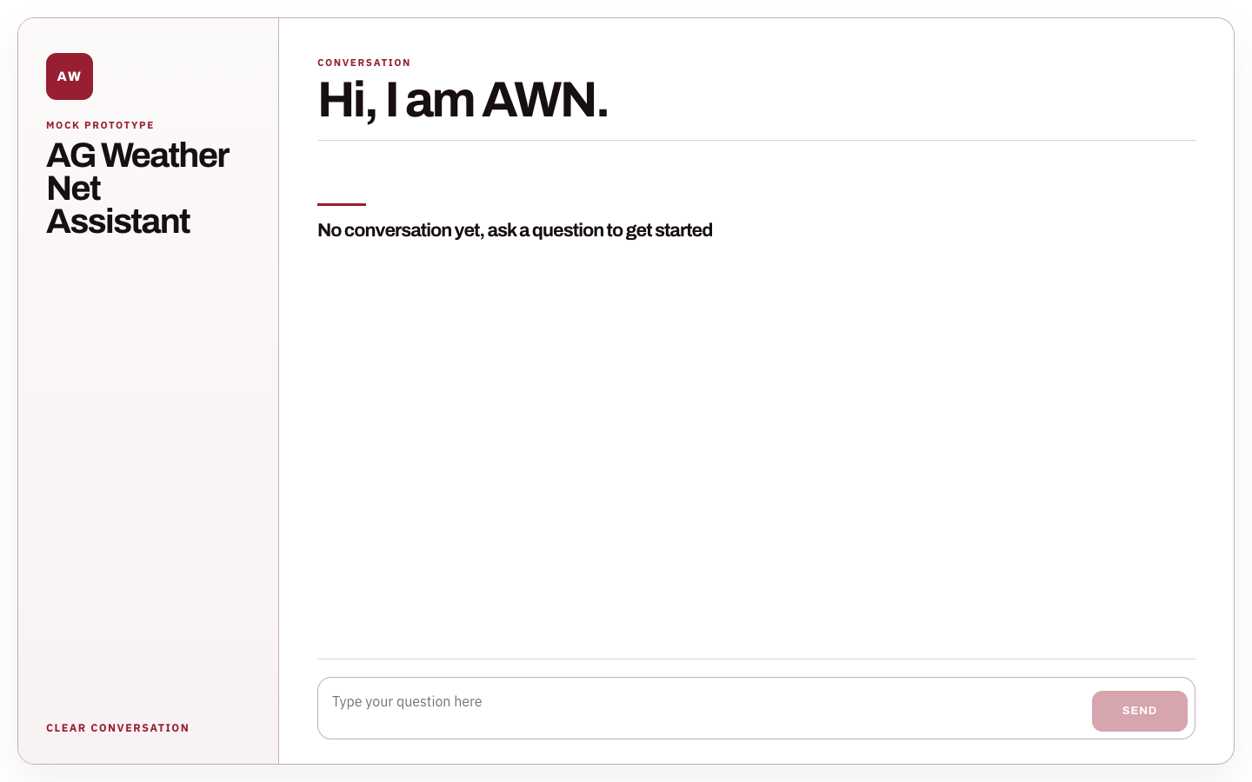
Figure XII.1: Empty React chat screen at localhost 5173.
The screenshot in Figure XII.1 shows the loaded empty state before any request is sent. This is the starting point for the smoke test.
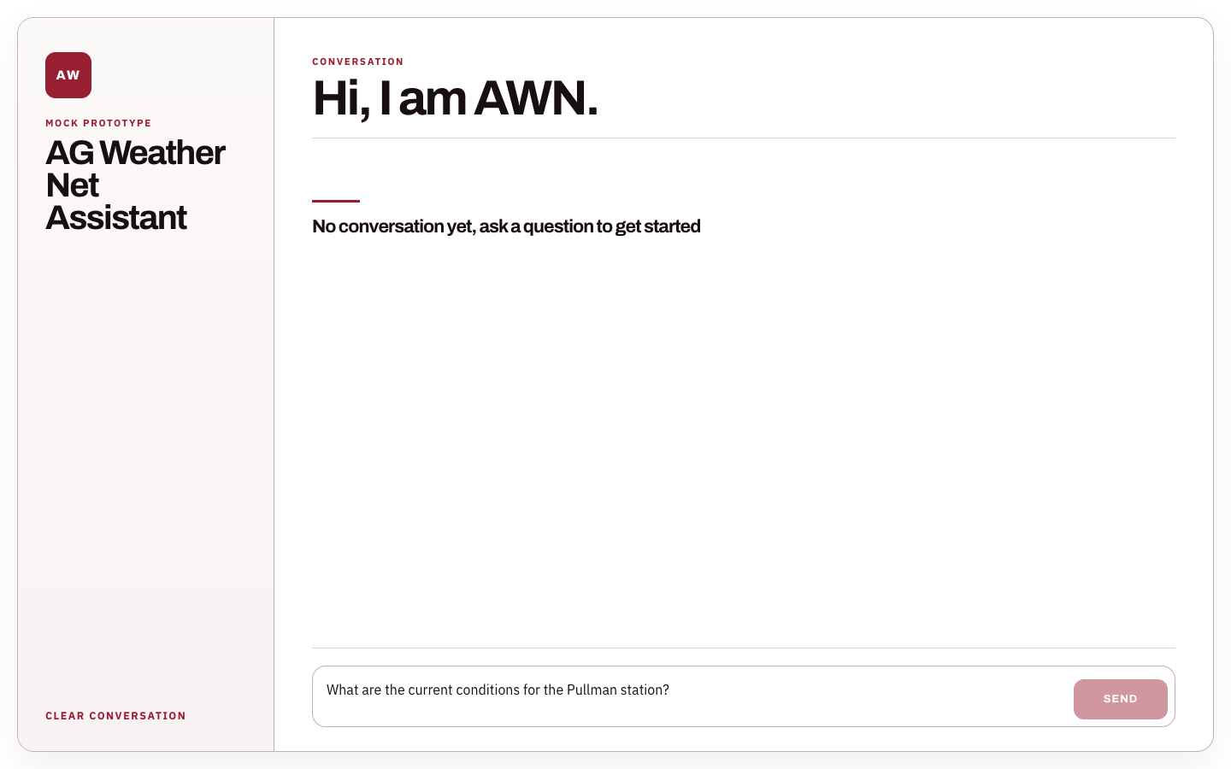
Figure XII.2: User question typed into the frontend composer.
Figure XII.2 shows the same screen after the user typed a station question. At this point the send button is enabled and the browser is ready to submit the chat request.
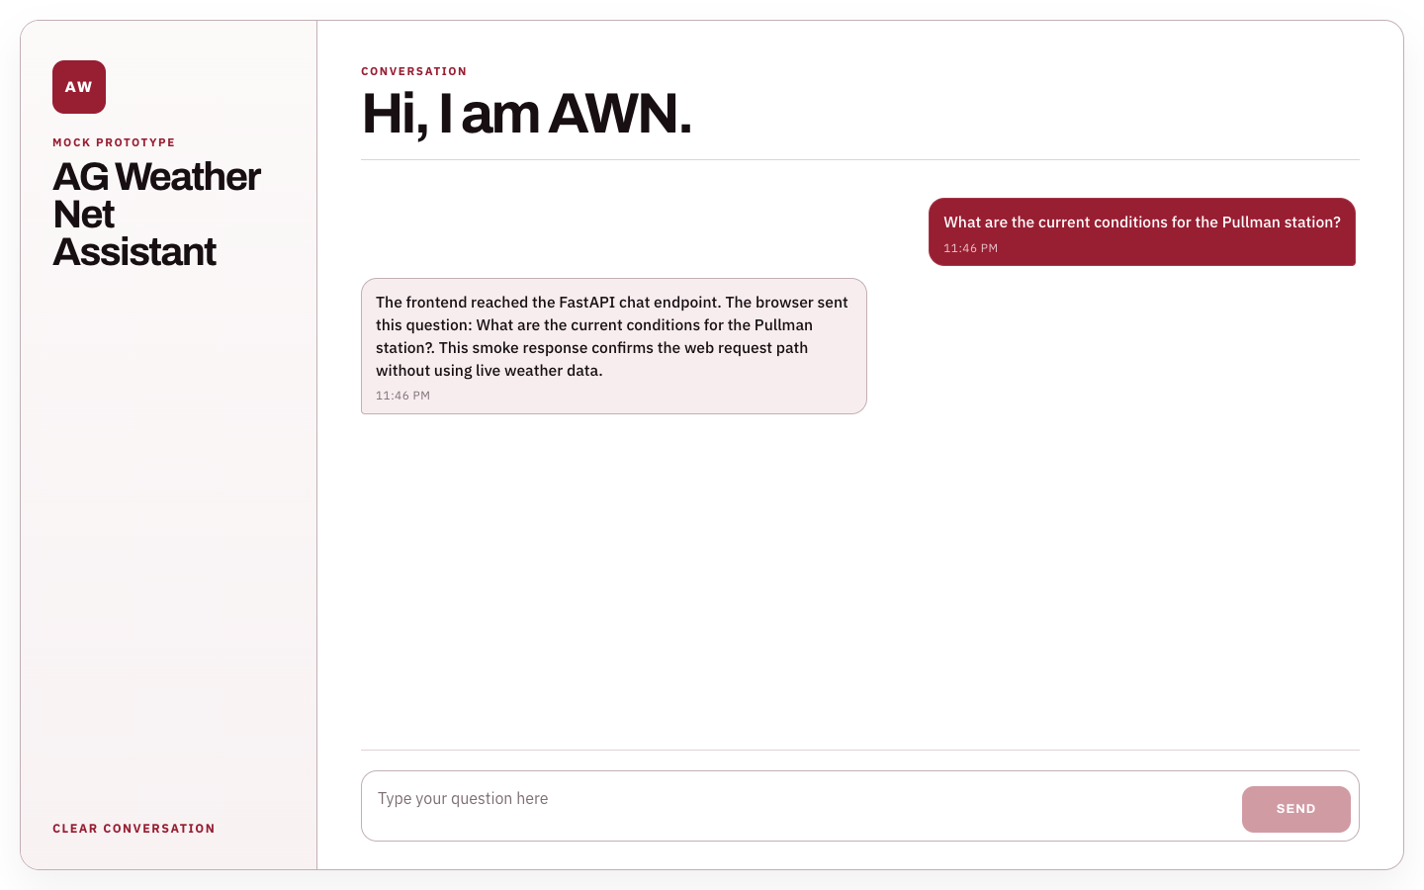
Figure XII.3: Frontend response after POST /api/chat returns.
Figure XII.3 shows the completed request. The assistant message came from the FastAPI compatible smoke endpoint through the same /api/chat path. The response is deterministic so the screenshot proves the request flow and not the weather answer quality.
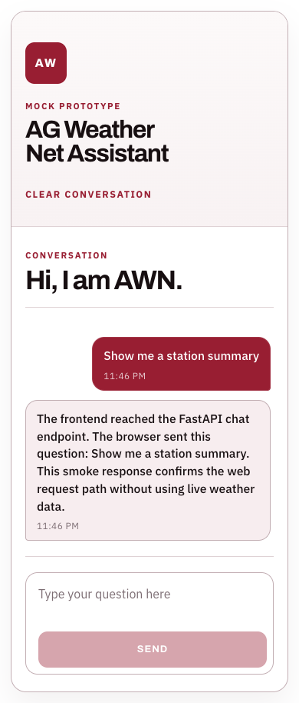
Figure XII.4: Mobile sized frontend response view.
Figure XII.4 shows the same flow on a narrow viewport. The sidebar stacks above the conversation and the composer moves into a vertical layout. This checks that the prototype remains usable on a phone sized screen.
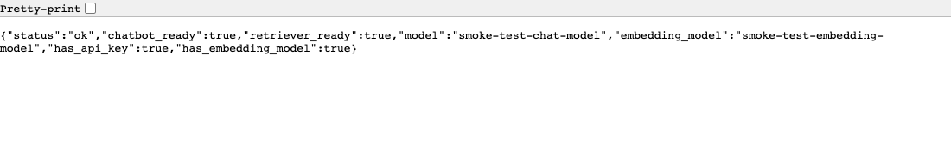
Figure XII.5: FastAPI health response from the smoke run.
Figure XII.5 shows the FastAPI health endpoint used during the smoke run. The endpoint returns status ok with the retriever and chatbot fields marked ready in the deterministic test server.
XII.1.1 Preliminary Tests
The preliminary frontend tests focused on build health browser behavior and the API contract. npm run build completed successfully in code/frontend. The successful build checks the TypeScript compile step and the Vite production bundle.
Backend bridge tests were also run because the frontend depends on the FastAPI contract. The command used the repository virtual environment from outside the repository root so the local code package would not shadow the Python standard library. The selected FastAPI and vector store tests passed with six tests in 0.45 seconds. These tests cover health metadata the latest user message path empty message validation missing user message validation pgvector similarity search and the empty table result.
A headless browser smoke test was run against the local Vite server and a deterministic FastAPI compatible endpoint. The test loaded the empty screen typed a weather station question submitted it waited for the /api/chat response and saved the resulting screenshots. This test proves that the browser can render the UI can send the request and can display the assistant reply. It does not prove data accuracy because the response was intentionally deterministic.
The current frontend does not yet have a dedicated React unit test suite. The next test work should add tests for lib/api.ts with fetch mocked and component tests for the composer pending bubble error bubble clear conversation action and disabled send state. A later end to end test should run against the real Docker stack after daily_index is loaded with AWN records.
One code quality issue remains from the current branch. npm run lint reports an empty catch block in code/frontend/src/lib/api.ts. The build still passes. The next frontend cleanup should replace that empty block with a short comment or a small fallback path so lint can be included as a passing preliminary check.
XII.1.2 Remaining Work
The main future work is to move from the prototype chat screen to a production ready webserver path. The UI still needs portal authentication and should only be visible to authorized AgWeatherNet users. FastAPI also needs production CORS settings rather than the current local development origins. The Docker nginx path should be tested on the target EC2 environment with the same /api forwarding used in the local demo.
The frontend also needs better user feedback when retrieval fails or when the vector index has no weather context. The current error bubble shows the backend detail. That is useful for developers but it should be rewritten into a clearer message for farmers researchers and extension users.
After the indexing work fills daily_index with real records the team should run a full weather accuracy test through the browser. That test should start in the React screen pass through FastAPI call Retriever.retrieve and compare the answer with expected AWN data. At that point the frontend test will cover both the webserver bridge and the weather response quality.

