**For Question 1 create file as CustomPlayer.html**

**Question 1:**

**Create a custom video player using the media features in HTML5.**

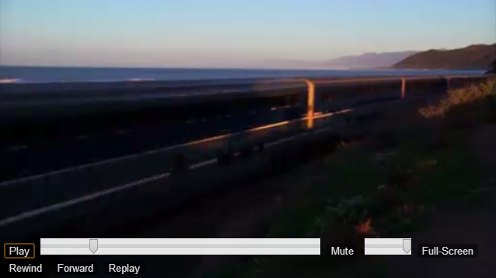

**Following are the functionalities expected:**

1. A customized video player must be created without using the default controls provided by browsers. It must have six buttons, 1 seek bar and 1 slider for volume control as shown in above screen.
2. The functionalities for these controls must be provided programmatically using JavaScript.
3. Listed below the expected behavior for each button.
   1. **“Play/Pause”**: On clicking on “Play”, the video must start playing and the label on button must be changed to “Pause “ and vice versa.
   2. **”Rewind”:** The video must skip back by 10 seconds.
   3. **”Forward”:** The video must skip move ahead by 10 seconds.
   4. **”Replay”:** The video must start playing from beginning.
   5. **”Mute/UnMute”:** On clicking on “Mute”, the video must mute and the label on button must change to “UnMute ” and vice versa.
   6. ”**FullScreen”:** The video must play in fullscreen mode. Add support for all browsers.
4. The player must have a seek bar to display the duration of video played so far which must be continuously updated as the video is playing.
5. The player must also include a volume control in the form of a slider.
6. **A sample video file has been provided in Sample_Video.zip along with this document. Kindly extract and use the video present in it.**
7. Avoid uploading your own video files and use the sample video provided.
8. It is recommended to use latest version of chrome to test your player.
9. Zip all contents of html, js, css and video as **CustomPlayer.zip** and upload.