**For Question 1 create file as MovieBooking.html**

**Question 1:**

**Create a form for online booking of movie tickets with following layout.**

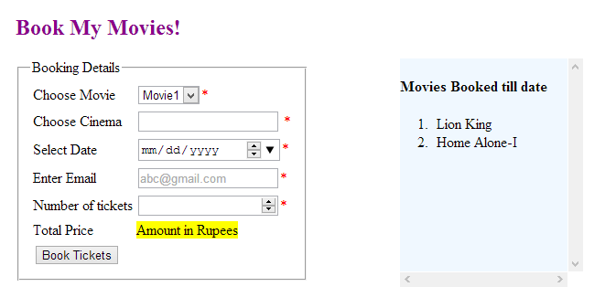

**Following are the functionalities expected:**

1. The Booking details form must have the 5 input fields with appropriate types as introduced in HTML5.
2. All fields are mandatory and hence appropriate error message to be shown when user tries to click on “Book Tickets” when some field is empty. The default required message is to be displayed.
3. Placeholder to be added for email field.
4. The list of cinemas to be displayed as shown below:

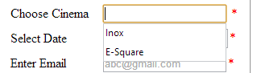

1. Use legends and fieldset to display the booking form details.
2. After user enters the number of tickets, the total amount must be displayed in the highlighted area**. Implement this functionality using web workers.**
3. The formula for calculation is: ticketPrice*number of tickets.

Discount of 5% is to be given if the date chosen is on a weekday (Mon to Friday).

Further discount of 10% is to be given if user’s list of booked shows is >=10 till date.

The final value is to be displayed back on the form in field “Total Price”.

1. When user clicks on “Book Tickets”, no server side processing is expected. The movie name must be added to local storage and same page must be displayed by clearing the form values.
2. On the right side of the page, display all movies booked by user by making use of localStorage. The data must not be stored or retrieved from server side pages. When user visits the page, he must see the list of movies booked till date.