Enterprise Network Design and Access Control List (ACL) Implementation
Student: Raheemah Lartey
Programme: 10Alytics Cybersecurity Programme
Submission: Cisco Packet Tracer Assignment

1. Introduction
This project involved designing and implementing a small enterprise network in Cisco Packet Tracer. The network consists of three departments (Sales, HR and IT), each connected through a dedicated switch to a Cisco router. Static IP addressing was configured for all hosts and inter-network communication was enabled. An Extended Access Control List (ACL) was then implemented to prevent the HR department from accessing the IT subnet while allowing legitimate communication from the Sales department.

2. Network Topology
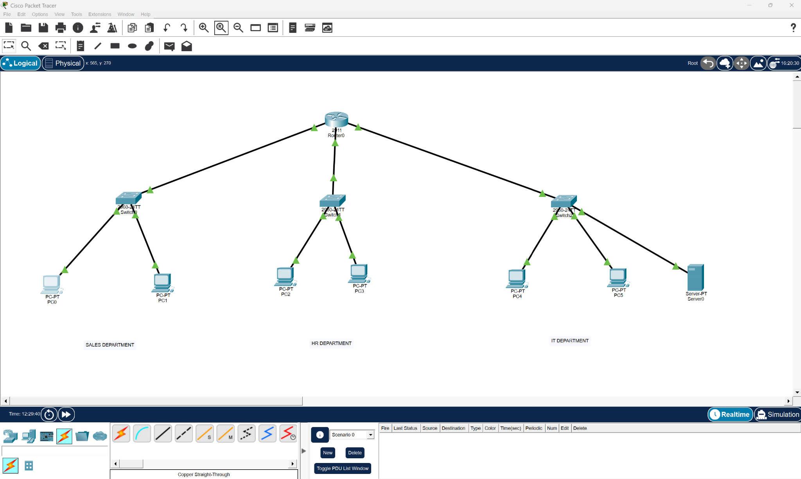
Figure 1: Completed Enterprise Network Topology

3. IP Address Configuration
The following screenshots show the static IP configuration for the devices used in each department.
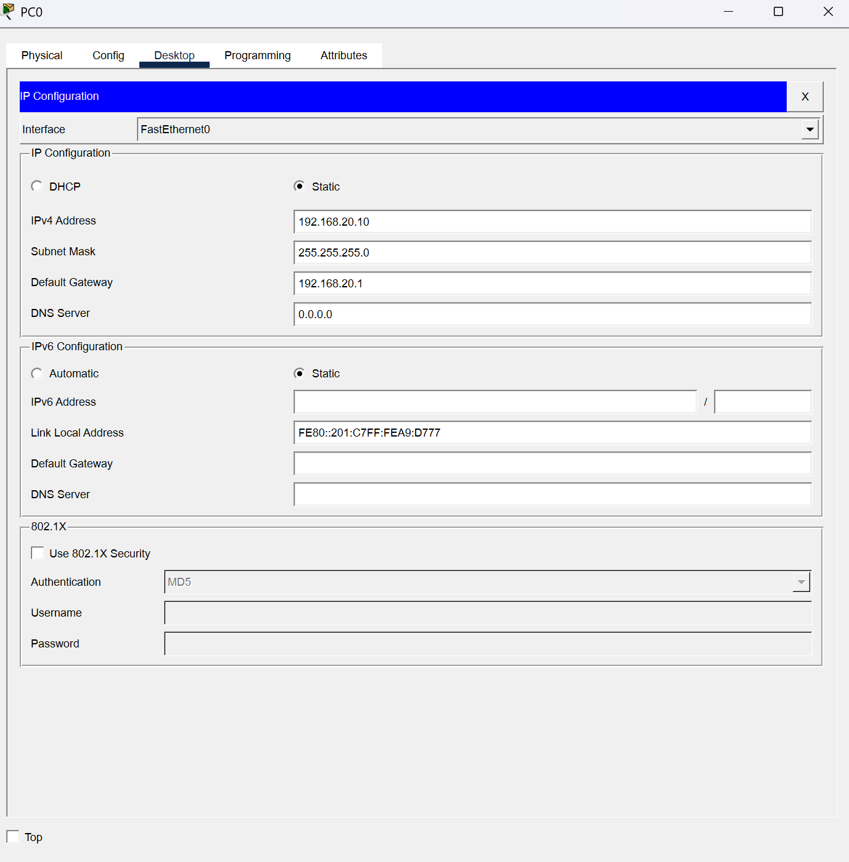
Figure 2: Sales PC0 IP Configuration
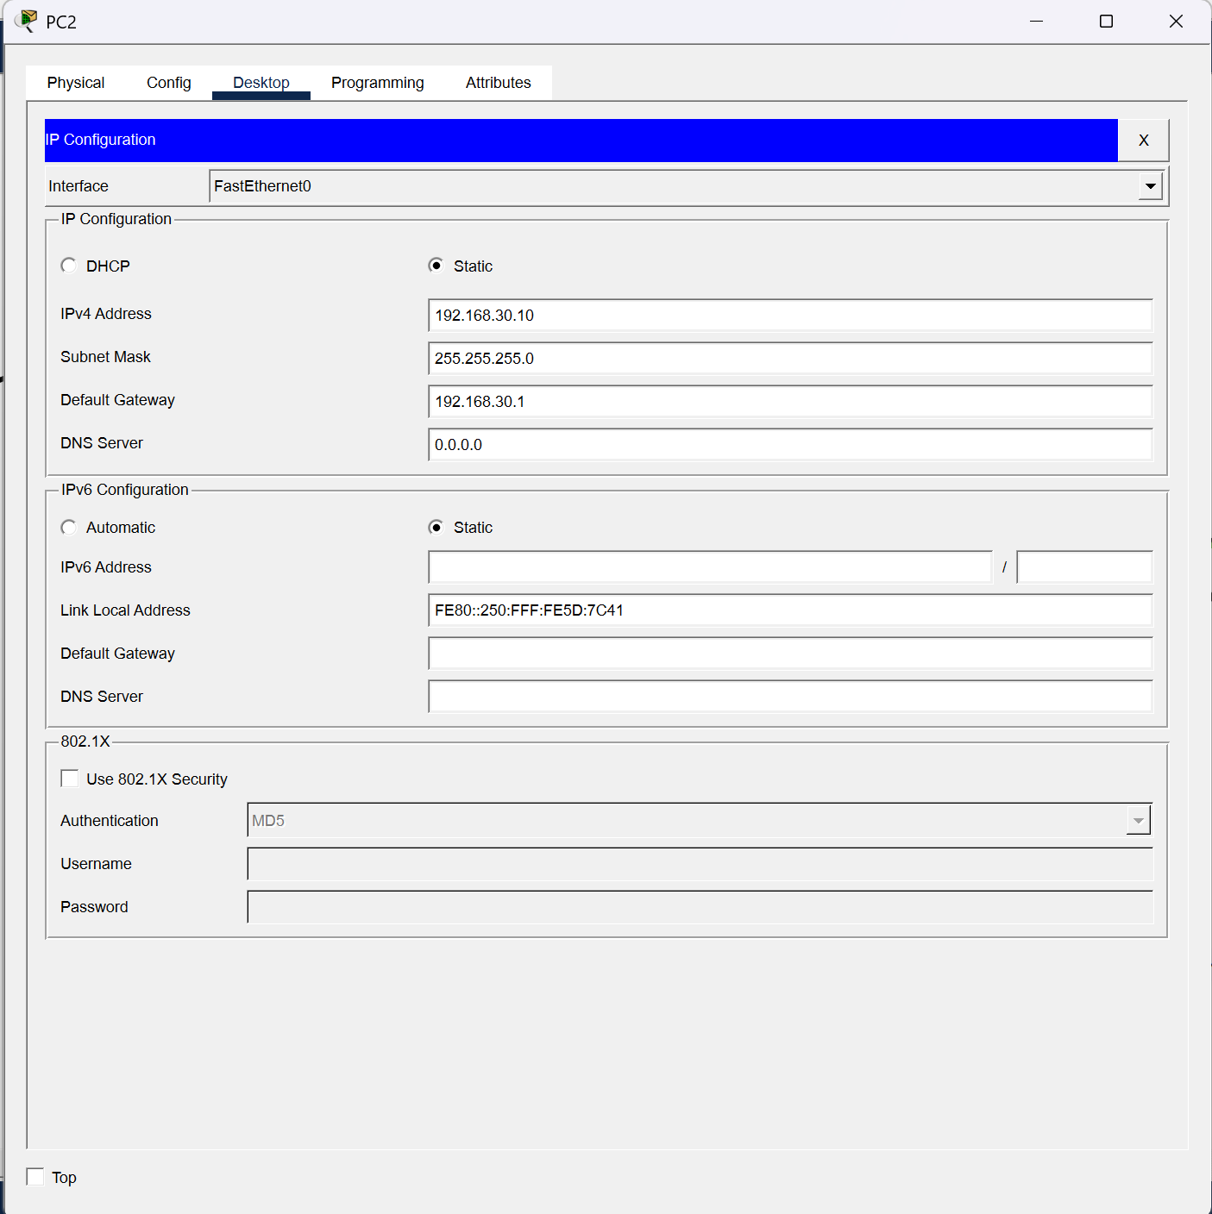
Figure 3: HR PC2 IP Configuration
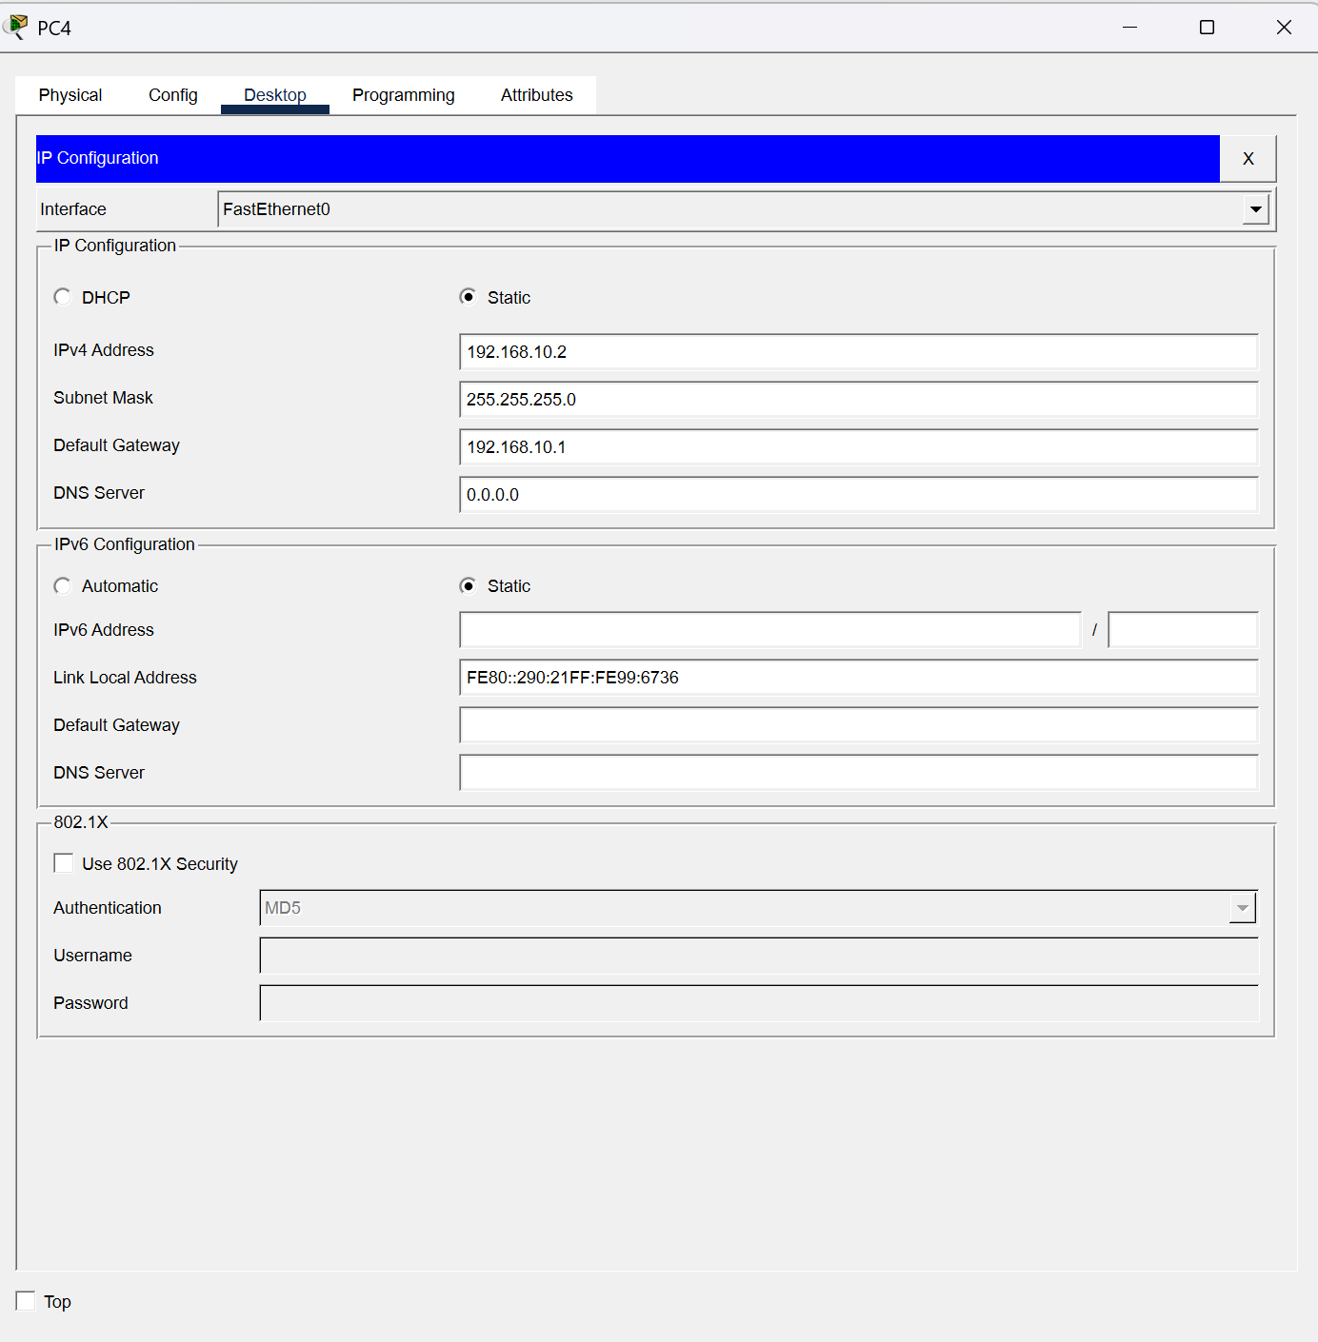
Figure 4: IT PC4 IP Configuration
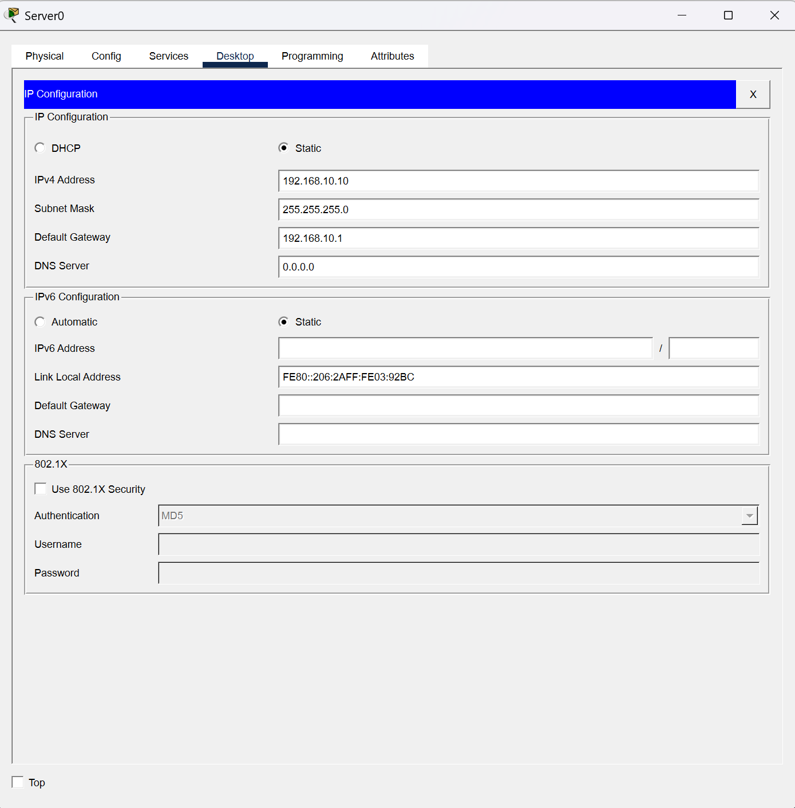
Figure 5: Server IP Configuration

4. Connectivity Verification
Connectivity tests were performed using the ping command. The Sales department successfully communicated with the IT network, confirming proper routing. After implementing the ACL, the HR department was unable to communicate with the IT subnet, confirming that the security policy was successfully enforced.
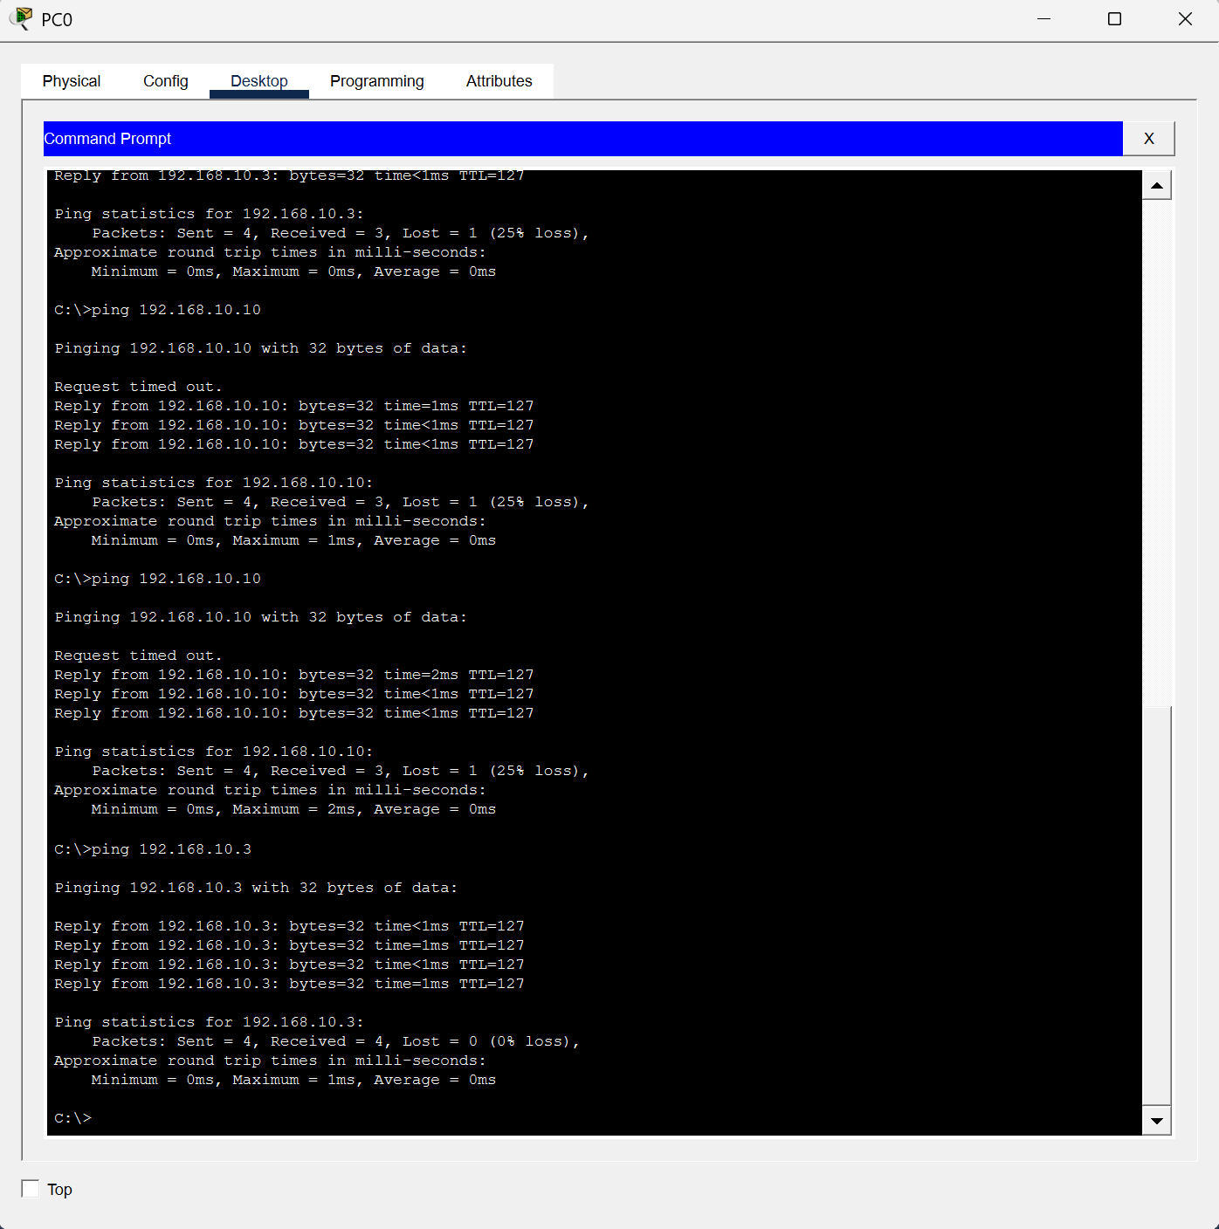
Figure 6: Successful Ping from Sales PC to IT Network
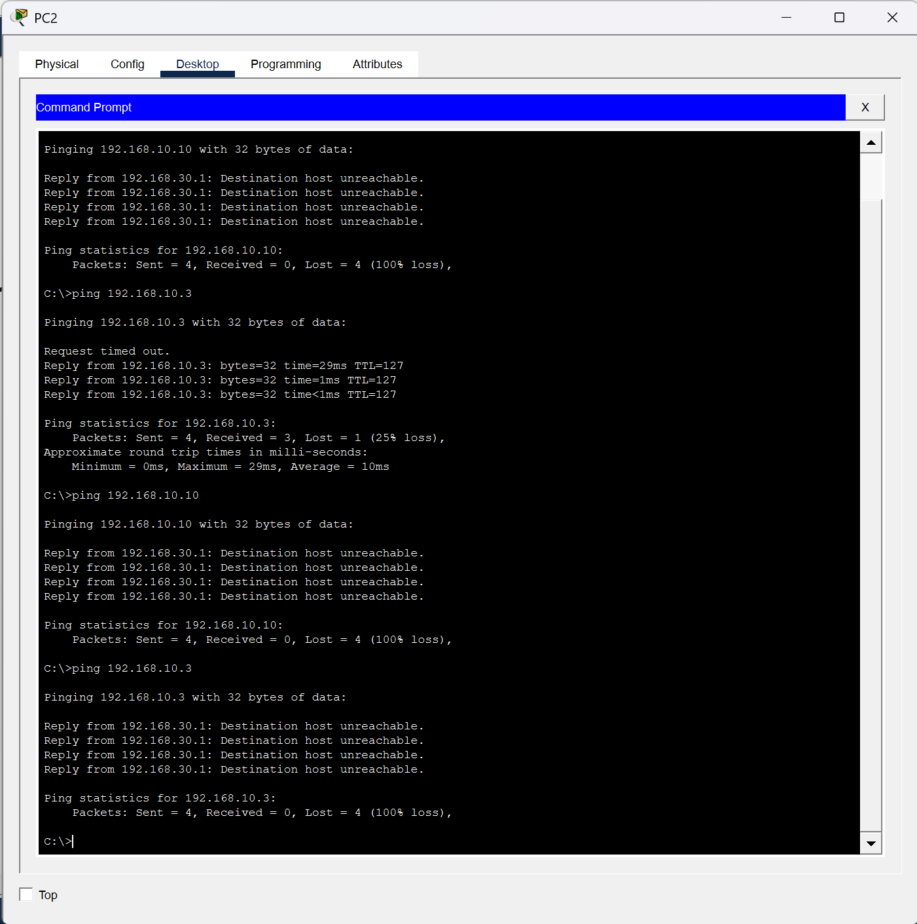
Figure 7: Failed Ping from HR PC to IT Network

5. Router Configuration and ACL
The router interfaces were configured with gateway addresses for each subnet. An Extended Access Control List (ACL 100) was configured and applied inbound on the HR interface to block all traffic originating from the HR subnet (192.168.30.0/24) to the IT subnet (192.168.10.0/24), while permitting all other traffic.
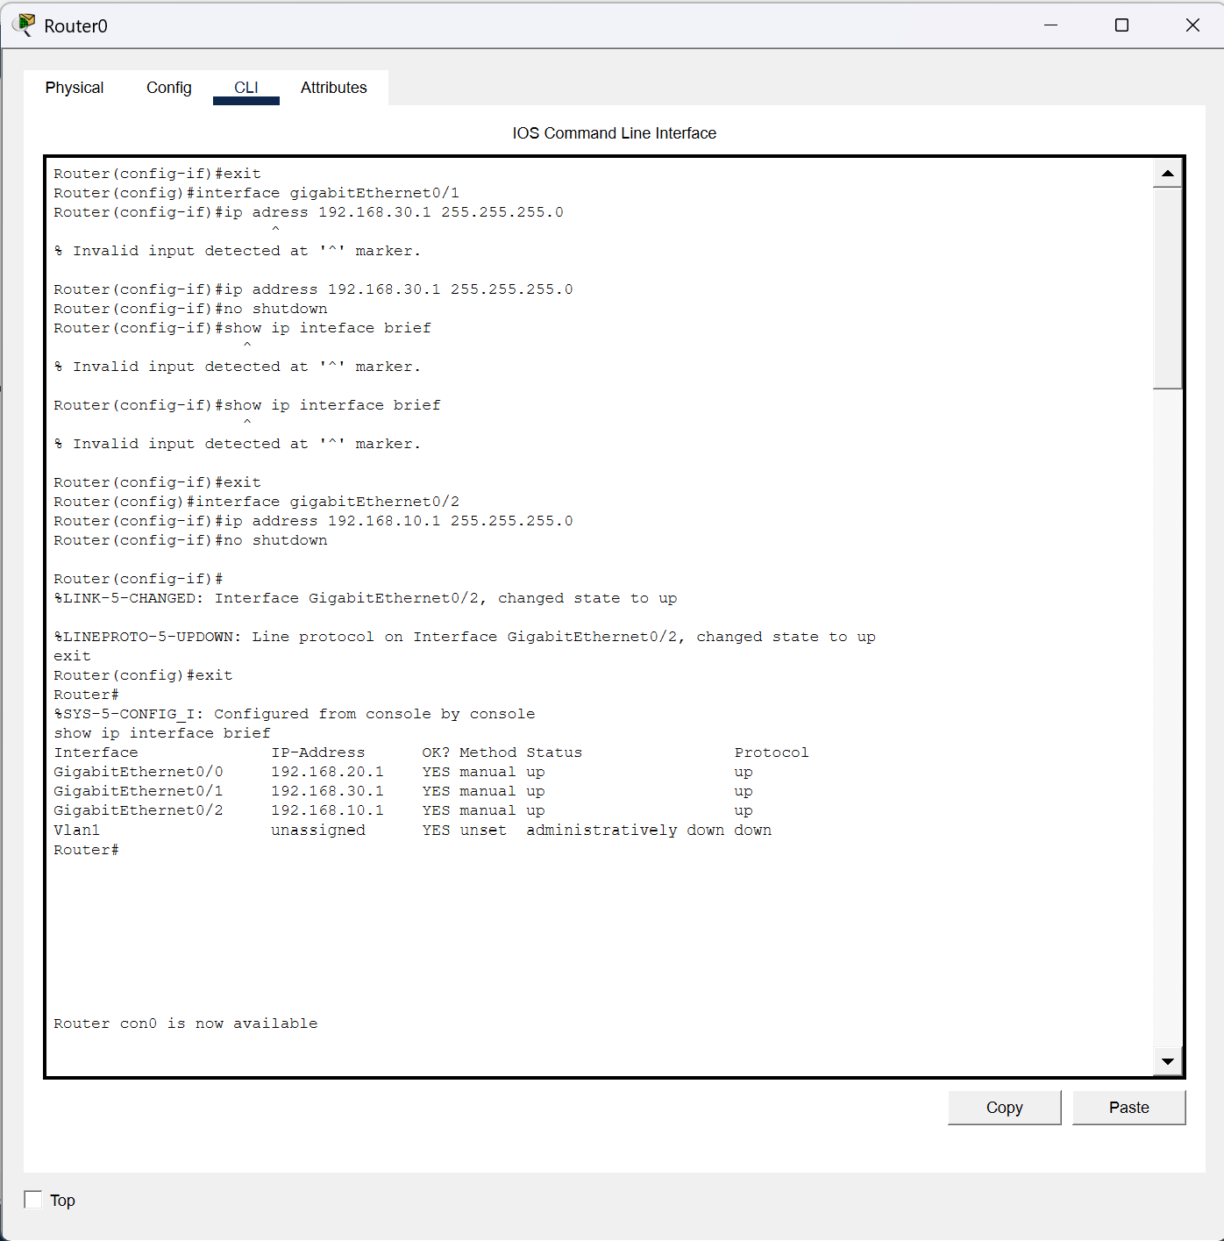
Figure 8: Router Interface Configuration
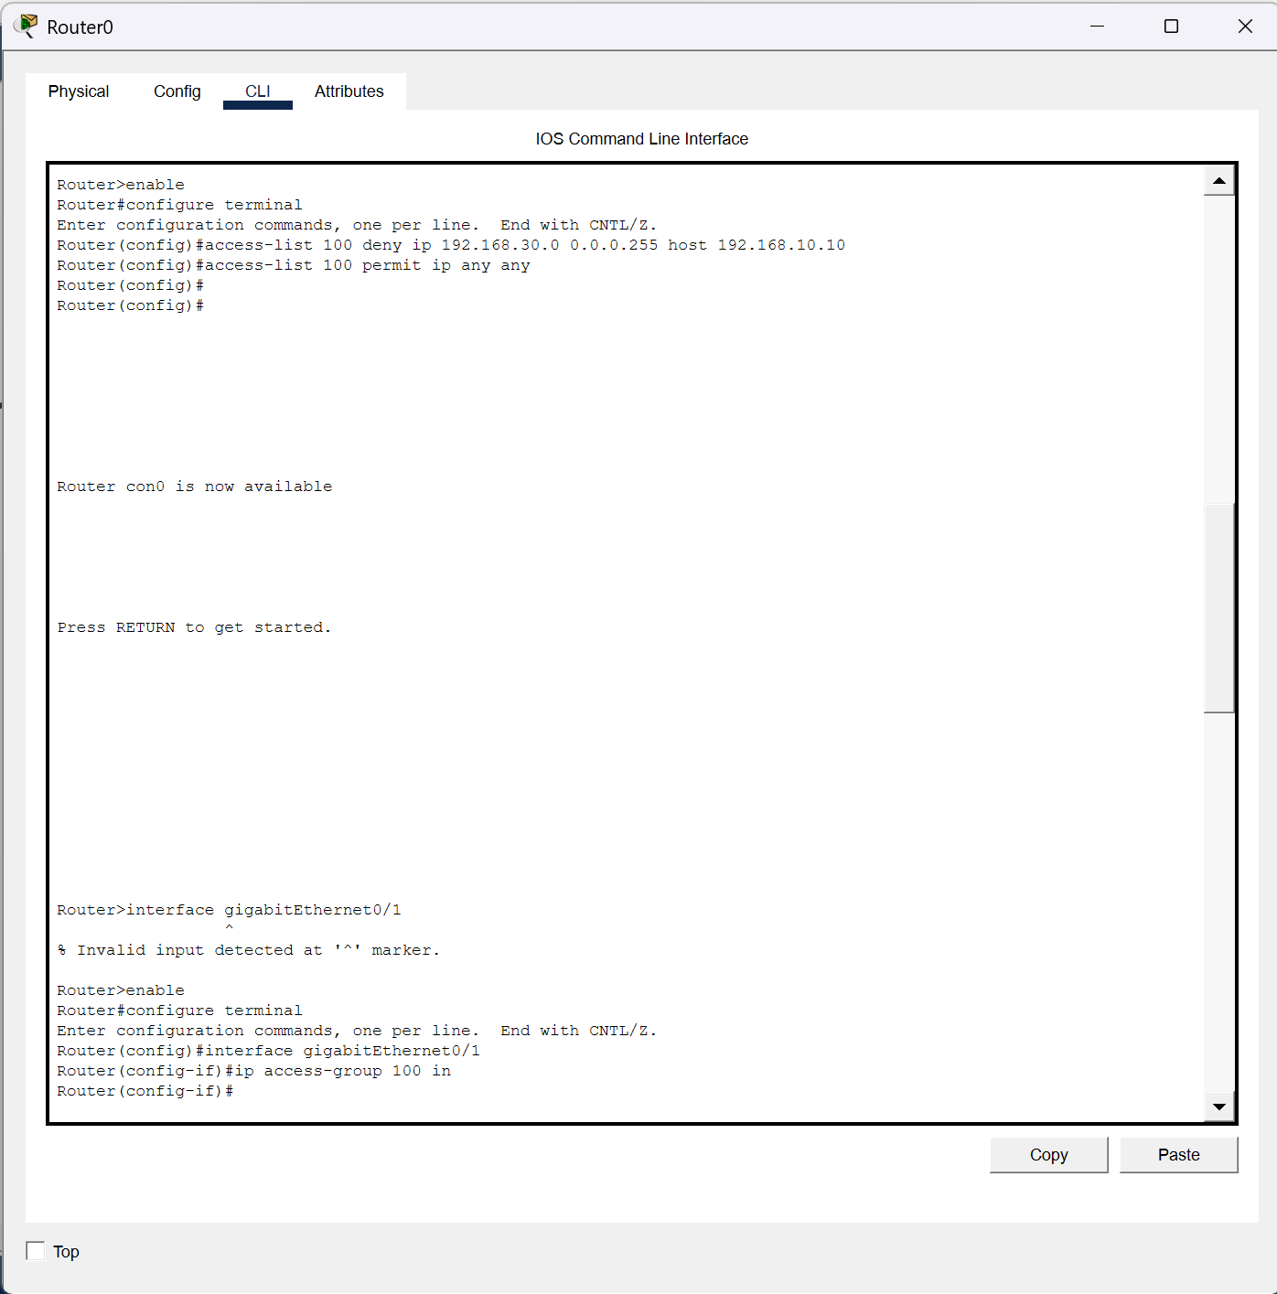
Figure 9: ACL Applied to HR Interface
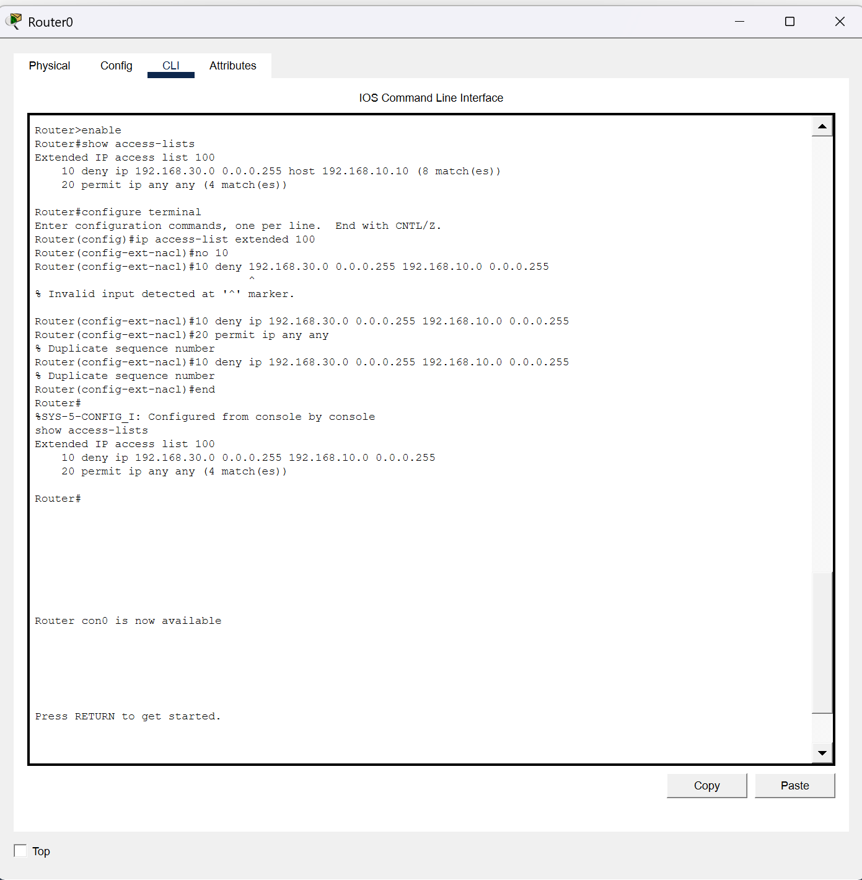
Figure 10: Final ACL Verification

6. Results
Test | Expected Result | Outcome
Sales PC → IT PC | Successful communication | Passed
Sales PC → Server | Successful communication | Passed
HR PC → IT PC | Communication blocked | Passed
HR PC → Server | Communication blocked | Passed

7. Conclusion
The objectives of the assignment were successfully achieved. The enterprise network was designed and configured using Cisco Packet Tracer, static IP addressing was implemented, routing between the three departments was verified, and an Extended ACL was successfully deployed to restrict HR users from accessing the IT subnet while maintaining authorised communication for other departments. The screenshots included in this report provide evidence that all required tasks were completed successfully.

