**AI Customer Service: The Future Smart Customer Support for Better Customer Satisfaction**

Artificial Intelligence-based customer service ensures customer satisfaction more efficiently, unbiasedly, precisely than a human receptionist, ensuring customer satisfaction 24 hours in the Bengali language.

*Rahad Arman Nabid, Shehan Irteza Pranto, Ahnaf Mozib Samin, Mohammad Nurul Huda, Nabeel Mohammed, Khondaker A. Mamun*

**July 1, 2022-Dhaka, Bangladesh-** AI customer service is an artificial intelligence-based human-robot interaction tool that can work as a receptionist in the Bengali Language to provide the best possible response to the customers. Besides, voice recognition is integrated with the system that can work as an authentication tool to identify registered and non-registered customers. At the same time, the system can work continuously 24 hours on the online website or in a physical robot, or in a telephone call center which will reduce the cost for companies to a great extent.

Customer dissatisfaction is common in private & government offices, educational institutions, and hospitals, especially in Bangladesh. Customers feel that they are not properly valued when they go for access to customer care. For example, In-office customers face difficulties finding helpful information. They have to go from desk to desk for information. Sometimes, receptionist behavior may be biased according to their mood. In many offices, the third party takes advantage by providing false info to their users. In education institutions, guardians face difficulties finding their son/daughter's results and other admission information. In fact, in hospitals, general people face problems finding their services and doctors' reservation call center. In an eCommerce company, customers can't get proper response 24 hours. As a result, people gather in hospitals, offices, and reception desks, creating mass congregations during this pandemic. Moreover, companies spend much money on their reception and call centers, but human receptionists can't serve for 24 hours. This problem creates customer dissatisfaction with the company.

Our system aims to solve these problems by providing an artificial intelligence-enabled customer service system that will recognize users’ moods & voice and can communicate naturally to deliver customer’s query, information, reservation, customer support in Bangla language. This system can be integrated into a tab, small computer, or online customer care service, which costs are meager. The customer’s voice and expressions will be captured to assess whether he is an old customer or new, creating a great impression. AI reception will work instead of a human receptionist by asking customers queries and responses in the Bangla language. Moreover, users’ responses can be saved according to the situation, such as reservation, attendance, date and times, voice, pictures, requests, into a database for assessment.

Our respective team leader mentioned that “Al customer service will revolutionize the traditional customer service for enhancing greater customer satisfaction.”

Our system will enhance customers' experience by providing AI technology and prompt human communication in Bangla. Moreover, this system will be so much user friendly for general people as the system is voice-enabled. However, we also provide typing facilities to customers who are physically challenged. Owners can get reports, monitor, and customize their query domains according to their needs from the backend without extra hardware and servicing costs. Moreover, the system can continuously run customer service 24 hours a day without tiredness with the same intensity, suppressing human ability.

Our AI Customer got an initial positive response from Uniter International University. We can integrate the service to the official website for experimental. Moreover, one of the most prominent private companies, CMED Health, also expressed interest in integrating the service in their server. More than one million customers get service directly from our developed model.

To know more in details about our project, please click on following link:

*Website Link*: [*https://aimsl.uiu.ac.bd/#/projects/bangla-smart-receptionist-robot*](https://aimsl.uiu.ac.bd/#/projects/bangla-smart-receptionist-robot)

**FAQ**

1. *Question*: Is there any other language except Bengali that AI reception can communicate?

*Answer:* AI reception can communicate in both Bengali and English language. But we set Bangla language as default.

2. *Question:* How you will deal with user’s data privacy?

*Answer:* User’s data will be encrypted in our database that won’t be available publicly.

3*. Question*: How can a customer can make sure that his response is properly stored into database?

*Answer:* After capturing response from user the system will show the summery and send confirmation SMS or mail especially for reservation.

4. *Question:* How the system ensures security?

*Answer:* The system is integrated with face recognition and voice recognition module that will ensure utmost security from authentication access.

5. *Question:* Which domain the reception can work?

*Answer:* The system can work in the domain of customer care, hospitals, offices, banks and reservations companies. If any company give us specific demands, we can provide them according to their requirement.

6. *Question:* How company can integrate the system?

*Answer:* Any company can buy from us any they can install the software to tab, computer or raspberry pi devices. If they want to purchase body structure from us, we will provide it with robot. For customer our team will give support for integration into hotline number.

7. *Question*: How it is different from traditional customer service where gives some options?

*Answer*: Traditional customer service will give you domain-based option to select, but our proposed system will automatically adjust from customer’s speech and deliver the answer in Bangla language.

*Contact Details:* [*https://aimsl.uiu.ac.bd/#/contact*](https://aimsl.uiu.ac.bd/#/contact)

*Email Address:* [*aimsl@uiu.ac.bd*](mailto:aimsl@uiu.ac.bd)

8. *Question*: Suppose a customer called an online ecommerce service to know his product delivery date, how it will answer?

*Answer*: The AI service will identify the customer by voice and some security question. After successful authentication it can access the SQL database where the status it described and tell the status to the customer.

9. *Question*: Which algorithm you used for building the model?

*Answer*: As our model is still in developing condition, we will not disclose it. But we have to integrate several models consists of GMM model, ASR model, TTS model, NLP model to build it.

10. Question: If any customer asks some new question to the AI customer service or the customer doesn’t satisfy about the answer, is it possible to communicate to human receptionist for further assistance?

*Answer*: Yes, we make the model adaptive where we save the new response as a summery to work for further development. Moreover, our model can identify the customers emotion whether she/he is satisfied or not, that’s why we ask them if they need further assistance or not.

**Visuals**

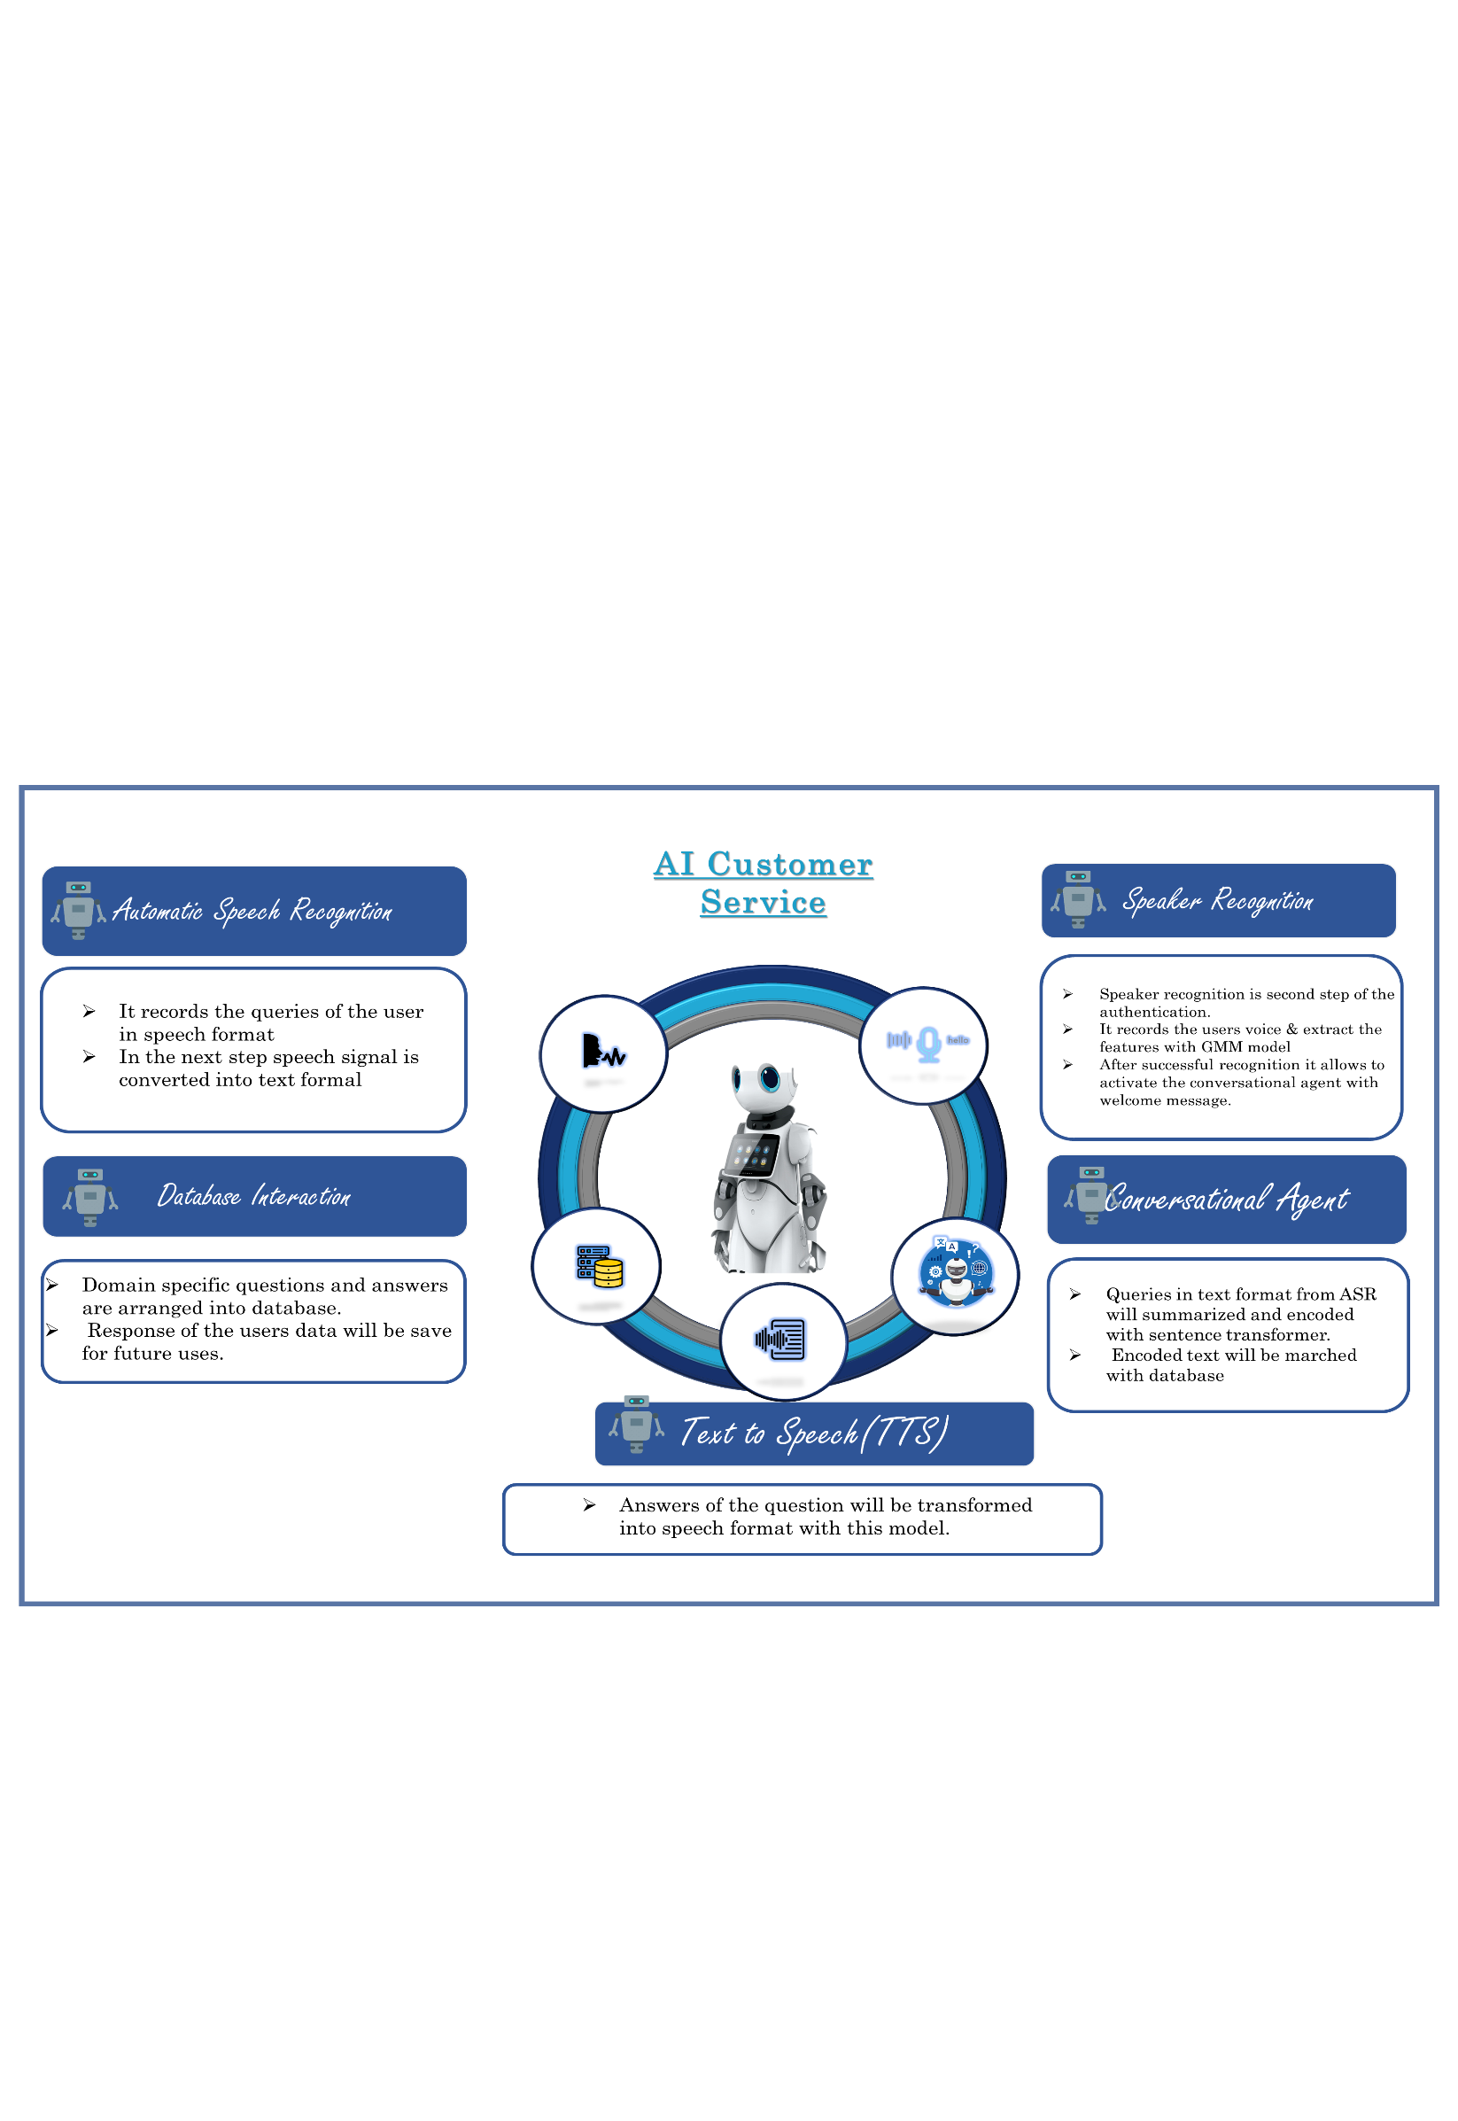

*Social Media Link:* [***https://www.facebook.com/aimslab/***](https://www.facebook.com/aimslab/)

Appendix

Acknowledgment:

We are very much grateful to United International University to provide us high computational power multiple GPU and hardware facilities, through which we can collect our dataset and train our model.

References:

*1. Shehan Irteza Pranto, Rahad Arman Nabid, Nabeel Mohammed, Mohammad Nurul Huda, Farhana Sarker and Khondaker A. Mamun” Human Robot Interaction in Bengali language for Healthcare Automation integrated with Speaker Recognition and Artificial Conversational Agent” In 2021 3rd International Conference on Electrical and Electronic Engineering (ICEEE), IEEE, 22-24 December2021. (Manuscript Submitted).*

*2. Rahad Arman Nabid, Shehan Irteza Pranto, Mohammad Nurul Huda, Nabeel Mohammed, Farhana Sarkar and Khondaker A. Mamun. AI Reception: An Artificial Intelligence-based Bengali Receptionist System integrating Face, Speech and Interaction recognition to automate reception” In 2021 Int’l Conference on Bangabandhu and Digital Bangladesh (ICBBDB), 03-04 December 2021. (Manuscript Submitted).*