Course No: EEE 428

Measurement and Instrumentation Laboratory

**Level/Term: 4/I**

**Section:** G-2

**Group No.** 2

**Department of Electrical and Electronic Engineering**

**Date of Submission:** 07-09-2019

Marjana Mahdia

Lecturer

Department of EEE

BUET

**Prepared by:**

Ordatun Jannat 1506139

Rahad Arman Nabid 1506142

Nafhatul Zinan Shifa 1506143

Naima Tasnim 1506144

Mahmudul Islam 1506155

Sheikh Tabrej 1506196

**Submitted to:**

Md. Irfan Khan

Lecturer

Department of EEE

BUET

Project Title:

IoT Based Attendance System

**Forwarding Letter**

7th September 2019

To

Marjana Mahdia

Lecturer

Md. Irfan Khan

Lecturer

Department of EEE

BUET

**SUBJECT: Report on the project ‘IoT Based Attendance System’.**

Dear Teachers,

We feel honored and enthusiastic to present our report on the project topic ‘IoT Based Attendance System’. On this occasion, we would like to express our gratitude for your kind encouragement & support. We also express our appreciation for the help our classmates have provided.

We apologize beforehand for any kind of mistakes we have made in this report despite our best effort. We have tried our best to build the project. If this report helps in any way to understand the process and logic of our project, we will feel humbled and honored.

Yours sincerely,

Ordatun Jannat 1506139

Rahad Arman Nabid 1506142

Nafhatul Zinan Shifa 1506143

Naima Tasnim 1506144

Mahmudul Islam 1506155

Sheikh Tabrej 1506196

**Table of Contents**

Introduction………………………………………………………………………..3

Key Features…………………………………………………………………….....4

List of Equipment Used……………………………………………………………4

Description of Components……………………………………………………......5

Block Diagram…………………………………………………………………......9

Hardware Implementation………………………………………………………….9

Working Principle…………………………………………………………...........10

Website……………………………………………………………………………12

Future Improvement………………………………………………………………14

**Introduction**

Students attendance have been considered as one of the crucial elements or issues that reflects the academic achievements and the performance contributed to any university compared to the traditional methods that impose time-consuming and inefficiency. Diverse automatic identification technologies have been more in vogue such as Radio Frequency Identification (RFID). RFID is a wireless technology, which uses to a purpose of identifying and tracking an object via radio waves to transfer data from an electronic tag, called RFID tag or label to send data to RFID reader. The project focuses on implementing an RFID based Attendance Management System (AMS) and also information service system for an academic domain by using RFID technology in addition to the programmable Logic Circuit (such as Arduino, NodeMCU), and web-based application. The proposed system aims to manage students’ attendance recording and provides the capabilities of tracking student absentee ,the proposed attendance and information system is time-effective and it reduces the documentation efforts as well as, it does not have any power consumption.

The presence by using RFID is faster than the traditional way and implementation of the internet system of things (IoT) and data storage clouds enables the system to run in real time with accurate data.

**Key Features**

(I) Wi-Fi based control system

(II) Auto-updates in every 6 seconds

(III) Takes attendance time as well as leave time

(IV) Only permits access to valid cards

(V) Works in private server

(VI) Sends SMS to guardian about present status

(VII) Shows full information of a student

(VIII) Low cost implementation

(IX) Can also be implemented with the Library Card of BUET

**List of Equipment Used**

**Hardware**

* RFID Access Control-MFRC522
* ESP8266 NodeMCU V2 Development Board
* Arduino Mega 2560
* SIM808 GSM GPRS Shield
* Power Bank
* Wires and Cables

**Software**

* Arduino IDE
* XAMPP – to create local web server
* Google Chrome – web browser

**Description of Components**

**(I) RFID Access Control-MFRC522:**

*Model : MOD-00199*

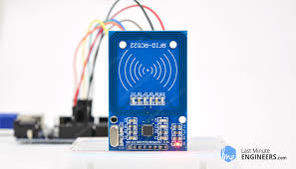**Radio-frequency identification (RFID)** uses electromagnetic fields to automatically identify and track tags attached to objects. The tags contain electronically stored information. Passive tags collect energy from a nearby RFID reader's interrogating radio waves. Active tags have a local power source (such as a battery) and may operate hundreds of meters from the RFID reader. Unlike a barcode, the tags don't need to be within the line of sight of the reader, so it may be embedded in the tracked object.

Figure : RFID Module

The most notable is that RFID tag data can be read outside the line-of-sight, whereas barcodes must be aligned with an optical scanner.

RFID is one method of automatic identification and data capture (AIDC).AIDC methods automatically identify objects, collect data about them, and enter those data directly into computer systems with little or no human intervention. RFID methods utilize radio waves to accomplish this. At a simple level, RFID systems consist of three components: an RFID tag or smart label, an RFID reader, and an antenna. RFID tags contain an integrated circuit and an antenna, which are used to transmit data to the RFID reader (also called an interrogator). The reader then converts the radio waves to a more usable form of data. Information collected from the tags is then transferred through a communications interface to a host computer system, where the data can be stored in a database and analyzed at a later time.

**(II) Arduino Mega 2560:**

*Model : ARD-00047*

The Arduino Mega 2560 is a microcontroller board based on the ATmega2560. It has 54 digital input/output pins (of which 15 can be used as PWM outputs), 16 analog inputs, 4 UARTs (hardware serial ports), a 16 MHz crystal oscillator, a USB connection, a power jack, an ICSP header, and a reset button. It contains everything needed to support the microcontroller; simply connecting it to a computer with a USB cable or powering it with a AC-to-DC adapter or battery is needed to get started.It can be powered by the USB cable or by an external 9-volt battery, though 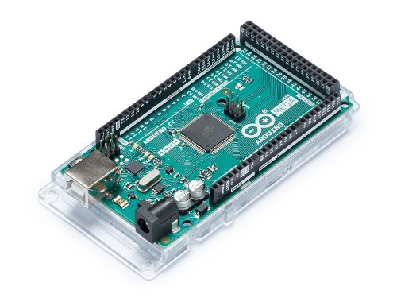it accepts voltages between 7 and 20 volts. It is also similar to the Arduino Nano and Leonardo. The hardware reference design is distributed under a Creative Commons Attribution Share-Alike 2.5 license and is available on the Arduino website. Layout and production files for some versions of the hardware are also available.

Figure : Arduino Mega 2560

The Mega 2560 R3 also adds SDA and SCL pins next to the AREF. In addition, there are two new pins placed near the RESET pin. One is the IOREF that allow the shields to adapt to the voltage provided from the board. The other is a not connected and is reserved for future purposes. The Mega 2560 R3 works with all existing shields but can adapt to new shields, which use these additional pins.

**(III) ESP8266 NodeMCU V2 Development Board with CP2102**

*Model : WIR-00074*

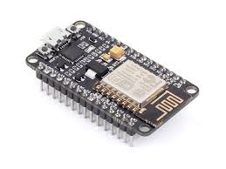**NodeMCU** is an open source Io platform. It includes firmware which runs on the ESP8266 WI-FI SoC from Espressif Systems, and hardware which is based on the ESP-12 module. The term "NodeMCU" by default refers to the firmware rather than the development kits. The firmware uses the Lua scripting language. It is based on the eLua project, and built on the Espressif Non-OS SDK for ESP8266. It uses many open source projects, such as lua-cjson and SPIFFS. NodeMCU is implemented in C and is layered on the Espressif NON-OS SDK.

The firmware was initially developed as is a companion project to the popular ESP8266-based NodeMCU development modules, but the project is now community-supported, and the firmware can now be run on any ESP module.

Figure : NodeMCU

The NodeMCU uses the CH340 serial to USB programmer, which requires the installation of a specific driver. NodeMCU is a Wi-Fi SOC (System On a Chip) produced by Espressif Systems. It is based ESP8266 -12E WiFi module. It is an highly integrated chip designed to provide full internet connectivity in a small package. ESP8266 is a low-cost, WiFi Module chip that can be configured to connect to the Internet for Internet of Things(IoT) and similar Technology Projects.

It can be programmed directly through USB port using LUA programming or Arduino IDE. By simple programming we can establish a WiFi connection and define input/output pins according to your needs exactly like arduino, turning into a web server and a lot more. NodeMCU is the WiFi equivalent of ethernet module. It combines the features of WiFi access point and station + microcontroller. These features make the NodeMCU extremely powerful tool for WiFi networking. It can be used as access point or station, host a web server or connect to internet to fetch or upload data.

**(IV) SIM808 GSM GPRS Shield**

*Model : GGG-00041.*

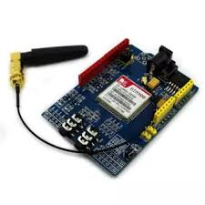

Figure : GSM Module

**GSM** is an international standard for mobile telephones. It is an acronym that stands for Global System for Mobile Communications. It is also sometimes referred to as 2G, as it is a second-generation cellular network.

To use GPRS for internet access, and for the Arduino to request or serve webpages, you need to obtain the Access Point Name (APN) and a username/password from the network operator. See the information in Connecting to the Internet for more information about using the data capabilities of the shield.

Among other things, GSM supports outgoing and incoming voice calls, Simple Message System (SMS or text messaging), and data communication (via GPRS).

The Arduino GSM shield is a a GSM modem. From the mobile operator perspective, the Arduino GSM shield looks just like a mobile phone. From the Arduino perspective, the Arduino GSM shield looks just like a modem.

With the GSM shield, it is also possible to leverage the data communication to access the internet. Similar to the Ethernet and WiFi libraries, the GSM library allows the Arduino to act as a client or server, using http calls to send and receive web pages.

In addition to the GSM shield and an Arduino, a SIM card is needed. The SIM represents a contract with a communications provider. The communications provider selling you the SIM has to either provide GSM coverage where you are, or have a roaming agreement with a company providing GSM coverage in your location.

**(V) Power bank:**

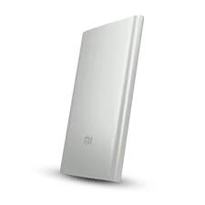*Model:Xiaomi Mi 20000mAh Power Bank 2C - White*

Figure : Power bank

**Power bank** has been used to give power supply to the arduino and nodeMCU module. As the GSM module draws 2 Ampere current, we used power bank to supply the huge current.

\

**Block Diagram**

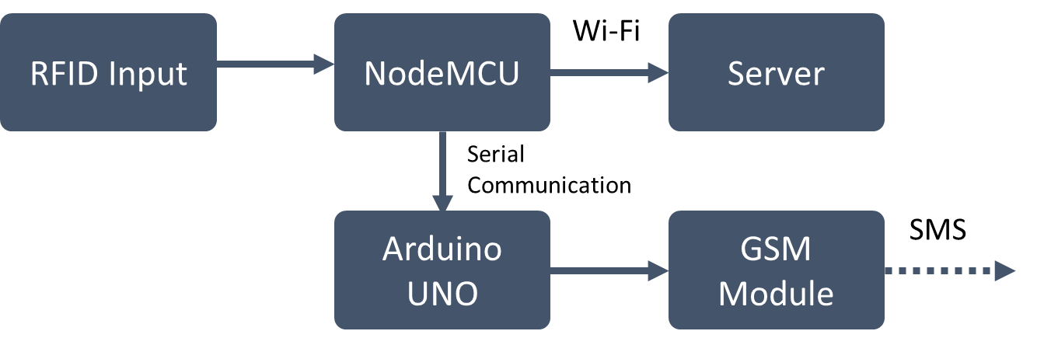

**Hardware Implementation**

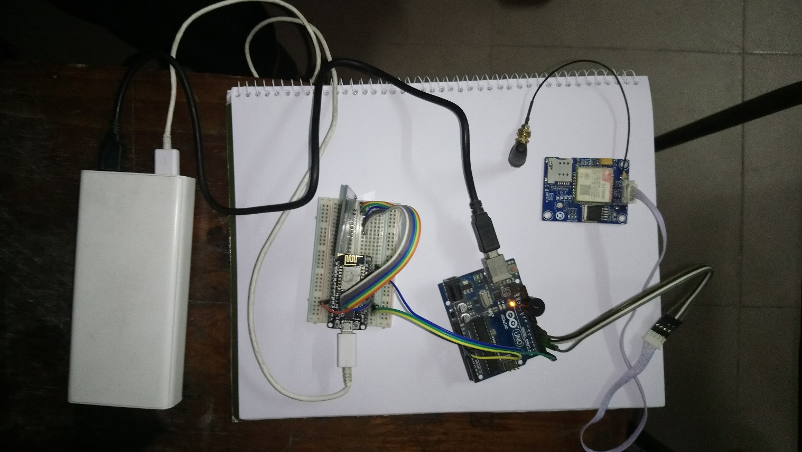

Figure : Full hardware setup

The website is locally hosted on a laptop. NodeMCU communicates with the laptop via Wi-Fi. Hence, no cable connection is needed.

**Working Principle**

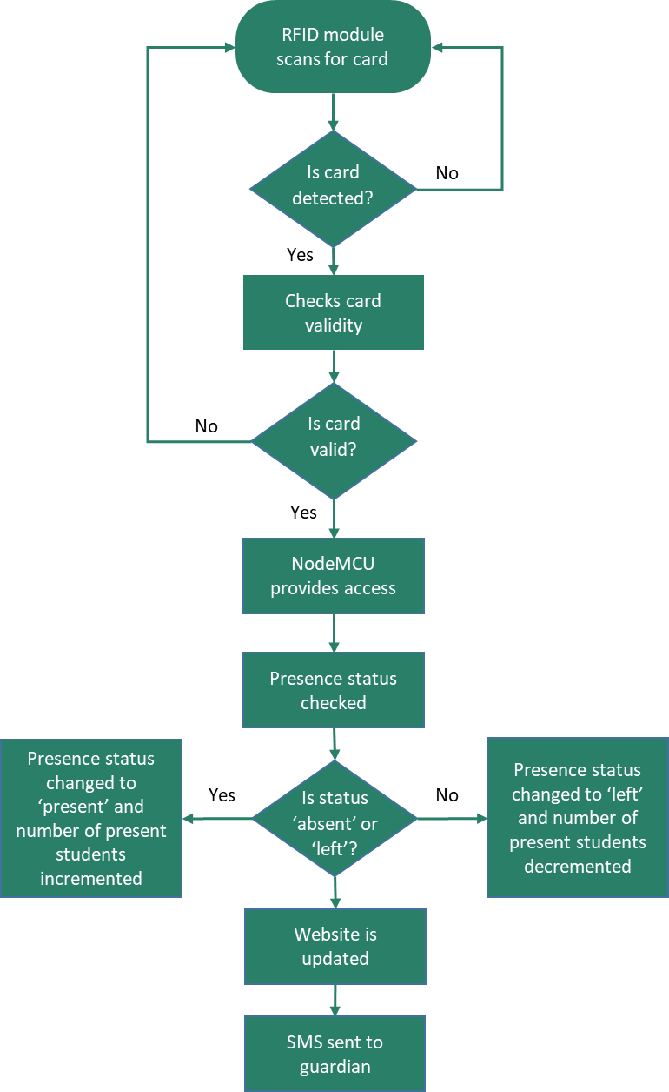

Figure : Flow chart of working principle

The whole process can be divided into two major parts- a) Hardware, and b) Website.

The hardware setup is used for recognizing ID card. After that, information is processed and sent to parents and the server for updating website. In the hardware setup, first the input is taken using RFID Access Control-MFRC522. It scans the ID card of specific frequency (13.6MHz in this case). Now the ID card number is passed to nodeMCU and processed for identification. In our experiment, we assumed that there were 10 students and there information was saved as ‘Valid card ID’.

In the arduino code, the identification is done by comparing the input ID card number with the existing ID numbers in the database. If an ID card number is recognized for a student, his/her present status (Absent, Present or Left) is updated. This is done in this way- the initial status of a student is ‘Absent’. If his/her card is scanned once, his/her status becomes ‘Present’. If the same card is scanned again, it means he/she is leaving and therefore the status is changed to ‘Left’. The present status of any of the students can be sent as SMS to the respective guardian by connecting the nodeMCU with GSM module via Arduino Mega. The summary of the Arduino code’s working procedure is given below-

🡪 System is connected to website

🡪 Presence of any new card is checked and the card is read

🡪 Card ID is compared with existing valid ID strings

🡪 If ID is matched, present state is changed

🡪 The information of the student is sent to server

**Website**

Every time the present status of any student is updated, the nodeMCU connects to server using Wi-Fi and does necessary changes in information. The website is dynamic, which is updated every 6 seconds. It is written and styled in HTML, CSS and PHP and hosted locally. The website has the academic information of all the students in the ‘Student data’ link and has a ‘Dashboard’. In the dashboard, the present status of the students is displayed with their names, roll numbers and corresponding departments. It also shows the time of entering and leaving. The dashboard can be refreshed by selecting the ‘delete data’ option.

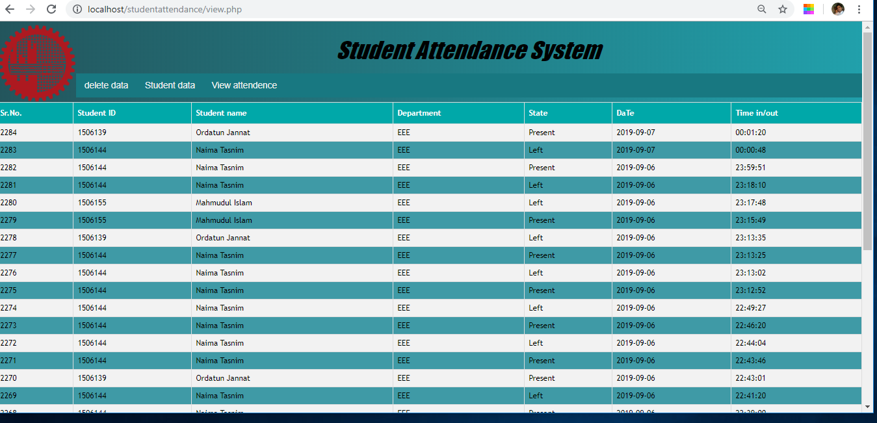

Figure : Dashboard - It views students' attendance information

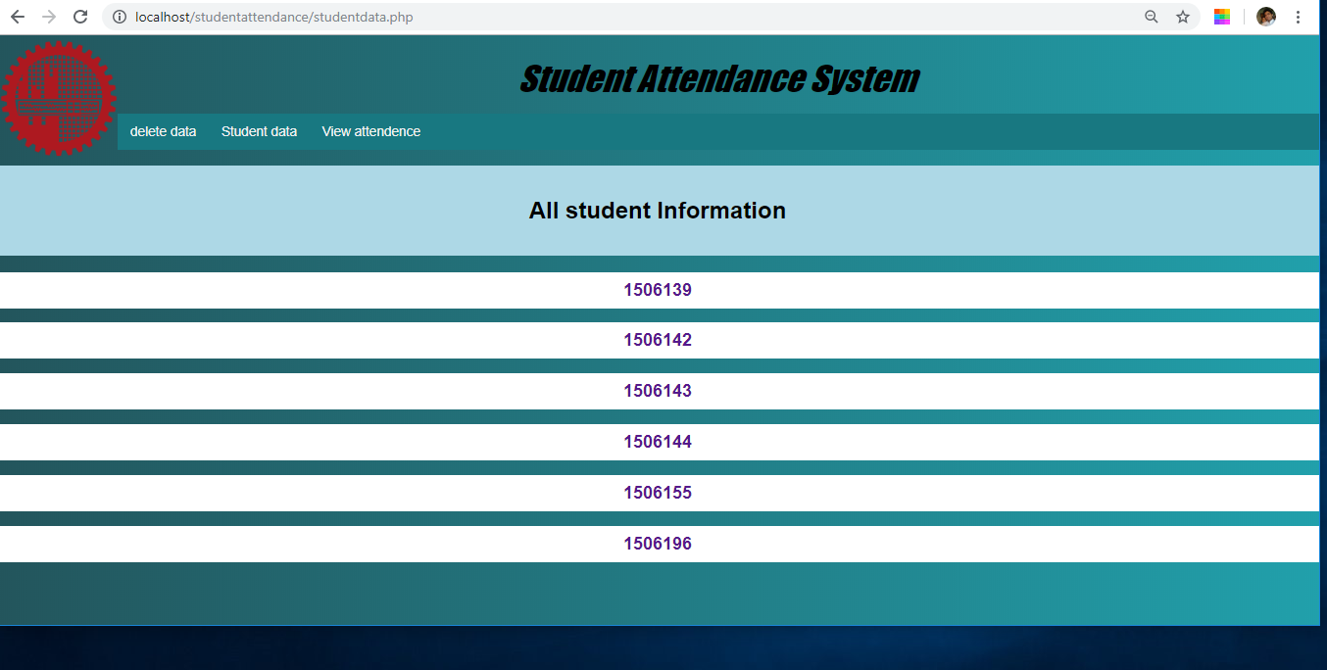

Figure : Student data - links to detailed information of each student

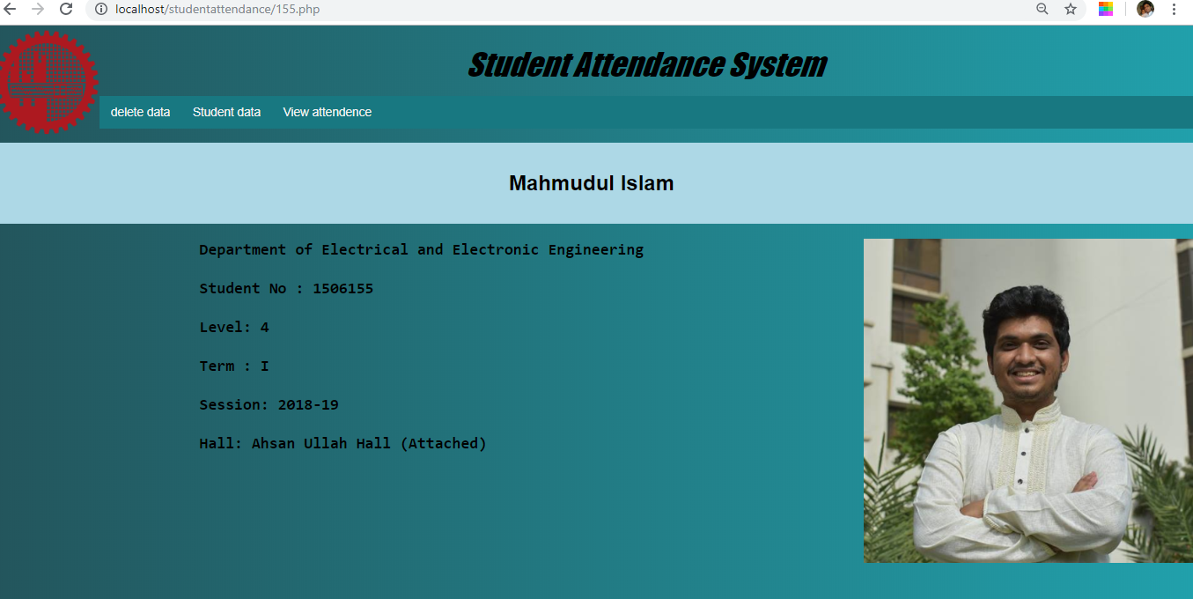

Figure : Detailed information of one student

**Future Improvement**

(I) We can easily add image based detection system and also finger-print based detection system.

(II) Additional functionality such as information service about student grading marks, daily timetable, lectures time and classroom numbers, and other student-related instructions that provided by faculty department staff can also be added.