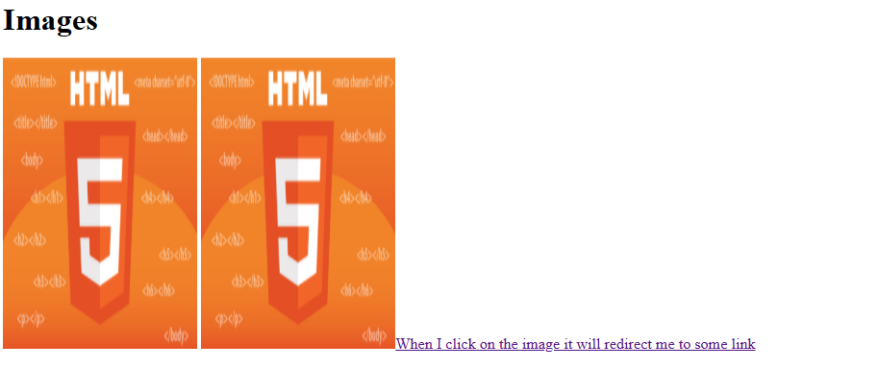

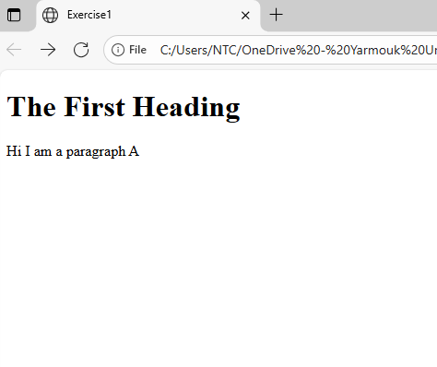
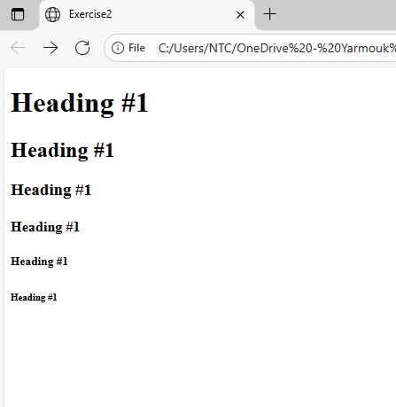

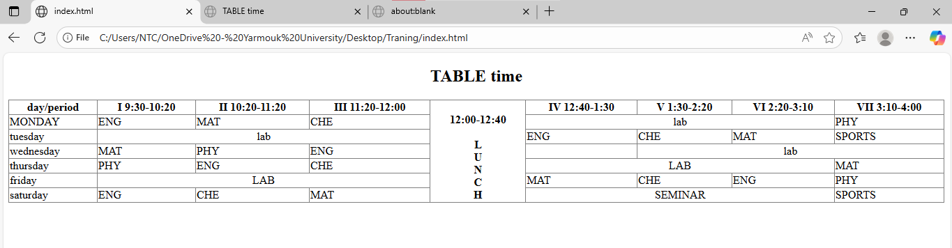
<!DOCTYPE html>
<html>
<head>

</head>

<body>

<table border="1" hight="600" style="border-collapse: collapse;" width=100%>

<tr >
<th>day/period</th>
<th>I 9:30-10:20</th>
<th>II 10:20-11:20</th>
<th>III 11:20-12:00</th>

<h2 align="center"> TABLE time</h2>
<th rowspan="7">

<br>

12:00-12:40<br><br>
L<br>U<br>N<br>C<br>H
</th>

<th>IV 12:40-1:30</th>
<th>V 1:30-2:20</th>
<th>VI 2:20-3:10</th>
<th>VII 3:10-4:00</th>
</tr>

<tr>
<td>MONDAY</td>
<td>ENG</td>
<td>MAT</td>
<td>CHE</td>
<td colspan="3" align="center">lab </td>
<td>PHY</td>
</tr>

<tr>
<td>tuesday</td>
<td colspan="3" align="center">lab</td>
<td>ENG</td>
<td>CHE</td>
<td>MAT</td>
<td>SPORTS</td>
</tr>

<tr>
<td>wednesday</td>
<td>MAT</td>
<td>PHY</td>
<td>ENG</td>
<td></td>
<td colspan="3" align="center"> lab </td>

</tr>

<tr>
<td>thursday</td>
<td>PHY</td>
<td>ENG</td>
<td>CHE</td>
<td colspan="3" align="center">LAB</td>

<td>MAT</td>

</tr>

<tr>
<td>friday</td>
<td colspan="3" align="center">LAB</td>
<td>MAT</td>
<td>CHE</td>
<td>ENG</td>
<td>PHY</td>

</tr>

<tr>
<td>saturday</td>
<td>ENG</td>
<td>CHE</td>
<td>MAT</td>
<td colspan="3" align="center">SEMINAR</td>
<td>SPORTS</td>
</tr>

</table>

</body>
</html>

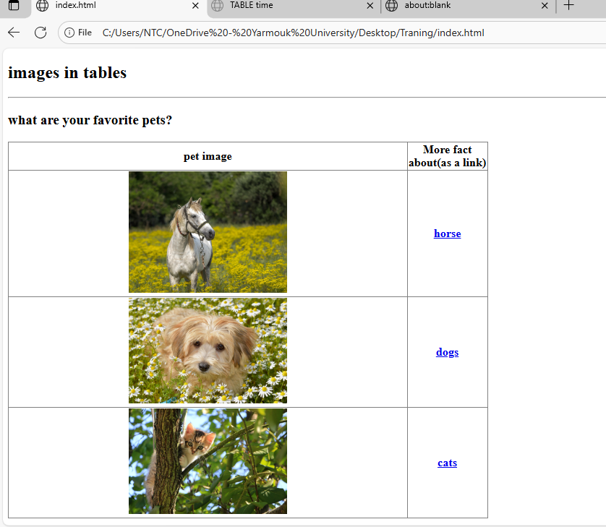

<!DOCTYPE html>
<html>
<head>

</head>

<body>
<h2>images in tables</h2>

<hr>

<h3>what are your favorite pets?</h3>
<table border="1" style="border-collapse: collapse;" width=50%>

<thead>
<tr>
<th>pet image</th>
<th>More fact about(as a link)</th>

</tr>
</thead>

<tbody>
<tr>
<th ><img src="images/horse.jpg" width=40%></th>
<th> <a href="#">horse</a> </th>

</tr>

<tr>
<th ><img src="images/dogs.jpg" width=40%></th>
<th><a href="#">dogs</a></th>
</tr>

<tr>
<th><img src="images/cats.jpg" width=40%></th>
<th><a href="#">cats</a></th>

</tr>

</tbody>

</table>

</body>
</html>

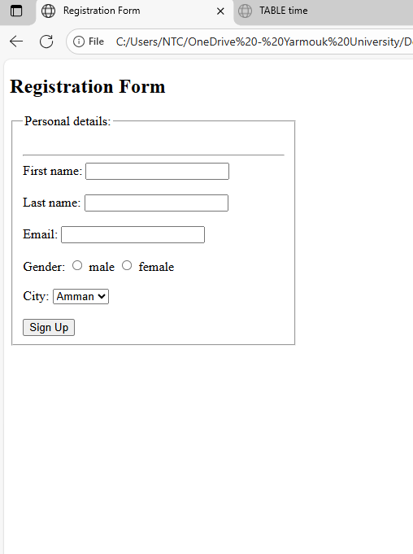
<!DOCTYPE html>
<html>
<head>
<title>Registration Form</title>
</head>

<body>

<h2>Registration Form</h2>

<div style="width:350px;">
<fieldset>
<legend>Personal details:</legend>

<br><hr>

<label>First name:</label>
<input type="text" name="fname">
<br><br>

<label>Last name:</label>
<input type="text" name="lname">
<br><br>

<label>Email:</label>
<input type="text" name="email">
<br><br>

<label>Gender:</label>
<input type="radio" name="gender" value="male"> male
<input type="radio" name="gender" value="female"> female
<br><br>

<label>City:</label>
<select>
<option>Amman</option>
<option>Irbid</option>
<option>Alsalt</option>
<option>Aqaba</option>
</select>
<br><br>

<button>Sign Up</button>

</fieldset>
</div>

</body>
</html>

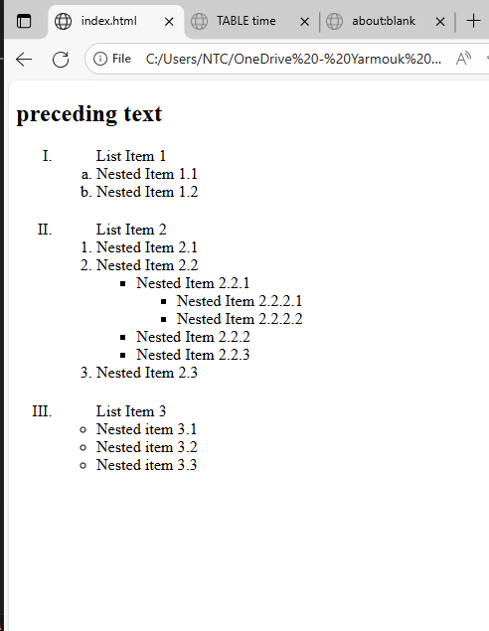<!DOCTYPE html>
<html>
<body>

<h2>preceding text</h2>

<ol type="I" >
<li style="margin-bottom:20px;">
<span style="margin-left:40px;">List Item 1</span>
<ol type="a" >
<li>Nested Item 1.1</li>
<li>Nested Item 1.2</li>
</ol>
</li>

<li style="margin-bottom:20px;">
<span style="margin-left:40px;">List Item 2</span>

<ol type="1" >
<li>Nested Item 2.1</li>

<li>
Nested Item 2.2
<ul >
<li>
Nested Item 2.2.1
<ul>
<li>Nested Item 2.2.2.1</li>
<li>Nested Item 2.2.2.2</li>
</ul>
</li>

<li>Nested Item 2.2.2</li>
<li>Nested Item 2.2.3</li>
</ul>
</li>

<li>Nested Item 2.3</li>
</ol>
</li>

<li>
<span style="margin-left:40px;">List Item 3</span>
<ul >
<li>Nested item 3.1</li>
<li>Nested item 3.2</li>
<li>Nested item 3.3</li>
</ul>
</li>

</ol>

</body>
</html>

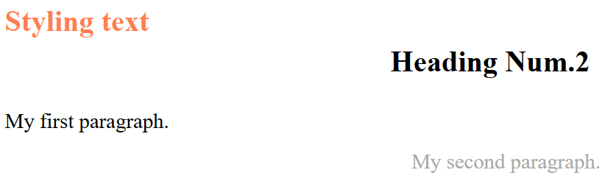

<!DOCTYPE html>
<html>
<body>

<div style="float:left; width:50%;">

<p style="color:coral;font-weight:bold; font-size:28px">Styling text</p>
<br>
<p style="font-size:20px">My first paragraph.</p>

</div>
<br>
<br>

<div style="float:right;width:50%; ">

<p style="font-weight:bold ; font-size:28px">Heading Num.2</p>
<br>

<p style="color:darkgray;margin: right 2px; margin-left: 20px;font-size:20px">My second paragraph.</p>
</div>

</body>
</html>

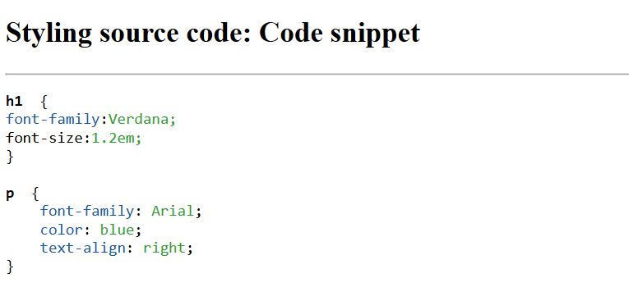

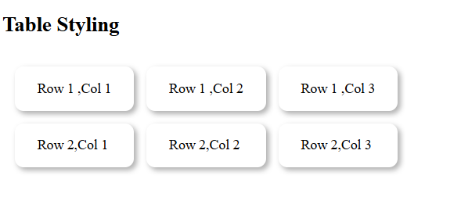

<!DOCTYPE html>
<html>
<head>
<meta charset="utf-8">

<h2>Table Styling </h2>
</head>
<body>
<table>

<tr>
<td>Row 1 ,Col 1</td>
<td>Row 1 ,Col 2</td>
<td>Row 1 ,Col 3</td>

</tr>

<tr>
<td>Row 2,Col 1</td>
<td>Row 2,Col 2</td>
<td>Row 2,Col 3</td>

</tr>

<style>
table{

border-spacing:15px;

}

td{

padding:15px 25px;
box-shadow: 3px 3px 6px rgba(0,0,0,0.3);
border:1px solid #0000;
border-radius:10px;

}

</style>

</table>

</body>
</html>

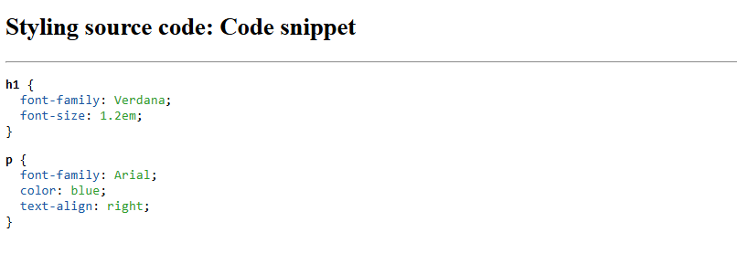

<!DOCTYPE html>
<html>
<head>
<meta charset="utf-8">
<style>
.selector { color: black; font-weight: bold; }
.property { color: #1a57a5; }
.value { color: #2ca02c; }
</style>
</head>
<body>

<h2>Styling source code: Code snippet</h2>
<hr>

<pre>
<span class="selector">h1</span> {
<span class="property">font-family</span>: <span class="value">Verdana</span>;
<span class="property">font-size</span>: <span class="value">1.2em</span>;
}
<pre>
<span class="selector">p</span> {
<span class="property">font-family</span>: <span class="value">Arial</span>;
<span class="property">color</span>: <span class="value">blue</span>;
<span class="property">text-align</span>: <span class="value">right</span>;
}

</pre>

</body>
</html>

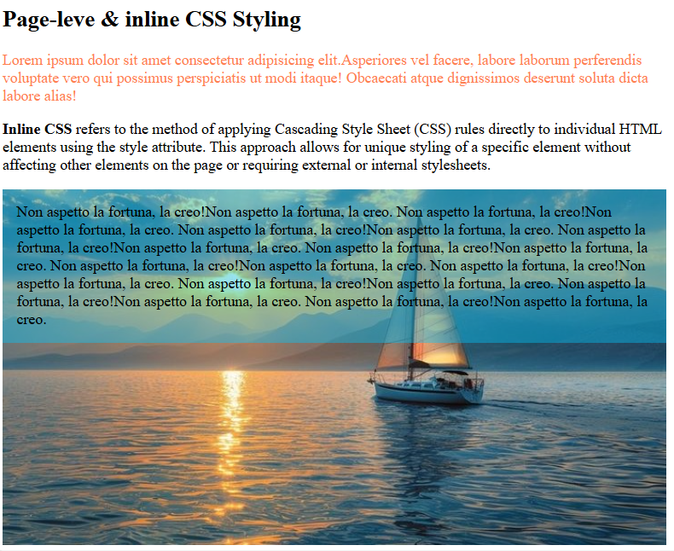

<!DOCTYPE html>
<html>
<head>
<meta charset="utf-8">

<h2>Page-leve & inline CSS Styling</h2>

</head>
<body>

<p style="color:coral; width:700px">
Lorem ipsum dolor sit amet consectetur adipisicing elit.Asperiores vel facere,
labore laborum perferendis voluptate vero qui possimus perspiciatis ut modi
itaque! Obcaecati atque dignissimos deserunt soluta dicta labore alias!</p>

<p style="width: 700px;">
<b > Inline CSS </b>refers to the method of
applying Cascading Style Sheet (CSS) rules directly to individual HTML
elements using the style attribute. This approach allows for unique styling
of a specific element without affecting other elements on the page or requiring
external or internal stylesheets.</p>

<div class="img-box">
<img src="images/download (38).jpg" alt="image">

<div class="text-over">
Non aspetto la fortuna, la creo!Non aspetto la fortuna, la creo.
Non aspetto la fortuna, la creo!Non aspetto la fortuna, la creo.
Non aspetto la fortuna, la creo!Non aspetto la fortuna, la creo.
Non aspetto la fortuna, la creo!Non aspetto la fortuna, la creo.
Non aspetto la fortuna, la creo!Non aspetto la fortuna, la creo.
Non aspetto la fortuna, la creo!Non aspetto la fortuna, la creo.
Non aspetto la fortuna, la creo!Non aspetto la fortuna, la creo.
Non aspetto la fortuna, la creo!Non aspetto la fortuna, la creo.
Non aspetto la fortuna, la creo!Non aspetto la fortuna, la creo.
Non aspetto la fortuna, la creo!Non aspetto la fortuna, la creo.
</div>

</div>
<style>

.bold{
font-weight: bolder;
font-weight: 500px;
font-style:oblique;
}

.img-box {
position: relative;
display: inline-block;
}

.img-box img {
width: 700px; /* عدّليه حسب بدك */
height: auto;
}

.text-over {
position: absolute;
top: 0;
left: 0;
width: 95.7%;
background: rgba(0, 200, 255, 0.4); /* خلفية ملونة شفافة */
padding: 15px;
}

</style>

</body>
</html>

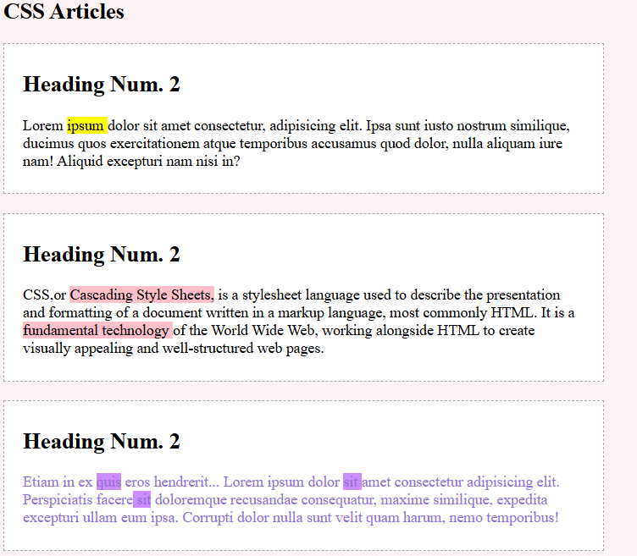
<!DOCTYPE html>
<html lang="en">
<head>
<meta charset="UTF-8">

<style>
.box {
width:50%;
border: 1px dashed #aaa;
padding: 9px 20px;
margin-bottom: 20px;
background-color:white;
}

.box2 span { background: pink;}
.box3 span { background: rgb(202,141,255); }

body{
background-color:rgb(252, 243, 244);
}
</style>

</head>
<body>

<h2>CSS Articles</h2>
<div class="box box1">
<h2>Heading Num. 2</h2>
<p >

Lorem <span style="background-color:yellow;">ipsum </span>dolor sit amet consectetur, adipisicing elit.
Ipsa sunt iusto nostrum similique,
ducimus quos exercitationem atque
temporibus accusamus quod dolor,
nulla aliquam iure nam!
Aliquid excepturi nam nisi in?

</p>
</div>
<div class="box box2">
<h2>Heading Num. 2</h2>
<p>

CSS,or <span>Cascading Style Sheets,</span> is a stylesheet language
used to describe the presentation and formatting of a document written
in a markup language, most commonly HTML. It is a <span>fundamental technology </span>
of the World Wide Web, working alongside HTML to create visually appealing
and well-structured web pages.
</p>
</div>

<div class="box box3">
<h2>Heading Num. 2</h2>
<p style="color:mediumpurple">
Etiam in ex <span>quis</span> eros hendrerit...
Lorem ipsum dolor <span>sit </span>amet consectetur adipisicing elit.
Perspiciatis facere<span> sit</span> doloremque recusandae consequatur,
maxime similique, expedita excepturi ullam eum ipsa.
Corrupti dolor nulla sunt velit quam harum, nemo temporibus!
</p>
</div>

</body>
</html>

