**IS 234T: MULTI-TIER APPLICATION DEVELOPMENT**

**FINAL PROJECT REPORT**

**ONLINE SHOPPING WEBSITE**

|  |  |
| --- | --- |
| **NAME** | **ID** |
| **RAHAF ALARFAJ** | **437000592** |
| **MUNA ALZAHRANI** | **437000406** |
| **RAWAN ALQAHTANI** | **438002158** |
| **SARA ALMURAYBIDH** | **437003955** |
| **RAWAN HAZAZI** | **434002967** |

**SECTION: 4ID**

**Introduction:**

Online shopping is the process of buying goods and services from merchants over the Internet. Since the emergence of the World Wide Web, merchants have sought to sell their products to people who spend time online. Shoppers can visit web stores from the comfort of their homes and shop as they sit in front of the computer.

The goal of this project is to develop a custom website for online shopping, the system enables customers to browse through the shop and add items to shopping cart, edit and delete the cart, and checkout. And it allows the admin to update the website and verify payment details. It also helps customers purchase the products online without having to visit the shop physically.

**Site map:**

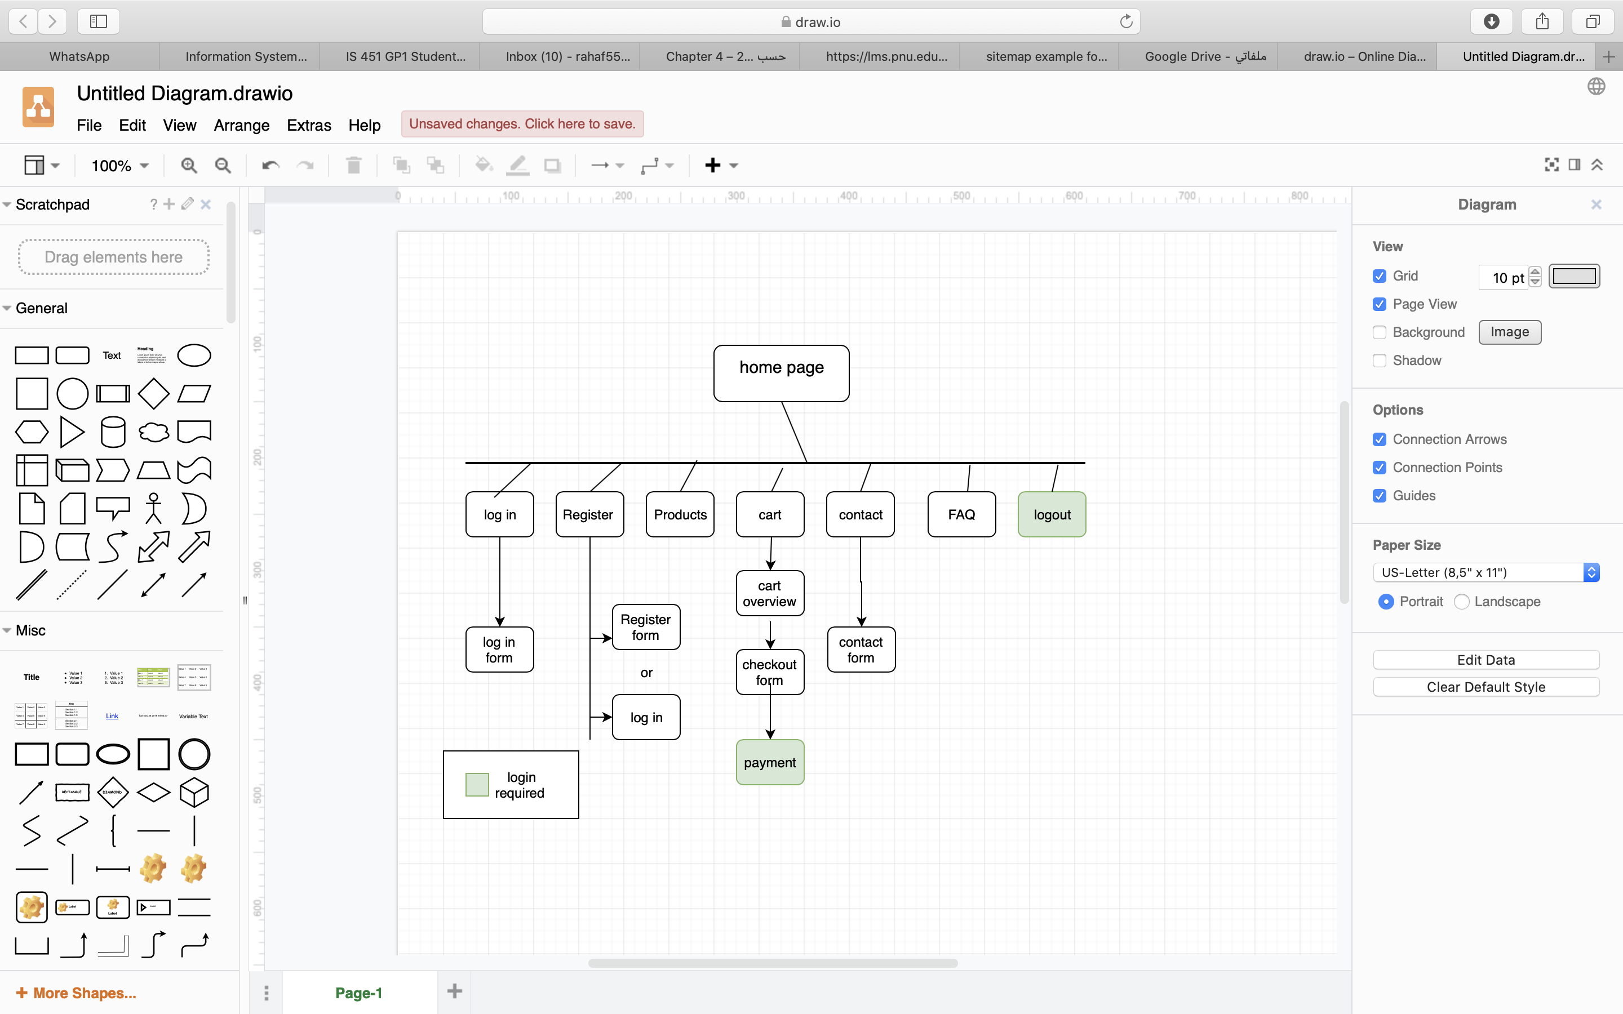

**ER-Diagram of the database:**

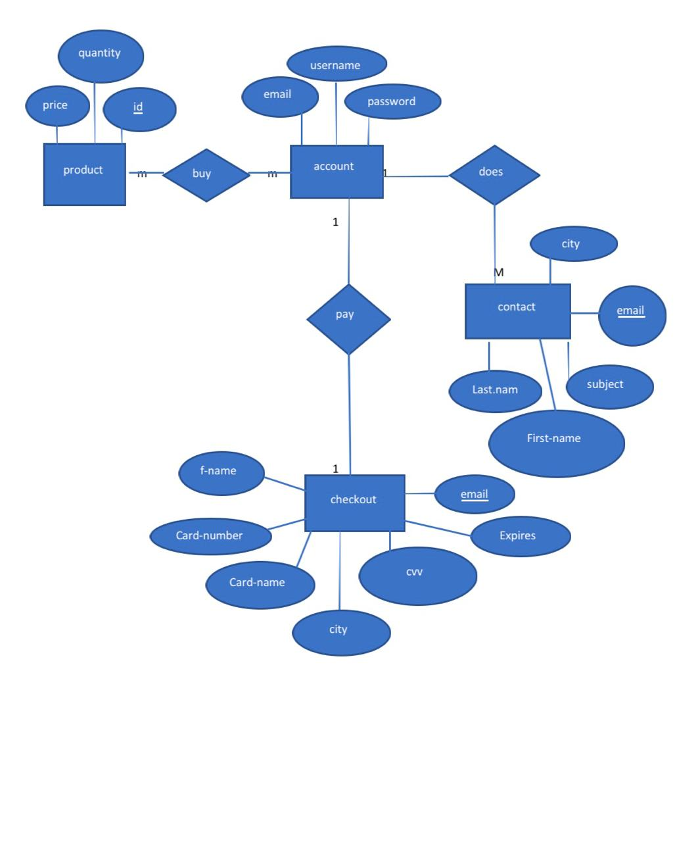

**Use case diagram for the admin/customer functions:**

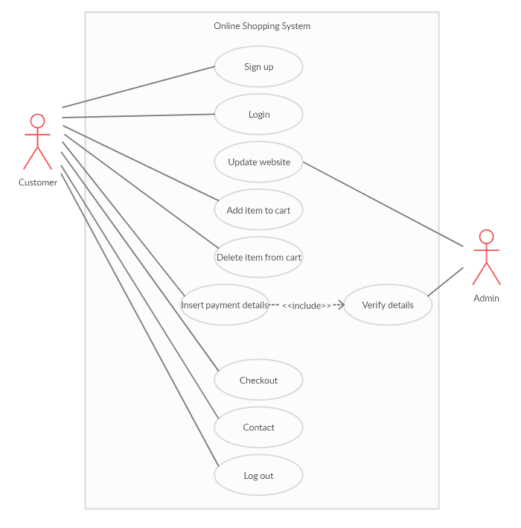

**Screenshots of database table from PhpMyAdmin:**

**From product table:**

**From account table:**

**From contact table:**

**From payment table:**

**User interface:**

**Conclusion:**

In conclusion , our site will allow customers to place order without even visiting the actual shop and provide the ability to buy anything , at any time, in any place. The website will enable them to browse before they shop and check the product so they have more confidence in what they are buying. We developed this online shopping website by letting the customers view the shop and add the desired items to shopping cart and enable them to edit or delete the cart and then to checkout. It's also enable the admin to manage the website and verify the customer's payment which make the online shopping become more enjoyable and easier than real-world shopping.