Survey Analysis Report

Goal: Understand how often people engage in physical activity.

Hypothesis: People in urban areas engage in physical activity less frequently than those in rural areas.

Target Group: Adults aged 18-40 in both urban and rural areas.

Time Taken (in minutes): 1

# Analysis:

### Summary of Survey Results:  
  
The survey was conducted among adults aged 18-40 in both urban and rural areas. The main goal was to understand how often they engage in physical activity and their beliefs and experiences related to it. The survey consisted of both closed and open-ended questions.  
  
### Closed-ended Questions Analysis:  
  
1. **How often do you engage in physical activity?**  
  
 User 1: Several times a week  
 User 2: Once a week  
  
2. **Do you believe physical activity has a positive impact on your mental health?**  
  
 User 1: Agree  
 User 2: Disagree  
  
3. **Have you noticed any improvements in your mood or stress levels after exercising?**  
  
 User 1: Yes  
 User 2: No  
  
4. **Do you feel more focused and productive after participating in physical activity?**  
  
 User 1: Yes  
 User 2: No  
  
### Thematic Analysis for Open-ended Questions:  
  
1. **What types of physical activity do you engage in regularly?**  
  
 User 1: Jogging, yoga, and swimming  
 User 2: Gym workouts and cycling  
  
2. **What barriers prevent you from engaging in physical activity more frequently?**  
  
 User 1: Lack of time due to academic workload  
 User 2: Lack of motivation  
  
### Hypothesis Evaluation:  
  
As the dataset is extremely limited (only two respondents), it is not possible to make a valid conclusion about the hypothesis that people in urban areas engage in physical activity less frequently than those in rural areas. We need a larger sample size to conduct a meaningful analysis and verify the hypothesis.  
  
### Recommendations:  
  
For a more robust analysis, it is recommended to collect more data. A larger sample size will provide a broader perspective and more accurate insights into people's engagement in physical activity and the factors that influence it. Furthermore, it would be beneficial to include questions that explicitly ask about the respondents' living areas (urban or rural) to directly test the hypothesis.

Question: Have you noticed any improvements in your mood or stress levels after exercising?

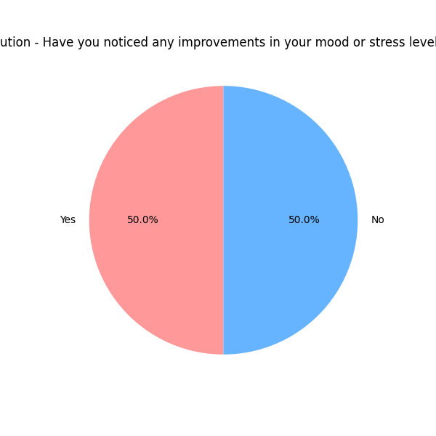

Question: Do you feel more focused and productive after participating in physical activity?

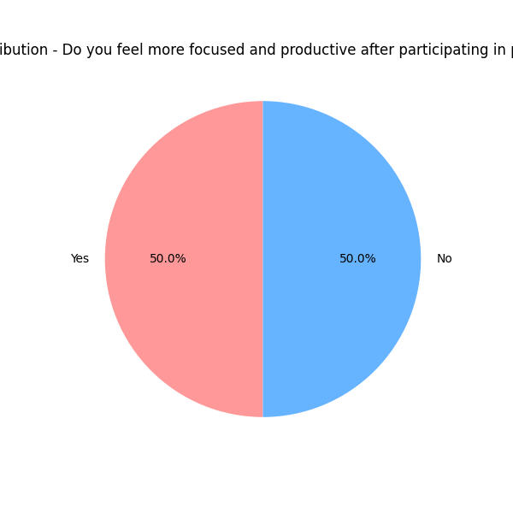

Top 10 Most Common Words in Open-Ended Questions

