Survey Analysis Report

Goal: Understand how often people engage in physical activity.

Hypothesis: People in urban areas engage in physical activity less frequently than those in rural areas.

Target Group: Adults aged 18-40 in both urban and rural areas.

Time Taken (in minutes): 1

# Analysis:

### Summary of Survey Results  
  
The survey was conducted among adults aged 18-40 in both urban and rural areas. The survey contained both closed-ended and open-ended questions. The goal of the survey was to understand how often people engage in physical activity. The hypothesis was that people in urban areas engage in physical activity less frequently than those in rural areas.   
  
### Closed-Ended Questions Analysis  
  
1. **How often do you engage in physical activity?**  
  
Among the two respondents, one reported engaging in physical activity several times a week, while the other reported doing so once a week.  
  
2. **Do you believe physical activity has a positive impact on your mental health?**  
  
Both respondents agreed that physical activity has a positive impact on their mental health. One respondent agreed, while the other strongly agreed.  
  
3. **Have you noticed any improvements in your mood or stress levels after exercising?**  
  
Both respondents reported noticing improvements in their mood and stress levels after exercising.  
  
4. **Do you feel more focused and productive after participating in physical activity?**  
  
Both respondents reported feeling more focused and productive after participating in physical activity.  
  
5. **Would you be interested in joining a physical activity program aimed at improving mental health?**  
  
Both respondents expressed interest in joining a physical activity program aimed at improving mental health.  
  
### Thematic Analysis for Open-Ended Questions  
  
1. **What types of physical activity do you engage in regularly?**  
  
The types of physical activity that the respondents engage in regularly include jogging, yoga, swimming, walking, and cycling.  
  
2. **What barriers prevent you from engaging in physical activity more frequently?**  
  
The barriers that prevent the respondents from engaging in physical activity more frequently include lack of time due to academic workload, weather, and lack of motivation.  
  
### Hypothesis Evaluation  
  
Based on the data from the two respondents, it is impossible to make a definitive conclusion regarding the hypothesis that people in urban areas engage in physical activity less frequently than those in rural areas. More data is needed to make a valid conclusion. Therefore, the hypothesis is currently *Not Supported*.  
  
### Charts  
  
For a more comprehensive and visual representation of the data, charts can be created. For example, a pie chart can be used to show the distribution of responses for the closed-ended questions, and a word cloud can be used to represent the responses to the open-ended questions.  
  
Please note that this analysis is based on only two responses, and the results may not be representative of the wider population. More responses are needed for a more reliable analysis.

Question: Have you noticed any improvements in your mood or stress levels after exercising?

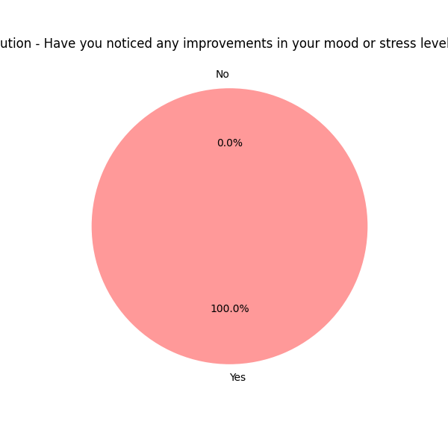

Question: Do you feel more focused and productive after participating in physical activity?

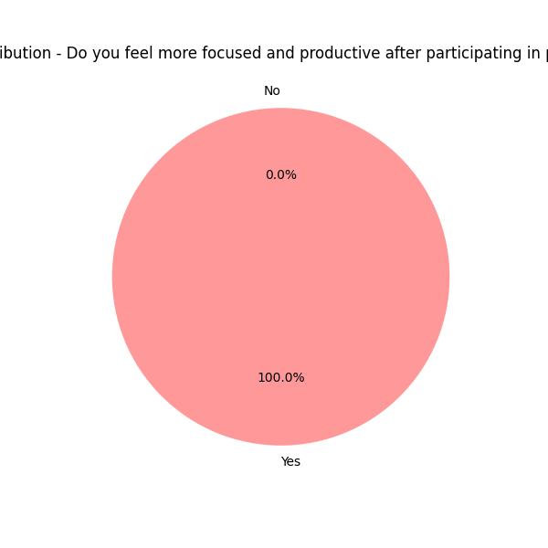

Question: Would you be interested in joining a physical activity program aimed at improving mental health?

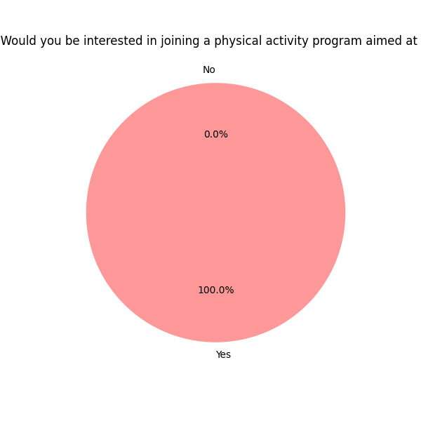

Top 10 Most Common Words in Open-Ended Questions

