Survey Analysis Report

Goal: qa testing

Hypothesis: is it important for frontend devs

Target Group: None

Time Taken (in minutes): None

# Analysis:

### Summary of Survey Results:  
  
The survey was conducted to understand the importance of QA testing in frontend development. All respondents agreed that QA testing is important for frontend development. When asked about the aspects of frontend development that benefit the most from QA testing, the response was not clear. The primary method of implementing QA testing was automated testing. Respondents believe that ideally, 1-2 hours should be spent on QA testing for frontend development. Respondents did not provide any clear challenges encountered during QA testing in frontend development.  
  
### Analysis of Closed-Ended Questions:  
  
1. Do you think QA testing is important for frontend development?  
  
 - True: 100%   
  
This indicates unanimous agreement on the importance of QA testing in frontend development.  
  
### Thematic Analysis of Open-Ended Questions:  
  
1. What aspects of frontend development do you believe benefit the most from QA testing?  
  
 - No clear response was given.  
  
2. What is your primary method of implementing QA testing in frontend development?  
  
 - Automated Testing: 100%  
  
3. Please describe any challenges you have encountered during QA testing in frontend development.  
  
 - No clear response was given.  
  
### Evaluation of Hypothesis:  
  
The hypothesis that QA testing is important for frontend developers is supported by the data. All respondents agreed on the importance of QA testing in frontend development. However, there is a lack of clarity on which aspects benefit the most from QA testing and the challenges encountered during testing, which could be due to the limited number of responses or lack of experience among the respondents.   
  
### Recommendations:  
  
It would be beneficial to conduct a more detailed survey with more respondents and more explicit questions to gain a deeper understanding of the importance and implementation of QA testing in frontend development. This will help in gaining more comprehensive insights and making more accurate conclusions.   
  
### Charts:  
  
Due to the limited and homogeneous nature of the responses, it is not possible to create meaningful charts for this analysis.

Question: Do you think QA testing is important for frontend development?

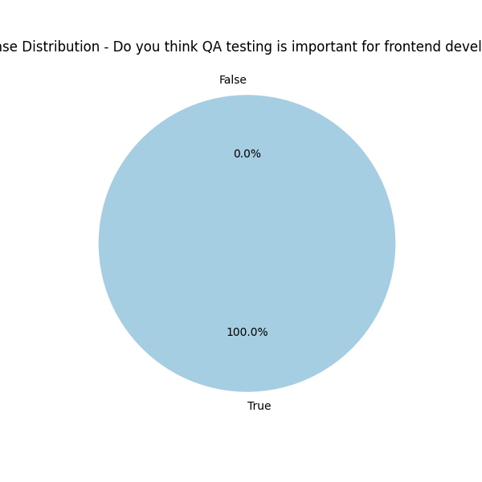

Question: What is your primary method of implementing QA testing in frontend development?

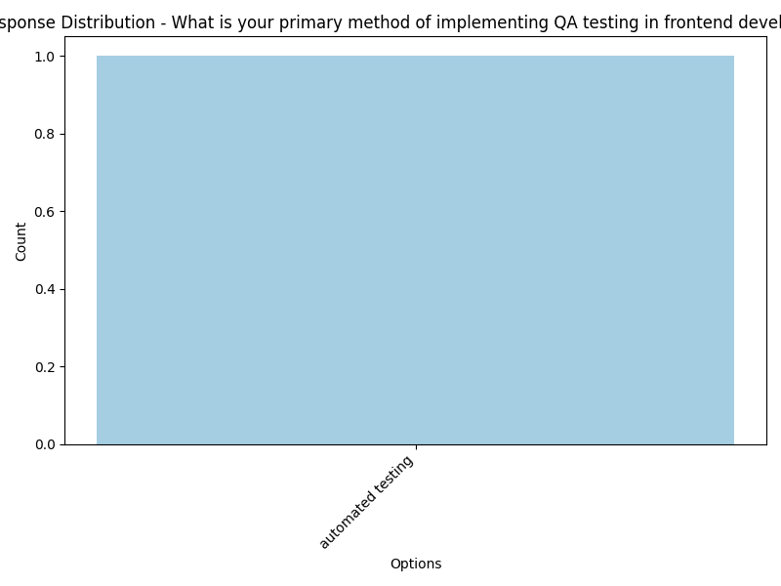

Question: Based on your experience, how much time should ideally be spent on QA testing for frontend development?

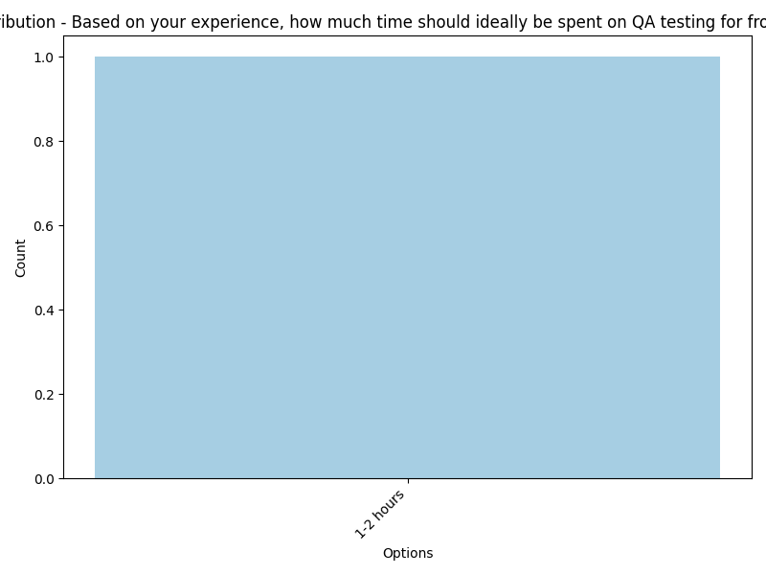

Top 10 Most Common Words in Open-Ended Questions

