Telidon (https://en.wikipedia.org/wiki/Telidon) was the first Canadian public network service before the Internet. It was available in the late 1970s. It provided videotex and teletex services to Canadians so they could read news, do banking, book flights and shop. Telidon was developed by Canadian Communications Research Center (CRC). It was the second generation of videotex system, providing 2D colour graphics, multilingual support and improvement on interactivity.
Telidon had a few issues. First, it was difficult to maintain the users interrest because there was limited content in the system and users were able to exhaust their favorite contents in a short period of time. Second, the system was dominated by the one-way contents such as advertising from large vendors or broadcasting news, and interactivity was limited to menu selections or sending information on forms (bank forms). This would make it difficult for users to produce content on the system. The other disadvantage of Telidon was its price. The Telidon terminals ranged about $2000.
By emerging the early home computers by mid-1980s and using information services like CompuServe and The Source, users could receive great online services that Telidon failed to offer and with far lower prices, so Telidon started to disappear by mid-1980s.
Dialup proprietary networks: Network service providers like CompuServe (https://en.wikipedia.org/wiki/CompuServe), The Source and Usenet were commercial dial up services that Canadians started to use them in about mid-1980s. These networks were not connected to the ARPANET or NSFNET(backbone of the Internet). These where proprietary networks that users’ computers would connect to them via modems to use the services like emails, access to the news, and transfer files.
Video:https://www.youtube.com/watch?v=vjMUe7hkwRs&t=11s

NetNorth: (https://www.canarie.ca/a-birthday-for-canadas-internet/) NetNorth was the first Canadian network, developed in 1980’s. It connected universities across Canada.
The idea started from Waterton and Guelph (https://www.canarie.ca/wp-content/uploads/2021/02/Publication-A-Nation-Goes-Online.pdf) universities In 1983. They had joint graduate programs, and there was a big computer purchased at Waterloo. They wanted to move their data back and forth between the two universities and be able to log into that computer from Guelph. This became a motivation in the ACSD conference held in Toronto at Ryerson Polytechnic Institute in November 1983 to build a network similar to BITNET , in U.S., to context universities’ networks to each other.
NetNorth used IBM's Network Job Entry protocol(https://www.sciencedirect.com/science/chapter/edited-volume/abs/pii/B9781555580476500084#:~:text=Publisher%20Summary,to%20provide%20file%2Dtransfer%20services.). It was a protocol used in the U.S. BITNET organization to connect academy communities by point-to-point links.
NSFNET(https://en.wikipedia.org/wiki/National_Science_Foundation_Network): In 1985, the National Science Foundation (NSF) funded a project to create an academic research network, called NSFNET, to facilitate access by researchers to the supercomputing centers. NSFNET applied TCP/IP protocols which was initially deployed successfully by ARPANET. NSFNET became the Internet backbone for the U.S. government agencies and universities, and ARPANET project was formally decommissioned in 1990.
In Canada, universities and other networks started to connect to the NSFNET instead of ARPANET through the CA*net from 1990.
CA*net:(https://www.canarie.ca/a-birthday-for-canadas-internet/) In 1989, the group that managed NetNorth decided to apply the TCP/IP standard, which was introduced in the US by ARPA (Advanced Research Projects Agency) in 1980. The motivation behind it was to have high speed networks with the goal of establishing links between their networks and provincial networks, that some of them had already implemented TCP/IP, as well as connection to some other external networks, including ARPANET and later NSFNET in the U.S. This idea was supported by Canada’s National Research Council financially and a committee was established to define a project for this. The project was granted to the University of Toronto and with the contribution from IBM Canada and INSINC. This network was called CA*net. This network started working at a relatively low speed of about 56 kbps. CA*net was launched in 1990 as the first coast-to-coast, IP-based production network(https://www.canarie.ca/wp-content/uploads/2021/02/Publication-A-Nation-Goes-Online.pdf).
CANARIE:(https://www.canarie.ca/a-birthday-for-canadas-internet/)It was a non-profit organization, formed in 1993, to contribute to the development of digital technologies. One of the specific purposes of CANARIE was to upgrade the speed of CA*net to 1.5 megabits per second. CA*net started an interest in network communication, the volume of request for the network services increased so that CA*Net could not meet the demand. In return commercial networks (ISPs) started emerging in the market. In 1997, CA*net acknowledged that commercial network had become capable of meeting its members needs for commodity Internet services and decided to wind down and other parts of its mission were taken by the CANARIE Connection Services. CANARIE is now a dedicated connection for researchers who need a direct connection to high-performance computing centers or research facilities across Canada or around the world by being directly installed into their infrastructure.
Video: https://www.youtube.com/watch?v=vaqHLxs2h0E&t=30s
ISPs
Dial-up:
UUNET(https://www.canarie.ca/wp-content/uploads/2021/02/Publication-A-Nation-Goes-Online.pdf): UUNET Canada was the first commercial ISP in Canada was established in 1991. The motivation behind it was that for individuals and organizations denied access by provincial networks and CA*net, the only option remained the comparatively slow and functionally limited networks such as Usenet that operated using temporary dialup connections between nodes over regular phone lines. UUNET Canada was 20% owned by the US network provider UUNET Technologies, founded in 1987. U.S., as the first commercial provider. UUNET Technologies, constructed its own network called AlterNet, and UUNET Canada gained access to this network. Later UUNET Canada constructed its own network known as AlterNet Canada.
iSTAR Internet(https://country-studies.com/canada/history-of-internet-in-canada.html): founded in 1994, carved its niche not only as another national ISP but also as the first to offer a high-speed internet service in Canada. The considerable rise in commercial ISPs during this era played a vital part in promoting internet usage among the broader Canadian public. Later in 1997, PSINet acquired iSTAR.
NetCom(https://en.wikipedia.org/wiki/Netcom_(United_States)): In December 1995, Netcom Canada, a subsidiary of Netcom On-line, was launched in Toronto, Ontario, with Ron Close as its CEO. Netcom Canada boasted a Canada-wide network, and allowed U.S. Netcom customers to access their Internet accounts via their network using either NetCruiser or any PPP dialer.

Broadband Internet
DSL
Sympatico(Bell Canada)(https://en.wikipedia.org/wiki/Bell_Internet): Sympatico started DSL services in 1997(https://crtc.gc.ca/eng/archive/1999/o99-591.htm), through the Nortel 1-Meg Modem, which connected to only one computer. Sympatico changed its name to Bell Canada on August 8, 2008.

Sympatico started DSL services in 1997(https://crtc.gc.ca/eng/archive/1999/o99-591.htm), through the Nortel 1-Meg Modem, which connected to only one computer. Sympatico changed its name to Bell Canada on August 8, 2008.
Telus(https://assets.ctfassets.net/fltupc9ltp8m/5nrtxy6gcUJ6lwdjN5nS09/5f942c1f4e89a0a31066e3cc12a51dfd/_SIA-4j__Issue_Date__Aug._22__1997_): In 1997, Telus started announced a plan to provide DSL services over the existing telephone loops having metallic continuity, to provide simultaneous voice and data capability between the subscriber and the serving central office.

Cable Internet:
Rogers (https://en.wikipedia.org/wiki/Rogers_Xfinity?utm_source=chatgpt.com): 1995,
In 1995, Rogers began offering high-speed internet service with a technology named Cable Internet which was branded as Hybrid Fiber. This technology would carry the Internet data through fiber cables to the regional optical nodes, and from there via the same coaxial cables used to television. Different frequency bands were used to separate Internet data from television signals.
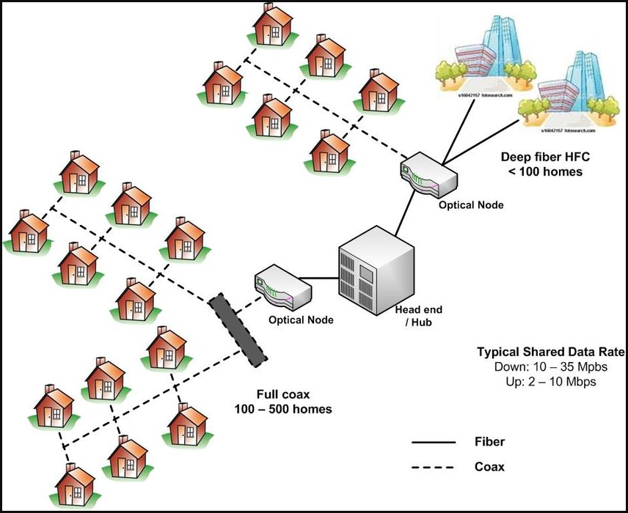
Hybrid Fiber(file:///C:/Users/hraha/Downloads/14281.pdf)
FTTH
Bell Aliant(https://en.wikipedia.org/wiki/Fibe_%28Bell_Aliant%29?utm_source=chatgpt.com): In 2009, Bell Aliant launched its FiberOP (briefly Fiber) services as the first ISP in Canada to cover an entire city (New Brunswick) with fiber to the home (FTTH) technology with the speeds of 25 Mbps download and 5 Mbps upload(https://www.fierce-network.com/telecom/bell-aliant-enhances-ftth-product-symmetrical-speeds-new-tv-features). The Bell Aliant extended its FiberOP to other cities of Atlantic Canada between 2010 and 2011, and then in Ontario between 2012 and 1014. The company took the ownership of Bell Aliant in 2014, and FiberOP services are still available with speeds up to 1.5 Gbit/s download and 940 Mbit/s upload.
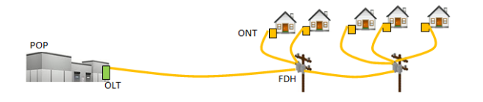
FTTH Schematic Diagram (https://www.novascotia.ca/sites/default/files/documents/1-1066/middle-mile-strategy-en.pdf)
Bell Canada (https://www.newswire.ca/news-releases/bell-high-speed-fibre-rollouts-enable-new-internet-and-tv-services---bellsnew-fibetm-internet-service-now-offers-fastest-upload-speeds-in-the-market-539266571.html): In 2010, Bell Canada announced a three-year plan to deploy high speed Fibre-to-the-home (FTTH) across the Québec City region, including Ancienne-Lorette, Beauport, Charlesbourg, Lévis-Wolfe, Loretteville, St-Cyrille, Ste-Foy, St-Nicolas, St-Réal and St-Romuald. with download speeds of at least 100 Megabits per second and upload speeds of at least 20 Mbps.
Telus: In 2016, Telus announced a project called PureFiber to provide FTTH in BC and Alberta. The Internet service offers download speeds of up to 150 Mbps and same for upload. Later, in 2023, Telus introduced a groundbreaking new tier of home Internet called “PureFibre X 3.0” to customers in Alberta and British Columbia, giving them access to the fastest speeds in Western Canada. With symmetrical upload and download speeds of 3.0 Gbps. (https://www.globenewswire.com/news-release/2023/09/25/2748825/0/en/TELUS-brings-ultra-fast-3-0-gigabit-Internet-to-customers-in-Western-Canada.html).

WISPs

Inukshuk Wireless (https://en.wikipedia.org/wiki/Inukshuk_Wireless): This wireless ISP was established in 2005 to e build a Canada-wide network for wireless Internet connectivity in 45 major cities and over 120 rural communities. It was built using a pre-WiMax which was provided by Expedience Solution, now called Nexpedience Networks.
The spectrum and technology were merged into the joint venture with Bell (which was named Sympatico before 2008) in 2005. Bell Internet Portable was referred to as Sympatico High Speed Unplugged or Bell WiMAX Unplugged. Likewise, Bell Internet Rural was referred to as Bell WiMAX In-home. Bell had announced termination of its Portable Internet service on February 14, 2012.

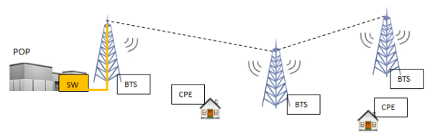
Fixed Wireless Schematic Diagram(https://www.novascotia.ca/sites/default/files/documents/1-1066/middle-mile-strategy-en.pdf)
Wireless Nomad (https://en.wikipedia.org/wiki/Wireless_Nomad): It was a cooperative based in Toronto. It started providing free Wi-Fi wireless Internet access and music to over a hundred nodes, making it the largest free Wi-Fi network in the country at the time. In 2009, Wireless Nomad shutdown all Wi-Fi nodes and turned over its DSL Internet connection to TekSavvy.
Project Chapleau(https://en.wikipedia.org/wiki/Project_Chapleau): Project Chapleau was a Wi-Fi internet connection that covered the entire town of Chapleau, Ontario, Canada. It was the first of its kind in Canada and began on November 9, 2005.
An analysis of the impact of high-speed internet on the residents and town of Chapleau was published in 2010 by University of Toronto sociologists Jessica Collins and Barry Wellman. The research was claimed that Broadband use has aided health care, shopping, and information gathering and has connected the island to the outside world.
In April, 2007, Project Chapleau concluded without a reason being given. The Project Chapleau office (The Chapleau Innovation Centre) was converted into a public internet access point, with job search and community networking facilities (https://en.wikipedia.org/wiki/Chapleau%2C_Ontario).
Xplore Inc(https://www.xplore.ca/about/news/xplore-launches-new-ultra-fast-wireless-home-internet-for-rural-canada/): In 2025, Xplore Inc., a Canadian-based internet provider, announced the launch of 5G Ultra, a new generation of wireless home Internet. 5G Ultra leverages the latest 5G+ technology to offer speeds up to 500 Mpbs to Canadians in small towns and rural communities. This Technology works similar to 5G cellular networks. The signals are transmitted via 5G towers and received by a special modem/ router in home.


5G Schematic Diagram (https://www.shutterstock.com/image-vector/5g-connectivity-high-speed-internet-connection-2297401641)

Mobile Data:
Rogers Wireless: Since 2002, Rogers started its DSM network with GPRS(known as 2.5G) and later with EDGS (known as 2.75G) which were mobile phone technologies for packet switched data transmission[3]. GPRSwas limited to 114 kbit/s, and EDGS was limited to 384 kbit/s which is only about four times the speed of dial-up.
In 2006, Rogers became the first Canadian carrier to operate a 3G UMTS/HSPA network, which was upgraded to HSPA+ in 2009. Enhancements included download speeds of up to a theoretical 21 Mbit/s. Further enhancements increased the download speeds up to a theoretical 42 Mbit/s. Rogers' UMTS network coverage was in all Canadian provinces and operating on 850 MHz.
In July 2011, Rogers was the first Canadian telecom operator to launch a commercial long-term evolution (LTE) network. Cat-6 LTE-Advanced has been available since January 2015, through carrier aggregation of band 4 and band 7, with a maximum download speed of 225 Mbit/s.
Rogers launched its 5G network in January 2020 and uses Block I from the 2500Mhz Frequency Block Plan. The company stated that rollout will expand to use its further reaching 600 MHz spectrum later in the year for improved 5G coverage[1][2][3].

Government policies and legislation
Telecommunications Act (https://en.wikipedia.org/wiki/Telecommunications_Act_%28Canada%29):The Telecommunications Act enacted in 1993 as an Act of the Parliament of Canada that regulates telecommunications by ensuring reliable services, protecting privacy, and to protect and encourage the Canadian media. The Act is administered by the Canadian Radio-television and Telecommunications Commission (CRTC) which reports to Industry Canada. It replaced the Railway Act of 1906, which governed telecommunication prior to 1993, making it the first full legislative scheme addressing telecommunications.
In this act, internet providers are considered utilities under this law in that they can't give "undue or unreasonable preference", nor can they influence the content being transmitted over their networks.
PIPEDA (https://en.wikipedia.org/wiki/Personal_Information_Protection_and_Electronic_Documents_Act): Personal Information Protection and Electronic Documents Act (PIPEDA) became law on 13 April 2000 to promote consumer trust in electronic commerce. The act was also intended to reassure the European Union that the Canadian privacy law was adequate to protect the personal information of European citizens.
Protecting Canadians from Online Crime Act : This act, named “Protecting Canadians from Online Crime Act”, is was introduced by Stephen Harper's Conservative government on November 20, 2013 and came into force on march 10, 2015[1][2].
Provisions in the Protecting Canadians from Online Crime Act include:
- Prohibiting the non-consensual distribution of intimate images.
- Empowering a court to order the removal of non-consensual intimate images from the Internet.
- Permitting the court to order forfeiture of the computer, cell phone or other device used in the offence.
- Providing for reimbursement to victims for costs incurred in removing the intimate image from the Internet or elsewhere; and
- Empowering the court to make an order to prevent someone from distributing intimate images.
National Security Act(https://en.wikipedia.org/wiki/National_Security_Act_2017_%28Canada%29): This act received Royal assent on June 21, 2019 , and is a statute of the Parliament of Canada that restructured oversight of Canada's national security and intelligence agencies. It expanded the CSE's mandate to include active and defensive cyber operations. Part V of this act lays out changes to the disclosure regime between federal agencies including limits on what information can be shared by agencies as well as what privacy protections should be in place.

Broadband as a Basic Service(https://crtc.gc.ca/eng/archive/2016/2016-496.html): In December 21, 2026, CRTC recognized the broadband Internet access as the basic telecommunication services. The established an objective stating that Canadian residential and business subscribers should have access to speeds of at least 50 megabits per second (Mbps) download and 10 Mbps upload, and to subscribe to a service offering with an unlimited data allowance.
Video: https://www.youtube.com/watch?v=fO7eZKT89rw&t=30s
The Internet Code(https://crtc.gc.ca/eng/archive/2019/2019-269.html): This code was established by the CRTC and took effect on January 31, 2020. The Code protects consumer rights by requiring service providers to follow certain principles to ensure clarity in prices, contracts, and offers, as well as facilitating the extension of services or switching service providers.
ACA (https://www.canada.ca/en/employment-social-development/programs/accessible-canada.html):The Accessible Canada Act (ACA) came into force in 2019. The legislation benefits all Canadians, especially persons with disabilities, through the proactive identification, removal and prevention of barriers to accessibility in 7 priority areas including information and communication technologies (ICT). This Act supports accessibility requirements of ICT products, including web pages, through the standard CAN/ASC - EN 301 549(https://accessible.canada.ca/creating-accessibility-standards/canasc-en-301-5492024-accessibility-requirements-ict-products-and-services).

Online Streaming Act (https://www.canada.ca/en/canadian-heritage/services/modernization-broadcasting-act.html): It received royal assent on April 27, 2023, and is the first major reform of the Broadcasting Act since 1991. The Act is about having broadcasters, including online streaming services to do a few things, such as:
- Showcasing Canadian stories and music.
- Contributing to the production of Canadian stories and music in English, French and Indigenous languages.
- Supporting a broadcasting system that reflects Canada's diversity.
- Helping to make programs accessible without barriers to persons with disabilities.

Figma link:
https://www.figma.com/proto/o7SXnsf0WmcbUzvriYqwVi/Untitled?node-id=85-2553&p=f&t=ULrLgc60bsftUWqw-0&scaling=min-zoom&content-scaling=fixed&page-id=0%3A1&starting-point-node-id=64%3A2240&show-proto-sidebar=1
Responsive:
desktop: 1140*960
Mobile: 402*874
Tablet: 744*1133

Google form:
https://docs.google.com/forms/d/e/1FAIpQLSe-6YZG0YfqtuRj8f7WqOG7zmbj_ZQK7JGOUw--tX5C9TuvKA/viewform?usp=dialog
vis-timeline:
I installed the npm package and copied the umd(universal module definition) folder (standalone version of the library) to my project in the lib folder so I embed it in index.html directly without needing to use a bundler.

Logo is taken feon gemini:
https://gemini.google.com/share/ca342016a9b2
https://gemini.google.com/share/575b3c0da950
https://gemini.google.com/share/49031dc9f5d9
JSON Validation:
https://jsonlint.com/

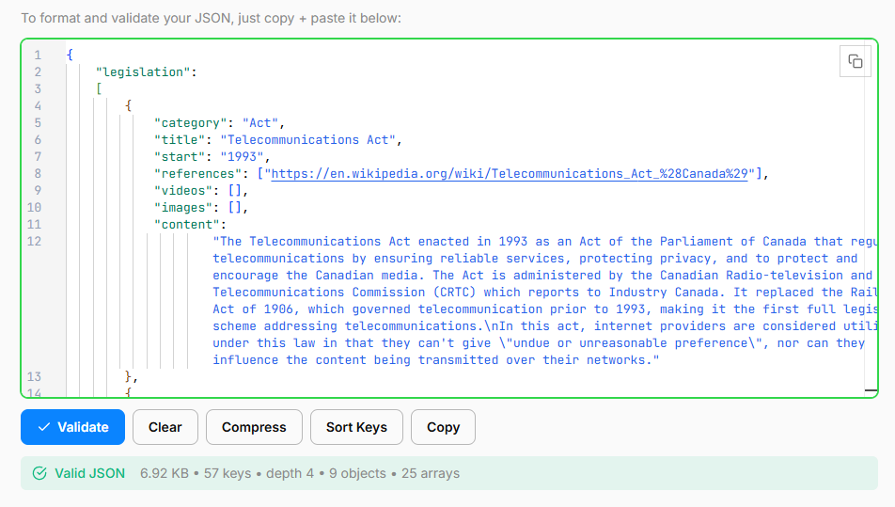

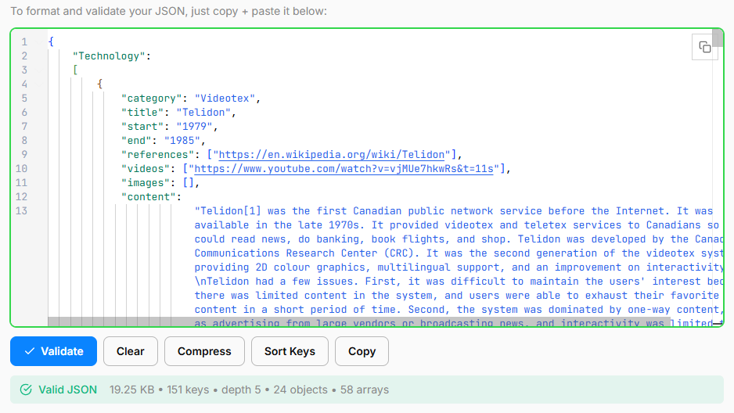
Youtube embeding:
<!--https://developers.google.com/youtube/player_parameters is used for embeding youtube videos in the page/-->

