SMT Synthetic Data Generator
A high-level overview and comparison to the synthetic data in Shenoy & Ameri (2026), “Uncertainty-Aware Neurosymbolic Root-Cause Analysis for Surface-Mount Assembly,” IEEE Trans. Semiconductor Manufacturing, DOI 10.1109/TSM.2026.3673999.

1. Purpose
This generator produces a synthetic surface-mount-assembly (SMT) dataset that stands in for the data used in the paper, so the full neurosymbolic root-cause-analysis pipeline can be developed and evaluated against known ground truth before any real-world data is involved. The paper neither releases its dataset nor its generator code, so this is a faithful reconstruction: its structure mirrors the paper exactly, and its quantitative behavior is calibrated to the few anchors the paper does report (the class balance in Table I and the graded-risk form in Eq. 8).

2. What it produces
200,000 per-board records, written from a single specification file (domain/smt_paper.yaml). The code contains only mechanism; everything domain-specific lives in the spec, so re-targeting to another device class is a file swap, not a code change. Each record carries:
- Six monitored process parameters across two stages — paste printing (ambient humidity, ambient temperature, paste viscosity, stencil thickness) and reflow (time above liquidus, peak reflow temperature).
- A defect-class label: no defect, open circuit, or solder bridging.
- A mechanism label for each stage.
- A graded risk score for each parameter (the paper’s Eq. 8).
- The exact label posterior p(y|x) — the probability of each class given the parameters — which is what makes the difficulty measurable.
- Full provenance: generator version, seed, batch, timestamp, board id.

3. How it works
Each record is built in six steps:
- Correlated sampling: a Gaussian copula draws the six parameters together with a specified correlation matrix (nearest positive-definite corrected), so realistic cross-parameter dependence is preserved.
- Drift: equipment aging (stencil wear with periodic replacement) and a daily temperature cycle add non-stationarity; records are emitted in batch/shift groups with different seeds and start hours.
- Normalization: each parameter is expressed as a deviation from nominal, scaled so that a deviation of 1.0 sits exactly at its specification limit.
- Causal labeling: an Ishikawa cause-effect map turns those deviations into a defect probability p(y|x); the label is sampled from that distribution, so two boards with identical readings can still receive different labels — realistic, irreducible noise.
- Mechanisms and risk: the most-implicated mechanism is assigned per stage, and each parameter receives a graded risk score via the paper’s Eq. 8.
- Calibration: the labeling is tuned two ways: class frequencies are matched to the paper’s reported balance, and the overall difficulty is set so the best-possible accuracy lands in the paper’s regime (~95%).

4. Why the results can be trusted
- Known posterior → exact difficulty. Because the generator knows p(y|x), the theoretical best-possible accuracy (the Bayes floor) is computed in closed form, not estimated — then confirmed by training real classifiers.
- Deterministic and auditable. The same seed produces byte-for-byte identical output, and every record traces back to its source.
- Single source of truth. The spec file is the contract the generator, ontology, and evaluation all share, preventing silent drift.
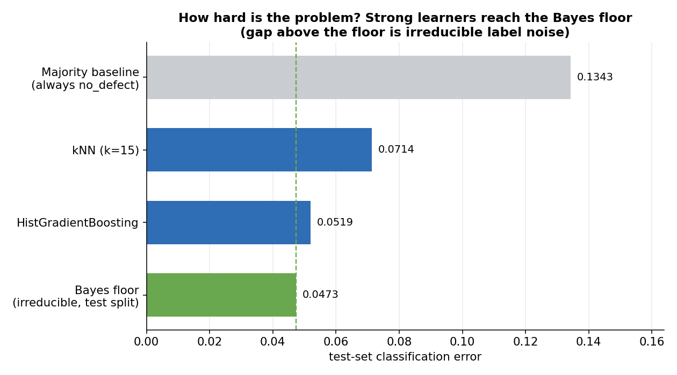
Figure 1. How hard the classification problem is. A strong learner reaches ~94.8% accuracy, just under the Bayes-optimal ceiling (~95.3% test / 95.5% population); the paper’s reported 95.00% sits between them.

5. How it compares to the synthetic data in the paper
The generator is structurally identical to the paper and quantitatively calibrated to its reported anchors. The table below summarizes the correspondence.
Aspect | Paper (Shenoy & Ameri 2026) | This generator
Domain & stages | SMT: paste printing, then reflow | Same
Process parameters | Six (humidity, ambient temp, paste viscosity, stencil thickness; time above liquidus, peak reflow temp) | Same six
Defect classes | No defect, open circuit, solder bridging | Same three
Sampling | Gaussian copula + nearest-PD correction | Same (Gaussian marginals)
Non-stationarity | Stencil wear + diurnal temperature; batch/shift groups | Same
Causal map | Ishikawa fishbone (Fig. 2) | Matched edge-for-edge; open-circuit half mirrored from the bridging tree
Class balance (Table I) | 175,420 / 12,011 / 12,569 (87.71% / 6.01% / 6.28%) | Calibrated to those priors (87.7% / 6.0% / 6.3% realized)
Graded risk | Eq. 8–10 (0.05 → 0.70 at spec → 0.99 out of spec) | Exact Eq. 8 implementation
Dataset size / split | 200,000; 140k / 30k / 30k (batch-grouped) | Same
Defect-head accuracy | 95.00% (reported) | Oracle ceiling 95.5%; strong learner 94.8% (target achievable)
Released artifacts | None (no code, no constants) | Full generator, spec, and analysis

6. What cannot be matched exactly (reproducibility gaps)
The paper specifies the form of the data-generating process but not all of its numbers. The following are reconstructed to be process-plausible and calibrated to the paper’s reported anchors, and are documented so they can be revised if more detail becomes available:
- The correlation matrix, parameter spec bounds, and process spreads.
- The drift coefficients and the causal-edge weights.
- The risk-function constants (the two breakpoints and the out-of-spec rise rate); the paper gives the levels 0.05 / 0.70 / 0.99 but not these.
- The exact defect-labeling rule (not described in the paper); implemented as a calibrated logit model over the causal map.
- The open-circuit half of the causal map: the paper’s Fig. 2 draws only the solder-bridging subtree, so the open-circuit edges are mirrored from it (inferred from the paper’s “opposite non-compliance directions” note).

7. Bottom line
The synthetic data is structurally identical to the paper, quantitatively calibrated to its reported class balance and difficulty, and — unlike the paper — fully released, deterministic, and auditable. Because the label posterior is known, the Bayes floor gives an exact, principled performance target for the model stage: a defect classifier should approach ~95% accuracy, matching the paper’s reported result.

