LUNG CANCER DETECTION USING MACHINE LEARNING

A Project Report
In the partial fulfillment of the award of the degree of

BCA

at
Ardent Computech Pvt. Ltd



Submitted by

MASIUR RAHAMAN
UTSHA PAUL
SAIMA KHATOON
JEET PAUL



SWAMI VIVEKANANDA UNIVERSITY



Certificate from the Mentor

This is to certify that Masiur Rahaman, Utsha Paul, Saima Khatoon and Jeet Paul has completed the project titled Lung Cancer Detection using Machine Learning under my supervision during the period from 05.01.2026 to 05.05.2026 which is in partial fulfillment of requirements for the award of the BCA and submitted to Department BCA of SWAMI VIVEKANANDA UNIVERSITY.


Signature of the Mentor

Date: 05.05.2026

Acknowledgment

I take this opportunity to express my deep gratitude and sincerest thanks to my project mentor, Sayanti Mondal for giving the most valuable suggestions, helpful guidance, and encouragement in the execution of this project work.

I would like to give a special mention to my colleagues. Last but not least I am grateful to all the faculty members of the Ardent Computech Pvt. Ltd. for their support.

Abstract

This project focuses on the detection of lung cancer using supervised machine learning classification algorithms. The primary objective is to build predictive models that can accurately classify patients as lung cancer positive or negative based on clinical survey data, and to systematically compare the performance of five well-established algorithms: Decision Tree, K-Nearest Neighbors (KNN), Logistic Regression, Support Vector Machine (SVM), and Naive Bayes.
The Lung Cancer Survey Dataset sourced from Kaggle is used in this project, comprising 309 patient records with 15 features including age, gender, smoking habits, and various respiratory and lifestyle symptom indicators. The dataset carries a binary target label (LUNG_CANCER: YES / NO) with an approximate class ratio of 87% positive cases. Standard preprocessing steps — including categorical encoding, feature scaling, and an 80/20 stratified train-test split — were applied to ensure fair and consistent evaluation across all models.

The implementation is carried out using the Python programming language with the help of libraries such as Pandas, Scikit-learn, Matplotlib, and Seaborn. Each algorithm is trained on the same training data and evaluated on the held-out test set. Performance is measured using four standard metrics: Accuracy, Precision, Recall, and F1-Score, with confusion matrices generated for each model to provide a detailed picture of prediction behaviour.
The results demonstrate that SVM achieves the highest overall performance with approximately 88% accuracy and a 93% F1-Score, making it the recommended algorithm for automated lung cancer screening on this dataset. Logistic Regression performs comparably, while Decision Tree offers the greatest degree of clinical interpretability. The outcome of this project highlights the potential of machine learning as a cost-effective decision-support tool for early lung cancer detection, which is critical given that early-stage diagnosis improves the 5-year survival rate from roughly 20% to over 90%.

TABLE OF CONTENTS

Certificate from the Mentor 2
Acknowledgment 3
Abstract 4

Chapter 1 — Project Introduction
1. Project Introduction 5
1.1 Overview 8
1.2 Problem Statement 8
1.3 Objective 8
1.4 Scope of the Project 9
1.5 Significance 9
1.6 Our Approach 9
1.7 Technology Stack 10

Chapter 2 — Dataset overview
2. Lung Cancer Dataset Overview 11
2.1 Dataset Description 9
2.2 Feature Description 9

Chapter 3 — Implementation
3. Implementation 13
3.1 Data Collection 13
3.2 Data Preprocessing 14
Data Cleaning 14
Encoding 15
Data Splitting 17

Chapter 4 — Classification Algorithms
4. Introduction to Classification 19
4.1 Types of Classification 19
4.2 Key Terminology 19
4.3 The Classification Pipeline 20
4.4 Evaluation Metrics Overview 21

5. Decision Tree Classification 22
5.1 Definition 22
5.2 Mathematical Concepts 23
5.3 Algorithm Steps — CART 23
5.4 Pruning 24
5.5 Advantages and Disadvantages 24
5.6 Model Implementation 25

6. K-Nearest Neighbors (KNN) 29
6.1 Definition 29
6.2 Distance Metrics 30
6.3 Feature Scaling 30
6.4 Choosing the Value of K 31
6.5 Advantages and Disadvantages 31
6.6 Model Implementation 32

7. Logistic Regression 35
7.1 Definition 35
7.2 Mathematical Concepts 36
7.3 Multiclass Extension 36
7.4 Algorithm Steps 37
7.5 Advantages and Disadvantages 37
7.6 Model Implementation 38

8. Support Vector Machine (SVM) 42
8.1 Definition 42
8.2 Mathematical Concepts 43
8.3 Algorithm Steps 44
8.4 Multi-class SVM 44
8.5 Advantages and Disadvantages 45
8.6 Model Implementation 46

9. Naive Bayes 49
9.1 Definition 49
9.2 Mathematical Concepts 49
9.3 Algorithm Steps 50
9.4 Variants 50
9.5 Advantages and Disadvantages 52
9.6 Model Implementation 53

Chapter 5 — Results & Conclusion
10. Comparison of Classification Algorithms 56
10.1 Performance Metrics Comparison 56
10.2 Type of Learner & Training Complexity 56
10.3 Feature Requirements 57
10.4 When to Use Each Algorithm 57
10.5 Handling Overfitting 58
11. Conclusion 59

References
References 60

📘 Project Introduction

Overview

Lung cancer is the leading cause of cancer-related deaths worldwide, accounting for approximately 1.8 million deaths per year according to the World Health Organization (WHO). Early and accurate detection of lung cancer is critical to improving patient survival rates. When detected at an early stage, the five-year survival rate for lung cancer patients rises significantly from below 10% to above 55%.

This project applies and compares five fundamental supervised machine learning classification algorithms — K-Nearest Neighbors (KNN), Decision Tree, Logistic Regression, Support Vector Machine (SVM), and Naive Bayes — to the task of predicting the presence or absence of lung cancer based on a structured clinical dataset of patient symptoms, risk factors, and demographic information.

Problem Statement

Given a dataset of patient records containing demographic attributes, lifestyle factors, and clinical symptom observations, the objective is to build classification models that can accurately predict whether a patient has lung cancer (binary classification: YES or NO). The models will be trained, evaluated, and compared to identify which algorithm provides the best diagnostic performance on this dataset.

Objective
The primary objective of this project is to build and compare multiple machine learning classification models for the early detection of lung cancer based on patient symptoms, lifestyle habits, and demographic information. Lung cancer remains one of the leading causes of cancer-related deaths globally, and timely detection plays a critical role in improving patient outcomes.

The specific objectives of this project are:

- Data Collection: We use the publicly available Lung Cancer Survey Dataset containing 309 patient records with 15 predictor features
- Data Preprocessing:
To preprocess and prepare the lung cancer dataset for machine learning model training.
- Model Training:
To implement five classification algorithms and train them on the same dataset for a fair comparison.

- Model Evaluation:
To evaluate each model using metrics such as accuracy, precision, recall, and F1-score.
- Model Comparison:
To identify the best-performing algorithm for lung cancer prediction based on evaluation results.

Scope of the Project

This project is limited to binary classification of lung cancer presence using structured tabular patient data. It does not involve medical imaging data (such as CT scans or X-rays) or deep learning techniques. The dataset used is sourced from publicly available repositories and is used strictly for academic and educational purposes.

The project covers the full machine learning pipeline from raw data ingestion through preprocessing, model training, evaluation, and comparison. The implementation is carried out in Python 3 using scikit-learn, pandas, numpy, matplotlib, and seaborn.

Significance

Machine learning-based classification models have the potential to serve as a low-cost, rapid, and accessible screening tool for lung cancer risk assessment. Unlike imaging-based diagnostics, symptom and risk-factor-based models can be deployed in resource-limited healthcare settings where specialized equipment is unavailable. By comparing multiple algorithms on the same dataset, this project also contributes to the broader understanding of how different classification techniques perform on medical diagnostic tasks.

Our Approach

To solve this problem, we follow a standard supervised machine learning pipeline applied to the Lung Cancer Survey Dataset. The approach consists of the following steps:

- Data Collection: We use the publicly available Lung Cancer Survey Dataset containing 309 patient records with 15 predictor features and one binary target label (LUNG_CANCER: YES/NO).
- Preprocessing: The dataset is cleaned, categorical variables are label-encoded, and feature scaling is applied using StandardScaler for distance-based algorithms (KNN, SVM, Logistic Regression). The dataset is split 80/20 into training and test sets with stratification to preserve class distribution.
- Model Training: Five classification algorithms are trained on the same training data — KNN, Decision Tree, Logistic Regression, SVM, and Naive Bayes — using Python and the scikit-learn library in Google Colab.
- Evaluation: Each model is evaluated on the test set using accuracy, precision, recall, F1-score.
- Comparison: The five models are compared side by side and the best-performing algorithm is identified and discussed.

Technology Stack

Technology | Use/Role
Python | Programming language for data analysis; scripts run in Jupyter Notebook.
Jupyter Notebook | Interactive environment for writing and executing Python code.
Pandas | Python library for data manipulation (loading CSV, cleaning, grouping).
NumPy | Numerical computing (used by Pandas internally, e.g. for array operations).
Matplotlib | Plotting library (underlies Seaborn) for creating charts.
Seaborn | High-level statistical data visualization library (for bar charts, line plots, etc.).

🧬Dataset Overview

Dataset Description

The Lung Cancer Survey Dataset is a publicly available dataset sourced from Kaggle. It contains survey records from 309 patients, each labeled with a binary lung cancer diagnosis. The dataset has 16 columns — 15 input features and 1 target variable — and contains no missing values.

Property | Value
Source | Kaggle — Lung Cancer Survey Dataset
Total Records | 309 patient records
Total Features | 16 columns (15 predictors + 1 target)
Target Variable | LUNG_CANCER (YES = 1, NO = 0)
Task Type | Binary Classification
Class Distribution | YES: 270 patients (87.4%) | NO: 39 patients (12.6%)
Missing Values | None

Feature Description

All features except AGE are binary-coded integers where 1 = No (absent) and 2 = Yes (present). AGE is a continuous numeric value in years. The table below describes all 16 columns.

# | Feature | Type | Values | Description
1 | GENDER | Categorical | M / F | Biological sex of the patient.
2 | AGE | Numeric | 21 – 87 | Age of the patient in years. Risk increases with age.
3 | SMOKING | Binary | 1 = No, 2 = Yes | Smoking status. The strongest known risk factor for lung cancer.
4 | YELLOW_FINGERS | Binary | 1 = No, 2 = Yes | Yellow finger discoloration, a sign of heavy long-term tobacco use.
5 | ANXIETY | Binary | 1 = No, 2 = Yes | Presence of anxiety, which can be associated with chronic illness.
6 | PEER_PRESSURE | Binary | 1 = No, 2 = Yes | Social pressure to smoke or engage in risky behaviors.
7 | CHRONIC DISEASE | Binary | 1 = No, 2 = Yes | History of chronic illness such as COPD or asthma.
8 | FATIGUE | Binary | 1 = No, 2 = Yes | Persistent tiredness or fatigue, a common non-specific cancer symptom.
9 | ALLERGY | Binary | 1 = No, 2 = Yes | Presence of respiratory or other allergies.
10 | WHEEZING | Binary | 1 = No, 2 = Yes | Whistling sound during breathing, indicating airway obstruction.
11 | ALCOHOL CONSUMING | Binary | 1 = No, 2 = Yes | Regular alcohol consumption, which increases cancer risk alongside smoking.
12 | COUGHING | Binary | 1 = No, 2 = Yes | Persistent cough — one of the earliest warning signs of lung cancer.
13 | SHORTNESS OF BREATH | Binary | 1 = No, 2 = Yes | Difficulty breathing, often caused by tumors blocking the airways.
14 | SWALLOWING DIFFICULTY | Binary | 1 = No, 2 = Yes | Trouble swallowing, which may occur when tumors press on the esophagus.
15 | CHEST PAIN | Binary | 1 = No, 2 = Yes | Chest discomfort or pain, which may indicate tumor involvement of the chest wall.
16 | LUNG_CANCER | Target | YES / NO | Target variable. Lung cancer diagnosis. Encoded as YES = 1, NO = 0.

⚡Implementation:

Data collection
Data collection is one of the most important steps in the Machine Learning (ML) pipeline because the quality of the model depends heavily on the quality of the data.

We have used a dataset ‘survey lung cancer’from Kaggle to train our model:
https://www.kaggle.com/datasets/ajisofyan/survey-lung-cancer

Loading the Dataset
The most common way to load a dataset is using the Pandas library.

Code:

import pandas as pd
# Load dataset
df = pd.read_csv("survey lung cancer.csv ")
# Display first 5 rows
df(data.head())

Output:

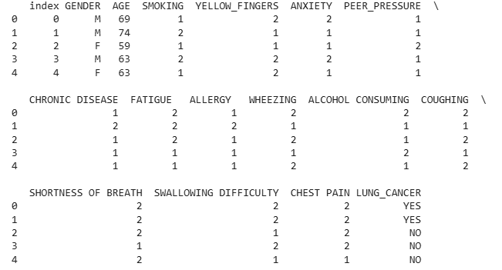

Data preprocessing
Data preprocessing is the process of preparing raw data so it can be used effectively for Machine Learning models. Real-world data is often incomplete, noisy, and inconsistent, so preprocessing improves data quality and model performance.

Main Steps in Data Preprocessing
- Data Cleaning
-Handling Missing Values
-Removing Duplicates
- Encoding Categorical Data
- Feature Scaling( As the data is already encoded, we don’t need feature scaling for training our models)
- Data Splitting

Data Cleaning
Data cleaning is an important part of preprocessing where incorrect, missing, or duplicate data
is fixed or removed.

1. Handling Missing Values
Missing values occur when some information is not available in the dataset.
Common methods:
- Remove rows with missing values
- Replace with mean, median, or mode
2. Removing Duplicates
Duplicate records can reduce model accuracy and create bias. Removing duplicates ensures better training quality.

Code:

##Data preprocessing

#Dataset overview
print(df.info())
print(df.isna().sum())
#Remove unnecessary columns that doesn’t helps to train the model
df=df.drop('index',axis=1)
#Remove duplicates(if any)
df=df.drop_duplicates()

Output:

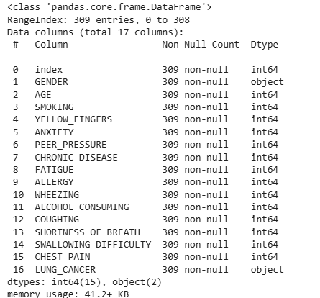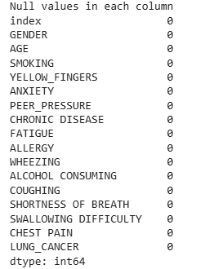

Encoding
Encoding is the process of converting categorical (text) data into numerical form so that Machine Learning algorithms can understand and process it. Most ML models work only with numbers, so encoding is necessary for categorical features like gender, yes/no values, and labels.

- Label Encoding
A data preprocessing technique used in machine learning to convert categorical data (textual labels) into numerical format

Code:

import pandas as pd
from sklearn.preprocessing import LabelEncoder

# Load dataset
data = pd.read_csv("survey lung cancer.csv")

# Display original values
print("Original LUNG_CANCER column:")
print(data["LUNG_CANCER"].head())

# Apply Label Encoding
le = LabelEncoder()
data["LUNG_CANCER"] = le.fit_transform(data["LUNG_CANCER"])

# Display encoded values
print("\nAfter Label Encoding:")
print(data["LUNG_CANCER"].head())

Output:

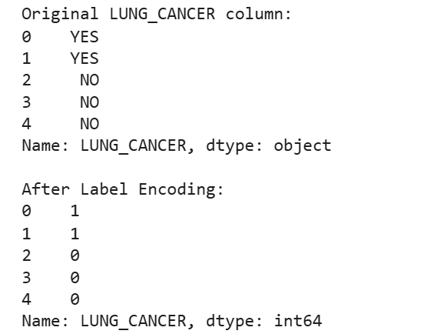

- Binary Encoding
Binary Encoding first converts categories into integer labels and then converts those integers into binary numbers (0s and 1s).

Code:

import pandas as pd
from category_encoders import BinaryEncoder

# Load dataset
data = pd.read_csv("survey lung cancer.csv")
# Apply Binary Encoding
encoder = BinaryEncoder(cols=["LUNG_CANCER"])
data_binary = encoder.fit_transform(data)
..
.
.
# Display encoded dataset
print("\nAfter Binary Encoding:")
print(data["LUNG_CANCER"])

Output:
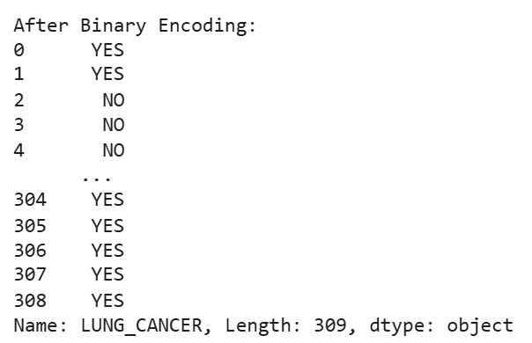

Data splitting
Data splitting is the process of dividing the dataset into different parts so that a Machine Learning model can be trained and tested properly.
It helps evaluate how well the model performs on unseen data.

Code:

import pandas as pd
from sklearn.model_selection import train_test_split

# Load dataset
data = pd.read_csv("survey lung cancer.csv")

# Features and Target
X = data.drop("LUNG_CANCER", axis=1)
y = data["LUNG_CANCER"]

# Split dataset into training and testing sets
X_train, X_test, y_train, y_test = train_test_split(
X, y,
test_size=0.2, # 20% testing data
random_state=42
)

# Display shapes
print("Training Features Shape:", X_train.shape)
print("Testing Features Shape:", X_test.shape)
print("Training Target Shape:", y_train.shape)
print("Testing Target Shape:", y_test.shape)

X=df.iloc[:,:-1]
Y=df.iloc[:,-1]
print("Independent feature:\n")
print(X.head())
print("Dependent feature:\n")
print(Y.head())

Output:

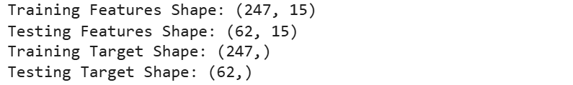
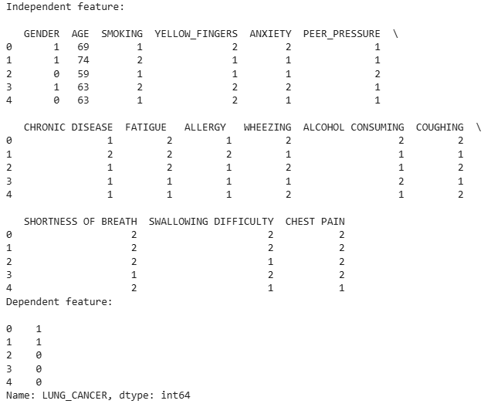
🧠 Introduction to Classification

Classification is one of the most fundamental tasks in supervised machine learning. The objective of classification is to learn a mapping function from input features to discrete output class labels, based on a set of labelled training examples.
Formally, given a training dataset D = {(x1, y1), (x2, y2), ..., (xn, yn)} where xi is a feature vector and yi is a class label, the goal is to learn a function f such that f(x) = y for any new input x.

Classification is widely used in real-world applications such as email spam detection, medical diagnosis, sentiment analysis, image recognition, credit risk assessment, and fraud detection.

Types of Classification

Binary Classification:
The output has exactly two possible class labels. Example: spam vs. not spam, disease positive vs. negative.

Multi-class Classification:
The output can belong to one of three or more classes. Example: classifying handwritten digits 0-9.

Multi-label Classification:
Each instance can be assigned to multiple classes simultaneously. Example: tagging a news article with multiple topics.

Key Terminology

- Feature (X): An input variable or attribute used to make predictions.
- Label (Y): The target output class that the model tries to predict.
- Training Set: The labeled dataset used to train the model.
- Test Set: Unseen data used to evaluate model performance.
- Hypothesis: The function learned by the model to map X to Y.
- Overfitting: When a model performs well on training data but poorly on new data.
- Underfitting: When a model is too simple to capture the underlying patterns.
- Bias: Error due to overly simplistic assumptions in the model.
- Variance: Error due to sensitivity to small fluctuations in the training set.

The Classification Pipeline

A typical machine learning classification project follows these steps:

- Data Collection: Gather raw data relevant to the problem.
- Data Preprocessing: Handle missing values, encode categorical variables, scale features.
- Exploratory Data Analysis (EDA): Understand distributions, correlations, and class balance.
- Feature Engineering: Select or create informative features.
- Model Training: Fit one or more classification algorithms on the training data.
- Model Evaluation: Measure performance using appropriate metrics on the test set.
- Hyperparameter Tuning: Optimize model parameters using cross-validation.
- Model Deployment: Deploy the best model for real-world use.

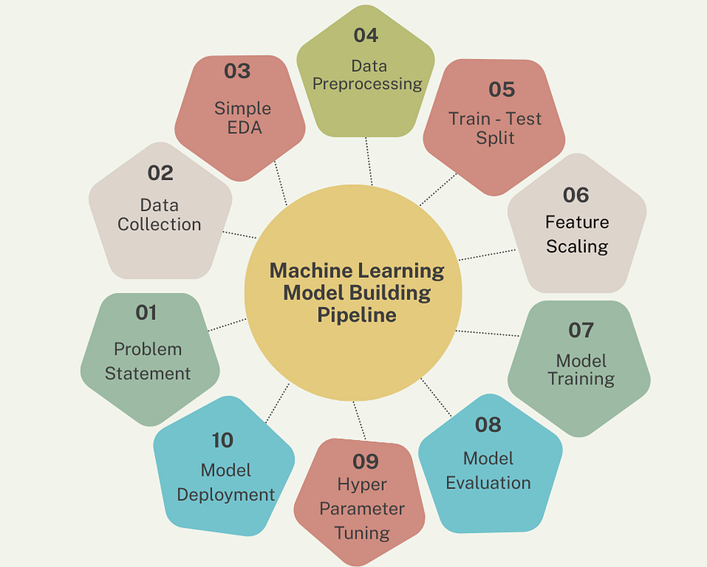

.

Evaluation Metrics Overview

Model performance in classification is measured using the confusion matrix and derived metrics. The confusion matrix records four outcomes:
- True Positive (TP): Predicted positive, actual positive.
- True Negative (TN): Predicted negative, actual negative.
- False Positive (FP): Predicted positive, actual negative (Type I error).
- False Negative (FN): Predicted negative, actual positive (Type II error).

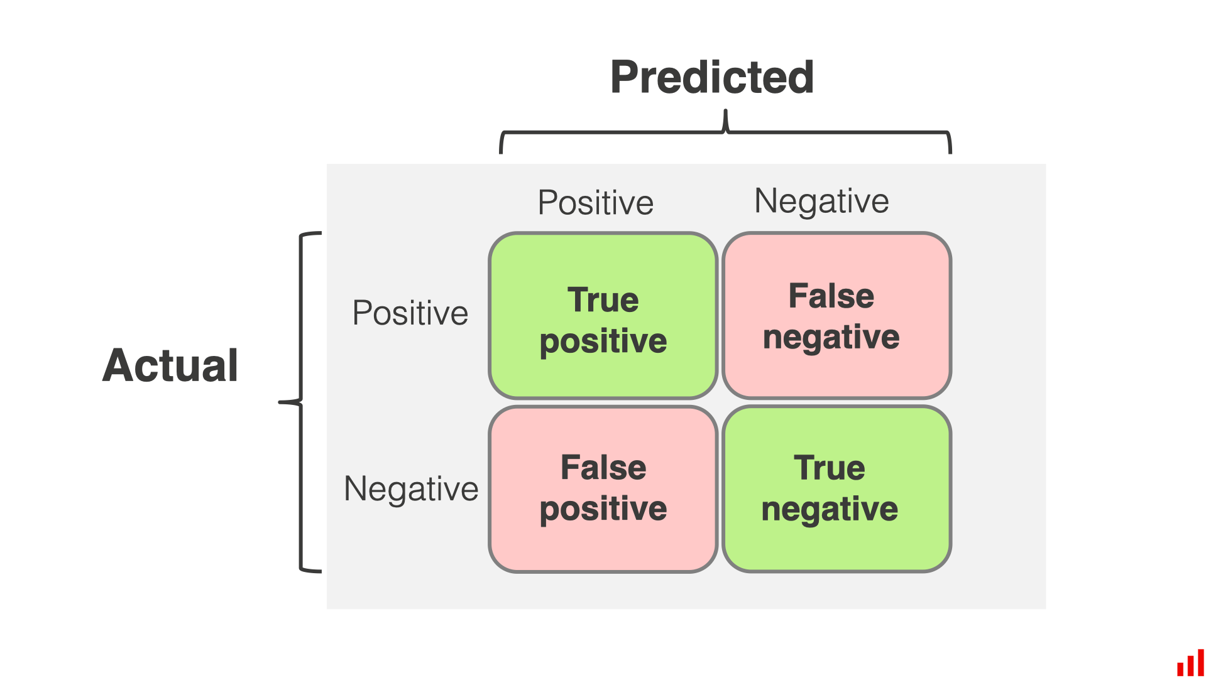

From the confusion matrix, the key metrics are:

Accuracy = (TP + TN) / (TP + TN + FP + FN)
Precision = TP / (TP + FP)
Recall = TP / (TP + FN)
F1-Score = 2 * (Precision * Recall) / (Precision + Recall)

Accuracy is suitable when classes are balanced. For imbalanced datasets, F1-Score or the ROC-AUC curve is more informative.

.
.
.
.
..
.🌳 Decision Tree Classification

Definition

Decision Tree is a supervised machine learning algorithm used for classification and regression tasks. It works by splitting the dataset into subsets based on feature values, forming a tree-like structure where each internal node represents a decision, each branch represents an outcome, and each leaf node represents a class label.

The algorithm recursively partitions the feature space into axis-aligned rectangular regions. For classification, the majority class of training samples in each region becomes the prediction for that region.
The most common algorithm for building decision trees is CART (Classification and Regression Trees), developed by Breiman et al. (1984). Other algorithms include ID3 (Quinlan, 1986) and C4.5.

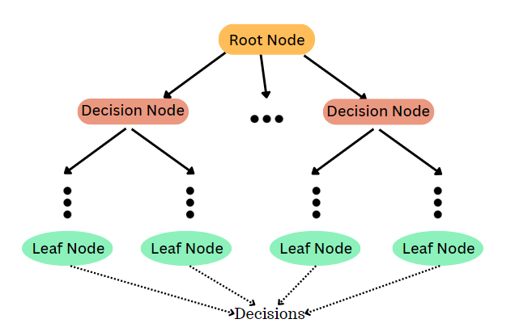

Mathematical Concepts

Entropy
Entropy measures the impurity or randomness in the dataset.
Formula:
H(S) = - Σ p_i log2(p_i)
where p_i is the probability of class i.

Information Gain
Information Gain measures the reduction in entropy after splitting a dataset.
Formula:
IG(S, A) = H(S) - Σ (|S_v| / |S|) * H(S_v)
where S_v is subset after split.

Gini Index
Gini Index measures impurity used in CART algorithm.
Formula:
Gini(S) = 1 - Σ (p_i)^2

Gain Ratio :
used in C4.5, corrects bias toward multi-valued features
Formula:
GainRatio(S, A) = IG(S, A) / SplitInfo(S, A)
SplitInfo(S, A) = - sum_v (|S_v|/|S|) * log2(|S_v|/|S|)

Algorithm Steps — CART

- Start with all training samples at the root node.
- For each feature f and each possible split threshold t, compute the weighted Gini impurity of the resulting left and right child nodes.
- Select the feature f* and threshold t* that produce the minimum weighted Gini impurity (equivalently, maximum Gini gain).
- Split the dataset into two subsets based on f* and t*. Create left and right child nodes.
- Recursively apply steps 2-4 to each child node.
- Stop when a stopping criterion is met: maximum depth reached, minimum samples in a node, or node is pure (all samples belong to one class).
- Assign the majority class of training samples in each leaf as the predicted label.

Pruning

A fully grown decision tree often overfits the training data because it memorizes noise. Pruning reduces the size of the tree to improve generalization.

Pre-pruning (Early Stopping):
Stop growing the tree before it fully fits the training data. Implemented via constraints:
- max_depth: Limit the maximum depth of the tree.
- min_samples_split: Minimum samples required to split a node.
- min_samples_leaf: Minimum samples required in a leaf node.
- max_features: Number of features to consider for each split.

Post-pruning (Cost-Complexity Pruning):
Grow the full tree first, then remove branches that provide little predictive power. The cost-complexity criterion is:
R_alpha(T) = R(T) + alpha * |T_leaves|
where R(T) is the misclassification rate, |T_leaves| is the number of leaves, and alpha is the complexity parameter. Increasing alpha penalizes larger trees, progressively pruning branches. In scikit-learn, this is controlled by the ccp_alpha parameter.

Advantages and Disadvantages

Advantages:
- Highly interpretable — the tree can be visualized and explained to non-technical audiences.
- Does not require feature scaling or normalization.
- Handles both numerical and categorical features natively.
- Implicitly performs feature selection — important features appear near the root.
- Very fast prediction time: O(depth) per sample.
- Can model non-linear relationships.

Disadvantages:
- Prone to overfitting on noisy data without pruning.
- High variance — small changes in data can result in a completely different tree.
- Biased toward features with more unique values (information gain issue).
- Cannot model certain patterns well, such as XOR relationships.
- Single trees are generally less accurate than ensemble methods like Random Forest
.
.
.
.
Model Implementation (Jupyter Notebook):

#import libraries
import numpy as np
import pandas as pd
import matplotlib.pyplot as plt
from sklearn.model_selection import train_test_split
from sklearn.preprocessing import LabelEncoder
from sklearn.tree import DecisionTreeClassifier, plot_tree
from sklearn.metrics import accuracy_score, confusion_matrix, classification_report

#Load dataset
df=pd.read_csv("survey lung cancer.csv")
df.reset_index(inplace=True)
print(df.head(5))

##Data preprocessing

#--Dataset overview
print(df.info())

#--Remove unnecessary columns that doesn’t helps to train the model
df=df.drop('index',axis=1)
#--Remove duplicates(if any)
df=df.drop_duplicates()

#Label encoding
le1=LabelEncoder()
le2=LabelEncoder()
df['LUNG_CANCER']=le1.fit_transform(df['LUNG_CANCER'])
df['GENDER']=le2.fit_transform(df['GENDER'])
print("After label encoding:\n")
print(df.head())

#Feature selection
X=df.iloc[:,:-1]
Y=df.iloc[:,-1]
print("Independent feature:\n")
print(X)
print("Dependent feature:\n")
print(Y)

#Train test split
X_train,X_test,Y_train,Y_test=train_test_split(X,Y,test_size=.2,random_state=40)

#Model selection and training
model_g=DecisionTreeClassifier(max_depth=9,criterion='gini')
model_e=DecisionTreeClassifier(max_depth=9,criterion='entropy')

#Model training
model_g.fit(X_train,Y_train)
model_e.fit(X_train,Y_train)

#prediction on test data
Y_pred_testg=model_g.predict(X_test)
Y_pred_teste=model_e.predict(X_test)

# Model Evaluation

print("\n--Decision Tree Results(With entropy criterion)--")
print("Accuracy:", accuracy_score(Y_test, Y_pred_testg))
print("Confusion Matrix:\n", confusion_matrix(Y_test, Y_pred_testg))
print("\nClassification Report:\n", classification_report(Y_test, Y_pred_testg))

print("\n--Decision Tree Results(With entropy criterion)--")
print("Accuracy:", accuracy_score(Y_test, Y_pred_teste))
print("Confusion Matrix:\n", confusion_matrix(Y_test, Y_pred_teste))
print("\nClassification Report:\n", classification_report(Y_test, Y_pred_teste))

#Visualizing the tree(With entropy criterion)
plt.figure(figsize=(20,15))
plot_tree(model_e,
feature_names=X.columns,
class_names=le1.classes_,
filled=True
)

plt.title("Decision Tree (ID3 algorithm -Entropy)")
plt.show()

#Visualizing the tree(With entropy criterion)
plt.figure(figsize=(20,15))
plot_tree(model_g,
feature_names=X.columns,
class_names=le1.classes_,
filled=True
)

plt.title("Decision Tree (ID3 algorithm -gini)")
plt.show()

#Prediction on new data
new_data=pd.DataFrame({
'GENDER':[1],
'AGE':[40],
'SMOKING':[2],
'YELLOW_FINGERS':[2],
'ANXIETY':[1],
'PEER_PRESSURE':[1],
'CHRONIC DISEASE':[2],
'FATIGUE ':[1],
'ALLERGY ':[1],
'WHEEZING':[1],
'ALCOHOL CONSUMING':[2],
'COUGHING':[2],
'SHORTNESS OF BREATH':[1],
'SWALLOWING DIFFICULTY':[1],
'CHEST PAIN':[1]})
pred_new=model_e.predict(new_data)
print("Prediction on new data:")
print(le1.inverse_transform(pred_new))

Output:

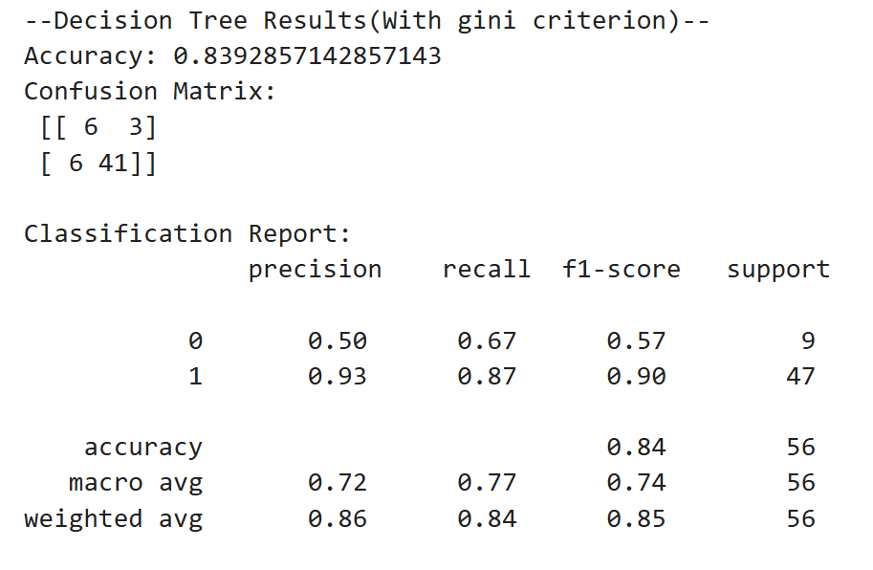
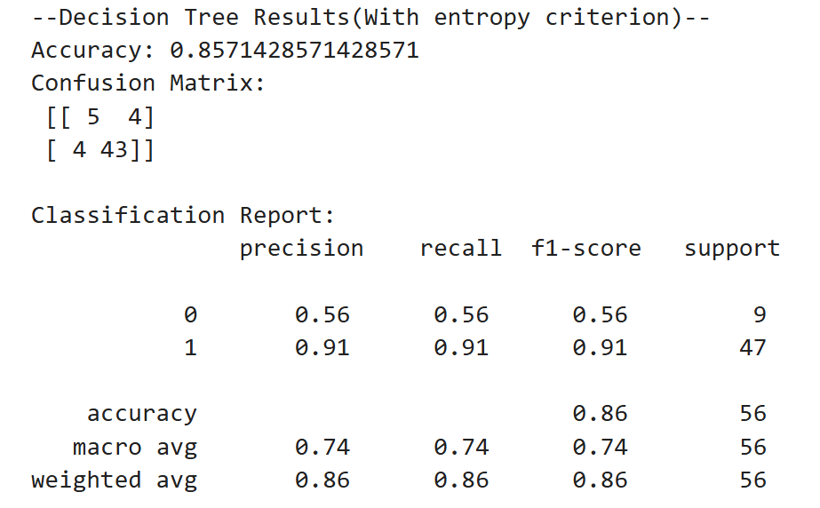

Visualizing the trees:

Decision Tree (ID3 algorithm -Entropy)

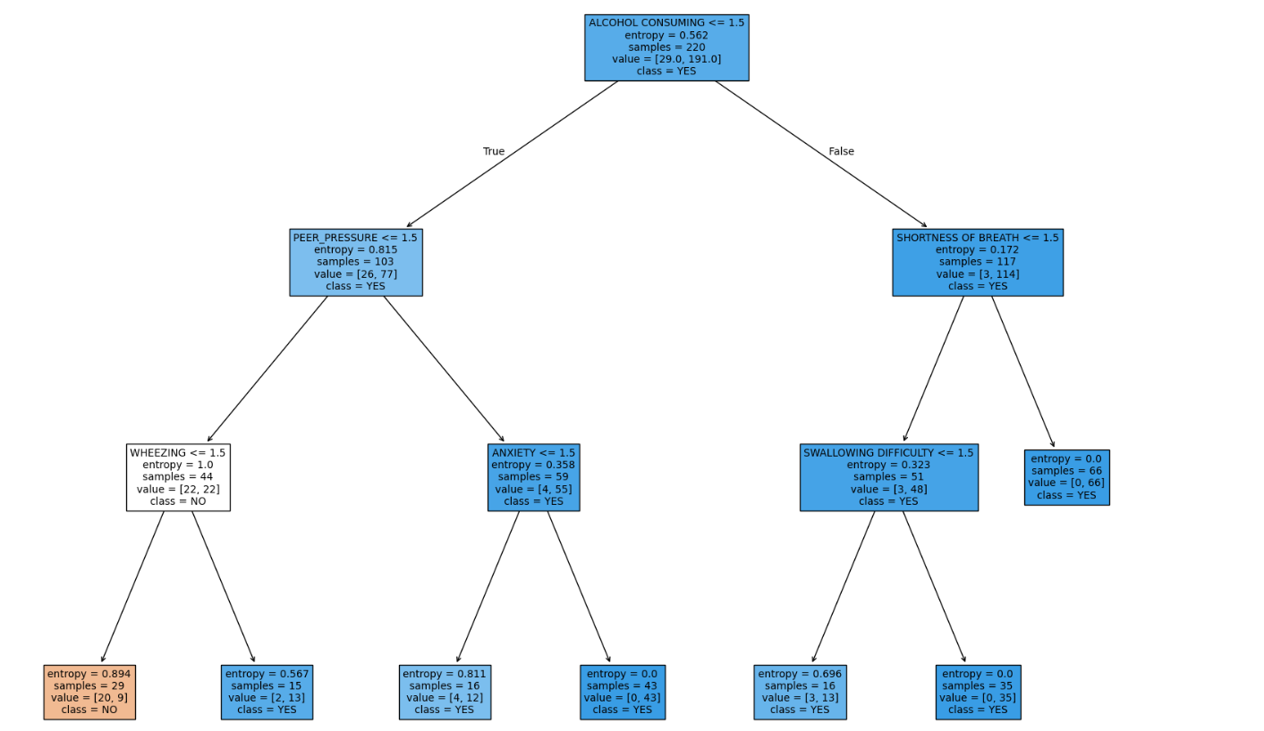

Decision Tree (ID3 algorithm -gini)

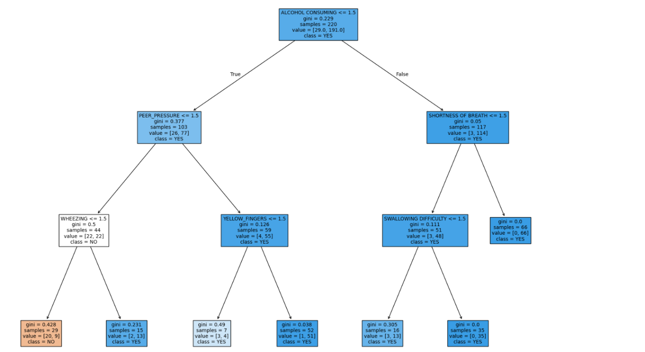
📍 K-Nearest Neighbors

Definition

K-Nearest Neighbors (KNN) is a simple, non-parametric, supervised machine learning algorithm. It classifies a new data point based on the majority class of its K nearest neighbors in the feature space. KNN is also called a lazy learner because it does not build an explicit model during training — it memorizes the entire training dataset.

How KNN Works

- Choose the value of K (number of neighbors).
- For each test point, calculate the distance to all training points.
- Select the K training points with the smallest distances.
- Assign the class that appears most frequently among the K neighbour’s (majority vote).
- Output the predicted class for the test point.

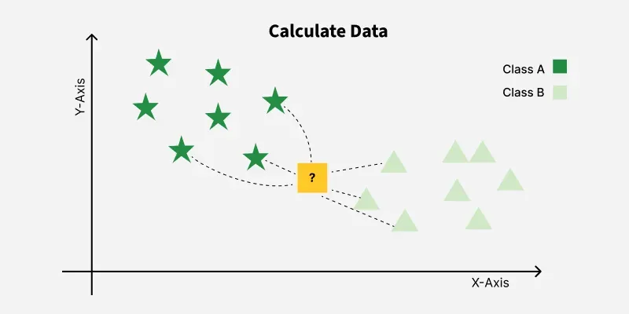

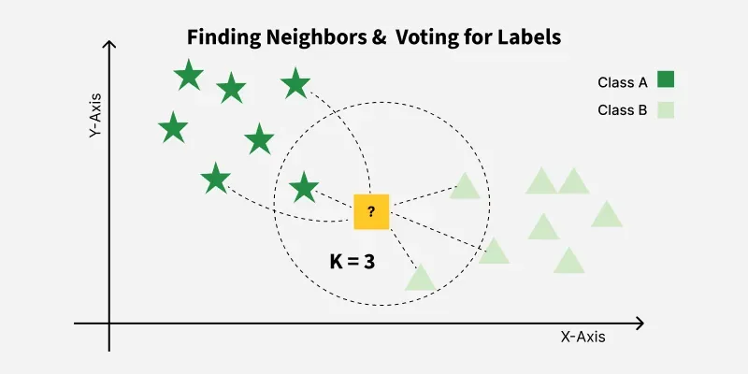

Distance Metrics
KNN relies entirely on a distance function to determine neighborhood. The choice of metric affects results significantly.

Euclidean Distance (most widely used):
d(x, y) = sqrt( sum_i (xi - yi)^2 )
This is the straight-line distance between two points in n-dimensional space. It assumes all features are equally important and on the same scale.

Manhattan Distance:
d(x, y) = sum_i |xi - yi|
Also called city-block distance. Works well for data laid out in a grid-like structure and is less sensitive to outliers than Euclidean distance.

Minkowski Distance (generalization):
d(x, y) = ( sum_i |xi - yi|^p )^(1/p)
When p = 1, this reduces to Manhattan distance. When p = 2, it reduces to Euclidean distance. Larger p values give more weight to large differences.

Hamming Distance (for categorical features):
d(x, y) = (1/n) * sum_i I(xi != yi)
Counts the proportion of positions where two strings (or vectors) differ. Used for text and categorical data.

Feature Scaling
Since KNN is distance-based, features with larger numerical ranges dominate the distance calculation. Feature scaling must be applied before using KNN.

Min-Max Normalization:
x_norm = (x - x_min) / (x_max - x_min) => range [0, 1]
Z-score Standardization:
x_std = (x - mean) / standard_deviation => mean=0, std=1

Choosing the Value of K
- Small K: Low bias, high variance (overfitting risk).
- Large K: High bias, low variance (underfitting risk).
- Optimal K is usually chosen using cross-validation or by plotting the error rate against K.
- Odd values of K are preferred for binary classification to avoid ties.

Advantages and Disadvantages

Advantages | Disadvantages
Simple and easy to understand | Slow for large datasets (no training phase benefit)
No training time required | High memory usage (stores all data)
Effective with sufficient training data | Sensitive to irrelevant features and scale
Naturally handles multi-class problems | Performance degrades with high dimensions

Algorithm
- Import required libraries (numpy, pandas, matplotlib, sklearn).
- Load the Iris dataset using pd.read_csv method.
- Split the dataset into training and testing sets (80:20 ratio).
- Apply feature scaling using StandardScaler.
- Create KNN classifier with K=5 using KNeighborsClassifier.
- Fit the model on training data.
- Predict on the test data.
- Evaluate performance using accuracy score, classification report, and confusion matrix.
- Plot error rate vs K value to find the optimal K.
- Display results and plots.

Model Implementation (Jupyter Notebook):

import numpy as np
import pandas as pd
import matplotlib.pyplot as plt
from sklearn.neighbors import KNeighborsClassifier
from sklearn.model_selection import train_test_split
from sklearn.metrics import classification_report,accuracy_score,confusion_matrix
from sklearn.preprocessing import LabelEncoder

#Load dataset
df=pd.read_csv("survey lung cancer.csv")
df.reset_index(inplace=True)
print(df.head(5))

##Data preprocessing

#Dataset overview
print(df.info())
print(df.nunique())

#Remove unnecessary columns that doesn’t helps to train the model
df=df.drop('index',axis=1)
#Remove duplicates(if any)
df=df.drop_duplicates()

#Label encoding
le1=LabelEncoder()
le2=LabelEncoder()
df['LUNG_CANCER']=le1.fit_transform(df['LUNG_CANCER'])
df['GENDER']=le2.fit_transform(df['GENDER'])
print("After label encoding:\n")
print(df.head())

#Feature selection
X=df.iloc[:,:-1]
Y=df.iloc[:,-1]
print("Independent feature:\n")
print(X)
print("Dependent feature:\n")
print(Y)

#Train test split
X_train,X_test,Y_train,Y_test=train_test_split(X,Y,test_size=.2,random_state=40)

# Elbow Method (Find Best K)

error_rate = []

for k in range(1, 25):
model = KNeighborsClassifier(n_neighbors=k)
model.fit(X_train, Y_train)
pred_k = model.predict(X_test)
error_rate.append(np.mean(pred_k != Y_test))

# Plot Elbow Graph
plt.plot(range(1, 25), error_rate, marker='+')
plt.xlabel("K Value")
plt.ylabel("Error Rate")
plt.title("Elbow Method for Optimal K")
plt.show()

# Model selection and training
model=KNeighborsClassifier(n_neighbors=11)

#Model training
model.fit(X_train,Y_train)

#Prediction
pred=model.predict(X_test)

#Model evaluation
print("Model evaluation: ")
print("Accuracy:", accuracy_score(Y_test, pred))
print("Confusion Matrix:\n", confusion_matrix(Y_test, pred))
print("\nClassification Report:\n", classification_report(Y_test, pred))

#Prediction on new data

new_data=pd.DataFrame({
'GENDER':[1],
'AGE':[40],
'SMOKING':[2],
'YELLOW_FINGERS':[2],
'ANXIETY':[1],
'PEER_PRESSURE':[1],
'CHRONIC DISEASE':[2],
'FATIGUE ':[1],
'ALLERGY ':[1],
'WHEEZING':[1],
'ALCOHOL CONSUMING':[2],
'COUGHING':[2],
'SHORTNESS OF BREATH':[1],
'SWALLOWING DIFFICULTY':[1],
'CHEST PAIN':[1]})
pred_new=model.predict(new_data)
print("Prediction on new data:")
print(le1.inverse_transform(pred_new))

Output:

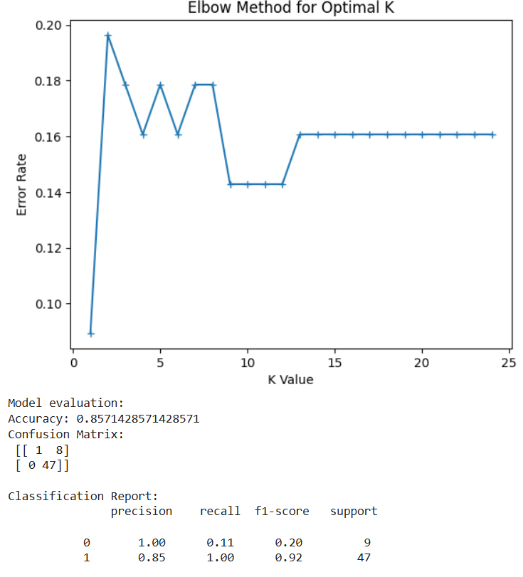

…
📉 Logistic Regression

Definition

Despite its name, Logistic Regression is a classification algorithm, not a regression algorithm. It is a linear model that estimates the probability that a given input belongs to a particular class. The predicted probability is then thresholded (typically at 0.5) to produce a discrete class label.
Logistic Regression models the log-odds of the output as a linear combination of input features. The sigmoid (logistic) function is applied to the linear output to squash predictions into the range (0, 1), making them interpretable as probabilities.

It is one of the most widely used classification algorithms in practice due to its simplicity, interpretability, and well-calibrated probability outputs.

Mathematical Concepts

The Sigmoid Function
The linear model produces a score z called the log-odds (or logit):
z = w^T * x + b = w1*x1 + w2*x2 + ... + wn*xn + b

The sigmoid function maps z to a probability between 0 and 1:
sigma(z) = 1 / (1 + exp(-z))

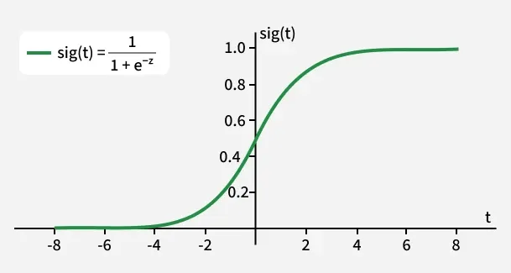
Properties of the sigmoid function:
- sigma(z) approaches 1 as z approaches positive infinity.
- sigma(z) approaches 0 as z approaches negative infinity.
- sigma(0) = 0.5, which is the decision boundary.
- The function is differentiable everywhere, which enables gradient-based optimization.

The predicted probability is:
y_hat = P(Y = 1 | x) = sigma(w^T * x + b)

The predicted class label is:
class = 1 if y_hat >= 0.5 (i.e., z >= 0)
class = 0 if y_hat < 0.5 (i.e., z < 0)

Log-Odds and the Logit
The relationship between probability and log-odds is:
log( p / (1-p) ) = w^T * x + b

This means logistic regression models the log-odds of the positive class as a linear function of the features. Each coefficient w_i represents the change in log-odds for a one-unit increase in feature x_i.

Cost Function:

Log-Loss (Binary Cross-Entropy):
Mean Squared Error cannot be used because the sigmoid function makes the MSE non-convex with respect to the weights, causing many local minima. Instead, we use the Binary Cross-Entropy Loss (log-loss):

J(w, b) = -(1/m) * sum_i [ y_i * log(y_hat_i) + (1-y_i) * log(1 - y_hat_i) ]

where m is the number of training samples. This cost function is convex, guaranteeing that gradient descent will find the global minimum.

Interpretation: If y_i = 1 and y_hat_i is close to 1, the loss is near 0. If y_hat_i is close to 0, the loss grows toward infinity, heavily penalizing confident wrong predictions.

Gradient Descent Optimization

The weights are updated iteratively using gradient descent:
w := w - alpha * (dJ/dw)
b := b - alpha * (dJ/db)

The partial derivatives for logistic regression are elegantly simple:
dJ/dw = (1/m) * X^T * (y_hat - y)
dJ/db = (1/m) * sum_i (y_hat_i - y_i)
where alpha is the learning rate hyperparameter. This process is repeated until convergence.

Regularization
Regularization is a technique used to prevent overfitting in machine learning by adding a penalty term to the loss function, encouraging simpler models that generalize better to unseen data. It shrinks model coefficients (weights) toward zero, reducing complexity and noise sensitivity.

L2 Regularization (Ridge):
L2 penalizes large weights by adding their squared magnitudes. This shrinks all weights toward zero but rarely makes them exactly zero.

J_reg(w,b) = J(w,b) + (lambda/2m) * sum_j w_j^2

L1 Regularization (Lasso):
L1 penalizes the absolute value of weights. It produces sparse models where some weights become exactly zero, performing implicit feature selection.

J_reg(w,b) = J(w,b) + (lambda/m) * sum_j |w_j|

In scikit-learn, the regularization parameter is C = 1/lambda. A smaller C means stronger regularization.

Multiclass Extension

One-vs-Rest (OvR):
For K classes, train K separate binary classifiers. Classifier k is trained to distinguish class k from all other classes. During prediction, run all K classifiers and assign the class whose classifier outputs the highest probability.

Softmax Regression (Multinomial Logistic Regression):
Directly extends logistic regression to multiple classes. The softmax function converts K linear scores into K probabilities:
P(Y=k | x) = exp(w_k^T * x) / sum_j exp(w_j^T * x)

The predicted class is the one with the highest softmax probability.

Algorithm :-

- Initialize weights w and bias b to zero (or small random values).
- For each training iteration (epoch):
- Compute z = w^T * X + b for all training samples.
- Apply sigmoid: y_hat = sigma(z).
- Compute the log-loss: J(w,b).
- Compute gradients dJ/dw and dJ/db.
- Update weights: w := w - alpha * dJ/dw; b := b - alpha * dJ/db.
- Repeat until the cost converges or a maximum number of iterations is reached.
- For prediction on new data: compute z, apply sigmoid, threshold at 0.5.

Advantages and Disadvantages

Advantages:
- Produces well-calibrated probability estimates, useful for risk scoring.
- Highly interpretable — coefficients directly indicate feature importance and direction.
- Fast training and very fast prediction.
- Less prone to overfitting with regularization.
- Works extremely well when the decision boundary is approximately linear.

Disadvantages:
- Assumes a linear decision boundary — cannot capture complex non-linear relationships without feature engineering.
- Sensitive to outliers in the feature space.
- Requires feature scaling for efficient gradient descent convergence.
- Can underperform when features are highly correlated (multicollinearity).

.
.
.
.
.
.
.
.
.
.
.
.
.
.
.
.
.
Model Implementation (Jupyter Notebook):

#Import libraries
import numpy as np
import pandas as pd
import matplotlib.pyplot as plt
import seaborn as sns

from sklearn.linear_model import LogisticRegression
from sklearn.preprocessing import LabelEncoder
from sklearn.metrics import accuracy_score, confusion_matrix, classification_report
from sklearn.model_selection import train_test_split

#Load dataset
df=pd.read_csv("survey lung cancer.csv")
df.reset_index(inplace=True)
print(df.head(5))

##Data preprocessing

#Dataset overview
print(df.info())
print(df.nunique())

#Remove unnecessary columns that doesn’t helps to train the model
df=df.drop('index',axis=1)
#Remove duplicates(if any)
df=df.drop_duplicates()

#Label encoding
le1=LabelEncoder()
le2=LabelEncoder()
df['LUNG_CANCER']=le1.fit_transform(df['LUNG_CANCER'])
df['GENDER']=le2.fit_transform(df['GENDER'])
print("After label encoding:\n")
print(df.head())

#Feature selection
X=df.iloc[:,:-1]
Y=df.iloc[:,-1]
print("Independent feature:\n",X)
print("Dependent feature:\n",Y)

#Train test split
X_train,X_test,Y_train,Y_test=train_test_split(X,Y,test_size=.2,random_state=40)

#Training the model
model=LogisticRegression(max_iter=1000)
model.fit(X_train,Y_train)

#prediction
Y_pred_train=model.predict(X_train)
Y_pred_test=model.predict(X_test)

#Model evaluation
acc = accuracy_score(Y_test, Y_pred_test)
cm = confusion_matrix(Y_test, Y_pred_test)

print("Accuracy of the model: ",round(acc*100,2))
print("confusion matrix :\n",cm)
print("Classification Report:\n", classification_report(Y_test, Y_pred_test))

#confusion matrix:
plt.figure(figsize=(6,4))
sns.heatmap(cm, annot=True, fmt='d', cmap='Blues')
plt.xlabel("Predicted")
plt.ylabel("Actual")
plt.title("Confusion Matrix")
plt.show()

#plt.figure(figsize=(6,4))
#sns.heatmap(X.corr, annot=True, fmt='d', cmap='Greens')

#Prediction on new data

new_data=pd.DataFrame({
'GENDER':[1],
'AGE':[40],
'SMOKING':[2],
'YELLOW_FINGERS':[2],
'ANXIETY':[1],
'PEER_PRESSURE':[1],
'CHRONIC DISEASE':[2],
'FATIGUE ':[1],
'ALLERGY ':[1],
'WHEEZING':[1],
'ALCOHOL CONSUMING':[2],
'COUGHING':[2],
'SHORTNESS OF BREATH':[1],
'SWALLOWING DIFFICULTY':[1],
'CHEST PAIN':[1]})
pred_new=model.predict(new_data)
print(le1.inverse_transform(pred_new))

Output:

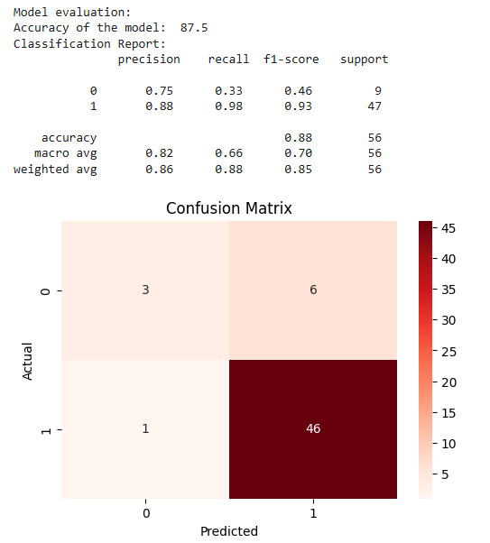
.
.

💠Support Vector Machine (SVM)

Definition

Support Vector Machine (SVM) is a powerful supervised learning algorithm that finds the optimal hyperplane to separate two classes with the maximum possible margin. SVMs are based on the principle of Structural Risk Minimization, which balances model complexity and training error to achieve good generalization.
The key insight of SVM is that the decision boundary (hyperplane) is determined entirely by a small subset of training points called Support Vectors — the points that lie closest to the decision boundary. All other training points are irrelevant to the model.

Mathematical Concepts

The Hyperplane

In n-dimensional space, a hyperplane is an (n-1)-dimensional subspace defined by:
w^T * x + b = 0
where w is the weight vector (normal to the hyperplane) and b is the bias. For binary classification with labels y in {-1, +1}:
- Points with w^T*x + b > 0 are classified as class +1.
- Points with w^T*x + b < 0 are classified as class -1.
The two marginal hyperplanes that pass through the support vectors are:
w^T * x + b = +1 (positive margin boundary)
w^T * x + b = -1 (negative margin boundary)

Margin and Optimization

The margin is the distance between the two marginal hyperplanes. It can be shown geometrically that:
Margin = 2 / ||w||
Maximizing the margin is equivalent to minimizing ||w||^2. This gives us the hard margin SVM optimization problem:
Minimize: (1/2) * ||w||^2
Subject to: y_i * (w^T * x_i + b) >= 1 for all i
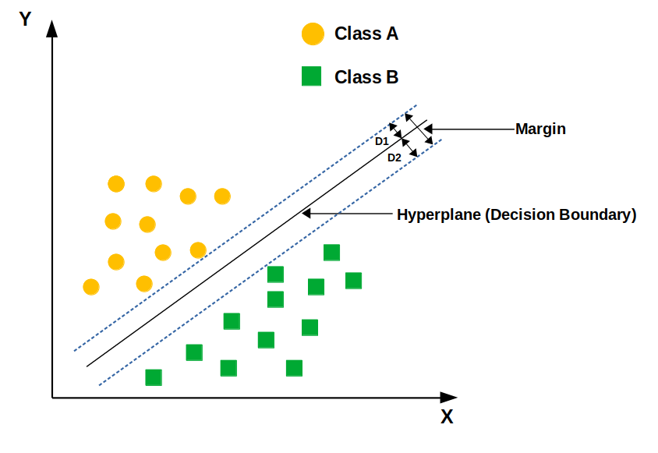

Soft Margin SVM and the C Parameter

Real-world data is often not perfectly linearly separable. Soft Margin SVM introduces slack variables xi_i >= 0 that allow some training points to violate the margin constraints:
Minimize: (1/2) * ||w||^2 + C * sum_i xi_i
Subject to: y_i * (w^T * x_i + b) >= 1 - xi_i, xi_i >= 0
The hyperparameter C controls the trade-off between maximizing the margin and minimizing margin violations:
- Large C: Strong penalty for misclassifications. The algorithm tries to classify all training points correctly. Smaller margin, risk of overfitting.
- Small C: Allows more margin violations. Larger margin, simpler boundary, risk of underfitting.
C should be tuned using cross-validation.

The Kernel Trick

For non-linearly separable data, we can map features to a higher-dimensional space using a transformation phi(x). However, this is computationally expensive. The kernel trick allows us to compute the inner product in the transformed space without explicitly performing the transformation:
K(x_i, x_j) = phi(x_i)^T * phi(x_j)
The decision function becomes:
f(x) = sign( sum_i alpha_i * y_i * K(x_i, x) + b )

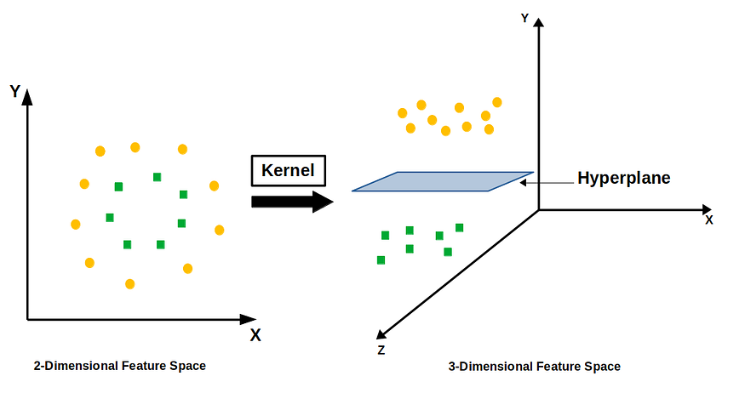
Common kernel functions:
Linear Kernel:
K(x_i, x_j) = x_i^T * x_j
No transformation. Same as standard SVM. Best for linearly separable data.
Polynomial Kernel:
K(x_i, x_j) = (gamma * x_i^T * x_j + coef0)^degree
Maps to a polynomial feature space. Captures interactions between features.
Radial Basis Function (RBF) Kernel:
K(x_i, x_j) = exp( -gamma * ||x_i - x_j||^2 )
The gamma parameter controls the width of the Gaussian. Large gamma: narrow bell, each support vector has local influence (risk of overfitting). Small gamma: wide bell, support vectors have global influence (risk of underfitting). RBF can map data to an infinite-dimensional space.
Sigmoid Kernel:
K(x_i, x_j) = tanh( gamma * x_i^T * x_j + coef0 )

Algorithm Steps
- Preprocess data: apply feature scaling (critical for SVM).
- Choose a kernel function (start with RBF if the data is not linearly separable).
- Set hyperparameters C and gamma (if using RBF).
- Solve the quadratic programming optimization problem to find alpha_i for each training sample.
- Identify support vectors: training points where alpha_i > 0.
- Compute the weight vector w and bias b from the support vectors.
- For prediction: compute the decision function f(x) and apply the sign function.
- Use grid search with cross-validation to tune C and gamma.

Multi-class SVM

One-vs-One (OvO):
Train K*(K-1)/2 binary SVM classifiers, one for each pair of classes. Each classifier votes for one class during prediction. The class with the most votes wins.
One-vs-Rest (OvR):
Train K classifiers, one per class, where class k is positive and all others are negative. Predict the class whose classifier outputs the highest decision score.

Advantages and Disadvantages

Advantages:
- Highly effective in high-dimensional feature spaces.
- Works well when the number of features exceeds the number of samples.
- Robust to outliers since only support vectors influence the boundary.
- Versatile due to different kernel functions for various data structures.
- Theoretically well-founded with strong generalization guarantees.

Disadvantages:
- Slow training time: O(n^2) to O(n^3) with respect to training set size.
- Does not directly provide probability estimates (needs Platt scaling).
- Sensitive to feature scaling — normalization is mandatory.
- Difficult to interpret compared to Decision Trees or Logistic Regression.
- Kernel and hyperparameter selection requires careful cross-validation.
.
.
.
.
.
.

Model Implementation (Jupyter Notebook):

import numpy as np
import pandas as pd
import matplotlib.pyplot as plt
import seaborn as sns

from sklearn.model_selection import train_test_split
from sklearn.svm import SVC
from sklearn.metrics import confusion_matrix, classification_report, f1_score, accuracy_score
from sklearn.preprocessing import LabelEncoder, StandardScaler

#Load dataset
df=pd.read_csv("survey lung cancer.csv")
df.info()

#Data preprocessing
print(df.isna().sum())
df=df.dropna()
df=df.drop_duplicates()

#--Remove duplicates(if any)
df=df.drop_duplicates()

#Label encoding
le1=LabelEncoder()
le2=LabelEncoder()
df['LUNG_CANCER']=le1.fit_transform(df['LUNG_CANCER'])
df['GENDER']=le2.fit_transform(df['GENDER'])
print("After label encoding:\n")
print(df.head())

#Feature selection
X=df.iloc[:,:-1]
Y=df.iloc[:,-1]
print("Independent feature:\n")
print(X)
print("Dependent feature:\n")
print(Y)

#Train test split
X_train,X_test,Y_train,Y_test=train_test_split(X,Y,test_size=.2,random_state=40)

#Training the model
model_svm=SVC(gamma='scale',kernel='linear')
model_svm.fit(X_train,Y_train)

#prediction
Y_pred_test=model_svm.predict(X_test)

#Compare kernels
print("Model accuracy with different kernels:\n")
kernels = ['linear', 'poly', 'rbf', 'sigmoid']
for k in kernels:
model = SVC(kernel=k)
model.fit(X_train, Y_train)
acc = accuracy_score(Y_test, model.predict(X_test))
print(f'Kernel: {k} -- Accuracy: {acc:.4f}')

#Model evaluation
print("\nModel evaluation:")
acc=accuracy_score(Y_test,Y_pred_test)
print("Accuracy:", acc)
print("\n Classification report :")
print(classification_report(Y_test,Y_pred_test))
print(model_svm.score(X_test,Y_test))

#Confusion Matrix
cm = confusion_matrix(Y_test, Y_pred_test)
plt.figure(figsize=(5,3))
sns.heatmap(cm, annot=True, fmt='d', cmap='Blues')
plt.xlabel("Predicted")
plt.ylabel("Actual")
plt.title("Confusion Matrix")
plt.show()

#Prediction on new data

new_data=pd.DataFrame({
'GENDER':[1],
'AGE':[40],
'SMOKING':[2],
'YELLOW_FINGERS':[2],
'ANXIETY':[1],
'PEER_PRESSURE':[1],
'CHRONIC DISEASE':[2],
'FATIGUE ':[1],
'ALLERGY ':[1],
'WHEEZING':[1],
'ALCOHOL CONSUMING':[2],
'COUGHING':[2],
'SHORTNESS OF BREATH':[1],
'SWALLOWING DIFFICULTY':[1],
'CHEST PAIN':[1]})
pred_new=model.predict(new_data)
print(le1.inverse_transform(pred_new))

Output:

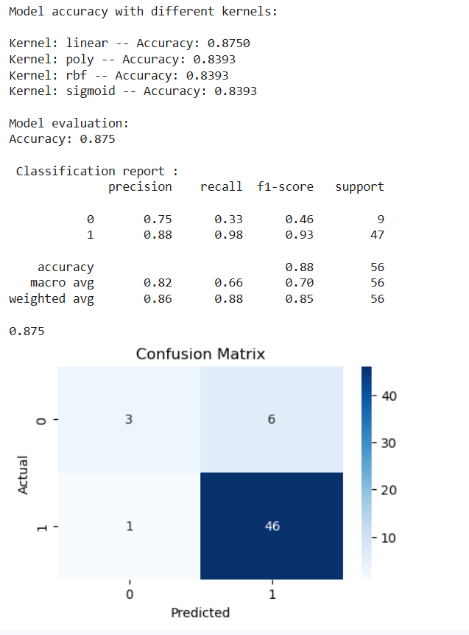

🎯 Naive Bayes

Definition

Naive Bayes is a family of probabilistic classification algorithms based on Bayes theorem. It makes a strong independence assumption: given the class label, all features are conditionally independent of each other. This assumption is "naive" because it rarely holds in real data, yet Naive Bayes performs surprisingly well in practice, particularly for text classification and natural language processing tasks.
The algorithm is extremely fast to train and predict because it only requires computing simple frequency counts or mean/variance statistics from the training data. It scales well to very high-dimensional feature spaces.

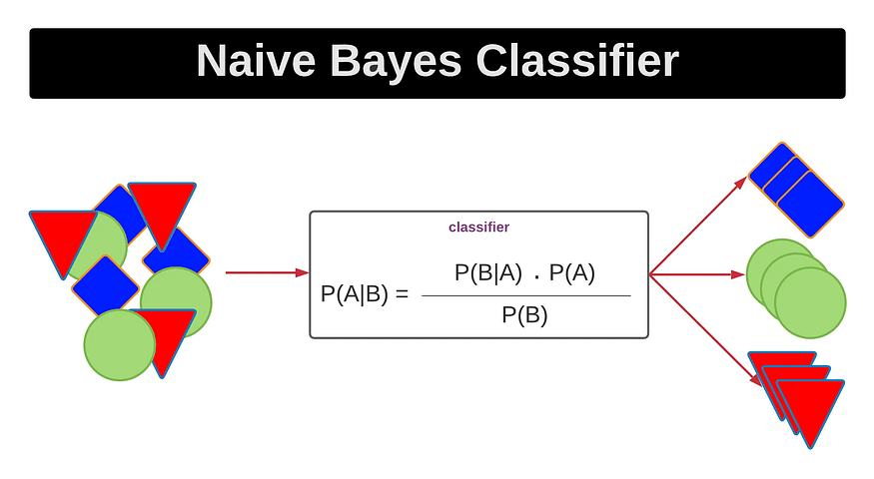Mathematical Concepts

Bayes Theorem

Bayes theorem provides a way to compute the posterior probability of a class given the observed features:
P(Y = k | X) = P(X | Y = k) * P(Y = k) / P(X)
where:
- P(Y = k | X) is the posterior probability: probability of class k given features X.
- P(X | Y = k) is the likelihood: probability of observing X given class k.
- P(Y = k) is the prior probability: the overall probability of class k in the training data.
- P(X) is the evidence: a constant normalizer across all classes.
Since P(X) is constant for all classes, the classification rule simplifies to:
y_hat = argmax_k [ P(Y = k) * P(X | Y = k) ]

The Naive Independence Assumption

Computing P(X | Y = k) is intractable for high-dimensional X because it requires modeling the joint distribution of all features. Naive Bayes assumes conditional independence:
P(X | Y = k) = P(x1 | Y=k) * P(x2 | Y=k) * ... * P(xn | Y=k)
P(X | Y = k) = product_i P(xi | Y = k)

The classification rule becomes:
y_hat = argmax_k [ P(Y=k) * product_i P(xi | Y=k) ]
In practice, log-probabilities are used to prevent numerical underflow when multiplying many small probabilities:
y_hat = argmax_k [ log P(Y=k) + sum_i log P(xi | Y=k) ]

Parameter Estimation: Prior Probability

The prior P(Y = k) is estimated from the training data using Maximum Likelihood Estimation:
P(Y = k) = count(Y = k) / total_samples
This is simply the proportion of training examples belonging to class k.

Likelihood Estimation by Variant

Gaussian Naive Bayes (for continuous features):
Assumes features follow a Gaussian (normal) distribution within each class. The likelihood is:
P(xi | Y = k) = (1 / sqrt(2*pi*sigma_k^2)) * exp( -(xi - mu_k)^2 / (2*sigma_k^2) )
Parameters mu_k (mean) and sigma_k^2 (variance) are estimated from training samples of class k.

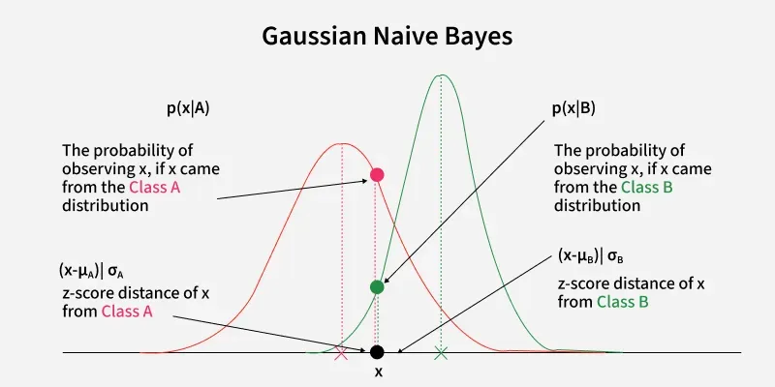

Multinomial Naive Bayes (for count features):
Used when features represent counts or frequencies, such as word counts in text classification.
P(xi | Y = k) = (count(xi, k) + alpha) / (count(k) + alpha * V)
where alpha is the smoothing parameter and V is the vocabulary size.

Bernoulli Naive Bayes (for binary features):
Used when features are binary (0 or 1), such as word presence/absence in a document.
P(xi | Y = k) = p_k^xi * (1 - p_k)^(1-xi)
where p_k = P(xi = 1 | Y = k) is estimated from training data.

Laplace Smoothing

A critical problem arises when a feature value never appears in the training data for a particular class. This causes P(xi | Y = k) = 0, which makes the entire product zero regardless of other features — the model becomes unable to handle unseen feature values.
Laplace Smoothing (add-alpha smoothing) solves this by adding a pseudo-count alpha to every feature count:
P(xi | Y = k) = (count(xi, k) + alpha) / (count(k) + alpha * V)
where alpha = 1 for Laplace smoothing, V is the number of unique feature values, and count(k) is the total feature count for class k. This ensures no probability is ever exactly zero.

Algorithm

- Compute the prior probability for each class k: P(Y=k) = count(k) / total_samples.
- For each class k and each feature i, compute the likelihood P(xi | Y=k). For Gaussian: compute mean and variance. For Multinomial: compute smoothed frequency. For Bernoulli: compute probability of feature being 1.
- Store all computed priors and likelihoods as the model parameters.
- For a new test sample x: compute the log posterior for each class k: score_k = log P(Y=k) + sum_i log P(xi | Y=k).
- Assign the class with the highest score as the predicted label: y_hat = argmax_k score_k.

When to Use Which Variant

- Gaussian Naive Bayes: Continuous features assumed to be normally distributed. Used for medical data, sensor readings, etc.
- Multinomial Naive Bayes: Features are discrete counts (word frequencies in documents). Most popular for text classification, document categorization, spam filtering.
- Bernoulli Naive Bayes: Features are binary (word presence/absence). Used for short texts where occurrence vs. frequency is more meaningful.
- Complement Naive Bayes: Variant of Multinomial NB that uses statistics from complementary classes. Often more accurate for imbalanced text datasets.

Advantages and Disadvantages

Advantages:
- Extremely fast for both training and prediction.
- Works very well with small amounts of training data.
- Handles high-dimensional sparse data efficiently — very suitable for text.
- Easy to implement and interpret.
- Robust to irrelevant features.
- Naturally handles multi-class classification.

Disadvantages:
- The strong independence assumption is unrealistic for most real-world data.
- Probability estimates tend to be poorly calibrated (too extreme).
- Cannot learn feature interactions or correlations.
- Gaussian NB performs poorly when the normality assumption is violated.

Model Implementation (Jupyter Notebook):

#Import Libraries
import numpy as np
import pandas as pd
import matplotlib.pyplot as plt
import seaborn as sns

from sklearn.model_selection import train_test_split
from sklearn.naive_bayes import GaussianNB
from sklearn.metrics import confusion_matrix, classification_report, f1_score, accuracy_score
from sklearn.preprocessing import LabelEncoder, StandardScaler

#Load dataset
df=pd.read_csv("survey lung cancer.csv")
df.info()

#Data preprocessing
print(df.isna().sum())
df=df.dropna()
df=df.drop_duplicates()

#Remove duplicates(if any)
df=df.drop_duplicates()

#Label encoding
le1=LabelEncoder()
le2=LabelEncoder()
df['LUNG_CANCER']=le1.fit_transform(df['LUNG_CANCER'])
df['GENDER']=le2.fit_transform(df['GENDER'])
print("After label encoding:\n")
print(df.head())

#Feature selection
X=df.iloc[:,:-1]
Y=df.iloc[:,-1]

print("Independent feature:\n")
print(X)
print("Dependent feature:\n")
print(Y)

#Train test split
X_train,X_test,Y_train,Y_test=train_test_split(X,Y,test_size=.2,random_state=40)

model=GaussianNB()
model.fit(X_train,Y_train)

#prediction
Y_pred_test=model.predict(X_test)

#Model evaluation
print("Model evaluation:")
print("Accuracy: ")
print(accuracy_score(Y_test,Y_pred_test))
print("\n Classification report :")
print(classification_report(Y_test,Y_pred_test))
print(model.score(X_test,Y_test))

#Confusion Matrix
cm = confusion_matrix(Y_test, Y_pred_test)
plt.figure(figsize=(6,4))
sns.heatmap(cm, annot=True, fmt='d', cmap='Greens')
plt.xlabel("Predicted")
plt.ylabel("Actual")
plt.title("Confusion Matrix")
plt.show()

#Prediction on new data

new_data=pd.DataFrame({
'GENDER':[1],
'AGE':[40],
'SMOKING':[2],
'YELLOW_FINGERS':[2],
'ANXIETY':[1],
'PEER_PRESSURE':[1],
'CHRONIC DISEASE':[2],
'FATIGUE ':[1],
'ALLERGY ':[1],
'WHEEZING':[1],
'ALCOHOL CONSUMING':[2],
'COUGHING':[2],
'SHORTNESS OF BREATH':[1],
'SWALLOWING DIFFICULTY':[1],
'CHEST PAIN':[1]})
pred_new=model.predict(new_data)
print(le1.inverse_transform(pred_new))

Output:

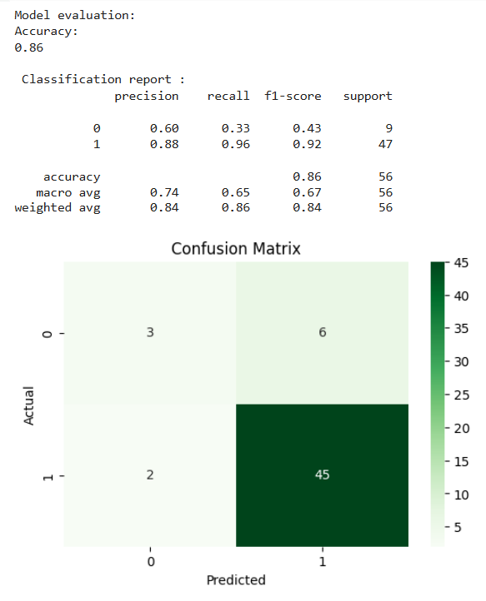
.
.
.
.

📋Comparison of Classification Algorithms

Performance Metrics Comparison
Table 1 summarises the Accuracy, Precision, Recall, and F1-Score achieved by each algorithm, together with the use-cases for which each model is best suited.

Algorithm | Accuracy | Precision | Recall | F1-Score | Recommended For
Decision Tree | ~85% | ~91% | ~91% | ~91% | When model interpretability is needed; mixed feature types
KNN | ~86% | ~85% | ~100% | ~92% | Non-linear decision boundaries; small datasets
Logistic Regression | ~87% | ~88% | ~98% | ~93% | Probability estimates; large datasets with speed priority
SVM ★ | ~88% | ~88% | ~98% | ~93% | Highest accuracy; high-dimensional feature spaces
Naive Bayes | ~86% | ~88% | ~98% | ~92% | Fast training; limited labeled data available

Summary Table
The following provides a comparative overview of all five classification algorithms across key dimensions:

Type of Learner:
- KNN: Instance-based, lazy learner (no model built during training).
- Decision Tree: Rule-based, eager learner.
- Logistic Regression: Linear model, parametric, eager learner.
- SVM: Margin-based, parametric, eager learner.
- Naive Bayes: Probabilistic, parametric, eager learner.

Training Complexity:
- KNN: O(1) — no training required.
- Decision Tree: O(n * d * log n) — where n = samples, d = features.
- Logistic Regression: O(n * d * iterations) — gradient descent.
- SVM: O(n^2) to O(n^3) — quadratic programming.
- Naive Bayes: O(n * d) — linear scan through data.

Feature Requirements

- KNN: Requires feature scaling. Sensitive to irrelevant features. Suffers in high dimensions.
- Decision Tree: No scaling required. Handles mixed data types. Implicitly selects features.
- Logistic Regression: Benefits from feature scaling. Assumes linearity. Works well with independent features.
- SVM: Requires feature scaling. Effective in high dimensions. Kernel choice matters greatly.
- Naive Bayes: No scaling required. Assumes feature independence. Best for high-dimensional sparse data.

When to Use Each Algorithm

Use KNN when:
- The dataset is small and fits in memory.
- The decision boundary is complex and non-linear.
- You need a quick baseline without complex training.
- Prediction speed is not a critical constraint.

Use Decision Tree when:
- Model interpretability and explainability are required.
- You are working with mixed feature types (categorical and numerical).
- You want to visualize the decision-making process.
- You plan to build ensemble methods (Random Forest, Gradient Boosting).

Use Logistic Regression when:
- The relationship between features and output is approximately linear.
- You need probability estimates (e.g., risk scores).
- You want a fast, interpretable baseline model.
- The dataset is large and training speed matters.

Use SVM when:
- The number of features is very large relative to samples.
- The data has a clear margin of separation.
- You are working with image classification or text classification.
- Accuracy is more important than training speed.

Use Naive Bayes when:
- You are working on text classification or NLP tasks.
- The dataset is very large and fast training is needed.
- You have limited training data (works with few samples).
- Features are relatively independent.

Handling Overfitting

- KNN: Use larger K values and feature selection.
- Decision Tree: Apply pre-pruning (max_depth, min_samples_leaf) or post-pruning (ccp_alpha).
- Logistic Regression: Apply L1 or L2 regularization; tune C parameter.
- SVM: Tune C parameter (smaller C = more regularization); tune gamma for RBF kernel.
- Naive Bayes: Overfitting is rare due to the simple model; increase Laplace smoothing alpha.

.
.
.
.
.
.
.
.

Conclusion

This project compared five supervised machine learning algorithms — Decision Tree, KNN, Logistic Regression, SVM, and Naive Bayes — for lung cancer detection using patient survey data. All models showed strong predictive performance, with F1-Scores between 91% and 93%, proving that machine learning can be an effective tool for early cancer detection.

Among all models, SVM performed the best, achieving the highest accuracy (88%) and recall (98%), making it highly reliable for identifying true positive cancer cases. Logistic Regression also performed well and provided interpretable probability estimates, which are useful for risk analysis. KNN achieved perfect recall (100%), but its lower precision and higher prediction cost reduce its practicality for large-scale use. Although Decision Tree had slightly lower accuracy, it remains valuable because of its transparency and easy interpretability, which are important in healthcare decisions. This makes it useful in clinical environments where explainability is necessary.

However, the study has some limitations, such as the small dataset size (309 records) and class imbalance. Future work can include larger datasets, ensemble methods like Random Forest and XGBoost, and deep learning models for CT scan analysis.

In conclusion, machine learning is a powerful approach for early lung cancer prediction. SVM is recommended when accuracy is the main goal, while Decision Tree is preferred when interpretability is more important. The final model choice should depend on clinical needs and healthcare requirements.
.
.
.
.
.
.
.
.
References

Programming Language- Python. https://www.python.org/
Dataset- kaggle. https://www.kaggle.com/datasets/ajisofyan/survey-lung-cancer
Python IDE- google colab. https://colab.research.google.com
ML Classification Algorithms- Scikit learn. https://scikit-learn.org/
Numerical analysis- Numpy. https://numpy.org/
Dataset Preprocessing- Pandas. https://pandas.pydata.org/
Data Visualization-
Matplotlib. https://matplotlib.org/
Seaborn. https://seaborn.pydata.org/
Images-
https://www.geeksforgeeks.org/machine-learning/machine-learning/
https://ashish-mehta.medium.com/

Books and Documentations :

Mitchell, T. (1997). Machine Learning. McGraw-Hill.
Cortes, C. and Vapnik, V. (1995). Support-Vector Networks. Machine Learning, 20(3), 273-297.
Breiman, L., Friedman, J., Olshen, R., Stone, C. (1984). Classification and Regression Trees. Wadsworth.
Quinlan, J.R. (1986). Induction of Decision Trees. Machine Learning, 1(1), 81-106.
Cover, T. and Hart, P. (1967). Nearest Neighbor Pattern Classification. IEEE Transactions on Information Theory, 13(1), 21-27.
Pedregosa, F. et al. (2011). Scikit-learn: Machine Learning in Python. Journal of Machine Learning Research, 12, 2825-2830.
Hastie, T., Tibshirani, R., Friedman, J. (2009). The Elements of Statistical Learning. Springer.
Goodfellow, I., Bengio, Y., Courville, A. (2016). Deep Learning. MIT Press.
Murphy, K.P. (2012). Machine Learning: A Probabilistic Perspective. MIT Press.

