SIMATS ENGINEERING

ASSESSMENT TOOL 1

COURSE NAME: Data Warehousing and Data Mining COURSE CODE: CSA1613

COURSE OUTCOME COVERED
CO4: Examine the applicability of clustering algorithms in real-world scenarios, presenting findings through clear reports with effective visualizations.

QUESTIONS: 05 Total Marks:50

Annexure A Data Interpretation

Criteria | Understandin g of Data (2.5) | Analysis  (2.5) | Applicatio n of Concepts  (2) | Conclusion  (1.5) | Clarity (1) | Total(10  )
Weightag e | 25% | 25% | 20% | 20% | 10% | 100%
Q1
Q2
Q3
Q4
Q5

Code of Conduct:
I SK RAHAMATH ALI (192365048) (Name / Reg No) certify that this submission is my original work and that I have adhered to the guidelines specified for this assessment.
I understand that any violation of academic integrity rules will result in disciplinary action.

Signature of the student: SK RAHAMATH ALI
RUBRICS FOR CALCULATION:

Criteria | Weightage | Level 4 (Exemplary) | Level 3 (Proficient) | Level 2 (Developing) | Level 1 (Beginning)
Understanding of Data | 25% | Accurately interprets all data patterns, trends, and  relationships | Interprets data correctly with minor gaps | Partial understanding; misses key trends | Misinterprets or fails to understand data
Analysis | 25% | Provides deep analysis with strong logical reasoning and  justification | Provides reasonable analysis with some justification | Basic analysis with weak reasoning | No meaningful analysis provided
Application of Concepts | 20% | Effectively applies relevant concepts/tools to interpret data  accurately | Applies concepts with minor errors | Limited application; requires guidance | Unable to apply concepts to data
Conclusion | 20% | Draws clear, meaningful conclusions with strong insights and  implications | Provides valid conclusions with moderate insights | Conclusions are vague or weak | No clear or valid conclusions
Clarity | 10% | Presents interpretation clearly using proper structure, visuals, and  terminology | Generally clear with minor issues | Lacks clarity or proper structure | Poor presentation and difficult to understand
Annexure A

Q1. Dataset: Hospital Patient Segmentation
Patient ID Age Monthly Medical Expense (₹) Health Risk Score
P1 | 28 | 12000 | 65
P2 | 55 | 25000 | 40
P3 | 42 | 20000 | 75
P4 | 30 | 11000 | 70
P5 | 60 | 28000 | 35

SSE Values K SSE
1 600

2 350
3 220
4 200
5 190

Question (BL4 – 8 Marks):
A healthcare organization uses K-Means clustering to group patients based on their medical expenses and health risk scores. Interpret the elbow point from the SSE values provided and determine the optimal number of clusters. Discuss how selecting this number of clusters affects patient segmentation and healthcare decision-making.

Q2. Dataset: E-Commerce Order Analysis
Order ID Product Category Order Value (₹)
O1 | Electronics | 55000
O2 | Clothing | 25000
O3 | Electronics | 57000
O4 | Furniture | 30000
O5 | Clothing | 27000
Question (BL4 – 8 Marks):
An online retailer applies hierarchical clustering to group customer orders based on product category and order value. A dendrogram is generated from the dataset. Interpret how the clusters are formed and identify the appropriate number of clusters. Explain the significance of the selected clusters in understanding customer purchasing behavior.
Q3. Dataset: Mobile App User Behavior
User Daily Usage Time (min) Login Frequency In-App Purchase (₹)
U1 | 120 | 18 | 2000
U2 | 60 | 5 | 5000
U3 | 140 | 22 | 1500
U4 | 50 | 4 | 6000
U5 | 130 | 20 | 1800
Question (BL5 – 8 Marks):
A mobile application company uses the HAC algorithm to segment users based on their activity patterns. Interpret how users are assigned to clusters using probability-based membership values. Discuss the advantages of soft clustering over hard clustering for customer behavior analysis.

Q4. Dataset: Agricultural Crop Monitoring Farm Rainfall (mm) Soil Fertility Score Crop Yield (tons)

F1 | 300 | 8 | 85
F2 | 500 | 4 | 70
F3 | 400 | 6 | 80
F4 | 280 | 9 | 90
F5 | 520 | 3 | 65
Question (BL4 – 8 Marks):
An agricultural research center performs clustering on farm data before and after applying normalization. Interpret the differences observed in the clustering results. Explain how normalization influences cluster formation and improves the reliability of agricultural data analysis.

Q5. Dataset: Employee Performance Evaluation
Employee Productivity Score Attendance (%) Skill Assessment Score
E1 | 88 | 92 | 84
E2 | 62 | 75 | 68
E3 | 78 | 88 | 72
E4 | 55 | 65 | 58
E5 | 93 | 96 | 90
Silhouette Scores Model Score
K=2 | 0.48
K=3 | 0.68
K=4 | 0.52

Question (BL5 – 8 Marks):
A company clusters employees based on productivity, attendance, and skill assessment scores. Analyze the silhouette scores obtained for different clustering models and determine the most suitable number of clusters. Justify your answer and explain how the selected model contributes to effective employee performance evaluation.

Q1. Hospital Patient Segmentation

Given Data

Patient | Age | Medical Expense ₹ | Risk Score
P1 | 28 | 12,000 | 65
P2 | 55 | 25,000 | 40
P3 | 42 | 20,000 | 75
P4 | 30 | 11,000 | 70
P5 | 60 | 28,000 | 35

Given SSE

K | SSE
1 | 600
2 | 350
3 | 220
4 | 200
5 | 190

Formula:
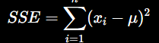

SSE Reduction:
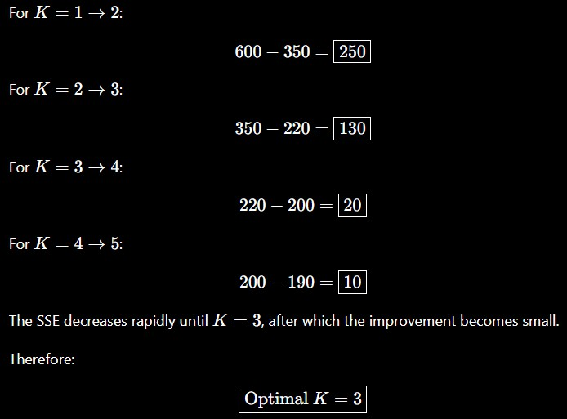

Interpretation

The three clusters can represent:
- Cluster 1: Low-risk/low-expense patients.
- Cluster 2: Moderate-risk patients.
- Cluster 3: High-risk/high-expense patients.
This segmentation helps hospitals prioritize high-risk patients, allocate medical resources, plan treatments and estimate healthcare costs.

Conclusion:
K = 3
is selected because the elbow occurs at K=3.

Q2. E-Commerce Order Analysis

Given Data

Order | Category | Value ₹
O1 | Electronics | 55,000
O2 | Clothing | 25,000
O3 | Electronics | 57,000
O4 | Furniture | 30,000
O5 | Clothing | 27,000

Distance Formula
For numerical order value:

Cluster Formation:

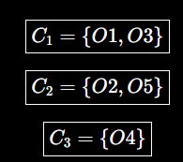

Thus, a reasonable interpretation is:
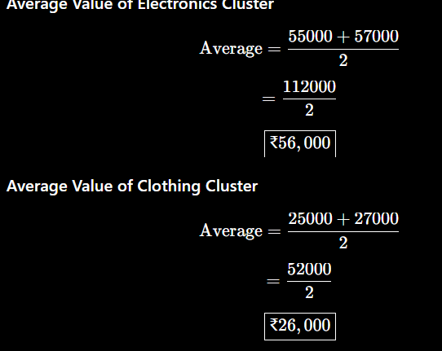

Interpretation:
- Electronics → high-value orders.
- Clothing → lower-value orders.
- Furniture → separate category.
These clusters help the retailer understand purchasing behavior and create category-specific offers and recommendations.

Conclusion:
Hierarchical clustering can identify meaningful groups of orders based on category and order value.

Q3. Mobile App User Behavior

Given Data

User | Usage (min) | Login Frequency | Purchase ₹
U1 | 120 | 18 | 2,000
U2 | 60 | 5 | 5,000
U3 | 140 | 22 | 1,500
U4 | 50 | 4 | 6,000
U5 | 130 | 20 | 1,800
The question specifically asks about probability-based membership values, so soft clustering such as Fuzzy C-Means is appropriate.

Membership Formula
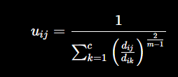
Assume: m = 2
Suppose a user's distances from two cluster centers are: d1 = 10, d2 = 20

Substitution:

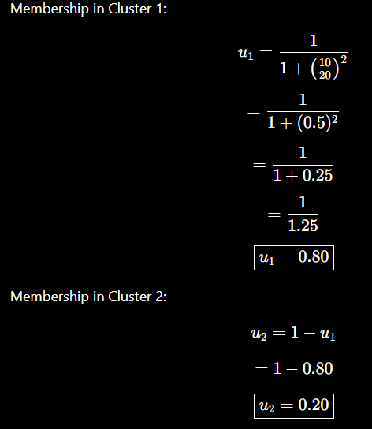

Therefore, the user has:
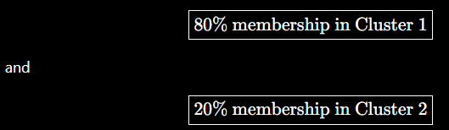

Membership Condition:
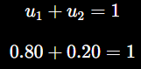
Hence, the membership values are valid.

Interpretation:
Soft clustering is better than hard clustering because a user can have characteristics of multiple groups.
For example, a user may be:
- Highly active,
- But also a high-value purchaser.

Instead of forcing the user into only one group, soft clustering gives partial membership.

Advantages:
- Handles mixed customer behavior.
- Gives probability-like membership values.
- Provides more flexible segmentation.
- Supports personalized recommendations.
- Helps identify borderline users.

Conclusion:
Soft clustering provides a more detailed understanding of customer behavior because users can belong to multiple clusters with different membership strengths.

Q4. Agricultural Crop Monitoring

Given Data

Farm | Rainfall | Fertility | Yield
F1 | 300 | 8 | 85
F2 | 500 | 4 | 70
F3 | 400 | 6 | 80
F4 | 280 | 9 | 90
F5 | 520 | 3 | 65
Soft clustering provides a more detailed understanding of customer behavior because users can belong to multiple clusters with different membership strengths.

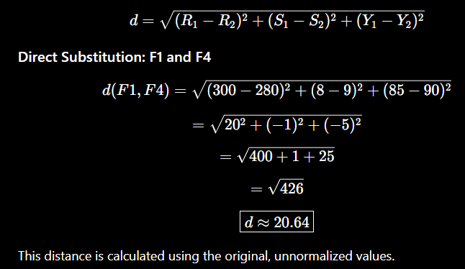
Euclidean Distance Formula:

Min-Max Normalization:
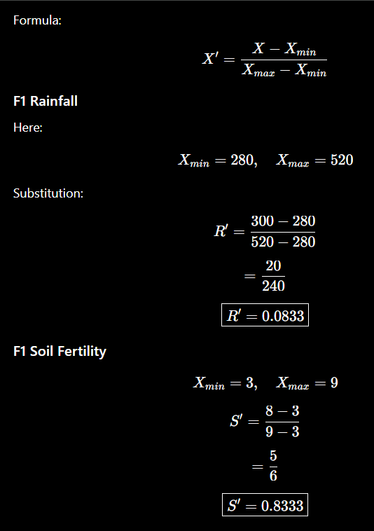

F1 Crop Yield:

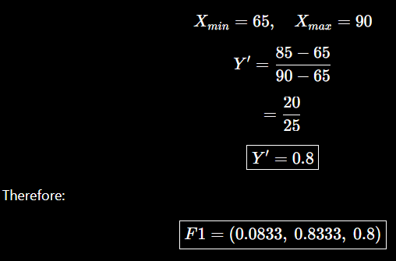

Interpretation:
Before normalization, rainfall has a much larger numerical scale than soil fertility. Therefore, it can dominate the distance calculation.
After normalization: 0≤X′≤1
All attributes contribute more fairly to clustering.

Conclusion:
Normalization produces more reliable clusters because it prevents large-scale variables from dominating the clustering process.

Q5. Employee Performance Evaluation

Given Data

Employee | Productivity | Attendance | Skill
E1 | 88 | 92 | 84
E2 | 62 | 75 | 68
E3 | 78 | 88 | 72
E4 | 55 | 65 | 58
E5 | 93 | 96 | 90

Given Silhouette Scores:

K | Score
2 | 0.48

K Score

3 | 0.68
4 | 0.52
The question asks specifically to analyze these scores and select the most suitable model.

Silhouette Formula:
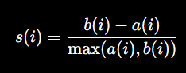
where:
- a(i) = average distance within the same cluster.
- b(i) = average distance to the nearest other cluster. Higher silhouette score means better clustering.

Step 1: Compare Scores:
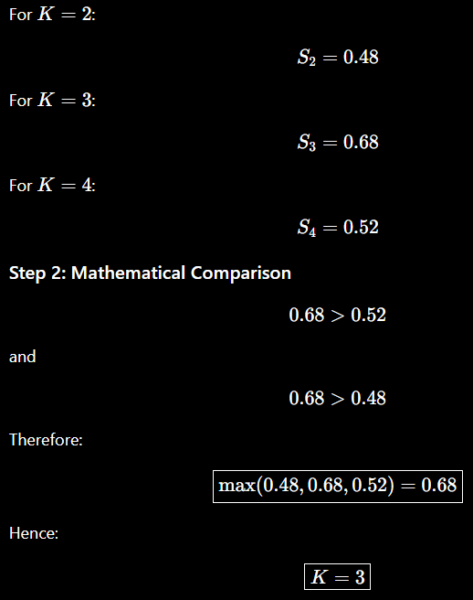

Interpretation:

The three clusters can represent:

Cluster 1 – High performers
High productivity, attendance and skill. Example: E1,E5
Cluster 2 – Moderate performers Moderate performance characteristics. Example: E3

Cluster 3 – Lower performers
Lower productivity, attendance and skill. Example: E2,E4
Why K = 3?
The silhouette score is highest at: 0.68
This means the K = 3 model provides better-defined and better-separated clusters than the K = 2 and K = 4 models.

Conclusion:
The company can use these three employee groups to identify high performers, provide training to employees who need improvement, and design targeted performance-development programs.

