SIMATS ENGINEERING

ASSESSMENT TOOL 3

COURSE NAME: CSA1613 COURSE CODE: Data Warehousing and Data Mining

COURSE OUTCOME COVERED
CO4: Examine the applicability of clustering algorithms in real-world scenarios, presenting findings through clear reports with effective visualizations.

QUESTIONS: 05 Total Marks:50

Annexure A Industry Problem Solving Task

Criteria | Understandin g of Industry Problem (2) | Application of  Engineering Concepts  (2.5) | Solutio n  Design  (2.5) | Use of Tools (2) | Analysis (1) | Total(10  )
Weightag e | 20% | 25% | 25% | 20% | 10% | 100%
Q1
Q2
Q3
Q4
Q5

Code of Conduct:
I SK RAHAMATH ALI (192365048) (Name / Reg No) certify that this submission is my original work and that I have adhered to the guidelines specified for this assessment.
I understand that any violation of academic integrity rules will result in disciplinary action.
Signature of the student: SK RAHAMATH ALI
RUBRICS FOR CALCULATION:

Criteria | Weighta ge | Level 4 – Exemplary | Level 3 – Proficient | Level 2 – Developing | Level 1 – Beginning
Criteria | Weightag e | Level 4 – Exemplary | Level 3 – Proficient | Level 2 – Developing | Level 1 – Beginning
Understandi ng of Industry  Problem | 20% | Comprehens ive understandi ng of  realworld problem and  constraints | Good understandi ng with  minor gaps in  requirement s | Basic understandi ng; some  requirement s unclear | Poor understandi ng;  misinterpret s problem context
Application of  Engineering Concepts | 25% | Applies advanced and relevant concepts  effectively to solve the  problem | Applies  appropriate concepts with minor errors | Limited  application of concepts | Incorrect or no  application of concepts
Solution Design | 25% | Innovative, practical, and feasible solution aligned with industry  standards | Logical and feasible  solution with minor gaps | Basic solution  with limited feasibility | Unclear or impractical solution
Use of Tools | 15% | Effective use of modern tools, technologies  , and real data | Appropriate use of tools with correct implementat ion | Limited or inconsistent use of tools | Minimal or incorrect  use of tools
Analysis | 10% | Thorough analysis with  validated results and performance evaluation | Good analysis with  reasonable validation | Basic analysis  with limited validation | Poor or no analysis
Professionali sm | 5% | Highly  professional, well-  documented, and clearly presented  work | Good documentati on and  presentation | Basic documentati on with  some gaps | Poor documentati on and  presentatio n

Annexure A

Q1 . Dataset: Supermarket Purchases
Customer Visits/Month Avg Spend (₹) Items Bought
C1 | 10 | 2000 | 15
C2 | 4 | 5000 | 8
C3 | 12 | 1800 | 18
C4 | 3 | 6000 | 6
C5 | 11 | 2100 | 16
Question:
Using the above dataset, propose a clustering approach to segment customers and explain how it supports targeted marketing. (BL3 – 7 Marks)

Q2. Dataset: Credit Card Transactions
Transaction Amount (₹) Location Time (hrs)
T1 | 200 | Chennai 10
T2 | 5000 | Delhi 2
T3 | 150 | Chennai 11
T4 | 7000 | Mumbai 1
T5 | 180 | Chennai 12
Question:
Design a clustering-based solution using this dataset to detect unusual or fraudulent transactions. (BL4 – 7 Marks)

Q3. Dataset: Telecom Usage
User Call Duration (min) Data Usage (GB) Recharge (₹)
U1 | 300 | 5 | 200
U2 | 100 | 2 | 100
U3 | 350 | 6 | 220
U4 | 80 | 1 | 90
U5 | 320 | 5.5 | 210
Question:
Explain how clustering can be applied to identify churn-prone users and improve customer retention strategies. (BL4 – 7 Marks)
Q4 . Dataset: E-commerce Behavior
User Product Views Clicks Purchases
U1 | 50 | 20 | 5
U2 | 30 | 10 | 2
U3 | 60 | 25 | 6
U4 | 20 | 8 | 1
U5 | 55 | 22 | 5
Question:

Suggest a clustering technique to group users and explain how it improves recommendation systems. (BL3 – 7 Marks)

Q5. Dataset: Traffic Data
Location Vehicle Count Avg Speed (km/h) Delay (min)
L1 | 200 | 30 | 10
L2 | 500 | 15 | 25
L3 | 220 | 28 | 12
L4 | 600 | 10 | 30
L5 | 210 | 32 | 9

Question:
Design a clustering-based solution to identify traffic congestion zones and explain how it helps in traffic management. (BL4 – 7 Marks)

Q1. Supermarket Purchases – Customer Segmentation

Given Dataset
C3 | 12 | 1800 | 18
C4 | 3 | 6000 | 6
C5 | 11 | 2100 | 16
C1 | 10 | 2000 | 15
C2 | 4 | 5000 | 8

The question asks for a clustering approach to segment customers and explain how it supports targeted marketing.

Mathematical Approach
We use K-Means clustering.
Since the three attributes have different scales, normalization is required.

Step 1: Min-Max Normalization:
- 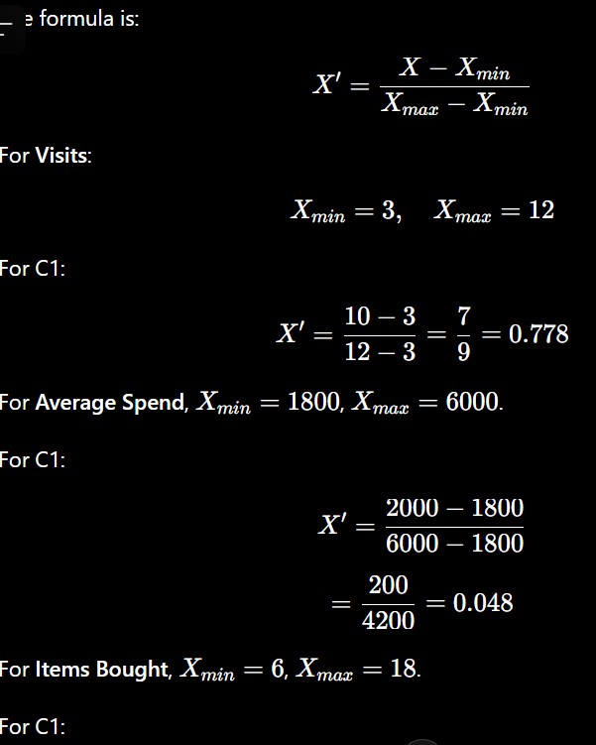
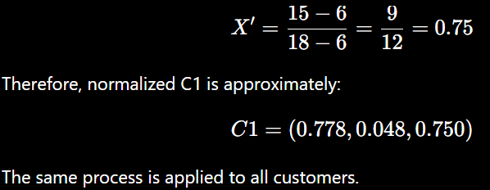

Step 2: Euclidean Distance:
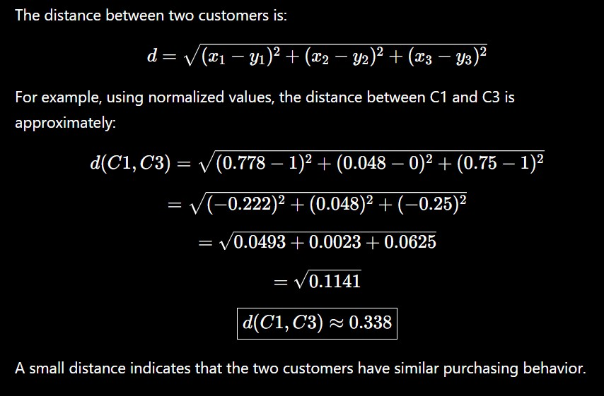

Step 3: Cluster Interpretation:
Using , the customers can approximately be divided into:
Cluster 1 – Frequent/regular customers C1;C3;C5
Cluster 2 – Low-frequency/high-spend customers C2;C4
Step 4: Centroid:

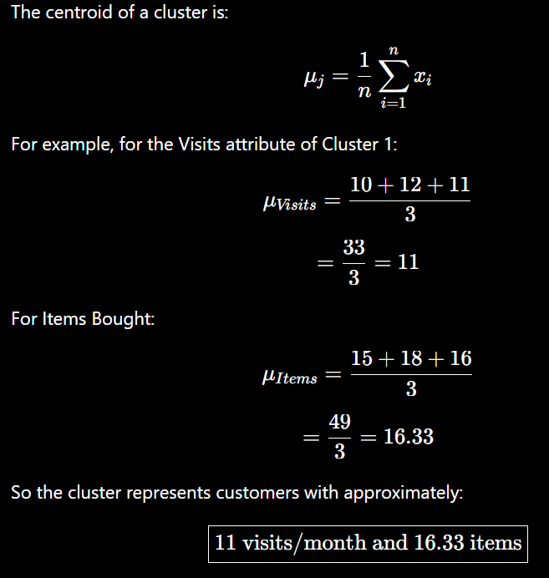

Targeted Marketing:
The supermarket can use the clusters for:
- Loyalty rewards for frequent customers.
- Premium offers for high-spending customers.
- Discounts to increase visits.
- Product recommendations based on purchasing behavior.
- Bundle offers for customers buying many items.

Conclusion:
K-Means clustering successfully divides customers into groups with similar purchasing behavior. This allows the supermarket to use personalized marketing strategies instead of providing the same offer to every customer.

Q2. Credit Card Transactions – Fraud Detection

Given Dataset

Transaction | Amount ₹ | Location | Time
T1 | 200 | Chennai | 10
T2 | 5000 | Delhi | 2
T3 | 150 | Chennai | 11
T4 | 7000 | Mumbai | 1
T5 | 180 | Chennai | 12
The question asks for a clustering-based solution to detect unusual or fraudulent transactions.

Mathematical Approach
We can use K-Means clustering with :
- Cluster 1 → Normal transactions
- Cluster 2 → Suspicious transactions
Because Location is categorical, it should be encoded before applying a numerical distance measure.
For a simplified mathematical demonstration, consider Amount and Time. Step 1: Normalize Amount:

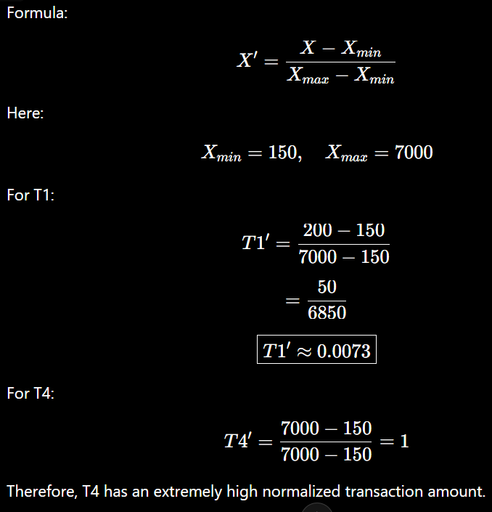

Step 2: Normalize Time:
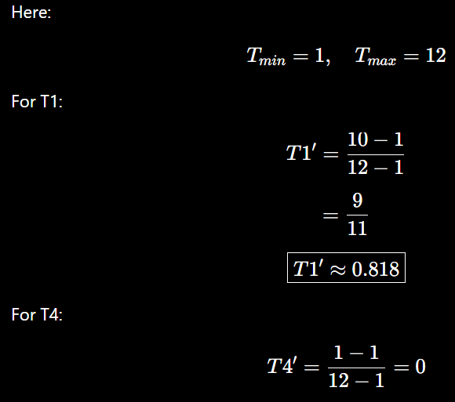

Step 3: Euclidean Distance:
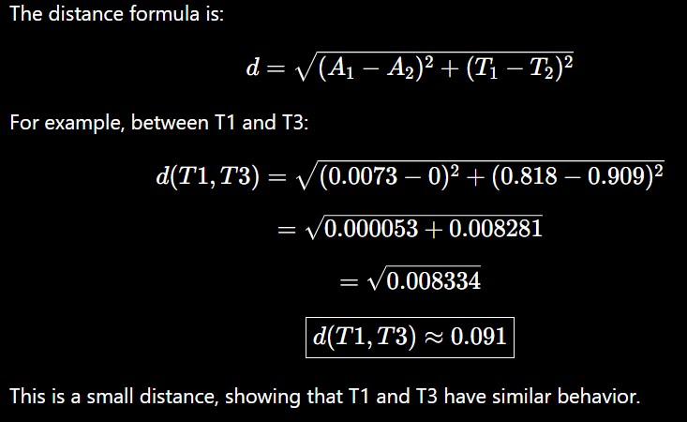

Step 4: Cluster Formation:
The likely grouping is:
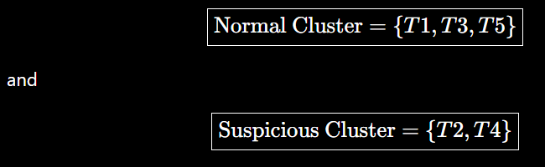
T2 and T4 have very high transaction amounts and occur at early hours.

Step 5: Fraud Detection
A transaction can be considered suspicious when:
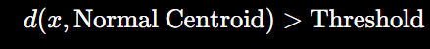
Thus, transactions that are far from the normal cluster can be flagged for further investigation.

Conclusion:
Clustering can identify unusual transaction patterns without requiring every fraudulent transaction to be manually labelled. In the given dataset, T2 and T4 are the suspicious transactions, while T1, T3 and T5 form the normal-like group.

Q3. Telecom Usage – Churn-Prone Users

Given Dataset

User | Call Duration | Data Usage | Recharge ₹
U1 | 300 | 5 | 200
U2 | 100 | 2 | 100
U3 | 350 | 6 | 220
U4 | 80 | 1 | 90
U5 | 320 | 5.5 | 210
The question asks how clustering can identify churn-prone users and improve retention strategies.

Mathematical Approach:
We use K-Means clustering with: K = 2
The features are: x = (Call Duration ,Data Usage ,Recharge)

Step 1: Calculate Distance:
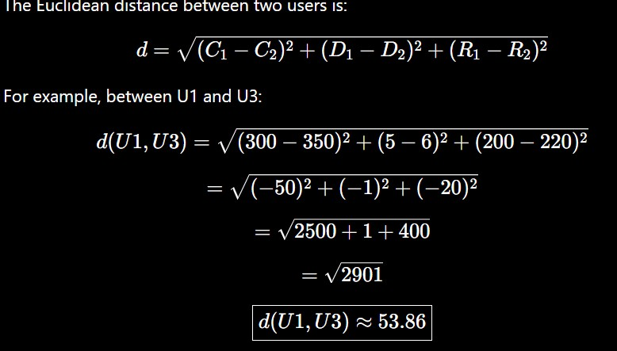
This indicates that U1 and U3 are relatively similar compared with users having very different usage patterns.

Step 2: Cluster Formation
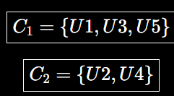
The likely clusters are:

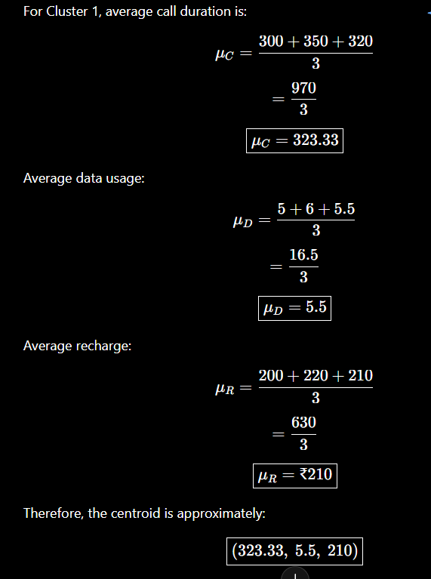
Cluster 1 has high usage and higher recharge values. Cluster 2 has low usage and lower recharge values. Step 3: Centroid Calculation:

Churn Analysis
The low-usage cluster: {U2,U4}
can be investigated as a possible churn-prone segment.
However, clustering alone does not prove that these users will churn. Historical churn labels should be used to verify whether this cluster actually has a high churn rate.

Retention Strategies:
For potentially churn-prone users:
- Give personalized recharge plans.
- Provide additional data benefits.

- Offer loyalty discounts.
- Provide customized offers.
- Contact customers with declining usage.
- Recommend suitable plans.

Conclusion:
Clustering helps telecom companies identify groups with different usage patterns. Users belonging to a low-usage cluster can be investigated further and targeted with appropriate retention strategies.

Q4. E-Commerce Behavior – Recommendation System

Given Dataset

User | Views | Clicks | Purchases
U1 | 50 | 20 | 5
U2 | 30 | 10 | 2
U3 | 60 | 25 | 6
U4 | 20 | 8 | 1
U5 | 55 | 22 | 5
The question asks for a clustering technique to group users and explain how it improves recommendation systems.

Mathematical Approach: Step 1: Euclidean Distance:

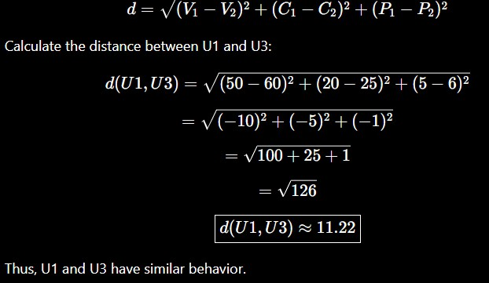

Step 2: Cluster Formation
The likely groups are:
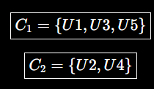

Step 3: Centroid Calculation:
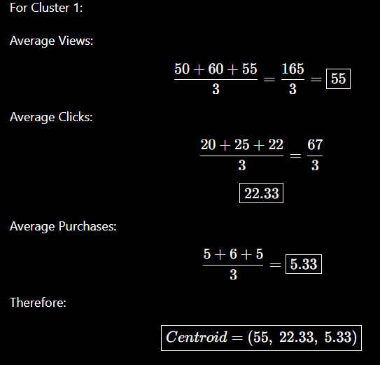

Recommendation Process:
After clustering:

- Identify the cluster of a user.
- Study products purchased by users in that cluster.
- Find frequently purchased or viewed products.
- Recommend similar products to other users in the same cluster.
For example, if users in Cluster 1 frequently purchase electronic products, the system can recommend related electronic products to other users in Cluster 1.

Conclusion:
Clustering improves recommendation systems by grouping users with similar behavior. This enables the e-commerce platform to provide personalized product recommendations, improve customer engagement and potentially increase purchases.

Q5. Traffic Data – Congestion Zones
The question asks to design a clustering-based solution to identify traffic congestion zones and explain how it helps in traffic management.

Given Data

Location | Vehicle Count | Avg Speed | Delay
L1 | 200 | 30 | 10
L2 | 500 | 15 | 25
L3 | 220 | 28 | 12
L4 | 600 | 10 | 30
L5 | 210 | 32 | 9

Clustering Method
Use K-Means clustering with: K = 2

- Cluster 1 → Low congestion
- Cluster 2 → High congestion


Euclidean Distance Formula:
For L1 and L3:

Hence, L1 and L3 have similar traffic characteristics.

Cluster Formation:
C1 = {L1,L3,L5}
These locations have low vehicle count, higher speed and low delay, so they represent the low-congestion zone.
C2 = {L2,L4}
These locations have high vehicle count, low speed and high delay, so they represent the high-congestion zone.

Centroid Calculation:
Centroid formula:
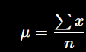
For high-congestion cluster :

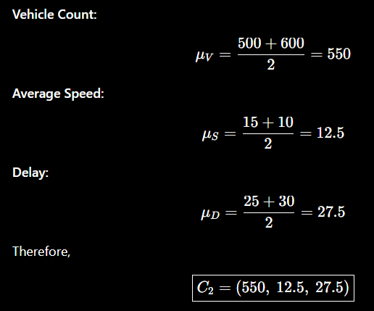

Result:
L2 and L4 are identified as high-congestion zones. L4 is the most congested because it has 600 vehicles, 10 km/h average speed and 30 minutes delay.

Traffic Management
Clustering helps authorities to:
- Identify congestion hotspots.
- Optimize traffic signal timings.
- Suggest alternative routes.
- Provide real-time traffic alerts.
- Deploy traffic-control personnel.
- Plan road improvements.

Conclusion:
K-Means clustering groups locations with similar traffic conditions. It helps traffic authorities identify high-congestion zones and take appropriate traffic-management actions.

