INDEX

Sl No | Name of the program | Date | Page No | Remarks
1 | Create your class time table using table tag. |  | 3
2 | Design a web Page for your college containing description of courses, department, faculties, library etc. Using list tags, href tags and anchor tags. |  | 5
3 | Create your Resume using HTML. Use text, link, and lists |  | 9
4 | Create a webpage of a supermarket using (internal CSS) . |  | 12
5 | Use Inline CSS to format your resume that you have created. |  | 15
6 | Use External CSS to format your time table created. |  | 18
7 | Use all the CSS (inline, internal, and external) to format the college web page that you have created. |  | 20
8 | Write a HTML program to create your college website for mobile device |  | 24
9 | Write an HTML/Javascript page to create a login page with validations. |  | 28
10 | Develop a Simple calculator for addition, subtraction, multiplication and division operation using Javascript. |  | 30
11 | Use Regular Expressions for validations in Login Page using JavaScript |  | 32
12 | Write a Program to retrieve date from a text file and display it using AJAX. |  | 34
13 | Create a web page using Frame with rows and columns where we will have header frame, left frame, right frame, and status bar frame. On clicking in the left frame, information should be displayed in the right frame. |  | 36

Program 1
Create class time table using table tag

Aim
Create a html page to display class time table

Program

<!DOCTYPE html>
<html>
<head>
<title>Class time table</title>
<h2 align="centre">BCA SECOND SEM TIME TABLE</h2>
<table border="4" align="centre">
<tr>
<th></th>
<th>1st</th>
<th>2nd</th>
<th>3rd</th>
<th>4th</th>
<th>5th</th>
</tr>
<tr>
<td>DAY 1</td>
<td>DS</td>
<td>OS</td>
<td>ENGLISH</td>
<td colspan="2">WEB LAB</td>
</tr>
<tr>
<td>DAY 2</td>
<td>HINDI\MALAYALAM</td>
<td>DS</td>
<td>IC</td>
<td>MATHS</td>
<td>OS</td>
</tr>
<tr>
<td>DAY 3</td>
<td>DS</td>
<td>ENGLISH</td>
<td>HINDI\MALAYALAM</td>
<td>OS</td>
<td>MATHS</td>
</tr>
<tr>
<td>DAY 4</td>
<td>OS</td>
<td>DS</td>
<td>ENGLISH</td>
<td>MATHS</td>
<td>HINDI\MALAYALAM</td>
</tr>
<tr>
<td>DAY 5</td>
<td>DS</td>
<td>MATHS</td>
<td>IC</td>
<td>WEB</td>
<td>DS LAB</td>
</tr>
</head>
</html>

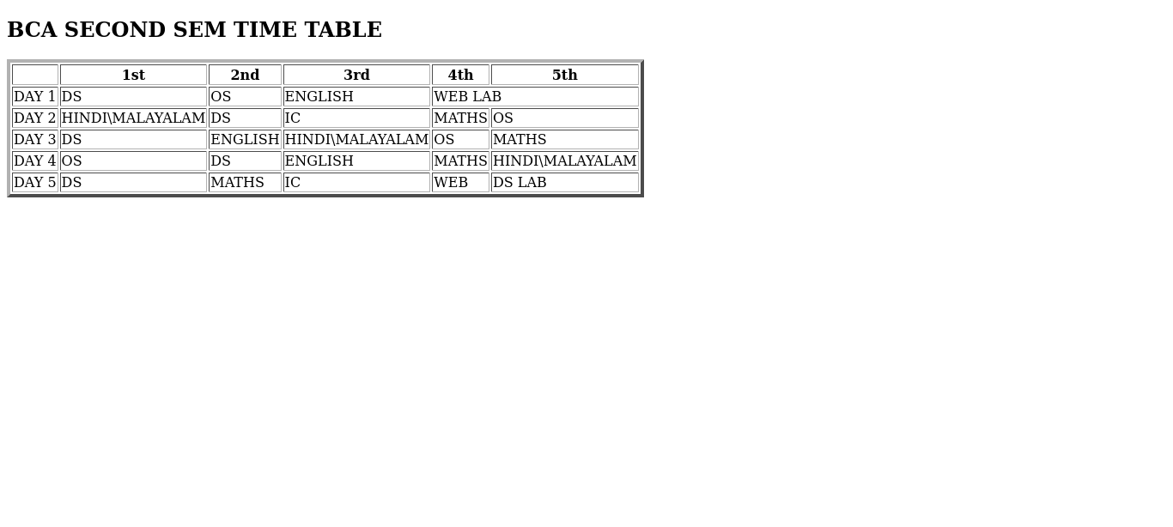
Output

Program 2
Design a web Page for your college containing description of courses, department, faculties, library ect. Using list tags, href tags and anchor tags.

Aim
Design a web Page for your college containing description of courses, department, faculties, library etc. Using list tags, href tags and anchor tags.

Program

<!DOCTYPE html>

<html>

<head>
<title>College</title>
</head>

<body>
<h3>ST.GEORGE'S COLLEGE ARUVITHURA</h3>
<p><strong>St. George's College Aruvithura</strong> is a college under Mahatma Gandhi University, Kottayam. It is located in Aruvithura, Erattupetta, Kottayam District in Kerala, India. It was reaccredited with <strong>'A++' Grade by NAAC</strong> for seven years in the fourth cycle.</p>
<p><strong>St. George’s College Aruvithura</strong>, is a minority educational institution founded by St. George Forane Church, Aruvithura in 1965. Pioneered under the patronage of His Excellency Mar Sebastian Vayalil, the first Bishop of Pala, and cherished by a host of visionaries and philanthropists like Very Rev. Fr. Thomas Araythinal and Mr T. A. Thomman (Former Minister), the college, right from its inception, embarked on an odyssey towards academic pre-eminence. Very Rev. Fr. Thomas Manakkat, the founding manager and a great visionary, was truly instrumental in laying the foundations for a great beginning and Very Rev. Fr. Jacob Thazhathel, who followed him, was equally adept and insightful in his ideals, guiding the college during the early stages of its growth. For more than two decades, His Excellency Mar Joseph Pallickaparampil, the Bishop of Pala, had been the patron of the college. His Excellency Mar Joseph Kallarangattu is the present patron of this seat of learning.</p>
<img src="sgc.jpg" height="350" width="650"alt="college image">
<h3>PROGRAMMES</h3>
<ol>
<li>UG</li>
<li>PG</li>
<li>Phd</li>
<li>OPEN COURSE</li>
<li>CERTIFICATE COURSE</li>
</ol>
<h3>COURSES OFFERED</h3>

<h4>AIDED</h4>
<ol>
<li>B.Sc (Honours) Mathematics</li>
<li>B.Sc (Honours) Physics</li>
<li>B.Sc (Honours) Chemistry</li>
<li>B.Sc (Honours) Botany</li>
<li>B.A (Honours) Economics</li>
<li>B.A (Honours) Political Science</li>
<li>B A (Honours) English with Specialization in Media Studies & Film Studies</li>
<li>B.Com (Honours) with Specialization in Finance & Taxation</li>
<li>BCA (Honours) with Specialization in Data Science & Full Stack Development</li>
</ol>

<h4>SELF</h4>
<ol>
<li>B.Com(Honours)With Specialization in Finance & Taxation</li>
<li>B.Com(Honours)With Specialization in Finance & Taxation & Accounting</li>
<li>B.Com(Honours)With Specialization in Financial Markets & Logistics Management</li>
<li>B.A(Honours) Journalism & Mass Communication</li>
<li>B.Sc (Honours) Food Science & Quality Control with Specialization in in Food Safety</li>
<li>B.Voc Food Technology & Analysis</li>
<li>BCA (Honours) with Specialization in Artificial Intelligence and Machine learning & Full Stack Development</li>
</ol>

<h3>DEPARTMENTS</h3>

<ol>
<li>Department of Botany & Zoology</li>
<li>Department of Chemistry</li>
<li>Department of Commerce</li>
<li>Department of Computer Applications</li>
<li>Department of Economics</li>
<li>Department of English</li>
<li>Department of Food Science and Technology</li>
<li>Department of Hindi & Malayalam</li>
<li>Department of Mathematics & Statistics</li>
<li>Department of Physics</li>
<li>Department of Political Science & History</li>
</ol>

<h3>FACULTIES</h3>

<ul>
<li><a href="">Department of Botany & Zoology</a></li>
<li><a href="">Department of Chemistry</a></li>
<li><a href="">Department of Commerce</a></li>
<li><a href="">Department of Computer Applications</a></li>
<li><a href="">Department of Economics</a></li>
<li><a href="">Department of English</a></li>
<li><a href="">Department of Food Science and Technology</a></li>
<li><a href="">Department of Hindi & Malayalam</a></li>
<li><a href="">Department of Mathematics & Statistics</a></li>
<li><a href="">Department of Physics</a></li>
<li><a href="">Department of Political Science & History</a></li>
</ul>
<h3>LIBRARY</h3>
</body>
<li><a href="https://sgcaruvithura.ac.in/library">Library</a></li></ul>
Click here for more informations:<a href="https://sgcaruvithura.ac.in/index.html">College website</a>
</html>
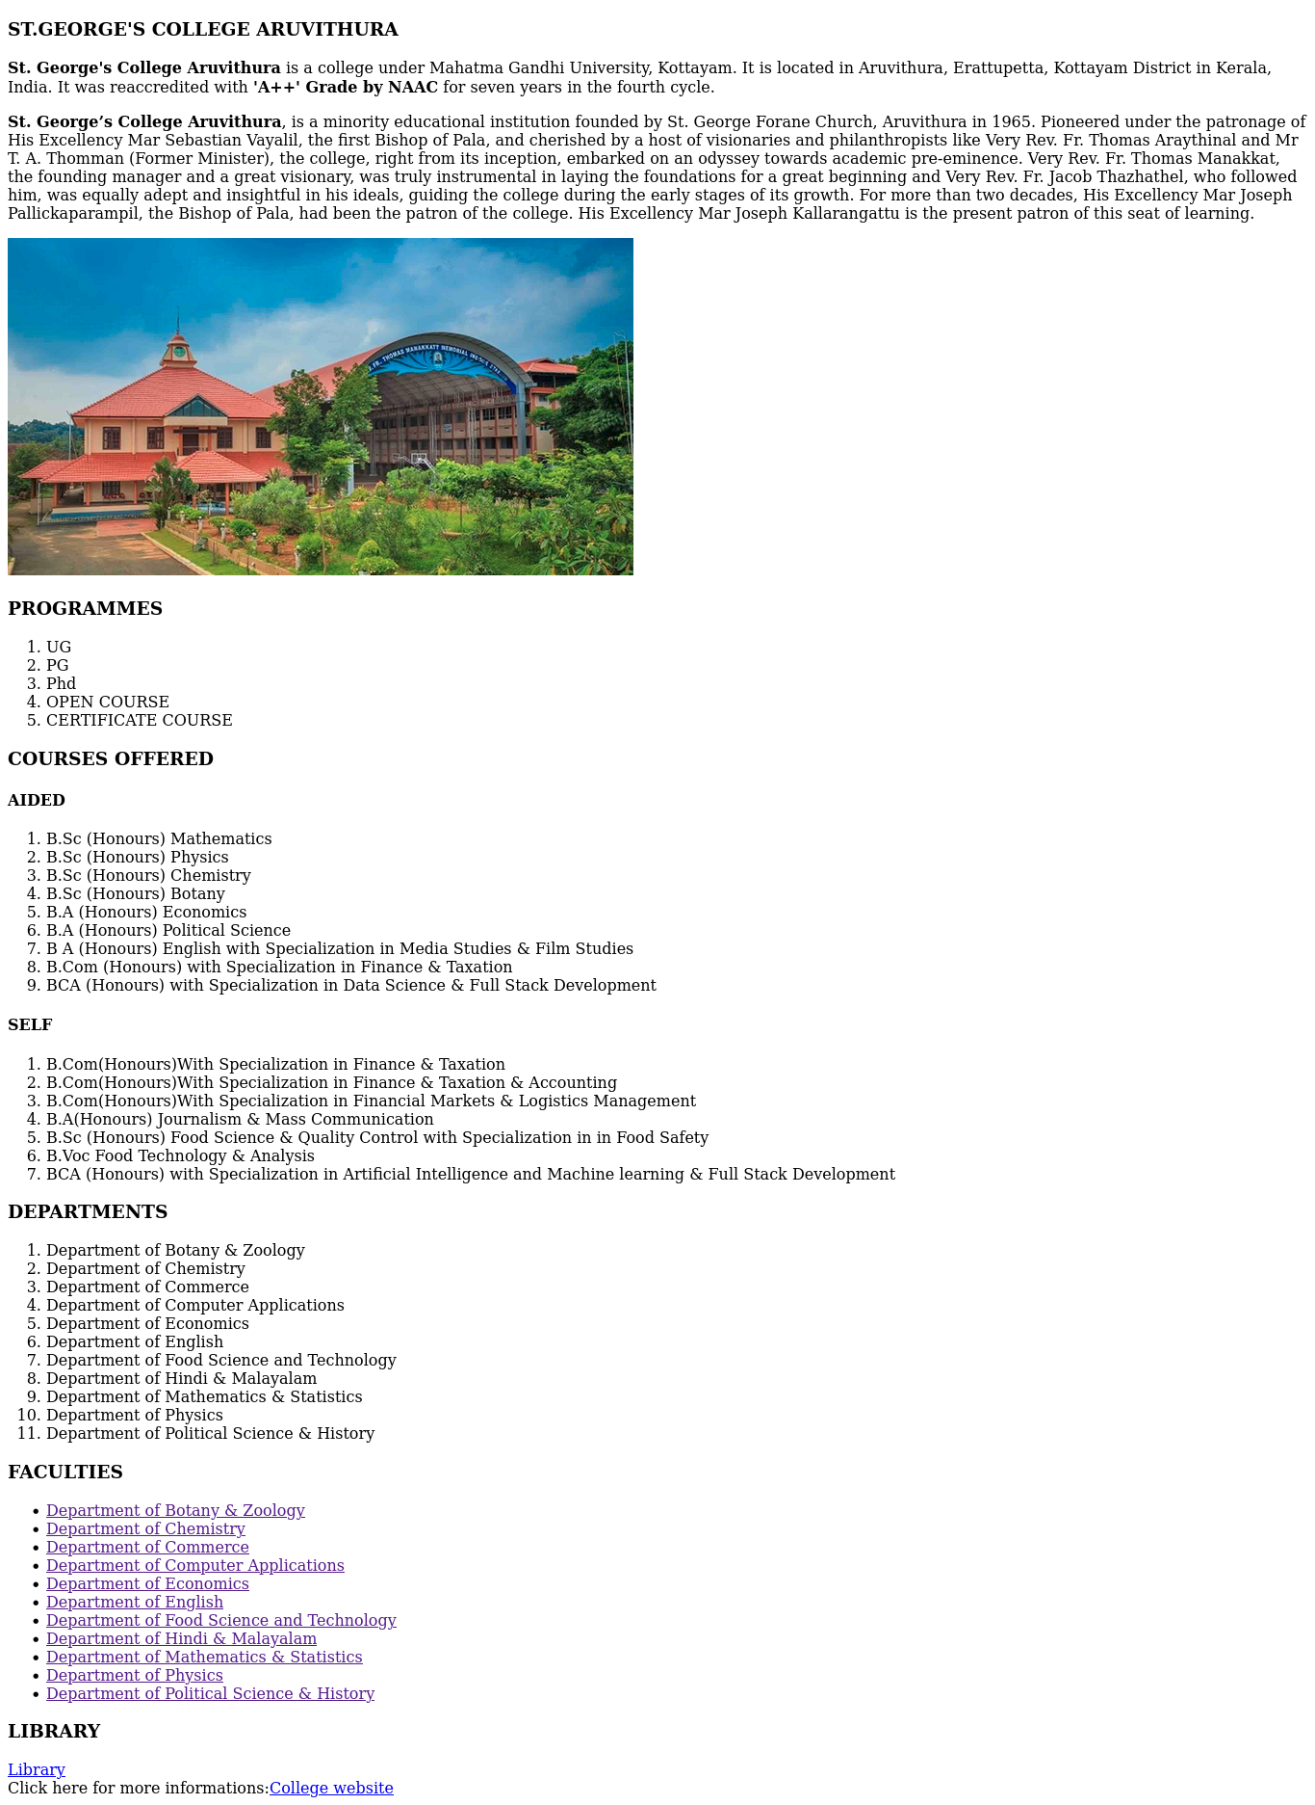
Output

Program 3
Create your Resume using HTML. Use text, link, and lists .

Aim
Create your Resume using HTML. Use text, link, and lists .

Program

<!DOCTYPE html>
<html>
<head>
<title>RESUME</title>
</head>
<body>
<h1><u>RESUME</u></h1>

<h2><u>PERSONAL INFORMATION</u></h2>
<p>NAME: RAHAN MIRAS KS</p>
<p>REG NUM:2369</p>
<p>E-MAIL: <a href="rahanmiraz5@gmail.com">rahanmiraz5@gmail.com</a></p>
<p>MOBILE: 9847425394</p>
<p>DOB:02/02/2005</p>

<h2><u>EDUCATIONAL INFORMATION</u></h2>
<p><b>HAYATHUDHEEN HS ERATTUPETTA</b><br>
High School Education (SSLC) | 99%</p>

<p><b>MG GOVT HSS PALA</b><br>
Higher Secondary Education (+2) | 82%</p>

<p><b>St. George’s College,Aruvithura</b><br>
Bachelors of Computer Applications [HONOURS]</p>

<h2><u>SKILLS & ACTIVITIES</u></h2>
<ul>
<li>Language: C programming, C++, Java programming</li>
<li>Operating systems: Windows 2000/XP/Windows 7 & Linux</li>
<li>MS Office and FrontPage</li>
<li>Web technologies: HTML, CSS, JavaScript, ASP.NET</li>
</ul>
<h2><u>HOBBIES</u></h2>
<ul>
<li>Gaming</li>
<li>Football</li>
<li>Music</li>
</ul>
<h2><u>STRUCTURE</u></h2>
<ul>
<li>Work with a positive attitude and contribute towards the healthy functioning of the organization</li>
<li>Self-confidence and great patience</li>
</ul>
</body>
</html>
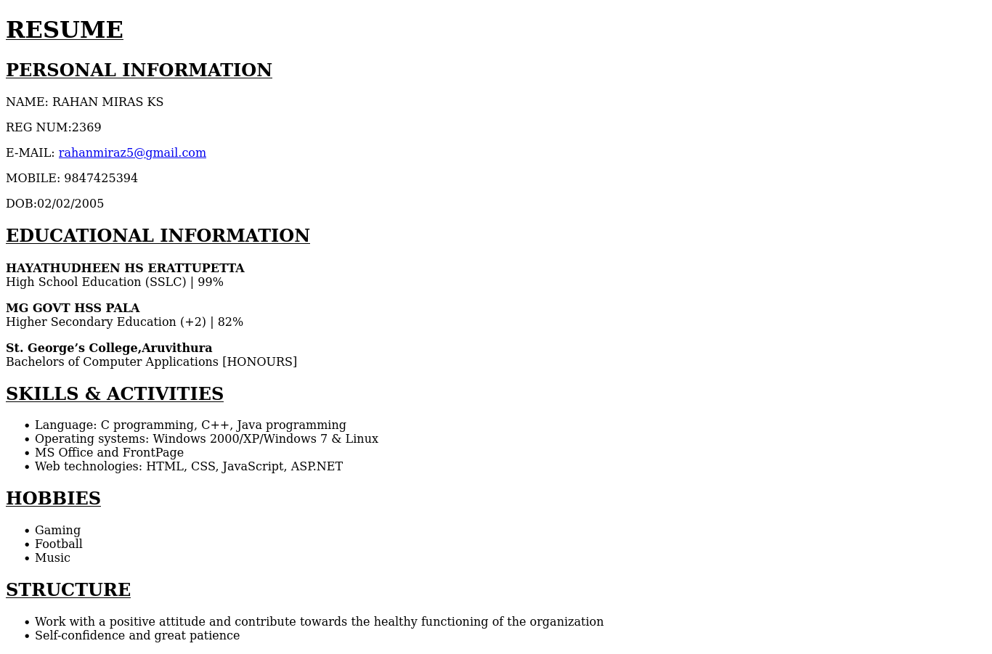
Output

Program 4
Create a webpage of a supermarket using (internal CSS) .
Aim
Create a webpage of a supermarket using (internal CSS) .

Program

<!DOCTYPE html>
<html>
<head>
<title>SUPRMRKT</title>
</head>
<style>
h4{
color:indigo;
font-size:19px;
background-color:yellow;
}
h1{
background-color:lightblue;
}
</style>
<body>
<h1><u>SUPER MARKET</u></h1>
<h3><u>PRODUCT CATEGORIES</u><h3>
<h4><u>GROCERIES</u></h4>
<ol>
<li>RICE</li>
<li>SUGAR</li>
<li>FLOUR</li>
<li>MILK</li>
<li>NUTS</li>
<li>CURRY POWDERS</li>
</ol>
<h4><u>VEGETABLES</u></h4>
<ol>
<li>TOMATO</li>
<li>ONION</li>
<li>BRINJAL</li>
<li>CARROT</li>
<li>CAPSICUM</li>
<li>LADIES FINGER</li>
</ol>
<h4><u>FRUITS</u></h4>
<ol>
<li>APPLE</li>
<li>ORANGE</li>
<li>BANANA
<ul>
<li>RIPE</li>
<li>RAW</li>
</ul>
</li>

<li>WATERMELON</li>
<li>GRAPES</li>
<li>MANGO
<ul>
<li>RIPE</li>
<li>RAW</li>
</ul>
</li>
</ol>
<h4><u>BAKERY</u></h4>
<ol>
<li>BISCUITS</li>
<li>CHIPS</li>
<li>CAKES
<ul>
<li>CUP CAKES</li>
<li>CREAM CAKES</li>
</ul>
</li>

<li>BUNS</li>
<li>MUFFINS</li>
<li>PUFFS
<ul>
<li>SP EGG</li>
<li>MEAT</li>
</ul>
</li>
</ol>
</body>
</html>

Output
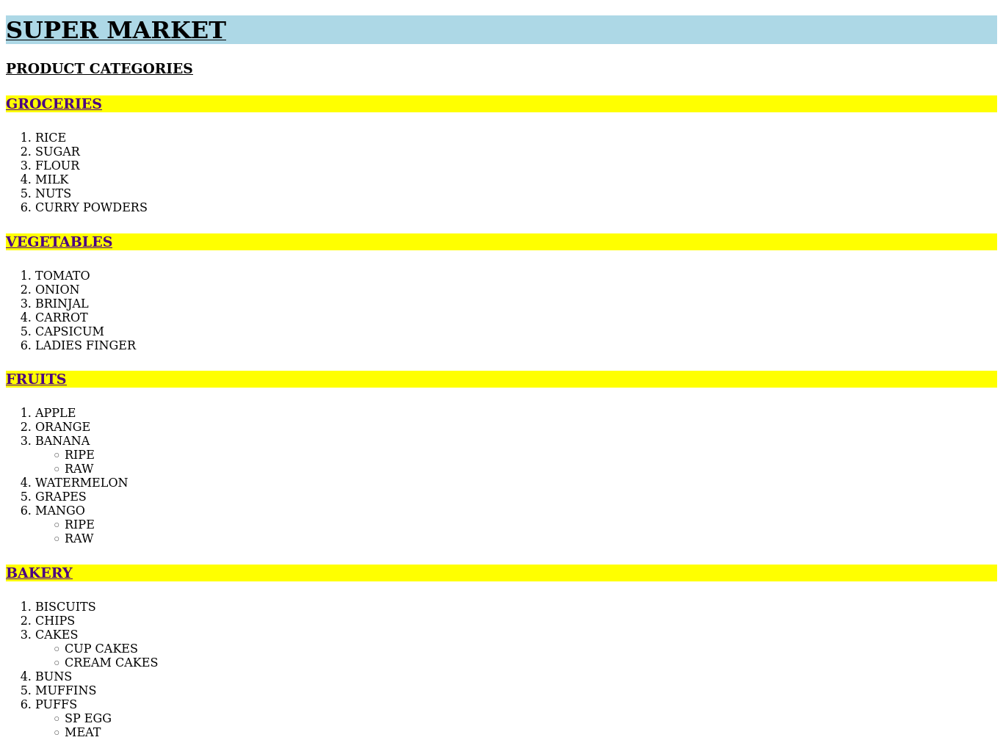

Program 5
Use Inline CSS to format your resume that you have created.
Aim
Use Inline CSS to format your resume that you have created.

Program

<!DOCTYPE html>
<html>
<head>
<title>RESUME</title>
</head>
<body>
<h1><u>RESUME</u></h1>

<h2><u style="color:brown;font-size:22px;">PERSONAL INFORMATION</u></h2>
<p>NAME: RAHAN MIRAS KS</p>
<p>REG NUM:2369</p>
<p>E-MAIL: <a href="rahanmiraz5@gmail.com">rahanmiraz5@gmail.com</a></p>
<p>MOBILE: 9847425394</p>
<p>DOB:02/02/2005</p>

<h2><u style="color:brown;font-size:22px;">EDUCATIONAL INFORMATION</u></h2>
<p style="color:blue;font-size:18px;"><b>HAYATHUDHEEN HS ERATTUPETTA</b><br>
High School Education (SSLC) | 99%</p>

<p style="color:blue;font-size:18px;" ><b>MG GOVT HSS PALA</b><br>
Higher Secondary Education (+2) | 82%</p>

<p style="color:blue;font-size:18px;"><b>St. George’s College,Aruvithura</b><br>
Bachelors of Computer Applications [HONOURS]</p>

<h2><u style="color:brown;font-size:22px;">SKILLS & ACTIVITIES</u></h2>
<ul>
<li>Language: C programming, C++, Java programming</li>
<li>Operating systems: Windows 2000/XP/Windows 7 & Linux</li>
<li>MS Office and FrontPage</li>
<li>Web technologies: HTML, CSS, JavaScript, ASP.NET</li>
</ul>
<h2><u style="color:brown;font-size:22px;">HOBBIES</u></h2>
<ul>
<li>Gaming</li>
<li>Football</li>
<li>Music</li>
</ul>
<h2><u style="color:brown;font-size:22px;">STRUCTURE</u></h2>
<ul>
<li>Work with a positive attitude and contribute towards the healthy functioning of the organization</li>
<li>Self-confidence and great patience</li>
</ul>
</body>
</html>

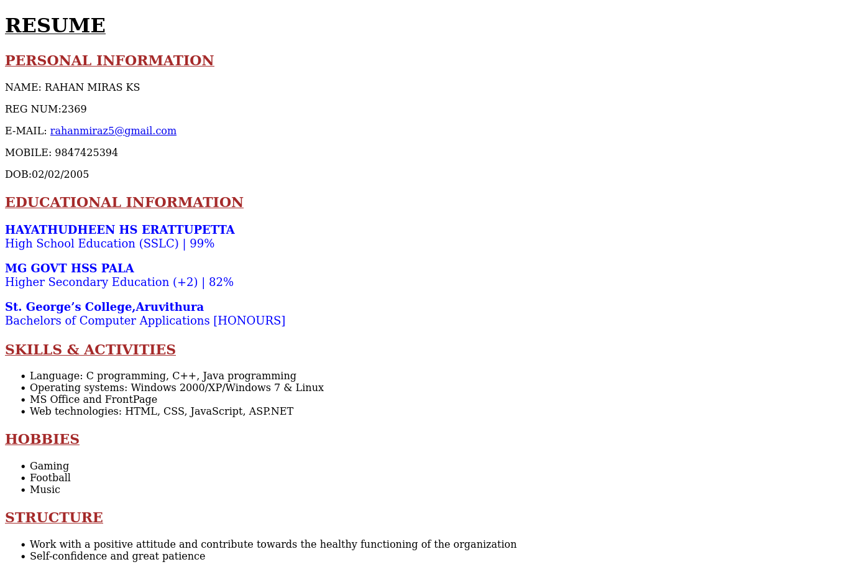
Output

Program 6
Use External CSS to format your time table created.
Aim
Use External CSS to format your time table created.

Program

<!DOCTYPE html>
<html>
<head>
<link rel="stylesheet" href="style3.css">
<title>Class time table</title>
<h2 align="centre">BCA SECOND SEM TIME TABLE</h2>
<table border="4" align="centre">
<tr>
<th></th>
<th>1st</th>
<th>2nd</th>
<th>3rd</th>
<th>4th</th>
<th>5th</th>
</tr>
<tr>
<td>DAY 1</td>
<td>DS</td>
<td>OS</td>
<td>ENGLISH</td>
<td colspan="2">WEB LAB</td>
</tr>
<tr>
<td>DAY 2</td>
<td>HINDI\MALAYALAM</td>
<td>DS</td>
<td>IC</td>
<td>MATHS</td>
<td>OS</td>
</tr>
<tr>
<td>DAY 3</td>
<td>DS</td>
<td>ENGLISH</td>
<td>HINDI\MALAYALAM</td>
<td>OS</td>
<td>MATHS</td>
</tr>
<tr>
<td>DAY 4</td>
<td>OS</td>
<td>DS</td>
<td>ENGLISH</td>
<td>MATHS</td>
<td>HINDI\MALAYALAM</td>
</tr>
<tr>
<td>DAY 5</td>
<td>DS</td>
<td>MATHS</td>
<td>IC</td>
<td>WEB</td>
<td>DS LAB</td>
</tr>
</head>
</html>

style3.css
h2
{
color: brown;
font-size:23px;
}

Output
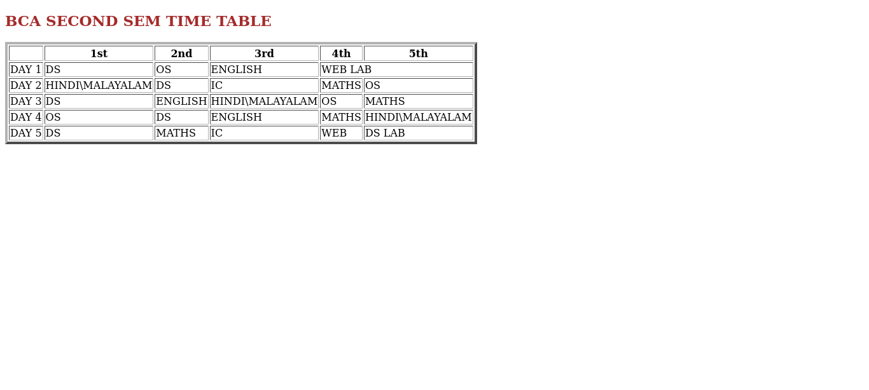

Program 7
Use all the CSS (inline, internal, and external) to format the college web page that you have created.

Aim
Use all the CSS (inline, internal, and external) to format the college web page that you have created.

Program
<!DOCTYPE html>
<html>
<head>
<link rel="stylesheet" href="style2.css">
<title>College</title>
</head>
<style>
p{
color:red;
font-size:19px;
}
</style>
<body>
<h2>ST.GEORGE'S COLLEGE ARUVITHURA</h2>
<p style="color:blue;font-size:18px;"><strong>St. George's College Aruvithura</strong> is a college under Mahatma Gandhi University, Kottayam. It is located in Aruvithura, Erattupetta, Kottayam District in Kerala, India. It was reaccredited with <strong>'A++' Grade by NAAC</strong> for seven years in the fourth cycle.</p>
<p><strong>St. George’s College Aruvithura</strong>, is a minority educational institution founded by St. George Forane Church, Aruvithura in 1965. Pioneered under the patronage of His Excellency Mar Sebastian Vayalil, the first Bishop of Pala, and cherished by a host of visionaries and philanthropists like Very Rev. Fr. Thomas Araythinal and Mr T. A. Thomman (Former Minister), the college, right from its inception, embarked on an odyssey towards academic pre-eminence. Very Rev. Fr. Thomas Manakkat, the founding manager and a great visionary, was truly instrumental in laying the foundations for a great beginning and Very Rev. Fr. Jacob Thazhathel, who followed him, was equally adept and insightful in his ideals, guiding the college during the early stages of its growth. For more than two decades, His Excellency Mar Joseph Pallickaparampil, the Bishop of Pala, had been the patron of the college. His Excellency Mar Joseph Kallarangattu is the present patron of this seat of learning.</p>
<img src="sgc.jpg" height="350" width="650"alt="college image">
<h3>PROGRAMMES</h3>
<ol>
<li>UG</li>
<li>PG</li>
<li>Phd</li>
<li>OPEN COURSE</li>
<li>CERTIFICATE COURSE</li>
</ol>
<h3>COURSES OFFERED</h3>

<h4>AIDED</h4>
<ol>
<li>B.Sc (Honours) Mathematics</li>
<li>B.Sc (Honours) Physics</li>
<li>B.Sc (Honours) Chemistry</li>
<li>B.Sc (Honours) Botany</li>
<li>B.A (Honours) Economics</li>
<li>B.A (Honours) Political Science</li>
<li>B A (Honours) English with Specialization in Media Studies & Film Studies</li>
<li>B.Com (Honours) with Specialization in Finance & Taxation</li>
<li>BCA (Honours) with Specialization in Data Science & Full Stack Development</li>
</ol>

<h4>SELF</h4>
<ol>
<li>B.Com(Honours)With Specialization in Finance & Taxation</li>
<li>B.Com(Honours)With Specialization in Finance & Taxation & Accounting</li>
<li>B.Com(Honours)With Specialization in Financial Markets & Logistics Management</li>
<li>B.A(Honours) Journalism & Mass Communication</li>
<li>B.Sc (Honours) Food Science & Quality Control with Specialization in in Food Safety</li>
<li>B.Voc Food Technology & Analysis</li>
<li>BCA (Honours) with Specialization in Artificial Intelligence and Machine learning & Full Stack Development</li>
</ol>

<h3>DEPARTMENTS</h3>

<ol>
<li>Department of Botany & Zoology</li>
<li>Department of Chemistry</li>
<li>Department of Commerce</li>
<li>Department of Computer Applications</li>
<li>Department of Economics</li>
<li>Department of English</li>
<li>Department of Food Science and Technology</li>
<li>Department of Hindi & Malayalam</li>
<li>Department of Mathematics & Statistics</li>
<li>Department of Physics</li>
<li>Department of Political Science & History</li>
</ol>

<h3>FACULTIES</h3>

<ul>
<li><a href="">Department of Botany & Zoology</a></li>
<li><a href="">Department of Chemistry</a></li>
<li><a href="">Department of Commerce</a></li>
<li><a href="">Department of Computer Applications</a></li>
<li><a href="">Department of Economics</a></li>
<li><a href="">Department of English</a></li>
<li><a href="">Department of Food Science and Technology</a></li>
<li><a href="">Department of Hindi & Malayalam</a></li>
<li><a href="">Department of Mathematics & Statistics</a></li>
<li><a href="">Department of Physics</a></li>
<li><a href="">Department of Political Science & History</a></li>
</ul>
<h3>LIBRARY</h3>
</body>
<li><a href="https://sgcaruvithura.ac.in/library">Library</a></li></ul>
Click here for more informations:<a href="https://sgcaruvithura.ac.in/index.html">College website</a>
</html>

style2.css
h3
{
color: violet;
font-size:23px;
}

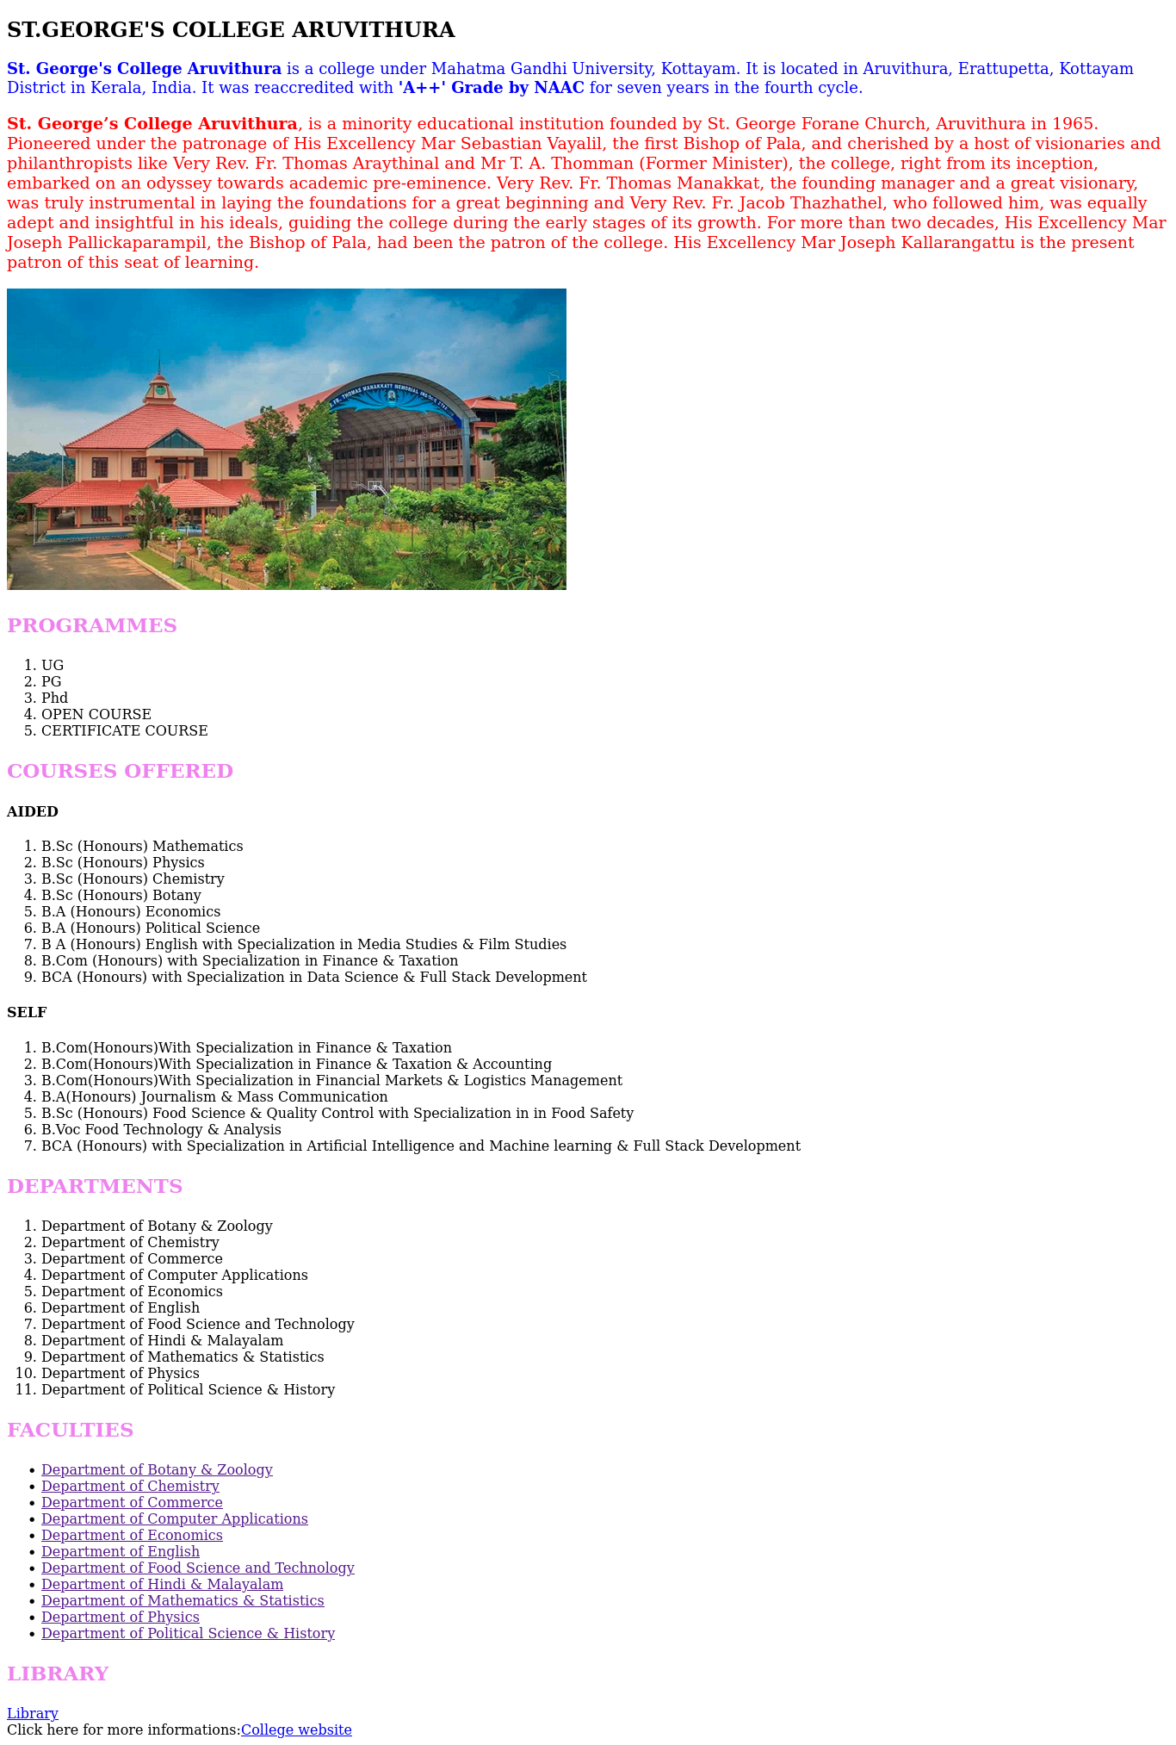
Output

Program 8
Write a HTML program to create your college website for mobile device .

Aim
Write a HTML program to create your college website for mobile device .

Program

<!DOCTYPE html>

<html>

<head>
<meta name="view port" content="width=device-width,initial-scale=1.0"
<link rel="stylesheet" href="style2.css">
<title>College</title>
</head>
<style>
p{
color:red;
font-size:19px;
}
</style>
<body>
<h2>ST.GEORGE'S COLLEGE ARUVITHURA</h2>
<p style="color:blue;font-size:18px;"><strong>St. George's College Aruvithura</strong> is a college under Mahatma Gandhi University, Kottayam. It is located in Aruvithura, Erattupetta, Kottayam District in Kerala, India. It was reaccredited with <strong>'A++' Grade by NAAC</strong> for seven years in the fourth cycle.</p>
<p><strong>St. George’s College Aruvithura</strong>, is a minority educational institution founded by St. George Forane Church, Aruvithura in 1965. Pioneered under the patronage of His Excellency Mar Sebastian Vayalil, the first Bishop of Pala, and cherished by a host of visionaries and philanthropists like Very Rev. Fr. Thomas Araythinal and Mr T. A. Thomman (Former Minister), the college, right from its inception, embarked on an odyssey towards academic pre-eminence. Very Rev. Fr. Thomas Manakkat, the founding manager and a great visionary, was truly instrumental in laying the foundations for a great beginning and Very Rev. Fr. Jacob Thazhathel, who followed him, was equally adept and insightful in his ideals, guiding the college during the early stages of its growth. For more than two decades, His Excellency Mar Joseph Pallickaparampil, the Bishop of Pala, had been the patron of the college. His Excellency Mar Joseph Kallarangattu is the present patron of this seat of learning.</p>
<img src="sgc.jpg" height="350" width="650"alt="college image">
<h3>PROGRAMMES</h3>
<ol>
<li>UG</li>
<li>PG</li>
<li>Phd</li>
<li>OPEN COURSE</li>
<li>CERTIFICATE COURSE</li>
</ol>
<h3>COURSES OFFERED</h3>

<h4>AIDED</h4>
<ol>
<li>B.Sc (Honours) Mathematics</li>
<li>B.Sc (Honours) Physics</li>
<li>B.Sc (Honours) Chemistry</li>
<li>B.Sc (Honours) Botany</li>
<li>B.A (Honours) Economics</li>
<li>B.A (Honours) Political Science</li>
<li>B A (Honours) English with Specialization in Media Studies & Film Studies</li>
<li>B.Com (Honours) with Specialization in Finance & Taxation</li>
<li>BCA (Honours) with Specialization in Data Science & Full Stack Development</li>
</ol>

<h4>SELF</h4>
<ol>
<li>B.Com(Honours)With Specialization in Finance & Taxation</li>
<li>B.Com(Honours)With Specialization in Finance & Taxation & Accounting</li>
<li>B.Com(Honours)With Specialization in Financial Markets & Logistics Management</li>
<li>B.A(Honours) Journalism & Mass Communication</li>
<li>B.Sc (Honours) Food Science & Quality Control with Specialization in in Food Safety</li>
<li>B.Voc Food Technology & Analysis</li>
<li>BCA (Honours) with Specialization in Artificial Intelligence and Machine learning & Full Stack Development</li>
</ol>

<h3>DEPARTMENTS</h3>

<ol>
<li>Department of Botany & Zoology</li>
<li>Department of Chemistry</li>
<li>Department of Commerce</li>
<li>Department of Computer Applications</li>
<li>Department of Economics</li>
<li>Department of English</li>
<li>Department of Food Science and Technology</li>
<li>Department of Hindi & Malayalam</li>
<li>Department of Mathematics & Statistics</li>
<li>Department of Physics</li>
<li>Department of Political Science & History</li>
</ol>

<h3>FACULTIES</h3>

<ul>
<li><a href="">Department of Botany & Zoology</a></li>
<li><a href="">Department of Chemistry</a></li>
<li><a href="">Department of Commerce</a></li>
<li><a href="">Department of Computer Applications</a></li>
<li><a href="">Department of Economics</a></li>
<li><a href="">Department of English</a></li>
<li><a href="">Department of Food Science and Technology</a></li>
<li><a href="">Department of Hindi & Malayalam</a></li>
<li><a href="">Department of Mathematics & Statistics</a></li>
<li><a href="">Department of Physics</a></li>
<li><a href="">Department of Political Science & History</a></li>
</ul>
<h3>LIBRARY</h3>
</body>
<li><a href="https://sgcaruvithura.ac.in/library">Library</a></li></ul>
Click here for more informations:<a href="https://sgcaruvithura.ac.in/index.html">College website</a>
</html>

style2.css
h3
{
color: violet;
font-size:23px;
}

Output

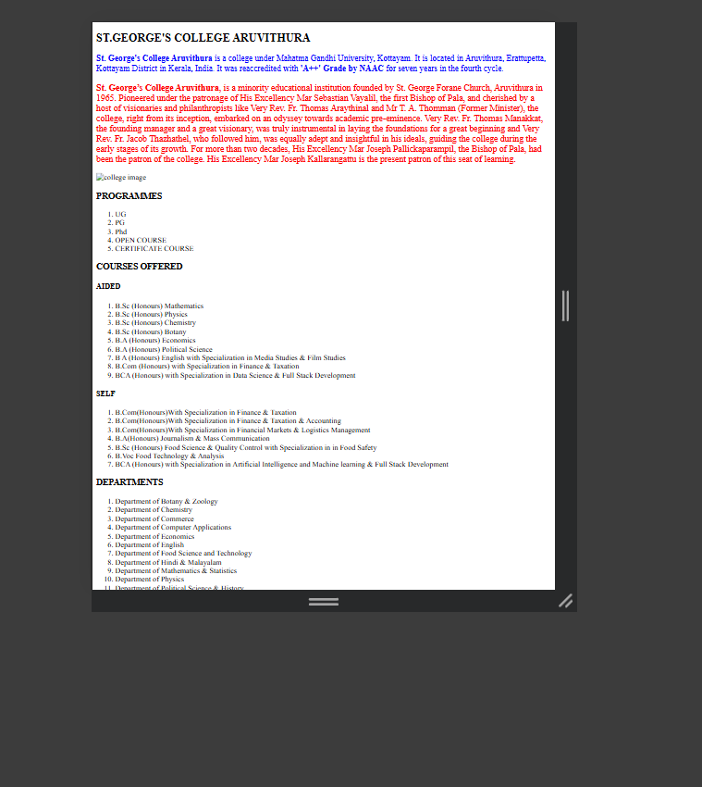

Program 9
Write an HTML/Javascript page to create a login page with validations.

Aim
Write an HTML/Javascript page to create a login page with validations.

Program
<!DOCTYPE html>
<html>
<head>
<title>LOGIN</title>
</head>
<body>
<h2 align="center">Welcome to Login Page</h2>
Username:<input type="text" id="username" placeholder="name"><br><br>
Password:<input type="password" id="password"
placeholder="username"><br><br>
<input type="submit" value="Submit" id="btn" onclick="checkvalue()">
<script>
function checkvalue()
{
let username=document.getElementById("username").value;
if(username.trim() === "")
{
alert("Username is required!");
return;
}
let password=document.getElementById("password").value;
if(password.length<6 || password.length>12)
{
alert("Password must be 6 to 12 characters!");
return;
}
document.getElementById("otp").innerHTML="Login Successful!";
}
</script>
<p id="otp"></p>
</body>
</html>

Output
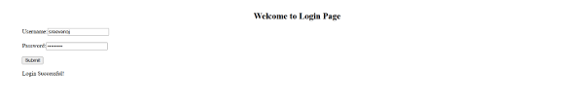

Program 10
Develop a Simple calculator for addition, subtraction, multiplication and division operation using Javascript.

Aim
Develop a Simple calculator for addition, subtraction, multiplication and division operation using Javascript.

Program
<!DOCTYPE html>
<html>
<head>
<title>Calculator</title>
</head>
<body>
<h3 align="center">Simple Calculator</h3>
<input type="number" id="A" placeholder="First number">
<input type="number" id="B" placeholder="Second number">
<br><br>
<input type="text" maxlength="1" id="op" placeholder="Which operation">
<input type="button" id="btn" value="submit">
<p id="output"></p>
<script>
document.getElementById("btn").addEventListener("click",function()
{
let x = Number(document.getElementById("A").value);
let y = Number(document.getElementById("B").value);
let op = document.getElementById("op").value;
let result;
switch(op)
{
case '+':
result = x+y;
break;
case '-':
result = x-y;
break;
case '*':
result = x*y;
break;
case '/':
result = x/y;
break;
default:
document.write("Invalid choice");
}
document.getElementById("output").innerHTML="The result is: "+result;
});
</script>
</body>
</html>

Output
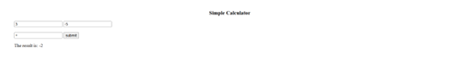

Program 11
Use Regular Expressions for validations in Login Page using JavaScript.

Aim
Use Regular Expressions for validations in Login Page using JavaScript.

Program
<!DOCTYPE html>
<html>
<head>
<title>loginpage</title>
<script>
function checkvalue()
{
let user=document.getElementById("email").value;
let pattern=/\w+@\w+\.\w+/;
if(pattern.test(user))
{
console.log("Correct");
}
else
{
alert("username is incorrect");
return;
}
let password=document.getElementById("password").value;
if(password.length<4 || password.length>8)
{
alert("password must contain 4 to 8 characters");
return;
}
document.getElementById("output").innerHTML="Login successful";
}
</script>
</head>
<body>
<h2 align="center">Welcome to Login!!</h2>
Username:<input type="email" id="email"
placeholder="name@gamil.com"><br><br>
Password:<input type="password" id="password" placeholder="abc"><br><br>
<input type="submit" value="submit" id="btn" onclick=checkvalue()>
<p id="output"></p>
</script>
</body>
</html>

Output
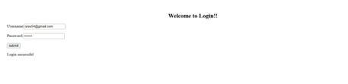

Program 12
Write a Program to retrieve date from a text file and display it using AJAX.

Aim
Write a Program to retrieve date from a text file and display it using AJAX.

Program
<!DOCTYPE html>
<html>
<head>
<title>AJAX JSON Example</title>
</head>

<body>

<h2>Student List</h2>

<button onclick="loadStudents()">Load Students</button>

<ul id="result"></ul>

<script>

function loadStudents()
{
let xhr = new XMLHttpRequest();

xhr.open("GET", "students.json", true);

xhr.onload = function()
{
let students = JSON.parse(xhr.responseText);

let output = "";

for (let i in students)
{
output += "<li>" + students[i].name +
" - " + students[i].course +
" - " + students[i].mark +
"</li>";
}

document.getElementById("result").innerHTML = output;
};

xhr.send();
}

</script>

</body>
</html>

students.json
[
{"name": "Arun", "course": "BCA", "mark": 85},
{"name": "Meera", "course": "BCA", "mark": 91},
{"name": "Rahul", "course": "BCA", "mark": 78},
{"name": "Anjali", "course": "BCA", "mark": 88}
]

Output
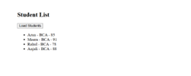

Program 13
Create a web page using Frame with rows and columns where we will have header frame, left frame, right frame, and status bar frame. On clicking in the left frame, information should be displayed in the right frame.

Aim
Create a web page using Frame with rows and columns where we will have header frame, left frame, right frame, and status bar frame. On clicking in the left frame, information should be displayed in the right frame.

Program
<!DOCTYPE html>
<html>
<head>
<title>frame</title>
<frameset rows="20%,70%,10%">
<frame src="header.html" name="header">
<frameset cols="50%,50%">
<frame src="left.html" name="left">
<frame src="right.html" name="right">
</frameset>
<frame src="status.html" name="status">
</frameset>
</head>
</html>
header.html
<!DOCTYPE html>
<html>
<head><title>header</title>
<style>
h1{
color:#60128a;
}
</style>
<body>
<h1 align="center">My Website</h1>
</body>
</html>

right.html
<!DOCTYPE html>
<html>
<head>
<title>right</title>
</head>
<body>
<h2 align="center">Result</h2>
</body>
</html>

left.html
<!DOCTYPE html>
<html>
<head><title>header</title></head>
<body>
<ul>
<li><a href="name.html" target="right">Name</a>
</li>
<li><a href="address.html" target="right">Address</a>
</li>
<li><a href="contact.html" target="right">Contact</a>
</li>
</ul>
</body>
</html>

name.html
<!DOCTYPE html>
<html>
<head>
<title>Name</title>
</head>
<body>
<h2 align="center">Personal Information</h2>
<p align="center">Name: Sreelakshmi</p>
<p align="center">Age: 20</p>
</body>
</html>

address.html
<!DOCTYPE html>
<html>
<head>
<title>Address</title>
</head>
<body>
<h2 align="center">Address Details</h2>
<p align="center">Place: Thrissur</p>
<p align="center">State: Kerala</p>
<p align="center">Country: India</p>
</body>
</html>

contact.html
<!DOCTYPE html>
<html>
<head>
<title>Contact</title>
</head>
<body>
<h2 align="center">Contact Details</h2>
<p align="center">Phone: 1234567890</p>
<p align="center">Email: example@gmail.com</p>
</body>
</html>

status.html
<!DOCTYPE html>
<html>
<head>
<title>Status</title>
</head>
<body>
<h3 align="center">Welcome! Click on the links to see details.</h3>
</body>
</html>

Output
