

Jagannath University,Dhaka

Department of Computer Science & Engineering

Report  
on  
Internet & Web Programming (Project)

Course Code:CSE-3109

Submitted to  
Nazia Alam

Lecturer  
Department of Computer Science & Engineering

Submitted by  
MD.Rahat Hasan (B160305019)

Table of Contents

1.0 Introduction 3

1.1 Objective 3

1.2 Motivation 4

2.0 Background Story 6

3.0 Proposed Work 7

3.1 Features 7

3.2 Detail Description of Pages: 8

3.2.2 PHP Server Side Pages: 9

3.3 Snapshots: 11

3.4 Access of different type of user’s: 15

3.5 Description of Database: 15

3.6 Entity relationship diagram: 20

3.7 Use Case Diagram: 20

3.8 Language: Programming Language 22

4.0 Conclusion 25

4.1 Experience: 25

4.2 Future Work: 25

1.0 Introduction

Nearly everyone goes on a vacation and a Tourism management system would play a vital role in planning the perfect trip. The tourism management system allows the user of the system access all the details such as weather, location, events, etc. The main purpose is to help tourism companies to manage customer. The system can also be used for both professional and business trips.

* Normalization and Dependencies are handled
* Queries useful for the user of the database
* The Queries are translated into relational algebra

The project “Tourism Management System,” deals with the traveling places of Bangladesh in North, East, West, South directions. It shows their prices and traveling time of each place. The user is free to choose any package according to the flexibility of prices of location, timing and mode of traveling etc. This is the very interactive project. The user needs not to go many places to search about the traveling place. He can book it by using this project. He can also cancel the book package.

This system is designed in editor with SQL Server as back end. All the data will be stored in the server and in case of any data loss situation, a backup will be available by this server. The software is being designed in such a way that all the details related to every aspect of tourism will be available separately and the customers and agents will not have to go through any of the problem. They just have to click once and all the details will become available to them.

This project can be run in any traveling agency to support the travelers. The project is made by keeping in view the problems of customers. And this project will solve their problems by giving them proper guidance.

1.1 Objective

The main objective of developing “Tourism Management System” is to provide the good facilities & technology. It provides the staff as well as customer a well- maintained friendly environment and makes

process easy to use. Every industry wants to give the best service to the customer and this was one of the main objectives to develop the system.

The primary objectives behind the development of “Tourism Management System” are as follows:-

* This management system is designed keeping in view the easiness from management as well as operators point of view.
* Quick & fast service to the customer
* Provide the friendly and attractive environment
* Provide availability of all products
* Make each and every transaction computerized
* Remove chances of errors in billing.

1.2 Motivation

For many people, tourism is a way of satisfying their psychological needs such as travelling, performing leisure activities, exploring novelty and capabilities, self-expression and self-assurance, creativity, competition, need for relaxation, and belongingness.

The intrinsic motivation drives the tourists to opt for tourism for intangible rewards such as fun, assurance, and other emotional needs.

Internal Factors of Motivation

Internal factors arouse, direct, and integrate a person’s behavior and influence his decisions for travelling.

* Intrinsic Motivation − For many people, tourism is a way of satisfying their psychological needs such as travelling, performing leisure activities, exploring novelty and capabilities, self-expression and self-assurance, creativity, competition, need for relaxation, and belongingness. The intrinsic motivations pertaining to assuring one’s capabilities on different emotional fronts. Intrinsic motivation drives the tourists to opt for tourism for intangible rewards such as fun, assurance, and other emotional needs. The other intrinsic factors of motivation are
  + Attitudes of Tourist − Knowledge of a person, place, or object + Positive or negative feelings about the same.
  + Tourist’s Perception − By observing, listening, or getting knowledge, a tourist forms the perception about a place, person, or an object.
  + Values or Beliefs − A tourist believes or values a specific mode of conduct which is acceptable personally or socially.
  + Personality of the Tourist − The nature and physique of a tourist plays an important role towards motivation in tourism.

External Factors of Motivation

There are external motives in tourism that can influence tourists and pull them towards a certain motivation and subsequent decision.

* Extrinsic Motivation − Here, a tourist gets motivated by external factors such as money and the need to feel competent on the scale of expenditure and performance.
* Place of Origin − The grooming of the tourist depends upon the place of its origin. For example, for the Indian married women, tourism might come last in the list of preferential things they wish to do whereas for American ladies, tourism would acquire much higher rank.
* Family and Age − The family matters when it comes to the structure and the income. Today, the families with nuclear structure and double income tend to opt for long distance, extravagant tourism more than joint families or families with single earning member who are interested in visiting domestic places. The tourists also have different preferences of places according to their age. For example, tourists in the age group of 5 to 45 years might enjoy visiting destination in the USA such as Disneyland more than senior citizens.
* Culture or Social Class − Tourists of different cultures prefer different places, events, and different types of tourism. In addition, if friends and families who have visited a place earlier spread the first hand information that motivates the others to visit the place too.
* Market − Ever-changing market variables alter tourism. Changes in value of currency, political situations, and economic well-being of the country influence the decisions of a tourist.

2.0 Background Story

Background of the study is the measure of how beneficial the development of an information system would be to an organization. The main aim in background study activity is to determine whether it is financially and technically feasible to develop the website. The background study activity involves the analysis of the problem and collecting relevant information relating to the website which would be required in the processing by the system.

In the existing system, all the records are not kept perfectly because all the work is done manually, so keeping up to date details of the packages is not done. Amount of the overall trips are kept in documents and the calculations done are manually which made lead to huge mistakes.  
Thus, the existing system is very time consuming and being manual work sometimes lead to a great loss as well.

The proposed system is highly automated and makes the travelling activities much easier and flexible. The user can get the right information at the right time. This will increase the trust of the customer into the travel company as well.

Once bookings are confirmed all the relevant details related to the trip will be available to the client. They just need to click using mouse and everything is made available to them.

3.0 Proposed Work

3.1 Features

In our project we have two types of features. Common features that is visible for all.

Authorized features that are only for the registered people.

Authorized Features

|  |  |
| --- | --- |
| Dashboard  Users list  Package list  Feedback list | Tour History  Bookings |

Common Features

|  |  |
| --- | --- |
| Home  Packages | Privacy Policy  Contact |

3.2 Detail Description of Pages:

3.2.1 Detail Description of Website Pages:

Description of the website pages are as per mentioned here for the better understanding of the project.

Detail of common Pages:

Home:  
Description about our Tourism Management site.

Packages:   
Full description of packages like type, destination ,price . In this page , user can find their desired packages according to their capability and also can book packages after sign in .

Privacy Policy:

Privacy issue and terms to use our site.

Contact:  
Contact information. User /guest user may contact through this information.

Detail of Authorized Pages (Registered Users):

Home:  
Description of some popular Packages and user can book those via online.

Profile:   
User can see his/her profile and change its password if needed.

Tour History:   
User can see his/her tour history.

Payment:

User can see the full procedure about payment method.

Feedback:  
Can give feedback about the services

Detail of Authorized Pages (Admin):

Dashboard  
A glimpse of total users, total packages and total bookings.

Manage Packages:   
Admin can edit packages.

Add Packages:   
New packages can be added.

Users and Feedback:

Track the total number of users , their bookings and their valuable feedback.

Booking :

Admin can confirm booking as well as cancel it

## 3.2.2 PHP Server Side Pages:

Sign Up:

To be the member of this website people will have to register them. For registration, some personal details will be asked on the portal.

Name: Each user will have to provide his/her name.

Email ID – The email id is also necessary field. The email id can be used to recover the password and all the important information regarding the user.

Password: The user will have to enter the password of his / her choice so that he/she easily remembers. The password will be used to authenticate the user.

Retype password: The user must re-type password to confirm the given password is correct.

Login:

After successful completion of the registration process, the user can log into users account by entering the unique id, which will be sent to the user via email, and the password user provides at the time of registration.

If only and if the username and password combination match with the data stored in the system, the user is granted access to the website.

Sign Out:

This option is used to signing out from the site after the authorized user is done with the browsing session to this site. There won’t be any automatic login system. The user must sign out to get out of the site. This is not mandatory though.

## 

## 

## 

## 

## 

## 

## 

3.3 Snapshots:

Guest User View :

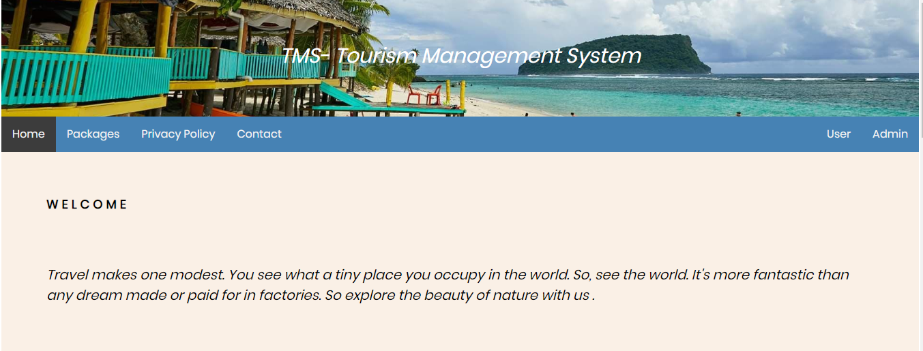

Registered User View :

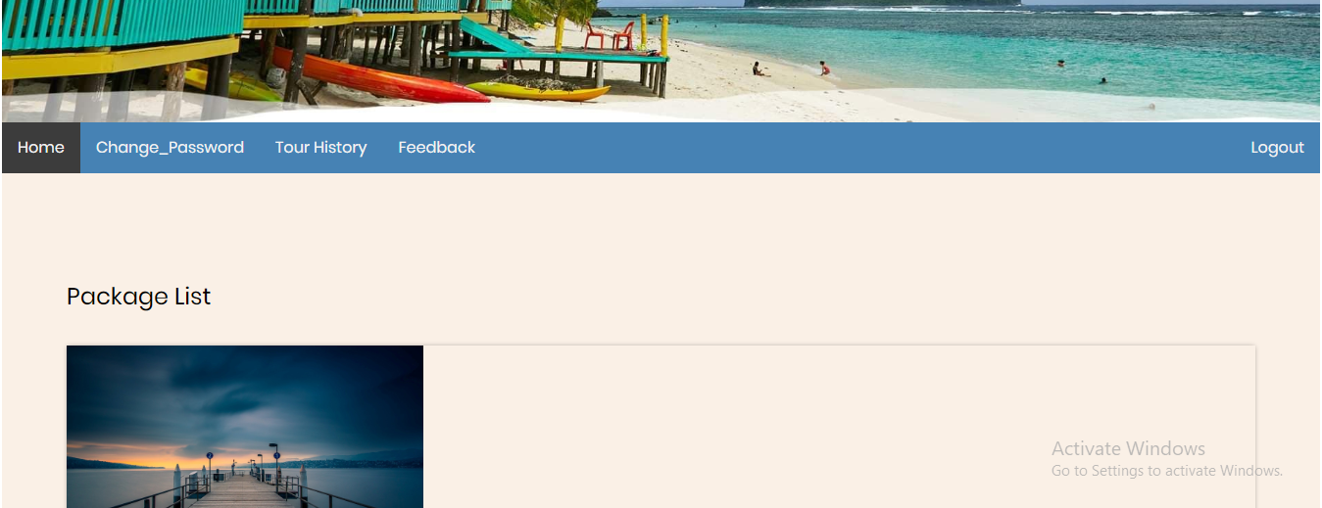

Admin view :

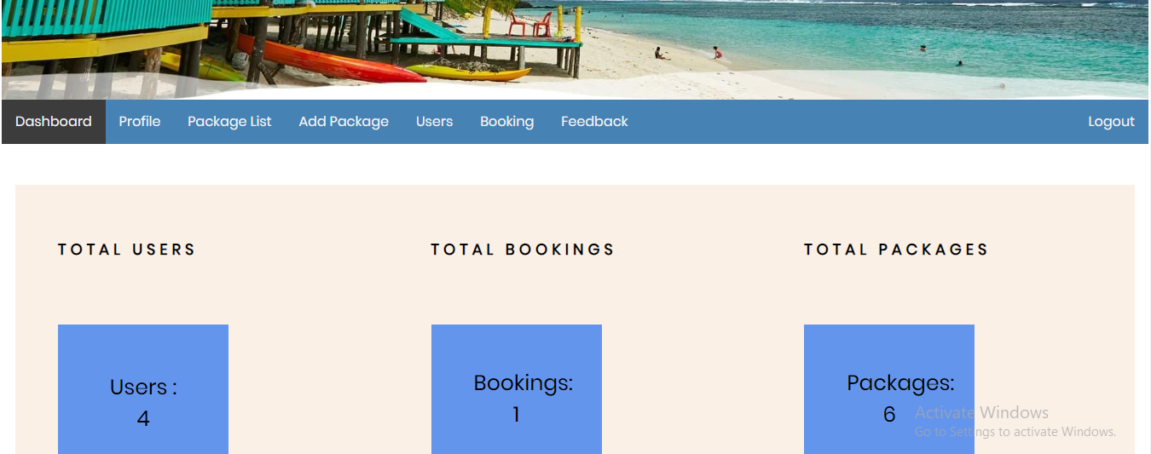

Booking form :

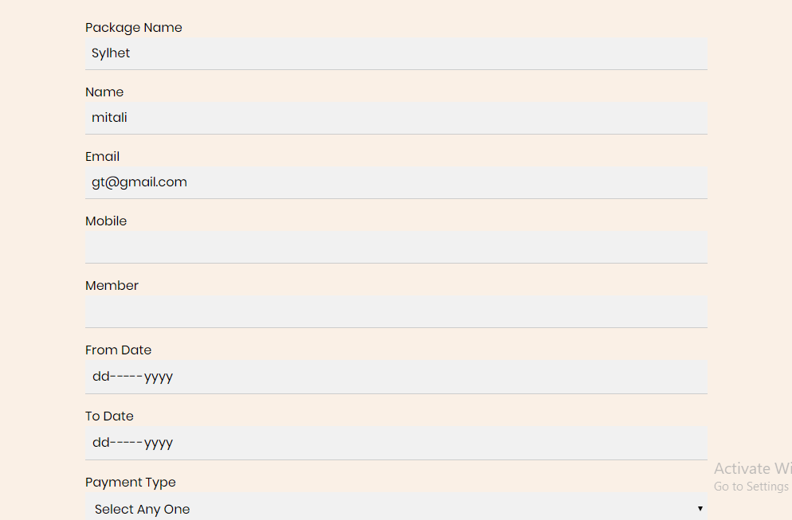

Registration form :

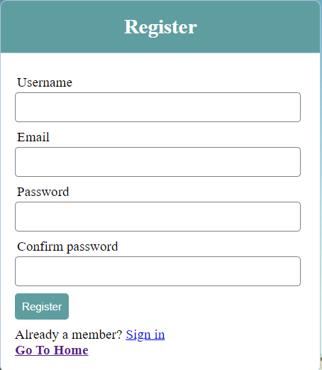

Login form

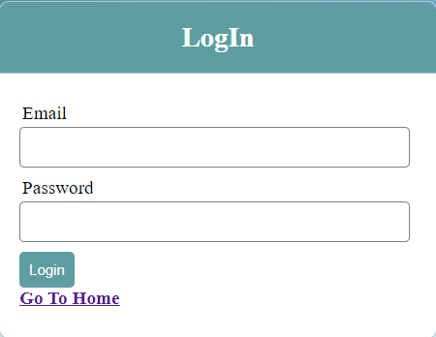

3.4 Access of different type of user’s:

In our website there are three types of users:

Guest Users-

Visit the Website

Guest user can make enquiries

Admin-

Manage packages(Create ,Update )

Manage Users

Manage Enquiries

Manage Booking

User (Tourist)

User can register herself.

User can login with email and password.

Tour Booking.

Manage profile.

3.5 Description of Database:

A database is a collection of information that is organized so that it can be easily accessed, managed. It is a data structure that stores organized information.

Database (also called electronic database) is any collection of data, or information that is specially organized for rapid search and retrieval by a computer. However, today's relation a database allow users to access, update, and search information based on the relationship of data stored in different tables.

In our database we have five tables:

Package

User

Booking

Feedback

Admin

Table: 1 admin table

|  |  |  |  |
| --- | --- | --- | --- |
| Attribute Name | Datatype | Size | Constraint |
| id | INT | 10 | PRIMARY |
| UserName | VARCHAR | 25 | NOT NULL |
| Password | INT | 10 | NOT NULL |
| UpdationDate | TIMESTAMP | --- | NOT NULL |

Table: 2 feedback table

|  |  |  |  |
| --- | --- | --- | --- |
| Attribute Name | Datatype | Size | Constraint |
| F_ID | INT | 10 | PRIMARY |
| Id | INT | 10 | NOT NULL |
| Name | VARCHAR | 25 | NOT NULL |
| Email | VARCHAR | 25 | NOT NULL |
| Comment | TEXT | --- | NOT NULL |
| PostingDate | TIMESTAMP | --- | NOT NULL |

Table: 3 user table

|  |  |  |  |
| --- | --- | --- | --- |
| Attribute Name | Datatype | Size | Constraint |
| Id | INT | 10 | PRIMARY |
| username | VARCHAR | 25 | NOT NULL |
| email | VARCHAR | 25 | NOT NULL |
| password | INT | 10 | NOT NULL |
| RegDate | TIMESTAMP | ----- | NOT NULL |
| UpdationDate | TIMESTAMP | ---- | NOT NULL |

Table: 4 package table

|  |  |  |  |
| --- | --- | --- | --- |
| Attribute Name | Datatype | Size | Constraint |
| P_ID | INT | 10 | PRIMARY |
| P_Name | VARCHAR | 25 | NOT NULL |
| P_Type | VARCHAR | 25 | NOT NULL |
| Place | VARCHAR | 25 | NOT NULL |
| p_image | VARCHAR | 255 | NOT NULL |
| Feature | TEXT | ----- | NOT NULL |
| Price | INT | 10 | NOT NULL |
| CreationDate | TIMESTAMP | ----- | NOT NULL |
| UpdationDate | TIMESTAMP | ---- | NOT NULL |

Table: 5 booking table

|  |  |  |  |
| --- | --- | --- | --- |
| Attribute Name | Datatype | Size | Constraint |
| B_ID | INT | 10 | PRIMARY |
| Id | INT | 10 | NOT NULL |
| username | VARCHAR | 25 | NOT NULL |
| Email | VARCHAR | 25 | NOT NULL |
| mobile | INT | 15 | NOT NULL |
| P_ID | INT | 10 | NOT NULL |
| P_Name | VARCHAR | 25 | NOT NULL |
| FromDate | DATE | ----- | NOT NULL |
| ToDate | DATE | ------ | NOT NULL |
| Payment_Type | VARCHAR | 25 | NOT NULL |
| Price | INT | 10 | NOT NULL |
| Paid_Price | INT | 10 | NOT NULL |
| Remaining_Price | INT | 10 | NOT NULL |
| member | INT | 255 | NOT NULL |
| T_ID | INT | 10 | NOT NULL |
| RegDate | TIMESTAMP | ----- | NOT NULL |
| UpdationDate | TIMESTAMP | ---- | NOT NULL |
| Status | INT | 11 | NOT NULL |
| Action | VARCHAR | 25 | NOT NULL |

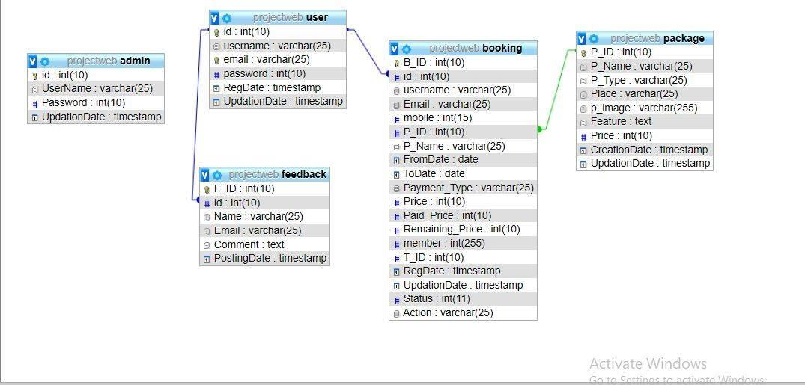

Fig: Database Configuration

## 

3.6 Entity relationship diagram:

This is a higher-level data model that is based on a perception of a real world that consists of a collection of basic objects, called entities and of relationships among these objects.Heretherelationshipistheassociationamongseveralentities.More specifically, entity-relationshipmodelisawidelyusedmodelthatprovidesaconvenient graphical representation to view data, relationships and constraints.

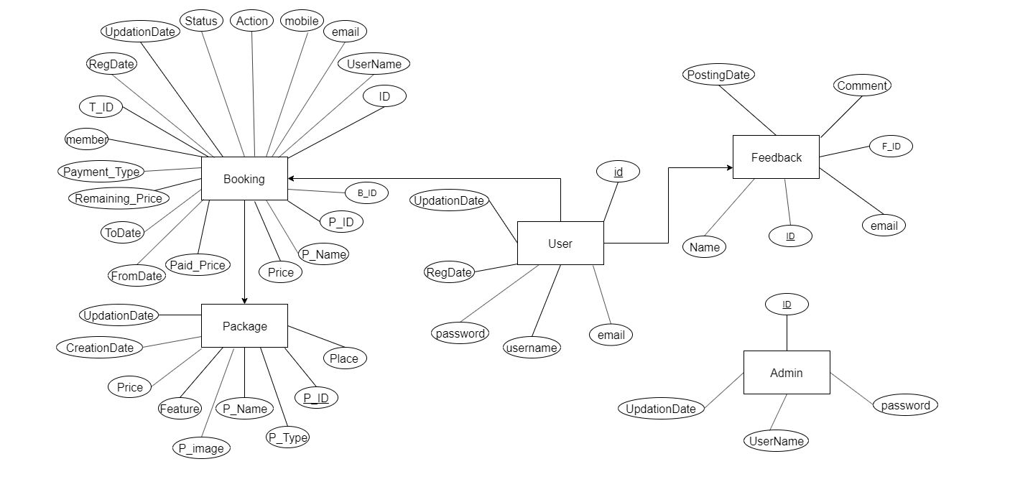

Fig: ER diagram

3.7 Use Case Diagram:

Use case diagram is a graphic depiction of the interactions among the elements of a system. The diagram doesn't go into a lot of detail—for example; don't expect it to model the order in which steps are performed. Instead, a proper use case diagram depicts a high-level overview of the relationship between use cases, actors, and systems. A use case diagram contains four components:

The boundary, which defines the system of interest in relation to the world around it.

The actors, usually individuals are involved with the system defined according to their roles.

The use cases, which the specific roles are played by the actors within and around the system.

The relationships between and among the actors and the use cases.

There are three use case diagrams in the website (for admin, guest and registered user).

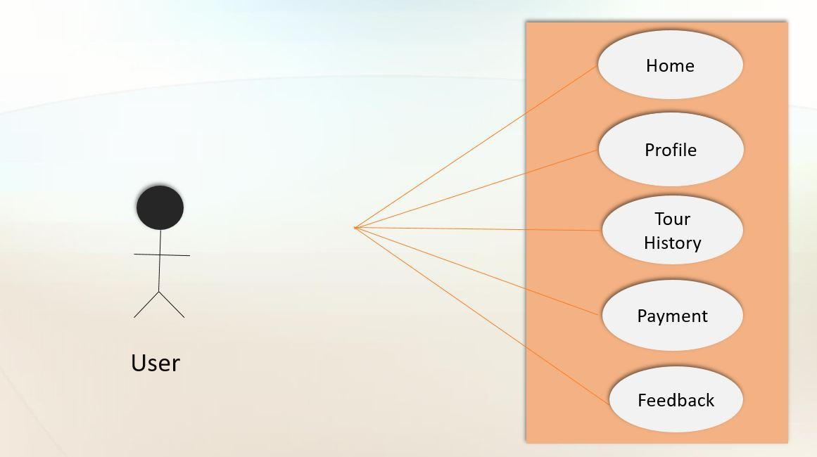

Fig : Use Case Diagram For Registered User

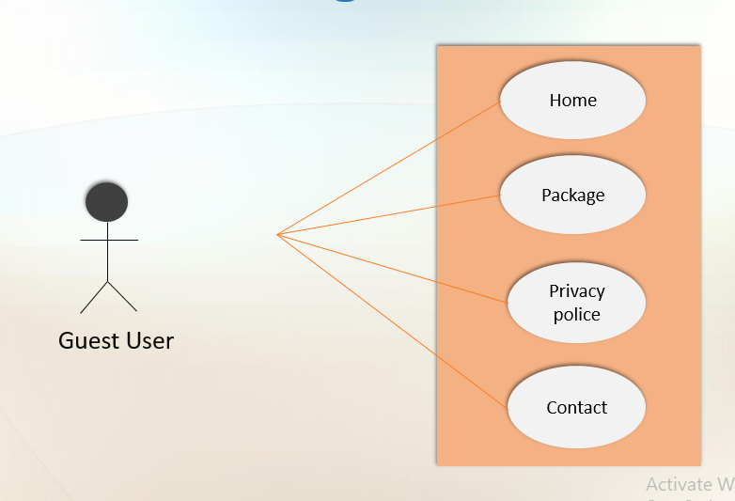

Fig: For Guest User

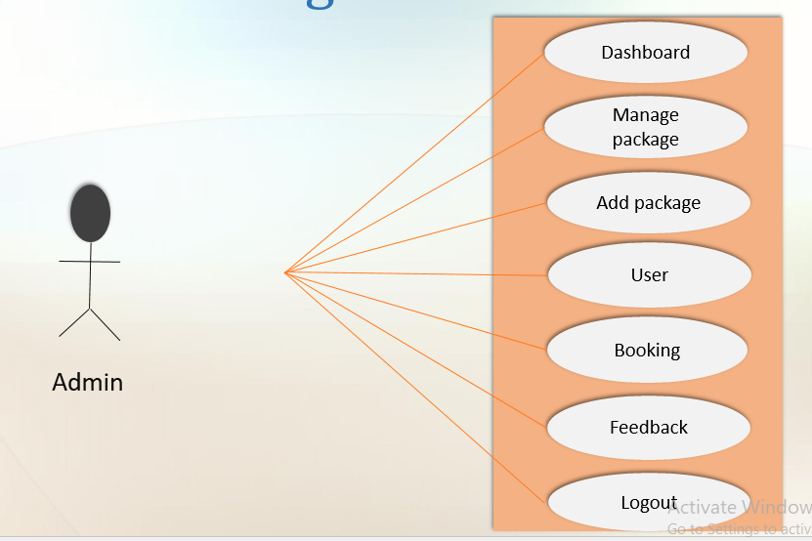

Fig: For Admin

3.8 Language: Programming Language

A programming language is a computer language to create a standard form of commands. These commands can be interpreted into a code understood by a machine. Programs are created through programming languages to control the behavior and output of a machine through accurate algorithms, similar to the human communication process.

One scripting languages have been used to build this project. This language is server side. The server side scripting language is PHP. We have chosen PHP as a server side scripting languages for reasons; it is an open source, robust, platform independent language.

PHP (Hypertext Pre Processor)

PHP recursive acronym for Hypertext Preprocessor is a widely-used open source general-purpose scripting language that is especially suited for web development and can be embedded into HTML. Instead of lots of commands to output HTML, PHP pages contain HTML with embedded code. The PHP code is enclosed in special start and end processing instructions PHP and that allow programmer to jump into and out of PHP mode. PHP is a server-side scripting language for creating dynamic Web pages. One can create pages with PHP and HTML.

In addition to manipulating the content of web pages, PHP can also send HTTP headers. We can set cookies, manage authentication, and redirect users. It offers excellent connectivity to many databases (and ODBC), and integration with various external libraries that let you do everything from generating pdf documents to parsing XML. PHP goes right into Web pages, so there’s no need for a special development environment or IDE.

PHP’s language syntax is similar to C’s and Perl’s. Programmer doesn’t have to declare variables before use them, and it’s easy to create arrays and hashes. PHP even has some rudimentary object-oriented features, providing a helpful way to organize and encapsulate code.

Design Tools

Design tools are objects, media, or computer programs, which can be used to design. They may influence the process of production, expression and perception of design ideas and therefore need to be applied skillfully.

HTML (Hyper Text Markup Language)

Hypertext markup language (HTML) is the major markup language used to display Web pages on the Internet. In other words, Web pages are composed of HTML, which is used to display text, images or other resources through a Web browser.

All HTML is plain text, meaning it is not compiled and may be read by humans. The file extension for an HTML file is .html or .html.

When a Web developer builds an application, the work is performed on the server, and raw HTML is sent out to the user. HTML was never designed for the Web that exists today, as it is just a markup language with severe limitations, in terms of control and design. Numerous technologies have been used to work around this issue - the most significant being cascading style sheet (CSS).

CSS (Cascading Style Sheets)

Cascading Style Sheets (CSS) is a standard (or language) that describes the formatting of markup language pages. CSS defines formatting for the following document types:

* Hyper Text Markup Language (HTML)
* Extensible Hyper Text Markup Language (XHTML)
* Extensible Markup Language (XML)
* Scalable Vector Graphic (SVG)
* XML User Interface Language (XUL)

CSS enables developers to separate content and visual elements for greater page control and flexibility. A CSS file is normally attached to an HTML file by means of a link in the HTML file.

HTML document formatting was tedious and complex before CSS because of built-in HTML style attributes. Specifically, styled tags required detailed and repetitious descriptions of the following elements:

* Font colors
* Background styles
* Element alignments
* Borders
* Sizes

CSS structurally defines elements for headings (h1), sub-headings (h2), sub-sub-headings (h3) etc. Element options are available for font, color, emphasis, size, etc.

CSS allows developers to move styling elements to a separate HTML area for clean markup. For example, if a developer wanted to change the font for all h2 headings in an HTML file, a single change could be made to the attached CSS file. If no CSS file was attached, the developer would have to change the font option for each h2 heading in the main HTML file.

JavaScript (JS):

JavaScript, often abbreviated as JS, is a high-level, interpreted programming language. It is a language which is also characterized as dynamic, weakly typed, prototype-based and multi-paradigm. Alongside HTML and CSS, JavaScript is one of the three core technologies of the World Wide Web.

Software and Tools:

* PHP
* My SQL
* JAVASCRIPT
* HTML.
* CSS
* XAMPP

# 

# 

# 

4.0 Conclusion

The Main objective of this Tourism Management project is to make the travel easy and comfortable for the users. But our site cannot able to provide all the facilities like about hotel information, transport system, deciding travel route automatically etc.

4.1 Experience:

* Our knowledge has been enriched in server side works
* Increased communication skills.

4.2 Future Work:

* Provide hotel information, transport system.
* Increased the capability of admin panel, admin will be able to delete package.
* Increased the website security.