

**Faculty of Engineering & Technology**

***Department of Information and Communication Engineering***

***PRACTICAL LAB REPORT***

**Course Code:** *ICE-* *4104.*

**Course Title:** Cellular and Mobile Communication Sessional*.* .

|  |  |
| --- | --- |
| **Submitted by:**  **Name: MD RAHATUL RABBI**  **Roll:** **190609**  **Session: 2018-2019**  **4th year 1st Semester**  **Department of ICE**,  **Pabna university of Science and Technology** | **Submitted to:**  **Dr. Md. Imran Hossain**  **Associate Professor**  **Department of ICE,**  **Pabna University of Science and Technology**  **Teacher’s Signature** |

**INDEX**

1. If a total of 33 MHz of bandwidth is allocated to a particular FDD cellular telephone system which uses two 25 kHz simplex channels to provide full duplex voice and control channels, compute the number of channels available per cell if a system uses-

(a) 4-cell reuse. (b) 7-cell reuse. (c) 12-cell reuse.

If 1 MHz of the allocated spectrum is dedicated to control channels, determine an equitable distribution of control channels and voice channels in each cell for each of the three systems.

1. If a signal to interference ratio of 15 dB is required for satisfactory forward channel performance of a cellular system, what is the frequency reuse factor and cluster size that should be used for maximum capacity if the path loss exponent is-
2. n = 4. (b) n = 3.

Assume that there are 6 co-channels cells in the first tier and all of them are at the same distance from the mobile. Use suitable approximations.

1. How many users can be supported for 0.5% blocking probability for the following number of trunked channels in a blocked calls cleared system?
2. 1, (b) 5, (c) 10, (d) 20, (e) 100.

Assume each user generates 0.1 Erlangs of traffic.

1. An urban area has a population of 2 million residents. Three competing trunked mobile networks (systems A, B, and C) provide cellular service in this area. System A has 394 cells with 19 channels each, system B has 98 cells with 57 channels each, and system C has 49 cells, each with 100 channels. Find the number of users that can be supported at 2% blocking if each user averages 2 calls per hour at an average call duration of 3 minutes. Assuming that all three trunked systems are operated at maximum capacity, compute the percentage market penetration of each cellular provider.
2. A certain city has an area of 1,300 square miles and is covered by a cellular system using a 7-cell reuse pattern. Each cell has a radius of 4 miles and the city is allocated 40 MHz of spectrum with a full duplex channel bandwidth of 60 kHz. Assume a GOS of 2% for an Erlang B system is specified. If the offered traffic per user is 0.03 Erlangs, compute-
3. The number of cells in the service area,
4. The number of channels per cell,
5. Traffic intensity of each cell,
6. The maximum carried traffic,
7. The total number of users that can be served for 2% GOS,
8. The number of mobiles per channel, and
9. The theoretical maximum number of users that could be served at one time by the system.
10. If a transmitter produces 50 watts of power, express the transmit power in units of

a) dBm, and b) dBW.

If 50 watts is applied to a unity gain antenna with a 900 MHz carrier frequency,

1. Find the received power in dBm at a free space distance of 100 m from the antenna,
2. What is P (10 km)?

Assume unity gain for the receiver antenna.

1. Determine the path loss of a 900MHz cellular system in a large city from a base station with the height of 100m and mobile station installed in a vehicle with antenna height of 2m. The distance between mobile and base station is 4Km.
2. Determine the path loss between base station (BS) and mobile station (MS) of a 1.8GHz PCS system operating in a high-rise urban area. The MS is located in a perpendicular street to the location of the BS. The distances of the BS and MS to the corner of the street are 20 and 30 meters, respectively. The base station height is 20m.
3. A mobile is located 5 km away from a base station and uses a vertical λ /4 monopole antenna with a gain of 2.55 dB to receive cellular 3 radio signals. The E-field at 1 km from the transmitter is measured to be V/m. The carrier frequency used for this system is 900 MHz.
4. Find the length and the gain of the receiving antenna.
5. Find the received power at the mobile using the 2-ray ground reflection model assuming the height of the transmitting antenna is 50 m and the receiving antenna is 1.5m above ground.
6. A hexagonal cell within a 4-cell system has a radius of 1.387 km. A total of 60 channels are used within the entire system. If the load per user is 0.029 Erlangs, and λ= call/hour, compute the following for an Erlang C system that has a 5% probability of a delayed call-
   1. How many users per square kilometer will this system support?
   2. What is the probability that a delayed call will have to wait for more than 10s?
   3. What is the probability that a call will be delayed for more than 10 seconds?

**Problem-1:** If a total of 33 MHz of bandwidth is allocated to a particular FDD cellular telephone system which uses two 25 kHz simplex channels to provide full duplex voice and control channels, compute the number of channels available per cell if a system uses-

(a) 4-cell reuse. (b) 7-cell reuse. (c) 12-cell reuse.

If 1 MHz of the allocated spectrum is dedicated to control channels, determine an equitable distribution of control channels and voice channels in each cell for each of the three systems.

**Solution:**

Have given,

Total bandwidth = 33 MHz,

= 33,000 kHz

Channel bandwidth = 25 kHz x 2 simplex channels

= 50 kHz / duplex channel

Total available channels = Total Bandwidth / Channel Bandwidth

= 33,000 / 50

= 660 channels

***If 1 MHz of the allocated spectrum is dedicated to control channels,***

i.e. Control channel bandwidth = 1000 kHz

The number of available control channel = Control channel bandwidth / Channel bandwidth

= 1000 / 50

= 20 channels

**(a)**

Have given,

Cluster size, N = 4

**Total number of channels available per cell** = Total available channels / N

= 660/4

$≈$ 165 channels.

$∴$**Equitable distribution of,**

**Voice Channel**  = (Total available channels - The number of available control channel) / N

= (660 – 20) / 4

$≈$ 160 channels

**Control Channel** = Total number of channels available per cell – Voice Channel

= 165 – 160

= 5 channels

**(b)**

Have given,

Cluster size, N = 7

**Total number of channels available per cell** = Total available channels / N

= 660/7

$≈$ 94 channels.

$∴$**Equitable distribution of,**

**Voice Channel**  = (Total available channels - The number of available control channel) / N

= (660 – 20) / 7

$≈$ 91 channels

**Control Channel** = Total number of channels available per cell – Voice Channel

= 94 – 91

= 3 channels

**(c)**

Have given,

Cluster size, N = 12

**Total number of channels available per cell** = Total available channels / N

= 660/12

$≈$ 55 channels.

$∴$**Equitable distribution of,**

**Voice Channel**  = (Total available channels - The number of available control channel) / N

= (660 – 20) / 12

$≈$ 53 channels

**Control Channel** = Total number of channels available per cell – Voice Channel

= 55 – 53

= 2 channels

**Source Code (MATLAB):**

|  |
| --- |
| clc;  clear all;  close all;  cluster_sizes = input('Enter Cluster Sizes with [ ] around Them :'); % Such as [4 7 12]    bw = 33000; % Total Bandwidth in kHz  sim_ch_bw = 25; % Simplex channel bandwidth in kHz  dup_ch_bw = 2*sim_ch_bw; % Duplex channel bandwidth in kHz    t_ch = (bw/dup_ch_bw); % Total available channels    cc_bw = 1000; % Control channel bandwidth  t_cc = cc_bw/dup_ch_bw; % The number of available control    for N = cluster_sizes    % Calculate Desired Result For each system uses  ch_per_cell = round(t_ch/N); % Channels available per cell  vc = round((t_ch-t_cc)/N); % Voice channel  cc = ch_per_cell-vc; % Control channel    % Result Print  fprintf('For Cluster size N = %d\n',N);  disp('-------------------------');  fprintf('Total number of channels available per cell : %d channels\n',ch_per_cell);  fprintf('Voice Cannel : %d channels\n',vc);  fprintf('Control Cannel : %d channels\n',cc);  fprintf('\n\n');  end |

**Input:**

Enter Cluster Sizes with [ ] around them: [4 7 12].

**Output:**

**For Cluster size N = 4**

Total number of channels available per cell : 165 channels

Voice Cannel : 160 channels

Control Cannel : 5 channels

**For Cluster size N = 7**

Total number of channels available per cell : 94 channels

Voice Cannel : 91 channels

Control Cannel : 3 channels

**For Cluster size N = 12**

Total number of channels available per cell : 55 channels

Voice Cannel : 53 channels

Control Cannel : 2 channels

**Problem-2:** If a signal to interference ratio of 15 dB is required for satisfactory forward channel performance of a cellular system, what is the frequency reuse factor and cluster size that should be used for maximum capacity if the path loss exponent is-

* + 1. n = 4. (b) n = 3.

Assume that there are 6 co-channels cells in the first tier and all of them are at the same distance from the mobile. Use suitable approximations.

**Solution:**

Have given,

Minimum Required Signal-to-Noise interference ratio, S/I = 15 dB,

The number of Co-channel interfering cells, io = 6

We Know,

Number of cell reuse, N = i2 + i*j + j2 ……………………………………………. (i)

First, let us consider a 7-cell reuse pattern, N = 7 For i=1, j=2

Also,

The Frequency Reuse Factor, Q = D/R

= $√(3N)$……………..………………………… (ii)

= 4.583.

Where,

D = Distance between centers of the nearest Co-channel cells.

R = Radius of the cell.

**(a)**

Have given,

Path Loss exponent, n = 4

**Frequency Reuse Factor**, Q = 4.583.

We know,

Signal-to-Noise interference ratio, S/R = 10 log (Qn / i0 )

= 10 log ((4.583)4 / 6)

= 18.66 dB.

Since this is greater than the minimum required S/I (18.66 > 15), N = 7 can be used.

**(b)**

Have given,

Path Loss exponent, n = 3

We know,

Signal-to-Noise interference ratio, S/R = 10 log(Qn / i0 ) ……………….....…. (iii)

= 10 log ((4.583)3 / 6)

= 12.05 dB.

*Since this is less than the minimum required S/I (12.05 < 15), we need to use a larger N.*

Using equation (i), the next possible value of N = 12; For i = j = 2.

The corresponding co-channel ratio is given by equation (ii) as-

**Frequency Reuse Factor**, Q = 6.

Using equation (iii) the signal-to-interference ratio, S/I = 15.56 dB.

**Since, this is greater than the minimum required S/I (15.56 > 15), N = 12 can be used.**

**Source Code (MATLAB):**

|  |
| --- |
| clc;  clear all;  close all;    pl_exponent = input('Enter Path Loss exponent with [ ] around Them :'); % Such as [4 3]  r_si = 15; % Minimum Required S/I in dB  i0 = 6; % The number of Co-channel interfering cells  for n = pl_exponent  N = 7; % Cluster size    % Calculate Result  Q = sqrt(3*N); % Frequency reuse factor  si = 10*(log10((Q^n)/i0)); % Signal to interference ratio in dB    % If First Condition is Not Satisfied  if (si<r_si)  i = 2; j = 2;  N = (i*i)+(i*j)+(j*j);  Q = sqrt(3*N);  si = 10*(log10((Q^n)/i0));  end    % Result Print  fprintf('For Path Loss Exponent, n = %d\n',n);  disp('---------------------------');  fprintf('Signal-to-Noise interference Ratio S/I: %7.3f dB > %d dB\n',si,r_si);  fprintf('Hence, Cluster size N: %d\n',N);  fprintf('Frequency Reuse Factor Q: %7.3f\n',Q);  fprintf('\n\n');  end |

**Input:**

Enter Path Loss exponent with [ ] around them: [4 3].

**Output:**

**For Path Loss Exponent, n = 4**

Signal-to-Noise interference Ratio, S/ I: 18.663 dB > 15 dB

Hence, Cluster size, N : 7

Frequency Reuse Factor, Q : 4.583

**For Path Loss Exponent, n = 3**

Signal-to-Noise interference Ratio, S/I : 15.563dB > 15 dB

Hence, Cluster size, N : 12

Frequency Reuse Factor, Q : 6.000

**Problem-3:** How many users can be supported for 0.5% blocking probability for the following number of trunked channels in a blocked calls cleared system?

1. 1, (b) 5, (c) 10, (d) 20, (e) 100.

Assume each user generates 0.1 Erlangs of traffic.

**Solution:**

Have given,

Blocking Probability, PB = 0.5%,

Traffic Intensity, Au = 0.1 Erlangs

We Know,

For Erlangs B, Grade of Service, GOS = PB

= 0.005

And, Total number of user, U = A / Au ……………………………....... (i)

Where,

A = Offered Traffic Intensity.

Also,

**Table 3.1:** Capacity of an Erlang B System.

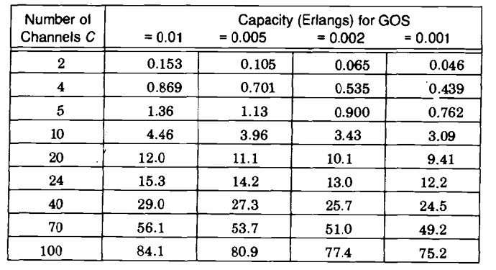

From Table 3.1, we can find the total capacity in Erlangs for the 0.5% GOS for different numbers of channels.

**(a)**

Have given,

Trunked channels, C = 1

From table 3.1, For C = 1 we obtain, A = 0005

From equation (i), we have-

Total number of user, U = A / Au

= 0.05 users.

**But, actually one user could be supported on one channel. So, U = 1.**

**(b)**

Have given,

Trunked channels, C = 5

From table 3.1, For C = 5 we obtain, A = 1.13 Erlang.

From equation (i), we have-

**Total number of user**, U = A / Au

11 users.

**(c)**

Have given,

Trunked channels, C = 10

From table 3.1, For C = 10 we obtain, A = 3.96 Erlang

From equation (i), we have-

**Total number of user**, U = A / Au

39 users.

**(d)**

Have given,

Trunked channels, C = 20

From table 3.1, For C = 20 we obtain, A = 11.10 Erlang

From equation (i), we have-

**Total number of user**, U = A / Au

110 users.

**(e)**

Have given,

Trunked channels, C = 100

From table 3.1, For C = 100 we obtain, A = 80.9 Erlang.

From equation (i), we have-

**Total number of user**, U = A / Au

809 users.

**Source Code (MATLAB):**

|  |
| --- |
| clc;  clear all;  close all;  GOS = 0.5/100; % Blocking probablity (0.5%)  Au = 0.1; % Traffic intensity per user    % From Erlang B chart Offered Traffic Intensity, A  A = [0.005 1.13 3.96 11.1 80.9];  % Trunked Channels  C = [1 5 10 20 100];    U = round(A/Au); % Total number of user    % Result Print  fprintf('Grade of Service, GOS = %7.3f\n',GOS);  disp('Trunked Channels, C :');  disp(C);  disp('From table 3.1, we obtain Offered Traffic Intensity, A For all Channels, C :');  disp(A);  disp('Total number of user, U');  disp('---------------------------');  disp(U); |

**Input:**

Trunked Channels, C = [1 5 10 20 100];

**Output:**

Grade of Service, GOS = 0.005

Trunked Channels, C: 1 5 10 20 100

Offered Traffic Intensity, A: 0.0050 1.1300 3.9600 11.1000 80.9000

**Total number of user, U:** 0 11 40 111 809

**Problem-4:** An urban area has a population of 2 million residents. Three competing trunked mobile networks (systems A, B, and C) provide cellular service in this area. System A has 394 cells with 19 channels each, system B has 98 cells with 57 channels each, and system C has 49 cells, each with 100 channels. Find the number of users that can be supported at 2% blocking if each user averages 2 calls per hour at an average call duration of 3 minutes. Assuming that all three trunked systems are operated at maximum capacity, compute the percentage market penetration of each cellular provider.

**Solution:**

Have given,

Blocking Probability, PB = 2%,

The average number of call requests per unit time $λ$ = 2.

The average duration of a call, H = 3/60 seconds

There are 2 million residents in the given urban area = 2000000

We Know,

For Erlangs B, Grade of Service, GOS = PB

= 0.02

And, Traffic Intensity, Au = H

= 0.1 Erlangs

Also, Total number of user, U = A / Au …………………………....... (i)

Where,

A = Offered Traffic Intensity.

Also,

**Table 4.1:** Capacity of an Erlang B System.

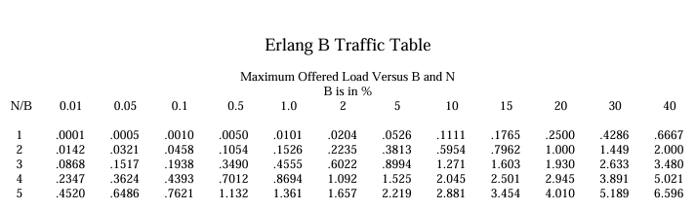

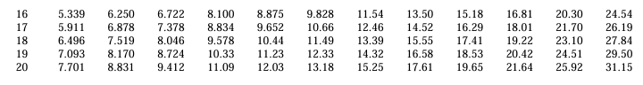

From Table 4.1, we can find the total capacity in Erlangs for the 2% GOS for different numbers of channels.

**For System-A**

Have given,

Number of channels per cell used in the system, C = 19

From table 4.1, For C = 19 and GOS = 0.02 we obtain, A = 12 Erlangs

From equation (i), we have-

Total number of user, U = A / Au

= 120 users.

*Since there are 394 cells, the total number of' subscribers that can be supported by* ***System A*** *is equal to 120 x 394 = 47280.*

**Since, the percentage market penetration** = 47280/2000000 = 2.36%

**For System-B**

Have given,

Number of channels per cell used in the system, C = 57

From table 4.1, For C = 57 and GOS = 0.02 we obtain, A = 45 Erlangs

From equation (i), we have-

Total number of user, U = A / Au

= 450 users.

*Since there are 98 cells, the total number of' subscribers that can be supported by* ***System B*** *is equal to 450 x 98 = 44,100.*

**Since, the percentage market penetration** = 44100/2000000 = 2.205%

**For System-C**

Have given,

Number of channels per cell used in the system, C = 100

From table 4.1, For C = 100 and GOS = 0.02 we obtain, A = 88 Erlangs

From equation (i), we have-

Total number of user, U = A / Au

= 880 users.

*Since there are 49 cells, the total number of' subscribers that can be supported by* ***System C*** *is equal to 880 x 49 = 43,120.*

**Since, the percentage market penetration** = 43,120/2000000 = 2.156%

Therefore, total number of cellular subscribers that can be supported by these three systems are (47280 + 44100 + 43120) = 134500 users.

***The market penetration of the three systems combined is equal to 134500/2000000 = 6.725***

**Source Code (MATLAB):**

|  |
| --- |
| clc;  clear all;  close all;  blocking_probability = 2/100; % GOS  population = 2000000;  Au = (2/60)*3; % Traffic intensity per user  disp('For system A:');  disp('--------------');  C1 = 19; % Number of channels per cell  A1 = 12; % Total traffic intensity from erlang B chart, GOS=0.02, C=19  U1 = A1/Au; % Total number of user  Aa = U1*394; % Total Number of Subscriber  percentage_A = (Aa/population)*100;  fprintf('Total number of users for system A: %d\n',Aa);  fprintf('Percentage market penetration for System A: %7.3f%% \n',percentage_A);    fprintf('\n\nFor system B:\n');  disp('--------------');  C2 = 57; % Number of channels per cell  A2 = 45; % Total traffic intensity from erlang B chart, GOS=0.02, C=57  U2 = A2/Au; % Total number of user  Bb = U2*98; % Total Number of Subscriber  percentage_B = (Bb/population)*100;    fprintf('Total number of users for system B: %d\n',Bb);  fprintf('Percentage market penetration for System B: %7.3f%% \n',percentage_B);    fprintf('\n\nFor system C:\n');  disp('--------------');  C3 = 100; % Number of channels per cell  A3 = 88; % Total traffic intensity from erlang B chart, GOS=0.02, C=100  U3 = A3/Au; % Total number of user  Cc = U3*49; % Total Number of Subscriber  percentage_C = (Cc/2000000)*100;    fprintf('Total number of users for system C: %d\n',Cc);  fprintf('Percentage market penetration for System C: %7.3f%% \n',percentage_C);    fprintf('\n\nFor all three systems:\n');  disp('--------------------');    T = Aa+Bb+Cc; % Total Subscribers  percentage_T = (T/2000000)*100;  fprintf('Total number of users of all three system: %d\n',T);  fprintf('Percentage market penetration for all three System: %7.3f%% \n',percentage_T); |

**Input:**

Trunked Channels, C = [19 57 100];

**Output:**

**For system A:**

Total number of users for system A: 47280

Percentage market penetration for System A: 2.364%

**For system B:**

Total number of users for system B: 44100

Percentage market penetration for System B: 2.205%

**For system C:**

Total number of users for system C: 43120

Percentage market penetration for System C: 2.156%

**For all three systems:**

Total number of users of all three system: 134500

Percentage market penetration for all three System: 6.725%

**Problem-5:** A certain city has an area of 1,300 square miles and is covered by a cellular system using a 7-cell reuse pattern. Each cell has a radius of 4 miles and the city is allocated 40 MHz of spectrum with a full duplex channel bandwidth of 60 kHz. Assume a GOS of 2% for an Erlang B system is specified. If the offered traffic per user is 0.03 Erlangs, compute-

1. The number of cells in the service area,
2. The number of channels per cell,
3. Traffic intensity of each cell,
4. The maximum carried traffic,
5. The total number of users that can be served for 2% GOS,
6. The number of mobiles per channel, and
7. The theoretical maximum number of users that could be served at one time by the system.

**Solution:**

**(a)**

Have given,

Total coverage area = 1300 miles

Cell radius = 4 miles

We know,

The area of a cell (hexagon) can be shown to be 2.5981R2

Thus each cell covers 2.5981 (4)2 = 41.57 sq km.

**Hence, the total number of cells, Nc**= 1300/41.57 = 31 cells

**(b)**

Have given,

Allocated spectrum = 40, 000,000 Hz

Channel width = 60,000 Hz

Frequency reuse factor, N = 7 cells

We know,

The total number of channels per cell, C = Allocated spectrum / (Channel width $×$ N)

= 40, 000,000 / (60,000 $×$ 7)

= 95 channels/cell

**(c)**

Have given,

From (b) No, C = 95

And, GOS = 0.02

From the table 4.1 (Erlang B chart) For C = 95 and GOS = 0.02, we have-

Traffic intensity per cell, A = 84 Erlangs/cell

**(d)**

Have given,

From (a), Number of cells = 31 cells

From (c), Traffic intensity per cell = 84 Erlangs/cell

We Know,

Maximum carried traffic = Number of cells $×$ Traffic intensity per cell

= 31 $×$ 84

= 2604 Erlangs.

**(e)**

Have given,

Traffic per user, Au = 0.03 Erlangs

From (d), Total traffic, A = 2604 Erlangs.

We Know,

Total number of users, U = A / Au

= 2604 / 0.03

= 86,800 users.

**(f)**

Have given,

Allocated spectrum = 40, 000,000 Hz

Channel width = 60,000 Hz

From (e), Number of users, U = 86,800 users.

We Know,

Number of channels = Allocated Spectrum / Channel Width

= 40, 000,000/60,000

$≈$ 666

Number of mobiles per channel = Number of users/Number of channels

= 86,800 / 666

$≈$ 130 mobiles/channel

**(g)**

Have given,

From (b) No, C = 95 channels/cell

From (a), the total number of cells, Nc= 31 cells.

From (e) Total number of users, U = 86,800 users.

We Know,

The theoretical maximum number of served mobiles is the number of available channels in the system (all channels occupied)

= C $×$ Nc

= 95 $×$ 31 = 2945 users,

Which is (2945/86,800) $×$ 100 = 3.4% of the customer base.

**Source Code (MATLAB):**

|  |
| --- |
| clc;  clear all;  close all;  % Question (a)  total_city_coverage_area = 1300;  radius = 4;  a = (2.591*radius^2); % Each cell covers  Nc = round(total_city_coverage_area/a); % Total number of cells, Nc  fprintf('(a) Total number of cells, Nc : %d cells\n\n',Nc);    % Question (b)  allocated_spectrum = 40000; % Allocated spectrum=40MHz,  channel_width = 60; % Full duplex channel BW = 60KHz  N = 7;  C = round(allocated_spectrum/(channel_width*N));  fprintf('(b) The total number of channels per cell, C : %d channels/cell\n\n',C);    % Question (c)  A = 84; % C=95, GOS=0.02 from erlang B chart  fprintf('(c) Traffic intensity per cell, A : %d Erlangs/cell\n\n',A);    % Question (d)  max_c_t = floor(Nc*A); % Number of Cell, Nc & Traffic Intensity per cell, A  fprintf('(d) Maximum carried traffic : %d Erlangs\n\n',max_c_t);    % Question (e)  U = round(max_c_t/0.03); % Traffic per user, Au = 0.03  fprintf('(e) Total number of users, U : %d users\n\n',U);    % Question (f)  no_of_channel = floor(allocated_spectrum/channel_width);  no_of_m_p_c = floor(U/no_of_channel); % Number of mobiles per channel  fprintf('(f) Number of mobiles per channel : %d mobiles/channel\n\n',no_of_m_p_c);    % Question (g)  g = C*Nc;  fprintf('(g) Theoritical maximum no of user that could be served : %d users\n\n',g); |

**Output:**

(a) Total number of cells, Nc : 31 cells

(b) The total number of channels per cell, C : 95 channels/cell

(c) Traffic intensity per cell, A : 84 Erlangs/cell

(d) Maximum carried traffic : 2604 Erlangs

(e) Total number of users, U : 86800 users

(f) Number of mobiles per channel : 130 mobiles/channel

(g) Theoretical maximum no of user that could be served: 2945 users

**Problem-6:** If a transmitter produces 50 watts of power, express the transmit power in units of

a) dBm, and b) dBW.

If 50 watts is applied to a unity gain antenna with a 900 MHz carrier frequency,

1. Find the received power in dBm at a free space distance of 100 m from the antenna,
2. What is P (10 km)?

Assume unity gain for the receiver antenna.

**Solution:**

Have given,

Transmitter power, Pt = 50 W

Carrier frequency, fc = 900 MHz

**(a)**

We know,

Transmitter power, Pt(dBm) = 10 log[Pt(mW)/(1mW)]

= 10 log [50 x 103]

= 47.0 dBm

**(b)**

We know,

Transmitter power, Pt(dBW) = 10 log[Pt(W)/(1W)]

= 10 log [50]

= 17.0 dBW

**(c)**

If 50 watts is applied to a unity gain antenna with a 900 MHz carrier frequency,

Have given,

Transmitter Gain, Gt = 1

Receiver Gain, Gr = 1

Wave length λ = c / f = 1 /3 m

The T-R separation distance, d = 100m

The system loss factor, L = 1

We know,

The received power, Pr = (Pt Gt Gr λ2) / (4π2 d2 L)

= (50 1 1 (1/3)2) / ((4π)2 1002 1)

= 3.5 10-3 mW

Received power, Pr(dBm) = 10 log[Pr(mW)]

= 10 log[Pr(3.5 10-3)]

= -24.5 dBm

**(d)**

Have given,

do = 10 km = 10000 m

We Know,

The received power at 10 km can be expressed in terms of dBm, we have

$∴$ Pr(10 km) = Pr(100) + 20 log[d / do]

= Pr(100) + 20 log[100 / 10000]

= -24.5 – 40

= -64.5 dBm

**Source Code (MATLAB):**

|  |
| --- |
| clc;  clear all;  close all;  pt = 50; % Transmitted power  fc = 900; % Carrier frequency  gt = 1; % Transmitter antenna gain  gr = 1; % Receiever antenna gain  d = 100; % Free space distance  L =1;  lambda = (3*10e8)/(fc*10e6); % lambda = c/f = 1/3    % Quesstion (a)  tr_dBm = ceil(10*log10(pt*1000));  fprintf('(a) Transmitter power,Pt in dBm: %d dBm\n\n',tr_dBm);    % Quesstion (b)  tr_dBW = ceil(10*log10(pt*1));  fprintf('(b) Transmitter power,Pt in dBW: %d dBW\n\n',tr_dBW);    % Quesstion (c)  c = ((pt*gt*gr*(lambda)^2)/((4*3.1416)^2*d^2*L))*1000;  Pr = 10*log10(c);  fprintf('(c) Received power,Pr in dBm: %7.2f dBm\n\n',Pr);    % Quesstion (d)  d = Pr + (20*log10(d/10000));  fprintf('(d) Received power,Pr at 10km in dBm: %7.2f dBm\n\n',d); |

**Output:**

(a) Transmitter power,Pt in dBm : 47 dBm

(b) Transmitter power,Pt in dBW : 17 dBW

(c) Received power,Pr in dBm : -24.54 dBm

(d) Received power,Pr at 10km in dBm : -64.54 dBm

**Problem-7:** Determine the path loss of a 900MHz cellular system in a large city from a base station with the height of 100m and mobile station installed in a vehicle with antenna height of 2m. The distance between mobile and base station is 4 km.

**Solution:**

Have given,

The frequency, fc = 900 MHz (150 MHz to 1500MHz)

The effective transmitter (base station) antenna height, hte = 100m

The effective transmitter (mobile) antenna height, hre = 2m

T-R separation distance, d = 4 km

Now, The correction factor for effective movile antenna height,

a(hre) = 3.2 (log 11.75 hre)2 – 4.97 dB for fc $≥$ 300 MHz

From Okumura-Hata Model we know,

The path loss in urban areas is given by

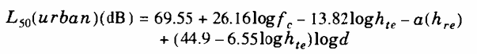

= 69.55 + 26.16 $×$ 2.954 – 13.82 $×$ 2 – 1.045 + (44.9 – 13.1) $×$ 0.6

= 137.3 dB

**Source Code (MATLAB):**

|  |
| --- |
| clc;  clear all;  close all;  hte = 100; % Effective transmitter (base station) antenna height in meter  hre = 2; % Effective receiver (mobile) antenna height in meter  fc = 900; % Frequency in MHz  d = 4; % T-R separation distance in kilometer    a_hre = (3.2*(log10(11.75*hre))^2)-4.97; % The correction factor(using okumura-hata model)    % Path Loss in urban areas  Lp = 69.55 + 26.16*log10(fc)-13.82*log10(hte)-a_hre+((44.9-6.55*log10(hte))*log10(d));  fprintf('The path loss in urban areas, Lp = %7.2f dB\n',Lp); |

**Input:**

hte = 100; % Effective transmitter (base station) antenna height in meter

hre = 2; % Effective receiver (mobile) antenna height in meter

fc = 900; % Frequency in MHz

d = 4; % T-R separation distance in kilometer

**Output:**

The path loss in urban areas, Lp = 137.29 dB.

**Problem-8:** Determine the path loss between base station (BS) and mobile station (MS) of a 1.8GHz PCS system operating in a high-rise urban area. The MS is located in a perpendicular street to the location of the BS. The distances of the BS and MS to the corner of the street are 20 and 30 meters, respectively. The base station height is 20m.

**Solution:**

Have given,

The frequency, fc = 1.8 GHz (0.9 to 2 GHz)

The effective transmitter (base station) antenna height, hb = 20m

T-R separation distance, d = (202 +302) = 0.036 km

From Okumura-Hata Model we know,

The path loss in a high-rise urban areas with Perpendicular Street to the location of the Base Station is given by-

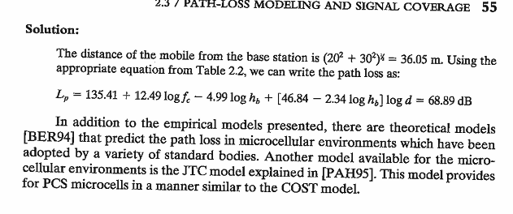

= 135.41 + 12.49 $×$ log (1.8) – 4.99 $×$ log 20 + [46.84 – 2.34 log20] $×$ log 0.036

= 68.91 dB

**Source Code (MATLAB):**

|  |
| --- |
| clc;  clear all;  close all;  fc = 1.8; % Frequency in GHz  hb = 20; % Effective transmitter (base station) antenna height in meter    d = (sqrt(20^2+30^2))/1000; % T-R separation distance in kilometer    % Path Loss in a high-rise urban areas  Lp = 135.41+(12.49*log10(fc))-(4.99*log10(hb))+((46.84-2.34*log10(hb))*log10(d));  fprintf('The path loss in a high-rise urban areas, Lp = %7.2f dB\n',Lp); |

**Input:**

hb = 20; % Effective transmitter (base station) antenna height in meter

fc = 1.8; % Frequency in GHz

**Output:**

The path loss in a high-rise urban areas, Lp = 68.91 dB

**Problem-9:** A mobile is located 5 km away from a base station and uses a vertical λ /4 monopole antenna with a gain of 2.55 dB to receive cellular 3 radio signals. The E-field at 1 km from the transmitter is measured to be V/m. The carrier frequency used for this system is 900 MHz.

1. Find the length and the gain of the receiving antenna.
2. Find the received power at the mobile using the 2-ray ground reflection model assuming the height of the transmitting antenna is 50 m and the receiving antenna is 1.5m above ground.

**Solution:**

Have given,

Frequency of operation, f = 900 MHz

Gain of antenna, G = 1.8 = 2.55 dB

**(a)**

We Know,

Wave length,

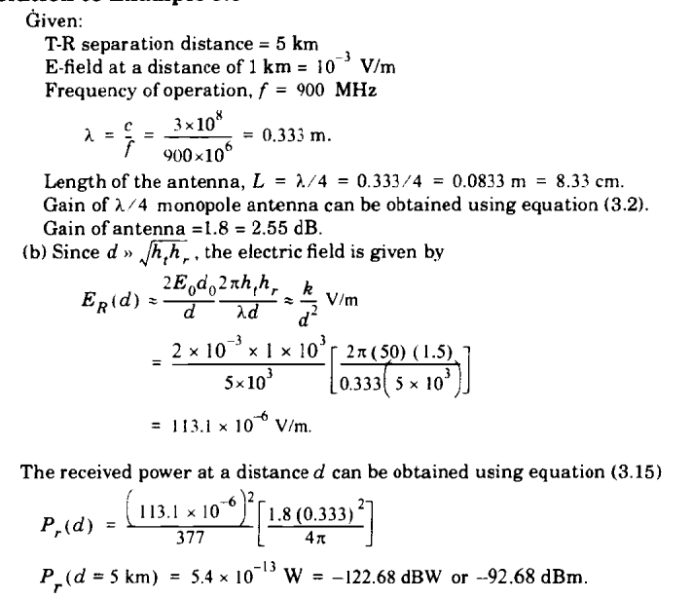

And, Gain of antenna, G = 2.55 dB.

**(b)**

Have given,

T-R separation distance, d = 5 km

E-field at a distance of 1 km, Eo = 10-3 V/m

Transmitter distance do  = 1km

Transmitting antenna height, ht = 50m

Receiving antenna height, hr = 1.5m

Wave length, λ = 0.333

We Know,

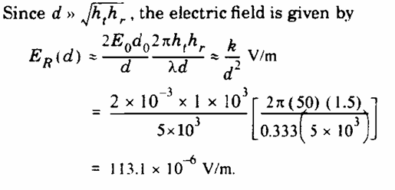

Here, Effective Aperture

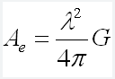

= 0.016 m2

Now, the received power at a distance d can be obtained using

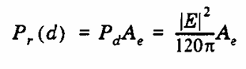

= ((113.1 10-6)2 0.016)/337

= 5.4 10-13 W

= -122.68 dbW

= -92.68 dBm

**Source Code (MATLAB):**

|  |
| --- |
| clc;  clear all;  close all;  f = 900; % Frequency in MHz  g = 2.55; % Gain of antenna in dB    % Question (a)    gain =(10^(g/10));  lemda = (3*10^8)/(f*10^6);  L = lemda/4; % Antenna Length  disp('For (a)');  disp('---------');  fprintf('Length of the antenna : %7.3f m\n',L);  fprintf('Gain of the antenna : %7.1f =%7.2fdB\n\n\n',gain,g);    disp('For (b)');  disp('---------');  d = 5000; % T-R seperation distance  E0 = 10^-3; % Electric-field  d0 = 1000; % Transmitter distance  ht = 50; % Transmitting antenna height, ht (m)  hr = 1.5; % Receiving antenna height, hr (m)    Er_d = (2*E0*d0*2*3.1416*ht*hr)/(lemda*d^2); % Electric Field  Ae = (gain*lemda^2)/(4*3.1416); % Effective Aperture  Pr_d = (Er_d^2/(120*3.1416))*Ae; % The received power at a distance d  Pr_dB = 10*log10(Pr_d);  fprintf('Electric Field, Er(d) : %7.9f v/m\n',Er_d);  fprintf('Effective Aperture, Ae : %7.3f m^2\n',Ae);  fprintf('Receiveed power at 5km distance Er(5 km) : %7.3f dbW\n',Pr_dB); |

**Input:**

f = 900; % Frequency in MHz

g = 2.55; % Gain of antenna in dB

d = 5000; % T-R separation distance

E0 = 10^-3; % Electric-field

d0 = 1000; % Transmitter distance

ht = 50; % Transmitting antenna height, ht (m)

hr = 1.5; % Receiving antenna height, hr (m)

**Output:**

**For (a)**

Length of the antenna, L : 0.083 m

Gain of the antenna, G : 1.8 = 2.55dB

**For (b)**

Electric Field, Er(d) : 0.000113098 v/m

Effective Aperture, Ae : 0.016 m^2

Received power at 5 km distance Er(5 km) : -122.679 dbW

**Problem-10:** A hexagonal cell within a 4-cell system has a radius of 1.387 km. A total of 60 channels are used within the entire system. If the load per user is 0.029 Erlangs, and λ= call/hour, compute the following for an Erlang C system that has a 5% probability of a delayed call-

1. How many users per square kilometer will this system support?
2. What is the probability that a delayed call will have to wait for more than 10s?
3. What is the probability that a call will be delayed for more than 10 seconds?

**Solution:**

Have given,

Cell radius, R = 1.387 km

Area covered per cell is 2.598 x (1.387)2  5 sq km

Number of cells per cluster,n = 4

Total number of channels, N = 60

Therefore, number of channels per cell = 60 / 4 = 15 channels.

From Erlang C chart, for 5% probability of delay with C = 15,

Traffic intensity, A = 9.0 Erlangs.

**(a)**

Have given,

Traffic per user, Au = 0.029 Erlangs.

We know,

The number of users, U = A / Au

= 9.0/0.029

= 310 users

The number of users per square km = 310 users /5 sq km

= 62 users /sq km

**(b)**

Have given,

Wave length, $λ$ = 1 call/hour

Holding time, H = Au /

= 0.029 hour

= 104.4 seconds.

Time, t = 10s

We know,

The conditional probability that a delayed call will have to wait for more than t seconds is Pr[delay > t | delay] = exp(-(C-A)t/H)

= exp (-(15-9)10/104.4)

= 56.29 %

**(c)**

Have given,

The probability of delayed call, Pr[delay > 0] = 5 % = 0.05

We know,

Probability that a call is delayed more than 10 seconds,

Pr[delay > 10] = Pr[delay > 0] $×$ Pr[delay > t | delay]

= 0.05 $×$ 0.5629

= 2.81 %

**Source Code (MATLAB):**

|  |
| --- |
| clc;  clear all;  close all;  R = 1.387; % Cell Radius  n = 4; % No of cell  N = 60; % Total no of channel  area = round(2.5981*R^2);% Area covers per cell  C = N/4; % No of channel per cell  A = 9; % Traffic intensity at c=15, GOS=0.05, Au=0.029 from erlang C chart    % Question (a)  Au = 0.029; % Traffic per user  U = floor(A/Au); % Number of user  U_per = round(U/area); % Number of users per square km  fprintf('(a) Number of users per square km: %d users/sq km\n\n',U_per);    % Question (b)  lemda = 1 ; % lamda = 1 hour  H = (Au/lemda)*3600; % Holding Time hour to second  Prb = (exp((-(C-A)*10)/H)); % t=10s, C=15, A=9, H=104.4  fprintf('(b) The probability that a delayed call will have to wait: %7.2f%%\n\n',Prb*100);    % Question (c)  Prc = 0.05*Prb*100; % 5% probability of delayed call  fprintf('(c) The probability that a call will be delayed : %7.2f%%\n\n',Prc); |

**Output:**

(a) Number of users per square km : 62 users/sq km

(b) The probability that a delayed call will have to wait : 56.29%

(c) The probability that a call will be delayed : 2.81%