Clause Extractor

Introduction
This document summaries, the design, implementation and recommendations for future work for the clause extractor home assignment.

Architecture

User / Browser
Frontend /
React
Backend /
FastAPI
AI /
Anthropic API

DB /
SQLite
prompts
SQL
REST API
HTTP

Taxonomy
The first task was to identify what contract types and what clause types the product will recognized. Naturally, the best scenario is that the types are close list, with no overlapping and covering all the intended contract types and clauses types.
Surprisingly, there is no common standard and each product so I asked claude to collect available sources and too compile a list. The list of clauses and contract types was kept in the json file contract-taxonomy.json and in a more readable form in Contract-Taxonomy-Reference.pdf. For each supported contract type and clause type the source of the type is specified. Main sources were:
- CUAD v1 (Contract Understanding Atticus Dataset) — an academic dataset of 500 commercial contracts with 41 labeled clause types, created by legal experts at Atticus. This is the primary source for most clause types.
- WorldCC Most Negotiated Terms 2022 — an industry report from the World Commerce & Contracting association identifying the clauses most commonly negotiated in commercial contracts globally.
- Ironclad, Agiloft, Sirion — three leading contract lifecycle management (CLM) platforms. Their out-of-the-box clause libraries reflect what enterprise legal teams actually care about in practice.
Still during testing I found out that some very common clauses like Delivery for example were left out and they were added manually with the source “Added”.

Database

Tables
contracts
- Stores the filename, upload date, raw extracted text, and the contract type classification (MSA, NDA, etc.) with its confidence score, evidence phrases, and ambiguity flags
- The raw_text column stores the full contract text
clauses
- Linked to contracts via contract_id
- Stores the clause type, span_start / span_end (character offsets into the raw text), confidence, evidence, and ambiguity flags

entities
- Linked to clauses via clause_id
- Stores entity_name (e.g. amount, jurisdiction), value_json, confidence, evidence, ambiguity flags
- Flat key-value structure — each entity is its own row rather than a JSON blob on the clause

Major Design Decisions
- Three-level hierarchy (Contract → Clause → Entity)
- Spans as character offsets – to be able to highlight clauses in the UI
- confidence, evidence, ambiguity_flags: the purpose of these flags was to help debugging cases of ambiguity and errors in classification, the idea was to identify edge cases and to record AI decisions. “evidence” was some text explaining why a category was selected, “ambiguity flags” what was the reason for ambiguities. Turns out classification was very binary, either the category was identified in high confidence or the categorization failed. After adding a missing category it was identified with high confidence
- Cascade deletes: No orphans clauses, if the contract was deleted all related clauses and entities were deleted as well

Chunking, Extraction and Categorization
This was a tricky task that required some iterations. We start with chunking based on numbered paragraphs using regex:
heading_re = re.compile(r'^\d+(?:.\d+).?\s+\S[^\n]', re.MULTILINE)
Some cases we had to deal with:
- Sometimes clauses are separated by newline and not end of paragraphs
- On the other hand sometimes a clause spans multiple paragraphs, so we had to parse both line by line but also to combine lines in case of long clause.
- However we never merged numbered paragraphs even if they are of the same clause type
- Text that is not a clause was skipped but was not ignored. For example the contract title is not a clause but is very useful for categorizing the contract
- Categorization is done by LLM, I asked claude to elaborate on how categorization works in order to improve prompting if needed, the claude output can be found in Annotation-Guide.pdf
- When text looks like a clause but categorization fails, type is set to “Unknown_Type “. During testing, I fix missing categorization and updated the taxonomy accordingly

Contract Files
I support only uploading from local machine and only contracts in pdf format (no OCR). Only files with the .pdf suffix are allowed, file size is limited to 20MB.

UI
The UI was designed to include all the different elements: contract, clauses, extracted entities without being too dense. The main windows also include buttons for uploading new contracts and for deleting contracts. Upload is only supported from local files so other sources are grayed out. The UI includes the list of contracts, for each selected contract the raw text is displayed in one pane and the list of clauses in another pane. When a clause is selected the clause is highlighted in the raw text. I another pane the clause extracted enetities are displayed.
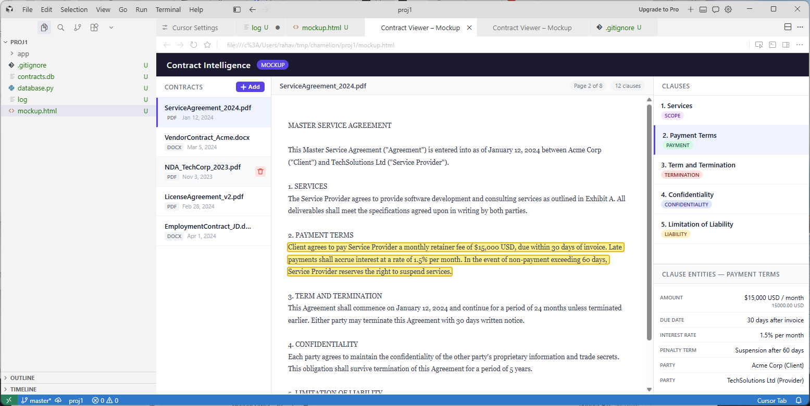

Testing
- I collected a small set of contracts from the internet and use them for testing. The can be found in the test_contracts directory
- I tested the GET API using curl and the POST API using the script test_extract.sh
- I used the UI to validate chunking categorization
- I used DB browser the validate database content especially for data that is not part of the UI like confidence figures

AI Usage
Used AI intensively,
used chatGPT for
- Help finding good taxonomy
- identify missing clause types
Used claude code
- Code generation
- debugging
Used ANTHROPIC API
- For categorization

API
API documentation can be found in http://localhost:6363/docs

Install & Run
See Install-and-Run-Guide.docx

