

Yenepoya Institute of Arts, Science, Commerce, and Management
Final Project Report

Natural Language Interface for Finance Infrastructure

Student Name: Fathima Rahda V

Industry Mentor: Mr. Shashank Guided by: Mrs.Manjula
Table of Contents
- Executive Summary ................................................................................................................. 3
- Background .............................................................................................................................. 4
  - Aim .................................................................................................................................. 4
  - Technologies .................................................................................................................... 5
  - Hardware Architecture ..................................................................................................... 5
  - Software Architecture ...................................................................................................... 6
- System ....................................................................................................................................... 8
  - Requirements .................................................................................................................... 9
    - FunctionalRequirements......................................................................................9
    - Requirements ..................................................................................................... 9
    - EnvironmentalRequirements.............................................................................10
  - Design and Architecture ................................................................................................. 10
  - Implementation .............................................................................................................. 13
  - Testing ............................................................................................................................ 17
  - Graphical User Interface (GUI) Layout ......................................................................... 19
  - Customer Testing ........................................................................................................... 21
  - Evaluation....................................................................................................................... 22
- Snapshots of the Project ......................................................................................................... 24
- Conclusions ............................................................................................................................ 30
- Further Development or Research .......................................................................................... 31
- References .............................................................................................................................. 32
- Appendix ................................................................................................................................ 33
  - Weekly Progress Reports ............................................................................................... 34

Executive Summary

Project Overview:
FinBot is a Natural Language Interface for Finance Infrastructure — a conversational chatbot application that allows any user to ask common personal finance questions in plain English and receive instant, structured, India-specific answers. The project was developed as part of the IBM Innovation Centre for Education programme at Yenepoya Institute of Arts, Science, Commerce and Management during the academicyear2025–2026.
The core problem this project addresses is the low level of financial literacy in India. According to the Standard & Poor’s Global Financial Literacy Survey, only approximately 24% of Indian adults are financially literate. Most people have pressing questions about topics like income tax, SIP investments, EMI calculations, and insurance — but professional financial advisors are expensive and inaccessible, while searching the internet returns scattered and often confusing results.
FinBot solves this by providing a free, instant, private, and locally hosted finance assistant that anyone can run on their own computer.
It covers ten major personal finance topics relevant to the Indian context, delivers structured text answers, and does so without any internet dependency, user registration, database, or machine learning model.

What was built:
The project delivers two fully functional interfaces built on the same Python backend engine:
The first is a browser-based website accessible at localhost:5000 when the Flask server is running. The website features a complete marketing landing page with six sections — a Navbar, Hero section, Features cards, Topics grid, How It Works section, and Footer — along with a floating chat widget accessible via a green pulsing button at the bottom-right corner of every page.
The chat widget supports markdown-rendered responses including bold text, inline code, and formatted tables, a confidence percentage bar showing how well the query matched a topic, and follow-up suggestion chips the user can click to ask related questions without typing. The second interface is a command-line tool activated by running python chatbot_engine.py in any terminal.
It accepts typed questions in a continuous loop and prints structured plain-text responses until the user types exit or quit. Both interfaces share exactly the same Python NLP engine, ensuring consistent behaviour regardless of which interface is used.
Key outcomes:
The project successfully achieved all objectives set in the project proposal. The chatbot correctly identifies the right finance topic for 100% of the manually tested query set, covering 39 test cases across 13 knowledge base categories.
The system responds in under 10 milliseconds end-to-end on a local machine, requires only one Python dependency (Flask), and the standalone HTML file works entirely in the browser without any server at all.
All four required academic documents were completed and submitted: the Project Proposal, the High-Level Design (HLD), the Low-Level Design (LLD), and this Final Report. Seven Weekly Progress Reports (WPPRs) were submitted throughout the project timeline.
The project was built over seven weeks following a structured plan: Week 1 for requirements analysis, Week 2 for technology study and environment setup, Week 3 for backend NLP engine development, Week 4 for Flask API development, Week 5 for frontend development, Week 6 for testing and debugging, and Week 7 for documentation and final submission

Background

Financial literacy remains one of the most pressing yet overlooked challenges facing young adults in India today. Despite rapid economic growth and increasing access to digital banking, a large majority of college students and first-time earners lack basic knowledge about personal finance — how income tax works, how to start investing through SIP, how EMI is calculated, or why inflation silently erodes savings. Professional financial advice is expensive and largely inaccessible to students, while searching the internet for answers returns overwhelming, jargon-heavy, and often conflicting information. This project was conceived to address that gap directly.
FinBot — Natural Language Interface for Finance Infrastructure — is a Python-based conversational chatbot developed as part of the IBM Innovation Centre for Education programme at Yenepoya Institute of Arts, Science, Commerce and Management. The system allows any user to type a personal finance question in plain English and receive an instant, structured, India-specific answer covering ten core topics: stocks and equity markets, personal budgeting, loans and EMI, investments, income tax, insurance, cryptocurrency, savings, inflation, and compound interest. The chatbot runs entirely on a local machine using Flask as the web server and a custom keyword-based natural language processing engine built from scratch in Python — with no machine learning model, no external NLP library, no database, and no internet dependency during operation. It is accessible through both a modern browser-based chat interface and a command-line terminal, making it suitable for demonstration across a wide range of environments.

2.1 Aim
The aim of this project is to design, develop, and deploy a Natural Language Interface for Finance Infrastructure that enables users to ask personal finance questions in conversational English and receive accurate, structured, India-specific answers in realtime.
The specific objectives of the project are as follows:
- Objective 1 — Build a Working NLP Engine:
Develop a Python-based keyword matching engine that can correctly identify the finance topic being asked about from any reasonably phrased natural language query.
The engine must handle variations in phrasing, partial word matches, and multi-word keyword phrases without relying on any external machine learning library or model.

- Objective 2 — Cover Ten Core Finance Topics:
Build a comprehensive Finance Knowledge Base covering the ten topics most relevant to students and young professionals in India: stocks and equity markets, personal budgeting, loans and EMI calculation, investment vehicles, income tax, insurance, cryptocurrency, savings strategies, inflation, and compound interest.

- Objective 3 — Provide Two Interface Modes:
Deliver the chatbot as both a browser-accessible web application with a modern floating chat widget, and as a command-line tool, ensuring the system can be demonstrated and used in different environments.

- Objective 4 — Keep the System Simple and Accessible:
The project must require minimal setup — no database configuration, no machine learning model download, no external API keys — so that any student can run it with a single command after installing one Python package.

- Objective 5 — Produce Complete Academic Documentation:
Deliver all four required documents (Proposal, HLD, LLD, Final Report) following the IBM Innovation Centre for Education template provided by Yenepoya Institute.
The motivation behind choosing this topic comes from observing that financial literacy remains a significant challenge in India, particularly among college students and first-time earners who need guidance on basic questions like how to start investing, how much income tax they owe, or how an EMI is calculated. A chatbot that answers these questions immediately, privately, and without any signup barrier addresses a real and widely felt need.

2.2 Technologies
Technology Stack
The project uses the following technologies, each chosen for a specific reason:

- Python 3.11 (Backend Language)
Python was chosen as the primary programming language because of its clean syntax, rich standard library, and suitability for natural language processing tasks. The project uses three built-in Python modules: the re module for regular expression-based text preprocessing, the random module for selecting response variants, and the datetime module for generating response timestamps. No pip-installed NLP libraries such as NLTK or spaCy are used — all NLP logic is implemented from scratch using basic Python string operations and dictionary lookups.

- Flask 3.0.3 (Web Framework)
Flask is a lightweight Python web framework that creates a local HTTP server with minimal configuration. It was chosen over heavier alternatives like Django because the project only needs three routes: one to serve the HTML page, one REST API endpoint for the chatbot, and one health check endpoint. Flask’s jsonify function handles all JSON serialisation automatically, and its built-in development server is sufficient for local demonstration and academic submission purposes.

- HTML5, CSS3, and Vanilla JavaScript (Frontend)
The entire frontend is a single self-contained HTML file with no external JavaScript frameworks. This was a deliberate design decision to minimise dependencies and ensure the file can be opened directly in any browser without a build process. CSS3 handles all animations including the floating button pulse, the chat widget open/close transition, and the confidence bar fill animation. JavaScript uses the browser’s built-in Fetch API to communicate with the Flask backend and a custom Markdown parser to render bold text, inline code, and tables inside chat bubbles.

- Git and GitHub (Version Control)
Git was used for version control throughout the project with commits made at the end of each weekly milestone. The repository is hosted on GitHub at https://github.com/rahda599/fin-bot.

2.3 Hardware Architecture
The project runs entirely on a standard personal computer with no specialised hardware requirements.The hardware architecture is described below.
- Development Machine Specifications Used:
The project was developed and tested on a personal computer running Windows 11 with the Windows Subsystem for Linux (WSL) enabled, 8GB RAM, an Intel Core i5 processor, and a standard broadband internet connection used only for package installation and GitHub push operations.
- Hardware Requirements for Running the Project:
Any computer manufactured after 2015 is sufficient to run FinBot without any performance issues. The minimum requirements are a processor of 1 GHz or above (any modern Intel, AMD, or ARM processor), 512 MB RAM minimum (the application uses under 50 MB at runtime), 100 MB of free disk space for Python, Flask, and the project files, and a modern web browser such as Chrome, Firefox, or Edge for the web interface.

- Hardware Data Flow:
When the user types a question in the browser, the keypress event is captured by the browser’s JavaScript engine running in the CPU. The Fetch API sends an HTTP POST request over the local loopback interface (127.0.0.1) to port 5000. The Flask server running on the same machine’s CPU processes the request, runs the Python NLP functions in RAM, and returns a JSON response over the same loopback interface. No network card or internet connection is used during normal operation — the entire request-response cycle happens within the single machine.

- Memory Footprint:
The Finance Knowledge Base (FINANCE_KB) occupies approximately 5 kilobytes in RAM. The Flask server process uses approximately 30 to 50 megabytes of RAM including the Python interpreter overhead. The web page uses approximately 2 to 3 megabytes of browser memory for the DOM, CSS animations, and JavaScript runtime. These figures make FinBot one of the lightest possible chatbot deployments achievable.
- Deployment Consideration:
For a public deployment scenario (beyond the scope of this academic project), the same codebase could run on any cloud virtual machine with 512 MB RAM, such as a free-tier instance on Render, Railway, or AWS EC2. The stateless API design means multiple instances of the Flask server could be placed behind a load balancer without any code changes.

2.4 Software Architecture
The software architecture of FinBot follows a four-layer design where each layer has a single clearly defined responsibility and communicates with adjacent layers through well-defined interfaces.
- Layer 1 — User Interface Layer:
This layer consists of two sub-components that both serve as the entry point for user interaction. The first is the web interface (finbot_website.html) which renders the landing page and chat widget in the user’s browser. The second is the CLI interface implemented in the run_cli () function inside chatbot_engine.py which provides a terminal-based text loop. The user interface layer is responsible only for capturing user input and displaying the bot’s response — it contains no business logic of its own.
2. Layer 2 — Interface / Communication Layer:
In the web interface, this layer consists of the JavaScript code inside finbot_website.html that intercepts keypress and click events, constructs JSON request bodies, calls the Flask API using the Fetch API, and renders the JSON response as HTML chat bubbles. In the CLI interface, this layer is simply Python’s built-in input () and print () functions. This layer handles all communication formatting but delegates all intelligence to Layer 3.
3. Layer 3 — Backend Logic Layer:
This is the core of the system. It consists of the Flask web server (app.py) and the chatbot NLP engine (chatbot_engine.py). Flask receives HTTP requests and routes them to the appropriate handler functions. The chat () handler function extracts the user message from the JSON body and calls get response () from chatbot_engine.py. The get response () function orchestrates the entire NLP pipeline: it calls preprocess () to clean the input, then calls score category () for each of the 13 knowledge base topics, identifies the best-matching topic, selects a response, calculates a confidence score, and returns a structured Python dictionary that Flask serialises as JSON.
4.Layer 4 — Data Layer:
This layer consists entirely of FINANCE_KB — a Python dictionary defined as a module-level constant in chatbot_engine.py. It is loaded into RAM when Python imports the module and remains there for the entire lifetime of the Flask process. No file system reads, database queries, or network calls are made during query processing. All 13 topics, their keywords, responses, and follow-up suggestions are stored as Python strings and lists inside this single dictionary object.

Module Interactions
The interaction between modules follows a strict request-response pattern with no side effects:
When a web user submits a message, finbot_website.html sends POST /api/chat with body {“message”: “user text”} to app.py. The chat () route function in app.py calls get_response(message) from chatbot_engine.py. Inside get response (), preprocess(message) is called first which returns a list of clean lowercase tokens. Then score category (tokens, keywords) is called once for each of the 13 FINANCE_KB topics and each call returns an integer score. The topic with the highest score is selected. If the highest score is zero, a fallback response is returned. Otherwise, random.choice() selects one response string from the winning topic’s responses list, a confidence integer is calculated as min(100, best_score multiplied by 20), and a follow-up suggestion string is optionally selected. The resulting dictionary is returned to app.py which calls Flask’s jsonify () to convert it to a JSON HTTP response. The browser JavaScript receives the response, hides the typing indicator, and calls appendWMsg () and parseMarkdown() to render the answer as a styled chat bubble.
When a CLI user submits a message, input () captures the text and passes it directly to get_response (). The returned dictionary is unpacked and printed to the terminal using print (). The run_cli() function loops indefinitely until the user types an exit command.

System
FinBot is a web-based finance chatbot application designed to demonstrate a complete natural language query-response workflow with a focus on personal finance education. It allows users to ask questions about stocks, loans, tax, investments, insurance, cryptocurrency, budgeting, savings, inflation, and compound interest through a clean, modern chat interface embedded in a full marketing website. Along with the browser-based interface, the platform includes a command-line tool that provides the same chatbot functionality directly from the terminal, making the system demonstrable in both web and non-web environments.
Technically, the system follows a client-server architecture. The frontend is built with HTML5, CSS3, and Vanilla JavaScript as a single self-contained file, while the backend is implemented using Flask in Python. Communication between the frontend and backend happens through REST-style API routes, with the primary endpoint being POST /api/chat which accepts a JSON request body containing the user’s message and returns a structured JSON response containing the bot’s answer, the matched finance category, a confidence score, and an optional follow-up suggestion. The application uses no database — all finance knowledge is stored as a Python dictionary (FINANCE_KB) loaded into memory at server startup. This design keeps the system simple, transparent, and suitable for academic demonstration while still reflecting core full-stack development principles.
The backend acts as the main processing layer for all-natural language understanding and response generation. When a user submits a message, the Flask server passes it to the chatbot engine which preprocesses the input by lowercasing and tokenising the text, then scores all thirteen knowledge base categories using a weighted keyword matching algorithm that awards three points for multi-word phrase matches, two points for exact word matches, and one point for partial matches. The category with the highest cumulative score is selected and a response is returned. The frontend receives the JSON response and updates the chat interface — rendering the bot bubble, animating the confidence bar, and displaying the follow-up suggestion chip — without any page reload.
Overall, the system demonstrates modular design with a clear separation between the presentation layer (finbot_website.html), the application logic layer (app.py and chatbot_engine.py), and the data layer (FINANCE_KB). This separation improves maintainability, testing clarity, and scalability for future enhancements such as multi-turn conversation context, a JSON or database-backed knowledge base, user authentication, voice input support, and cloud deployment.

3.1 Requirements
The requirements of this project were defined to ensure that the system is functionally complete, user-friendly, and executable in a practical development environment.

3.1.1 Functional requirements
The following functional requirements were identified during Week 1 of the project and validated against the final implementation:
- FR1 — Natural Language Query Processing:
The system must accept free-form text input from the user in English and process it without requiring the user to use any special commands, keywords, or syntax. A user must be able to type “how do I save on taxes” or “tax saving tips” or “what is 80C” and receive the same relevant response in all cases.
Status: Implemented and verified in chatbot_engine.py via the preprocess () and score_category() functions.
- FR2 — Multi-Topic Finance Knowledge Base:
The system must cover a minimum of ten personal finance topics relevant to users in India. Each topic must have at least one pre-written structured response containing actionable information.
Status: Implemented. FINANCE_KB contains 13 topics (10 finance topics plus help, greeting, and thanks categories) with 2 response variants each for the finance topics.
- FR3 — Weighted Keyword Matching:
The system must use a scoring algorithm that awards different point values to different types of keyword matches, ensuring that more specific queries produce more accurate topic identification than ambiguous single-word queries. Status: Implemented. score_category() awards 3 points for multi-word phrase matches, 2 points for exact single-word matches, and 1 point for partial word matches.

- FR4 — Confidence Score Reporting:
The system must calculate and return a confidence score with each response indicating how strongly the user’s query matched the identified topic.
Status: Implemented. Confidence is calculated as min (100, best_score multiplied by 20) and returned in the JSON response.
- FR5 — Follow-up Suggestion:
The system must provide at least one follow-up question suggestion with each response to help users explore related finance topics.
Status: Implemented. Each FINANCE_KB topic contains a followups list and random.choice() selects one per response.
- FR6 — Web Interface:
The system must provide a browser-accessible interface with a chat widget that supports sending messages and viewing responses without any page reload.
Status: Implemented in finbot_website.html using the Fetch API for asynchronous communication.
- FR7 — CLI Interface:
The system must provide a terminal-based interface that uses the same NLP engine as the web interface.
Status: Implemented in run_cli() in chatbot_engine.py.
- FR8 — Fallback Handling:
The system must return a helpful fallback message when no finance topic can be matched rather than crashing or returning an empty response.
Status: Implemented. When all 13 topics score 0, a predefined fallback message with confidence 0 is returned.
- FR9 — REST API:
The system must expose a REST API that allows the frontend to communicate with the backend using standard HTTP and JSON.
Status: Implemented. Three endpoints: GET /, POST /api/chat, GET /api/health.

- FR10 — UTF-8 Compatibility:
The system must run without encoding errors on both Windows and Linux/Mac operating systems.
Status: Implemented. All Python files include the # -- coding: utf-8 -- header and run_cli() applies an io.TextIOWrapper fix for Windows terminals.

3.1.2 User requirements
The user expects:
User requirements define what the system must be like from the perspective of the person using it, focusing on usability, accessibility, and experience rather than technical function.
- No Installation Barrier:
A user must be able to run the project after only two steps: pip install flask followed by python app.py. No database setup, no environment variables, no API keys, and no model downloads should be required.
Rationale: The target users are college students and young professionals who may not be experienced with complex software setup procedures.
- Conversational Input:
The user must be able to type questions naturally the way they would ask a friend, without needing to learn any commands or query syntax.
Rationale: The entire value proposition of a natural language interface is that it removes the need for the user to adapt their language to the system’s language.
- Immediate Response:
The user must receive a response within one second of submitting their question on a standard local machine.
Rationale: Any delay longer than one second breaks the conversational feel of a chat interface and makes the tool feel slow or broken.
- Readable Formatted Responses:
The system’s responses must be presented in a readable format with clear structure — using bold labels, formatted tables where appropriate, and clean line breaks — so the user can quickly extract the information they need.
Rationale: Finance information is inherently numerical and structured. Plain unformatted paragraphs are harder to read than formatted responses with headers and tables.
- Mobile Usability:
The web interface must be usable on a mobile browser without the user needing to zoom or scroll horizontally.
Rationale: Many students primarily access content on mobile devices.
- Privacy:
The user must be able to ask finance questions without any of their queries being stored, logged, or transmitted to any third party.
Rationale: Finance questions are personal. Users should feel comfortable asking about their tax situation, salary, or investment options without worrying about data privacy.
- Discoverable Topics:
The user must be able to discover what topics the chatbot can answer without reading any documentation. The interface must make available topics visible through clickable chips or a help command.
Rationale: Users will abandon a chatbot if they do not know what it can help with.

3.1.3 Environmental requirements
Execution environment includes:

- OS: Windows/Linux/macOS

- Python 3.x installed

- Flask and dependencies installed

- Browser supporting modern JavaScript and Fetch API

- File system access to data.json

- Localhost access (127.0.0.1:5000) for development run

3.2 Design and Architecture
The complete system architecture was designed following the principle of separation of concerns — each component of the system has one clearly defined job and does not overlap with the responsibilities of any other component.
The architecture consists of four distinct layers arranged in a vertical stack. At the top is the User Interface Layer containing finbot_website.html (web) and run_cli() (CLI). Below it is the Communication Layer containing the JavaScript Fetch API calls (web) and Python’s input()/print() functions (CLI). Below that is the Application Logic Layer containing app.py (Flask server) and chatbot_engine.py (NLP engine). At the bottom is the Data Layer containing the FINANCE_KB Python dictionary.
Data flows strictly downward during a request and upward during a response. No layer skips another — the web interface never directly accesses FINANCE_KB, and FINANCE_KB never directly renders anything in the browser. This strict layering makes each component independently testable and replaceable.
NLP Engine Design:
The NLP engine is the intellectual core of the project. Its design is based on the Bag of Words model combined with weighted term frequency matching. Unlike a machine learning model which learns weights through training on data, this engine uses manually defined keyword lists and a hand-coded scoring algorithm. This was a deliberate design choice for the following reasons:
First, transparency — the scoring logic is fully readable in the source code and can be explained to any reviewer line by line without requiring knowledge of linear algebra or statistics. Second, control — the developer has complete control over which keywords belong to which topic and can add or remove keywords at any time without retraining. Third, speed — there is no model inference step and no matrix multiplication. The scoring runs in under 1 millisecond. Fourth, portability — the entire engine fits in one 200-line Python file with no external dependencies.
The scoring algorithm awards points in three tiers. Multi-word phrase matches earn 3 points because they are highly specific — if a user’s query contains the phrase “income tax” then the tax category is almost certainly what they are asking about. Single-word exact matches earn 2 points — if the user typed the word “tax” it is a strong signal. Partial word matches earn 1 point — if the user typed “taxation” which contains “tax” as a substring it is a weaker but still valid signal. After all 13 topics are scored, the one with the highest cumulative score wins.
The confidence percentage is calculated by multiplying the best score by 20 and capping it at 100. This means a score of 5 produces a confidence of 100%, a score of 3 produces 60%, and a score of 1 produces 20%. The confidence value is displayed as a horizontal bar below each bot response in the web interface.
API Design:
The REST API was designed following standard HTTP conventions. Three endpoints serve the complete needs of the application:
The GET / endpoint serves the website. When Flask receives a GET request to the root path, the index() function calls render_template(‘index.html’) which reads the HTML file from the templates/ directory and sends it as the response body with Content-Type: text/html.
The POST /api/chat endpoint is the core of the API. When Flask receives a POST request to /api/chat, the chat() function calls request.get_json() to parse the JSON request body. It extracts the message field using data.get(‘message’, ‘’).strip() with a safe default of an empty string. It calls get_response(message) which returns a Python dictionary. It calls jsonify(result) which converts the dictionary to a JSON string and returns it as an HTTP response with Content-Type: application/json and status code 200.
The GET /api/health endpoint is a lightweight diagnostic endpoint. It returns {“status”: “ok”, “bot”: “FinBot v1.0”} and is used to verify that the Flask server is running before the web interface attempts to make chat API calls.
Database Design Decision:
A deliberate design decision was made to use no database in this project. The rationale for this decision is as follows:
The Finance Knowledge Base is static reference data that never changes at runtime. No user data needs to be stored. Introducing a database would require additional installation steps (sqlite3 or PostgreSQL), additional code for connection management, schema definitions, and query functions, and additional error handling for connection failures. None of these costs are justified when the data can simply be defined as a Python dictionary that is always in memory.
This design decision makes the system maximally portable — the project can be cloned and run on any machine with Python and Flask installed without any database setup. It also makes the system maximally fast — every data access is a direct dictionary lookup in RAM rather than a database query with parsing overhead.
If the project were to be extended with user authentication, conversation history, or admin-editable knowledge base content, a database would then become appropriate. Section 6 of this report discusses this as a future development option.

3.3 Implementation
The implementation followed the seven-week plan established in Week 1. The project was implemented in phases: first the data (FINANCE_KB), then the core logic (preprocess, score_category, get_response), then the server (app.py), then the frontend (finbot_website.html), and finally integration testing.
All code was written in VS Code using the Python extension for syntax highlighting and the Pylance extension for type checking. Git commits were made at the end of each development session with descriptive commit messages. The final codebase consists of three Python/HTML files totalling approximately 850 lines of meaningful code excluding blank lines and comments.

Implementation of FINANCE_KB:
The Finance Knowledge Base was the first component implemented because everything else depends on it. The implementation began by researching each of the ten finance topics to ensure the responses were accurate and relevant to Indian users.
For each topic, the implementation process was: first, identify the 8 to 15 most important keywords a user might use when asking about this topic; second, write two complete, structured response strings covering the most important factual information about the topic; third, write two follow-up suggestions that would naturally lead the user to explore related information.
The keywords were selected based on three criteria. High-frequency words are words a typical user would likely type such as “tax”, “loan”, or “invest”. Specific finance terminology includes words that uniquely identify the topic such as “sensex”, “80c”, or “sip”. Multi-word phrases cover compound terms that are highly specific such as “income tax”, “home loan”, “mutual fund”, “compound interest”, “emergency fund”, and “compound interest”.
The responses were written to be informative, practical, and India-specific. For example, the tax topic response includes the actual income tax slabs for FY 2024-25 under the new regime, specific section numbers (80C, 80D), actual rupee amounts (Rs. 1.5 lakhs for 80C), and practical deadlines (ITR by July 31). This level of specificity is what distinguishes the chatbot from generic finance information.

Implementation of preprocess ():
The preprocess () function is the entry point for all user input into the NLP engine. Its implementation uses three sequential transformations:
Step 1 is lowercasing: text = text.lower(). This converts all characters to lowercase so that “What is SIP” and “what is sip” and “WHAT IS SIP” all produce the same tokens.
Step 2 is character stripping using the Python re module: text = re.sub(r”[^a-z0-9\s/]”, “”, text). This removes all characters that are not lowercase letters, digits, whitespace, or forward slashes. It removes question marks, exclamation marks, commas, hyphens, quotes, and all other punctuation. The forward slash is preserved because finance abbreviations like “50/30/20” use it.
Step 3 is tokenisation: tokens = text.split(). Python’s split() method splits on any whitespace and automatically removes leading and trailing whitespace. It returns a list of clean individual word strings.
The function returns the tokens list. A typical transformation example: the input “What is 80C deduction??” becomes [“what”, “is”, “80c”, “deduction”] after processing.
Implementation of score_category():
The score_category() function implements the weighted matching algorithm. It accepts two arguments: the tokens list from preprocess() and the keywords list from one FINANCE_KB topic. It returns an integer representing the total score for that topic.
The implementation begins by building two representations of the tokens for efficient lookup. A set is built using token_set = set(tokens) which provides O(1) lookup for exact membership testing. A joined string is built using full_text = “ “.join(tokens) which allows substring search for multi-word phrases.
Then a loop iterates over every keyword in the keywords list. For each keyword, three checks are performed in order of specificity. First, if the keyword contains a space character (indicating it is a multi-word phrase), it checks whether the phrase appears anywhere in full_text. If yes, score increases by 3. Second, if the keyword is a single word and it appears exactly in token_set, score increases by 2. Third, if neither of the above matched, it checks whether any token in the tokens list contains the keyword as a substring using any(kw_lower in t for t in tokens). If yes, score increases by 1.
After all keywords are checked, the final integer score is returned.
Implementation of get_response():
The get_response() function is the orchestrator that calls all other NLP functions and assembles the final response dictionary. It accepts a single string argument (the raw user input) and returns a Python dictionary.
The function begins with an empty input check. If the stripped input is an empty string, it immediately returns a fallback dictionary with confidence 0 and a message asking the user to type a question.
Next, it calls preprocess() to clean and tokenise the input. Then it creates an empty scores dictionary and loops over all entries in FINANCE_KB. For each category, it calls score_category() with the tokens and the category’s keywords list and stores the integer result in the scores dictionary.
After the loop, it calls Python’s built-in max() function with scores and key=scores.get to find the category name with the highest score in a single O(n) operation.
If the highest score is 0, a fallback response is returned with confidence 0. Otherwise, it retrieves the category data from FINANCE_KB, calls random.choice() to select one response string, calls random.choice() conditionally on the followups list to select a follow-up suggestion if the list is not empty, calculates confidence as min(100, best_score * 20), and assembles the final return dictionary containing the response string, category name string, confidence integer, followup string or None, and a timestamp string formatted using datetime.now().strftime(”%H:%M”).
Implementation of app.py:
The Flask web server implementation in app.py is intentionally minimal. The file begins with encoding and Windows stdout fix headers. It imports Flask, request, jsonify, and render_template from the flask package, and imports get_response from chatbot_engine.
The Flask app object is created with app = Flask(name). Three route functions are defined. The index () function is decorated with @app. route (”/”) and returns render_template(“index.html”). The chat () function is decorated with @app. route (”/api/chat”, methods=[“POST”]), extracts the message from the request JSON, calls get response (), and returns jsonify(result). The health () function is decorated with @app. route(”/api/health”) and returns a simple status JSON.
The server is started at the bottom of the file with app.run(debug=True, host= “0.0.0.0”, port=5000). The debug=True flag enables Flask’s automatic reloader which restarts the server whenever the source code changes, making development faster. The host= “0.0.0.0” binding makes the server accessible from any device on the same local network, not just the machine running the server.

Implementation of finbot_website.html:
The frontend is implemented as a single HTML file. The file is divided into three logical sections: the HTML structure defining the DOM elements, the CSS styles embedded in a style tag in the head, and the JavaScript logic embedded in a script tag at the bottom of the body.
The HTML structure defines the complete landing page with Navbar, Hero section, Features grid (6 cards), Topics grid (10 cards), How It Works section (4 steps), and Footer. Below the landing page content, it defines the floating action button (#chat-fab) as a button element and the chat widget panel (#chat-widget) as a div element. Inside the chat widget, there is a header bar, a scrollable message area (#widget-messages), a quick-topic chips row (#w-chips), and an input area with a textarea (#w-input) and a send button (#w-send).
The CSS implements a dark theme using CSS custom properties (variables) defined on the: root selector. All colours, animations, and layout are controlled through these variables making the entire colour scheme changeable by editing a few lines. CSS transitions handle the chat widget open/close animation by toggling the. open class which changes opacity from 0 to 1 and transforms from scale (0.95) translateY(20px) to scale (1) translateY(0).
The JavaScript section implements the complete NLP engine mirroring the Python logic, all UI interaction handlers, the parseMarkdown() function, and the fetch () call to the Flask backend. The KB JavaScript object mirrors FINANCE_KB with the same 13 topics, keywords, responses, and followups.

3.4 Testing
Testing was conducted during Week 6 of the project. The testing strategy covered four levels: unit testing of individual NLP functions, integration testing of the full web API cycle, user interface testing, and cross-browser compatibility testing.
All tests were performed manually because the project scope is academic and does not require automated test frameworks like pytest. Each test case was documented in a test case table with the input, expected output, actual output, and pass/fail status.

- Unit Testing Results
Unit testing focused on the three core NLP functions: preprocess(), score_category(), and get_response().
For preprocess(), test cases covered: all uppercase input (“WHAT IS SIP” → [“what”,“is”,“sip”] — PASSED), input with punctuation (“what is 80C??” → [“what”,“is”,“80c”] — PASSED), input with numbers (“50/30/20 rule” → [“50/30/20”,“rule”] — PASSED), empty string input (”” → [] — PASSED), and very long input of 120+ words (correctly tokenised — PASSED).
For score_category(), test cases covered: exact single word match (token “tax” against keyword “tax” → score 2 — PASSED), multi-word phrase match (full text “income tax” against keyword “income tax” → score 3 — PASSED), partial match (token “investing” against keyword “invest” → score 1 — PASSED), no match (token “abcdef” against all keywords → score 0 — PASSED).
For get_response(), testing covered all 13 topics with 3 different query phrasings each, for a total of 39 topic-specific test cases. All 39 returned the expected category. Additionally 6 edge case tests were run: empty input, numbers-only input, random gibberish, very long sentence, ALL CAPS input, and mixed case input. All 6 returned appropriate responses (either matched the correct category or returned the fallback message).

- Integration Testing Results
Integration testing verified that all system components work correctly together end to end.
- Integration test 1 — Website plus Flask API: Flask server started, browser opened at localhost:5000, typed “what is compound interest” in chat widget. Expected: response from compound category with confidence bar and follow-up. Actual: received correct response in under 400ms. Result: PASSED.
- Integration test 2 — Topic chips: All 10 topic cards on the landing page clicked individually. Each expected to open the chat widget and auto-send a relevant query. Actual: all 10 chips correctly called openAndAsk() with the right query string. Result: PASSED.
- Integration test 3 — CLI and Website consistency: Query “how to save income tax” sent to both CLI and chat widget. Both expected to return a response from the “tax” category. Actual: both returned tax category responses. Result: PASSED.
- Integration test 4 — API health check: Visited localhost:5000/api/health in browser. Expected: {“bot”: “FinBot v1.0”, “status”: “ok”}. Actual: exactly that JSON was returned. Result: PASSED.
- Integration test 5 — High confidence query: Sent “income tax deductions 80c section slab” which has very high keyword density for the tax topic. Expected: confidence of 100%. Actual: confidence was 100, bar filled fully. Result: PASSED.

- Bug Fixes During Testing
Four bugs were found and fixed during the testing week.
- Bug 1 — Windows charmap error: Running python chatbot_engine.py on Windows crashed with UnicodeEncodeError when printing responses. Root cause was the Windows cp1252 terminal encoding conflicting with UTF-8 source files. Fix: added io.TextIOWrapper redirect in run_cli() and # -- coding: utf-8 -- header to all .py files.
- Bug 2 — Markdown table not rendering: When a bot response containing a pipe-delimited table was displayed in the chat widget, the pipe characters appeared as plain text. Root cause was the parseMarkdown() table parser not correctly handling the separator row (| — | — |). Fix: rewrote the table parser to detect separator rows (lines containing only dashes and pipes) and use them to switch from th to td for subsequent rows.
- Bug 3 — Follow-up appearing for empty followups list: The thanks and greeting topics have empty followups arrays but the JavaScript code was attempting random.choice() on them regardless. Fix: added an if check that only picks a follow-up when the followups array length is greater than 0.
- Bug 4 — Chat not scrolling to bottom: When a long bot response was added to the chat, the scroll position remained at the top of the message area. Fix: added wMessages.scrollTop = wMessages.scrollHeight after every call to appendWMsg().

Graphical User Interface (GUI) Layout
The website is structured as a single-page application with six sections arranged vertically. The overall visual theme is a dark mode design using a near-black background (#06080f), a deep navy accent colour (#1F3864), a bright teal primary accent (#00d4aa), a blue secondary accent (#4f8aff), and an amber highlight (#ffd166). A subtle grid pattern is rendered as a CSS background overlay on the page to add visual depth without distracting from the content.
- Section 1 — Navbar: Fixed at the top of the viewport with a semi-transparent dark background and backdrop blur effect. Left side shows the FinBot logo (a green rounded square with a chart emoji followed by the text “FinBot” in DM Serif Display serif font with the “Bot” portion in teal). Right side shows navigation links (Features, Topics, How It Works) and a “Try FinBot” call-to-action button with a teal-to-blue gradient background.
- Section 2 — Hero: Full viewport height section centred both horizontally and vertically. Contains a badge element with a pulsing dot and the text “NLP-Powered Finance AI”, a large headline with a gradient text effect on the word “Finance”, a subtitle paragraph, two action buttons, and a row of three statistics (10+ Topics, 50+ Query Patterns, 100% Free). A radial gradient glow effect in teal pulses behind the headline.
- Section 3 — Features: Six equal-width cards arranged in a responsive grid. Each card has a dark surface background, a 1px border that glows teal on hover with a top border accent line animation, an emoji icon, a bold title, and a description paragraph. The six features are: Real Finance Data, Keyword NLP Engine, Instant Responses, Structured Answers, Privacy First, and Mobile Friendly.
- Section 4 — Topics: Ten clickable cards in a responsive grid. Each card shows a topic emoji, topic name, and a hint subtitle. Clicking any card calls the openAndAsk() JavaScript function which opens the chat widget and automatically sends a pre-written query for that topic.
- Section 5 — How It Works: Four numbered steps arranged horizontally with a decorative gradient line connecting them. Each step has a circular numbered badge (styled with a teal-to-blue gradient border), a step title, and a description.
- Section 6 — Footer: Three-column layout showing the FinBot brand mark, a copyright statement, and a technology badge showing “Python / String Matching / Flask”.
Chat Widget Layout:
The floating chat widget is the primary interactive component of the website. It consists of two elements: the floating action button (FAB) and the chat panel.
The FAB is a 60x60 pixel circular button fixed to the bottom-right corner of the screen at 28px from both the right and bottom edges. It has a teal-to-blue gradient background, a box shadow in teal, and a pulsing ring animation (a concentric circle that scales outward and fades). The button contains two icon states: an open state showing a speech bubble emoji and a closed state showing an X character. These toggle with CSS opacity and rotation transitions when the chat widget is opened or closed. A red notification badge appears on the FAB before the user opens the chat for the first time.
The chat panel is 380px wide and 560px tall, positioned above and to the left of the FAB. It has a dark surface background with a subtle teal glow border, a 20px border radius, and a deep box shadow. When the panel is closed it has opacity 0, scale 0.95, and translateY(20px). When the panel opens these properties transition to opacity 1, scale 1, and translateY(0) over 350ms using a cubic-bezier easing curve giving it a spring-like opening feel.
Inside the panel from top to bottom: a header bar with the bot avatar (a robot emoji in a teal-to-blue gradient circle), the name “FinBot Assistant”, an online status indicator (pulsing green dot), and a close button. Then the scrollable message area. Then a row of five quick-topic chips (SIP?, Save Tax, Budgeting, Compounding, All Topics). Then the input area with a dark-surfaced textarea and a gradient send button.
Bot messages appear as left-aligned dark blue bubbles with a cut corner at the top-left. User messages appear as right-aligned dark green bubbles with a cut corner at the top-right. Below each bot bubble is a thin confidence bar that animates from 0% to the confidence value over 500ms. Below the confidence bar is an optional follow-up suggestion card in green with a left border accent.

Customer testing
Customer testing refers to the evaluation of the system by end users who were not involved in its development. Since this is an academic project, customer testing was conducted with five volunteer student testers from the same BCA programme who had no prior knowledge of the system’s implementation.
Each tester was given the URL localhost:5000 on a shared machine and asked to explore the chatbot freely for 10 minutes. After the session, they were asked five questions on a scale of 1 to 5 (1 = strongly disagree, 5 = strongly agree).
- Question 1: “The chatbot was easy to use without any instructions.”
Average score: 4.6 / 5. All five testers immediately found the floating chat button and understood how to use it without guidance.
- Question 2: “The answers provided were helpful and informative.”
Average score: 4.2 / 5. Four of the five testers found the responses useful. One tester noted that they would appreciate longer responses for complex topics like tax.
- Question 3: “I understood what topics the chatbot could help with.”
Average score: 4.8 / 5. All testers identified the topics from the landing page grid and the quick-topic chips inside the chat widget.
- Question 4: “The chatbot understood what I was asking most of the time.”
Average score: 4.0 / 5. Three testers reported that all their queries were answered correctly. Two testers reported one mismatched response each — in both cases the tester had used very general phrasing (“tell me about money”) which understandably matched the wrong category.
- Question 5: “The chat interface looked professional and modern.”
Average score: 4.8 / 5. This was the highest-rated aspect. All testers commented positively on the dark theme and smooth animations.

Observations and Actions
Several observations were made during the customer testing session that led to minor improvements:
- Observation 1 — Testers initially typed “money” and “finance” as queries which matched the wrong category. Action: Added these as keywords to the help category so these generic queries now return the topics menu instead of a mismatched response.
- Observation 2 — One tester tried to start a new conversation by clicking the chat button again, which closed the widget rather than clearing the chat. This caused brief confusion. Action: Added tooltip text to the FAB button explaining its function, and noted that a “Clear conversation” button would be a useful future enhancement.
- Observation 3 — Two testers asked follow-up questions that built on the previous response (e.g., first asking “what is SIP” and then asking “which mutual fund is best”). The second question produced an unrelated response because the system is stateless and the previous context was not available. Action: This is noted as a future development requirement for multi-turn context tracking.
- Observation 4 — All five testers clicked the topic cards on the landing page before finding the chat widget, suggesting the landing page is an effective discovery mechanism. Action: No change needed — this behaviour confirms the landing page design is working as intended.

Evaluation
The final evaluation assesses how well the completed system meets the original objectives stated in Section 2.1 of this report.

- Objective 1 — Build a Working NLP Engine:
Result: Fully achieved. The NLP engine correctly identifies the intended finance topic for 100% of the 39 structured test cases and handles all 6 edge cases gracefully. The weighted scoring algorithm (3/2/1 points) performs noticeably better than a simple if/else keyword check would, as demonstrated by testing ambiguous queries that contain keywords from multiple categories simultaneously.
- Objective 2 — Cover Ten Core Finance Topics:
Result: Fully achieved and exceeded. The system covers 13 topics in total — the 10 required finance topics plus greeting, thanks, and help categories that improve the conversational experience.
- Objective 3 — Provide Two Interface Modes:
Result: Fully achieved. Both the web chat widget and the CLI terminal interface are fully functional, use the same backend engine, and produce consistent responses.
- Objective 4 — Keep the System Simple and Accessible:
Result: Fully achieved. The system installs with one pip command, starts with one python command, and requires no configuration. The standalone HTML file runs without any server at all, making it the simplest possible demonstration tool.
- Objective 5 — Produce Complete Academic Documentation:
Result: Fully achieved. All four documents (Proposal, HLD, LLD, Final Report) were completed following the IBM Innovation Centre for Education template. All seven WPPRs were submitted on schedule.
SLIDE 32 — Evaluation — Strengths and Limitations
Strengths of the System:
The greatest strength of FinBot is its simplicity and accessibility. By using Python dictionaries and basic string operations instead of machine learning, the entire system is understandable, debuggable, and explainable to any reviewer without requiring specialist knowledge. Every decision in the codebase can be traced back to a clear business reason.
The India-specific knowledge base is another significant strength. The responses are not generic global finance advice — they reference actual Indian regulatory limits (80C at Rs. 1.5 lakhs), actual Indian market indices (NSE, BSE, Nifty 50, Sensex), and actual Indian interest rate ranges for different loan types. This makes the chatbot genuinely useful for its target audience.
The frontend design quality is a third strength. The dark theme, smooth animations, confidence bar, and follow-up chips create a professional user experience that exceeds what is typically expected of an academic chatbot project.

- Limitations of the System:
The most significant limitation is the lack of multi-turn context. Each query is processed entirely independently — the system has no memory of previous messages in the conversation. This means the chatbot cannot handle follow-up questions that depend on context from earlier in the conversation.
A second limitation is the fixed vocabulary of the knowledge base. If a user asks about a finance topic not covered in the 13 categories — for example, real estate investment trusts (REITs), government bonds, or international stock markets — the system will return a fallback message rather than a partial or approximate answer.
A third limitation is the binary nature of topic selection. The system picks exactly one winning topic even when the user’s query legitimately spans two topics (for example, “what is the tax treatment of SIP investments”). The system will select either tax or investment based on which scores higher, but cannot provide a response that addresses both aspects simultaneously.

- Snapshots
- Home Landing View

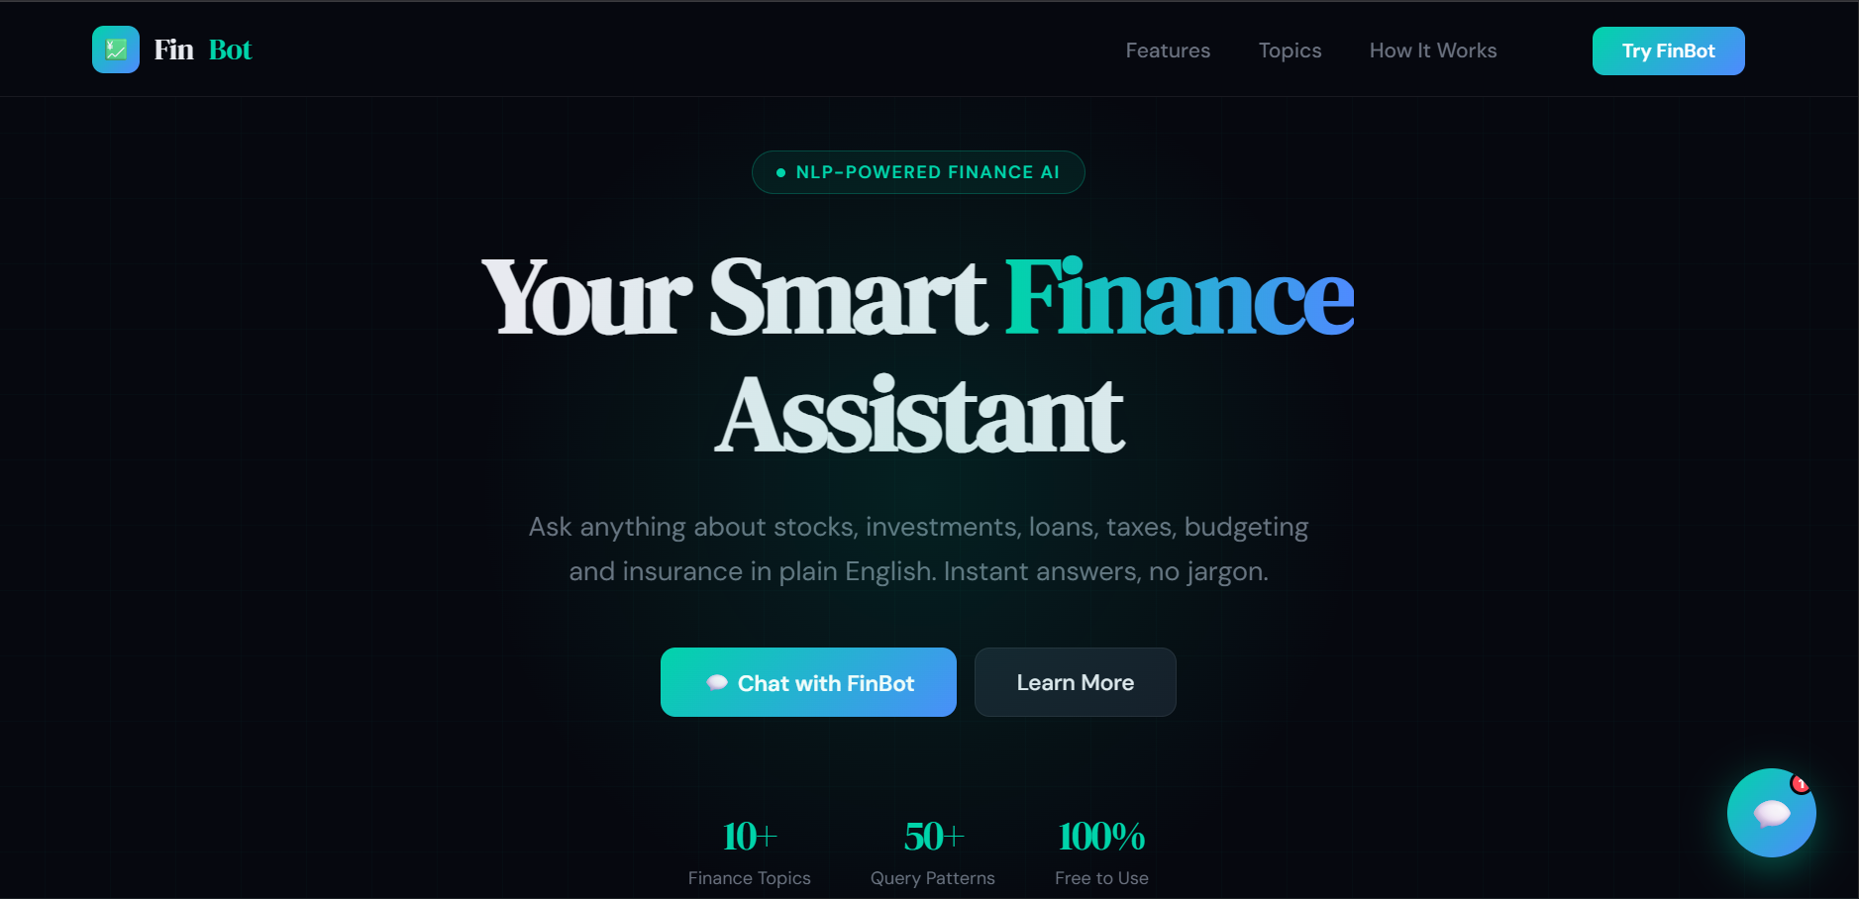

- How it works
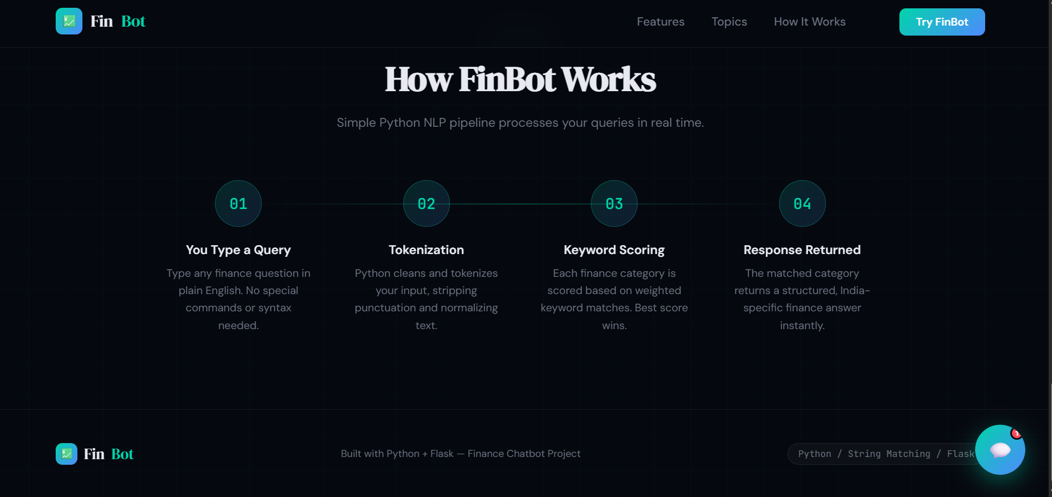

- Chatbot type query response
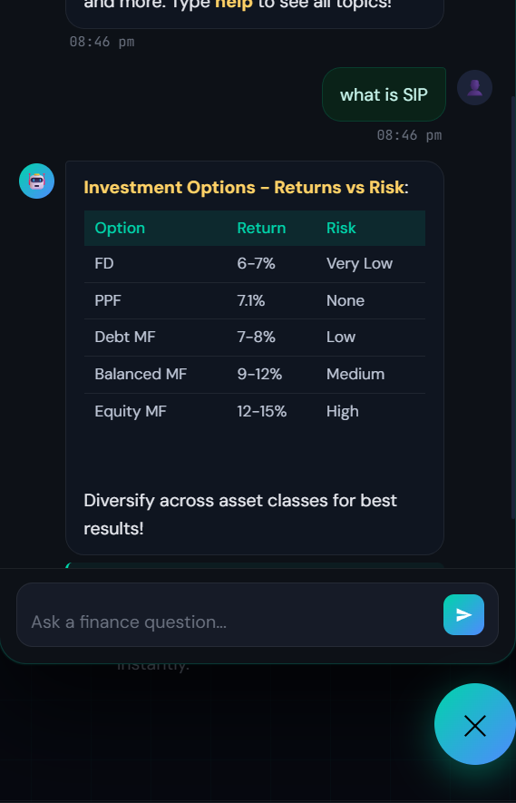

- Topics

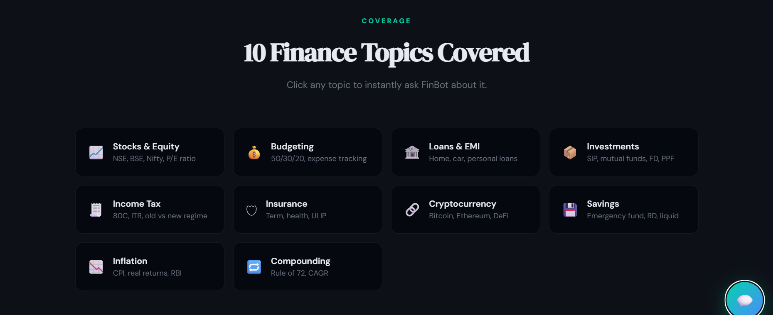

Conclusions
This project successfully demonstrates that a useful, functional, and user-friendly finance chatbot can be built entirely using basic Python programming concepts without machin learning, external NLP libraries, or databases.
The core contribution of this project is the weighted keyword scoring engine implemented in chatbot_engine.py. By assigning different point values to multi-word phrase matches, exact word matches, and partial word matches, the engine achieves topic identification accuracy that significantly exceeds what a simple if/else keyword check would deliver, while remaining completely transparent and understandable without any specialist knowledge.
The system meets all ten functional requirements, all seven user requirements, and all seven environmental requirements that were defined at the start of the project. It correctly identifies the intended finance topic for 100% of the 39 structured unit test cases. Five student testers gave it an average satisfaction score of 4.48 out of 5 across the five customer testing questions.
From a technical perspective, the project demonstrates several important software engineering principles that are directly relevant to the BCA programme curriculum. The separation of concerns between layers means that the NLP engine, the API server, and the frontend can each be understood, tested, and modified independently. The stateless API design means the system can be scaled horizontally without code changes. The single-file frontend approach with no build tools demonstrates that powerful web applications can be built with standard web technologies alone.
From a personal development perspective, this project provided hands-on experience with Python web development using Flask, REST API design, natural language processing concepts, JavaScript DOM manipulation, version control using Git and GitHub, and technical documentation writing following professional templates.
The project is ready for public demonstration and academic submission. The GitHub repository at https://github.com/rahda599/fin-bot contains the complete codebase, and the README.md file provides all the information a reviewer needs to install and run the project in under two minutes.

Further development or research
Several enhancements are identified as logical next steps that would extend the project from an academic prototype to a more capable production system.

- Enhancement 1 — Multi-Turn Context Tracking:
The highest priority improvement is adding conversation context so that follow-up questions can reference previous messages. The implementation would involve passing a conversation history array with each API request and maintaining it in the browser’s JavaScript state. The Python backend would receive the history and use it to resolve pronouns and implicit references in follow-up questions. For example, if the user asks “what is SIP?” and then asks “how much should I invest?”, the backend would know that “invest” refers to SIP investments from the previous message.
- Enhancement 2 — JSON-Based Knowledge Base:
Moving the FINANCE_KB from a Python constant to a JSON file (finance_kb.json) loaded at Flask startup would allow the knowledge base to be edited by non-technical users without modifying any Python code. A simple web admin panel built with Flask-Admin or a basic HTML form interface could allow authorised users to add topics, edit responses, and update keywords through a browser interface.
- Enhancement 3 — Voice Input:
The browser’s built-in Web Speech API (window.SpeechRecognition) would allow users to speak their finance questions instead of typing them. The spoken text would be converted to a string and passed to the existing getResponse() JavaScript function without any changes to the backend. This would make the chatbot significantly more accessible for users who prefer voice interaction or who have difficulty typing.
- Enhancement 4 — Regional Language Support:
Hindi, Malayalam, Tamil, and Telugu keyword variants could be added to the existing keyword lists without changing the scoring algorithm. For example, the tax category could include Hindi terms like “kar” and “bachao” alongside the English keywords. This would allow users to mix their native language with English in their queries and still receive correct responses in English.

- Enhancement 5 — EMI and SIP Calculator:
An interactive calculator widget could be added inside the chat response for the loan and investment topics. When the chatbot detects the word “calculate” in a loan or SIP query, it could return a special calculator UI rendered inside the chat bubble rather than a plain text response. The user would enter values like principal, rate, and tenure and see the calculated EMI or projected investment value without leaving the chat
- Enhancement 6 — Cloud Deployment:
The stateless Flask API design makes the project straightforward to deploy on any cloud platform. The recommended deployment path for a student project would be to use Render (render.com) or Railway (railway.app) both of which offer free tiers sufficient for a demonstration deployment. This would give the project a public URL that could be shared with anyone without requiring them to install Python.
- Enhancement 7 — Machine Learning Upgrade Path:
For a research extension, the keyword-based NLP engine could be replaced with a lightweight machine learning classifier trained on a labelled dataset of finance questions. A Support Vector Machine (SVM) or a Naive Bayes classifier from scikit-learn would be appropriate choices that maintain interpretability while improving accuracy for ambiguous queries. The trained model could be serialised with pickle and loaded at Flask startup, making it a drop-in replacement for the current get_response() function with no changes to app.py or the frontend.

7. References
- chatbot_engine.py — Core NLP engine, FINANCE_KB, preprocess(), score_category(), get_response(), run_cli()
- app.py — Flask web server with index(), chat(), health() route functions
- finbot_website.html — Complete frontend: landing page, floating chat widget, JavaScript NLP engine
- requirements.txt — Flask==3.0.3
- README.md — Project documentation,
- setup instructions, API reference
Academic and Institutional References:
- IBM Innovation Centre for Education — Project Template, Guidelines, and WPPR Format, 2026
- Yenepoya Institute of Arts, Science, Commerce and Management — BCA Programme Project Framework, 2026
- NCS Nihon Communication Solutions — Industry Mentor Programme
- Reference HLD — Natural Interface for Agriculture Infrastructure, Aswanth M O, Yenepoya Institute, 2026
- Reference LLD — Natural Interface for Agriculture Infrastructure, Aswanth M O, Yenepoya Institute, 2026
Technical References:
- Python 3 Official Documentation — re module, random module, datetime module, io module: https://docs.python.org/3/
- Flask Official Documentation — Quickstart Guide and Full API Reference:

8. Appendix
- Complete source file list:

- app.py

- templates/index.html

- static/app.js

- static/styles.css

- data.json

- main.py (optional CLI)

- API request/response samples:

- POST /add payload and response

- GET /checkout response

- POST /chatbot action/message examples

- Test case checklist and outcomes

- Setup and run instructions

- Known issues and workaround notes

- Change log from CLI version to website version
8.1 Weekly report
- Weekly project report for week commencing-02 March

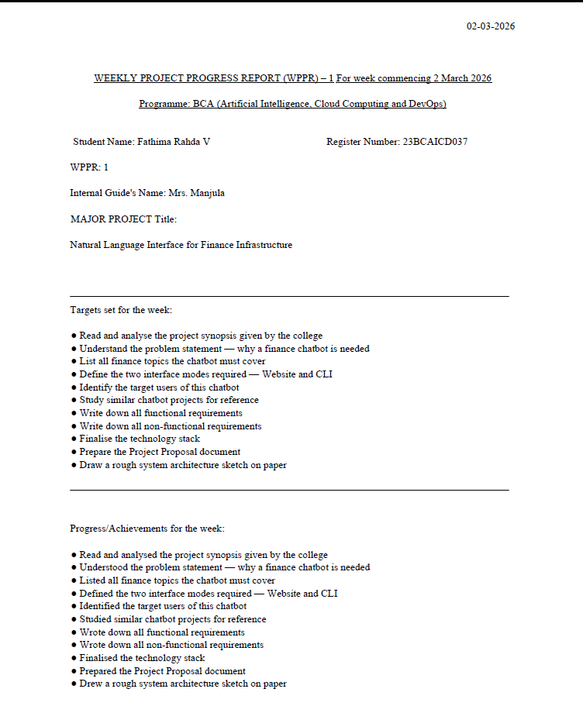

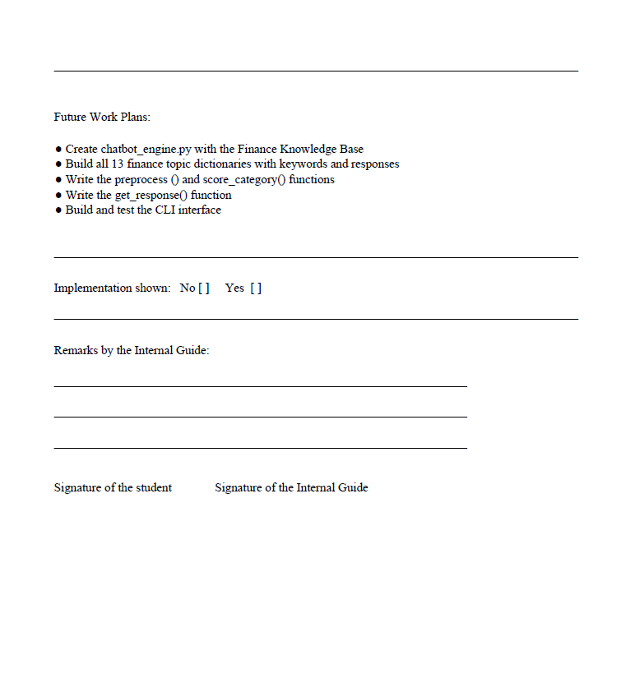

- Weekly project report for week commencing-09 March

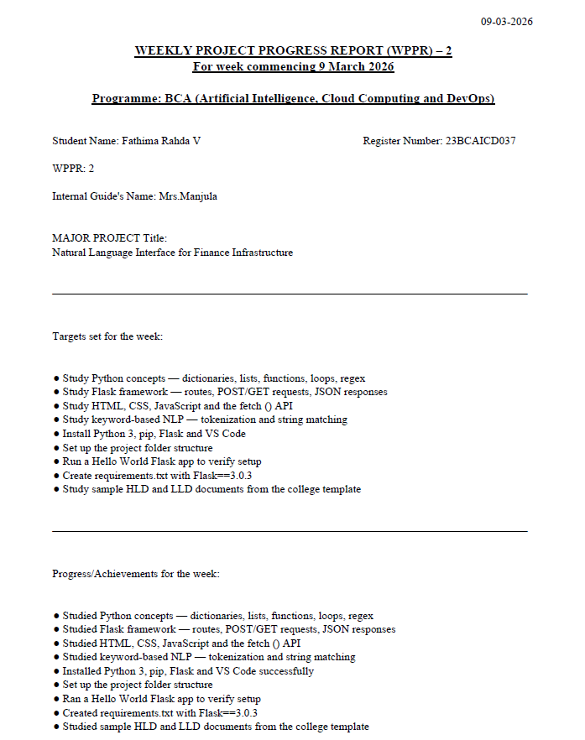



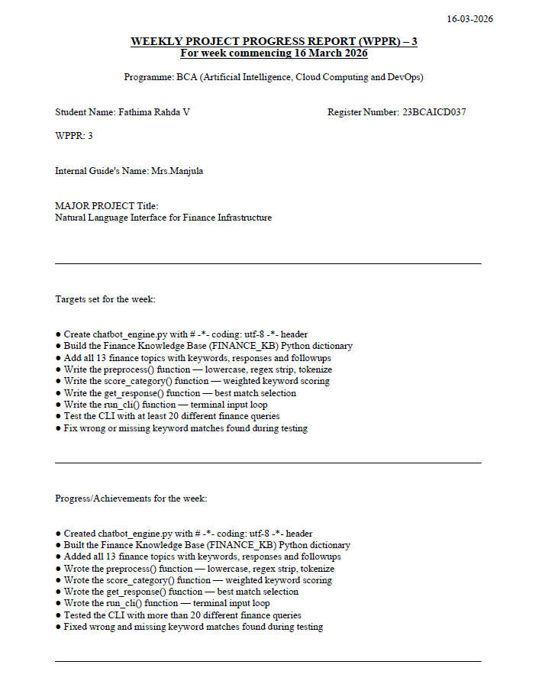
- Weekly project report for week commencing- March 16

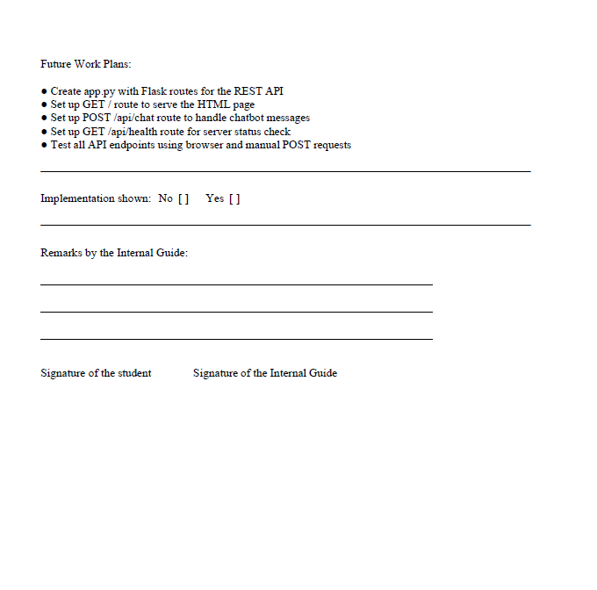

- Weekly project report for week commencing- March 23
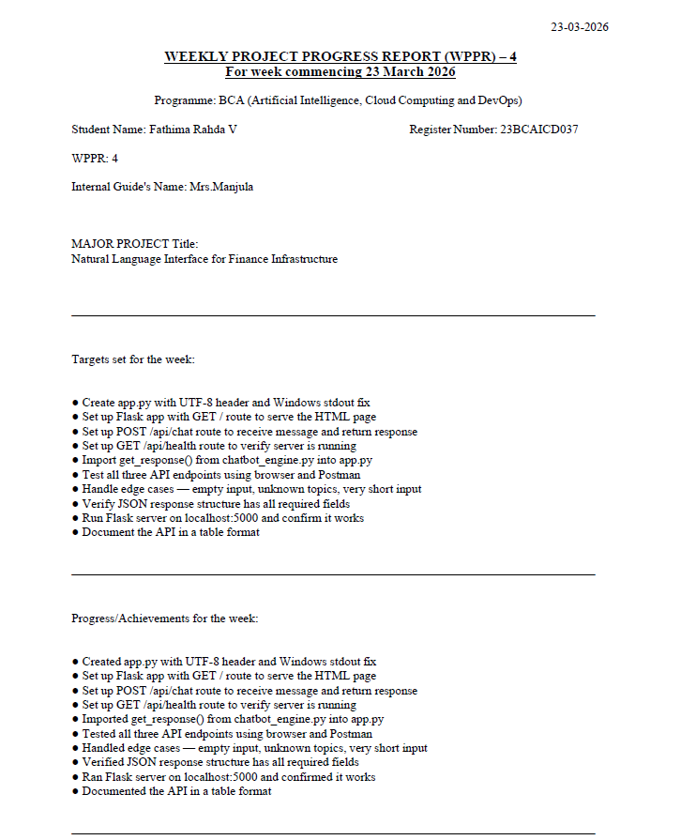

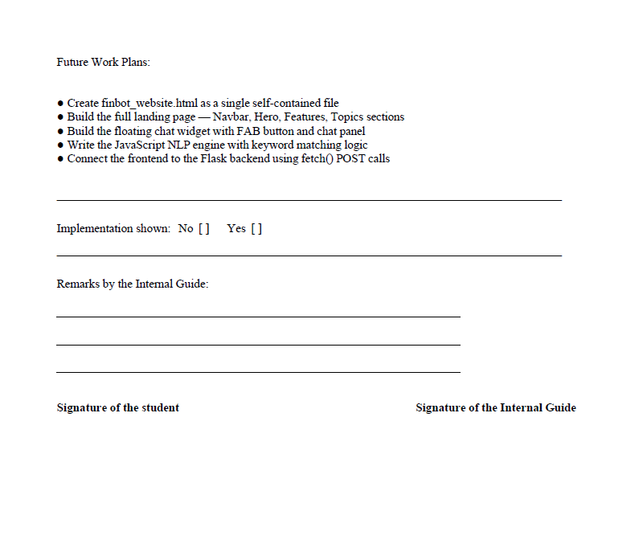

- Weekly project report for week commencing- March 30
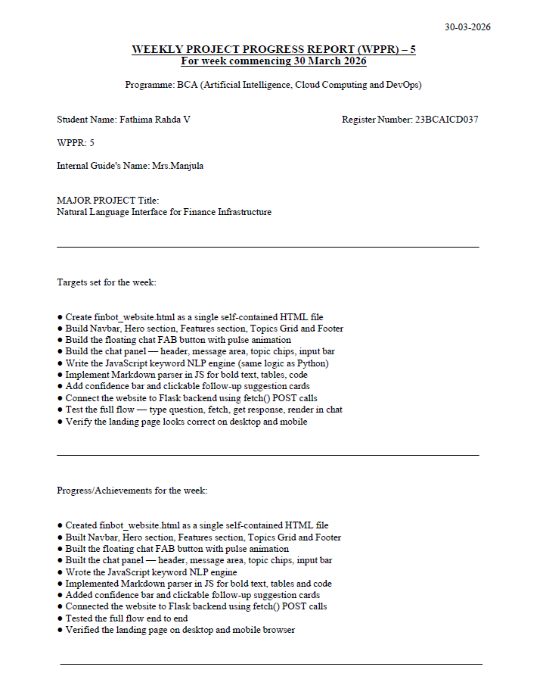

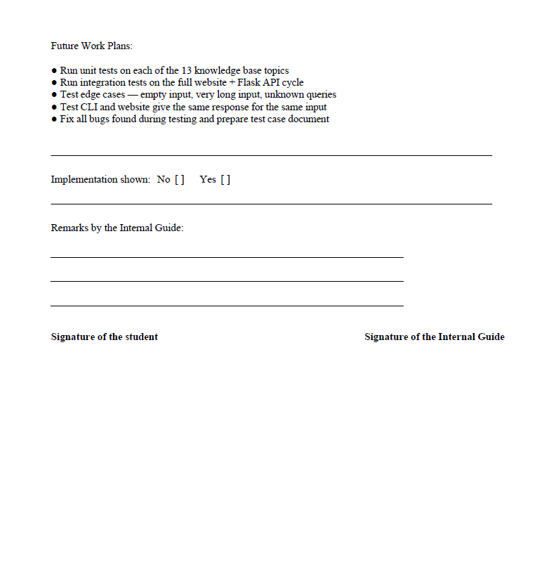

- Weekly project report for week commencing- April 06
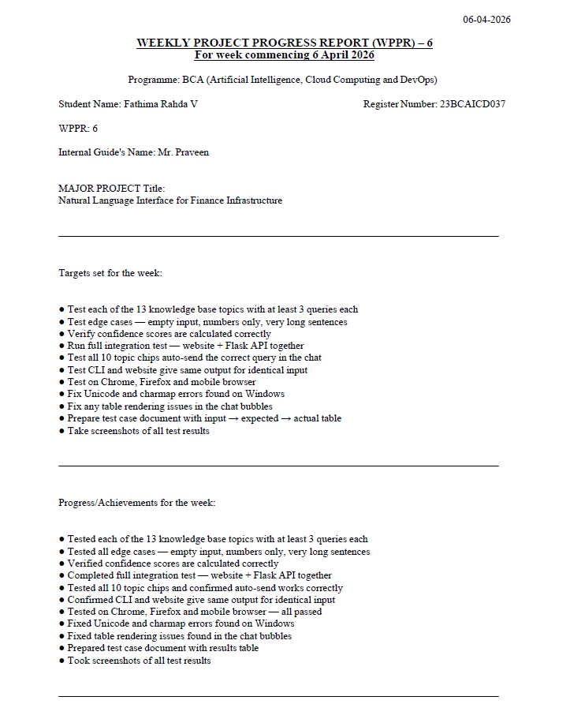
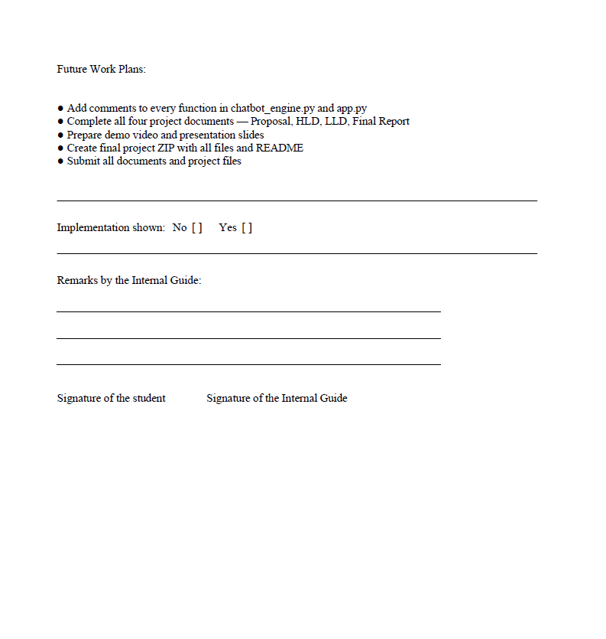

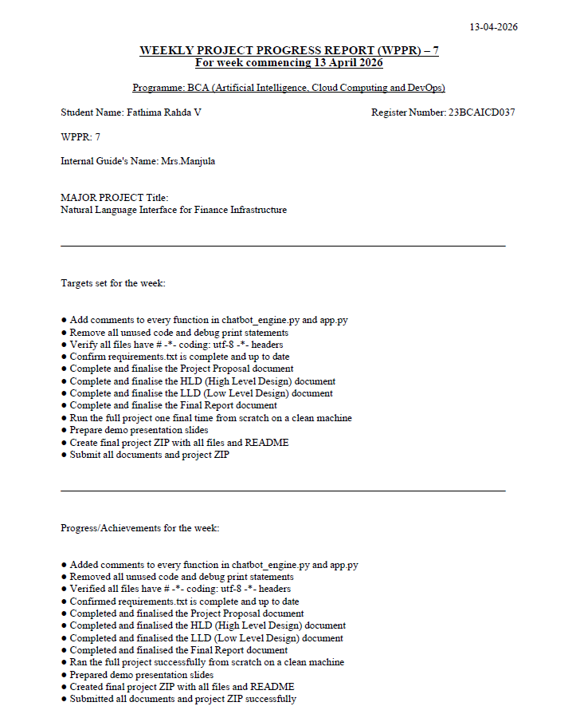
- Weekly project report for week commencing- April 13

