Smart Order Routing

A **SOR** is a facility that gets the best price for your buy/sell **orders** on available exchanges. When you select **SOR**, our system automatically compares the price of stock across the available exchanges and helps you get the best price instantly.

**Smart order routing** (SOR) is an automated process of handling orders, aimed at taking the best available opportunity throughout a range of different [trading venues](https://en.wikipedia.org/wiki/Trading_venue).

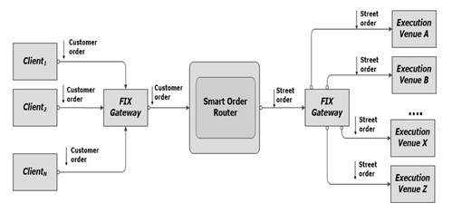

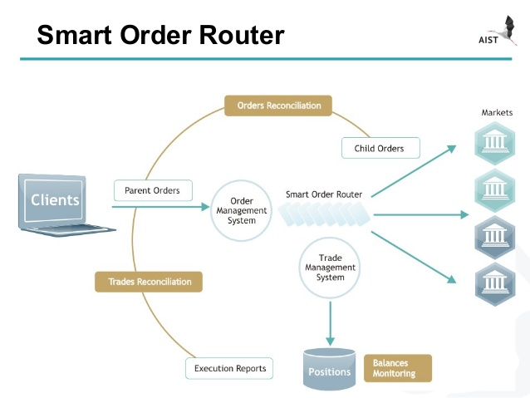

In India SOR Services are provided by:

1. HDFC Securities

2. Kotak Securities

3. BSE

4. NSE

5. IIFL

6. Interactive brokers India pvt ltd