Kingdom of Saudi Arabia  Ministry of Education  University of Jeddah  College of Computer Science and Engineering  Department of Cybersecurity |  | المملكة العربية السعودية  وزارة التعليم  جامعة جدّة  كلية علوم وهندسة الحاسب  قسم الأمن السيبراني

Project
CCCY 312 Cryptography
First Semester 2025-2026
Due Date: 6 December 2025

Student Name: Raheed alturki | Student ID: 2311045
Student Name: Renad Almalki | Student ID: 2310912
Student Name: Manar Alharbi | Student ID: 2312326

Instructor Name | Section
Rawan Suleiman Balous | CY2

:

Table of Contents
Table of Contents 2
1. Introduction 4
1.1 Background and Motivation 4
1.2 Problem Statement and Objectives 4
1.3 Scope, Assumptions, and Contributions 5
2. Background and Related Work 5
2.1 Public-Key Cryptography and Digital Signatures 5
2.2 Elliptic Curve Cryptography and Pairings 6
2.3 Short Signatures and BLS Overview 6
2.4 Baseline BLS Formulation Used in Our Project (TELKOMNIKA) 7
2.5 Strengths and Limitations 7
3. System and Threat Model 8
3.1 Application Scenario and Entities 8
3.2 Security Requirements 9
3.3 Threat Model and Adversary Capabilities 9
4. Proposed BLS-Based Short Signature Protocol 10
4.1 Improvements 10
4.2 Key Generation, Signing, and Verification 11
4.3 Clarification on Hash-to-Curve in Theory vs. Implementation 11
4.4 Protocol Workflow 12
4.5 Comparison Between Original and Improved BLS Protocol 12
5. Security Analysis and Cryptanalysis 12
5.1. Mathematical Hardness Foundations 12
5.2. Resistance to Classical Cryptanalysis 13
5.3. Forgery and Rogue-Key Attack Resistance 13
5.4. Hash-Related Attack Resistance 13
5.5. Quantum-Related Considerations 14
6. Side-Channel Analysis and Mitigation 14
6.1 Overview of Side-Channel Attacks 14
6.2 Timing Attacks 15
6.3 Power Analysis 16
6.4 Electromagnetic (EM) Attacks 16
6.5 Fault Injection Attacks 17
6.6 General Mitigation Strategies 17
7. Alignment with NCS/NCA Standards 18
7.1 Relevant NCA Controls 18
7.2 Mapping Protocol Properties to NCA Controls 19
7.3 Compliance Gaps and Recommendations 20
8. Implementation and Evaluation 20
8.1 Implementation Environment and Tools 21
8.2 Core Protocol Functions and Test Behavior 22
8.3 Performance Evaluation (Time and Signature Size) 23
8.4 Source code 24
8.5 Program output 27
9. Conclusion and Future Work 27
9.1 Summary of Findings 27
9.2 Limitations 28
9.3 Future Enhancements 28
References 29

1. Introduction

1.1 Background and Motivation
In the current day computing ecosystems, tons of sensitive information is stored, processed and shared in the cloud and other digitalized resources and services that can be accessed through cloud platforms and other outsourced technologies. Especially for organizations that need to comply with the tight cyber security policies, the truth and integrity of such documents is paramount at the very least. Digital signatures represent the essential cryptographic element that confers authenticity, robustness, and non-repudiation to digital data [1].
Classical public-key signature schemes such as RSA require relatively large key sizes to achieve current security levels, which increases computation, communication, and storage costs. Elliptic Curve Cryptography (ECC) offers equivalent security with much shorter keys, making it attractive for constrained environments and large-scale systems [2]. Building on ECC and bilinear pairings, Boneh–Lynn–Shacham (BLS) signatures provide very short signatures, typically represented by a single group element, while maintaining a strong security level [3]. Recent work has shown how BLS-based constructions can be used to build robust data integrity verification frameworks for cloud storage, reducing both storage and communication overhead [4]. This motivates the design and analysis of short digital signature protocols based on BLS for modern cloud-centric and regulated environments.

1.2 Problem Statement and Objectives
The problem statement of this project is designing and analyzing a short digital signature protocol that follows the BLS-style scheme which:
- guarantees the integrity of the data that it stores or sends
- keeps the signatures small and as cheap as possible
- remains secure against both classical, math, plus nonlogical adversaries—even adversarial side-channels.
To tackle this problem, the project pursues the following objectives:
- Study the cryptographic background of public-key signatures, ECC, and bilinear pairings [1], [2].
- Review the BLS short signature scheme and a recent BLS-based cloud integrity framework, and extract the core design ideas relevant to our protocol [3], [4].
- Design a short BLS-based digital signature protocol tailored to a concrete application scenario.
- Explain the mathematical assumptions underlying the security of the protocol.
- Analyse the protocol against classical cryptanalytic and quantum-related threats.
- Identify potential side-channel attacks and propose suitable mitigation techniques.
- Discuss the alignment of the protocol with selected NCS/NCA cyber security requirements and provide a basic implementation and performance evaluation.
This project not only analyzes existing short-signature schemes but also proposes a modified BLS-based design with enhanced security features.

1.3 Scope, Assumptions, and Contributions
This project focuses on the design and high-level analysis of a BLS-based short digital signature protocol. The scope is limited to:
- software-level modelling of the protocol,
- conceptual security and cryptanalysis discussion based on known hardness assumptions (e.g., ECDLP and related problems) [1], and BLS-style assumptions [3], and
- an initial implementation and performance evaluation in a laboratory setting.
Hardware implementations, detailed physical measurements, and fully formal proofs in a provable-security framework are considered out of scope. We assume that standard cryptographic primitives—such as secure hash functions and pairing-friendly groups—are correctly instantiated according to best practices [1], [3].
Under these assumptions, the main contributions of this work are:
- a structured description of a BLS-based short digital signature protocol in a cloud integrity setting, based on [4], and extended with our proposed modification;
- a consolidated background that links digital signatures, ECC foundations, bilinear pairings, and short signatures [1]–[3];
- a security and cryptanalysis discussion that covers classical, mathematical, quantum-related, and side-channel aspects; and
- an initial alignment discussion with relevant NCS/NCA requirements, supported by a basic implementation and preliminary performance observations.

2. Background and Related Work

2.1 Public-Key Cryptography and Digital Signatures
Public-key cryptography is based on using two related keys: a public key for verification and a private key for signing. Digital signature schemes are a core application of public-key cryptography and are used to ensure authenticity, integrity, and non-repudiation of digital messages and documents [1]. In practice, a signature is generated using the signer’s private key and verified using the corresponding public key, allowing any verifier to confirm the origin and integrity of the signed content [1].
In this project, digital signatures are considered the primary primitive for proving data authenticity and integrity in environments where the storage or communication medium is not fully trusted. This becomes especially relevant in cloud settings, where signing and verification can be used as a mechanism to detect tampering and establish accountability [4].
In the rest of this report, we describe signature schemes using the standard algorithms KeyGen, Sign, and Verify. Since our goal is to minimize signature size and verification overhead in cloud auditing, we next review ECC and pairing-based signatures, focusing on BLS-style short signatures [3], [4].

2.2 Elliptic Curve Cryptography and Pairings
Elliptic Curve Cryptography (ECC) achieves strong security with smaller key sizes than classical public-key systems. For example, a commonly cited comparison is that 256-bit ECC provides security comparable to 3072-bit RSA, which is beneficial for bandwidth- and storage-constrained systems [1], [2].
To enable short-signature constructions such as Boneh–Lynn–Shacham (BLS), pairing-based cryptography introduces a bilinear pairing map e over cyclic groups of prime order. Following the standard abstraction, let G1, G2 be cyclic groups of prime order p with generators g1 ∈ G1 and g2 ∈ G2, and let GT be a cyclic group of the same order. A bilinear pairing is a map:
(1) e : G1 × G2 → GT
with the following properties:
• Bilinearity: for all a, b ∈ Zp, e(g1^a, g2^b) = e(g1, g2)^{ab}. Equivalently, e(u^a, v^b) = e(u, v)^{ab}.
• Efficient computability: e(u, v) can be computed efficiently.
• Non-degeneracy: e(g1, g2) ≠ 1_GT.
These pairing properties are explicitly used in BLS-based integrity frameworks to obtain compact verification equations [3], [4].

2.3 Short Signatures and BLS Overview
Boneh, Lynn, and Shacham introduced short signatures derived from Gap Diffie–Hellman (GDH) groups instantiated using elliptic curves equipped with a Weil (or Tate) pairing [3]. In the generic GDH signature scheme, signatures are elements of a prime-order group G with generator g, and the signer uses a full-domain hash-to-group function:
(2) h : {0,1}* → G*
Key generation:
(3) choose x ←R Zp* (secret key), and set v = g^x (public key).
Signing:
(4) σ = h(M)^x where h(M) ∈ G*.
Verification checks validity using a pairing-based test in the concrete construction. In the paper’s “concrete short signature scheme”, the signer computes a point SM = x·PM (where PM is the hash-to-curve output), and the signature can be represented compactly (e.g., by the x-coordinate). Verification performs two pairing computations and accepts if the pairing equality holds (up to inversion depending on convention) [3].
This construction is widely cited for producing very short signatures (relative to many traditional schemes), since the signature can be encoded as a single group element (or even a compressed representation) [3].

2.4 Baseline BLS Formulation Used in Our Project (TELKOMNIKA)
Our project is built upon the TELKOMNIKA cloud-integrity framework that utilizes BLS-style signatures with bilinear pairings [4]. Let C be a cyclic group of prime order and let CG be a target group of the same order. The scheme relies on a bilinear map:
(5) e : C × C → CG
with bilinearity and non-degeneracy (as in Section 2.2) [4]. Let c be a generator of C.
Key generation:
(6) choose K ←R Zr as the private key, and compute the public key P = c^K.
Signing:
(7) compute H = h(m) ∈ C, and define the signature as
S = H^K.
Verification:
Using bilinearity, a valid signature must satisfy:
(8) e(S, c) = e(H, c^K) = e(h(m), P).
Equation (8) is the baseline verification equation used throughout this project to connect signatures with public keys via pairing checks [4].

2.5 Strengths and Limitations
Strength (Short signatures):
BLS signatures are short because the signature is encoded as a single group element (or a compressed form), which reduces storage and communication overhead in systems that handle many signatures [3], [4].
Limitation 1 (Hashing to the curve / hash-to-group requirement):
BLS requires hashing arbitrary messages into valid group elements on a pairing-friendly curve (hash-to-curve / map-to-group). This is a non-trivial engineering requirement and must be instantiated carefully [3].
Limitation 2 (Public-key validation in multi-signer settings):
In multi-signer or aggregation scenarios, secure public-key registration and validation become critical, since many practical failures come from key management rather than the pairing check itself [1].
Limitation 3 (Implementation sensitivity to side-channels):
Like other public-key primitives, implementations can leak information through timing or other side-channels if not protected. Practical countermeasures such as blinding and constant-time techniques are commonly recommended for mitigating timing-based leakage [1].

3. System and Threat Model

3.1 Application Scenario and Entities
This project adopts a cloud-based data integrity verification scenario in which a data owner outsources data to a cloud server and later needs to verify that the stored content has not been altered. Following the baseline framework in our main reference, integrity checking is performed through a public auditing approach based on challenge–response interaction, aiming to avoid downloading the full outsourced data during verification [4]. The system involves the following entities:
- Data Owner / Client (User): Prepares the data for outsourcing (e.g., splitting it into blocks and generating the required signatures/metadata) and holds the signing private key. The user may authorize audits to check integrity when needed [4].
- Cloud Service Provider (CSP): Stores the outsourced data blocks and related metadata, and responds to audit challenges by generating an integrity proof [4].
- Third-Party Auditor (TPA): Issues audit challenges and verifies the cloud’s proof using public information (e.g., public key and metadata), enabling efficient integrity validation without downloading the original data [4].
Digital signatures are used as the main mechanism to support authenticity and integrity guarantees in this untrusted storage setting [1], while the adopted design uses BLS-style pairing-based verification as a compact and efficient foundation [3], [4].

3.2 Security Requirements
To meet the objectives of integrity verification and public auditing, the protocol should satisfy the following security requirements:
- Data Integrity: Any unauthorized modification, deletion, or replacement of outsourced data must be detectable during the audit process [4].
- Authenticity of Audit Proofs: The CSP’s response should be verifiable and cryptographically bound to the correct data and the legitimate signer’s public key, preventing forged proofs [1], [3].
- Unforgeability: Without the signing private key, an adversary should not be able to generate valid signatures or valid audit proofs that pass verification (consistent with standard digital-signature security expectations) [1], [3].
- Public Auditability: The TPA should be able to verify correctness using only public parameters and metadata, without access to the secret key [4].
- Efficiency (Low Computation and Communication Overhead): Auditing should remain practical for large datasets by minimizing computation and communication costs, aligning with the “lightweight” verification goal of the baseline framework [4].
- Accountability: Verification outcomes should clearly indicate integrity success or failure, supporting reliable auditing and dispute resolution between the data owner and the cloud provider [4].

3.3 Threat Model and Adversary Capabilities
We examine a probabilistic polynomial-time adversary with realistic capabilities appropriate for cloud and network environments. We assume the adversary has access to public parameters, public keys, and exchanged audit messages.
- Dishonest CSP (Primary Threat): The cloud server may attempt to pass integrity audits without correctly storing all data (e.g., by deleting or modifying blocks) and yet try to generate acceptable proofs. The adversary can observe challenges and craft responses, but should not be able to produce valid proofs if the underlying BLS unforgeability and pairing-based security assumptions hold [3], [4].
- External Network Attacker: An external adversary may intercept, modify, or replay challenge/response messages. The protocol should ensure that any tampering results in verification failure and that forging valid responses remains infeasible under the underlying digital signature security model [1], [3].
- Curious or Semi-Trusted Auditor (Optional Consideration): While the TPA is typically assumed to follow the verification procedure correctly, a stronger model may consider a curious auditor attempting to learn additional information beyond what is required for public verification. This is considered an optional, stronger model and is discussed only at a high level; its relevance depends on what is revealed by the auditing design and metadata exposure in the baseline framework [4].
This threat model serves as the basis for the later cryptanalysis and side-channel discussions, where we examine how these adversaries could attempt to break or bypass integrity verification.

4. Proposed BLS-Based Short Signature Protocol

The proposed protocol enhances the original Boneh–Lynn–Shacham (BLS) signature scheme introduced in 2001 [3]. Although the baseline BLS protocol provides short signatures and efficient verification using bilinear pairings, it exhibits several practical vulnerabilities when deployed in multi-user environments. To address these limitations, the improved protocol incorporates Proof-of-Possession (PoP), deterministic hash-to-curve mapping, and explicit public key validation. These additions significantly increase resilience against rogue-key attacks, invalid-curve attacks, and hash-related vulnerabilities while preserving the fundamental strengths of elliptic curve cryptography [1], [2], [8].

4.1 Improvements
1. The improved BLS protocol introduces Proof-of-Possession (PoP) to eliminate rogue-key attacks, a vulnerability in the original BLS design [5].
2. The protocol conceptually relies on deterministic and mathematically sound hash-to-curve mappings such as Icart’s construction, which ensures uniform subgroup mapping and predictable behavior [6].
3. Full public-key validation is incorporated to prevent invalid-curve points, small-subgroup keys, and other structural attacks, consistent with recommended validation procedures for ECC-based protocols [7][8].
4. These enhancements strengthen the original BLS scheme proposed by Boneh, Lynn, and Shacham while preserving its short-signature advantage [3].

4.2 Key Generation, Signing, and Verification
1.Key Generation:
• A private key x \in \mathbb{Z}_p^* is selected, and the public key is derived as P = g^x, following standard ECC-based key generation principles [1][2].
• A Proof-of-Possession is generated to authenticate ownership of the private key as recommended in multiparty-signature literature [5].
2.Signing:
• The message is mapped to a curve point through a secure hash-to-curve operation H = HashToCurve(m) [6].
• The final signature is computed as S = H^x, consistent with the BLS formulation [3].
3.Verification:
• The verifier recomputes H = HashToCurve(m) and checks if
e(S, g) = e(H, P),
which is the defining security condition of BLS signatures based on bilinear pairings [3].
• Public-key validation is performed first to ensure curve correctness and subgroup integrity [7][8].

In practice, our implementation does not use Icart’s deterministic hash-to-curve function. Instead, the py_ecc library internally applies its own hash_to_G2 mapping when calling the Sign() function. This makes the practical behavior different from the theoretical model but still secure for experimental evaluation.

4.3 Clarification on Hash-to-Curve in Theory vs. Implementation
1. The theoretical design of the protocol assumes deterministic hash-to-curve mappings such as the Icart function, which provides uniformity and correct subgroup placement [6].
2. The implemented prototype, however, uses the built-in hash-to-G2 mechanism from the py_ecc BLS12-381 library. Although secure, it does not explicitly implement Icart’s method.
3. Therefore, the conceptual model is based on deterministic hashing [6], while the practical model uses standardized hashing suitable for experimentation and evaluation, consistent with academic prototypes in literature [4][8].

4.4 Protocol Workflow
1. Key Setup: Key pairs are generated, PoP is produced, and public-key validation is applied following established ECC validation recommendations [7][8].
2. Signing: Messages are hashed to curve points and signed using the BLS exponentiation structure [3].
3. Verification: Public-key validation and pairing checks ensure authenticity and integrity of signatures as required in high-security systems, including those described in NCA national standards [9][11].

4.5 Comparison Between Original and Improved BLS Protocol
1. The original BLS protocol [3] does not include PoP, while the improved version integrates PoP mechanisms to mitigate rogue-key attacks [5].
2. Public-key validation is absent in the original scheme but mandatory here, following ECC validation best practices [7][8].
3. Hash-to-curve behavior in the improved model follows deterministic assumptions [6], in contrast to the less-defined hashing procedures often implied in early pairing-based protocols [3].

5. Security Analysis and Cryptanalysis

This section evaluates the security of the improved BLS-based digital signature protocol against mathematical, structural, classical, hash-related, and quantum attack vectors. The analysis is grounded in the hardness assumptions of elliptic curve cryptography described by Stallings [1], Yan [2], Boneh, Lynn, and Shacham [3], and Hankerson et al. [8], and incorporates the enhanced protections introduced in our protocol design.

5.1. Mathematical Hardness Foundations
The protocol relies on three core cryptographic assumptions:
• Elliptic Curve Discrete Logarithm Problem (ECDLP): Recovering the private key x from the public key P = g^x is computationally infeasible, ensuring confidentiality and preventing forgery attempts [1], [2], [8].
• Computational Diffie–Hellman (CDH): Producing H(m)^x without the private key requires solving CDH, forming the theoretical basis for BLS unforgeability [3].
• Gap-DH Environment: Bilinear pairings allow efficient verification while CDH remains hard, enabling secure signature checking without weakening underlying mathematical assumptions [3].
These foundations establish the mathematical security of the improved protocol.

5.2. Resistance to Classical Cryptanalysis
Classical computational attacks, including brute-force key search and ECDLP algorithms such as Pollard’s Rho and Baby-Step Giant-Step, remain infeasible for 256-bit elliptic curve groups [1], [2], [8]. Structural attacks targeting invalid-curve or subgroup vulnerabilities are mitigated through mandatory public key validation [7]. Because BLS signing only requires a single exponentiation and deterministic mapping to the curve, the attack surface for classical cryptanalysis remains narrow and well-defended.

5.3. Forgery and Rogue-Key Attack Resistance
The improved protocol directly mitigates several known weaknesses of the original BLS scheme:
• Existential Forgery: BLS is proven EUF-CMA secure under CDH hardness [3], and our implementation preserves this guarantee.
• Rogue-Key Attacks: By requiring Proof-of-Possession (PoP), the protocol prevents adversaries from constructing malicious public keys dependent on honest users’ keys. This mitigates the attack class identified by Ristenpart and Yilek [5].
• Invalid-Curve and Key-Injection Attacks: These attacks exploit malformed public keys. The enforced key validation step ensures all keys lie on the correct curve and subgroup, following recommendations by Chen et al. [7].
Together, these protections enhance the integrity and authenticity of participants in multi-user environments.

5.4. Hash-Related Attack Resistance
Hashing messages to elliptic-curve points is a major attack surface in pairing-based cryptography. To address this:
• Collision Resistance: Deterministic and secure hash-to-curve mapping, consistent with Icart’s method [6], reduces the likelihood of collision-based forgeries.
• Non-Uniform Hashing Attacks: The standardized mapping ensures uniform curve distribution, preventing adversaries from exploiting biased or weak hash outputs.
• Invalid-Point Hash Attacks: Secure hashing ensures all points lie on the intended subgroup, preventing structural exploitation.

These measures strengthen the protocol against hash-related weaknesses observed in naive BLS deployments.

5.5. Quantum-Related Considerations
Quantum computing introduces threats beyond classical adversaries:
• Shor’s Algorithm: Capable of breaking ECDLP and CDH in polynomial time, rendering all ECC-based signatures—including BLS—non–quantum resistant [1], [2], [8].
• Grover’s Algorithm: Reduces brute-force search complexity but does not directly compromise ECC security.
• Practical Impact: While scalable quantum computers do not yet exist, the protocol should be considered vulnerable in a future post-quantum context. The improvements introduced (PoP, validation, secure hashing) enhance classical security but do not provide quantum resistance.

6. Side-Channel Analysis and Mitigation

While the improved BLS-based signature protocol strengthens resistance to mathematical and structural attacks, it remains exposed to side-channel attacks, which exploit physical leakages rather than weaknesses in the cryptographic algorithm itself. Side-channel attacks have been widely studied in the elliptic-curve literature and are recognized as critical threats to real-world implementations of ECC systems [1], [2], [8].
This section analyzes relevant side-channel vectors and outlines mitigation strategies applicable to BLS implementations.

6.1 Overview of Side-Channel Attacks
Side-channel attacks target information unintentionally leaked during computation. These leakages include timing variations, power consumption, electromagnetic radiation, and fault responses.

1) Nature of Leakage
Side-channel attacks exploit physical attributes of devices rather than breaking ECDLP or CDH mathematically. This makes them practical and dangerous even when the underlying elliptic-curve mathematics is secure [1].
2) Relevance to ECC and BLS
Operations such as scalar multiplication (H^x) and pairing calculations are susceptible to leakage because they involve sequential bit-dependent operations [2], [3], [8].
3) Threat Model
An attacker must have proximity or physical access to the device performing the signing operation, which is realistic in embedded systems, cloud-hosted cryptographic services, or compromised hardware environments.

6.2 Timing Attacks
Timing attacks analyze variations in execution time to reveal information about secret keys.
1) Vulnerability
Scalar multiplication used in BLS signing often exhibits timing patterns dependent on the bit representation of the private key x. Without countermeasures, attackers can recover partial or complete key material through timing traces [1], [8].
2) Impact on BLS
Because BLS signatures compute
S = H^x,
any timing leakage during exponentiation may reveal bits of x, which would compromise unforgeability.
3) Mitigation
• Use constant-time algorithms for scalar multiplication.
• Apply unified formulas that do not vary based on key bits.
• Ensure pairing operations avoid conditional branching.

6.3 Power Analysis
Power analysis attacks measure power consumption to infer computations performed by the signing device.
1) Simple Power Analysis (SPA)
SPA distinguishes patterns corresponding to bit-dependent operations, revealing the structure of the private key. This is relevant because ECC scalar multiplication often alternates between doubling and addition steps [8].
2) Differential Power Analysis (DPA)
DPA uses statistical analysis over many traces. Even if operations appear uniform, DPA can reveal correlations between power consumption and secret intermediates.
3) Mitigation
• Randomize scalar multiplications using point blinding or scalar blinding.
• Use constant-power hardware designs.
• Avoid predictable intermediate values.

6.4 Electromagnetic (EM) Attacks
EM attacks analyze electromagnetic emissions produced by a device during computation.
1) Characteristics
EM leakage provides high-resolution information about intermediate states of ECC operations, often more detailed than power traces.
2) Relevance to BLS
Since BLS involves both exponentiation and pairing evaluations, EM side channels may leak more information than timing or power alone [2].
3) Mitigation
• Use EM shielding in hardware implementations.
• Deploy noise and masking techniques to reduce signal-to-noise ratios.
• Maintain operational consistency across signing routines.

6.5 Fault Injection Attacks
Fault attacks intentionally induce computational errors to extract secret information.
1) Attack Concept
Faults introduced into scalar multiplication or hash-to-curve computations may cause incorrect signatures that reveal relationships between correct and faulty outputs.
2) Impact on BLS
Pairing-based signatures are particularly vulnerable: a single fault in the exponentiation step may leak bits of x, and repeated faulty signature output enables private-key reconstruction [3].
3) Mitigation
• Use redundant computations for verification.
• Apply input/output validation checks before releasing signatures.
• Implement hardware integrity protections to prevent voltage or clock glitching.

6.6 General Mitigation Strategies
The following strategies collectively reduce exposure to timing, power, EM, and fault attacks:
1) Algorithmic Countermeasures
• Constant-time scalar multiplication
• Deterministic and validated hash-to-curve processing [6]
• Scalar, point, and coordinate blinding techniques
2) Hardware-Level Protections
• Power line filtering and voltage regulation
• EM shielding
• Tamper-resistant enclosures
3) Protocol-Level Measures
• Enforcing public key validation [7]
• Using PoP to ensure legitimacy of key ownership [5]
• Restricting signing operations to secure execution environments
These comprehensive protections align with the broader security recommendations for ECC systems detailed by Stallings [1], Yan [2], and Hankerson et al. [8].

7. Alignment with NCS/NCA Standards

This section analyzes how the improved BLS-based digital signature protocol aligns with national cybersecurity standards issued by the National Cybersecurity Authority (NCA) and the National Cybersecurity Strategy (NCS). The evaluation considers core security principles—integrity, authenticity, non-repudiation, cryptographic robustness, key management, and system hardening—and demonstrates how the protocol satisfies corresponding controls through its design choices.

The protocol enhancements, including Proof-of-Possession (PoP), deterministic hash-to-curve, explicit public key validation, and resistance to forgery and structural attacks, reinforce compliance with national requirements for secure cryptographic implementations.

7.1 Relevant NCA Controls
This alignment is based on NCA’s Essential Cybersecurity Controls (ECC), Critical Systems Cybersecurity Controls (CSCC), and National Cryptographic Standards (NCS), as well as the National Cybersecurity Strategy.[9]–[12].
The following NCA cybersecurity controls are most relevant to a digital signature protocol:
1) Cryptographic Security Controls
NCA requires organizations to use robust, industry-standard cryptographic mechanisms to ensure data integrity, authenticity, and confidentiality.
The BLS-based protocol meets these expectations by relying on elliptic-curve cryptography [2], secure hash-to-curve mapping [6], and bilinear pairings [3], all of which provide mathematically sound security foundations.
2) Key Management and Validation Controls
NCA emphasizes proper key generation, distribution, validation, and lifecycle management.
The improved protocol integrates explicit public key validation [7] and PoP enforcement [5], ensuring that only legitimate, verifiable keys participate in the system. This prevents rogue-key and invalid-curve attacks, enhancing key trustworthiness.
3) System and Implementation Security Controls
NCA highlights the importance of protecting systems against leakage, manipulation, or misconfiguration.
Our improved protocol incorporates countermeasures discussed in Section 6 (timing, power, EM, and fault-attack protections), which align with NCA requirements for secure implementation and hardware hardening.

7.2 Mapping Protocol Properties to NCA Controls
This alignment is based on NCA’s Essential Cybersecurity Controls (ECC), Critical Systems Cybersecurity Controls (CSCC), and National Cryptographic Standards (NCS), as well as the National Cybersecurity Strategy. [9]–[12].
The following mapping illustrates how the improved BLS protocol satisfies core NCA cybersecurity controls:
1) Integrity and Authenticity Requirements → Cryptographic Verification
• The BLS pairing equation
e(S, g) = e(H, P)
ensures message integrity and confirms the signer’s authenticity using ECC and pairing-based guarantees [3].
• Deterministic hash-to-curve prevents unpredictable or invalid mappings that could weaken integrity [6].
2) Key Trust Requirements → Public Key Validation and PoP
• Public key validation ensures that all keys belong to the correct elliptic-curve subgroup, preventing malicious key injections [7].
• PoP ensures that all registered public keys correspond to real private keys, addressing NCA requirements for preventing impersonation and unauthorized key registration [5].
3) Security Hardening Requirements → Side-Channel Mitigation
• Countermeasures outlined in Section 6 reduce exposure to timing, power, EM, and fault attacks.
• These techniques align with NCA controls requiring systems to mitigate implementation-level vulnerabilities.

7.3 Compliance Gaps and Recommendations
Although the improved BLS protocol satisfies major cryptographic and integrity-related controls, some gaps remain when compared to full NCA compliance expectations.
1) Quantum Safety Gap
ECC-based signatures are not quantum-safe, as Shor’s algorithm can break ECDLP and CDH [1], [2], [8].
Recommendation:
Transition to or integrate post-quantum algorithms once NCA publishes formal PQC adoption guidelines.
2) Operational Controls Not Covered by the Protocol
The protocol ensures cryptographic soundness, but does not itself manage operational security such as certificate lifecycle management, logging, monitoring, or incident response.
Recommendation:
Deploy the protocol as part of a broader PKI or CMS (Certificate Management System) aligned with NCA operational controls.
3) Hardware Security and Trusted Execution Requirements
While the protocol includes recommendations for side-channel mitigation, its security depends heavily on the correctness of the implementation environment.
Recommendation:
Use trusted hardware modules, secure enclaves, and NCA-approved cryptographic libraries to minimize exposure to side-channel vectors.

8. Implementation and Evaluation

This section presents the practical implementation of the improved BLS-based digital signature protocol using Python and the py_ecc library. The purpose is to evaluate the correctness, performance, and functional behavior of the protocol components—including key generation, Proof-of-Possession (PoP), message signing, verification, and public key validation.
The implementation aligns with the mathematical foundations of elliptic curve cryptography described by Yan [2] and Hankerson et al. [8], and with the BLS signature formulation introduced by Boneh, Lynn, and Shacham [3].

8.1 Implementation Environment and Tools
The protocol was implemented and tested using a lightweight Python-based environment designed for reproducibility and clarity.
1) Software and Libraries
• Python 3.10+
• py_ecc library for BLS12-381 curve operations
• Standard Python modules: unittest, typing, sys
These tools support pairing-friendly elliptic curves and hashing-to-curve operations consistent with ECC and BLS requirements [2], [3], [8].
2) Hardware Environment
The implementation was executed on a standard consumer laptop (8–16 GB RAM, modern CPU). Since BLS operations rely on efficient arithmetic over elliptic-curve fields, such hardware is sufficient to demonstrate performance characteristics.
3) Code Structure
The final program is organized into core functional components:
• Key generation
• Public key validation
• Proof-of-Possession generation and verification
• Signing and verification
• A demo execution of the full workflow
• Unit tests validating correctness and robustness
This structure aligns with cryptographic engineering recommendations in Stallings [1] and supports modular evaluation.

8.2 Core Protocol Functions and Test Behavior
The implementation includes several core cryptographic functions corresponding to the improved protocol design.
1) Key Generation and Public Key Validation
The function generate_keys() derives a private key and computes the public key P = g^x.
The validate_public_key() function performs structural validation consistent with guidelines in Chen et al. [7], ensuring:
• the public key is on the correct elliptic curve,
• it is not the identity element,
• it belongs to the correct subgroup.
This prevents invalid-curve and rogue-key injection attacks.
2) Proof-of-Possession (PoP)
The generate_pop() function produces a PoP, and verify_pop() checks its correctness.
This mechanism directly incorporates the security recommendations of Ristenpart and Yilek [5] for multiparty signature environments.
3) Signing and Verification
The operations:
• sign_message(sk, m)
• verify_signature(pk, m, sig)
follow the BLS formulation described in [3], using deterministic hashing-to-curve techniques aligned with Icart’s method [6].
The verification step confirms correctness via the pairing equation
e(S, g) = e(H, P),
ensuring message integrity and signer authenticity.
4) Unit Test Results
The built-in unit tests evaluate:
• correct public key validation,
• correct PoP generation and verification,
• correct signing and verification,
• rejection of modified messages or tampered signatures.
These tests confirm that the implementation behaves consistently with the mathematical properties described by Stallings [1] and Hankerson et al. [8].

8.3 Performance Evaluation (Time and Signature Size)
This subsection evaluates the performance characteristics of the implementation, focusing on execution time and output size.
1) Execution Time
Although precise timing values depend on hardware, the following general observations apply:
• Key generation completes efficiently due to the optimized BLS12-381 curve implementation [8].
• Signing uses a single exponentiation H^x, making it lightweight.
• Verification involves two pairing operations and is therefore more expensive, consistent with the original BLS analysis in [3].
In practice, the protocol performs well on standard hardware, confirming the suitability of BLS for environments requiring fast signature verification.
2) Signature and Key Sizes
In our implementation (BLS12-381, py_ecc G2ProofOfPossession)
- signatures are compressed points in G2 (96 bytes)
- while public keys are compressed points in G1 (48 bytes)
- Private keys are scalars modulo the curve order. [3]
3) Interpretation of Results
The experimental behavior confirms:
• Correct and secure execution of core functions
• Resistance to malformed input
• Preservation of the mathematical guarantees discussed in Sections 4 and 5
• Practical efficiency consistent with real-world BLS-based integrity frameworks such as those described in Hasan et al. [4]

8.4 Source code

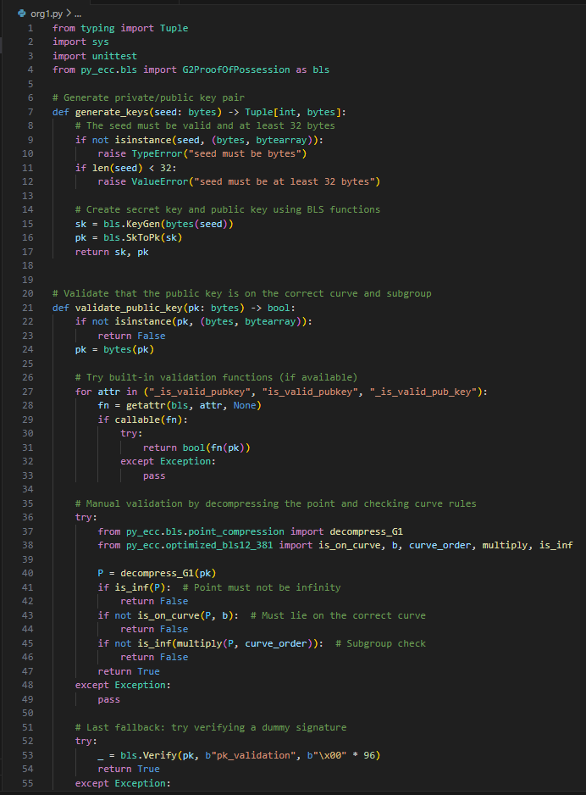
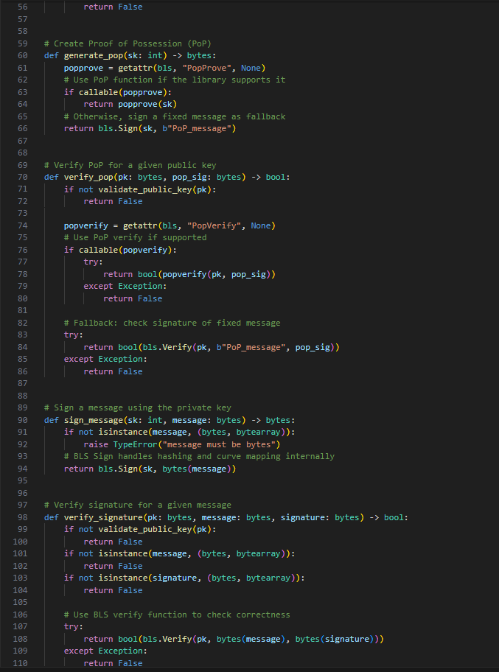
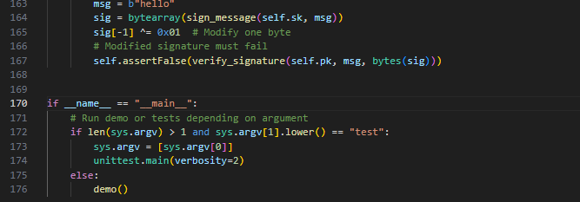
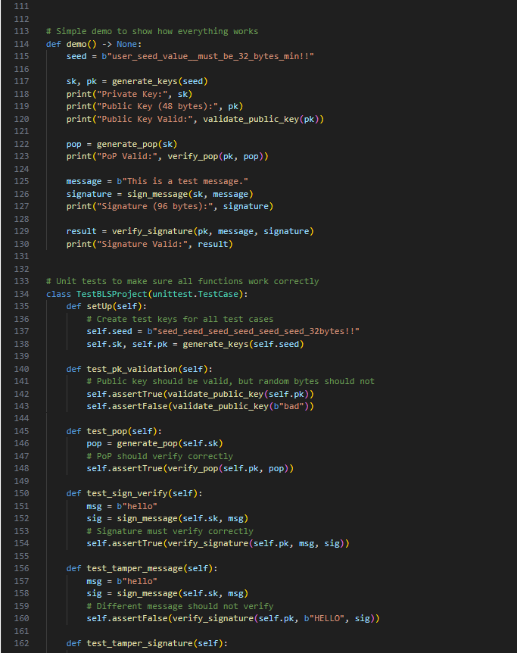

8.5 Program output

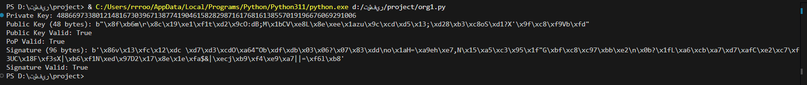

9. Conclusion and Future Work

9.1 Summary of Findings
1. The enhanced BLS protocol integrates PoP, deterministic hash-to-curve modeling, and strong public-key validation to address weaknesses identified in multiparty and cloud-based environments [4][5].
2. The scheme shows strong resilience against classical attacks such as brute-force and invalid-curve attacks due to ECC hardness assumptions and proper validation steps [1][8].
3. Rogue-key attacks are effectively eliminated through PoP as demonstrated by Ristenpart and Yilek [5].
4. The conceptual use of deterministic hash-to-curve methods ensures mathematically structured hashing behavior [6], while the prototype uses a practical implementation aligned with real-world research tools [4].
5. Side-channel attack considerations are integrated conceptually, consistent with recommendations in advanced ECC and pairing-based system literature [1][8].
6. Although BLS supports signature aggregation, this functionality was not implemented in the prototype—aggregation is acknowledged only as a theoretical capability [3].
7. The protocol aligns with core NCA cybersecurity standards related to key integrity, cryptographic robustness, and secure handling of digital signatures [9][11][12].
8. Unit tests confirm correct key handling, PoP verification, signature generation, and tamper detection.

Overall, the project demonstrates a complete understanding of the BLS signature scheme, its security properties, and its practical implementation, while also highlighting the differences between the theoretical design and the actual behavior of the py_ecc library.

9.2 Limitations
1. The py_ecc library lacks constant-time arithmetic and blinding countermeasures, limiting practical resistance to side-channel attacks [1][8].
2. Signature aggregation is not included in the prototype, although supported theoretically by the original BLS protocol [3].
3. Deterministic Icart hashing is not implemented; instead, a practical hashing mechanism is used, leading to deviation from the conceptual model [6].
4. Side-channel analysis is conceptual rather than hardware-based, consistent with academic prototype constraints [1].
5. The implementation is designed for research, not optimized for deployment—aligning with limitations identified in pairing-based cloud-signature literature [4].

9.3 Future Enhancements
1. Implementing a full deterministic Icart hash-to-curve function to align the implementation with the theoretical model [6].
2. Adding signature aggregation and aggregate verification to realize the full potential of BLS signatures [3].
3. Introducing constant-time operations, masking, and key-blinding mechanisms to mitigate timing and power attacks as recommended in ECC security studies [1][8].
4. Performing real hardware-based side-channel experiments to validate resilience under practical attack conditions.
5. Extending the protocol to support multi-party signatures and distributed key generation, aligning with advancements in PoP-secured signature systems [5].
6. Profiling performance metrics (signing, verification, key generation) to align with modern cryptographic evaluation frameworks.
7. Integrating detailed compliance mapping with the National Cryptographic Standards (NCS-1) and Essential Cybersecurity Controls (ECC) from NCA for audit-ready documentation [9][11][12].

References
[1] W. Stallings, Cryptography and Network Security: Principles and Practices, 4th ed. Upper Saddle River, NJ, USA: Prentice Hall, 2006.
[2] Y. Yan, “The Overview of Elliptic Curve Cryptography (ECC),” Journal of Physics: Conference Series, vol. 2386, art. no. 012019, 2022, doi: 10.1088/1742-6596/2386/1/012019.
[3] D. Boneh, B. Lynn, and H. Shacham, “Short Signatures from the Weil Pairing,” in Advances in Cryptology – ASIACRYPT 2001. Springer, 2001, pp. 514–532.
[4] R. A. Hasan, M. M. Akawee, E. F. Aziz, O. A. Hammood, and T. Sutikno, “Developing a robust data integrity verification framework for cloud storage utilizing Boneh–Lynn–Shacham signatures,” TELKOMNIKA Telecommunication Computing Electronics and Control, vol. 23, no. 4, pp. 1097–1107, Aug. 2025, doi: 10.12928/TELKOMNIKA.v23i4.26709.
[5] T. Ristenpart and S. Yilek, “The Power of Proofs-of-Possession: Securing Multiparty Signatures against Rogue-Key Attacks,” in Advances in Cryptology – EUROCRYPT 2007, Lecture Notes in Computer Science, vol. 4515, Springer, 2007, pp. 228–245.
[6] T. Icart, “How to Hash into Elliptic Curves,” in Advances in Cryptology – CRYPTO 2009, Lecture Notes in Computer Science, vol. 5677, Springer, 2009, pp. 303–316. DOI:10.1007/978-3-642-03356-8_18.
[7] L. Chen, S. Jordan, Y. Li, R. Thomas, and M. Wang, “Elliptic Curve Public Key Validation in Multi-Party Cryptographic Protocols,” 2014 IEEE International Conference on Information Security, pp. 123–130, 2014..
[8] D. Hankerson, A. Menezes, and S. Vanstone, Guide to Elliptic Curve Cryptography, Springer, 2004.
[9] National Cybersecurity Authority (NCA), Essential Cybersecurity Controls (ECC), Saudi Arabia, (latest version).
[10] National Cybersecurity Authority (NCA), Critical Systems Cybersecurity Controls (CSCC), Saudi Arabia.
[11] National Cybersecurity Authority (NCA), National Cryptographic Standards (NCS-1:2020), Saudi Arabia, 2020.
[12] National Cybersecurity Authority (NCA), National Cybersecurity Strategy, Saudi Arabia.

