

Student Insights Hub

Course instructor: Dr. Ayah Hakeem
Course Name: Software Project Management
Course Number: CCSW 313
Section: CY1

Done by

Name: | ID:
Allaa Faeq Maqadmi | 2310142
Nada Saeed Alzahrani | 2311004
Rana Khalid Almlki | 2210103
Raheed Alturki | 2311045

Table of Contents
INTRODUCTION ABOUT Student Insights Hub 3
Phase 1: 4
1. Business Case Analysis 4
1.1 Strategic Business Objective 4
1.2 Competitive Market Research 4
2. SWOT analysis 5
3. NPV 5
3.1 financial analysis (NPV, ROI & payback analysis) 5
3.2 risk analysis 6
4. Software Requirements Specification (SRS) 7
4.1 Functional Requirements: 7
4.2 Non-Functional Requirements: 7
5. Stakeholder 8
5.1 Stakeholder Register Report 8
5.2 Stakeholder Management Strategy 9
6 .Project Charter 10
7 . Kick-off Meeting 12
Phase 2: 13
8.Scope statement 13
9.WBS 14
1.0 Project Management & Initiation 14
2.0 Software Requirements & Design 14
3.0 Implementation & Development 15
4.0 Testing & Closure 15
10.Gantt chart 16
11.Network diagram 17
12.Activity Cost Estimates Template 19
13. Prototype 20
14.Conclusion 21
Task Table 21

INTRODUCTION ABOUT Student Insights Hub

Student Insights Hub is an intelligent tutoring platform designed exclusively for University of Jeddah students. The idea emerged from a growing need among learners who often struggle to find reliable academic support or trustworthy private tutoring sources. Many students rely on random external platforms or unverified individuals, which raises concerns about safety, cost, quality, and credibility.
This project aims to solve this problem by creating a university-approved, student-only learning hub where learners can easily find qualified peers who excel in the same courses. The system ensures that every tutor is a verified UJ student with a proven academic record, making the experience both trustworthy and relevant to the academic environment.
The application provides a seamless end-to-end flow that allows students to:
- search for tutors based on course, major, or expertise;
- book on-campus or online tutoring sessions;
- complete secure in-app payments;
- receive personalized learning progress summaries; and
- rate and review their tutoring experience.

For tutors, the platform provides symbolic earnings for paid sessions and offers volunteer options that generate official volunteer certificates in collaboration with the University of Jeddah after completing the required teaching hours. This creates a motivational and rewarding environment that benefits both sides.
Overall, Student Insights Hub promotes collaboration, improves academic performance, and strengthens the sense of community within the university. It bridges the gap between learners and skilled tutors while maintaining high standards of safety, reliability, and accessibility.

Phase 1:

Business Case Analysis

1.1 Strategic Business Objective
Strategic Business Objective This project proposes an intelligent mobile application designed exclusively for University of Jeddah students. The app connects learners who need academic help with classmates who excel in the same subjects, creating a safe, trusted, and organized platform for peer-to-peer learning within the university environment.
Through this app, students can:
- Search for tutors by course name and view verified profiles showing their major, GPA, and tutoring experience.
- Book live or recorded tutoring sessions either on-campus or online via Zoom or Microsoft Teams.
- Make secure digital payments within the app and access transparent session pricing.
- Rate and review lessons, helping others identify the most effective tutors.
- Track their learning progress and review session summaries for better academic performance.
Tutoring sessions are offered at symbolic prices, allowing tutors to earn small financial rewards while still keeping the service affordable. Additionally, tutors who choose to volunteer can accumulate teaching hours; once a tutor completes five verified hours, the system automatically generates a volunteer work certificate in collaboration with the University of Jeddah.
This initiative not only provides academic support but also promotes a culture of collaboration, motivation, and excellence on campus.

The app aims to:
- Enhance academic performance by providing accessible peer tutoring.
- Support skill development for tutors through teaching and communication experience.
- Encourage volunteerism and reward excellence with certificates and recognition.
- Foster community engagement by connecting students across different departments.
- Offer a safe, reliable, and university-approved alternative to random external tutoring platforms.

Competitive Market Research

When developing Student Insights Hub, it was important to study existing tutoring platforms that serve students. Apps such as Noon Academy and Wyzant provide online tutoring and scheduling features, but they mainly target large public audiences. These platforms allow anyone to register as a tutor, which often raises issues about trust, verification, and lesson quality. Additionally, most of them are not bilingual and lack specific options for university-based students to receive volunteer recognition or certificates.
In contrast, Student Insights Hub focuses exclusively on University of Jeddah students. Every user is verified through a UJ email, ensuring a closed and secure community. Tutors are current university students with verified GPAs, creating a trusted peer-to-peer experience. The app integrates volunteer certificates and symbolic payments, which motivates participation while keeping costs low. It also provides full Arabic/English support and direct links to university systems, which existing tutoring apps do not offer.

SWOT analysis
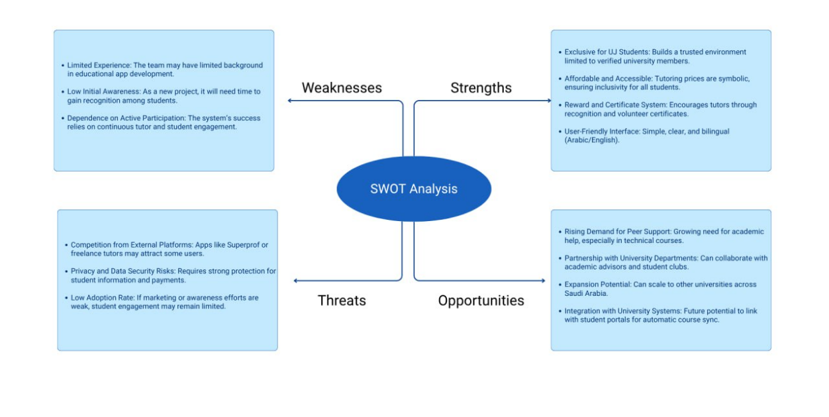

NPV

3.1 financial analysis (NPV, ROI & payback analysis)

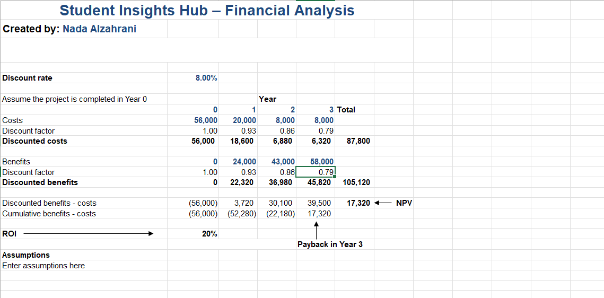

3.2 risk analysis
 | Strategy | Impact | Probability | Risk
  Response
 | Mitigate | High | Med | Low student participation
  Launch awareness campaigns and reward early users with points or badges.
 | Mitigate | Med | Med
  Implement tutor rating and feedback system after each session.
  Poor-quality tutoring sessions
 | Avoid | High | Low
  Use secure payment gateways and establish clear refund policies.
  Payment or refund issues
 | Mitigate | High | Med
  Conduct regular testing and provide in-app troubleshooting tips.
  Technical errors during online sessions
 | Avoid | High | High
  Use university email verification and encrypted data storage.
  Data privacy or account misuse
 | Accept | Med | Med | Tutors lose interest in volunteering
  Introduce certificates, recognition, and optional financial rewards.

Software Requirements Specification (SRS)

4.1 Functional Requirements:

1. Authentication & Account Management:
- The system must allow user registration and login exclusively using a verified University of Jeddah (UJ) email address to ensure a closed, trusted community.
- The system must verify the user's role (Learner or Tutor) to assign appropriate access permissions and features.

2. Learner (Student) Features:
- The system must allow learners to search for available tutors by course name, course code, college/major, and accumulated rating.
- The system must display detailed tutor profiles, including verified GPA, tutoring experience, and reliable ratings/reviews.
- The system must allow learners to book live or access pre-recorded tutoring sessions.
- The system must allow learners to select the session delivery mode: on-campus or online (via integrated services like Zoom or Microsoft Teams).
- The system must enable learners to rate and review the lesson quality and the tutor immediately after session completion.

3. Tutor Features & Incentives:
- The system must allow verified students to apply as a tutor for specified subjects and set their symbolic session price or choose voluntary teaching.
- The system must provide a dashboard for tutors to manage their schedule and track their financial earnings.
- The system must automatically track and accumulate a tutor's verified teaching hours.
- Once a tutor completes no less than five verified hours of teaching, the system must automatically issue a volunteer work certificate in collaboration with the University of Jeddah.

4. Payment & Transactions:
- The system must integrate a secure payment gateway for all digital transactions.
- The system must generate and enforce clear, transparent session pricing and refund policies.

Non-Functional Requirements:

1. Security:
  - All user personal data and payment information must be encrypted and protected according to industry standards.
  - Access to system administration and financial data must be restricted solely to authorized team/university personnel.

2. Performance:
- The application must load critical pages (search results, booking calendar) in under 3 seconds.
- The system must be capable of supporting a minimum of 200 concurrent online sessions during peak hours without performance degradation.

3. Usability (UX/UI):
- The interface must be clean, intuitive, and natively bilingual (Arabic/English), enabling easy navigation for all UJ students.
- A new user should be able to successfully complete the primary task (booking or scheduling a session) within 5 minutes of first use.

4. Reliability:
- The application and its core services must be available 99.5% of the time.
- The system must provide in-app troubleshooting guidance and automatically notify the support team of critical errors during a live session.

Stakeholder

5.1 Stakeholder Register Report
Stakeholder Name | Position | Type | Role | Contact Information
Dr. Ayah Hakeem | Main Investor / Course Instructor | Internal | Project Supervisor & Key Sponsor | ayah.hakeem@uj.edu.sa
Lab Instructor | Co-Investor | Internal | Technical Guidance & Review | labinstructor@uj.edu.sa
University of Jeddah – Student Affairs | Business Partner | Internal | Student Support & Approval | studentaffairs@uj.edu.sa
Microsoft Teams / Zoom Partners | Technology Partner | External | Video Session Provider | support@zoom-microsoft.com
App Development Team | Project Team | Internal | Developers & Testers | devteam@UJInsightsHub.com
UI/UX Designer | Consultant | External | Design Advisor | uiux@UJInsightsHub.com
Volunteer Tutors | Service Provider | Internal | Provide Tutoring Services | tutors@UJInsightsHub.com
Cybersecurity Specialist | Consultant | External | Secure Payment & Data Privacy Advisor | security@UJInsightsHub.com

5.2 Stakeholder Management Strategy
Stakeholder Name | Level of Interest | Level of Influence | Project Role (Required Engagement)
Dr. Ayah Hakeem | High | High | Provide frequent progress reports; Highlight milestones; Maintain clear communication and alignment with the strategic objective. (Manage Closely)
Lab Instructor | High | High | Collaborate closely; Ensure alignment with technical direction; Provide continuous support for the development process. (Manage Closely)
University of Jeddah – Student Affairs | High | High | Secure official approval for the service; Formalize the volunteer certificate generation process; Provide necessary institutional support. (Manage Closely)
Microsoft Teams / Zoom Partners | Medium | Medium | Maintain stable API integration; Monitor for service availability; Resolve technical integration issues rapidly. (Keep Satisfied)
App Development Team | High | Medium | Provide clear requirements (from SRS); Maintain frequent internal check-ins (Daily Stand-ups); Support task prioritization. (Keep Informed)
UI/UX Designer | Medium | Medium | Share prototypes early; Gather feedback from users; Align UI with application functionality and bilingual requirements. (Keep Satisfied)
Volunteer Tutors | High | Low | Collect continuous feedback via surveys; Communicate incentives clearly (certificates/payments); Encourage active participation. (Keep Informed)
Cybersecurity Specialist | Low | High | Secure payment gateway integration; Review security architecture; Ensure compliance with data privacy standards. (Keep Satisfied)

6 .Project Charter

Project Title: Student Insights Hub
Project Start Date: 03 / 09 / 2025 Projected Finish Date: 5/12/2025
Budget Information:
Within course scope; tooling/hosting to be defined with instructor approval.
Project Manager: Allaa Maqadmi 0557029931 2310142@uj.edu.sa
Project Objectives:
- Provide a trusted, UJ-only platform where learners can search for tutors by course, book sessions (on-campus or online via Teams/Zoom), pay securely in-app, and rate the session afterward.
- Enable tutor profiles with course expertise, short bio, and availability; allow simple scheduling and reminders.
- Capture a brief progress note per session so learners can review what was covered and track improvement.
- Deliver an MVP aligned with course requirements and university privacy guidelines.

Main Project Success Criteria:
- Core flows (search → profile → booking → payment → rating) work reliably and are easy for students to complete without assistance.
- The solution complies with basic privacy expectations (minimal PII, protected transmission, controlled access).
- Required deliverables (docs, demo, and hand-in) are completed on time and accepted by the course instructors.
- Positive qualitative feedback from pilot users (students/tutors) on usefulness, clarity, and trust.

Approach:
- Iterative (agile-lite): short cycles; show early prototypes to classmates/instructors; adjust based on feedback.
- Scope discipline: focus on essential MVP features only; defer extras to later phases.
- Quality & privacy first: minimize data collected; protect sign-in and payments; keep audit basics (who booked/when).
- Collaboration: weekly touch-points; shared issue/action log; quick decisions recorded by the PM.

Roles and Responsibilities :

Name | Role | Position | Contact information
Allaa Maqadmi | Team Manager | Manager | 2310142@uj.edu.sa
Nada Alzahrani | Team Member | IT department | 2311004@uj.edu.sa
Rana Almlki | Team Member | IT department | 2210103@uj.edu.sa
Raheed Alturki | investor | Client representative | 2311045@uj.edu.sa

Sign-off:

Name | Sign
Allaa Maqadmi
Nada Alzahrani
Rana Almlki
Raheed Alturki
Comments:

7 . Kick-off Meeting
Date: Sunday, 14 September 2025 – 3:15 PM

Project Name: Student Insights Hub
Meeting Objective:
Get the project off to a great start by introducing key stakeholders, reviewing project goals, and discussing future plans for the Student Insights Hub.

Agenda:
- Introductions of attendees
- Background of project — Why SIH? Problem statement (scattered private-lesson search) and vision (trusted UJ-only hub to find → book → pay → rate).
- Review of project-related documents (i.e., business case, project charter) — Confirm purpose, success criteria, and approach.
- Discussion of project organizational structure — Roles, responsibilities, decision/issue logs (RACI at high level).
- Discussion of project scope, time, and cost goals — MVP features only; phased delivery; semester timeline.
- Discussion of other important topics — Privacy & data handling, booking/reminder policy, cancellation/no-show and refunds, pilot colleges/courses, payment sandbox.
- List of action items from meeting

Action Item | Assigned To | Due Date
Prepare Business Case | Allaa Maqadmi | Monday, 3 Nov 2025 – 02:00pm
Draft Project Charter | Raheed Alturki | Thursday, 6 Nov 2025 – 01:20am
Complete Stakeholder Register | Nada Alzahrani | Monday, 3 Nov 2025 – 11:30pm
Develop SRS Document | Rana Almlki | Tuesday, 4 Nov 2025 – 9:15pm

Date and time of next meeting: 16/11/2025 – 03:00pm

Phase 2:

8.Scope statement
Project Name: Student Insights Hub
Date: November 2025

Project Goal:
To design and implement a secure, UJ exclusive peer to peer intelligent tutoring mobile application that connects University of Jeddah (UJ) learners with verified, excelling student tutors to improve academic performance, foster community engagement, and offer a safe alternative to external tutoring platforms.
Project Deliverables:
- Mobile Application (MVP): A natively bilingual (Arabic/English) mobile app for iOS/Android.
- User Authentication: Registration and login exclusively via verified University of Jeddah (UJ) email.
- Learner Features: Search for tutors by course/major/rating, view detailed profiles (verified GPA, experience), book sessions (on-campus/online via Zoom/Teams), make secure in-app payments, and rate/review sessions.
- Tutor Features: Application to tutor, setting symbolic price/volunteer option, session scheduling/management dashboard, and automatic tracking of teaching hours.
- Incentives/Rewards: Automatic generation of official volunteer work certificates in collaboration with the University of Jeddah upon completion of 5 verified teaching hours.
- Security & Performance: Encrypted data storage, restricted administrative access, application availability of 99.5%, and ability to support 200 concurrent sessions during peak hours.
- Documentation: Deliverables include the Business Case Analysis, Software Requirements Specification (SRS), Stakeholder Register/Strategy, Project Charter, WBS, Gantt Chart, Network Diagram, Activity Cost Estimates, and the final demo/presentation.
Project Exclusions:
- Integration with external, non UJ student users or tutors.
- Complex features such as full scale AI driven content recommendations.
- Live video conferencing server development (utilizing third-party services like Zoom/Teams).
- Development of a dedicated web portal (focus is solely on the mobile application).
- Full time, paid tutoring positions (tutors will receive symbolic earnings or volunteer certificates).
Project Constraints:
- Time: Projected finish date is 05/12/2025
- Budget: Within course scope; tooling/hosting costs subject to instructor approval.
- Policy: Must comply with basic university privacy guidelines (minimal PII, protected transmission).
- Platform: Must support both IOS and Android platforms.
Project Success Criteria:
- Core flows (search profile booking payment rating) work reliably.
- Compliance with basic privacy expectations.
- Required deliverables are completed on time and accepted by the course instructors.
- Positive qualitative feedback from pilot users on usefulness, clarity, and trust.

9.WBS

1.0 Project Management & Initiation
1.1 Initiation Phase (Stage I)
1.1.1 Develop Business Case Analysis for Tutoring/Services Exchange
1.1.2 Conduct Risk Analysis (Focus on Data Privacy & User Adoption)
1.1.3 Develop Project Charter
1.1.4 Identify Stakeholders (Including UJ Staff, Tutors, and External Consultants)
1.1.5 Develop Stakeholder Management Strategy
1.1.6 Develop Project Kick-off Meeting
1.2 Planning Phase (Stage II)
1.2.1 Prepare Detailed Project Scope Statement
1.2.2 Create WBS
1.2.3 Create Schedule & Baseline (Gantt Chart)
1.2.4 Create Network Diagram
1.2.5 Create Activity Cost Estimation
1.2.6 Planning Phase Completed

2.0 Software Requirements & Design
2.1 Software Requirements Specification (SRS)
2.1.1 Requirements Gathering (Focus on Booking/Payment, Chat/Communication, Rating System)
2.1.2 Requirements Analysis (Focus on Feasibility of UJ Integration and User Experience)
2.1.3 SRS Documentation
2.1.4 SRS Review & Approval (Milestone)
2.2 System Design
2.2.1 High-Level System Design (HLD) (Focus on Mobile Backend Analytics Architecture)
2.2.2 Low-Level Design (LLD) (Focus on Modules: User Profiles, Scheduling, Notification Engine)
2.2.3 Database Design (ERD + Schema) (Specifically for Tutor Data, Session History, and Feedback)
2.2.4 Prototype UI/UX Design (Wireframes) (Focus on Intuitive Search, Filtering, and Chat Interface)
2.2.5 Design Review & Approval

3.0 Implementation & Development
3.1 Implementation/Development
3.1.1 Project Setup & Environment Configuration (Setting up Cloud Services and Development Frameworks)
3.1.2 Frontend Development (Mobile App - Building Learner & Tutor Interfaces)
3.1.3 Backend Development (APIs & Logic - Developing Authentication, Scheduling Logic, and Matchmaking Algorithms)
3.1.4 System Integration (Integrating Payment Gateway and Zoom/Microsoft Teams for Virtual Sessions)
3.1.5 Internal Testing (Developers perform unit and integration tests)
3.1.6 Implementation Complete

4.0 Testing & Closure
4.1 Testing
4.1.1 Test Case Creation (Focus on Scenarios: Booking, Cancellation, Payment Flow, and Rating)
4.1.2 Detailed System Testing (Execute tests to verify core functionality)
4.1.3 Bug Fixing
4.1.4 Final Validation
4.1.5 Testing Completed (Milestone)
4.2 Final Delivery & Closing
4.2.1 Final Documentation (Including Technical Documentation for the Analytics Module)
4.2.2 Final Presentation Preparation
4.2.3 Submission & Demo Day (Demonstrating the full Learner-Tutor interaction flow)
4.2.4 Project Closure

10.Gantt chart

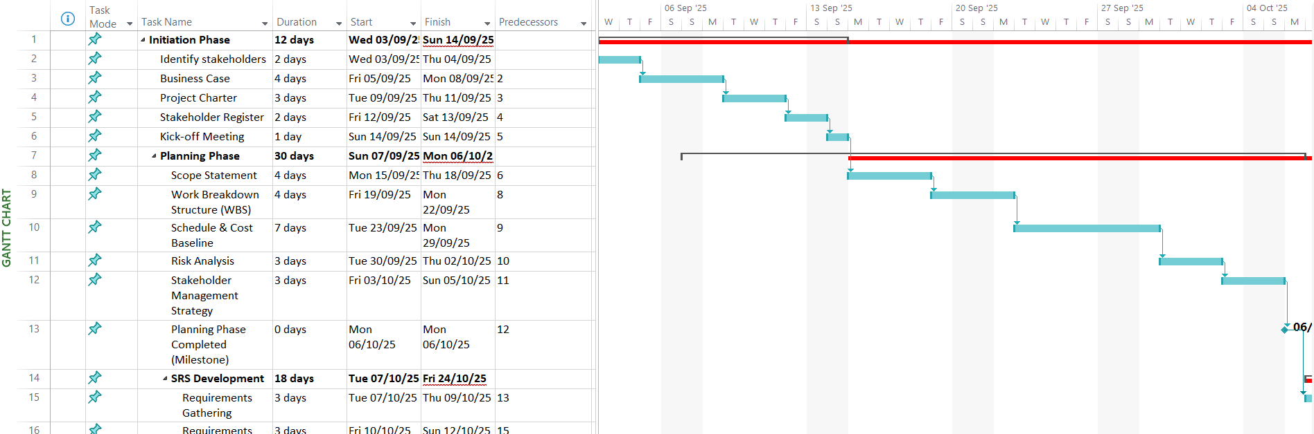
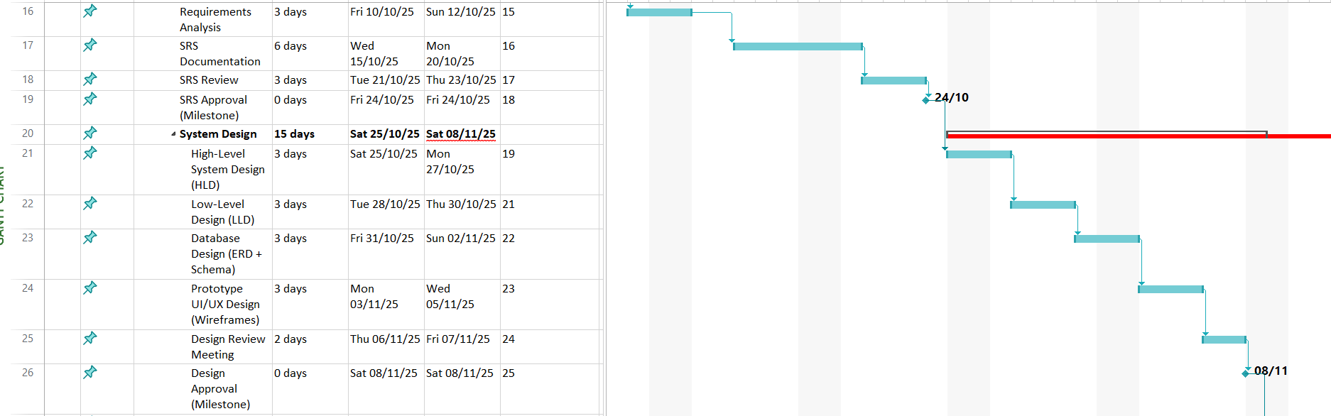
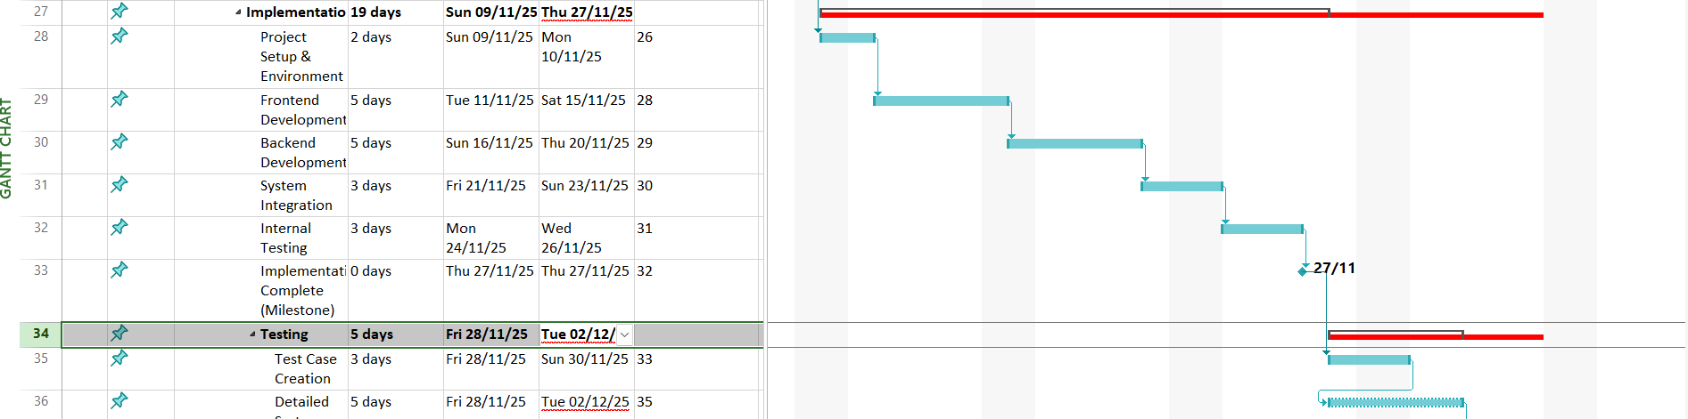


11.Network diagram
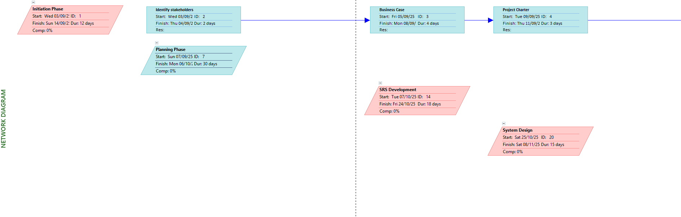

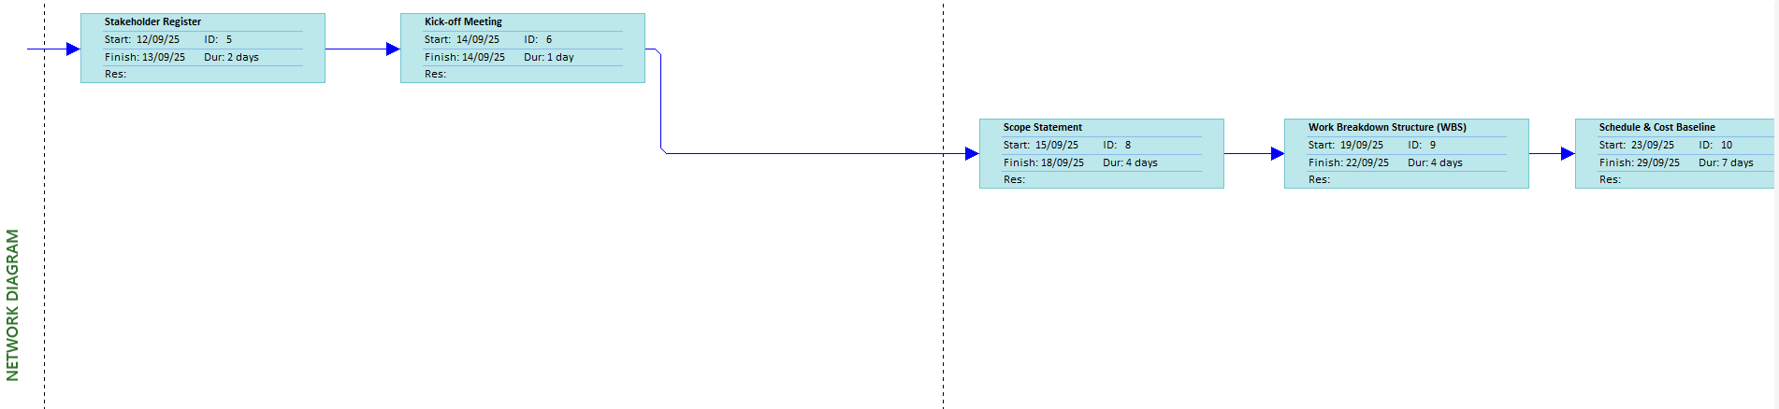
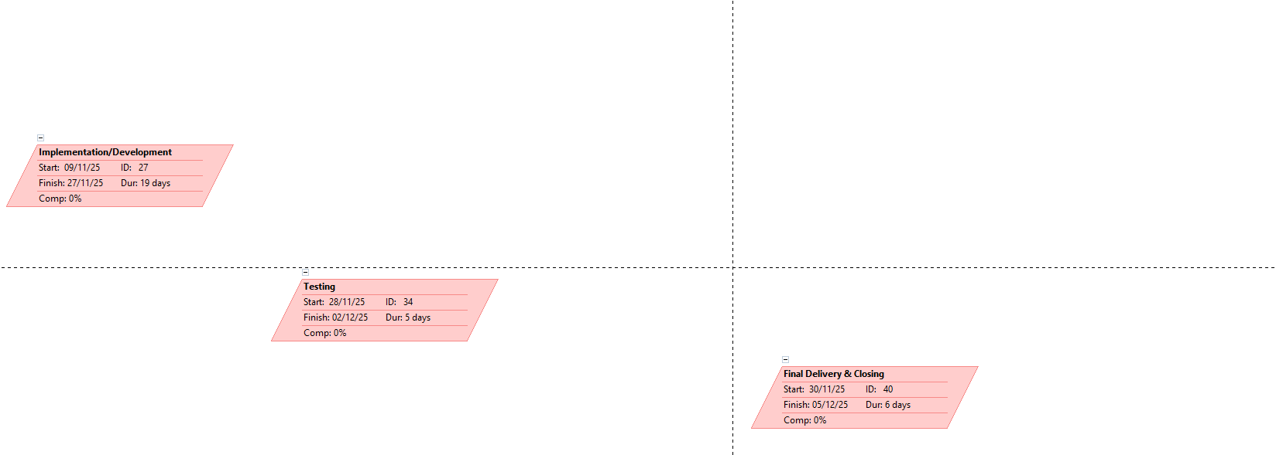
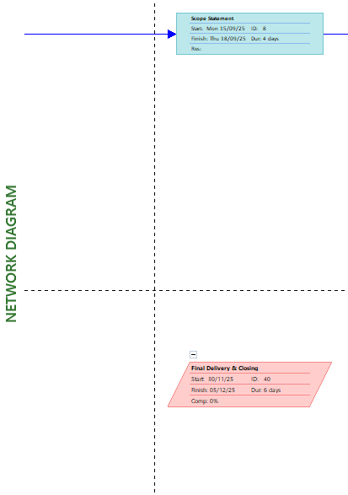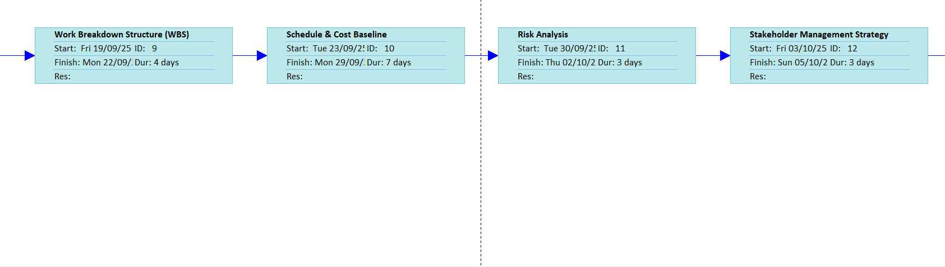

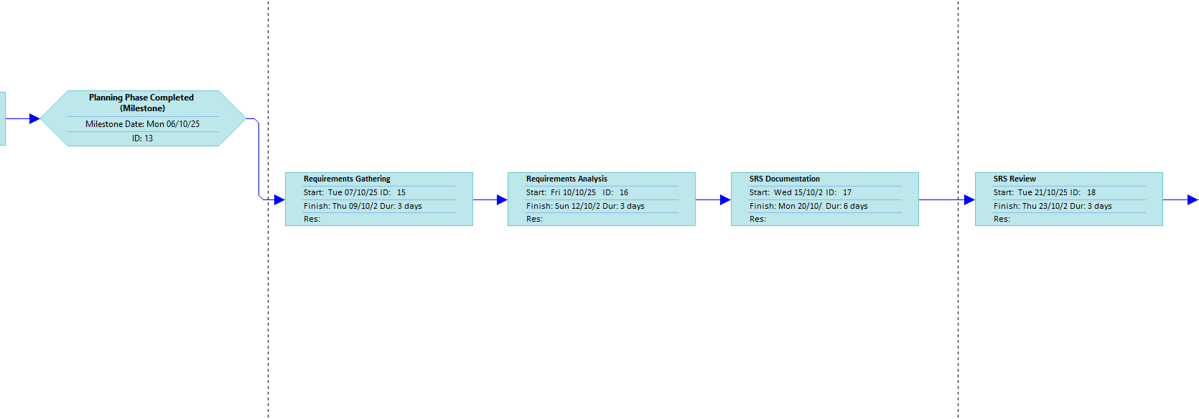
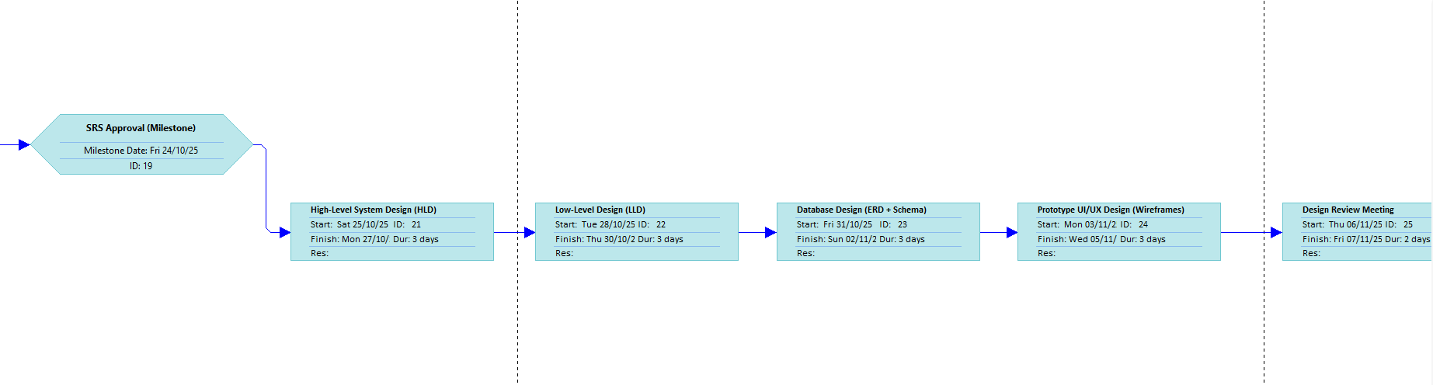
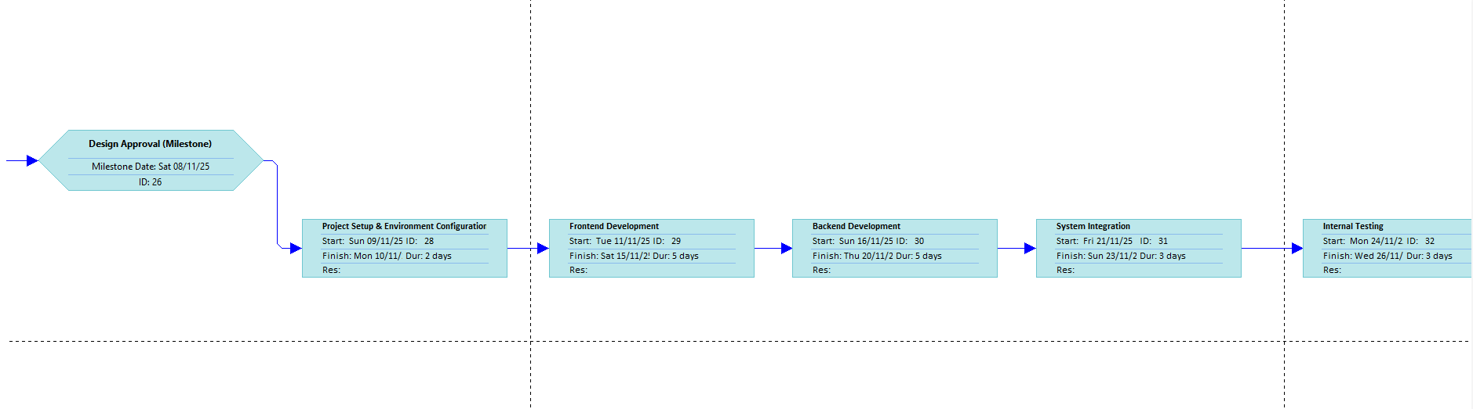
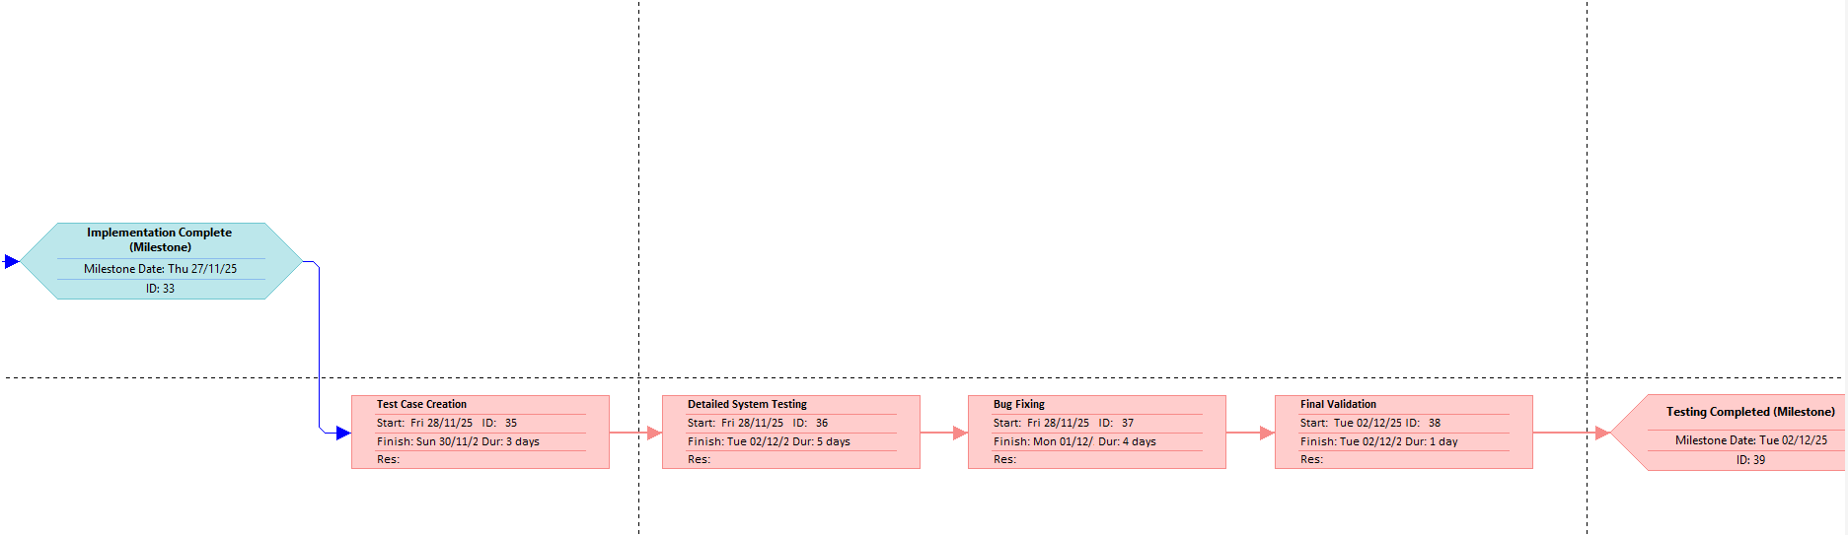
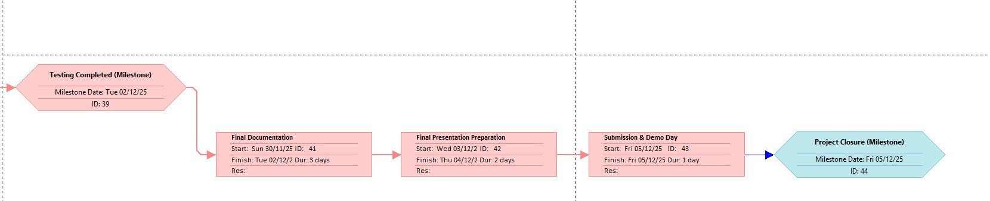

12.Activity Cost Estimates Template
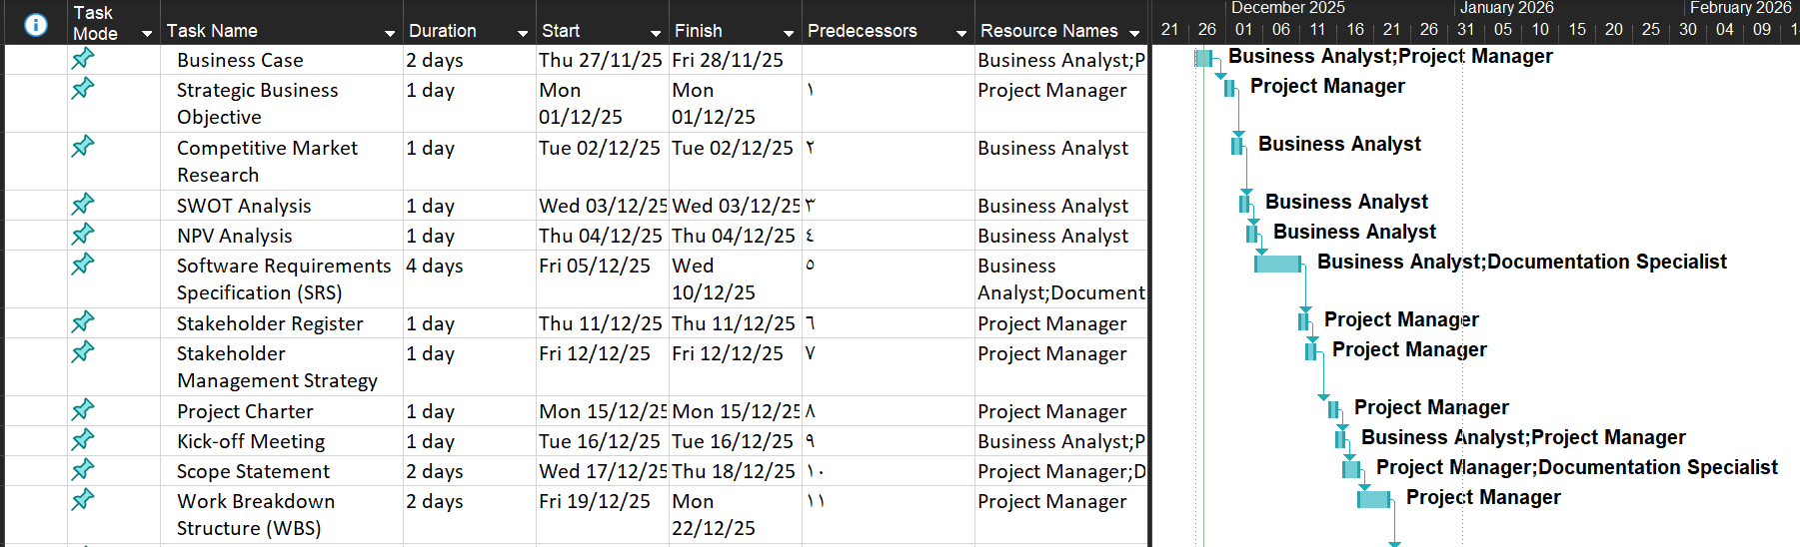

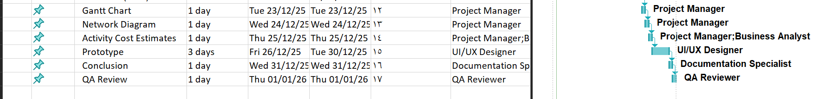

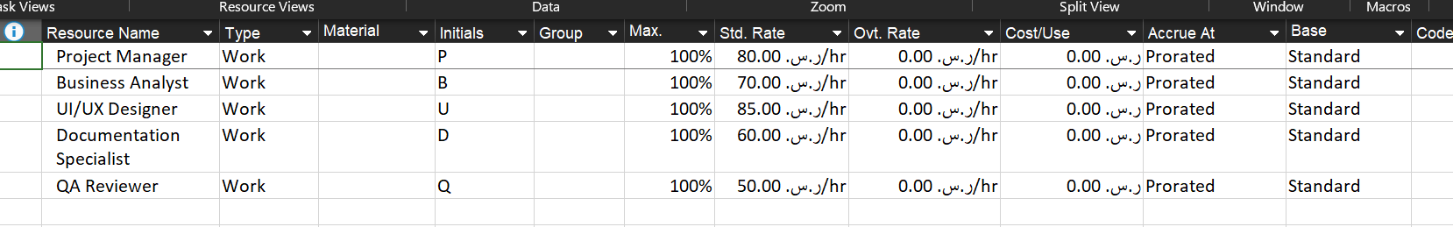

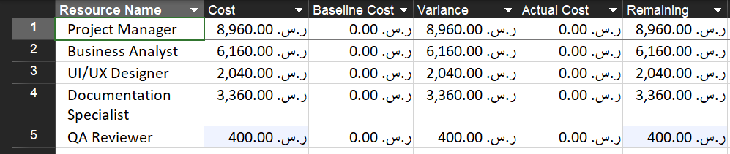

Prototype

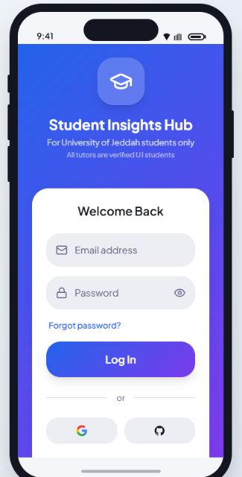
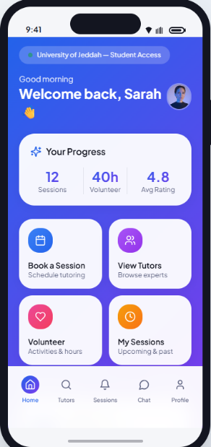
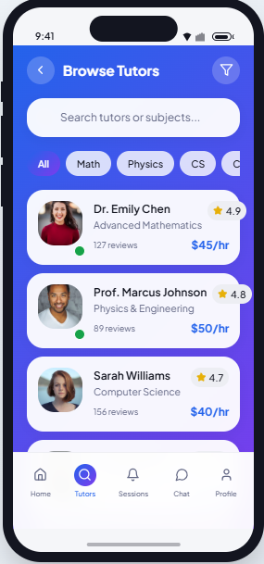

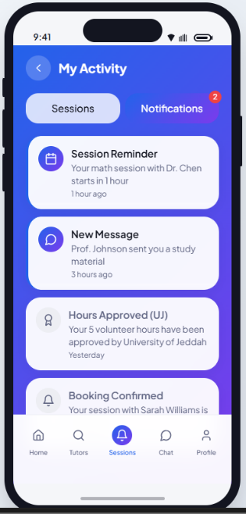
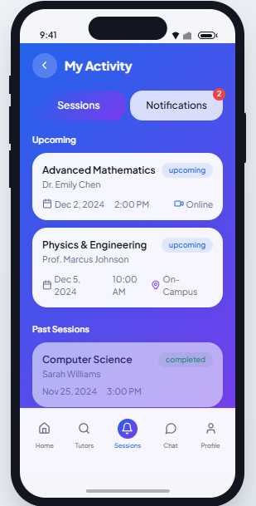
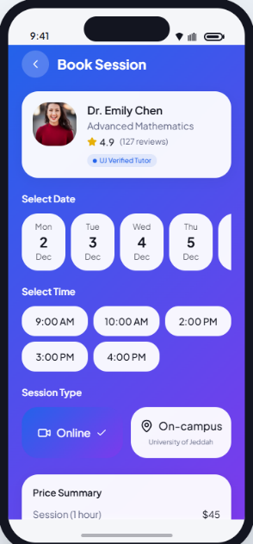

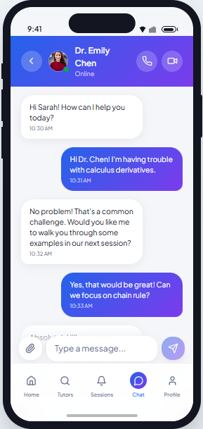
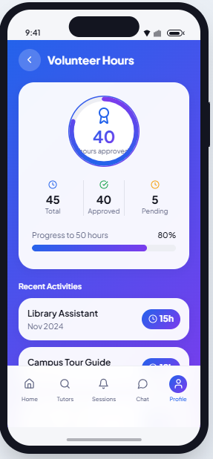

14.Conclusion

Student Insights Hub (SIH) concludes as a well-defined and feasible MVP project for a University of Jeddah–exclusive peer-to-peer intelligent tutoring mobile application. The project was designed to solve a clear student need: reducing the risks of relying on unverified external tutoring sources by providing a trusted UJ-only environment with verified tutors and an organized end-to-end tutoring experience.

Across the deliverables, SIH’s scope and requirements establish a complete core workflow: UJ email–based authentication, tutor discovery by course/major/rating, detailed tutor profiles (such as verified GPA and experience), booking for on-campus or online sessions (using platforms like Zoom or Microsoft Teams), secure in-app payments with clear pricing and refund handling, and post-session ratings and reviews to maintain quality and accountability.

In addition, the project supports long-term community engagement through tutor incentives, including optional volunteering with automatic hour tracking and issuing an official volunteer certificate after completing five verified teaching hours in collaboration with the University of Jeddah.

Finally, SIH defines strong non-functional expectations—security, performance, usability, and reliability—while keeping scope controlled by clearly limiting the first version to UJ users and the essential functionality only. This balance between clear scope and appropriate quality requirements provides a solid foundation for implementation and future enhancements once the MVP is delivered and evaluated.

Task Table

Action Item | Assigned To
- Prepare Business Case  - Gantt chart  - Network diagram | Allaa Maqadmi
- Prepare Business Case  - Complete Stakeholder Register report  - Activity Cost Estimates Template  - Prototype | Nada Alzahrani
- Draft Project Charter  - Develop the project kick-off meeting  - Table of Contents  - Conclusion | Raheed Alturki
- Develop SRS Document  - Develop fictitious management strategy of stakeholders | Rana Almlki

