**Assessment: 02**

* **identify the following cloud service types and list their characteristics and advantages**

**1) cisco webex 2) google app engine 3) amazon:**

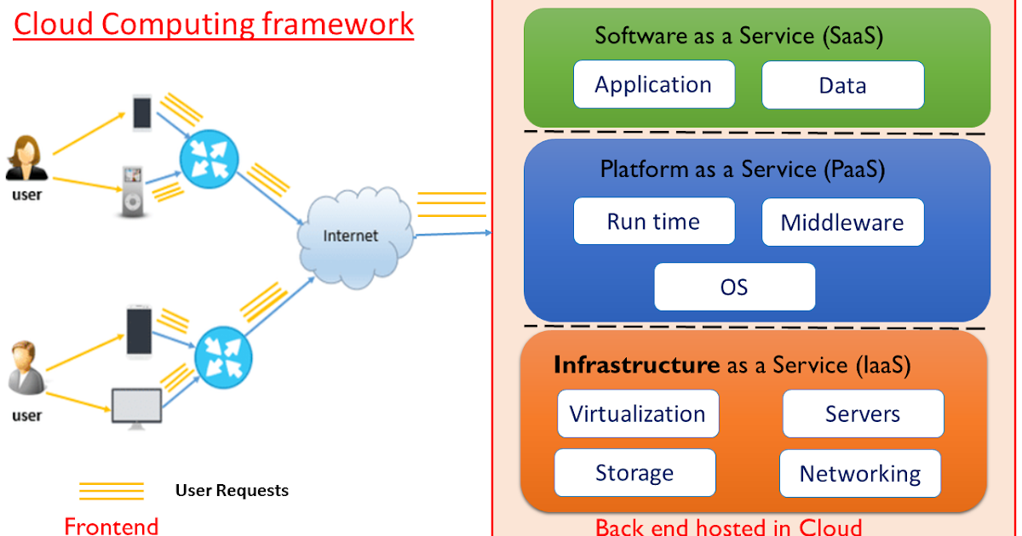

* Cloud services generally fall into several categories, each serving different purposes and offering distinct advantages. Here are some common types:

1. **Infrastructure as a Service (IaaS)**:
   * **Characteristics**: Provides virtualized computing resources over the internet. Users can rent virtual machines, storage, and networking infrastructure.
   * **Advantages**:

* **Scalability**: Resources can be scaled up or down based on demand.
* **Cost-effective**: Pay-as-you-go model reduces upfront costs.
* **Flexibility**: Users have control over the infrastructure and can configure it as needed.

2. **Platform as a Service (PaaS)**:

* + **Characteristics**: Offers a platform allowing customers to develop, run, and manage applications without building and maintaining the underlying infrastructure.
  + **Advantages**:
* **Faster development**: Developers can focus on coding rather than managing infrastructure.
* **Automatic updates**: Platform provider manages updates and patches.
* **Scalability**: Scales automatically based on application demand.

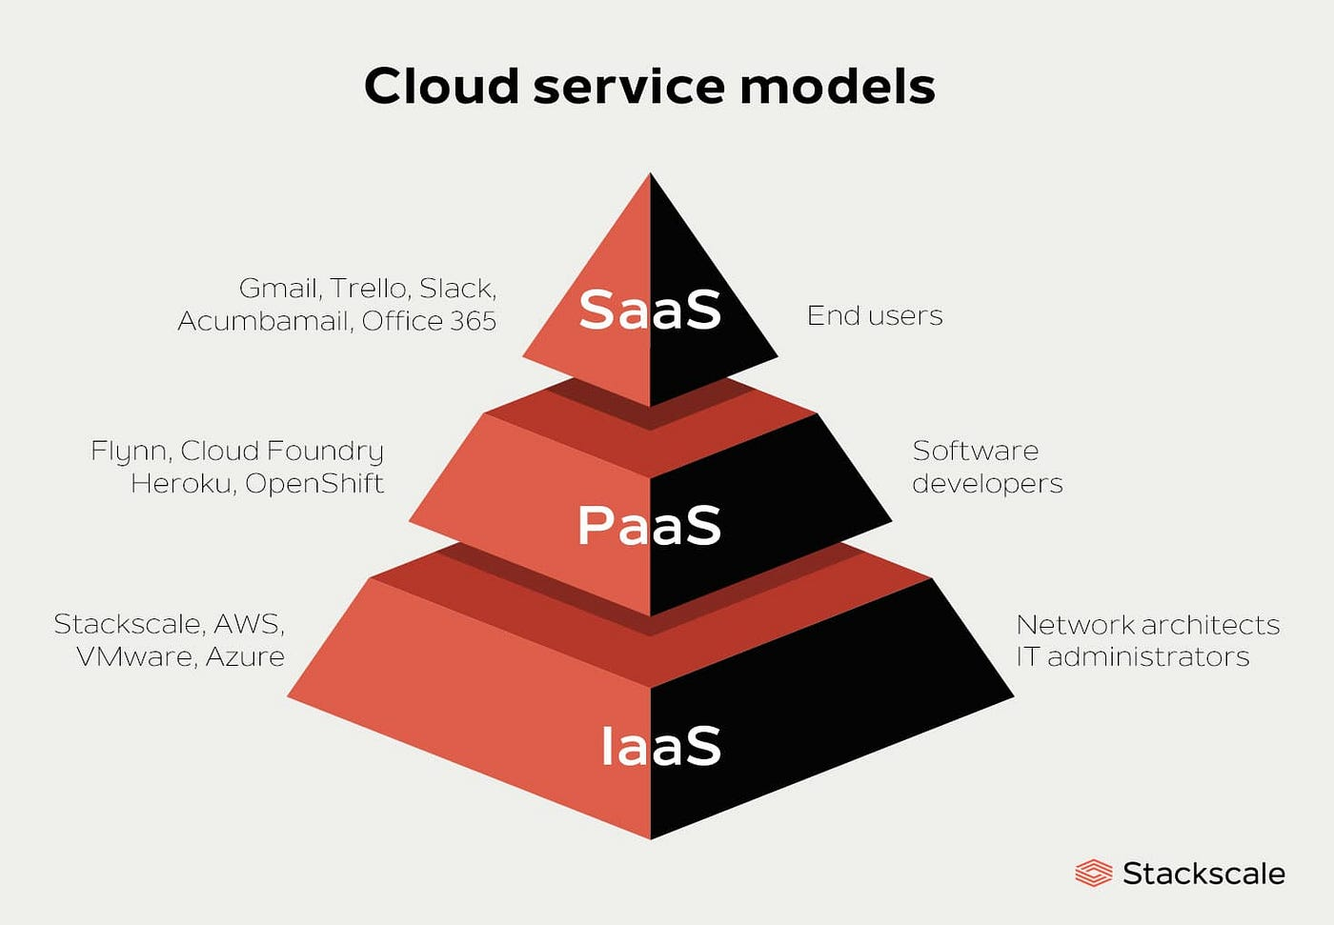

1. **Software as a Service (SaaS)**:
   1. **Characteristics**: Delivers software applications over the internet on a subscription basis. Users access applications through a web browser.
   2. **Advantages**:
      1. **Accessibility**: Accessible from any device with an internet connection.
      2. **Automatic updates**: Providers manage updates and maintenance.
      3. **Scalability**: Scales easily to accommodate user needs.
      4. **Lower upfront costs**: No need to purchase software licenses.

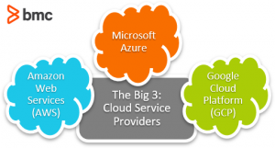

1. **Function as a Service (FaaS)**, also known as Serverless Computing:
   1. **Characteristics**: Executes functions in response to events without managing server infrastructure. Users only pay for the compute time consumed.
   2. **Advantages**:
      1. **Cost efficiency**: Users only pay for actual usage, not for idle server time.
      2. **Scalability**: Scales automatically with the number of requests.
      3. **Simplified management**: No need to manage servers or infrastructure.

* **Service Type:** Collaboration and Communication

**Cisco Webex**



**Characteristics:**

* **Real-time Collaboration:** Provides features like video conferencing, webinars, messaging, and file sharing.
* **Scalability:** Supports small team meetings to large-scale webinars with thousands of participants.
* **Security:** Offers encryption, secure authentication, and compliance with various data protection regulations.
* **Accessibility:** Supports multiple devices and platforms, including desktops, mobile devices, and browsers.

**Advantages:**

* **Ease of Use:** User-friendly interface suitable for both beginners and advanced users.
* **Reliability:** Stable performance with minimal downtime and high availability.
* **Versatility:** Suitable for various collaboration needs, from internal team meetings to external client interactions.
* **Cost Efficiency:** Offers scalable pricing plans that cater to different organizational sizes and needs.

**2. Google App Engine**

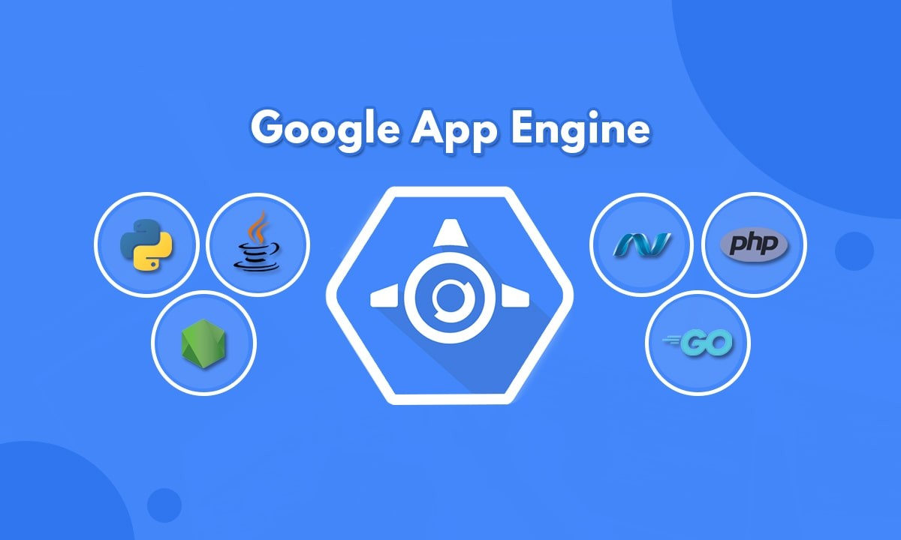

**Service Type:** Platform as a Service (PaaS)

**Characteristics:**

* **Scalability:** Automatically scales applications based on demand without requiring manual intervention.
* **Managed Services:** Google handles infrastructure management, allowing developers to focus on application development.
* **Support for Multiple Languages:** Supports several programming languages including Python, Java, Node.js, Go, and others.
* **Integration with Google Cloud Services:** Easily integrates with other Google Cloud Platform services like Cloud Storage, Big Query, etc.

**Advantages:**

* **Speed and Agility:** Enables rapid development and deployment of applications.
* **Cost-effectiveness:** Pay-as-you-go pricing model, reducing upfront costs and aligning expenses with actual usage.
* **Reliability:** High availability with built-in redundancy and automatic failover.
* **Scalability:** Scales seamlessly to handle varying levels of traffic and workload spikes.

1. **Amazon Web Services (AWS)**

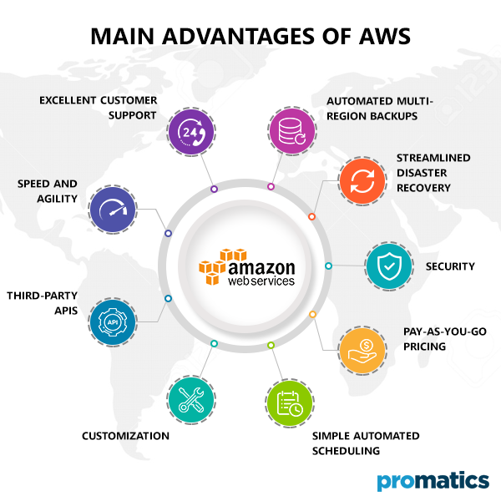

**Service Type:** Infrastructure as a Service (IaaS) and Platform as a Service (PaaS)

**Characteristics:**

* **Wide Range of Services:** Offers a vast array of cloud services including computing power, storage, databases, machine learning, and more.
* **Global Infrastructure:** Operates data centers worldwide, allowing for low-latency access and compliance with regional data regulations.
* **Flexibility:** Supports various operating systems, programming languages, and frameworks.
* **Security:** Provides robust security measures such as encryption, identity and access management, and compliance certifications.

**Advantages:**

* **Reliability:** Highly reliable with SLAs (Service Level Agreements) ensuring uptime and availability.
* **Elasticity:** Can rapidly provision and release resources as needed, accommodating fluctuating workloads.
* **Cost Management:** Offers cost-effective pricing models and tools for cost optimization.
* **Innovation:** Continuously introduces new services and features, staying at the forefront of cloud technology.
* **Community and Support:** Large ecosystem with extensive documentation, support options, and community forums.

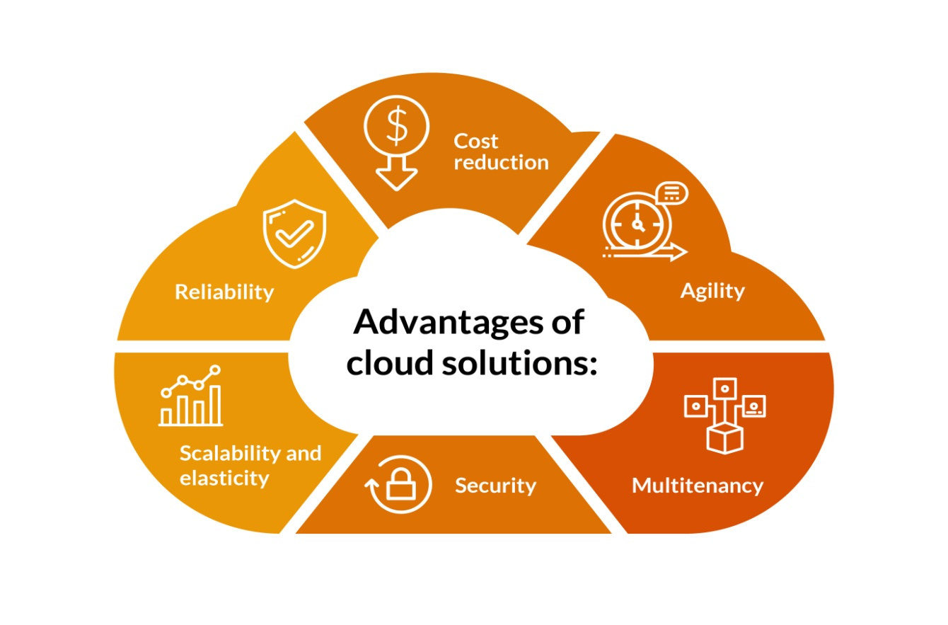Each of these cloud services brings distinct advantages tailored to different business needs, whether it's collaboration and communication (Cisco Webex), application development (Google App Engine), or a comprehensive range of cloud services (Amazon Web Services).