AI LinkedIn Post Generator using n8n & Groq AI

Project Report

Developed By
Raheela Nisar
Table of Contents
1. Abstract 1
2. Introduction 1
3. Problem Statement 1
4. Objectives 1
5. Scope of the Project 2
6. Software & Technologies Used 2
7. System Requirements 2
8. Workflow 3
9. Workflow Explanation 3
10. Implementation Steps 4
11. AI Prompt 5
12. JavaScript Code 5
13. Results 6
14. Screenshots 6
15. Challenges Faced 9
16. Solutions 9
17. Learning Outcomes 9
18. Future Enhancements 10
19. Conclusion 10
20. References 10

1. Abstract
The AI LinkedIn Post Generator is an intelligent automation workflow developed using n8n and Groq AI. It automatically creates professional LinkedIn posts from a user-provided topic. The generated content includes a title, post, and hashtags. The workflow stores the generated data in Google Sheets and sends it via Gmail, reducing manual effort and improving productivity.

2. Introduction
Artificial Intelligence is transforming content creation by automating repetitive writing tasks. This project demonstrates how AI and workflow automation can be combined to generate professional LinkedIn posts. Using n8n, Groq AI, Google Sheets, and Gmail, the workflow automatically generates, stores, and emails LinkedIn content.

3. Problem Statement
Writing professional LinkedIn posts manually is time-consuming and requires creativity. This project automates the process, enabling users to generate high-quality LinkedIn content within seconds.

4. Objectives
- Automate LinkedIn post generation.
- Integrate Groq AI with n8n.
- Store generated content in Google Sheets.
- Automatically send the generated content via Gmail.
- Learn AI workflow automation.

5. Scope of the Project
This project is suitable for:
- Content Creators
- Digital Marketers
- Students
- Freelancers
- Professionals
- Social Media Managers

6. Software & Technologies Used
Technology | Purpose
n8n | Workflow Automation
Groq AI | Content Generation
JavaScript | JSON Parsing
Google Sheets | Data Storage
Gmail | Email Automation
Google OAuth | Authentication

7. System Requirements
Hardware
- Intel i3 Processor or above
- 4GB RAM (Minimum)
- Internet Connection
Software
- Windows 10/11
- Google Chrome
- n8n
- Groq API Key
- Google Account

8. Workflow
Manual Trigger
│
▼
Edit Fields (Topic)
│
▼
AI Agent (Groq)
│
▼
Code (JavaScript)
│
▼
Google Sheets
│
▼
Gmail

9. Workflow Explanation
Step 1
The workflow starts with a Manual Trigger.
Step 2
The Edit Fields node accepts the topic entered by the user.
Step 3
The AI Agent sends the topic to Groq AI.
Step 4
Groq AI generates:
- Professional Title
- LinkedIn Post
- Hashtags
Step 5
The JavaScript Code node converts the AI response into structured JSON and adds the current date and time.
Step 6
Google Sheets stores the generated content.
Step 7
Gmail sends the generated LinkedIn post to the user's email.

10. Implementation Steps
- Install n8n
- Create Workflow
- Add Manual Trigger
- Add Edit Fields Node
- Configure AI Agent
- Connect Groq Chat Model
- Add JavaScript Code Node
- Configure Google Sheets
- Configure Gmail
- Execute Workflow

11. AI Prompt
You are a professional LinkedIn Content Writer.
Create a professional LinkedIn post on the following topic:
{{$json.topic}}
Instructions:
- Create a catchy and professional title.
- Write a LinkedIn post between 150 and 250 words.
- Use a professional and engaging tone.
- End the post with a question.
- Generate exactly 5 relevant hashtags.
Return ONLY valid JSON.
{
"title":"",
"post":"",
"hashtags":""
}

12. JavaScript Code
const text = $json.output.replace(/[\u0000-\u001F]+/g, "");
const data = JSON.parse(text);
const now = new Date();
return {
json: {
title: data.title,
post: data.post,
hashtags: data.hashtags,
date: now.toLocaleDateString("en-GB"),
time: now.toLocaleTimeString("en-US")
}
};

13. Results
The workflow successfully generates:
- Professional Title
- LinkedIn Post
- Hashtags
- Date
- Time
The generated content is automatically:
- Saved in Google Sheets
- Sent via Gmail

14. Screenshots
Add the following screenshots:
- Workflow
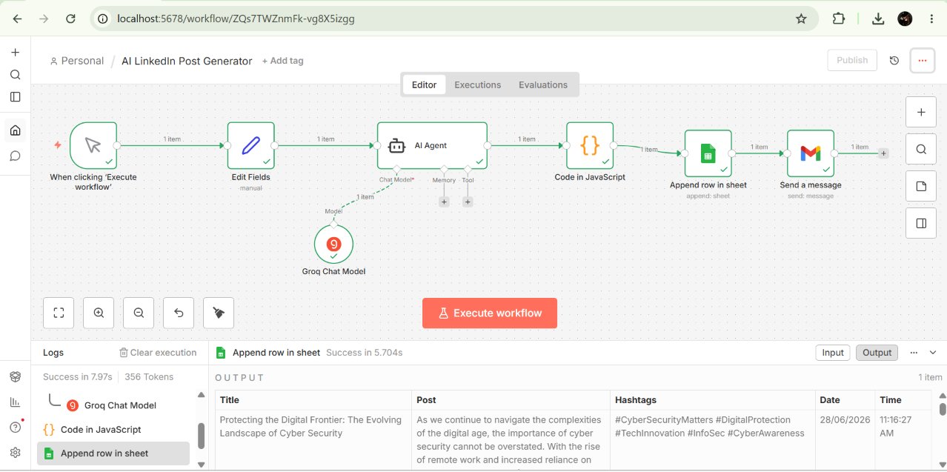
- AI Agent Output
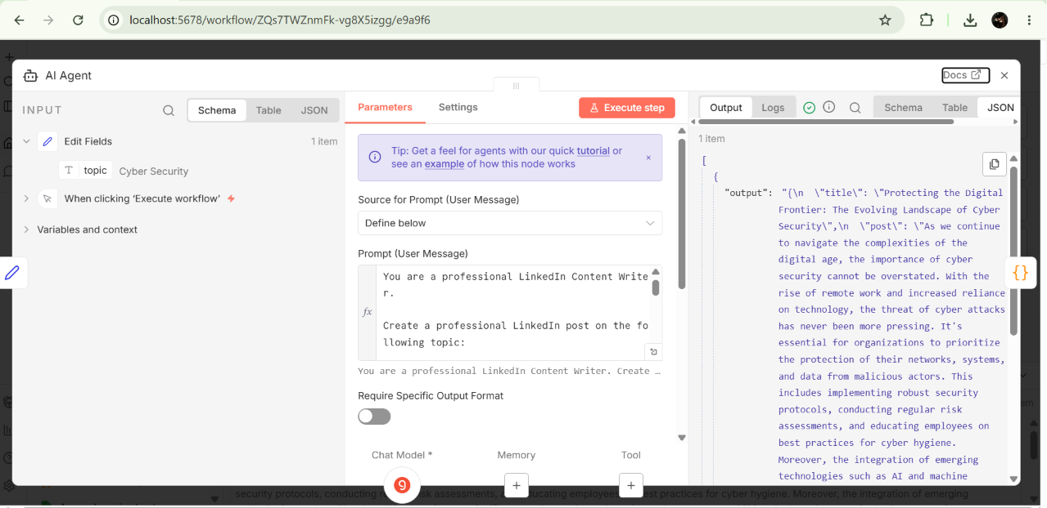
- Google Sheets Output
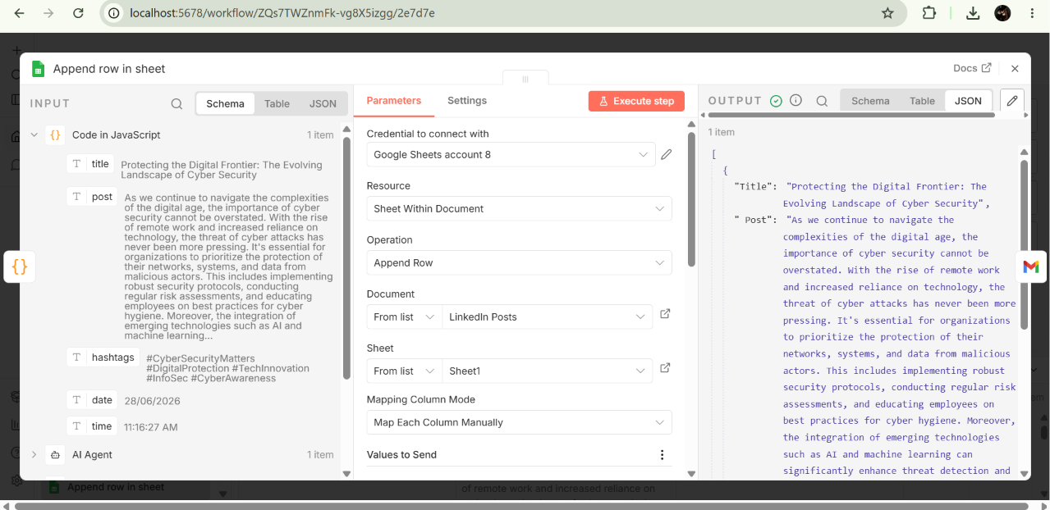
- Gmail Output
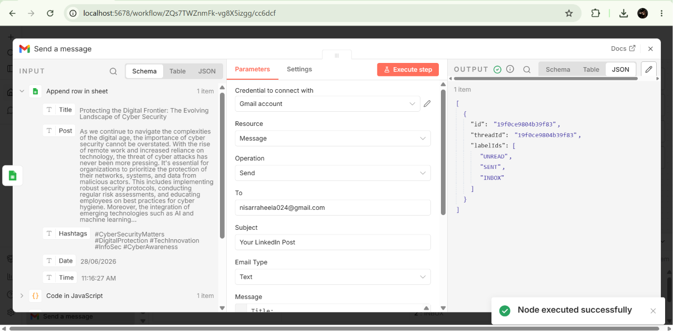
- Successful Execution
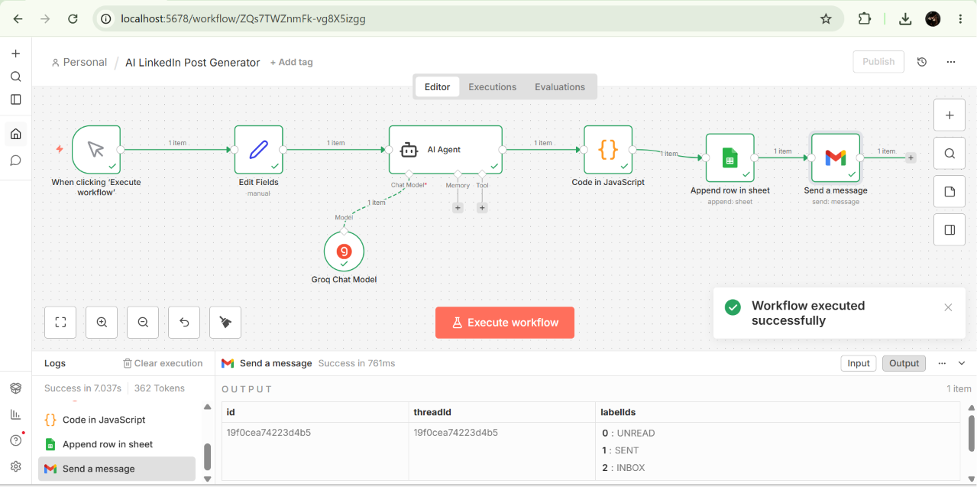
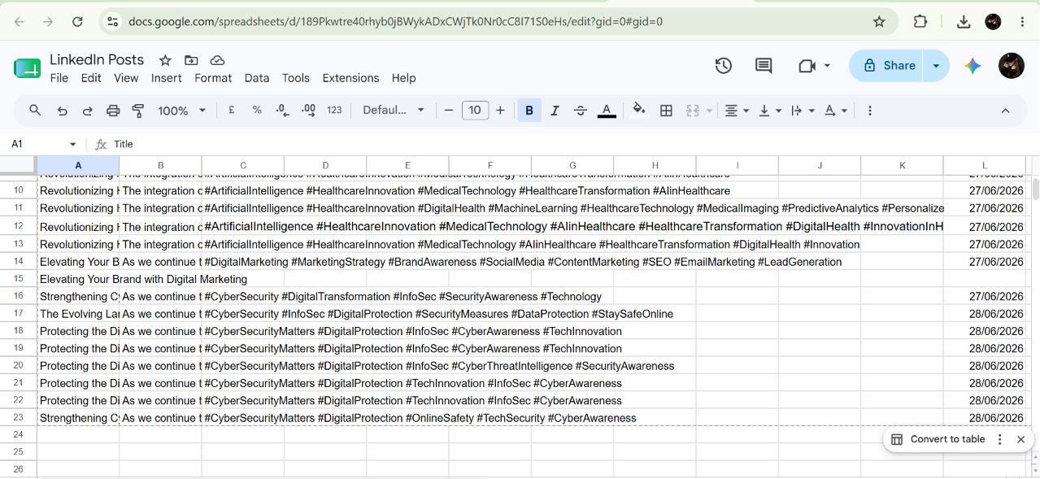

15. Challenges Faced
- Groq API configuration
- JSON parsing
- Gmail OAuth authentication
- Google Sheets field mapping
- Undefined values
- AI prompt optimization

16. Solutions
- Used Groq Chat Model
- Added JavaScript Code node
- Configured Gmail OAuth
- Correctly mapped Google Sheets columns
- Improved AI prompt

17. Learning Outcomes
This project helped in learning:
- AI Workflow Automation
- n8n
- Prompt Engineering
- Groq AI
- JavaScript
- Google Sheets Integration
- Gmail Automation
- API Integration
- Workflow Debugging

18. Future Enhancements
- Add Web Form for topic input
- Publish directly to LinkedIn
- Generate AI images
- Schedule automatic posts
- Support multiple social media platforms

19. Conclusion
The AI LinkedIn Post Generator successfully demonstrates the integration of Artificial Intelligence with workflow automation. It automates content creation, data storage, and email delivery, making it a practical solution for professionals and content creators while showcasing modern AI automation skills.

20. References
- n8n Documentation
- Groq API Documentation
- Google Sheets API Documentation
- Gmail API Documentation
- JavaScript Documentation

