SAFELIFE: CARE & COMPASSION

Lead Manager Integration Portal
---

Integration Requirements: SafeLife Lead Manager & VerveCare

1. Objective
The goal is to establish a real-time data integration between SafeLife (Home Health | Home Care | Hospice) and the VerveCare platform. This integration will automate the population of caregiver information, including profiles, contact details, and current schedules, into the Lead Manager dashboard to streamline lead-to-caregiver matching.

2. Data Scope
We require read access to the following data entities from the VerveCare platform:

A. Caregiver Profiles
- Full Name
- Employee ID / Unique Identifier
- Years of Experience / Skillsets
- Primary Language(s)
- Geographic Area/Service Zone

B. Contact Information
- Primary Phone Number
- Office Email Address
- Emergency Contact Details (if applicable)

C. Scheduling & Availability
- Real-time weekly/monthly schedules
- Current booked hours vs. available hours
- Vacation/Leave status
- Last-minute availability updates

3. Technical Requirements

A. Backend Implementation (FastAPI)
- Framework: Use the existing FastAPI backend to host the integration logic.
- REST endpoints: FastAPI will expose dedicated endpoints (e.g., /api/vervecare/webhook) to receive data.
- Microservice Architecture: High performance and asynchronous (async/await) capabilities of FastAPI make it ideal for handling real-time data.

B. API Access & Documentation
- API Specification: Verification of available REST or GraphQL endpoints.
- Documentation: Provision of the Swagger/OpenAPI documentation for onboarding.
- Sandbox Environment: Access to a staging or 'UAT' environment for testing.

C. Authentication & Security
- Auth Method: Preferred use of OAuth 2.0 or secure API Key (Bearer Token) authentication.
- Encryption: All data must be transmitted over TLS 1.2+ (HTTPS).
- Data Privacy: Ensure compliance with healthcare data privacy regulations (e.g., HIPAA).

D. Synchronization Method
- Webhooks (Preferred): Real-time 'Push' notifications from VerveCare when a caregiver’s profile or schedule is updated.
- REST Polling (Fallback): A 'Pull' mechanism where Lead Manager fetches updates every 15–60 minutes.

4. Proposed Data Flow
The following diagram illustrates the real-time data flow between VerveCare and the SafeLife Lead Manager ecosystem:
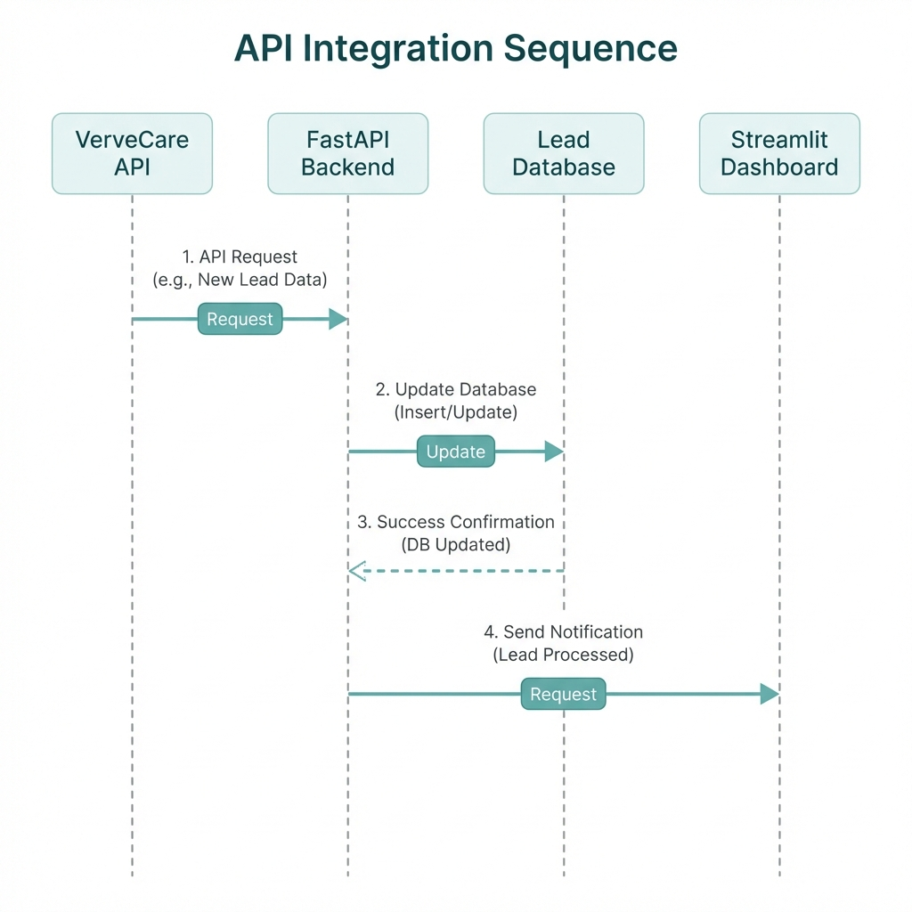

5. Next Steps for VerveCare Representative
- Provide the base URL for the API.
- Share the authentication protocol (Client ID/Secret or API Key).
- Confirm if Webhooks are supported for schedule changes.
- Provide a sample JSON response for a 'Get Caregiver Schedule' request.

