SafeLife Home Health
Lead Pipeline Analytics — Narrative Performance Report

Executive Summary
Based on the dashboard analytics (screenshots attached) and the exported dataset, SafeLife currently has 510 total leads in the pipeline. Within this pipeline, 93 leads are in the “Referral Sent” stage (plus 8 leads in “Initial Referral Sent”), and 122 leads are marked “Inactive.” A total of 60 authorizations have been received.

Lead Status Distribution
The lead status chart shows that the highest volume of leads is still at the front of the funnel. Specifically, “Initial Call” has 159 leads, followed by “Inactive” with 122 leads, and “Referral Sent” with 93 leads. Other key statuses include “Follow Up” (47), “Care Start” (43), and “Intro Call” (37). This distribution confirms where the team should focus to move more leads from Initial Call → Follow Up/Intro Call → Referral Sent → Care Start.

Referrals Sent and Top CCUs
Total referrals sent (leads marked “Referral Sent”) are 93. The CCU with the maximum referrals sent is DuPage County CS Programs with 26 referrals. The top five CCUs by referrals sent are: DuPage County CS Programs (26), Senior Services of Will County (10), Senior Services Ass. Aurora (9), Lake County Senior Social Services (Lake) (7), Solutions for Care (6).

Authorizations Received and Top CCUs
Total authorizations received are 60. The CCU with the maximum authorizations received is DuPage County Department of Community Services Division of Senior Citizen Services with 2 authorizations. The top five CCUs by authorizations received are: DuPage County Department of Community Services Division of Senior Citizen Services (2), SENIOR SERVICES CENTER OF WILL COUNTY (2), Solutions for Care (1), DuPage County Department of Community Services (1), IDHS - DRS (1).

Best Performing Source
The leads-by-source chart indicates that the strongest contributor is “External Referral,” generating 283 leads. The top sources overall are: External Referral (283), Event (109), Home Health Notify (43), Imported from Client Export (36), Other (23). This suggests that strengthening referral relationships and improving conversion handling for these leads can produce the biggest impact.

Best Performing Staff
Based on lead creation/handling activity, the highest-performing staff account is “Safelife,” with 308 leads handled. Other top contributors include: Safelife (308), muneeza (49), rakhman_gul (36), rai Faisal (32), rahman_gul (16), Maria_m (9), Shahzaib (8), Raheel (2). If you want this to show only named agents (e.g., Rai, Faisal, Raheel) and exclude generic accounts, I can apply that filter as well.

Dashboard Confirmation & Conversion Rates (From Analytics Screen)
From the Lead Pipeline Analytics screen, the dashboard shows a Referral/Confirmation rate of 34.7% and a Conversion rate of 33.9%. The confirmation donut indicates that 65.3% of items are Pending and 34.7% are Referrals. The conversion donut indicates that 65.5% are Pending, 33.9% are Care Start, and 0.565% are Not Start. These percentages are taken directly from the screenshots provided.

Appendix: Dashboard Charts (Screenshots)
Figure: Staff activity (leads handled by staff).
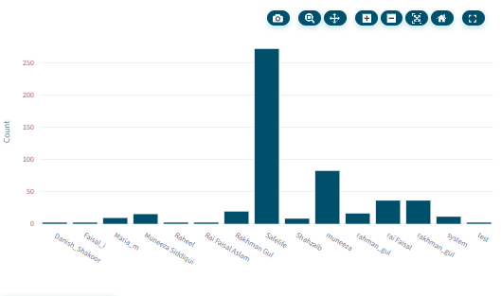

Figure: Leads by Source.
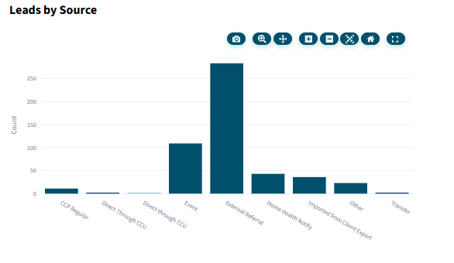

Figure: Detailed Referral Distribution (Referrals sent by CCU and Authorizations received from CCUs).
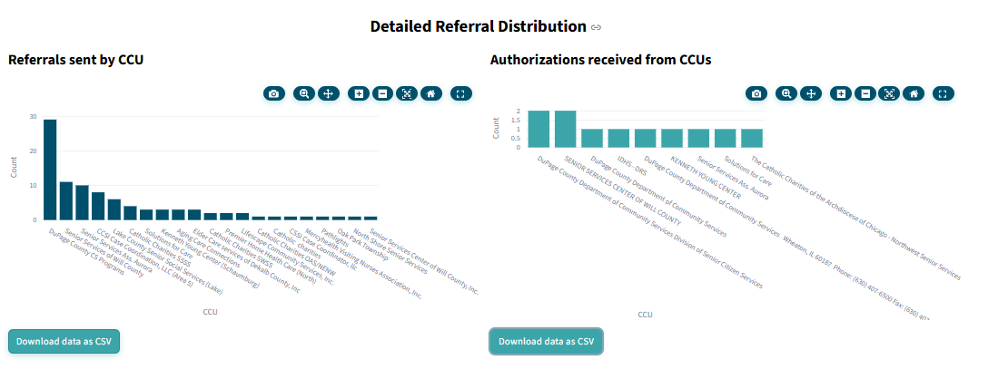

Figure: Leads by Status.
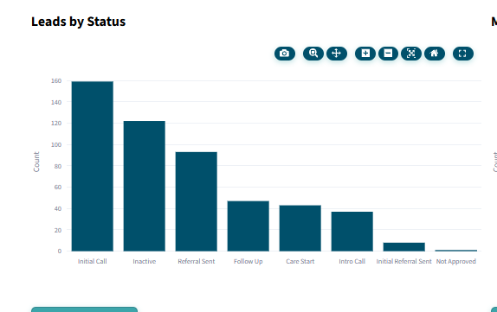

Figure: Event Leads.
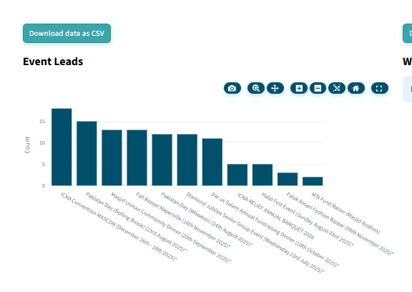

Figure: Lead Pipeline Analytics (Confirmation & Conversion).
