Pizza Store Management System
FULL STACK MERN -
CAPSTONE PROJECT

Submitted By: | Rahim Shaik
Program: | MERN STACK
Guide: | Abhishek Sharma
Submission Year: | 2026

1.Abstract
The Pizza Store Management System is a modern web-based application designed to simplify and streamline the process of ordering pizzas online while also providing administrative control for managing restaurant operations. The application allows customers to explore a digital menu, place orders, track order status, and view billing information through a user-friendly interface. At the same time, administrators can manage menu items, approve or reject orders, communicate order updates to customers, and analyze business revenue.
The project demonstrates the implementation of a full stack architecture using React for frontend development, Node.js with Express.js for backend services, and MongoDB for data storage. The system follows modern web development practices such as RESTful APIs, modular component design, and secure authentication using JSON Web Tokens (JWT).
The application is designed as a Single Page Application (SPA), allowing users to navigate across the platform without reloading pages. This improves performance and creates a smoother user experience. The project highlights how full stack technologies can be integrated to build scalable, secure, and user-friendly applications that replicate real-world restaurant ordering platforms.

2.Introduction
The rapid growth of online food delivery platforms has significantly changed the way customers order food. Restaurants now require efficient digital systems that allow customers to easily browse menus, place orders, and track delivery status while providing administrators with tools to manage orders and monitor business performance.
The Pizza Store Management System is developed to simulate a real-world pizza ordering platform similar to existing applications used by popular pizza brands. The system enables two types of users: administrators and customers.
Customers can register, log in, browse menu categories such as pizzas, sides, beverages, and combos, and place or cancel orders based on their preferences. They can also receive notifications regarding the status of their orders and view billing information along with available payment options.
Administrators have complete control over the application. They can manage menu items through CRUD operations, accept or reject customer orders, generate billing information, communicate order updates, and monitor the monthly revenue of the store.
The application is designed as a modern full-stack solution using React, Node.js, Express.js, and MongoDB. It follows industry best practices including RESTful APIs, JWT-based authentication, modular component architecture, and responsive user interface design.

3.Objectives of the Project
The main objectives of the Pizza Store Management System are:
- To design and develop a full-stack web application for managing pizza store operations.
- To implement user authentication and authorization for both administrators and customers.
- To provide customers with an easy-to-use interface for browsing menus and placing orders.
- To enable administrators to perform CRUD operations on menu items.
- To allow administrators to accept or reject customer orders.
- To provide billing functionality for completed orders.
- To implement real-time order status notifications.
- To generate revenue insights for administrators.
- To create a responsive and user-friendly interface accessible across multiple devices.
- To ensure secure communication between frontend and backend using JWT authentication.

4.Technology Stack
Frontend: HTML5, CSS3, JavaScript (ES6), React.js, React Router, Axios,
Backend: Node.js, Express.js, RESTful API Architecture, JSON Web Tokens (JWT), and Password Encryption.
Database: MongoDB, Mongoose ODM, and MongoDB Compass.
Testing: Mocha, Chai, Supertest.
Tools: Visual Studio Code, Postman, Git, and GitHub.

5.System Architecture
The Pizza Store Management System follows a three-tier architecture, which separates the application into distinct layers to improve scalability and maintainability.
1. Presentation Layer (Frontend)
The presentation layer is developed using React.js. It provides the user interface that allows customers and administrators to interact with the system. React components handle user inputs, display menu items, manage orders, and communicate with backend APIs using HTTP requests.
Key frontend components include:
- Login and Registration
- Menu Display
- Order Management
- Billing Interface
- Admin Dashboard

2. Application Layer (Backend)
The backend is developed using Node.js and Express.js. This layer contains the business logic and handles API requests from the frontend.
The backend performs the following functions:
- User authentication and authorization
- Menu item management
- Order processing
- Billing generation
- Order status messaging
- Payment handling
The backend communicates with the MongoDB database using Mongoose models.

3. Data Layer (Database)
MongoDB is used as the database to store application data. Collections are designed to store information related to users, menu items, orders, and billing.
Key collections include:
- Users
- Admins
- Menu Items
- Orders
- Payments
- Revenue Records
The database structure ensures efficient storage and retrieval of data required by the application.

6.System Module
The system is divided into two major modules:
Admin Module
The administrator manages the core operations of the pizza store.
Functions include:
- Admin login and logout
- Manage menu items (Create, Read, Update, Delete)
- Accept or reject customer orders
- Send order status notifications
- Generate billing information
- View monthly revenue statistics

Customer Module
Customers interact with the application to place and manage orders.
Functions include:
- User registration
- Login and logout
- Browse menu categories
- Select items from different categories
- Place or cancel orders
- Receive order status updates
- View bill details
- Choose delivery and payment options

7. Security Implementation
To ensure secure access to the system, authentication and authorization mechanisms are implemented using JSON Web Tokens (JWT).
The authentication workflow includes:
- User logs in using credentials.
- The backend verifies credentials.
- A JWT token is generated.
- The token is stored in the browser's local storage.
- All protected API requests include the token for verification.
This ensures that only authorized users can access protected resources.

8.ER Diagram And Application Workflow
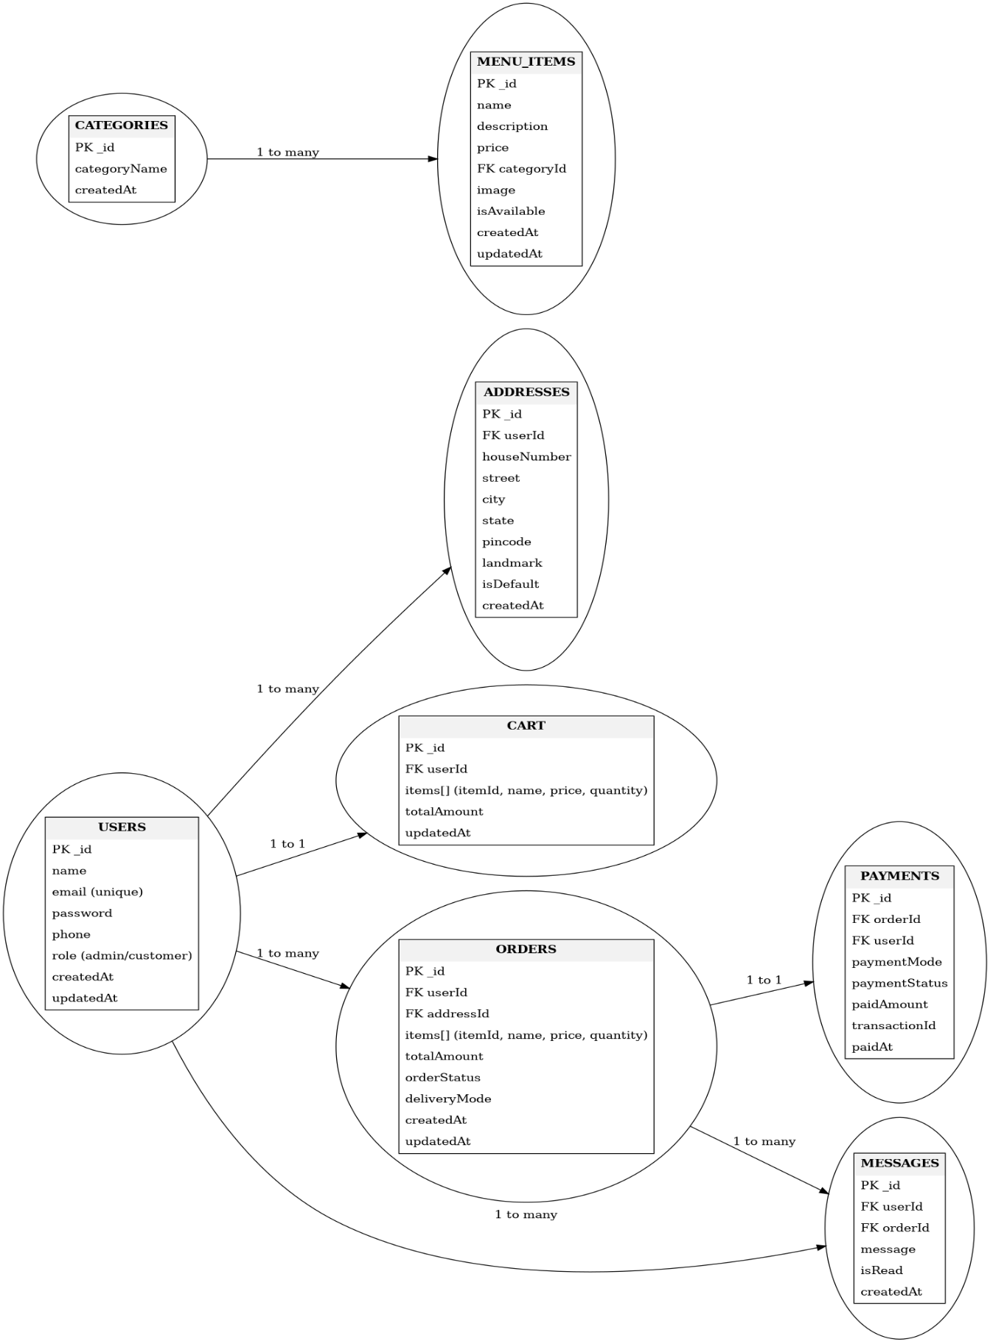

9.Application Screenshots
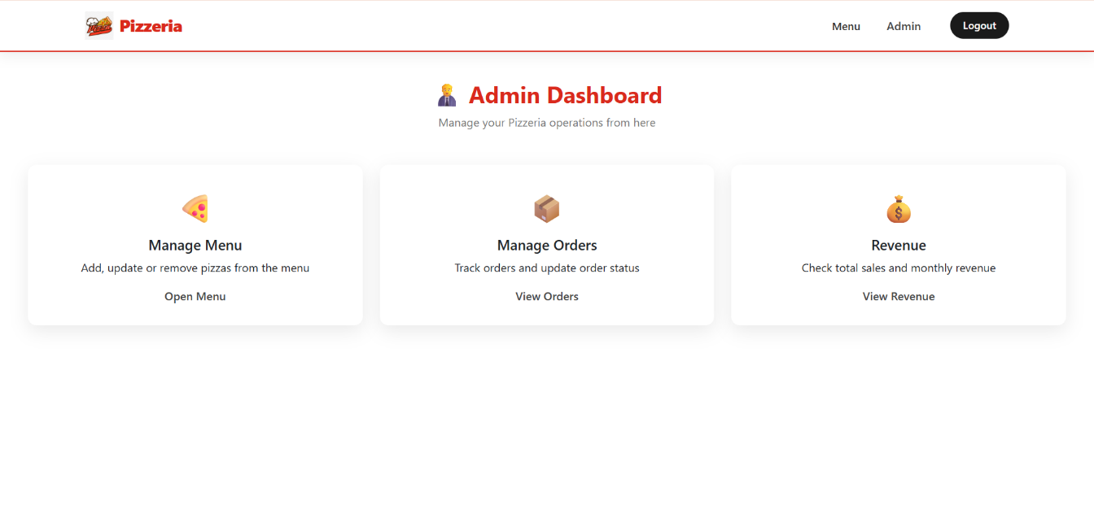

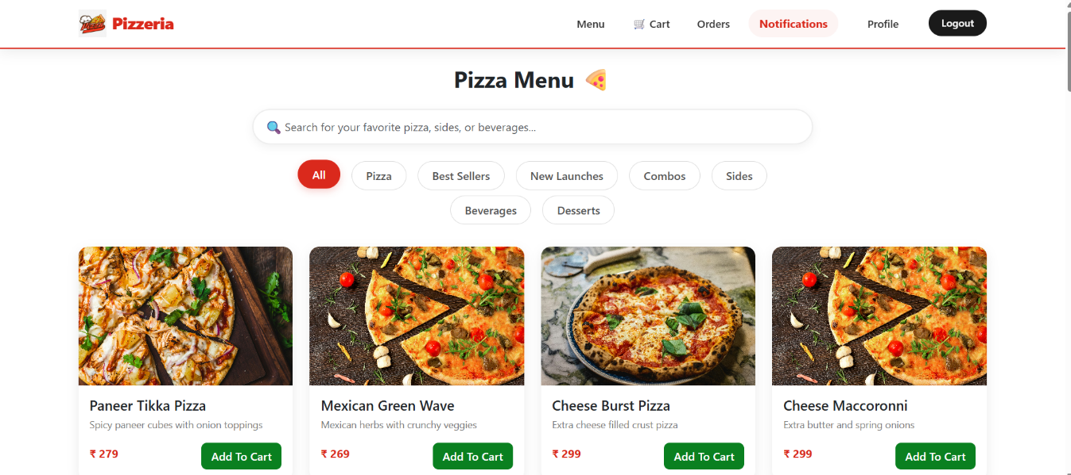
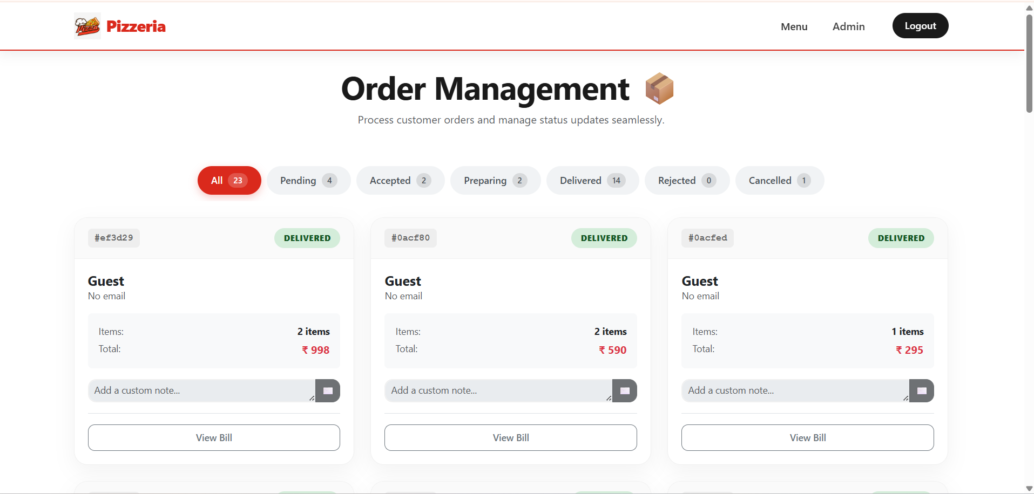

10.Application Features
The Pizza Store Management System includes the following features:
- User Registration and Authentication
- Menu Category Browsing
- Multi-item Order Selection
- Order Placement and Cancellation
- Real-Time Order Status Notifications
- Billing and Payment Options
- Admin Menu Management
- Order Processing by Admin
- Monthly Revenue Tracking
- Responsive Design

11.Conclusion
The Pizza Store Management System successfully demonstrates the implementation of a modern full-stack web application using industry-standard technologies. The system provides a seamless ordering experience for customers while offering powerful management capabilities for administrators.
By integrating React for the frontend, Node.js and Express.js for backend services, and MongoDB for database management, the application achieves scalability, performance, and maintainability. Security mechanisms such as JWT authentication ensure that user data and application resources remain protected.
This project highlights the practical application of full-stack development concepts including RESTful API design, database management, component-based frontend development, and secure authentication practices. The system can be further enhanced by integrating real-time notifications, payment gateway services, and advanced analytics to support business growth.

