Antivenom Within Reach
Quantum optimisation of snakebite antivenom placement in rural clinics
Qiskit Fall Fest 2026 · FAST NUCES Islamabad · Domain: Healthcare · SDG 3.3, 3.8, 10
Team: ______________________________
Code: https://github.com/raheemxghumman/antivenom-within-reach
Video (3 min): ______________________________

1. Problem and who it serves
Snakebite envenoming kills an estimated 81,000–138,000 people a year and leaves many more disabled (WHO). Victims are mostly rural farmers, herders and children across South Asia, sub-Saharan Africa and Latin America; children suffer more severe effects because of their smaller body mass. Antivenom only works if it is given in time, yet it is costly, scarce, and in liquid form needs a 2–8 °C cold chain. In sub-Saharan Africa alone there are roughly 314,000 envenomings a year, 95% in rural areas (Chippaux, 2011).
Decision maker. A district health officer, or an NGO supporting one, can afford to stock antivenom at only a few clinics. The question this project answers is: which clinics should stock it, so that the most bites reach antivenom within 6 hours? The answer must respect a hard budget, value children's bites, and account for clinics that would need a new solar fridge.
Scope. The problem is generic; we demonstrate it on a synthetic district modelled on rural sub-Saharan Africa, where antivenom shortages are most severe. Swapping in another region's clinic list and travel times needs no code change.

2. Formulation
Element | Definition
Decision variables | x_i ∈ {0,1}: candidate clinic i stocks antivenom (9 clinics → 9 qubits)
Coverage | covered_v = 1 − Π_{i∈S_v}(1 − x_i), with S_v the clinics reachable from village v within 6 h
Village weight | w_v = expected envenomings/yr × (1 + λ · share of children in v)
Objective | maximise Σ_v w_v · covered_v − μ · Σ_i needs_fridge_i · x_i
Constraint | Σ_i x_i = k (here k = 3); the district hospital is always stocked
Parameters | λ = 1.0 (a child's bite counts double), μ = 0.0 (fridge cost, swept 0–5)

Instance. Synthetic district (seed 2026): 30 villages, 40,655 people, about 94 envenomings a year, 9 candidate clinics, one district hospital. 13 villages are already within 6 h of the hospital, 14 depend on the clinic choice, and 3 are out of reach of every site. There are 84 valid plans among 512 bitstrings. Bite incidence (100–350 per 100,000 a year), child share (38–52% under 15), travel speeds and delays are drawn from published ranges listed in docs/data_sources.md.
Why the problem is not trivial. A village reachable from two clinics must be counted once, so the objective contains overlap terms x_a·x_b (and x_a·x_b·x_c for three clinics). Picking the clinics with the largest individual coverage (greedy) can therefore be wrong: on 100 random districts greedy missed the optimum in 9, by up to 10.6%.

3. Quantum mapping and algorithm choice
Mapping. Substituting x_i = (1 − Z_i)/2, each village contributes w_v(1 − 2^−|S_v| Σ_{T⊆S_v} Z_T). The objective therefore becomes an Ising Hamiltonian with Z, ZZ and ZZZ terms (21 terms, maximum order 3). We keep the three-body terms exactly instead of truncating to a QUBO: four villages in our district are reachable from three clinics, and dropping their terms would change plan scores by up to 6 weighted bites. Each ZZZ term is one CNOT-ladder rotation; no ancilla qubits are needed. check_model.py verifies that the Hamiltonian equals the classical objective for all 512 bitstrings (error < 1e-12).
Why QAOA. QAOA is the natural algorithm for binary optimisation with a diagonal cost Hamiltonian, and it runs at small depth. We compare two variants:
- Standard QAOA. X mixer with the budget as a penalty A(Σx − k)². Simple and shallow, but shots can break the budget and the result depends on choosing A.
- Constraint-preserving QAOA (XY mixer). Start in the equal superposition of all plans with exactly k clinics (a Dicke state) and mix with XX+YY gates, which preserve the number of stocked clinics (Hadfield et al., 2019). Every output is a valid plan and no penalty is needed.
- CVaR objective. Optimise the mean of the best α-fraction of outcomes instead of the full mean (Barkoutsos et al., 2020), which favours putting probability on the very best plans.
Training: COBYLA with a linear-ramp start plus seeded random restarts; exact output probabilities from the Qiskit Aer statevector simulator; final results also sampled with 4096 shots. Every random choice is seeded.

4. Implementation and architecture
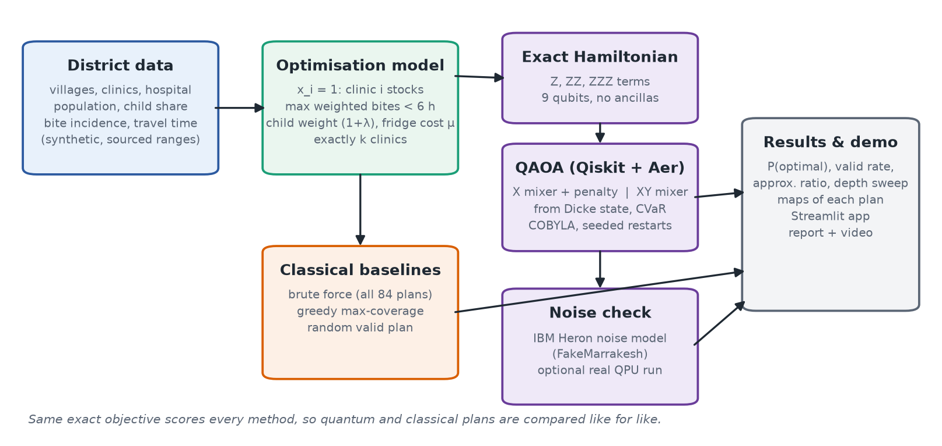
Figure 1. Architecture: one exact objective scores every method.
The code is a small Python package (avr/) built on Qiskit 2.6, Qiskit Aer 0.18 and qiskit-optimization 0.7: instance generator, exact objective, classical baselines, Hamiltonian and QAOA circuits, and plots. run_experiments.py reproduces every result in this report in about six minutes on a laptop CPU; run_noisy.py adds the noise study; app.py is an interactive Streamlit demo that draws the district map and runs QAOA live.

5. Results and comparison with classical baselines
Plan | Clinics stocked | Bites within 6 h | Child bites within 6 h | New fridges
Hospital only | — | 49.2% | 49.8% | 0
Exact optimum (brute force) | C1, C8, C9 | 83.4% | 83.2% | 2
Greedy max-coverage | C1, C8, C9 | 83.4% | 83.2% | 2
Random valid plan (mean) | — | score 0.64 × optimum

Stocking three clinics raises the share of yearly bites within 6 hours of antivenom from 49.2% to 83.4% (about 32 more envenomings a year reaching treatment in time in this district).
QAOA on the main district (ideal simulator). P(optimal) is the probability that one shot returns the optimal plan; a random valid plan has 0.012.
Variant | Depth p | Valid outputs | P(optimal) | vs random | Expected score / optimum
X mixer + penalty | 1 | 42% | 0.006 | 0.5× | 0.656
X mixer + penalty | 2 | 43% | 0.008 | 0.7× | 0.666
X mixer + penalty | 3 | 29% | 0.002 | 0.2× | 0.694
XY mixer | 1 | 100% | 0.024 | 2.0× | 0.710
XY mixer | 2 | 100% | 0.067 | 5.6× | 0.723
XY mixer | 3 | 100% | 0.071 | 6.0× | 0.729
XY mixer + CVaR α=0.1 | 2 | 100% | 0.120 | 10.1× | 0.639

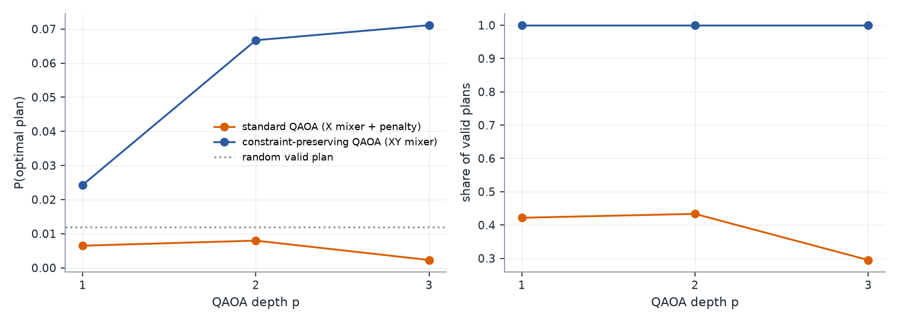
Figure 2. QAOA depth sweep: the constraint-preserving variant concentrates probability on the optimum and never breaks the budget.
Key findings.
- Quantum does real work. The XY-mixer QAOA returns only valid plans and raises the probability of the optimal plan to 0.071 at p = 3 (6.0× random); with CVaR (α = 0.1) this reaches 0.120 (10× random).
- Penalties are fragile. With the X mixer, a small penalty (0.1× the largest weight) gives only 2% valid outputs; a large one (3.0×) gives 62% valid but drowns the objective (P(optimal) 0.008, below random). This is why we built the XY mixer.
- Where greedy is not enough. On a district where greedy fails (seed 82, chosen from the 9 failures among 100), greedy stocks C4, C5, C9 and covers 80.8% of bites; the optimum (C1, C4, C8) covers 84.9%. QAOA (XY, p = 3) gives the optimal plan probability 0.062 (5.2× random) and samples it.
- Supply sweep. Coverage rises 63.3%, 75.8%, 83.4%, 88.6%, 93.4% as 1–5 clinics are stocked. At k = 5 greedy also misses the optimum on the main district (91.9% vs 93.4%).
- Trade-offs. Raising the child weight from λ = 0 to 4 changes the best plan in only 6 of 100 districts, because children are spread evenly across villages here; the most efficient plan is already nearly the best for children. The fridge cost does matter: with μ = 2 the optimum becomes C1, C6, C8, needing 1 new fridge instead of 2 for 0.7% less coverage.
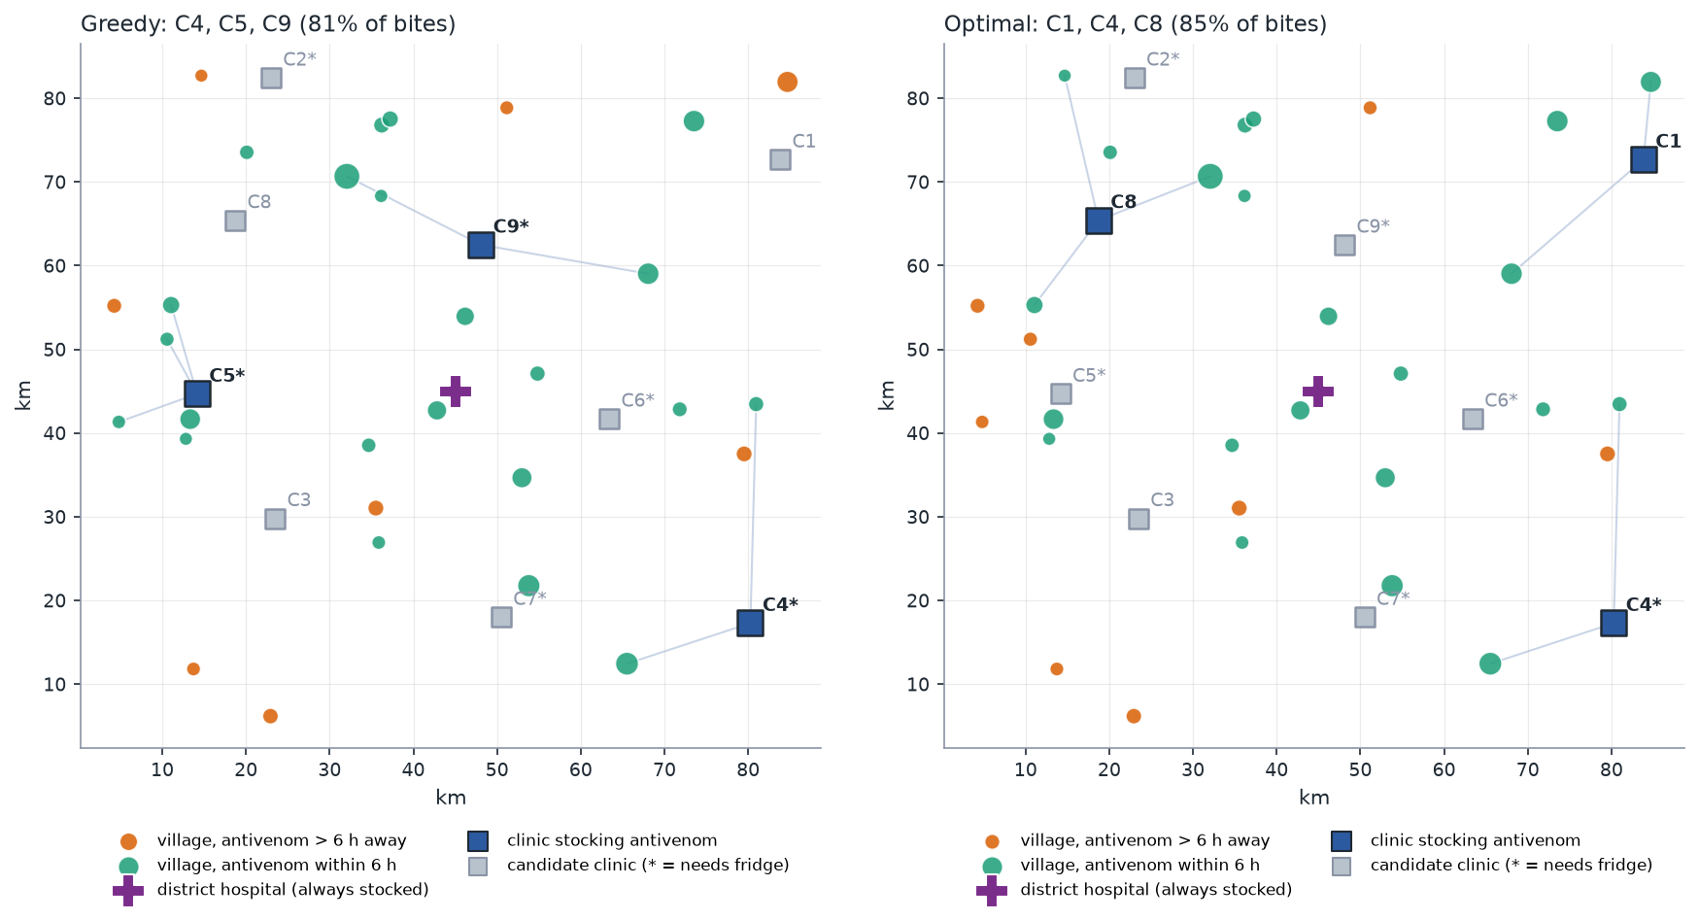
Figure 3. Hard-case district (seed 82): greedy plan (left) vs optimal plan (right). Green villages reach antivenom within 6 h.

Noise study (IBM Heron noise model)
Variant (p = 1) | Transpiled depth | 2-qubit gates | Valid: ideal → noisy | P(optimal): ideal → noisy
X mixer + penalty | 283 | 149 | 42% → 37% | 0.006 → 0.006
XY mixer | 3,052 | 1,055 | 100% → 35% | 0.024 → 0.003

Transpiled for the 156-qubit Heron device model FakeMarrakesh and simulated with its noise model (4096 shots). The shallow standard circuit survives noise roughly unchanged; the constraint-preserving circuit, which wins in simulation, becomes too deep (over a thousand two-qubit gates, mostly from the Dicke-state preparation and the all-pairs XY mixer) and its advantage disappears.

6. Limitations (honest assessment)
- Synthetic data. The district is synthetic. Parameters come from published ranges, but no real village or clinic is modelled. A real deployment needs real facility locations and travel-time data.
- No quantum advantage. At 9 qubits brute force solves the problem in milliseconds. We make no speed-up claim; the contribution is an exact quantum formulation measured against exact answers.
- Shallow QAOA. At p ≤ 3, QAOA concentrates probability on good plans (up to about 10× random) but the optimum is not the single most likely plan; deeper circuits or warm starts would be needed.
- Noise. The better algorithm (XY mixer) is the one that suffers most from noise on current hardware; ring-shaped mixers or cheaper Dicke-state circuits would reduce depth.
- Model scope. Coverage is binary (within 6 h or not). Rainy-season roads, travel-time uncertainty, vial quantities, stock expiry and upstream supply (manufacturers, lead times) are outside scope.

7. Reflection and next steps
The main lesson was that how the constraint is encoded matters as much as the algorithm: the same QAOA with a penalty did no better than random, while encoding the budget in the mixer made every shot useful. Keeping the three-body coverage terms exact also mattered, because a QUBO approximation would have optimised a different problem from the one we score.
- Real data: load real facility and road data (for example from a health-facility registry and road network) for one district.
- Richer model: vials per clinic as integer variables, and multiple seasons as scenarios.
- Hardware: hardware-efficient XY mixers and a real IBM QPU run of the shallow circuit.

References
- WHO. Snakebite envenoming – fact sheet (2023).
- Chippaux J-P. Estimate of the burden of snakebites in sub-Saharan Africa: a meta-analytic approach. Toxicon 57 (2011).
- Suraweera W. et al. Trends in snakebite deaths in India from 2000 to 2019. eLife 9 (2020).
- Farhi E., Goldstone J., Gutmann S. A Quantum Approximate Optimization Algorithm. arXiv:1411.4028 (2014).
- Hadfield S. et al. From the Quantum Approximate Optimization Algorithm to a Quantum Alternating Operator Ansatz. Algorithms 12(2), 34 (2019).
- Barkoutsos P. et al. Improving Variational Quantum Optimization using CVaR. Quantum 4, 256 (2020).
- Church R., ReVelle C. The maximal covering location problem. Papers of the Regional Science Association 32 (1974).
- Qiskit blog: Where should I locate my store? (QAOA for a covering problem).

