**Blur image detection**

**Laplacian:** Calculate the variance of the edges of objects. Mainly the rate of change in the value of the pixel matrix.

Limitations:

1. Background object
2. No ROI (region of interest)
3. Contrast of the edges.

**Results: (**percentage of blur)

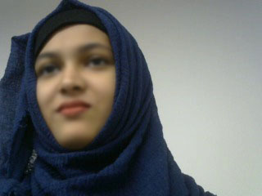

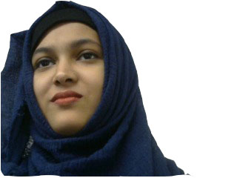

**8_motion_blur.jpg = 99.34%**

**8_no_back.jpg = 88.61%**

**8_face_blur.jpg = 98.70%**

**8_blur.jpg = 99.66%**

**8.jpg = 98.56%**

**Image Gradient Method:** This method measures the gradient of the image, which corresponds to the rate of change of pixel values

**Results: (**percentage of blur)





**8_motion_blur.jpg = 91.23%**

**8_no_back.jpg = 85.42%**

**8_face_blur.jpg = 89.42%**

**8_blur.jpg = 91.82%**

**8.jpg = 89.09%**

**Image Entropy Method:** This method measures the amount of entropy or randomness in the image, which is lower in a blurred image than in a sharp image

**Results: (**percentage of blur)





**8_face_blur.jpg = 92.63%**

**8_motion_blur.jpg = 92.51%**

**8_no_back.jpg = 60.30%**

**8_blur.jpg = 92.60%**

**8.jpg = 92.24%**

**Observation:** The method that are used don’t work properly in all condition. Moreover the percentage that are coming out of the methods are very random. But for the images that have no background (Background are removed manually using Photoshop) gives a lower percentage of blur but not relevant. **Image Entropy Method** gives a very low percentage of blur in different condition with no background such as.

**3_no_back_blur.jpg = 44.00%**

**3_no_back.jpg = 42.10%**

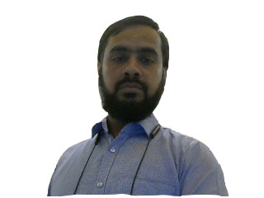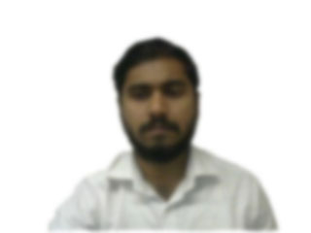

**13_no_back.jpg = 41.45%**

**3_no_back_blur02.jpg = 45.60%**

This gives lower percentage and comparatively relevant and reliable. Still not up to the expectation.

**Summary:**  The methods used are sourced from different online sources. The results shown on the source site and the real life implementation are very much contradictory. The best comparative result comes from Image entropy method. And it is the most relevant to our interest.