**Types of Blur**

There are different types of blur that can occur on an image, and they can be caused by different factors such as motion, optics, and digital processing. Here are some common types of blur:

**Motion Blur:** This type of blur is caused by the movement of the camera or the subject during the exposure time. It results in streaks or smears of the image in the direction of the motion.

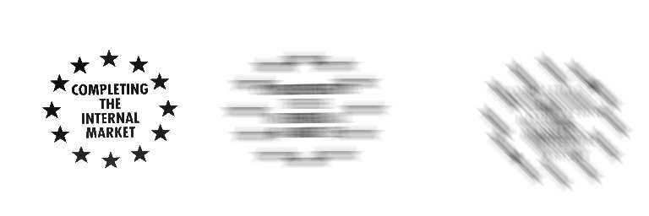

**Out-of-Focus Blur:** This type of blur is caused by incorrect focus on the subject. It results in a soft, fuzzy appearance of the image.

**Lens Aberration Blur:** This type of blur is caused by imperfections in the lens, such as chromatic aberration or spherical aberration. It results in distortion and color fringing around the edges of the image.

**Gaussian Blur:** This type of blur is a type of image smoothing technique used in digital image processing. It is used to reduce noise and detail in the image, resulting in a smoother appearance.



The Gaussian blur algorithm is a process of performing a weighted average operation on the entire image. The value of each pixel is obtained by weighted averaging of itself and other pixel values in the field.

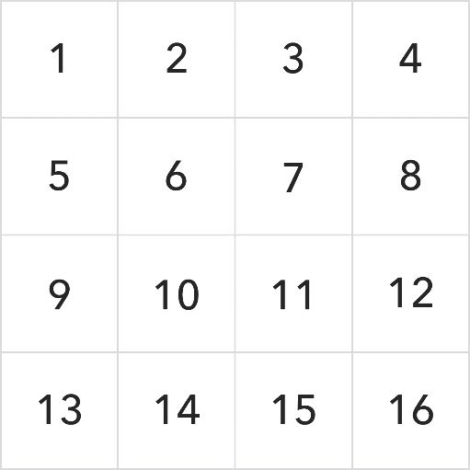

Assuming that the matrix is processed with a 3*3 convolution kernel, the convolution kernel is:

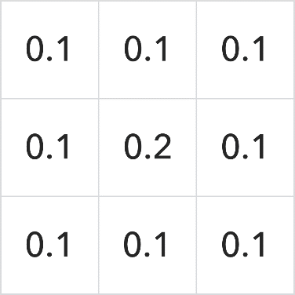

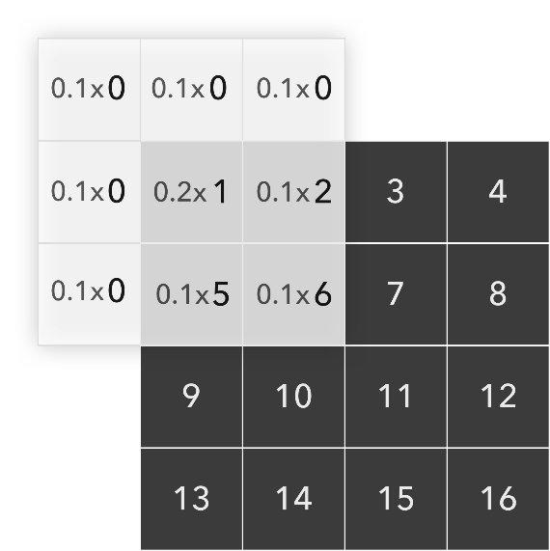First, flip the convolution kernel by 180°, and the result is the same as the original convolution kernel. Then, align the center of the convolution kernel with the corresponding element of the matrix to be processed, such as the first element in the upper left corner, and fill in 0 where there are no elements. The corresponding elements are multiplied and added together to get the result

0*0.1+0*0.1+0*0.1+0*0.1+1*0.2+2*0.1+0*0.1+5*0.1+6*0.1=1.5

All other values ​​on the matrix are processed to the final result

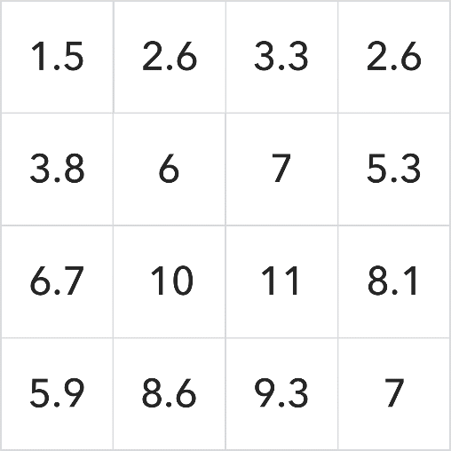

This is a simple matrix convolution operation process, which is an application of the Sliding Window Algorithm.