Name : Rania Ahmed Naji
Group : -B1-
H.W / Python

Q1) Write a Python program to enable users enter names and marks of
students of the English subject, then add them to a list called "stdmarks"
- Insert a new name and mark to the location "3"
- Replace the third name with a new name
- Find the all students who passed the module (everyone who's mark is
larger or equal to 50), then add them to another list that called
"passedStudents".
- Finally, display all passed students with their marks
Sol/
students = []
students.append(["Ali", 75])
students.append(["Sara", 88])
students.append(["Omar", 45])
students.insert(2, ["Lina", 90])
students[2][0] = "Mona”
passed_students = []
for s in students:
if s[1] >= 50:
passed_students.append(s)
print("Students List:", students)
print("Passed Students:", passed_students)

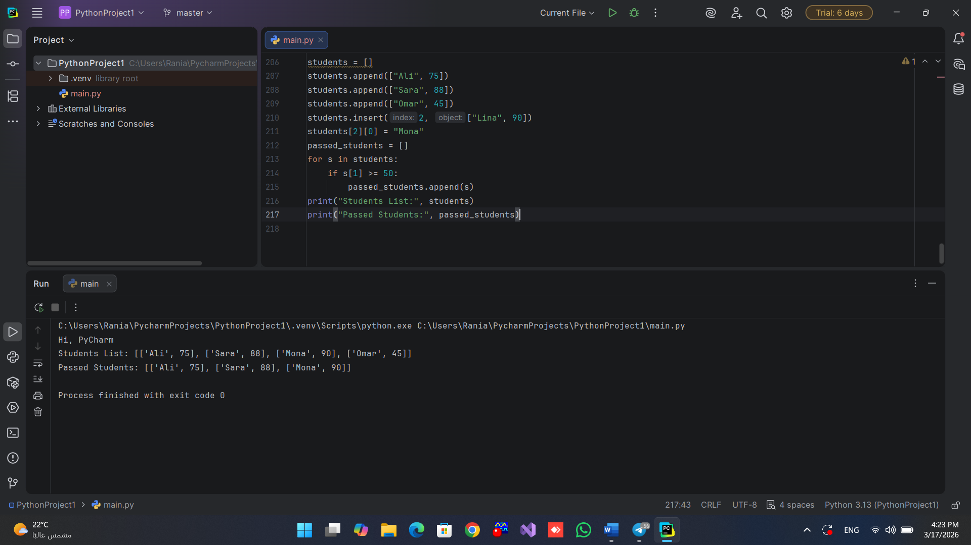

Q2) Write a Python program that prompts the user to enter a positive
integer and calculates the sum of its digits using a while loop.
Sol/
number = int(input("Enter number: "))
total = 0
while True:
if number == 0:
break
digit = number % 10
total = total + digit
number = number // 10
print("Result =", total)
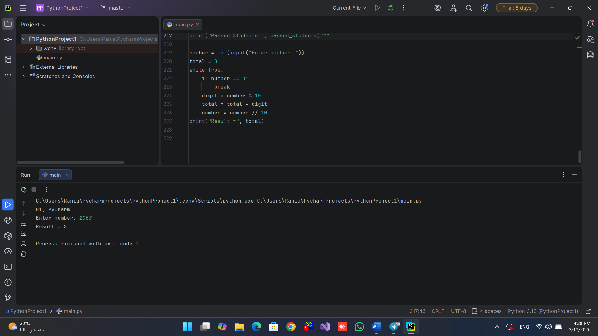

Q3) Write a Python program that calculates the factorial of a number
provided by the user.
Sol/
n = int(input("Enter value: "))
result = 1
i = 1
while i <= n:
result = result * i
i += 1
print("Factorial =", result)

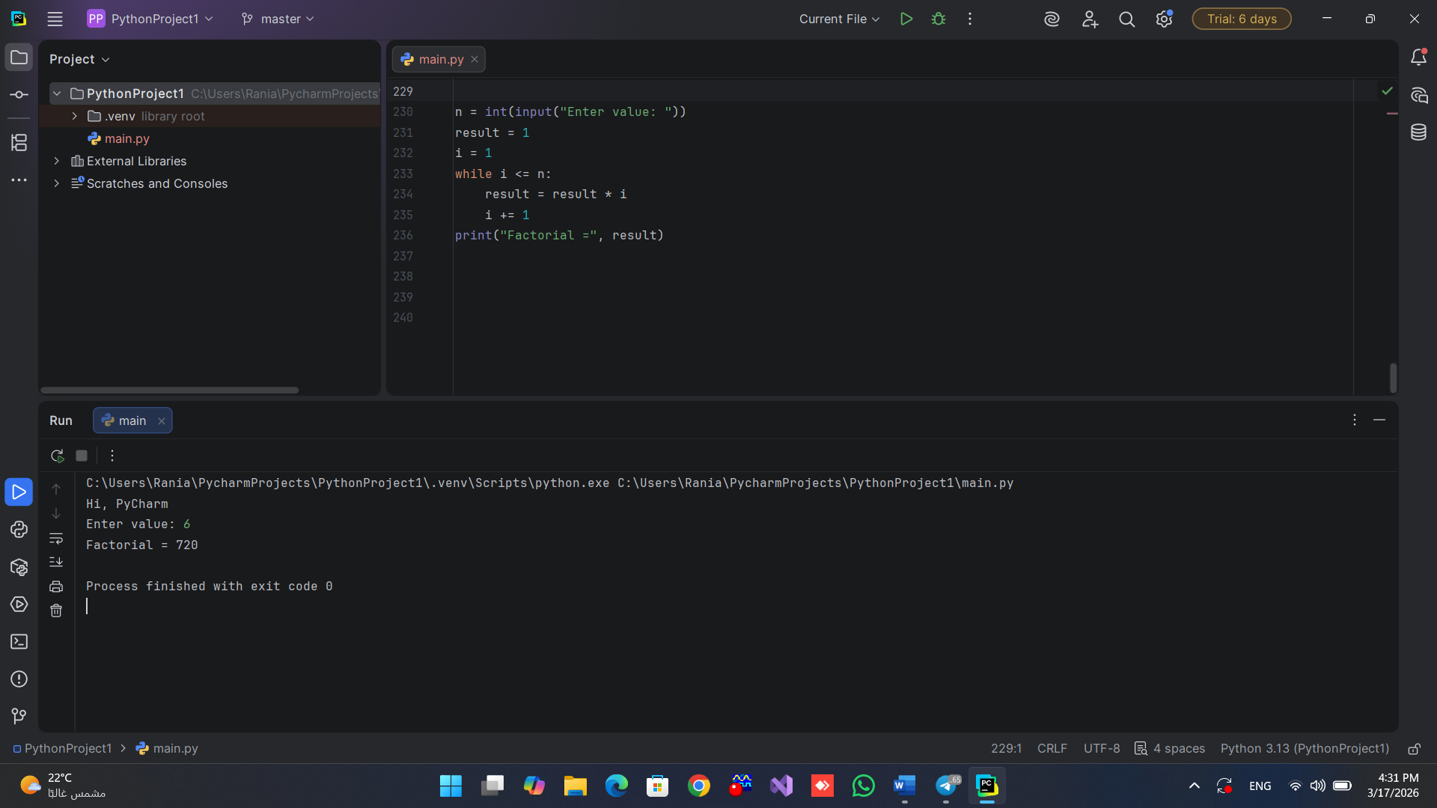

Q4) Write a Python program that accepts three numbers from the user and
prints the largest one.
Sol/
x = int(input("First: "))
y = int(input("Second: "))
z = int(input("Third: "))
if x >= y and x >= z:
print("Largest =", x)
elif y >= x and y >= z:
print("Largest =", y)
else:
print("Largest =", z)
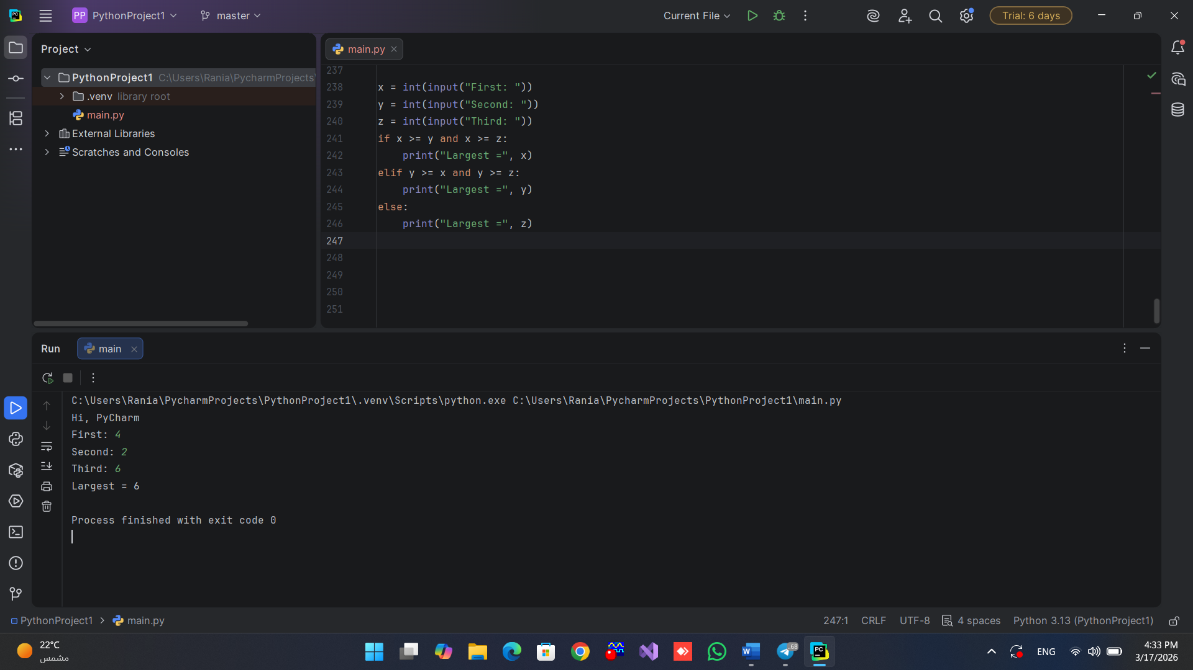

Q5) Write a Python program that calculates the sum of an N number,
where N is provided by the user.
Sol/
num = int(input("Enter number: "))
s = 0
i = 1
while i <= num:
s += i
i += 1
print("Total =", s)

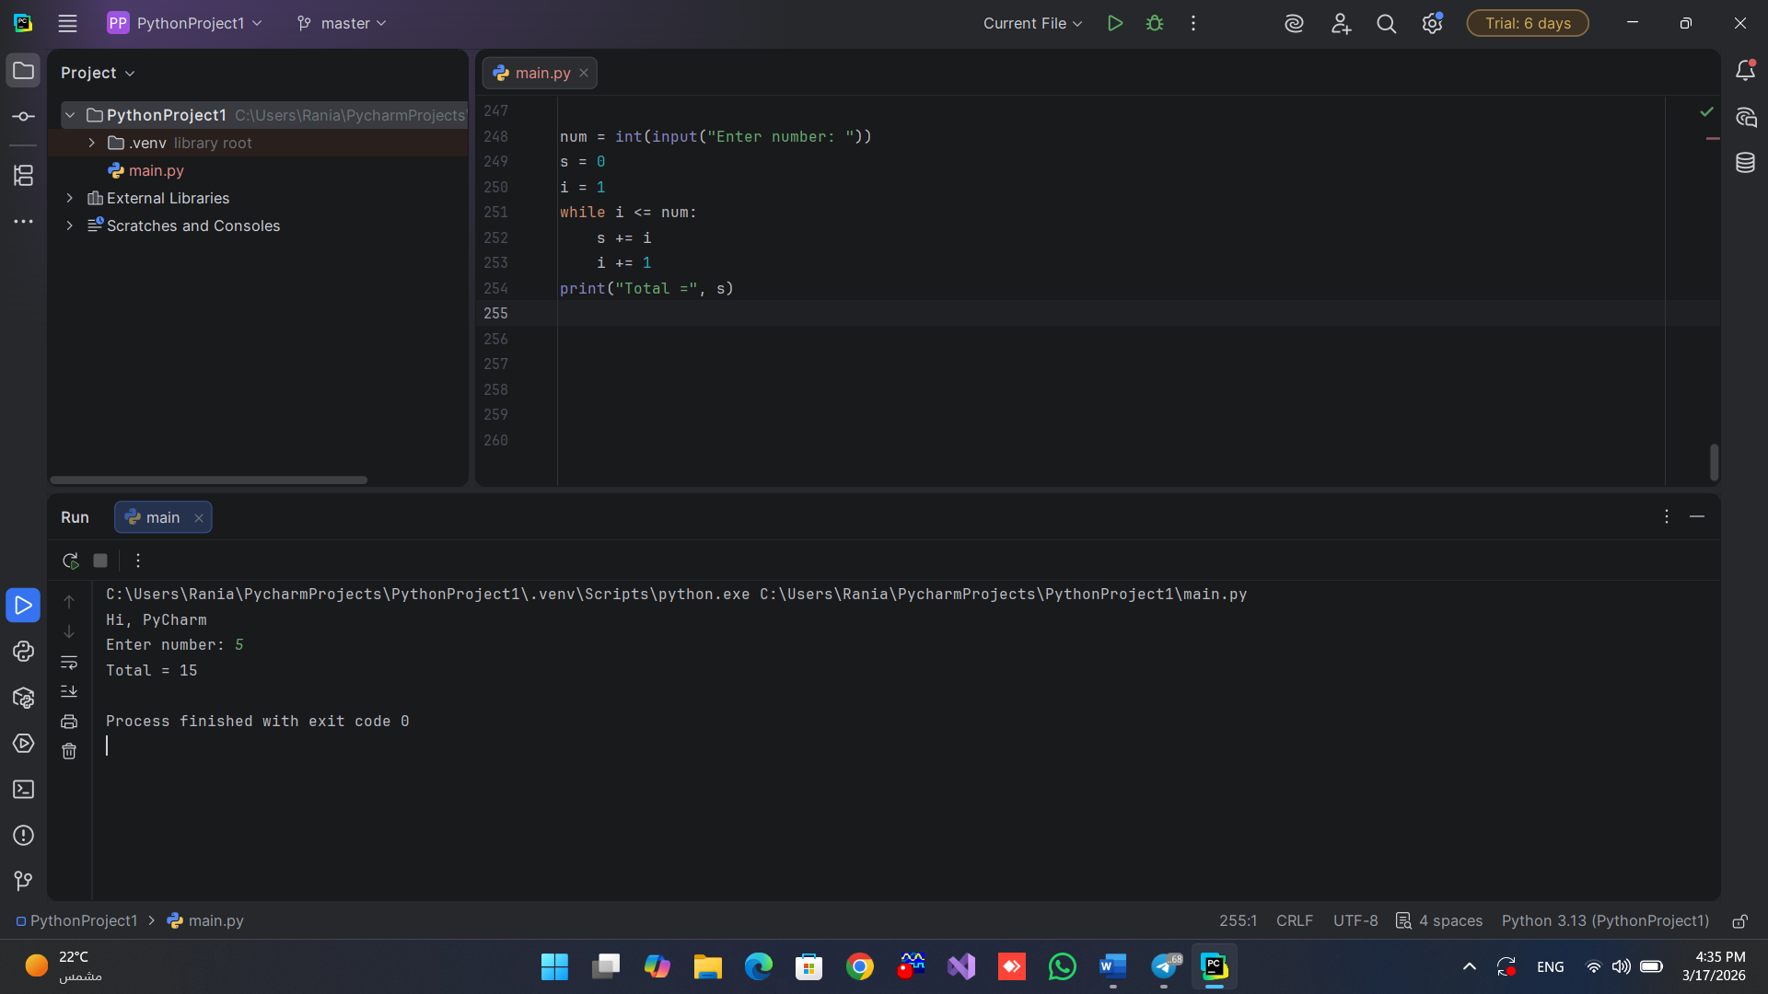

Q6) Write a Python program that counts the number of digits in an integer
entered by the user.
Sol/
value = int(input("Enter number: "))
digits = 0
while value > 0:
value = value // 10
digits += 1
print("Digits =", digits)
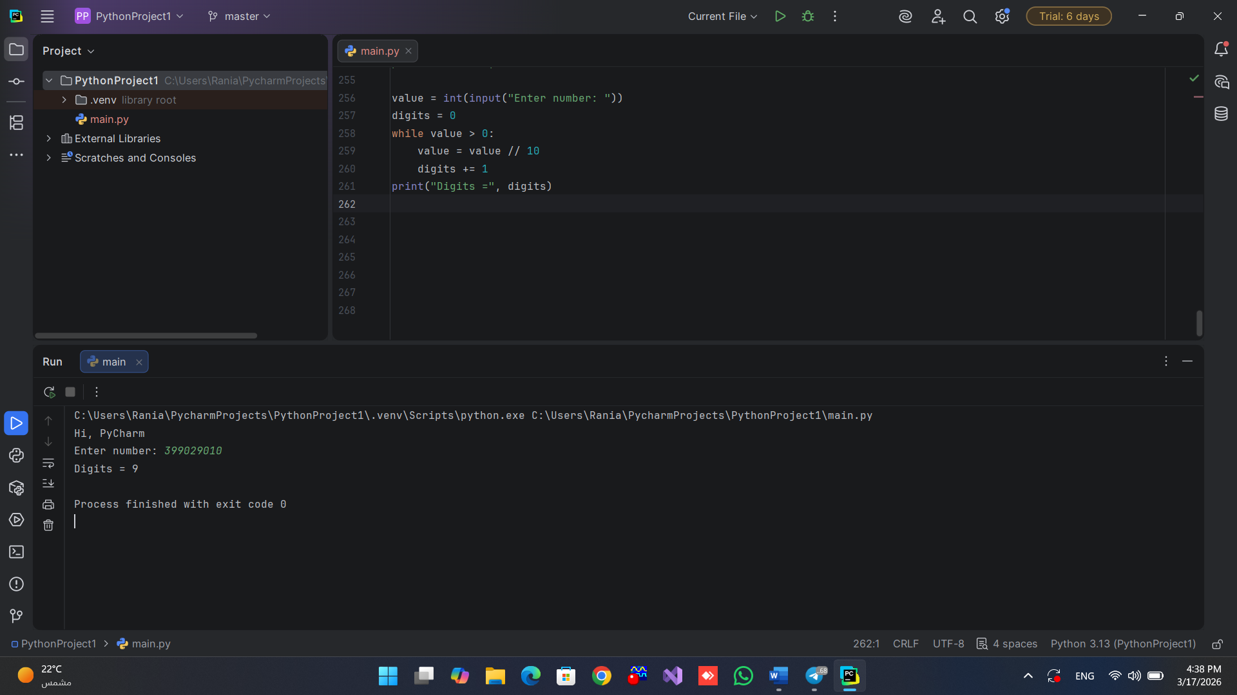

Q7) Write a Python program that accept integer input from users and then
store prime numbers in a tuple.
Sol/
nums = []
n = int(input())
for i in range(n):
nums.append(int(input()))
prime = []
for x in nums:
if x > 1:
p = True
for i in range(2,x):
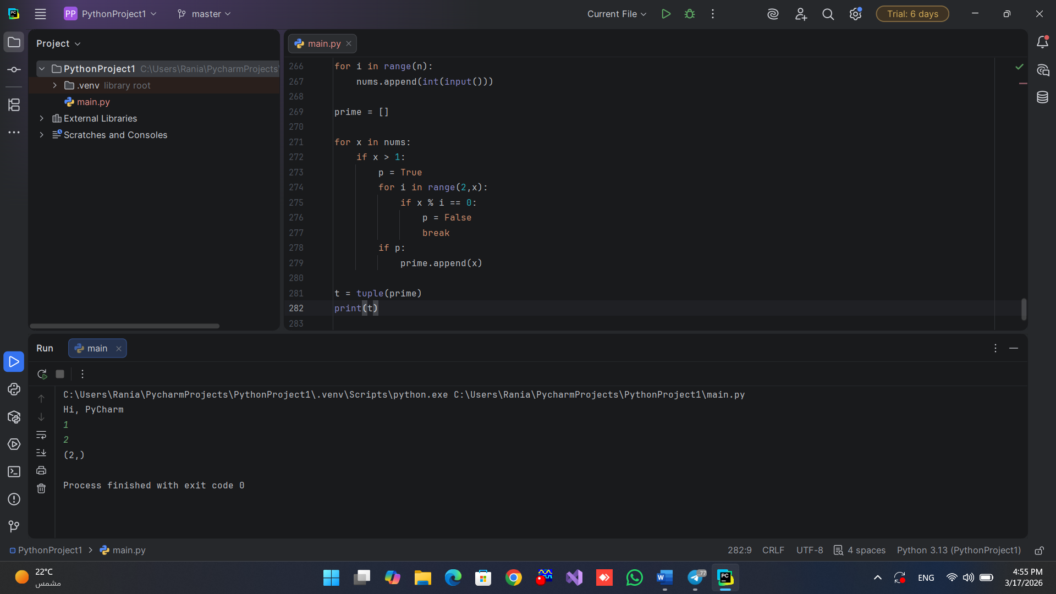
if x % i == 0:
p = False
break
if p:
prime.append(x)
t = tuple(prime)
print(t)

Q8) Write a python program to accept names of employees, then store
names in a list, then sort the list based on the alphabet.
Sol/
names = []
n = int(input())
for i in range(n):
names.append(input())
names.sort()
for x in names:
print(x)

