AI Assisted Coding
Assignment-1.2

Name: Mohammed Rahil Raza

Ht.no: 2303A51433
Batch. No: 21

1Q) Task 1: AI-Generated Logic Without Modularization (Factorial without Functions)
Prompt :
write a python code to calculate the factorial of a number without using any functions and input should be taken from user.
Code:
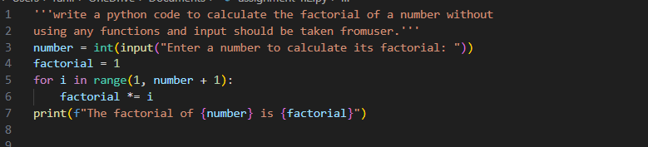
Output:
Justification:
By doing this task, the factorial of a number is calculated without using any functions.
The program takes input from the user and uses a single for loop to compute the factorial.
All steps are written directly in the main program using iterative logic.

2Q) Task 2: AI Code Optimization & Cleanup (Improving Efficiency)
Prompt used:
optimize the above code by adding comments, readability and with improved logic.
Code:
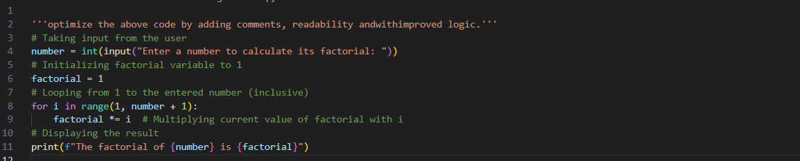
Output:
Justification:
By doing this task, the factorial program is optimized for better readability and understanding.
Meaningful comments and clear variable usage are added while keeping the logic simple and efficient.
The program still uses a single loop and user input, with all steps written in the main program.

3Q) Task 3: Modular Design Using AI Assistance (Factorial with Functions)
Prompt used:
- write a python code to calculate the factorial of a number using meaningful user defined functions and taking the input from the user.
- if user gives negative numbers then this code should handle that case as well.
Code:
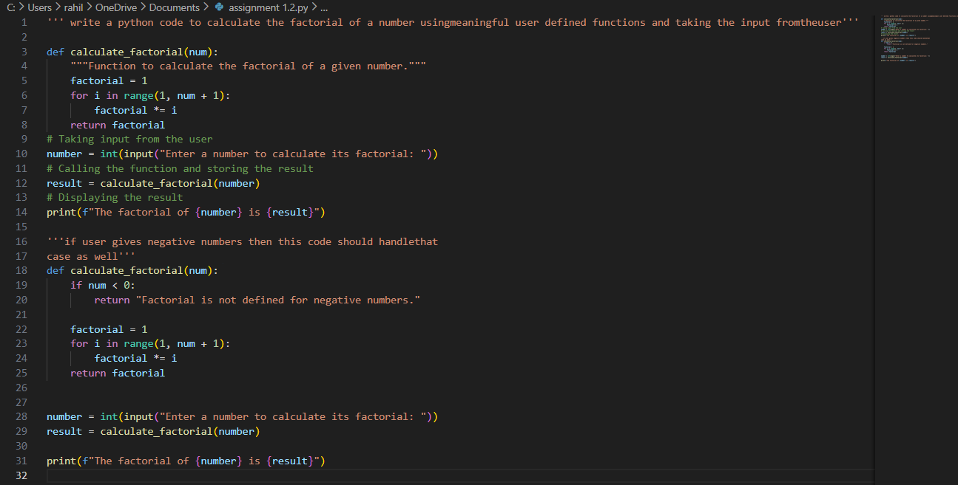
Output:
Justification:
By doing this task, the factorial logic is implemented using a meaningful user-defined function.
The program takes input from the user and handles negative numbers with proper validation.
Modular design improves code readability, reusability, and error handling.

4Q) Task 4: Comparative Analysis – Procedural vs Modular AI Code (With vs Without Functions)

Criteria Without Functions (Procedural Code)
Logic is written linearly in one place, which is easy to
With Functions (Modular Code)
Logic is clearly separated into
Logic Clarity

Reusability
follow for small programs but becomes cluttered as code grows.

Code cannot be reused easily; the same logic must be rewritten if needed again.
meaningful functions, making the flow easier to understand.
Functions can be reused multiple times across the program or in other programs.

Debugging
Debugging is harder because Easier to debug since
all logic is mixed in the main errors can be isolated
Ease

Suitability for Large Projects

AI
Dependency Risk

Conclusion:
program.

Not suitable for large projects due to poor structure and maintainability.
Higher risk, as AI-generated logic may be copied blindly without understanding due to lack of structure.
within specific
functions.
Highly suitable for large projects because of clean structure and modular design.
Lower risk, as modular design encourages understanding of logic, inputs, and outputs.
Procedural code is useful for small, simple tasks and beginners, while
modular code using functions is better suited for scalable, maintainable, and professional software development.

5Q) Task 5: AI-Generated Iterative vs Recursive Thinking
- An iterative version of the logic Prompt used:
write a python code to calculate the factorial of a number using iterative approach with meaningful user defined functions and taking the input from the user.
Code:
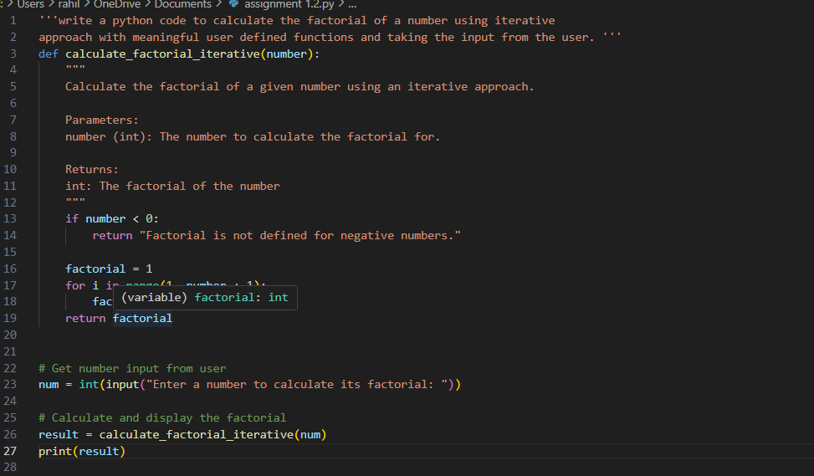
Output:

- A recursive version of the same logic Prompt used:
write a python code to calculate the factorial of a number using recursive approach with meaningful user defined functions and taking the input from the user.

Code:
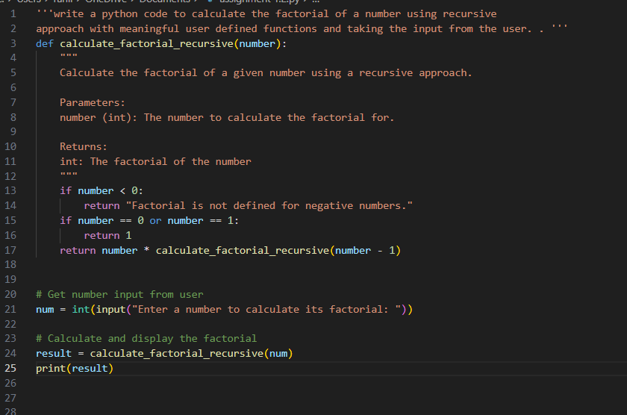
Output:
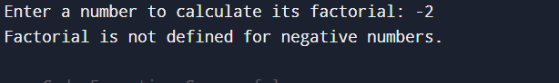
Justification:
By doing this task, factorial logic is implemented using both iterative and recursive approaches.
The iterative version uses a loop for step-by-step multiplication, while
the recursive version uses function calls and base conditions.
This comparison helps understand differences in readability, stack usage, performance, and when recursion should be avoided.

