**COMPUTER COMMUNICATION NETWORKS**

**EXPERIMENT 2**

**AIM:** To Crimp LAN cable using RJ-45. Plug with inserts.  
  
**APPARATUS:** RJ-45 Cable, Crimping Tool, Tester   
  
**PROCEDURE:**

1. Cut your cable and strip about 1” of the outer jacket off the tip.
2. Clip away the spleen. Untwist and splay out the wires.
3. Sort your wires in the proper pin out configuration and insert each wire through the insert. Set the insert as far down and as close to the
4. outer jacket as possible.
5. Trim away the excess wires from then end.
6. Insert the wire tips with the insert as far into the connector as
7. possible. The lip of the insert should be pointed down in the diagram to the left. Squeeze the outer jacket into the connector as well until it reaches the jacket clamp on the connector
8. Insert the plug into your crimper and crimp down.

**WIRING DIAGRAM:**

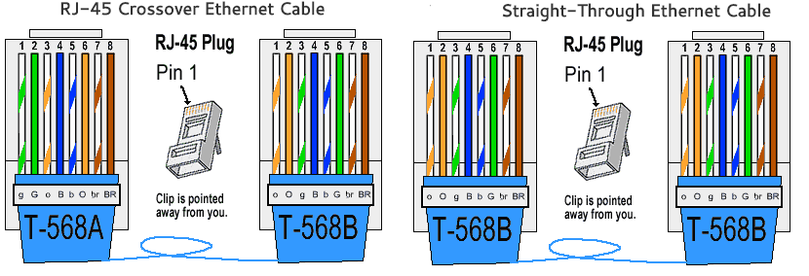

**SCREENSHOTS:**

1. Connections for cross-over Ethernet Cable:

1. Connections for straight wire:  
     
   Graphical user interface

   Description automatically generated

**CONCLUSION:** From this experiment we have learnt how to crimp and connect LAN CABLE using RJ-45.