Rahil Patel
Partner: Brian Dunn

Appointment
get/set time
get/set date

Bill
get/set list of charges
addRepairCharge()
addRentalCharge()

Car
get/set Make
repair()

CarOwner
get/set name  get/set "other identifying info"  provideRentalTo(RentalCar)?  wantsARentalCar()  fillOut(Paperwork)  call(RepairShop)  speakTo(RepairShopStaff)  giveToStaff(License)  confirmRental | RepairShopStaff

CarRentalCompany
get/set staff
get/set sites
pay(amount)

Driver
scheduleDelivery (RentalCar, RepairShop, Appointment)  requestPickup (RentalCar, RepairShop) | RepairShop?  RepairShopStaff?

RentalCar
subclass of Car
rentTo(CarOwner)
deliverTo(repairShop)?
returnTo(repairShop)?
pickUp(Driver)?

RepairShop
get/set staff
get/set address

RepairShopStaff
carBroughtInForRepair(Car,CarOwner)  makeAppointment(Car,CarOwner)  deliverCar (RentalCar, Paperwork)?  returnCar (CarOwner,RentalCar)?  pickedUpReturnedCar (RentalCar,Paperwork)?  call(RWCSite)  speakTo(RWCStaff)  giveInformation(carSize,name,address,age,licenseNum)  giveCarInfo(CarOwner)  confirmRental(RWCStaff)  giveQuote(RWCStaff) | Car  CarOwner  RWCStaff  CarRentalCompany

RWCSite
get/set address  getAvailableCars(desiredCarSize) | RWC

RWCStaff
wantsARental(CarOwner,CarMake,RepairShop,Appointment)  carhasBeenReturned(CarOwner,RentalCar,RepairShop)  giveRentalInfo(CarAvailable,RentalRate)  checkAvailable(desiredCarSize,RentalDate)  confirmAcceptable(rentalAge,blacklist)  addToInventory(RentalCar,RenalDate)  fillOut(DeliveryRequest)  fileRequest(DeliveryRequest)  extractRequests  assignDrivers(Driver)  checkAltenativeSites(RWC)  reserveCar(RWCSite)  estimateDrive | RWCSite  Driver  RWC

DeliveryRequest
get/set address | RCWStaff  Driver

RollingWrecksCorp (RWC)
add RWC site | RWC site

1)
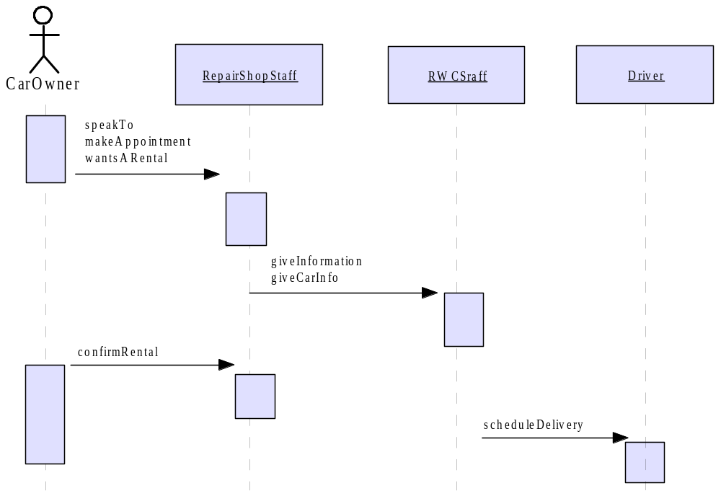
2)
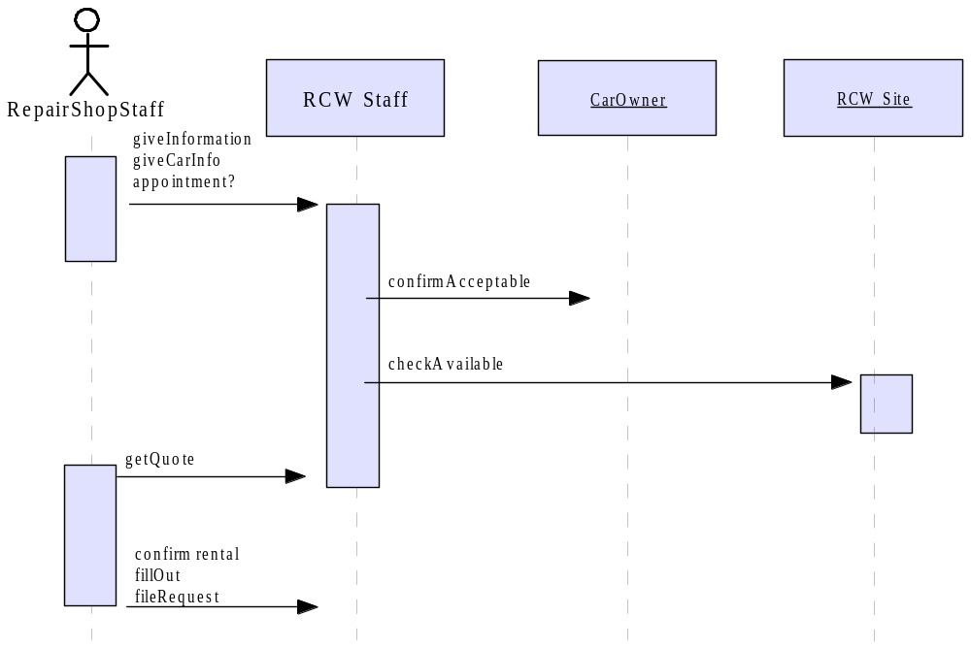
3)
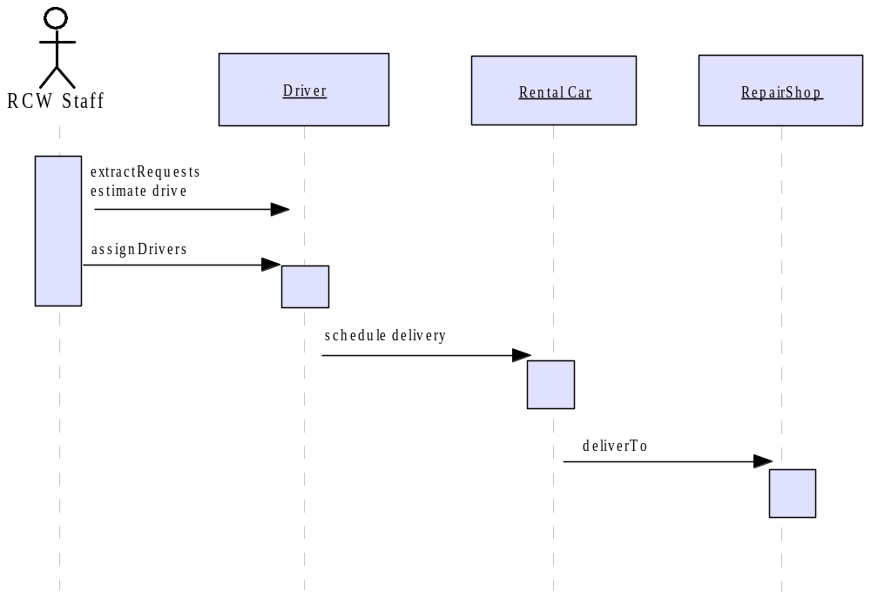
4)
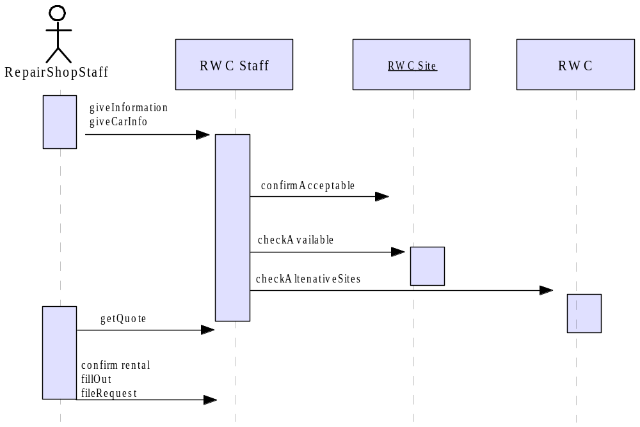

5)
