The Languages of North America:

Preserving the Speech of
Native Americans

Kyle Bohannan
Bryan Miller
David Norris
Rahil Patel
Russell Pratt Jr.

ABSTRACT:

Every day brings the beautiful languages of the Native American closer to extinction. The United States Government has made little effort to preserve indigenous languages. Non-Governmental Organizations (NGO) have been unable to find funding for a coordinated effort to preserve the languages of all Native American Tribes. Most funding only preserves a limited set of a single tribal dialect. No mechanism exists for the tribes to maintain their own languages in a recorded form. Unless some system to record and preserve the history and beauty of the Native American Languages is provided soon, their heritage will be lost.
As beneficiaries of the actions of the United States Government from Declaration of Independence through Slavery and Manifest Destiny to today, we should consider preserving the language of Native Americans as a minimal moral obligation to cultures that have been casualties of United States expansion.
TABLE OF CONTENTS:

1 Title Page
2 Abstract
3 Table of Contents
4-5 Problem Exposition
6-16 Proposed Solution
9 Figure WL-1 Super User Interface
10 Figure WL-2 Master Admin Interface
11 Figure WL-3 Expert Interface
12 Figure WL-4 Teacher Interface
13 Figure WL-5 Student Interface
14 Figure WL-1 Guest Interface
15 Figure UML-1 Learning Center Use Case
16 Figure UML-2 Language System Sequence Diagram
17 – 18 Budgetary Analysis
19 – 20 System Enhancements
21 - 38 Appendices
21 Team Assignments
22 – 23 Data Base Structure
24 – 29 System Story Cards
30 - 33 System Test Cards
34 - 38 Universal Modeling Language Diagram Documentation

PROBLEM EXPOSITION:

No system exists to record and retain the languages of Native Americans. Tribes have different degrees of recorded language. Some tribes, such as the Tulu, have no recorded version of their language. Other tribes, such as the Cherokee, have a documented language consisting of multiple dialects.
Each tribe has a unique circumstance created by the size and wealth of the tribe, as well as the number of tribe members fluent in their native language. The number of fluent speakers is decreasing daily.
A system needs to exist that can aid and encourage Native American Tribes to preserve Native American culture by increasing the number of people fluent in Native American Languages while allowing “outsiders” to record and retain “data” that is sacred to each individual tribe.

Due to variances in wealth and available technology, universal access through public libraries and the World Wide Web is essential. A database to record and retain Native American Languages must be created and maintained. Personnel must be retained to administer the system and act as a point of contact between the tribes and the system administrators.

PROPOSED SOLUTION:

An acceptable solution to encouraging the preservation of Native American Languages must provide universal access, record and retain the languages digitally, and provide an interface to learn the individual languages.
A system is proposed to teach Native American Languages and record the language digitally. Students will navigate web pages to view a specific language. The student can view symbols from the syllabary and hear pronunciation guides for the symbols. The student can browse a dictionary of words and hear the word pronounced as well as look-up a desired word. The student can train through lessons and evaluate progress through quizzes.

Old Dominion University will supply personnel to administer the database and act as a point of contact for tribal communication. Old Dominion University personnel will assign the Master Administrator for each physical location. The Master Administrator will be responsible for assigning individuals to a group of teachers or a group of language experts. Teachers will be responsible for assigning individuals as students and promoting student progress.
The system will provide a user interface through a web site to be hosted by Old Dominion University in Norfolk, VA. A Universal Resource Locator will be assigned to the system to allow Internet access to the system.
A database will be created to record and retain necessary data to preserve and provide a teaching interface for Native American Languages. The database will be created using ORACLE. Old Dominion University already possesses the necessary licenses to deploy an ORACLE database.

A license for ORACLE Maestro will need to be purchased to allow seamless integration of Excel spreadsheets into ORACLE. The current cost for a single user business license for Maestro is one hundred fifty-nine dollars. Additional information can be obtained at http://www.sqlmaestro.com. Old Dominion University will retain rights to the database.
HTML Web Page generation and communication will be provided by Common Gateway Interface. Programming Language / Structured Query Language embedded in C++ will be used to communicate with the ORACLE database. Included are diagrams of the Web Interface and a Universal Modeling Language diagram of the Learning Interface.

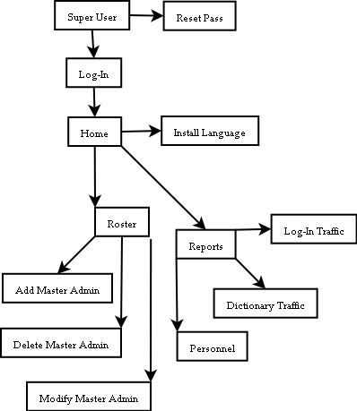
Figure WL-1

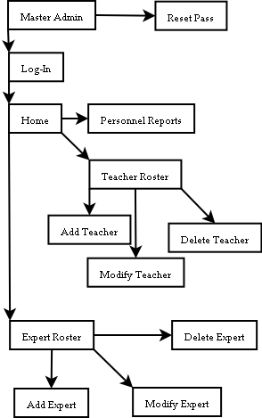
Figure WL-2
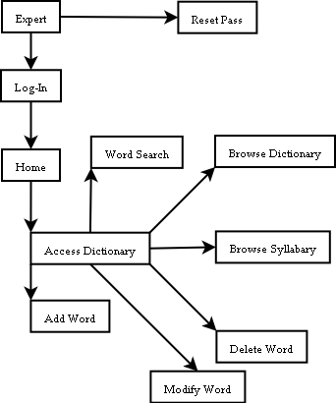
Figure WL-3

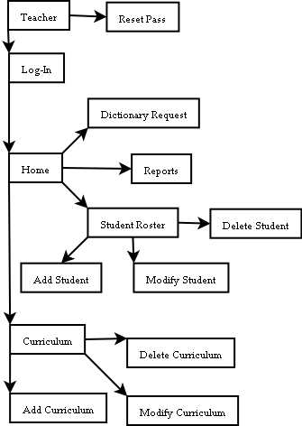
Figure WL-4

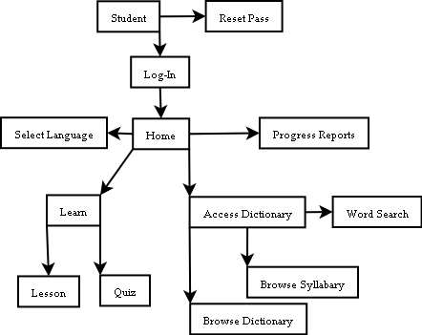
Figure WL-5

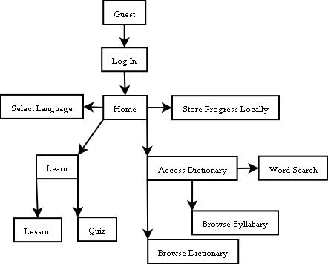
Figure WL-6

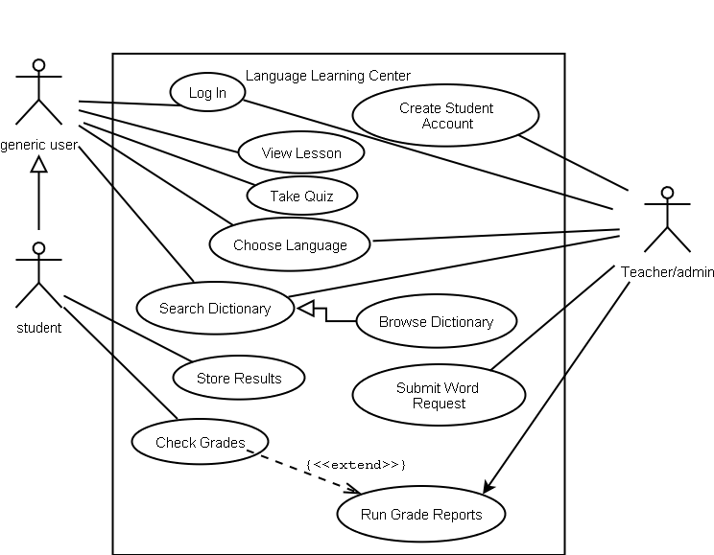
Figure UML-1

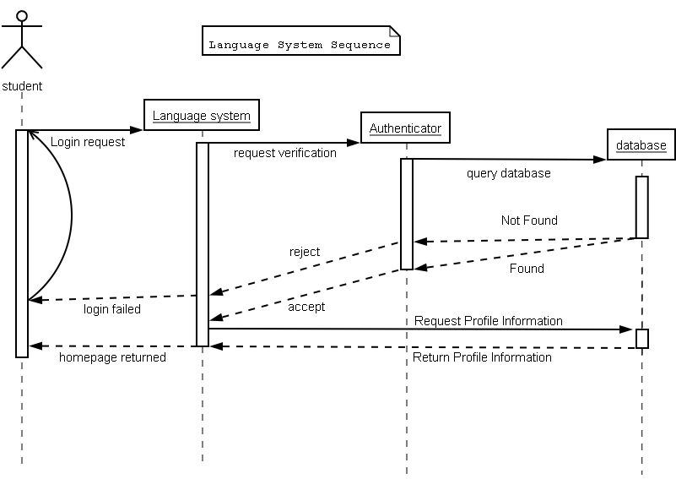

Figure UML-2

Budgetary Analysis

Estimated Cumulative budget (in hours): 2210

Estimated Budget Schedule:
Week | Description | Hours
1 | Team familiarization with technologies to be implemented and deployed. | 200
2 | Design and implement Database Structure and HTML for Super Interface. | 200
3 | Propagate Database and design and implement HTML for Master Admin Interface. | 200
4 | Acceptance tests on Database Structure. Design and implement HTML for Expert Interface. | 200
5 | Design and implement PL/SQL for Super and HTML for Teacher Interface. | 200
6 | Acceptance tests on Super User. Design and implement HTML for Student and PL/SQL for Master Admin and Expert. | 200
7 | Acceptance tests on Master Admin and Expert. Design and implement HTML for Guest and PL/SQL for Teacher. | 200
8 | Acceptance test on Teacher. Design and implement PL/SQL for Student and Guest. | 200
9 | Acceptance test on Student and Guest. Design and implement PL/SQL for system reports. | 200
10 | Acceptance tests on system reports. Design and implement PL/SQL for user reports | 200
11 | Acceptance tests on user reports. Final system Acceptance tests. | 200
12 | Deploy System | 10

System Enhancements
The following functionality can be added to the system at the client’s discretion:

Enhancement 1: WIKI Dictionary
Estimated Time: 75 hours.
The system will maintain two separate dictionaries. One will be the official dictionary of recognized words, and the second will be a WIKI dictionary. The WIKI would contain new words not contained in the official dictionary or words that are under review within a tribe. The Experts will create the WIKI dictionary. The system will provide an interface to allow the Experts for a language to add, modify, or delete words in the WIKI dictionary.

Enhancement 2: WIKI Promotion
Estimated time: 75 hours.
The system will allow the Experts a way to promote words from the WIKI dictionary to the official dictionary.

Enhancement 3: Teacher Curriculum
Estimated time: 80 hours.
The system will provide an interface to allow Teachers to create their own question bank. Teachers will be able to create their own lessons and quizzes and make them available to their Students.

Enhancement 4: Query Limits
Estimated time: 80 hours.
The system will provide an interface, while browsing the dictionary, which will display possible word matches based on each symbol as they are entered. Possible matches are words that start with the symbols typed by the user.

Enhancement 5: Suggested Words
Estimated time: 80 hours.
If a word search fails, the system will provide the user with optional words that are similar in spelling.

Appendices

Team Assignments

Technology | Personnel | Estimated work
CGI | David Norris  Russell Pratt Jr. | 630 hours
HTML | Bryan Miller  Rahil Patel | 690 hours
ORACLE | Kyle Bohannan  David Norris | 890 hours
TOTAL ESTIMATED WORK: |  | 2210 hours

Database Structure

AUTHENTICATE
Log-in Pass User-Type

E-MAIL
Log-In E-mail

PERMISSIONS
Log-In Language-Code Lesson-Code

ADDRESS
Log-In Street City State Zip

MASTER ADMIN
Log-In Fname Mname Lname

EXPERT
Log-In Fname Mname Lname MAdmin

TEACHER
Log-In Fname Mname Lname MAdmin

STUDENT
Log-In Fname Mname Lname Grade-Level Teacher

GRADES
Log-in Quiz-Code Score

LANGUAGE
Language-Code Name

SYLLABARY
Symbol Sound Phonetic

DICTIONARY
Native-Word Sound Phonetic Definition

WIKI
Native-Word Sound Phonetic Definition

QUESTION
Question-Code Language-Code Image Sound Choice1 Choice2 Choice3 Answer

LESSON
Lesson-Code Lesson-Num Question-Num Question-Code

QUIZ
Quiz-code Quiz-Num Question-num Question-Code

System Story Cards

Story 1 - Hosting Site
The system will be accessed via an ODU hosted web-site.
Estimated Time: N/A - ODU personnel will setup
Story 2 - Authentication
The system will allow the user to log-in with their current password
or request the password be reset and a new password be generated and
emailed to the address on file for the user.
Estimated Time: 40 hrs.
Story 3 - User Profile
On authentication, the system will provide a user specific menu.
Estimated Time: 35 hrs.
Story 4 - User Hierarchy
The system will divide users into the following categories:
Super-User, Master Administrator, Expert, Teacher, Student, and Guest.
Estimated Time: 10 hrs.
Story 5 - Super User
The system will allow the super user to administer the Master Administrator
roster, administer language packs, run reports, and back-up the database.
Estimated Time: 105 hrs.
Story 6 - Master Administrator
The system will allow the Master Administrator to administer the Teacher roster,
administer the Expert roster, access the dictionary, submit dictionary
requests to Experts, and run reports.
Estimated Time: 245 hrs.
Story 7 - Expert
The system will allow Experts to access the dictionary, provide an interface for
dictionary administration, and generate dictionary requests to other Experts.
Estimated Time: 195 hrs.
Story 8 - Teacher
The system will allow Teachers to administer the Student roster,
access the dictionary, submit dictionary requests to Experts, and run reports.
Estimated Time: 210 hrs.
Story 9 - Students
The system will allow Students to select a language, do a lesson, take a
quiz, access the dictionary, and run progress reports.
Estimated Time: 310 hrs.
Story 10 - Guest
The system will provide a Guest account to select a language, access
the dictionary for available languages, do available lessons, take available
quizzes, and store results locally.
Estimated Time: 300 hrs.
Story 11 - Database
The system will maintain an Oracle database at ODU.
Estimated Time: 120 hrs.
Story 12 - Master Administrator Roster
The system will allow the Super User to add, modify, and delete
Master Administrators.
Estimated Time: 35 hrs.
Story 13 - Administer Official Language Pack
The system will allow the Super User to select a language pack and
install or delete the Official Language Pack.
Estimated Time: 35 hrs.
Story 14 - Super User Reports
The system will maintain data to provide the following reports:
expert roster, master administrator roster, and traffic reports.
Estimated Time: 35 hrs.
Story 15 - Language Pack Back-Up
The system will provide a mechanism to back-up the database.
Estimated Time: N/A - ODU personnel will do backups
Story 16 - Teacher Roster
The system will allow the Master Administrator to add, modify, or delete
their Teacher roster.
Estimated Time: 20 hrs.
Story 17 - Expert Roster
The system will allow the Master Administrator to add, modify, or delete
their Expert roster.
Estimated Time: 20 hrs.
Story 18 Dictionary Administration
The system will provide an interface to allow the Experts for a
language to add, modify, or delete words in the dictionary.
Estimated Time: 25 hrs.
Story 19 - Submit Dictionary Request
The system will allow users to e-mail dictionary related
requests to the group of Experts assigned to a language.
Estimated Time: 25 hrs.
Story 20 - Master Administrator Reports
The system will maintain data to provide the following reports:
teacher roster and expert roster.
Estimated Time: 35 hrs.
Story 21 - Student Roster
The system will allow Teachers to add, modify, or delete their
Student roster.
Estimated Time: 20 hrs.
Story 22 - Teacher Reports
The system will maintain data for the student grade report.
Estimated Time: 20 hrs.
Story 23 - Language Pack Selection
The system will allow a Student to select or change the current
language.
Estimated Time: 20 hrs.
Story 24 - Lesson
The system will provide an interface to allow the Student to select
from available lessons and work through the lesson.
Estimated Time: 70 hrs.
Story 25 - Quiz
The system will provide an interface for the Student to select
an available quiz, take the quiz, and display and store the result.
Estimated Time: 50 hrs.
Story 26 - Student Reports
The system will maintain the data to provide Students with
progress reports on quizzes they have taken.
Estimated Time: 25 hrs.
Story 27 - Browse Syllabary
The system will provide an interface to allow the student to
browse the syllabary for a chosen language.
Estimated Time: 40 hrs.
Story 28 - Browse Dictionary
The system will provide an interface to allow the student to
browse the dictionary for a chosen language.
Estimated Time: 45 hrs.
Story 29 - Dictionary Look-Up
The system will provide an interface to allow the student to
find a word in the current language.
Estimated Time: 60 hrs.
Story 30 User Interface
The system will interact with the user through a collection of HTML
Web pages. Time will be allocated to familiarize teams with HTML.
Estimated Time: 40 hrs.
Story 31 Common Gateway Interface
The system will use CGI scripts to generate appropriate HTML. Time
will be allocated to familiarize teams with CGI protocols.
Estimated Time: 40 hrs.
Story 32 Inter-Process Database Communication
The system will use PL/SQL embedded in C++ to communicate with
the ORACLE database. Time will be allocated to familiarize teams with
embedded PL/SQL protocols.
Estimated Time: 40 hrs.
Story 33 Master Administrator Profile
The system will store the log-in, password, name, address, e-mail, and
language permissions for the Master Administrator.
Estimated Time: 10 hrs.
Story 34 Expert Profile
The system will store the log-in, password, name, e-mail, and language
permissions
Estimated Time: 10 hrs.
Story 35 Teacher Profile
The system will store the log-in, password, name, e-mail, language
permissions and their administrator.
Estimated Time: 10 hrs.
Story 36 Student Profile
The system will store the log-in, password, name, grade-level, e-mail,
language and lesson permissions, and grades.
Estimated Time: 10 hrs.
Story 37 Enhancement-WIKI Dictionary
The system will maintain two separate dictionaries. One will be the
official dictionary of recognized words and the second will be a WIKI
dictionary. The WIKI would contain new words not contained in the official dictionary or words that are under review within a tribe. The Experts will generate the WIKI dictionary. The system will provide an interface to allow the Experts for a language to add, modify, or delete words in the WIKI dictionary for that language.
Estimated Time: 75 hrs.

Story 38 Enhancement - WIKI Dictionary Administration
The system will allow the Experts to promote words from the
WIKI dictionary to the official dictionary.
Estimated Time: 75 hrs.
Story 39 Enhancement - Teacher Curriculum
The system will provide an interface to allow Teachers to create
their own lessons and quizzes and make them available to their
Students.
Estimated Time: 80 hrs.
Story 40 Enhancement - Query Limits
The system will provide an interface, while browsing the dictionary,
which will display possible word matches based on each symbol as they are entered. Possible matches are words that start with the symbols typed by the user.
Estimated Time: 80 hrs.

Story 41 Enhancement - Suggested Words
When a word search fails, the system will provide the user with a list of words that are similar in spelling.
Estimated Time: 80 hrs.

System Test Cards

Test 1:
None.

Test2:
A valid username and password will be accepted.
An invalid username and valid password will be rejected.
A valid username and invalid password will be rejected.
An invalid username and invalid password will be rejected.
A login of guest will be accepted without a password.
Reset the password based on correct user e-mail input.
New password is sent to correct e-mail address.

Test 3:
The user receives the appropriate menu of choices for their user type.

Test 4:
None.

Test 5:
Tests 12 - 15 pass.

Test 6:
Tests 16, 17, 27, 28, 29, 19, 20 pass.

Test 7:
Tests 18, 19, 27, 28, 29 pass.

Test 8:
Tests 19, 21, 22, 27, 28, 29 pass.

Test 9:
Tests 23 through 29 pass.

Test 10:
Tests 23, 24, 25, 27, 28, 29 pass.
Data is stored to a user-defined location on the local machine.
The data stored matches the current record for Guest.

Test 11:
A.C.I.D. properties will be optimized.

Test 12:
The data for the new Master Admin is stored correctly in database.
The system will check for duplicate Master Admins.
Deleting a Master Admin will cascade throughout database.
Modifying a Master Admin will cascade throughout database.

Test 13:
The dictionary and syllabary for a language will be propagated with data from a language pack.
The system will not propagate a database that currently contains data.
The system will delete data and preserve the database structure.
The system will delete data and database structure and reclaim memory.

Test 14:
The reports contain accurate data.

Test 15:
None.

Test 16:
A new teacher is correctly stored in the database.
The system will not duplicate teachers.
Deleting a Teacher will cascade throughout the database.
Modifying a Teacher will cascade throughout the database.

Test 17:
A new Expert is correctly stored in the database.
The system will not duplicate Experts.
Deleting an Expert will cascade throughout the database.
Modifying an Expert will cascade throughout the database.

Test 18:
Adding a word will store the data correctly in the database.
The system will not allow duplicate words.
Deleting a word will cascade throughout database.
Modifying a word will cascade throughout database.

Test 19:
An e-mail request will be generated to each Expert listed in the group of language exports for the given language.

Test 20:
The system will display all Teachers for a selected language.
The system will display all Experts for a selected language.

Test 21:
A new Student is stored correctly in the database.
The system will not allow duplicate Students.
Deleting a Student will cascade throughout the database.
Modifying a Student will cascade throughout the database.

Test 22:
The system will display all Students for a selected Teacher.
The system will display all completed quiz grades for the Students assigned to a selected Teacher.

Test 23:
The path to the dictionary changes to the dictionary for the user selected language.

Test 24:
The system will only display available lessons for the currently selected language.

Test 25:
The system will only display available quizzes for the currently selected language.
Students may take any quiz that is displayed.
The system will only display the results of quizzes taken by the current Student.

Test 26:
The system will display all completed quiz grades for selected Students.

Test 27:
The system will check for permission to view language syllabary.
Each symbol can be displayed to the screen.
Only symbols from the current language can be displayed.
The correct sound file is associated with each symbol.

Test 28:
The system will check for permission to view language dictionary.
Each word and definition can be displayed to the screen.
Only words from the current language can be displayed.
The correct sound file is associated with each word.

Test 29:
The search function will only display words in the selected language.
The search function will display multiple instances of a word (dialects) if they exist within the current language.

Test 30:
None.

Test 31:
None.

Test 32:
None.

Test 33:
The Master Admin report produces an accurate reflection of the data base state.

Test 34:
The Expert report produces an accurate reflection of the data base state.

Test 35:
The Teacher report produces an accurate reflection of the data base state.

Test 36:
The Student report produces an accurate reflection of the data base state.
UML Diagram Documentation

Browse Dictionary
Primary Actor: | Student
Goal in context: | The student is able to view all words in the current language, divided by beginning letter, displayed as multiple pages with option to turn page.
Scope: | Language
Level: | User
Stakeholders and interests: | User- the user wants to find out the translation and/or definition of a native word.
Preconditions: | The user has selected a language
Trigger: | None
Main success scenario | 1. System displays English and equivalent native words, based on language selection.  2. User may browse by page or select a letter to skip to first page of results starting with such a letter.
Extensions: | None

Choose Language
Primary Actor: | Student
Goal in context: | User selects from languages available, and given option to choose a lesson.
Scope: | All other menus dependant on language
Level: | User
Stakeholders and interests: | User – must choose language to learn
Preconditions: | The user has logged in to student or generic account
Trigger: | None
Main success scenario | 1. System displays languages available to the user  2. User selects a language  3. System stores selection and lists available lessons for the user
Extensions: | None

Create Student Account
Primary Actor: | Teacher
Goal in context: | The teacher is able to create/modify/delete a student.
Scope: | System
Level: | Admin
Stakeholders and interests: | Teacher – needs to give access to the students in his/her class to the software.
Preconditions: | Successful teacher authentication.
Trigger: | None
Main success scenario | 1. Teacher logs in  2. Teacher submits new account info or deletes student info  3. System verifies unique student name and gives option to continue if it is not.  4. System records new account info to database.
Extensions: | None

Login
Primary Actor: | Student
Goal in context: | The student submits username and password and gains access to system.
Scope: | Overall access to system
Level: | User
Stakeholders and interests: | User – wants access to system  Teacher – needs to administer lesson
Preconditions: | None
Trigger: | None
Main success scenario | 1. Student submits login information  2. System verifies user  3. System returns homepage
Extensions: | None

Run Grade Reports
Primary Actor: | Teacher
Goal in context: | The teacher may request a number of reports based on student, class, letter grade, etc…
Scope: | System
Level: | Teacher
Stakeholders and interests: | Teacher – needs to proof progress of students.
Preconditions: | The student roster has been set up
Trigger: | None
Main success scenario | 1. Teacher logs in  2. Teacher submits report request  3. System generates and returns report
Extensions: | 1a. (Check Grades) Students may also generate a report of their own activities. This will be a modification of this main report structure

Search Dictionary
Primary Actor: | Student
Goal in context: | The student is able to submit a search term and be returned any matching word and its native language equivalent.
Scope: | Language
Level: | Generic User/Teacher/Expert
Stakeholders and interests: | User – needs to know what a word means
Preconditions: | The user has selected a language
Trigger: | None
Main success scenario | 1. Student submits word request  2. System returns word and its native language equivalent, with definitions
Extensions: | None

Store Results
Primary Actor: | System
Goal in context: | The system stores all report information for students, but only gives option to save current session records to a Guest accounts personal computer.
Scope: | System
Level: | User
Stakeholders and interests: | User – wants to review their grades  Teacher – needs grades to run reports and determine eligibility for more material.
Preconditions: | User has signed on, selected and completed at least one quiz
Trigger: | Quiz completion – automatically save for student, offer to save for Guest.
Main success scenario | 1. Student completes quiz, all report data stored in the profile.  Generic user completes quiz, report generated and option to save to computer is offered.
Extensions: | None

Submit Word Request
Primary Actor: | Teacher
Goal in context: | The teacher may open a form to submit a request to the expert group for a translation of a word not found in the dictionary.
Scope: | System to external
Level: | Teacher
Stakeholders and interests: | User – wants to know what a word means and must ask teacher.  Teacher – may find a word he/she would like the students to know that is not known in the language or has not yet been added to dictionary.
Preconditions: | A word is not found when searching the dictionary.
Trigger: | None
Main success scenario | 1. Teacher finds or is informed of a word not found in dictionary.  2. Teacher opens request form and fills out the information  3. System submits the request to the experts mailing list for the specified language
Extensions: | None

Take Quiz
Primary Actor: | Student
Goal in context: | The student is given questions one at a time and asked to select the correct answer. Feedback is not stored for Guest but can be saved to their PC.
Scope: | Language
Level: | User
Stakeholders and interests: | User – must pass quiz to complete course  Teacher – need grades to verify student competency.
Preconditions: | Language has been selected, prerequisite lessons completed.
Trigger: | None
Main success scenario | 1. Student selects a quiz  2. System determines he/she is eligible.  3. System begins the quiz.
Extensions: | None

View Lesson
Primary Actor: | Student
Goal in context: | User begins the lesson for selected language.
Scope: | Language.
Level: | User
Stakeholders and interests: | User – primary learning process  Teachers – goal to have each student take lesson until they can pass the quiz.
Preconditions: | The user has logged in and selected a language and lesson.
Trigger: | Lesson selected from language screen
Main success scenario | 1. User has selected a lesson  2. Lesson is displayed
Extensions: | None

