The Languages of North America:

Preserving the Speech of
Native Americans

Kyle Bohannan
Bryan Miller
David Norris
Rahil Patel
Russell Pratt Jr.

ABSTRACT:

Every day brings the beautiful languages of the Native American closer to extinction. The United States Government has made little effort to preserve indigenous languages. Non-Governmental Organizations (NGO) have been unable to find funding for a coordinated effort to preserve the languages of all Native American Tribes. Most funding only preserves a limited set of a single tribal dialect. No mechanism exists for the tribes to maintain their own languages in a recorded form. Unless some system to record and preserve the history and beauty of the Native American Languages is provided soon, their heritage will be lost.
As beneficiaries of the actions of the United States Government from Declaration of Independence through Slavery and Manifest Destiny to today, we should consider preserving the language of Native Americans as a minimal moral obligation to cultures that have been casualties of United States expansion.

TABLE OF CONTENTS:

1 Title Page
2 Abstract
3 Table of Contents
4-5 Problem Exposition
6-16 Proposed Solution
9 Figure WL-1 Super User Interface
10 Figure WL-2 Master Admin Interface
11 Figure WL-3 Expert Interface
12 Figure WL-4 Teacher Interface
13 Figure WL-5 Student Interface
14 Figure WL-6 Guest Interface
15 Figure UML-1 Learning Center Use Case
16 Figure UML-2 Language System Sequence Diagram
17 Project Analysis
18 - 30 Appendices
18 Team Assignments
19 – 21 PSP Schedule
22 – 30 Individual Appendices
22 - 24 Team Database: Kyle Bohannan
25 Team HTML: Bryan Miller
26 - 28 Team Database: David Norris
29 Team HTML: Rahil Patel
30 - 31 Team CGI: Russell Pratt Jr.

PROBLEM EXPOSITION:

No system exists to record and retain the languages of Native Americans. Tribes have different degrees of recorded language. Some tribes, such as the Tulu, have no recorded version of their language. Other tribes, such as the Cherokee, have a documented language consisting of multiple dialects.
Each tribe has a unique circumstance created by the size and wealth of the tribe, as well as the number of tribe members fluent in their native language. The number of fluent speakers is decreasing daily.
A system needs to exist that can aid and encourage Native American Tribes to preserve Native American culture by increasing the number of people fluent in Native American Languages while allowing “outsiders” to record and retain “data” that is sacred to each individual tribe.

Due to variances in wealth and available technology, universal access through public libraries and the World Wide Web is essential. A database to record and retain Native American Languages must be created and maintained. Personnel must be retained to administer the system and act as a point of contact between the tribes and the system administrators.

PROPOSED SOLUTION:

An acceptable solution to encouraging the preservation of Native American Languages must provide universal access, record and retain the languages digitally, and provide an interface to learn the individual languages.
A system is proposed to teach Native American Languages and record the language digitally. Students will navigate web pages to view a specific language. The student can view symbols from the syllabary and hear pronunciation guides for the symbols. The student can browse a dictionary of words and hear the word pronounced as well as look-up a desired word. The student can train through lessons and evaluate progress through quizzes.

Old Dominion University will supply personnel to administer the database and act as a point of contact for tribal communication. Old Dominion University personnel will assign the Master Administrator for each physical location. The Master Administrator will be responsible for assigning individuals to a group of teachers or a group of language experts. Teachers will be responsible for assigning individuals as students and promoting student progress.
The system will provide a user interface through a web site to be hosted by Old Dominion University in Norfolk, VA. A Universal Resource Locator will be assigned to the system to allow Internet access to the system.
A database will be created to record and retain necessary data to preserve and provide a teaching interface for Native American Languages. The database will be created using ORACLE. Old Dominion University already possesses the necessary licenses to deploy an ORACLE database.

A license for ORACLE Maestro will need to be purchased to allow seamless integration of Excel spreadsheets into ORACLE. The current cost for a single user business license for Maestro is one hundred fifty-nine dollars. Additional information can be obtained at http://www.sqlmaestro.com. Old Dominion University will retain rights to the database.
HTML Web Page generation and communication will be provided by Common Gateway Interface. Programming Language / Structured Query Language embedded in C++ will be used to communicate with the ORACLE database. Included are diagrams of the Web Interface and a Universal Modeling Language diagram of the Learning Interface.
A rough prototype can be seen by pointing a Web Browser to http://www.cs.odu.edu/~dnorris.

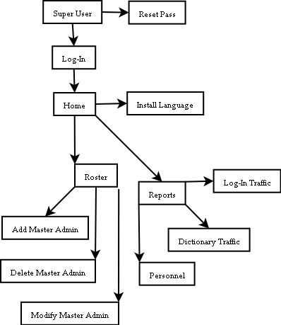
Figure WL-1

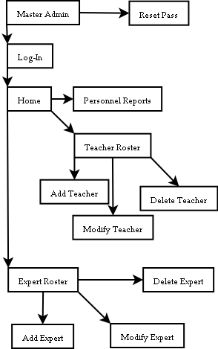
Figure WL-2
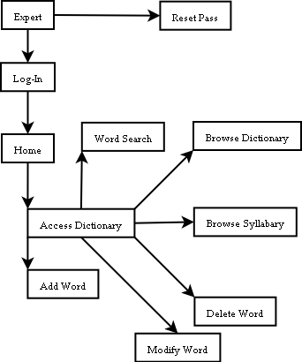
Figure WL-3

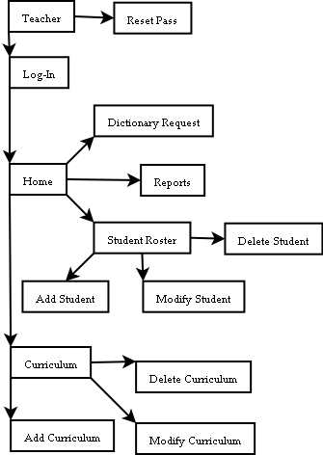
Figure WL-4

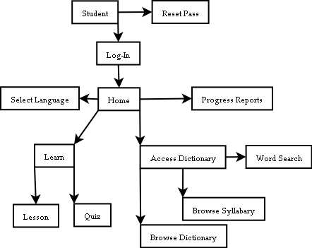
Figure WL-5

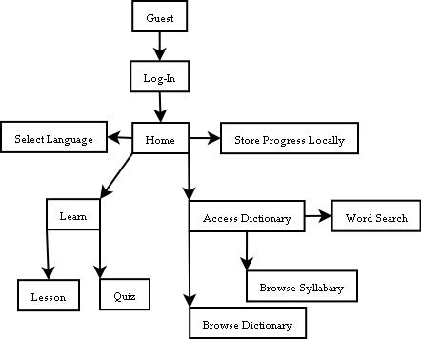
Figure WL-6

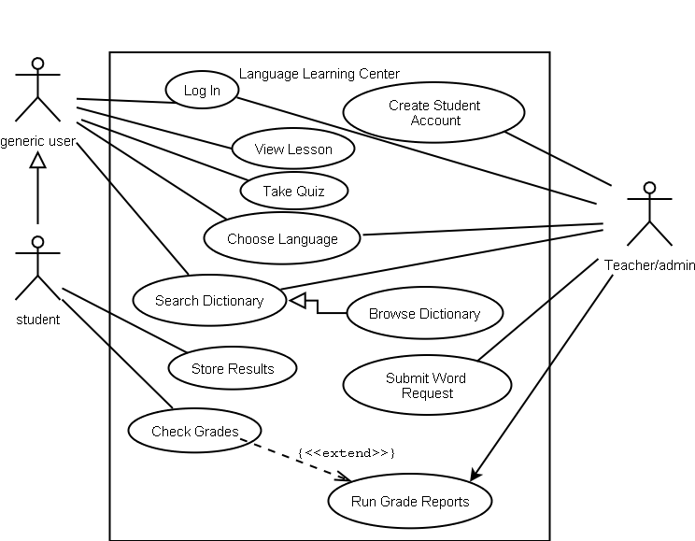
Figure UML-1

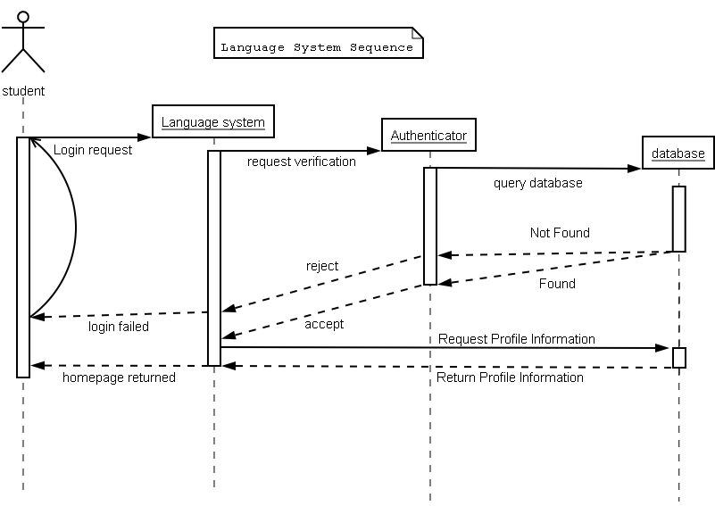

Figure UML-2

Project Analysis
Estimated Cumulative Budget (in hours): 2210
Actual Completed Budget (in hours): 169
Percent of Total Budget Completed: 7.7 %
Week | Description | Hours |  | Percent complete
Week | Description | Estimate | Actual | Percent complete
1 | Team familiarization with technologies to be implemented and deployed. | 200 | 40 | 20 %
2 | Design and implement Database Structure and HTML for Super Interface. | 200 | 49 | 24.5 %
3 | Propagate Database and design and implement HTML for Master Admin Interface. | 200 | 39 | 19.5 %
4 | Acceptance tests on Database Structure. Design and implement HTML for Expert Interface. | 200 | 41 | 20.5 %

Completion Analysis
The team is not meeting budget estimates. The variance in time, interest, and skill among the team members has yielded an approximate weekly completion of 21.125 percent, although, the overall project completion is at 7.7 percent. This suggests that more time is required for the front end of the project. The team would need 48 weeks at the current completion ratio to finish the project

Appendices

Team Assignments

Technology | Personnel | Estimated work
CGI | David Norris  Russell Pratt Jr. | 630 hours
HTML | Bryan Miller  Rahil Patel | 690 hours
ORACLE | Kyle Bohannan  David Norris | 890 hours
TOTAL ESTIMATED WORK: |  | 2210 hours

PSP Schedule

member | Date | % | Date | % | Date | % | Date | % | Total %
member | 4-1 | % | 4-2 | % | 4-3 | % | 4-4 | %
Kyle | Study PL/SQL | 6.2 | Study PL/SQL | 6.2 | Study PL/SQL | 6.2 | Study PL/SQL | 6.2 | 6.2
Bryan | Design Webpages | 100 | Design Webpages | 100 | Design Webpages | 100 | Design Webpages | 100 | 100
Dave | Study DDL | 25 | Study DDL | 25 | Study DDL | 25 | Study DDL | 25 | 25
Rahil | Study HTML | 75 | Study HTML | 75 | Study HTML | 75 | Study HTML | 75 | 75
Russell | Study CGI | 12 | Study CGI | 12 | Study CGI | 12 | Study CGI | 12 | 12

member | Date | % | Date | % | Date | % | Date | % | Total %
member | 4-7 | % | 4-8 | % | 4-9 | % | 4-10 | %
Kyle | Research passcheck | 2 | Design passcheck | 2 | Code passcheck | 2 | Research MA contact | 2 | 2
Bryan | Design Welcome | 100 | Design Super and Guest | 100 | Design MA and Expert | 100 | Design Teacher and Student | 100 | 100
Dave | Design authenticate, email | 5 | Code authenticate, email | 5 | Design address | 5 | Code address | 5 | 5
Rahil | Research Dreamweaver | 50 | Code Welcome, about, contact, login | 50 | Code Super | 50 | Code MA and Expert | 50 | 50
Russell | Research index | 10 | Design index | 10 | Code index | 10 | Research under construction | 10 | 10

member | Date | % | Date | % | Date | % | Date | % | Total %
member | 4-11 | % | 4-14 | % | 4-15 | % | 4-16 | %
Kyle | Design MA contact | 5 | Test passcheck | 5 | Code MA contact | 5 | Test MA contact | 5 | 5
Bryan | Deliver designs and co-ordinate with Rahil | 2.5 | Design Super sub-interfaces | 2.5 | Design MA sub-interfaces | 2.5 | Design Expert sub-interfaces | 2.5 | 2.5
Dave | Design and code MA | 30 | Propigate address, authenticate | 30 | Propigate email, MA | 30 | Design Expert | 30 | 30
Rahil | Code Teacher and Student | 50 | Code Guest | 50 | Code Super sub-interfaces | 50 | Code create MA and MA contact | 50 | 50
Russell | Design under construction | 10 | Code under construction | 10 | Research MA contact | 10 | Design MA contact | 10 | 10

member | Date | % | Date | % | Date | % | Date | % | Total %
member | 4-17 | % | 4-18 | % | 4-21 | % | 4-22 | %
Kyle | Research create MA | 5 | Design create MA | 5 | Research create Expert | 5 | Code create Expert | 5 | 5
Bryan | Design Teacher sub-interfaces | 10 | Design Student sub-interfaces | 10 | Design create Expert | 10 | Design Expert contact | 10 | 10
Dave | Code Expert | 30 | Propigate Expert | 30 | Code and propigate Expert, permissions, language | 30 | Code syllabary, dictionary, wiki | 30 | 30
Rahil | Code MA sub-interfaces | 50 | Code Expert sub-interfaces | 50 | Code Teacher sub-interfaces | 50 | Code Student sub-interfaces | 50 | 50
Russell | Code MA contact | 22 | Research create MA | 22 | Design create MA | 22 | Test index | 22 | 22

member | Date | % | Date | % | Date | % | Total %
member | 4-23 | % | 4-24 | % | 4-25 | %
Kyle | Test create Expert | 25 | Research Expert contact | 25 | Code Expert contact | 25 | 25
Bryan | Design Syllabary | 0 | Design Browse | 0 | Design search | 0 | 0
Dave | Propigate syllabary, dictionary, wiki | 55 | Code teacher, question, lesson, quiz, student, grades | 55 | Propigate teacher, question, quiz, lesson, student, grades | 55 | 55
Rahil | Code create Expert and Expert contact | 0 | Code syllabary | 0 | Code dictionary | 0 | 0
Russell | Test under construction | 13 | Research passcheck | 13 | Design passcheck | 13 | 13

Individual Appendices

Team Database: Kyle Bohannan
 | DATE | START |  | STOP | ACTIVITY |  |  | INTERRUPT |  | TOT_TIME
 | 03/22/08 | 6:15 |  | 6:35 | Design interface pages |  |  | Phone call |  | 0:20
 | 03/22/08 | 7:00 |  | 7:13 | Design interface pages |  |  | email |  | 0:13
 | 03/22/08 | 7:45 |  | 7:55 | Design interface pages |  |  | leaving work |  | 0:10
 | 03/24/08 | 7:00 |  | 7:10 | Design interface pages |  |  | Phone call |  | 0:10
 | 03/26/08 | 6:45 |  | 6:59 | Design interface pages |  |  | Phone call |  | 0:14
 | 03/26/08 | 7:15 |  | 7:45 | UML doc |  |  | Bio |  | 0:30
 | 03/26/08 | 8:45 |  | 9:33 | UML doc |  |  | break |  | 0:48
 | 03/27/08 | 6:45 |  | 6:56 | UML doc |  |  | parent |  | 0:11
 | 03/27/08 | 7:33 |  | 7:58 | UML doc |  |  | movie |  | 0:25
 | 03/29/08 | 7:28 |  | 7:45 | UML doc |  |  | Phone call |  | 0:17
 | 04/03/08 | 7:00 |  | 7:10 | learning sql |  |  | conversation |  | 0:10
 | 04/07/08 | 8:45 |  | 9:10 | learning sql |  |  | break |  | 0:25
 | 04/07/08 | 10:00 |  | 10:22 | learning sql |  |  | sleep |  | 0:22
 | 04/09/08 | 6:45 |  | 7:00 | Design interface pages |  |  | work |  | 0:15
 | 04/15/08 | 6:00 |  | 7:00 | Pl/sql |  |  | work |  | 1:00
 | 04/15/08 | 7:22 |  | 7:55 | Pl/sql |  |  | leaving work |  | 0:33
 | 04/16/08 | 6:55 |  | 7:33 | unix |  |  | work |  | 0:38
 | 04/17/08 | 7:33 |  | 7:55 | unix |  |  | leaving work |  | 0:22
 | 04/18/08 | 9:30 |  | 10:30 | unix/sql |  |  | sleep |  | 1:00
 | 04/23/08 | 6:39 |  | 7:10 | pl/sql functions |  |  | work |  | 0:31
 | 04/24/08 | 6:00 |  | 7:55 | pl/sql functions |  |  | leaving work |  | 1:55
 | 04/25/08 | 6:00 |  | 6:45 | pl/sql stored procedures |  |  | Phone call |  | 0:45
 | 04/25/08 | 7:11 |  | 7:55 | pl/sql stored procedures |  |  | leaving work |  | 0:44
 | 04/26/08 | 11:30 |  | 13:20 | pl/sql stored procedures |  |  | pizza |  | 1:50
 | 04/26/08 | 13:20 |  | 15:20 | pl/sql stored procedures |  |  | movie |  | 2:00
 | 04/26/08 | 9:00 |  | 9:20 | finishing touches |  |  | killed over dead |  | 0:20
 |  |  |  |  |  |  |  |  |  | 16:08
 |  |  | Week 1 |  |  | Week 2 | Week 3 |  | Week 4 |  | Week 5
Estimated time |  |  | 40hrs |  |  | 40hrs | 35hrs |  | 40hrs |  | 40 hrs
Actual time |  |  | 2:25 hrs |  |  | 1:03 hrs | 1:02 hrs |  | 3:33 hrs |  | 8:05 hrs
% estimated complete |  |  | 6% |  |  | 2% | 3% |  | 8% |  | 20%
Approximate Actual % complete |  |  | 35% |  |  | 10% | 10% |  | 25% |  | 45%

Estimated procedures to be written: 12
Actual procedures written: 3
Completion: 25%

PL/SQL Code

CREATE OR REPLACE procedure passcheck (
mylogin IN VARCHAR2,
mypass IN VARCHAR2,
myusertype OUT VARCHAR2 )
IS
BEGIN
declare
CURSOR checkit IS
SELECT login, pass, usertype
FROM authenticate a
WHERE mylogin = a.login AND mypass = a.pass;
checkitRow checkit%ROWTYPE;
BEGIN
myusertype := 'none';
OPEN checkit;
FETCH checkit INTO checkitRow;
IF checkit%FOUND THEN
myusertype := '%' || checkitRow.usertype || '%';
End IF;
CLOSE checkit;
dbms_output.put_line(myusertype);
end;
END;
/

CREATE OR REPLACE procedure ma_contact_list
IS
BEGIN
declare
v_lname varchar2(21);
v_fname varchar2(16);
v_street varchar2(31);
v_city varchar2(31);
v_state varchar2(3);
v_zip varchar2(6);
CURSOR contact IS
SELECT lname, fname, street, city, state, zip
FROM masteradmin m, address a
WHERE m.login = a.login;
contactRow contact%ROWTYPE;
begin
OPEN contact;
FETCH contact INTO contactRow;
WHILE contact%FOUND
LOOP
v_lname := contactRow.lname;
v_fname := contactRow.fname;
v_street := contactRow.street;
v_city := contactRow.city;
v_state := contactRow.state;
v_zip := contactRow.zip;

dbms_output.put_line(v_lname || ', ' || v_fname || ' ' || v_street
|| ' ' || v_city || ' ' || v_state || ' ' || v_zip);
FETCH contact INTO contactRow;
END LOOP;
CLOSE contact;
end;
END;
/

Team HTML: Bryan Miller

DATE | DAY | START | STOP | ACTIVITY | INTERRUPT | TOT_TIME
04/14/08 | Mon | 17:15 | 18:00 | welcome slide | n/a | 0:45
04/16/08 | Wed | 20:00 | 20:30 | Quiz slide 1 | telephone | 0:30
 |  | 21:00 | 21:30 | Quiz slide 1 |  | 0:30
04/17/08 | Thu | 13:00 | 13:30 | Quiz Slide 2 | class | 0:30
 |  | 16:00 | 16:20 | Quiz Slide 2 |  | 0:20
04/19/08 | Sat | 8:00 | 8:30 | Quiz Slide 3 | work | 0:30
 |  | 19:00 | 19:57 | Quiz Slide 3 |  | 0:57
04/22/08 | Tue | 9:00 | 9:43 | Quiz Slide 4 | n/a | 0:43

The designs for the HTML were produced in MS Powerpoint. The slides are included in the electronic submission only because they do not translate to print well.

Team Database: David Norris

DATE | START | STOP | ACTIVITY | INTERRUPT | TOT_TIME
04/01/08 | 11:00 | 13:00 | DB Design | home | 2:00
04/02/08 | 12:00 | 14:00 | Research DB | phone | 2:00
04/03/08 | 11:00 | 13:00 | DB Design | home | 2:00
04/04/08 | 12:00 | 14:00 | Research DB | appt | 2:00
 |  |  |  | SUB TOTAL | 8 hours
04/07/08 | 12:00 | 14:00 | Research DB | phone | 2:00
04/08/08 | 11:00 | 13:00 | DB Design | home | 2:00
04/09/08 | 12:00 | 14:00 | Research DB | appt | 2:00
04/10/08 | 11:00 | 14:00 | DB Design | home | 3:00
04/11/08 | 10:00 | 14:00 | DB Design | appt | 4:00
 |  |  |  | SUB TOTAL | 13 hours
04/14/08 | 12:00 | 14:00 | DB Design | appt | 2:00
04/15/08 | 11:00 | 14:00 | SQL research | home | 3:00
04/16/08 | 12:00 | 14:00 | SQL research | phone | 2:00
04/17/08 | 11:00 | 14:00 | PL/SQL design | home | 3:00
04/18/08 | 10:00 | 12:00 | Propigate DB | phone | 2:00
04/18/08 | 14:00 | 16:00 | SQL code | appt | 2:00
 |  |  |  | SUB TOTAL | 14 hours
04/21/08 | 12:00 | 14:00 | PL/SQL design | appt | 2:00
04/22/08 | 11:00 | 13:00 | CGI research | home | 2:00
04/23/08 | 12:00 | 14:00 | CGI research | phone | 2:00
04/24/08 | 11:00 | 13:00 | Group co-ordination | home | 2:00
04/25/08 | 10:00 | 12:00 | Load HTML | phone | 2:00
04/25/08 | 13:00 | 15:00 | Code CGI | phone | 2:00
04/25/08 | 18:00 | 22:00 | Test CGI | bed | 4:00
04/26/08 | 10:00 | 12:00 | Test CGI | PL/SQL | 2:00
04/26/08 | 12:00 | 16:00 | Test PL/SQL | dinner | 4:00
 |  |  |  | SUB TOTAL | 22 hours
 |  |  |  | TOTAL | 57 hours
Oracle Data Definition Language Code

CREATE TABLE authenticate (
login varchar2(15) NOT NULL,
pass varchar2(15) NOT NULL,
usertype varchar2(20) NOT NULL,
PRIMARY KEY(login) );
INSERT INTO authenticate(login, pass, usertype)
VALUES('rwpj', 'password', 'super');
INSERT INTO authenticate(login, pass, usertype)
VALUES('jdm', 'cs350', 'super');
INSERT INTO authenticate(login, pass, usertype)
VALUES('bpm', 'asdf', 'super');
INSERT INTO authenticate(login, pass, usertype)
VALUES('wkb', 'chronos', 'super');
INSERT INTO authenticate(login, pass, usertype)
VALUES('sittingbull', 'password', 'masteradmin');
INSERT INTO authenticate(login, pass, usertype)
VALUES('geronimo', 'password', 'masteradmin');
INSERT INTO authenticate(login, pass, usertype)
VALUES('guest', 'guest', 'guest');

CREATE TABLE email (
login varchar2(15) NOT NULL,
email varchar2(30) NOT NULL,
PRIMARY KEY(login) );
INSERT INTO email(login, email)
VALUES('jdm', 'jdm@cs.odu.edu');
INSERT INTO email(login, email)
VALUES('wkb', 'wboha001@odu.edu');
INSERT INTO email(login, email)
VALUES('bpm', 'bmiller003@odu.edu');
INSERT INTO email(login, email)
VALUES('rwpj', 'solargsx@gmail.com');
INSERT INTO email(login, email)
VALUES('sittingbull', 'sitbul@gmail.com');
INSERT INTO email(login, email)
VALUES('geronimo', 'ger@gmail.com');

CREATE TABLE address (
login varchar2(15) NOT NULL,
street varchar2(30) NOT NULL,
city varchar2(30) NOT NULL,
state varchar2(2) NOT NULL,
zip varchar2(5) NOT NULL,
PRIMARY KEY(login) );
INSERT INTO address(login, street, city, state, zip)
VALUES('geronimo', '229 warpath rd', 'virginia beach', 'va', '23455');
INSERT INTO address(login, street, city, state, zip)
VALUES('sittingbull', '101 wampum st', 'chesapeake', 'va', '23457');

CREATE TABLE masteradmin (
login varchar2(15) NOT NULL,
fname varchar2(15) NOT NULL,
mname varchar2(15) ,
lname varchar2(20) NOT NULL,
PRIMARY KEY(login) );
INSERT INTO masteradmin(login, fname, mname, lname)
VALUES('geronimo', 'jer', 'oni', 'mo');
INSERT INTO masteradmin(login, fname, lname)
VALUES('sittingbull', 'sitting', 'bull');

Team HTML: Rahil Patel

Budgetary Analysis Redux
Budget Schedule:
Week  Real | Description | Estimate  hours | Real  hours | Percent  Complete
1 | Learn HTML, XHTML and CSS.  Starting from the basics and learning along the way. | 90 | 20 | ~85%
1 | Welcome screen which includes login, sign up and misc. details. | 20 | 4 | 100%
2-3 | User pages. This is the bulk of the web site, which includes the dictionary, the roster, training, etc. | 150 | 40 | ~75%
1-3 | Team meetings (class/extra) & communicating with my partner. | 30 | 10 | ~40%
- | Make changes according to the team. | 40 | 0 | 0%
- | Add to ODU server & test it.  Test browser compatibility | 15 | 0 | 0%
T | Total | 345 | 74 | ~70%

A lot of overestimation has occurred here. HTML proved to be simpler than I thought, so learning was breeze. Creating the pages was barely tedious; as a lot of the user pages were similar. Also, when we created the budgetary analysis, the hours column was seen as the “maximum amount”, just so we did not underestimate. Although the HTML can be done in about 5 weeks, I would still have to wait for CGI to finish so I can make changes according to them. This could drag the job to the projected 9 or more weeks, so I cannot say I am about done yet.

The HTML code is only included in the electronic submission because DreamWeaver HTML code does not translate into MS Word documents well. A rough prototype can be seen at http://www.cs.odu.edu/~dnorris.

Team CGI: Russell Pratt Jr.

Date: | Start: | Working On: | Stop: | Reason:
25-Mar | 11:00 AM | Work on Proposal. | 12:15 PM | Class over.
1-Apr | 11:00 AM | Study CGI. | 12:15 PM | Class over.
3-Apr | 11:00 AM | Study CGI. | 12:15 PM | Class over.
4-Apr | 6:00 PM | Study CGI. | 6:40 PM | Restroom
 | 7:00 PM | Study CGI. | 8:15 AM | Watch a movie.
8-Apr | 11:00 AM | Study CGI. | 12:15 PM | Class over.
10-Apr | 11:00 AM | Study CGI. | 12:15 PM | Class over.
11-Apr | 1:00 PM | Study CGI. | 2:15 PM | Hang out with friends.
15-Apr | 11:00 AM | Study CGI. | 12:15 PM | Class over.
17-Apr | 11:00 AM | Study CGI. | 12:15 PM | Class over.
18-Apr | 12:15 PM | Study CGI. | 1:30 PM | Unload groceries.
 | 1:45 PM | Study CGI. | 2:20 PM | Video games.
 | 5:30 PM | Study CGI. | 7:00 PM | Watch a movie.
22-Apr | 11:00 AM | CGI program | 12:15 PM | Class over.
 | 2:30 AM | CGI program | 3:45 AM | Got to another class
24-Apr | 11:00 AM | CGI program | 12:15 PM | Class over.
 | 12:20 PM | CGI program | 1:30 PM | Lunch
 | 2:30 PM | CGI program | 4:00 PM | Work
25-Apr | 11:00 AM | CGI program | 11:45 PM | Lunch
 | 1:30 PM | CGI program | 2:15 PM | Work.

Common Gateway Interface Code
/* env.cgi.c */
#include <stdio.h>
extern char **environ;
int main()
{
char **p = environ;
printf("Content-Type: text/html\r\n\r\n");
printf("<html> <head>\n");
printf("<title>CGI Environment</title>\n");
printf("</head>\n");
printf("<body>\n");
printf("<h1>CGI Environment</h1>\n");
while(*p != NULL)
printf("%s<br>\n",*p++);
printf("</body> </html>\n");
}

/*index.cgi.c*/
#include <stdio.h>
int main()
{
printf("Location: /index.html\r\n\r\n");
}

/* construction.cgi.c */
#include <stdio.h>
int main() {
printf("Content-Type: text/html\r\n\r\n");
printf("<html> <head>\n");
printf("<title>Sorry! This page is under construction</title>\n");
printf("</head>\n");
printf("<body>\n");
printf("<h1>Sorry!<br> This page is under construction.</h1>\n");
printf("</body> </html>\n");
}

