CS 350
Fall 2005
Exam 1, In Class Part

Name _________________________

Note: To receive full credit on questions, you must base your answers on class discussion and textbook content.

This exam is open book, open notes, but all answers must be your own work.

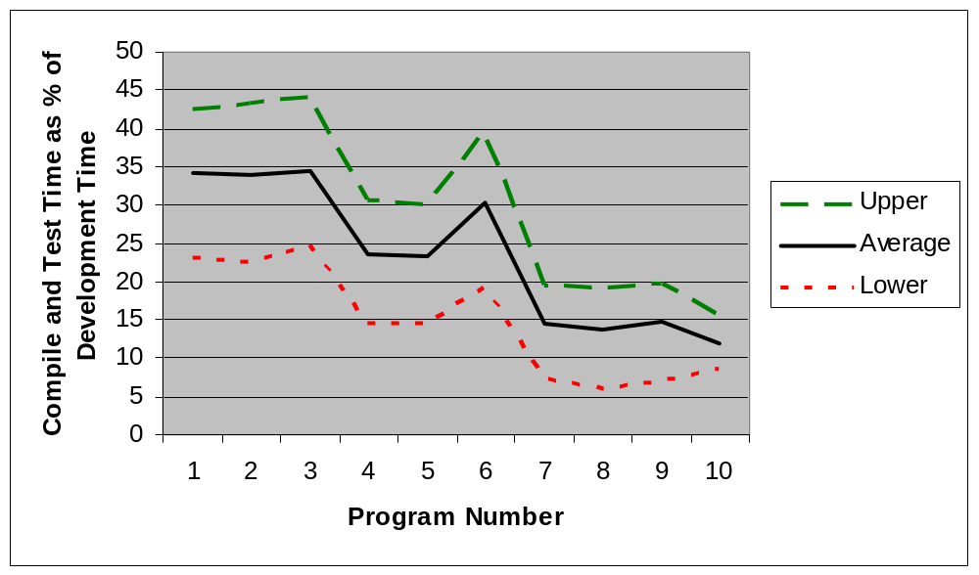
Figure 1

- (6 pts) Figure 1 shows compile and test time as a percentage of development time from students who have taken PSP at CMU. In light of typical industry data for integration and systems testing, why is this graph so significant?

- (10 pts) PSP emphasizes estimating LOC as part of project planning, but in fact planning is primarily about time and budgets, not LOC. Why does PSP still emphasize LOC estimation?

- (5 pts) Why might function points be better for planning than LOC?

- (6 pts) In software development, testing typically occupies 50% of total project time. How can PSP ignore this fact and base total project time estimates on only estimates of Modified and New LOC?

- (6 pts) If your historical data indicates that your actual times are typically 50% larger that you estimated times, roughly what value would you expect for β₁ in your regression computation?

- (6 pts) Precise and accurate estimates are the most desirable, but why are imprecise and accurate estimates preferred to precise and inaccurate estimates?

- (5 pts) Why is ‘grep “;” *.h” *.cpp | wc –s’ used to count LOC in CS 350?

- (5 pts) PSP requires estimates for base, deleted, modified, added, reused, and new reusable LOC, but does not use base, deleted, reused for time estimates. Why not?

- (5 pts) In project planning, name a likely event that would cause Planned Value for a task to change.

- (6 pts) Why does PSP include estimates for UPI and LPI for time planning?

- (6 pts) Consider the figure (based on Brooks The Mythical Man-Month):
time
Completed LOC
a) Explain why the top line rises and falls.

b) What does the straight diagonal line (from lower left to top right) represent? How is it determined?

c) Explain why the slope of the wavy line from lower left to top right often changes slope towards the end of projects.

- (6 pts) If we are in a testing phase of a software development project and the software has successfully passed 60% of the test cases, are we 60% done with testing? Explain.

- (6 pts) If employees A and B both estimate a new project to require 1200 LOC, but A’s estimates have been very accurate on previous projects while B’s have not, how will their individual UPI and LPI values compare?

- (6 pts) Why does PSP require you to estimate new reusable LOC?

- (6 pts) If you developed a new testing technique, how, within the PSP framework, would you determine if it is better that the current approach?

Pledged: I neither gave nor received help on this exam.

________________________________________________________
Signature

