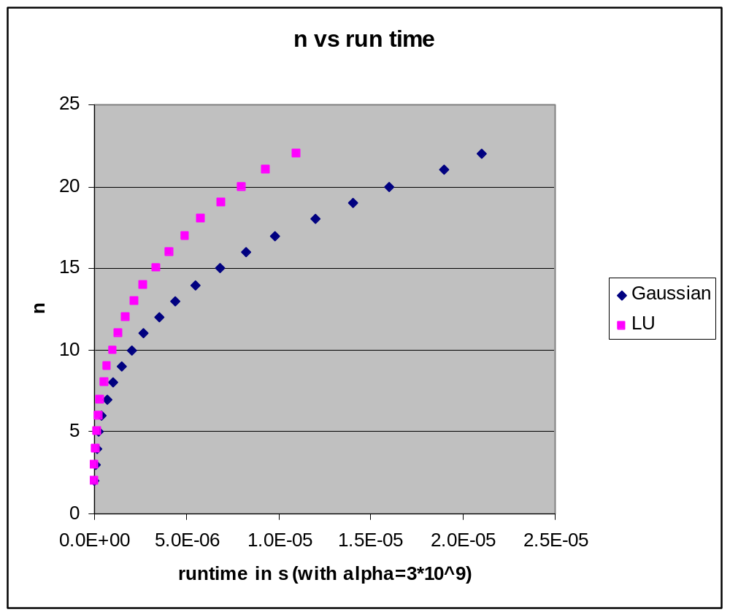

Observation: Gaussian is faster when n is larger than 6

