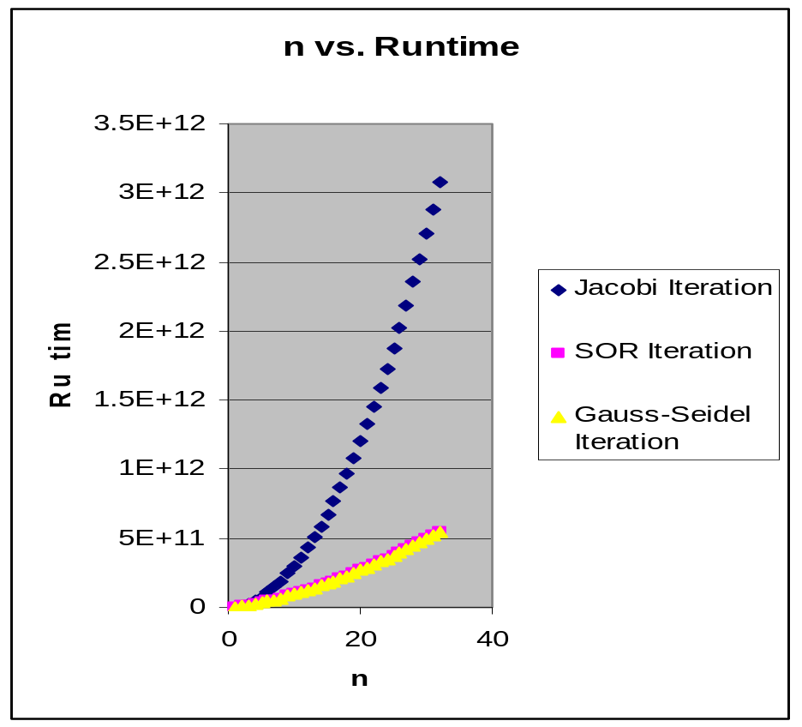

n=0-5 -> all 3 are similar
n>5 -> SOR and gauss-seidel are linear and perform almost identically, Whereas Jacobi’s runtime is exponential.

