CS 417
Last Assignment

1. You are to solve the Laplace equation on the domain illustrated below using Jacobi iteration. This domain is to be discretized on a 30x30 grid using 3point-centered difference approximations for the derivatives. Make note of the number of iterations required to converge to a error two-norm < 10^-6

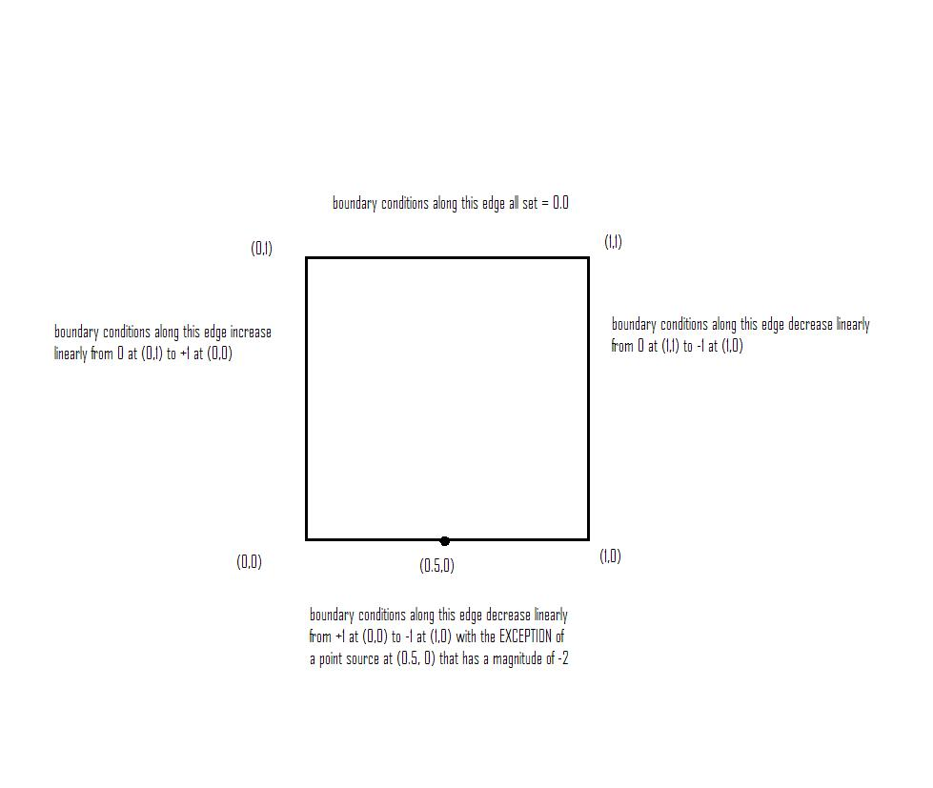

2. Divide the domain in problem 1 into 3 parallel strips, each one 10 grid points high and 30 wide. Set all internal boundary conditions = 0.0.
a. Solve each of the three problems separately using LU decomposition. Use the actual external boundary conditions and your constructed internal ones.
b. Compare the solutions you find with the known solutions from question 1 above. What is the 2-norm for the error vector for each of the subdomains?

3. Use your LU solutions as “first guess” values for your Jacobi solver, how many
iterations did it take this time?

4. Go back to your Jacobi solver. Run the solver for exactly half the number of iterations you needed for convergence in problem number 1. Now redo question 2 above EXCEPT instead of using internal boundary conditions of 0.0 use the values you just generated. Get your solutions and use them as input for the Jacobi solver again. How many additional iterations were required?

5. Look at the performance of each of these solver frameworks. Was there any difference? If not, why not, if so which performed best? Which performed the worst?

