Nicole Jackson
May 5, 2008
CS417-MW 5:45-7

CS 417 Final-Spring 2008
You have until NOON, Monday May 5th to submit your completed solutions. If you scan your documents please make sure that it is a legible .pdf file.

Answer each question as completely as possible. Be clear and succinct. Quality of response is more important than quantity. Take time to "THINK", they may not be as hard as they originally appear. It is open book and open notes; the only restriction is that you are not allowed to talk to any other person about this exam. You may use the library or any computer lab as well. Any violation of this rule is a violation of the Old Dominion University Honor Code.

- Is an alternating infinite series such as
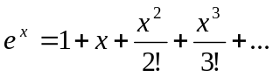
for x<0, difficult to evaluate in floating point arithmetic? Why or why not?

Yes, because as (n)! grows in the denominator, the increasing change gets smaller and smaller and therefore starts to effect only a small portion of the problem. The problem will eventually converge to a certain number or will produce an inaccurate result due to rounding errors.

- Given an upwardly dense matrix of the form below, suggest two different methods to get reasonable first guesses to use in a Jacobi solver? Can you predict what LU might look like (why or why not?)
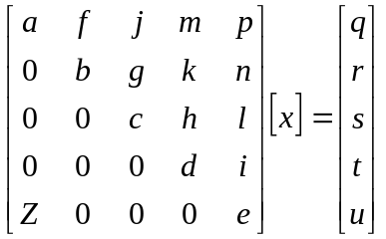

In terms of which two different direct methods I would use as an initial guess to the Jacobi Solver, it would be Gaussian Elimination and LU Decomposition. In terms of two methods in general to use as an initial guess, I would use Gaussian Elimination or just an arbitrary initial guess. I would think that I could sort of predict what the LU would look like, because the last row would go into the upper row. So that the last row would include all zeros until it gets to the last column.

- 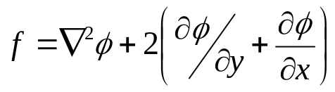Generate the matrix equation, Ax=b, that represents the following differential equation on a Unit Square. The grid is regular in each direction and has 10 nodes along the x-axis, 3 along the y-axis. The boundary conditions are dirchlet and have a value of –4. Just write out enough of the matrix to illustrate any pattern that exists.

- 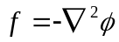Given the Laplace equation in 3-Dimensions on a unit CUBE, how would you handle the situation where the step size starts at 0, 0 = .5 in x, y, and z directions but it then halved with each additional step? How would it change the stencil? How would it change the matrix? The right hand side?

- Use Newton’s method to find an approximate zero for the following function on the interval [1, 2.2]. Make a plot showing the change in functional evaluation until the change in your zero is less than 10⁻³.

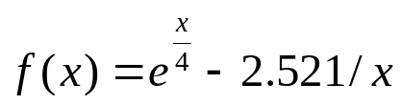

F(x)=e^(x/4)-(2.521/x)

X₁=x_{n}-f(x_{n})/f’(x_{n})=2.2-( (e^(2.2/4)-(2.521/2.2))/ ¼ e^(2.2/4)-2.521(2.2)^-2)
2.2-0.5873/.9541=1.584

X₂=x_{n}-f(x_{n})/f’(x_{n})=1.584-( (e^(1.584/4)-(2.521/1.584))/ ¼ e^(1.584/4)-2.521(1.584)^-2)
1.584-0.5873/.9541=1.661

X₃=x_{n}-f(x_{n})/f’(x_{n})=1.661-( (e^(1.661/4)-(2.521/1.661))/ ¼ e^(1.661/4)-2.521(1.661)^-2)
1.661-0.5873/.9541=1.6633

X₄=x_{n}-f(x_{n})/f’(x_{n})=1.6633-( (e^(1.6633/4)-(2.521/1.6633))/ ¼ e^(1.6633/4)-2.521(1.6633)^-2)
1.6633-0.5873/.9541=1.6633

- When an explosion occurs there is a major potential source at the center of the detonation but eventually measurable effects dissipate at some range R from the explosion. How would you initialize the boundary conditions and how would you handle the potential source being in the center of the domain?

I would initialize the boundary conditions from 0 to R, considering that R is the max length of the explosion affect. 0 is the source of the explosion. Therefore the change in x, y, and z would be R. By the explosion being in the center of the domain, it would have a full range of R, so destruction would be easily measured and easier to predict what would happen, instead of if there was a wall beside the explosion. The debris would reflect off the wall.

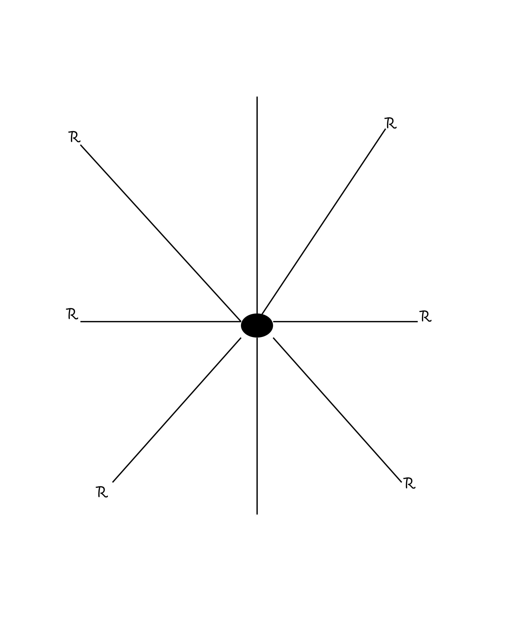
6a. (graduate students only) Given Problem 6 above, how would the problem change if the explosion takes place 100 meters (at the nearest point) from an indestructible, straight wall that extends infinitely (or nearly so) in both directions away from the detonation point. Be explicit with regards to suggested boundary conditions along the wall. (OMIT)

- Considering number 6 above, if we desire to solve the Laplace problem what would the stencil look like if we switched from a rectangular grid to circular coordinates? (e.g. not a rectangular grid but concentric circles at uniform radii from the center)

- A large cubic domain exists with 1000 nodes in x, y, and z directions. Estimate how long would it take to solve the matrix based on this domain on a single 4 Ghz computer using Gaussian elimination? How much ram would be necessary (for this application alone you may omit windows, winamp, napster etc). Justify your answer.

The Gaussian Elimination has a complexity of O(n^3), therefore I believe that it would take about 1 to 2 minutes to complete on a 4Ghz machine. The amount of RAM that would be necessary for this operation is about 2GB of RAM, since the matrix is being zeroed out n number of operations to zero out one column, and it takes another n-1 time to find new entries for 1000 nodes. As the problem goes on, it goes to (n-1) times to zero out the next column and (n-2) times to find the new entries. It continues to do this until the whole matrix is done.

- Solve the following two-point boundary value problem using finite differences.

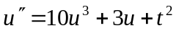, where 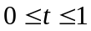

with u(0)=0 and u(1) = 1

directions: Divide the given interval for t into n+1 subintervals t_{i} (each with length h), Let y_{i} represent the approximate solution at the n interior points. Generate the system of n algebraic equations for those y equations by replacing the second derivative by the 1-d central difference approximation. Use initial guess equal to a linear interpolation of the values between the boundary conditions. Solve the problem for n = 1, 3, 7, and 15. Plot the series of solutions you get from each of these.

- (GRADUATE STUDENTS: REQUIRED) 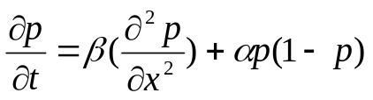The spread of genes in a population where p denotes the probability of occurrence of a specific allele is defined as

Please note that α and β are positive constants. Develop an explicit finite difference equation for this nonlinear partial differential equation using a forward difference in time and a central difference in space.

