CS 417
You have 1 week to complete this exam.Use the online Submit for your completed solutions. If you scan your documents please make sure that it is a legible .pdf file.

Answer each question as completely as possible. Be clear and succinct. Quality of response is more important than quantity. Take time to "THINK", they may not be as hard as they originally appear. It is open book and open notes; the only restriction is that you are not allowed to talk to any other person about this exam. You may use the library or any computer lab as well. Any violation of this rule is a violation of the Old Dominion University Honor Code.

- Is an alternating infinite series such as
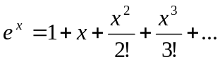

for x<0, difficult to evaluate in floating point arithmetic? Why or why not? Give an example that supports your position.

- Given an upwardly dense matrix of the form below, suggest two different methods to get reasonable first guesses to use in a Jacobi solver? Can you predict what LU might look like (why or why not?)
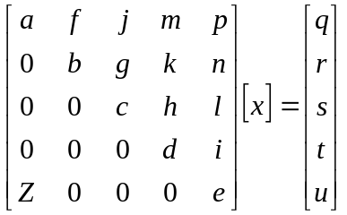

3) Write out the stencil for the following equation, use forward approximations for the first derivitives.

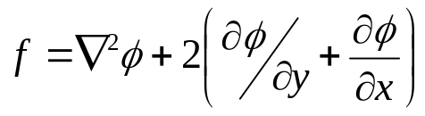

- Generate the matrix equation, Ax=b, that represents the following differential equation on a Unit Square. The grid is regular in each direction and has 10 nodes along the x-axis, 3 along the y-axis. The boundary conditions are dirchlet and have a value of –4. Just write out enough of the matrix to illustrate any pattern that exists.(n.b. nx does not equal ny)

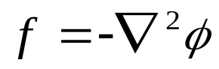

- Given the Laplace equation in 2-Dimensions on a unit square, how would you handle the situation where the step size starts at 0, 0 = .5 in both x and y directions but it then halved with each additional step? How would it change the stencil? How would it change the matrix? The right hand side?

- Use Newton’s method to find an approximate zero for the following function on the interval [1, 2.2]. Make a plot showing the change in functional evaluation until the change in your zero is less than 10⁻³.

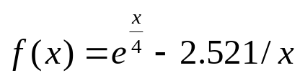

- When an explosion occurs there is a major potential source at the center of the detonation but eventually measurable effects dissipate at some range R from the explosion. How would you initialize the boundary conditions and how would you handle the potential source being in the center of the domain?

- Considering number 6 above, if we desire to solve the Laplace problem what would the stencil look like if we switched from a rectangular grid to circular coordinates? (e.g. not a rectangular grid but concentric circles at uniform radii from the center)

- A large cubic domain exists with 1000 nodes in x, y, and z directions. Estimate how long would it take to solve the matrix based on this domain on a single 4 Ghz computer using Gaussian elimination? How much ram would be necessary (for this application alone you may omit windows, winamp, napster etc). Justify your answer.

(GRADUATE STUDENTS: REQUIRED--Extra credit opportunity for UGRADS)

- Solve the following two-point boundary value problem using finite differences.

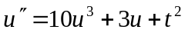, where 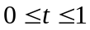

with u(0)=0 and u(1) = 1

Divide the given interval for t into n+1 subintervals t_{i} (each with length h), Let y_{i} represent the approximate solution at the n interior points. Generate the system of n algebraic equations for those y equations by replacing the second derivative by the 1-d central difference approximation. Use initial guess equal to a linear interpolation of the values between the boundary conditions. Solve the problem for n = 1, 3, 7, and 15. Plot the series of solutions you get from each of these.

10.The spread of genes in a population where p denotes the probability of occurrence of a specific allele is defined as

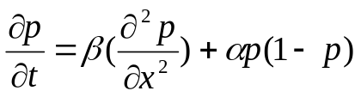

Please note that α and β are positive constants. Develop an explicit finite difference equation for this nonlinear partial differential equation using a forward difference in time and a central difference in space.

