CS 417: Introduction to Numerical Methods
Midterm Exam
Your solution to this exam should be submitted using the submit utility page (please zip all files, scans etc into one file)
Before midnight on Sunday, the 26th of October 2008.
The exam is open book etc, but the honor code is in effect and you must not seek assistance from any person (living or dead)

- Solve the following using L-U factorization. What is Q? (6pts)

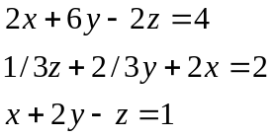
- Consider the following system of equations: (4pts each)
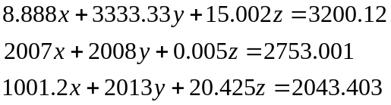
- Will this system converge using Jacobi iteration? Why or why not?
- What is the two-norm of the error vector after 4 iterations?

- Consider the following linear algebraic system where epsilon is a very small number. (3pts each)

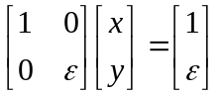

- Calculate the solution using Gaussian-elimination.
- Re-calculate the solution after perturbing the right hand side by the addition (e.g. add to b) of:
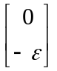

- Comment on the variation in the solution by such a small perturbation.

- Calculate the rotation matrix, G, (I call a Givens Rotation matrix) for the following vector, then calculate Gv. (6pts)
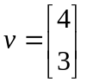

- Calculate the real eigenvalues and the corresponding eigenvectors for the following matrix. (6pts)

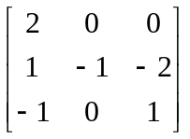

- Use the Power Method to estimate the maximum eigenvalue and the corresponding eigenvector for the following matrix (given the first estimate 'w1' provided.) Compute w2, w3, and w4 and the first three Rayleigh quotients. (1pt each)
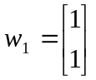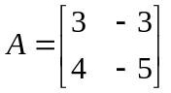

- Suppose that you are computing the solution to this overdetermined linear system.
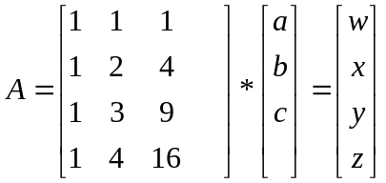

- How many Givens rotations would be required to reduce this to U form? (1pt)
- What is the value of the first Given’s rotation angle? (1pt)
- What does the right hand side vector look like after applying the first Givens rotation? (3pts)
- Will the value ‘z’ show up in the final solution in any way? Why or why not.(3pts)

- Consider the two infinite series below. On the machine of your choice estimate the maximum size of 'n' that your machine can utilize that will not result in a value of zero. Calculate the sum of the series using your machine. Is there any discrepancy with the closed form solution to these summations? If so, why is there? (you may code in any language you choose but C++ is preferred.) (4pts each)

a) b)
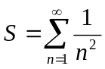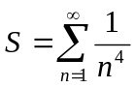

The following question is for 517 students only but 417 students may attempt them for extra credit if they so desire.
-------------------------------------------------------------------------------------------------------------------

- Given the following matrix:

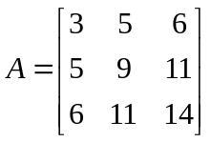

- Express A as a LU product where all the diagonals of L are 1’s (1pt)
- Find the Determinant of A (1pt)
- Find the inverse of A (1 pt)
- Find the SQUARE ROOT of A (5pts)

10. Generate a series of random diagonally dominant matrices A (2x2, 4x4, 8x8, 16x16, 32x32, and 64x64). Solve each twice using your Jacobi solver. The first time use the zero vector as the initial values of x, the second time use the inverse of DIAG(A) for the initial x. Compute the run time for each then plot the results. What do the curves illustrate if anything?

