Fundamentals of Computer Engineering Laboratory
ECE241

Flip-Flop circuit design
Lab Report 4

By: Spencer Garland

Instructor's Name:

Section: Friday 9 am to 11:50 am
Date: 09/17/08

Honor Pledge:

"I pledge to support the Honor System of Old Dominion
University. I will refrain from any form of academic dishonesty or
deception, such as cheating or plagiarism. I am aware that as a
member of the academic community, it is my responsibility to
turn in all suspected violators of the Honor System. I will report
to an Honor Council hearing if summoned."
Signature: ____________________
Introduction:
In this lab, we created a flip-flop circuit diagram, wire list, and implemented it onto a circuit board. Flip – Flop = set of gates that can retain or change input values (also feed back output for input).
Preliminary Work:
Given a specific circuit diagram, we were required to use the chips SN74LS08, SN74LS02, SN74LS74 and SN74LS04 to create a circuit layout matching the appropriate truth table and wire list.

Here is the truth table based on the Sample Circuit:
X | Q | Q’ | D
0 | 0 | 1 | 0
0 | 1 | 0 | 1
1 | 0 | 1 | 1
1 | 1 | 0 | 0
D = X’Q + XQ’

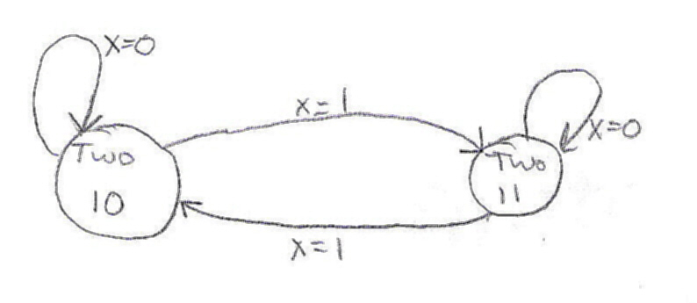

Circuit Diagram:

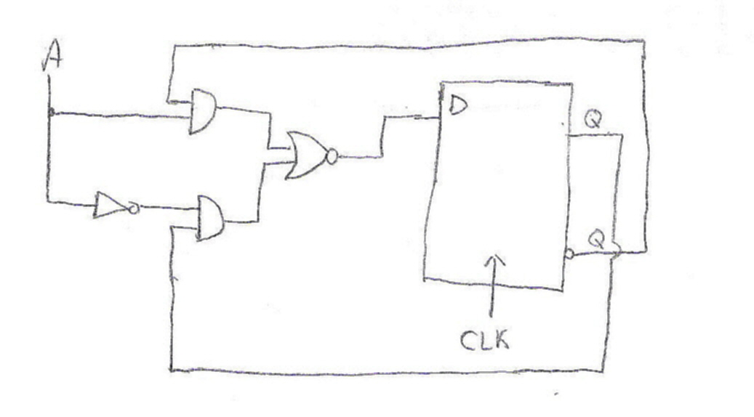

Chip Diagram:
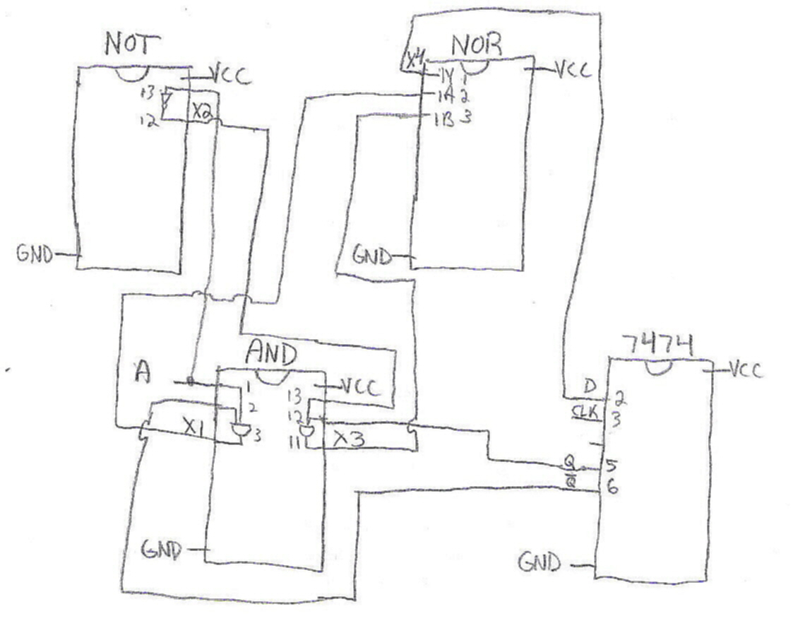

Wire List:
With Hazard:
U1 = NOT Chip, U2 = NOR Chip, U3 = AND Chip, U4 = 7474 Chip
VCC = Voltage
GND = Ground

VCC -> U1-14, U2-14, U3-14, U4-14 U3-11(X3) -> U2-3
GND -> U1-7, U2-7, U3-7, U4-7 U2-1(X4) -> U4-2(D)
A -> S1 -> U3-1, U2-13 U4-2(D) -> LED
U4-6 -> U3-2 U4-3(CLK) -> LED
U3-3 (X1) -> U2-2
U1-12 (X2) -> U3-13
U4-5 -> U3-12

Lab Results:
The results is all the information the Chip Diagram, Circuit Diagram, and Truth Table represent.

Observations and Conclusions:
A conclusion is that when A is 0, D changes back and forth, and as A is 1, D stays the same. An example of a modern day use for this is flashing stop lights or anything flashing. Since a NOR gate was used, the D is complemented.

