Fundamentals of Computer Engineering Laboratory
ECE241

2-Bit Counter circuit design
Lab Report 6

By: Spencer Garland

Instructor's Name:

Section: Friday 9 am to 11:50 am
Date: 09/17/08

Honor Pledge:

"I pledge to support the Honor System of Old Dominion
University. I will refrain from any form of academic dishonesty or
deception, such as cheating or plagiarism. I am aware that as a
member of the academic community, it is my responsibility to
turn in all suspected violators of the Honor System. I will report
to an Honor Council hearing if summoned."
Signature: ____________________
Introduction:
In this lab, we created a 2-bit counter circuit diagram, wire list, and implemented it onto a circuit board. We start off with the circuit diagram and then made the chip diagram, resulting in the creation of the circuit on the circuit board.
Preliminary Work:
Given a specific circuit diagram, we were required to use the chips SN74LS00, SN74LS02, and SN74LS74 to create a circuit layout matching the appropriate truth table and wire list.

Circuit Diagram:
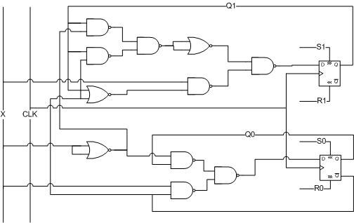

Chip Diagram:
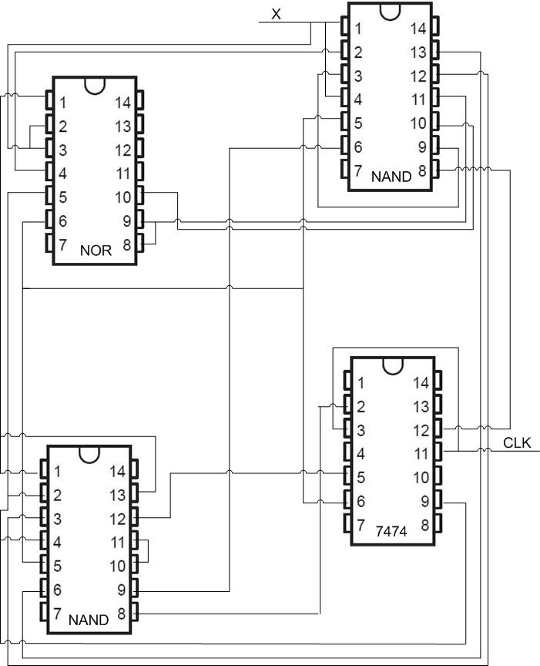

Wire List:
U1 = NOR Chip, U2 = NAND0 Chip, U3 = NAND1 Chip, U4 = 7474 Chip
VCC = Voltage
GND = Ground

VCC -> U1-14, U2-14, U3-14, U4-14 U1-1 -> U3-1, U3-13
GND -> U1-7, U2-7, U3-7, U4-7 U1-5 -> U3-2, U3-4, U4-9
X -> S1 -> U2-1, U2-4, U1-2, U1-3 U1-6 -> U3-5, U4-6
U2-2 -> U1-4 U3-12 -> U4-5
U2-3 -> U2-9 U3-11 -> U3-10
U2-5 -> U4-6 U3-8 -> U4-2(D)
U2-6 -> U3-9 U4-3(CLK), U4-11(CLK) -> LED
U2-13 -> U3-6 U4-2(D0) U4-12(D1) -> LED
U2-12 -> U3-3 U4-1(CLR’), U4-4(PRE’), U4-13(CLR’), U4-10(PRE’) -> LED
U2-11 ->U1-9, U1-8 Then:
U2-10 -> U1-10 U4-1(CLR’), U4-4(PRE’), U4-13(CLR’), U4-10(PRE’) -> switches
U2-8 -> U4-12

Here is the truth table based on the completed chip circuit:
Current State | X | Next State
00 | 0 | 00
00 | 1 | 01
01 | 0 | 01
01 | 1 | 10
10 | 0 | 10
10 | 1 | 11
11 | 0 | 11
11 | 1 | 00

State Diagram from Truth Table after analyzing circuit board and truth table:
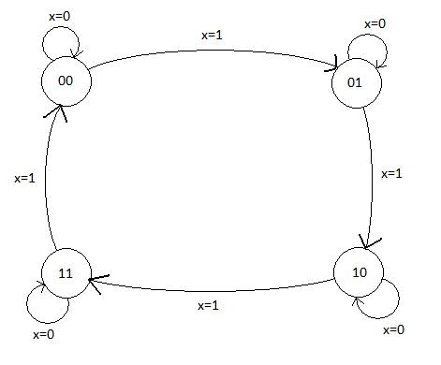

Time Diagram for circuit:
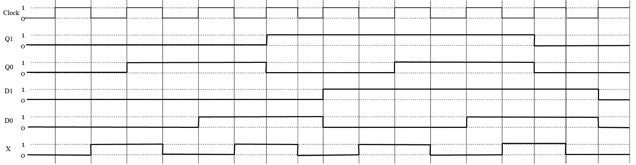

Lab Results:
The result is all the information the Chip Diagram, Circuit Diagram, and Truth Table represent. Also, when comparing the timing diagram to the state diagram, the state changes occur in patterns. D1 and Q1 change only twice during a full cycle of the states. Also, D0 and Q0 change four times and the value of X changes half as often as the clock.
Observations and Conclusions:
A conclusion I found was that the prepared circuit from lab was indeed a 2-Bit Counter. The most annoying part of the lab was the intense circuit diagram that needed to be implemented and the most confusing and beneficial part of the lab was the analyzing of the lights and switches to discover what we created. After everything was complete I discovered the circuit is designed to be a two bit counter, going from 0 to 3 and then restarting back at 0.

